Design Thinking From the Ground Up:
An Educator’s Guide to the Design Process
Megan Gilligan
Arizona State University

Abstract
This paper is the culmination of a fifteen-week design study in partnership with a high school teacher to utilize design thinking in a classroom context. A procedure for guiding the educator through the design process was developed and implemented to gain understandings into whether incorporating design thinking in a classroom context would enhance educators problem-solving abilities and empower them to effectively tackle complex problems. The findings suggest that design thinking is a powerful tool for educator’s and can have a positive impact on their classroom environment, though continued support is key. The paper begins with a situation analysis report to discuss the mission of the partner organization, as well as goals and expectations of the study. It continues with the theoretical inspiration statement which articulates the theoretical underpinnings of the study. Then, the design statement and prototype describe the outline of the procedures developed to guide the collaborating teacher through the design process. The paper concludes with the design enactment report which includes a narrative of the process and details the findings.

Situation Analysis Report
Purpose, Vision, and/or Mission
I am working with a high school teacher in the southwestern US. On the district website where my collaborator teaches, there is a page dedicated to describing their beliefs, vision, mission, and goals. I have organized them into a table below:
Beliefs | - Every member of our community plays a valuable role in the success of our students by supporting a positive, student-focused learning environment.  - It is vital to ensure equity and access to a high-quality educational experience for all.  - The essential skills for success are collaboration, creativity, communication and critical thinking.  - A collaborative and inclusive culture is critical to reach our goals.  - Lifelong learning is essential.
Vision | Our students will be the leaders of tomorrow with the skills, knowledge and confidence to realize their dreams in an ever-changing world.
Mission | To cultivate world-class thinkers.
Goals | - To work collaboratively to engage students in individualized, rigorous, and authentic learning opportunities so that they may reach their highest potentials.  - To create a culturally proficient climate that ensures equity and access for all in PVSchools

The words/phrases that seem most representative of the district’s overall philosophy are equity, collaboration, and authentic learning opportunities. Collaboration is mentioned is three separate sentences, which conveys to me that this is a foundational premise for their district. I would define collaboration as multiple people working together toward a shared goal, though their definition is not explicitly stated. Equity is also mentioned more than once, as is the idea of individualization. To me, this expresses a negative view toward sameness. Though teachers are teaching students the same material, students should not all always be doing the same things. The last phrase that is a defining feature is authentic learning opportunities. They mention an ever-changing world and a desire to cultivate lifelong learners and world-class thinkers. It appears that they believe this can be accomplished through real-world, meaningful work. When I asked my collaborator about his personal teaching philosophy, he did talk about his role as a facilitator to develop critical thinking skills in students, but he did not espouse the districts view on the importance of individualization or authentic learning practices. An implication of this for my project would be to see if the design thinking process can aide my collaborator in more closely matching his district’s vision and goals in his own classroom.
Organizational Overview
The school district, as well as most school districts in America, require professional development for their staff. This is a term “used in reference to a wide variety of specialized training, formal education, or advanced professional learning intended to help administrators, teachers, and other educators improve their professional knowledge, competence, skill, and effectiveness.” (Edglossary, 2013). I would say that my project fits within this same realm. My goal is for my collaborator to implement design thinking in his classroom to ultimately advance his practice and improve relevant student outcomes. The stakeholders this directly impacts are my collaborator and his students, but it is also relevant to his administration as well as district staff who are looking for ways to improve student outcomes. An implication of this for my project is that I need to make sure the results aren’t just tailored to individual educators, but to anyone in a position to make change.
Organizational Culture & Everyday Practice
My collaborators high school is made up of 77% Caucasian students with 7% of the school’s population in the free or reduced school lunch program. The average proficiency for the student body in reading and math is higher than both the state and national averages. Twenty nine percent of the student body participates in advanced placement courses. Sixty two percent of students go on to a four-year college. To me, this suggests that the majority of students at this school are already coming to the classroom with advantages that you might not find in every school in this region. This impacts not only the design challenge my collaborator selects, but also varies the constraints and affordances he is working with throughout the design process.
I asked my collaborator what a typical lesson looked like in his classroom. He said he has a PowerPoint presentation that accompanies his lecture, which lasts about 20 minutes. He said that within the lecture there is some discussion and questions for students. While he is lecturing, students are taking notes in their notebook. Instead of a weekly quiz, he’ll do random notebook checks. He described these notebook checks as essentially open note quizzes to make sure students are keeping up with their notes. Then, he’ll have students work either individually or in a group. Students are assigned reading/questions from the textbook or he’ll use an online resource called DBQ online. For this online resource, there is a guiding question and then multiple primary sources that go along with it. Students answer questions about the primary sources and then write a constructed response to the guiding question. He said this generally lasts about 20 minutes. For the remainder of class, he will go through the questions by calling on individual students to discuss their answers. My collaborator talked about the importance of the common core standards related to analyzing primary sources and developing research skills. I get a sense that he has fine-tuned this routine and enjoys knowing exactly what he will be doing but that he is starting to get a bit bored with it. He mentioned how he does not even have to think about what he is going to do the next day, he can just show up and pick out the lecture/primary resources he wants to use for the day. As we have been going through the very beginning stages of the design process, my collaborator has mentioned several times that he is eager to revamp some of his practices. An implication of this for the project is to make sure that he is not just revamping slightly to then do that same thing for the next five years, but to instill a mindset change and a desire to more regularly examine his classroom practices and gather feedback.
Resources
There is no budget allocated for this project. So, that acts as a constraint on the scope of what my collaborator’s prototypes can be. This project does need to be finished within a finite number of weeks, so again the scope of what we can tackle is somewhat limited. My collaborator coaches for multiple sports, so he has a limited amount of time to devote to this project on a daily basis. Depending on how my collaborator defines his final design challenge, it might be beneficial to contact an expert in the field or use my student access to research journals on a given topic. An important aspect of the design process is flexibility, and I believe my collaborator and I have reached a positive consensus on what this means in terms of this specific project.

Theoretical Inspiration Report
The concept of knowledge inspires many questions that people have pondered over for centuries. Does it reside in one’s mind? Are there different kinds of knowledge? How is it acquired? Is it acquired? Is knowledge truth? Can knowledge be distributed? Is it communal? What influences knowledge? Does knowledge have limits? To articulate a holistic theoretical perspective, I knew I needed to crystalize how I view knowledge in order to see and explain how these views impact all aspects of my work. Though it is difficult to pinpoint an exact title for an intricate set of beliefs that have been shaped by personal experiences, particular textual encounters, unique educational opportunities, etc., I feel that the idea of situated knowledge and learning most closely elucidates my perspective. This is the belief that “knowledge is situated, being in part a product of the activity, context, and culture in which it is developed and used” (Brown, Collins, & Duguid, 1989, p. 32). This belief and its inherent characteristics envelope and permeate the why and how of my project. Choi and Hannafin (1995) divide situated learning environments into four aspects: the role of context, the role of facilitation, the role of content, and the role of assessment. I will address these four aspects in relation to my current design study.
In situated learning, authenticity and context play a key role (Choi & Hannafin, 1995). In order for learners to understand a concept, they need “authentic tasks in an authentic context”, meaning that they need to participate in real-world activities in the actual setting that the task takes place in (Choi & Hannafin, p. 56, 1995). A fundamental principle of the Learning Sciences that aligns with this thinking is the concern with bridging research and practice (Nathan & Sawyer, 2014). This interest is also at the core of my project using design-based research (DBR) to study educators as designers, or design thinking for educators. Barab (2014) defines DBR as a compilation of methods employed in studying phenomena in their real-world contexts, “with the goal of advancing theory while at the same time directly impacting practice” (p. 151). Rather than solely attempting to understand the ways in which educators design classroom practices and environments, I am looking to impact practice by embedding the use of design thinking into the classroom context in order to enhance educators problem-solving abilities and empower them to effectively tackle complex problems. Simultaneously, I will be examining the influence of design thinking on various aspects of classroom practices and environments with the purpose of advancing theory on educators as designers. This means that my collaborator is not just practicing design thinking in hypothetical scenarios but is actually going through the design process with their students and implementing design ideas in their classroom.
Due to the use of authentic experiences for learning, learners in a situated learning environment require support and ongoing facilitation (Choi & Hannafin, 1995). A form of facilitation that is woven in throughout my design study is scaffolding. Scaffolding includes the collaboration of a learner with someone who is more knowledgeable to enable the learner to complete more complex tasks than they could on their own (Reiser & Tabak, 2014). In this case, I am more knowledgeable about the process of design thinking and am guiding my collaborator through the design process, which he otherwise might not be able to get through. In this design study, I began by presenting information to my collaborator about what design thinking is and why it is beneficial specifically to educators. My collaborator then took part in a design challenge ‘crash course’ in relation to the shoe buying experience, where he went through all the stages of the design process in under two hours. The purpose of this was to familiarize him with the general idea and concepts of the process. From there, we developed a timeline where we will go through one phase of the design process for his specific design challenge each week or two. For each phase, I have required tasks with resources to aid in completing each task. We have also been having weekly meetings as I help guide him through the tasks. In an ideal scenario, my collaborators next design challenge for his classroom would see him handle the stages more independently with the need for less and less guidance, as is typical with scaffolding.
The ultimate purpose of facilitation in a situated learning environment is to “attempt to help students to improve their cognitive abilities, self-monitoring, and self-correcting skills” (Choi & Hannafin, p. 63, 1995). This aligns with a Learning Sciences concept called metacognition. Metacognition is basically “thinking about the contents and processes of one’s mind”, which is central to problem solving (Winne & Azevedo, p. 63, 2014). One metacognitive form of thinking is metacognitive monitoring, which is a purposeful gauging of understanding (Winne & Azevedo, 2014). Part of my collaborators weekly task is a weekly survey, which has several questions meant to improve his self-monitoring skills. For example, one question is “How well do you feel you understand this stage of the design process?” This allows for reflection on my collaborators part related to his understanding and provides valuable information for me to adjust my facilitation methods. Another metacognitive form of thinking is metacognitive control, where insights from metacognitive monitoring are used to take action (Winne & Azevedo, 2014). This influenced the final question on the weekly survey, “How will your insights from the successes and challenges from this stage carry into the next stage?”. This question affords the opportunity for my collaborator to transfer lessons from one stage to another, inciting a deeper understanding.
To describe the relationship between situations and cognition in situated learning, Brown et al. (1989) liken it to vocabulary lessons. Though definitions can be taught and practiced, one cannot truly know what a given word in a sentence means without the context of the other words around it. Similarly, knowledge is “inextricably a product of the activity and situations in which [it is] produced” (Brown et al., p. 33, 1989). Therefore, knowledge is continuously evolving “because new situations, negotiations, and activities inevitably recast it in a new, more densely textured form (Brown et al., p. 33, 1989). This fluid, transformative view of knowledge is the reason for the concept at the forefront of my design project; design thinking. Not only is it included in the way I am conducting my research through the use of DBR and in what I am actually studying, design thinking for educators, but it influences every aspect of my decision making. That is because design thinking is not just a process, it is a mindset. It is empathetic, collaborative, optimistic, inquisitive, iterative, expansive, and the list could go on (IDEO, 2014). Teachers are inherently designers. As in design, “teaching is a highly complex activity” that occurs in “ill-structured, dynamic environments” and requires “continuous enactment and subsequent tweaking of activities and resources” (Garreta-Domingo et al., 2018). Consequently, I want to advocate to my collaborator the importance of design thinking’s iterative nature in new and ever-evolving situations.
This belief in the constant negotiation and recast of knowledge informs an aspect of design thinking that has played a major role in the development of my design study, which is ambiguity. In Design Unbound, Pendelton-Jullian and Brown state that “design is more than working towards a stated purpose with a stated goal” (p. 81). Though this might be the starting point, the process reaches a point where you do not really know what you are doing and these ambiguous moments are where the creative process flourishes (Pendelton-Jullian & Brown, 2015). The interesting dynamic here is that I am facing ambiguity in the creation and process of my design study, while my collaborator is facing and questioning ambiguity in the design process for his design challenge that I am guiding him through. So, I have to extol the virtues of this state of being in the process to my collaborator as I guide him while also going through the design process myself and having to give into the unknown and unintended. It feels doubly unbound in a sense, but I have learned to trust the process and know that it will converge, and intentions will become clearer.
An inherent characteristic of situated learning is a shift in the unit of analysis when employing this perspective in research. Rather than the traditional focus on the individual, the unit of analysis becomes “the group and the activity undertaken within it” and “what is learned – becomes a question of how the person changes, not what is acquired” (Waite & Pratt, p. 6, 2015). So, in my study, I will not be assessing my collaborator on what he knows about design thinking, but on the changes that occur in his classroom. A guiding framework for my design study is Bielaczyc’s Social Infrastructure Framework (SIF). Bielaczyc (2013) describes the framework as “a guide to critical design elements” which highlights four dimensions: Cultural Beliefs, Practices, Socio-Techno-Spatial Relations, and Interaction with the “Outside World” (p. 266). I intend to use the SIF as a way to document changes in action in the four dimensions before the enactment of the design prototype and during the enactment of the prototype.

Design Statement & Prototype
Design-based research (DBR) seeks to accomplish three main goals: understand systems of teaching and learning within their complex environments, engineer new systems of teaching and learning, and have a positive local impact which can then be generalized in other contexts (Barab, 2014). The driving purpose behind these goals is to develop knowledge “about both the process of learning and the means that are designed to support that learning” (Cobb et al., p. 10, 2003). This is accomplished through “an iterative design process featuring cycles of invention and revision” (Cobb et al, p. 10, 2003). A fundamental component in utilizing DBR is to assume a design thinking mindset. Some key characteristics of a design thinker mindset include human-centered concern, predisposition toward multifunctionality, and having a systemic vision (Razzouk & Shute, 2012). Design thinking is gaining popularity in many different fields, including education, due to its propensity for developing creative, user-driven solutions. Whether they realize it or not, educators are inherently designers. They design everything from learning opportunities and behavior management strategies to classroom layout and bathroom procedures. In order to be successful as designers, educators “need to adopt a design mindset and acquire the skills needed to address the design challenges they encounter in their everyday practice” (Garreta-Domingo, Sloep, & Hernandez-Leo, p. 1113, 2018). Therefore, my design study examines how an educator who is a design thinking novice interacts with the design thinking process. My specific challenge for this study is to understand and engineer systems for how we might incorporate design thinking in a classroom context to enhance educators problem-solving abilities and empower them to effectively tackle complex problems. I have developed a prototype for transitioning educators into a design thinking mindset and guiding them through the design process. Due to the iterative nature of DBR, there were many changes between the original prototype and the end result. These changes will be discussed further in the Design Enactment Report. What follows is a description of the prototype as it was at the completion of the design study.
The first aspect of the design challenge I considered was the specific design methods I wanted to employ. I spent some time researching various studies that looked at design thinking for educators, most of which used Massive Open Online Courses (MOOCs) and other various online learning design tools to guide educators through the design thinking process. Though I think these are great options for working on a larger scale, for the time limit and scope of this project, I knew I needed something smaller and easier to manage for just one teacher. I also noticed that many of the design approaches, such as that shown in Figure 1 from Garetta-Domingo et al. (2018), mimicked d.school’s Design Thinking Bootleg (2018) and IDEO’s Field Guide to Human-Centered Design (2015) design processes.
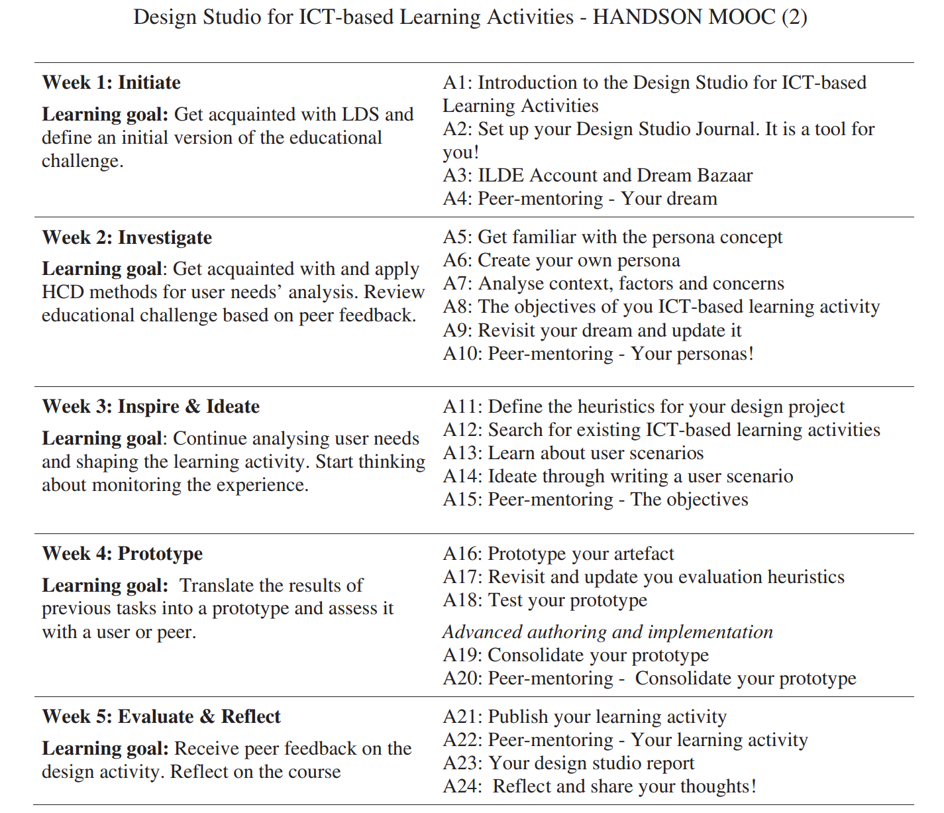
Figure 1. The HANSON’S MOOC course activities (Garreta-Domingo et al., 2018).
So, because these were the two processes that I was most familiar with and they seemed like a good representation of the design processes being used in similar contexts in other studies, I decided to use a combination of these two design processes in my design study.
Though the IDEO and d.school processes are similar to each other, there are some key differences. One difference is the wording of the stages. d.school’s stages are labeled as Empathize, Define, Ideate, Prototype, and Test. IDEO’s stages are labeled as Discovery, Interpretation, Ideation, Experimentation, and Evolution. As I discussed in my Theoretical Inspiration Statement, the use of authentic learning experiences necessitates ongoing facilitation. Rogoff and Gardner (1984) state that when an expert is facilitating and scaffolding for a novice, they must “structure their communication so that the novice is brought into the expert’s more mature understanding” (as cited in Choi & Hannafin, p. 62, 1995). So, I knew that my collaborator and I needed to have a shared language. I choose to use the d.school’s language. Although this could be a biased choice because of my familiarity with the d.school verbiage, I felt that the names for the d.school stages more clearly related to what is accomplished throughout each stage. Another difference is the methods that were offered for each stage of the process. Though there were some similar methods, there were many that were different. In a situated learning environment when using scaffolding to facilitate learning, it is important to provide the right level of challenge. If it is too easy they will get bored, and if it is too challenging then they will become frustrated (Choi & Hannafin, 1995). I struggled with not wanting to overwhelm my collaborator but also not wanting to limit his choices. So, I decided to use the d.school methods as my collaborators main source for each stage of the process because I believe that the language used is easier to understand and because they provide many examples. Then, I supplemented these with just the IDEO methods that differed from those offered in d.school. I took methods from both the IDEO Field Guide to Human-Centered Design (2015) and the IDEO Design Thinking for Educators (2014). Though IDEO has an educator specific design manual, I consider it to be overly simplified and do not believe it allows for as full of a process as the non-educator tailored manuals. Therefore, I sparingly pulled methods from the educator manual when I felt they differed from the d.school and could be helpful.
Once I decided on the specific design process and realized the need for optimization, I needed to determine how to disseminate and organize the information for my collaborator. “In situated learning environments, advice and guidance help students to make maximum use of their own cognitive resources and knowledge”, therefore I knew it was imperative that I be available to guide my collaborator through the implementation of the methods whenever the need arose (Choi & Hannafin, p. 62, 1995). So, I incorporated at least one weekly meeting through whatever means was most helpful for my collaborator, whether that be a telephone conversation, video chat, or in-person meeting. Then, of course, I am also available through email or text message outside of those weekly meetings. Taking inspiration from the online tools used in other studies, I decided to take advantage of Google Drive to organize the resources I was providing to my collaborator. It is a free service that is almost universally known, and I knew my collaborator would already be knowledgeable about the program and would not need extra training for it. I set up a design resource folder that I shared with my collaborator; see Figure 2 for the folder layout.
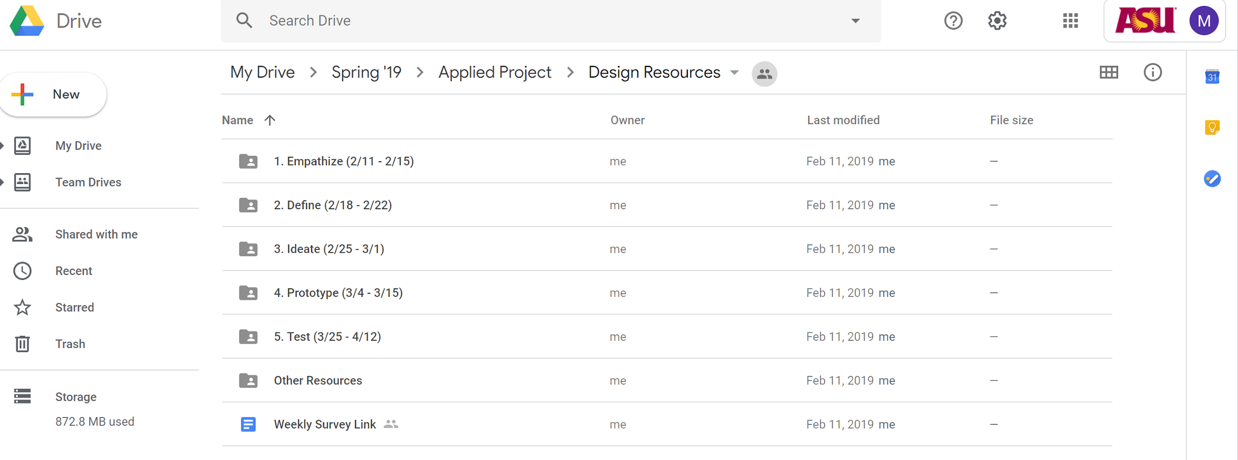
Figure 2. Design resource folder on Google Drive for my collaborator.
I then created a folder for each part of the process and put the dates that my partner and I agreed to when discussing the schedule for the project. Inside each folder, I uploaded a task document, a d.school document, and an IDEO document (see Figure 3).
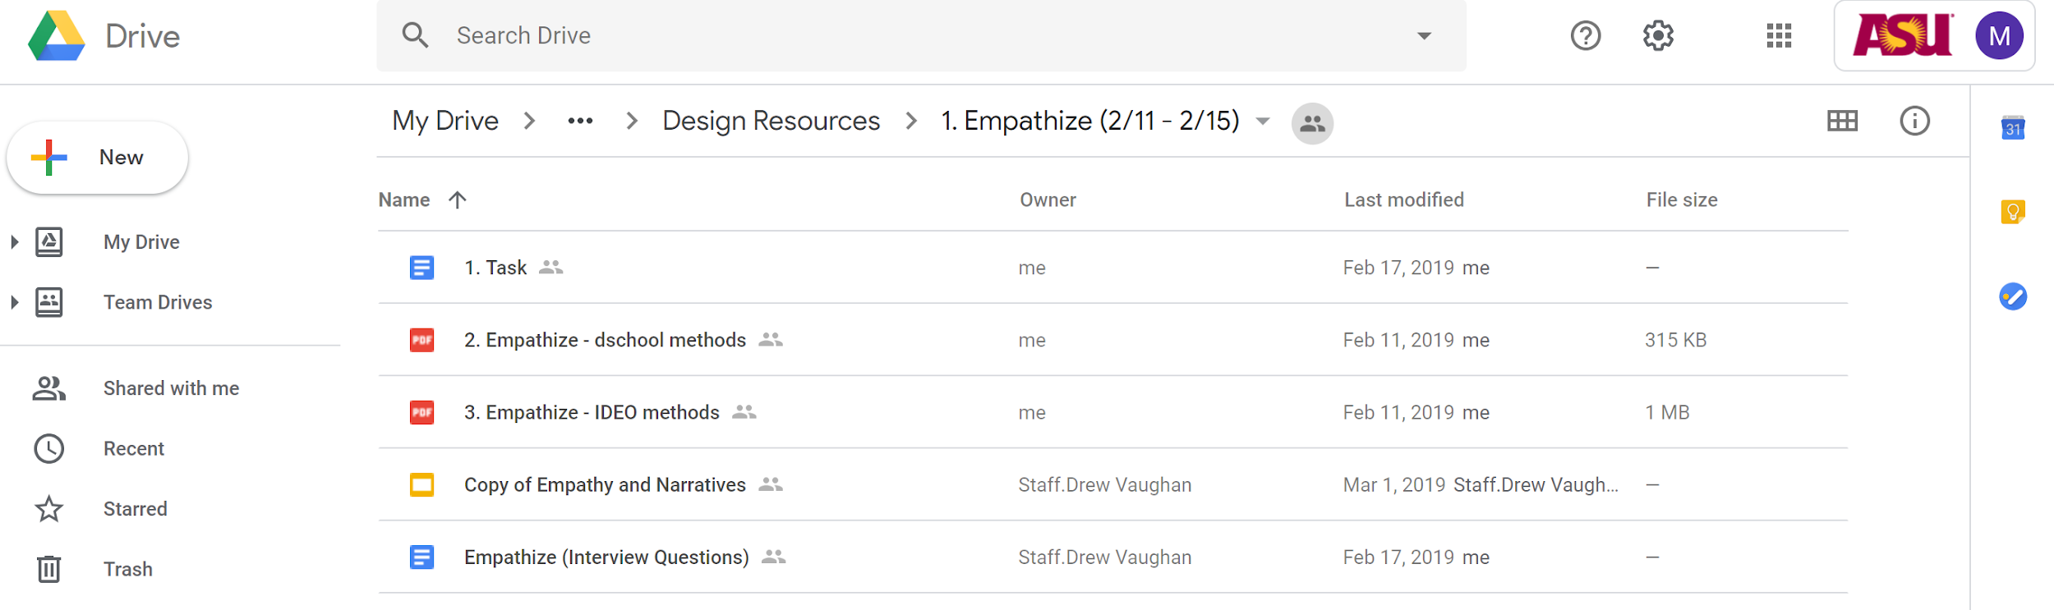
Figure 3. Empathize folder including supporting documents located in the shared design resource folder.
The task document lets my collaborator know what is expected from him that week (see Figure 4 for the task for the empathize stage).
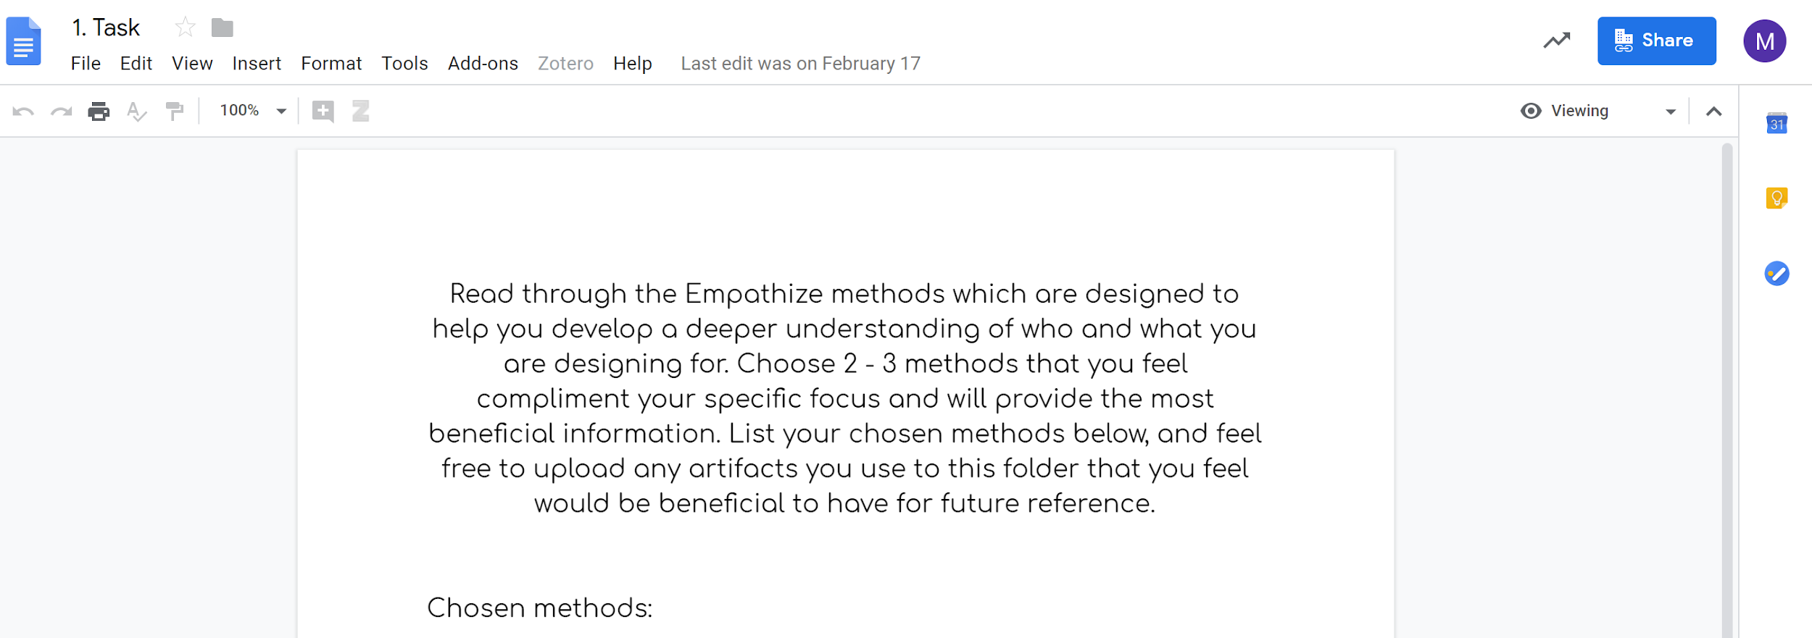
Figure 4. Task document located in the shared design resource folder.
Each week, the task includes reading the supporting documents in the folder which contains methods from d.school and IDEO on only the stage of the process for that folder, choosing the preferred methods, and then implementing the chosen methods.
After I determined the organization of the resources, I needed to establish an introductory procedure. Even in a situated learning environment, there is still an “importance of foundational subject knowledge” (Waite & Pratt, p. 7, 2015). To do this, I developed a presentation based off the d.school Design Thinking Bootleg (2018), the IDEO Field Guide to Human-Centered Design (2015), and the IDEO Design Thinking for Educators (2014). See Figure 5 for the presentation title page.
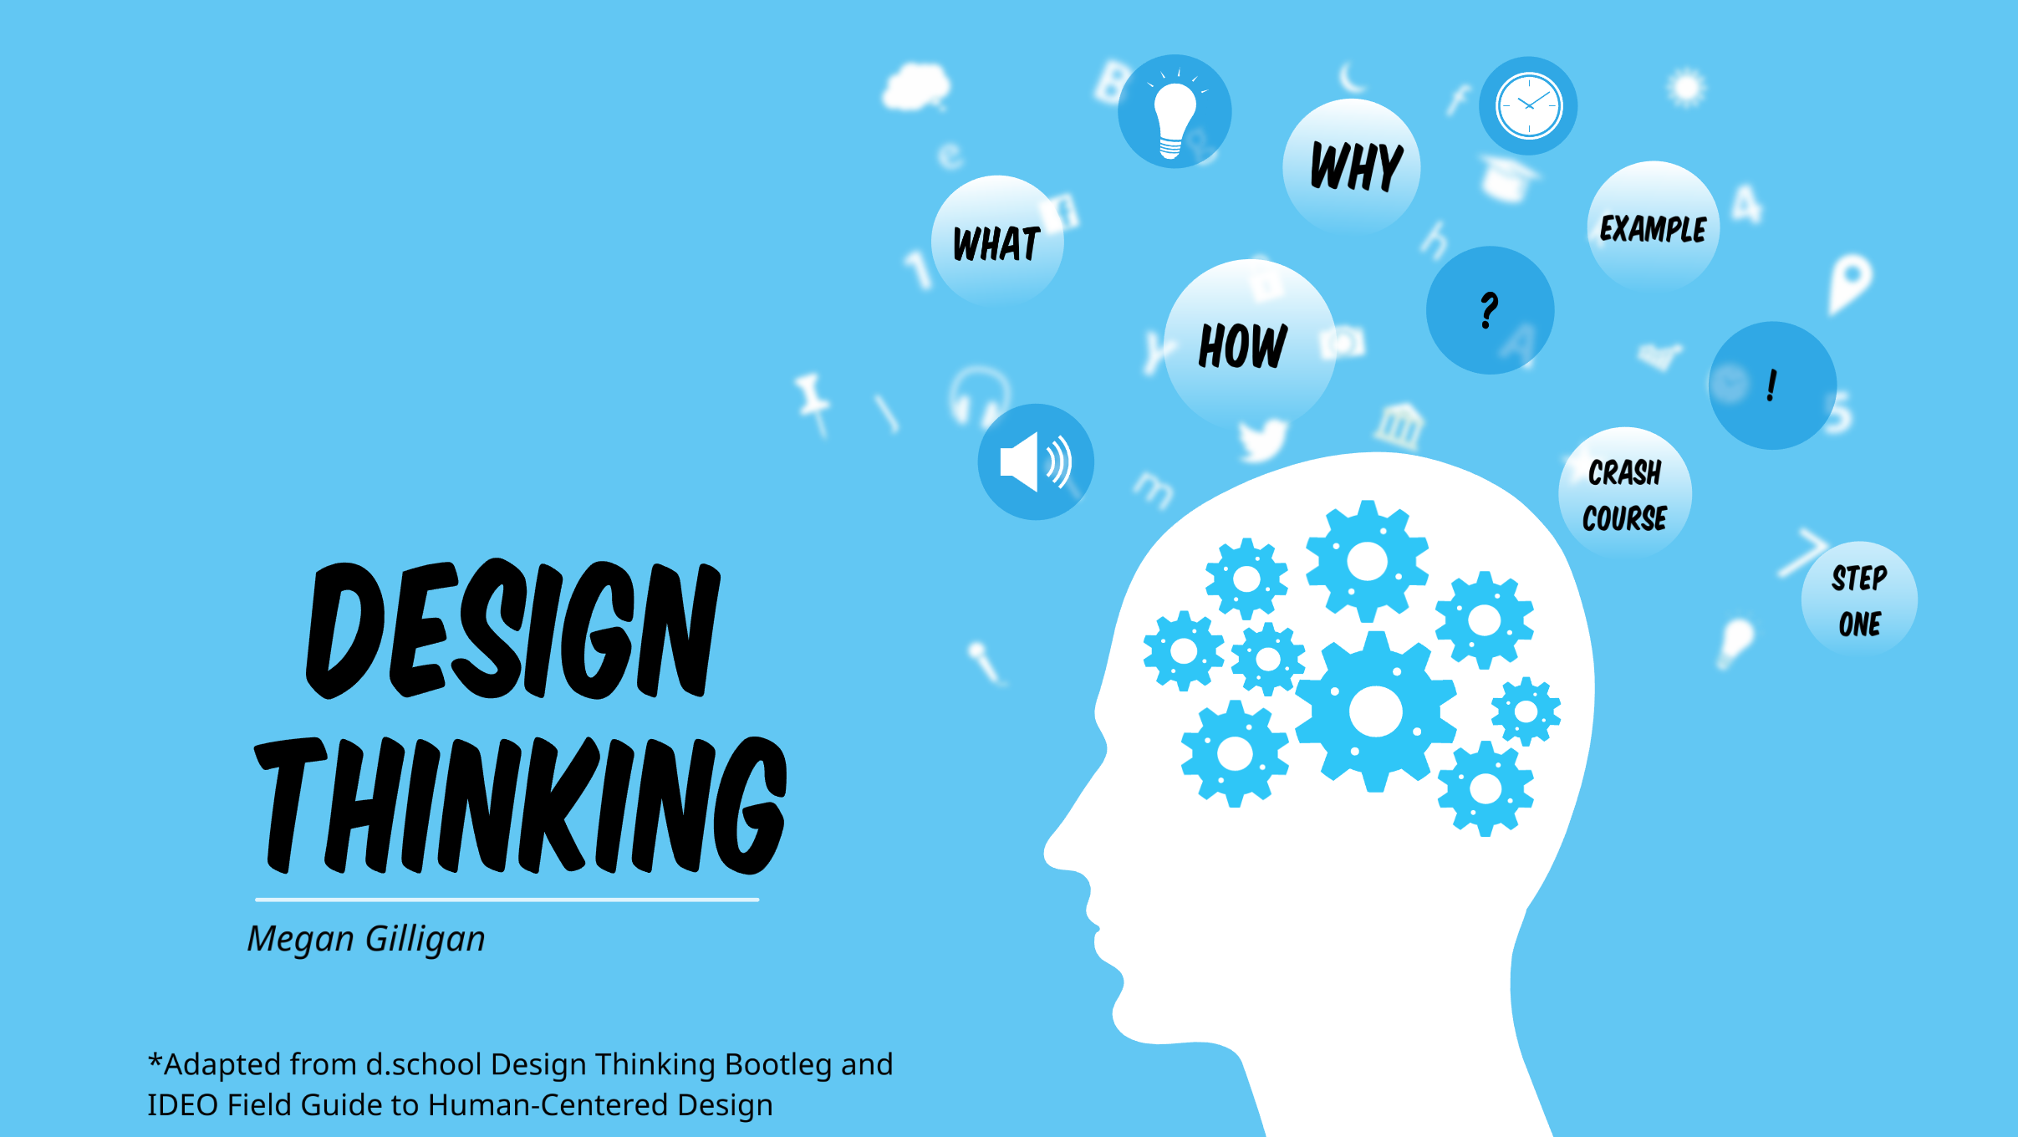
Figure 5. Design presentation title page.
I want to give my collaborator an overview of design thinking by loosely defining the term and giving an overview of how the process works as a whole. See Figures 6 to 13 for these slides.
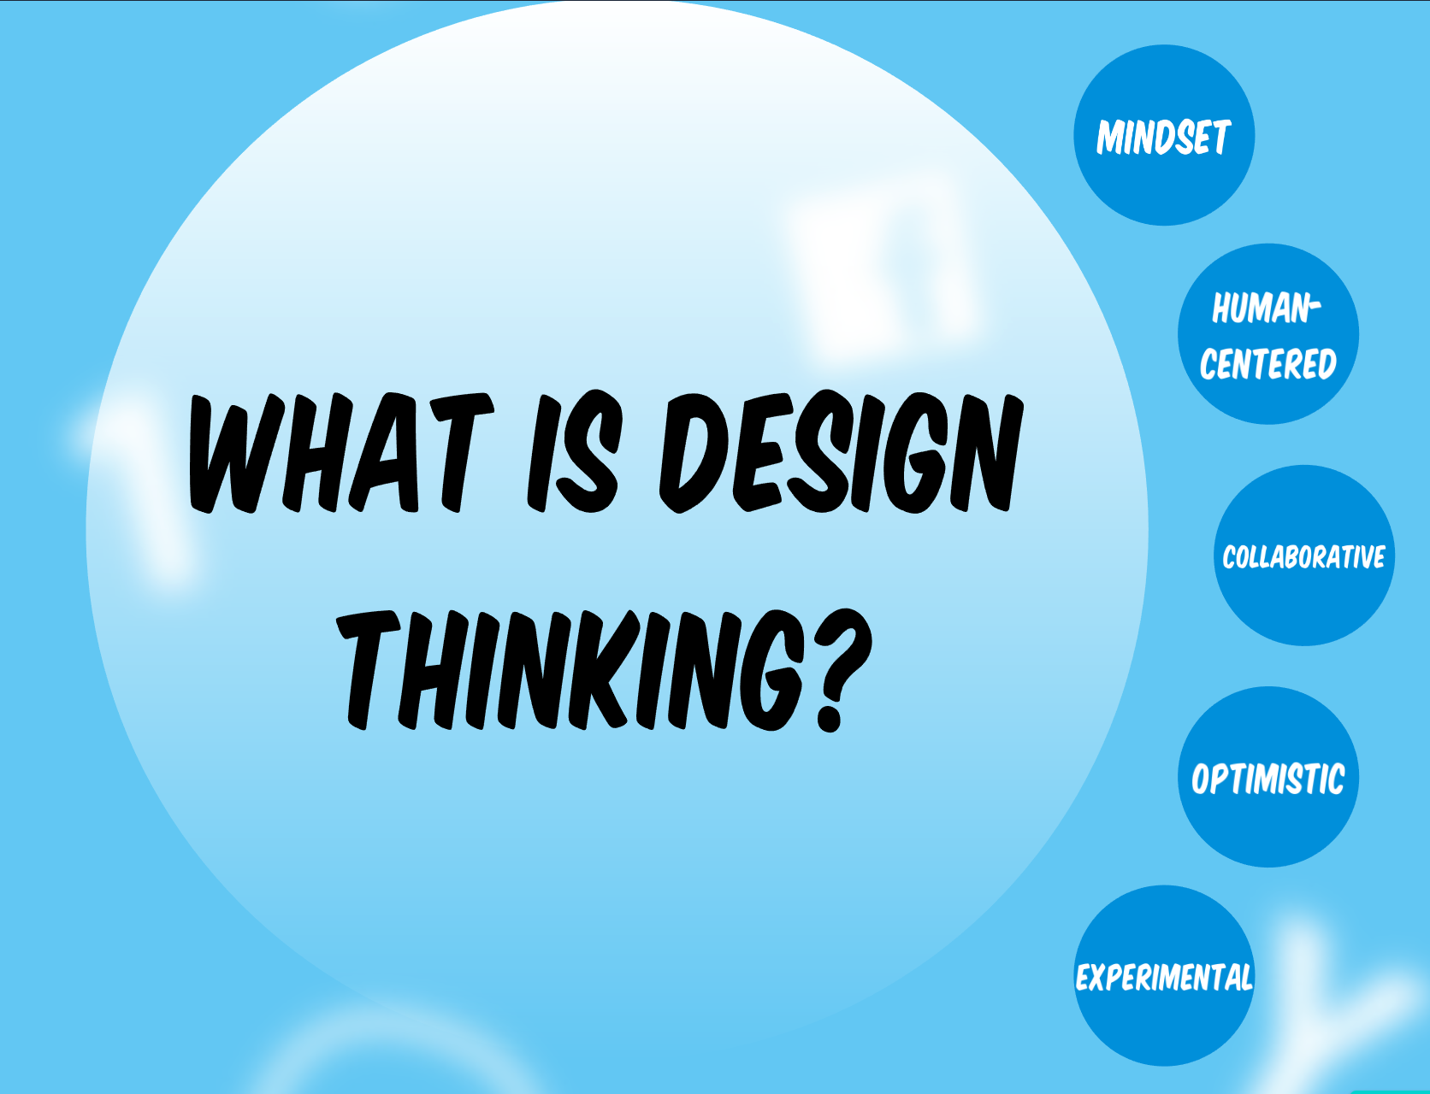
Figure 6. First slide in presentation to define design thinking.
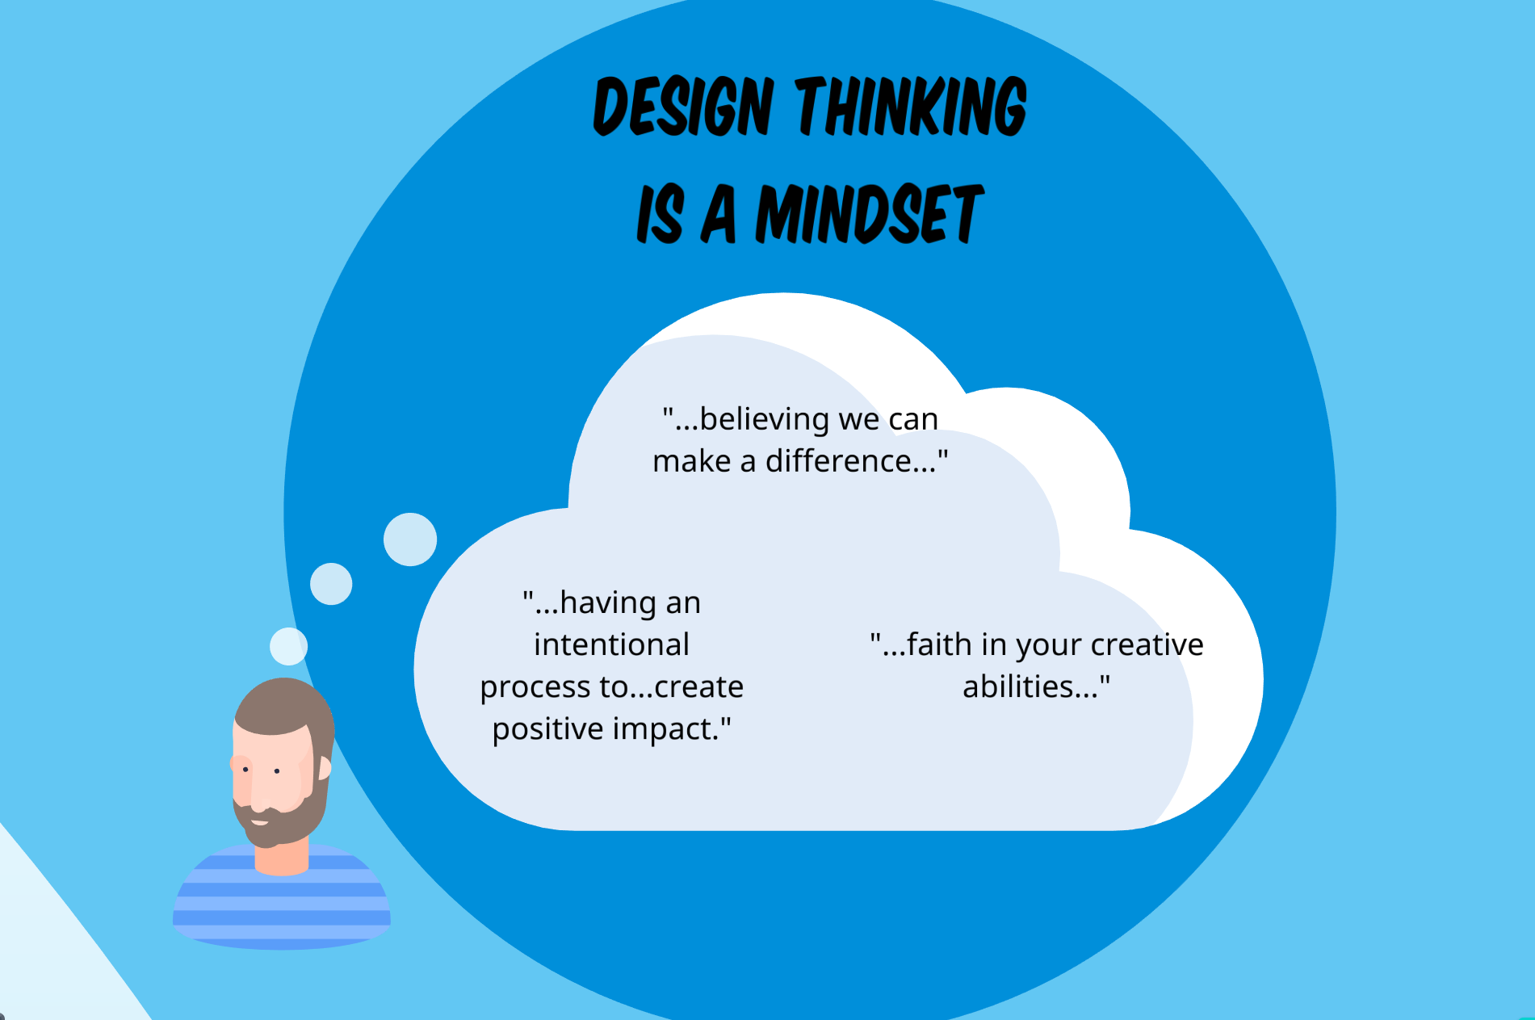
Figure 7. Second slide in presentation to define design thinking.
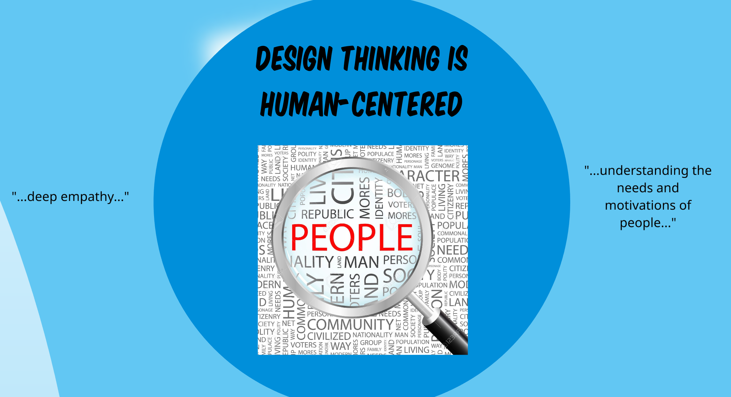
Figure 8. Third slide in presentation to define design thinking.
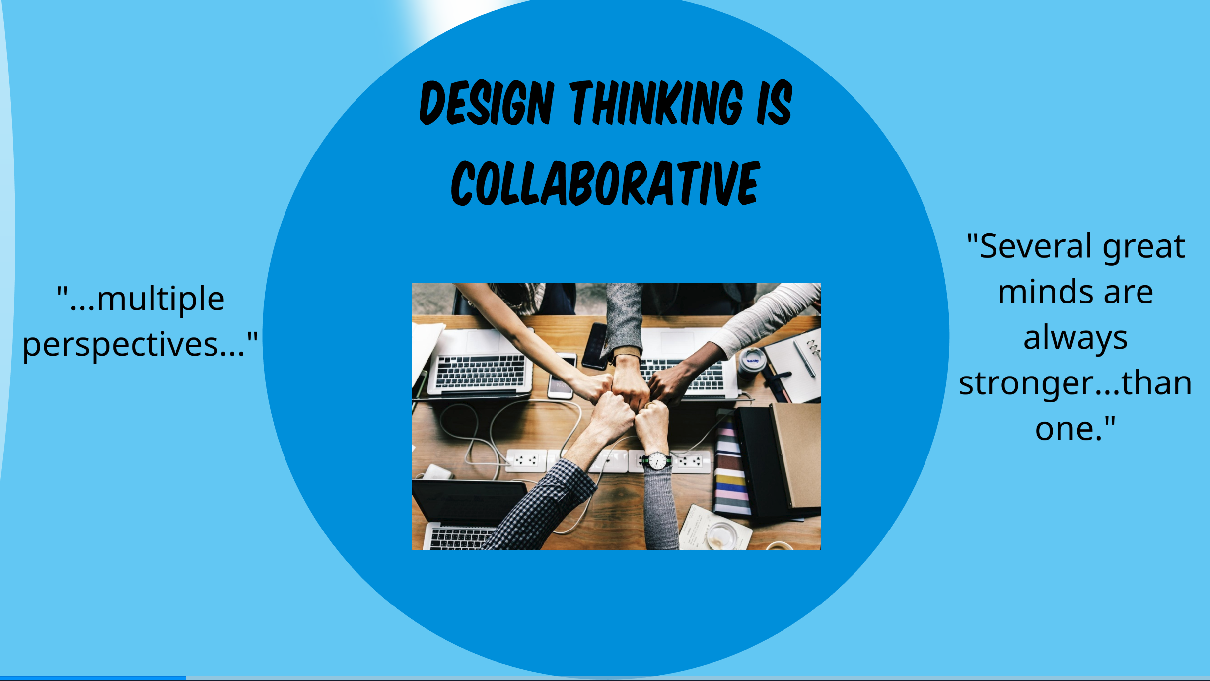
Figure 9. Fourth slide in presentation to define design thinking.
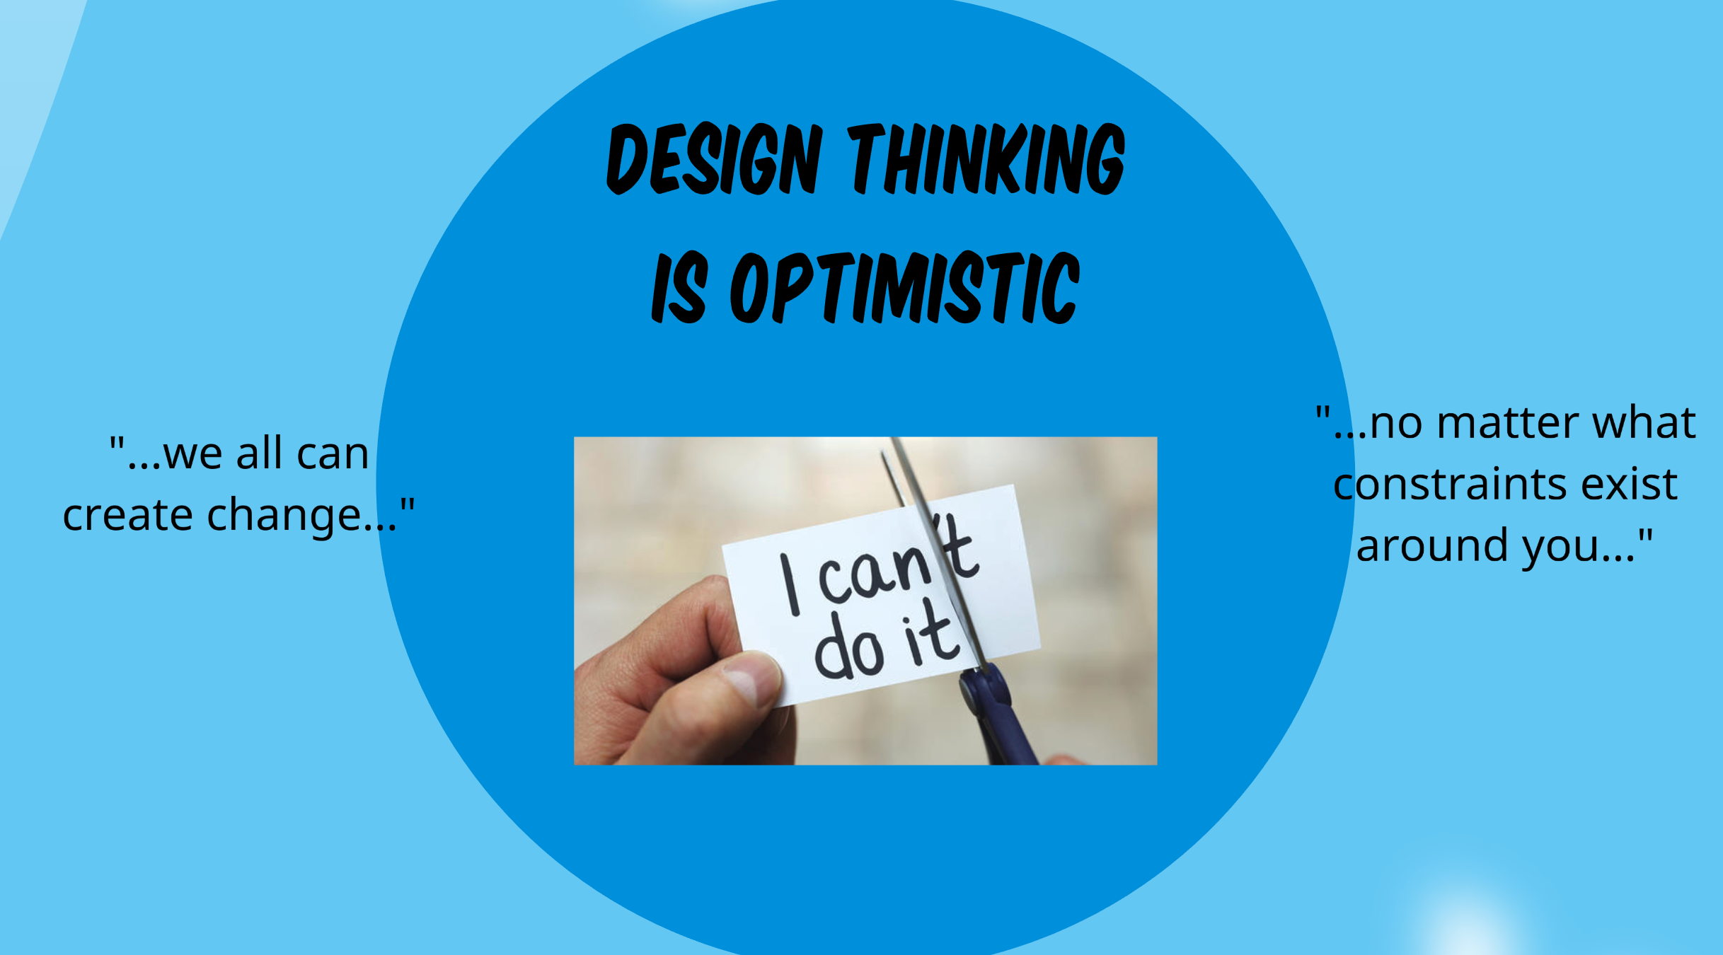
Figure 10. Fifth slide in presentation to define design thinking.
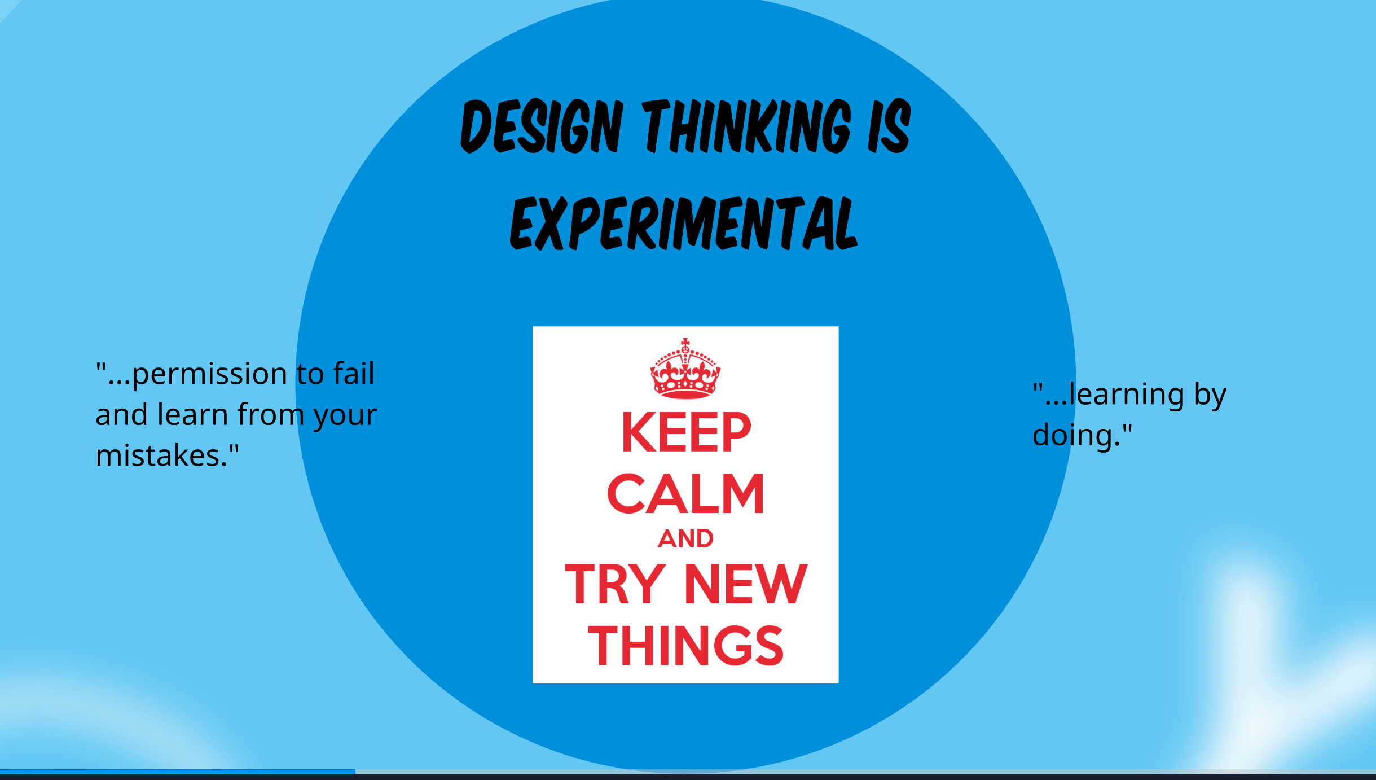
Figure 11. Sixth slide in presentation to define design thinking.
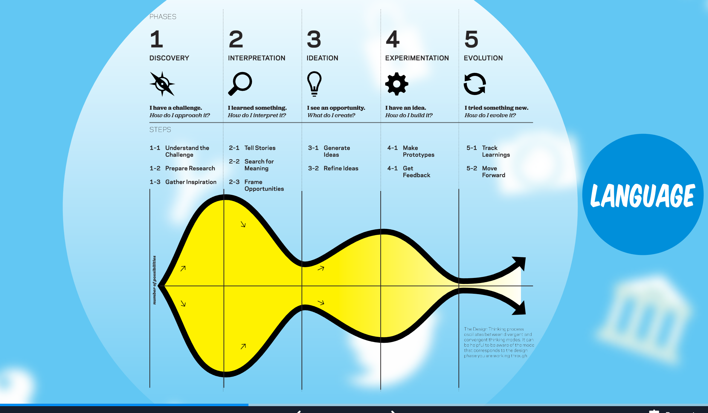
Figure 12. Diagram of the design process (IDEO, 2014).
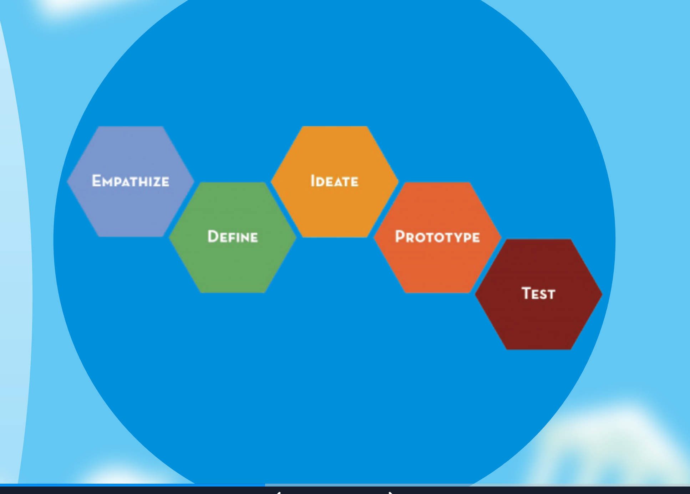
Figure 13. Design stages (d.school, 2018).
However, I also wanted to inspire my collaborator to consider himself a learning designer (Garreta-Domingo et al., 2018). Consequently, I included a brainstorming session into the presentation, see Figure 14, where we have the opportunity to brainstorm all the ways in which teachers design.
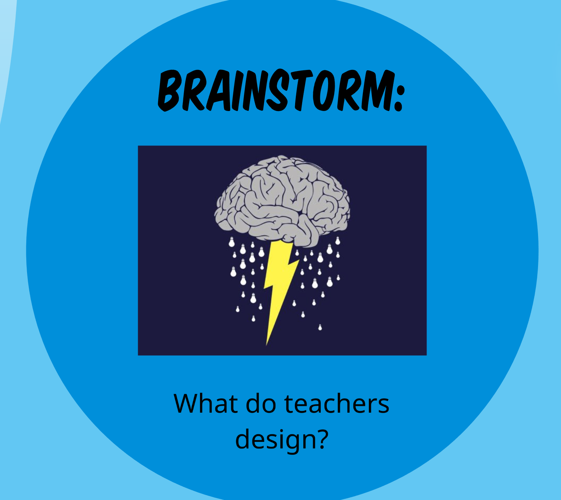
Figure 14. Brainstorm slide in design thinking presentation.
In keeping with the situated learning perspective, I wanted there to be “some connections to the real world or some aspect of that world” (Choi & Hannafin, p. 66, 1995). In order to create some connections between design thinking and why it’s use is important in the real world, I pulled some examples of famous products that were very unsuccessful in their debut. This will create opportunities for us to discuss the importance of empathizing with the users. See Figure 15 for these examples.
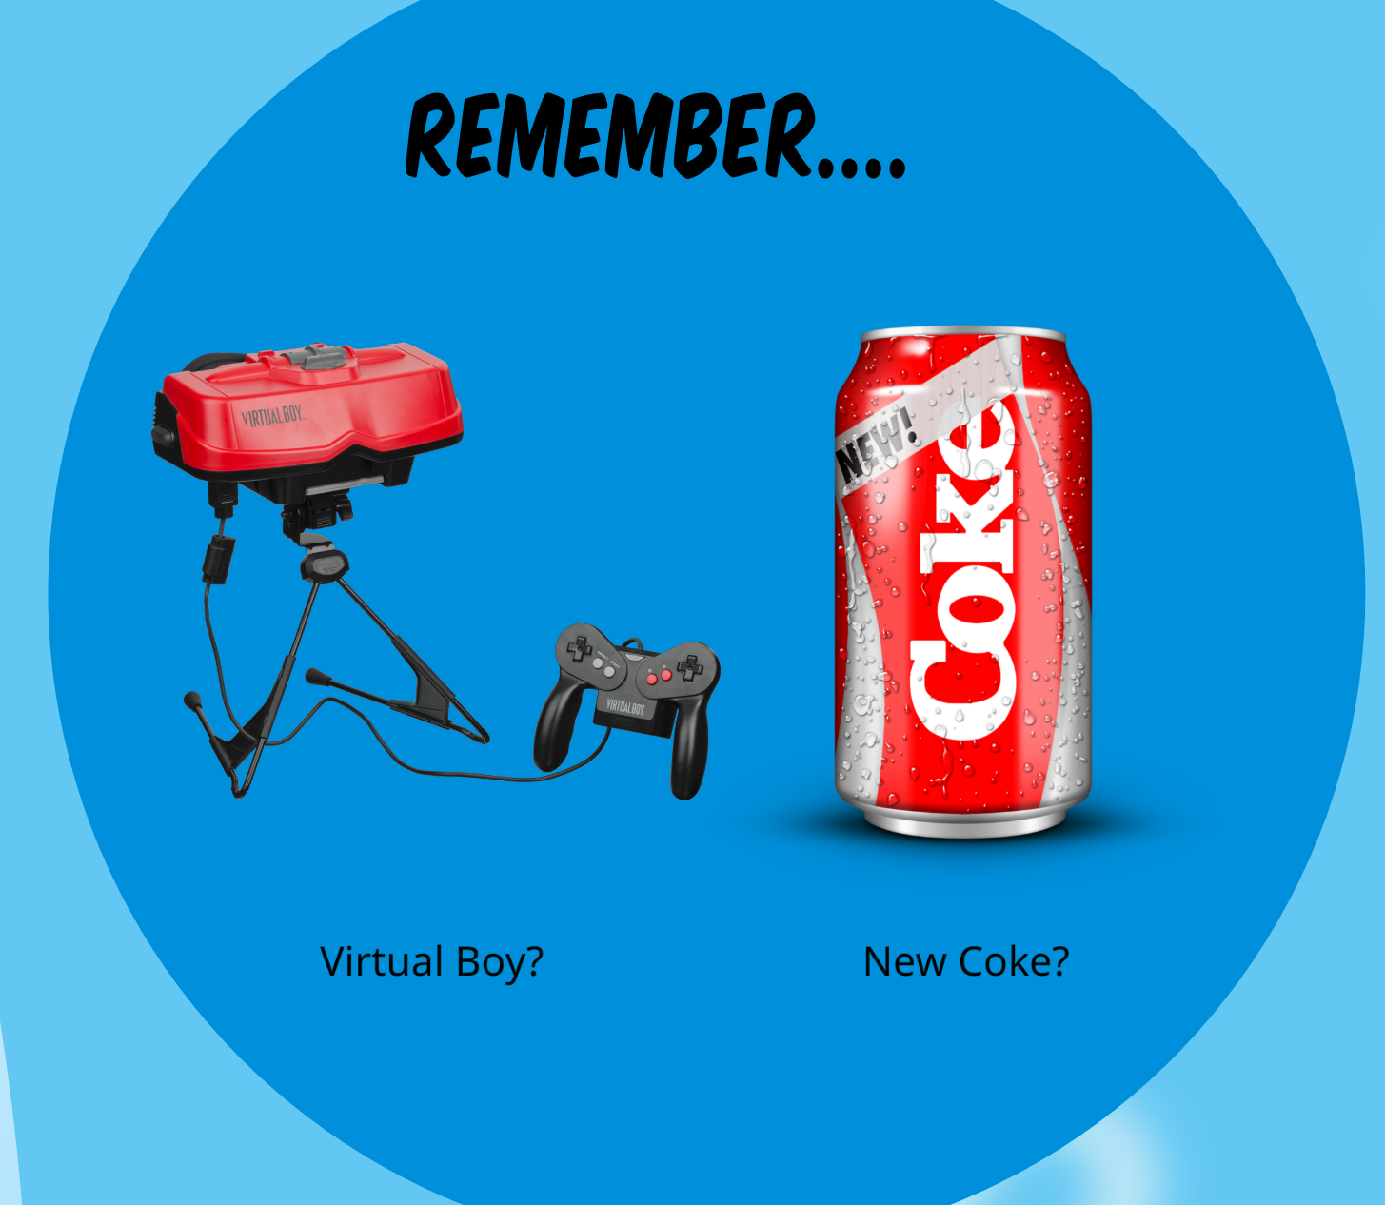
Figure 15. Examples slide of famous products that were very unsuccessful in their debut.
To continue with this theme of relevancy, I found a video of football helmet designs throughout the years. My collaborator coaches for various sports, so I thought this was a pertinent connection that might stick with him. I intend to play this video and pause it after each helmet to discuss why certain changes were made to the helmet and to espouse the idea that continuous iterations are important to make sure you have the best product possible. See Figure 16 for this slide.
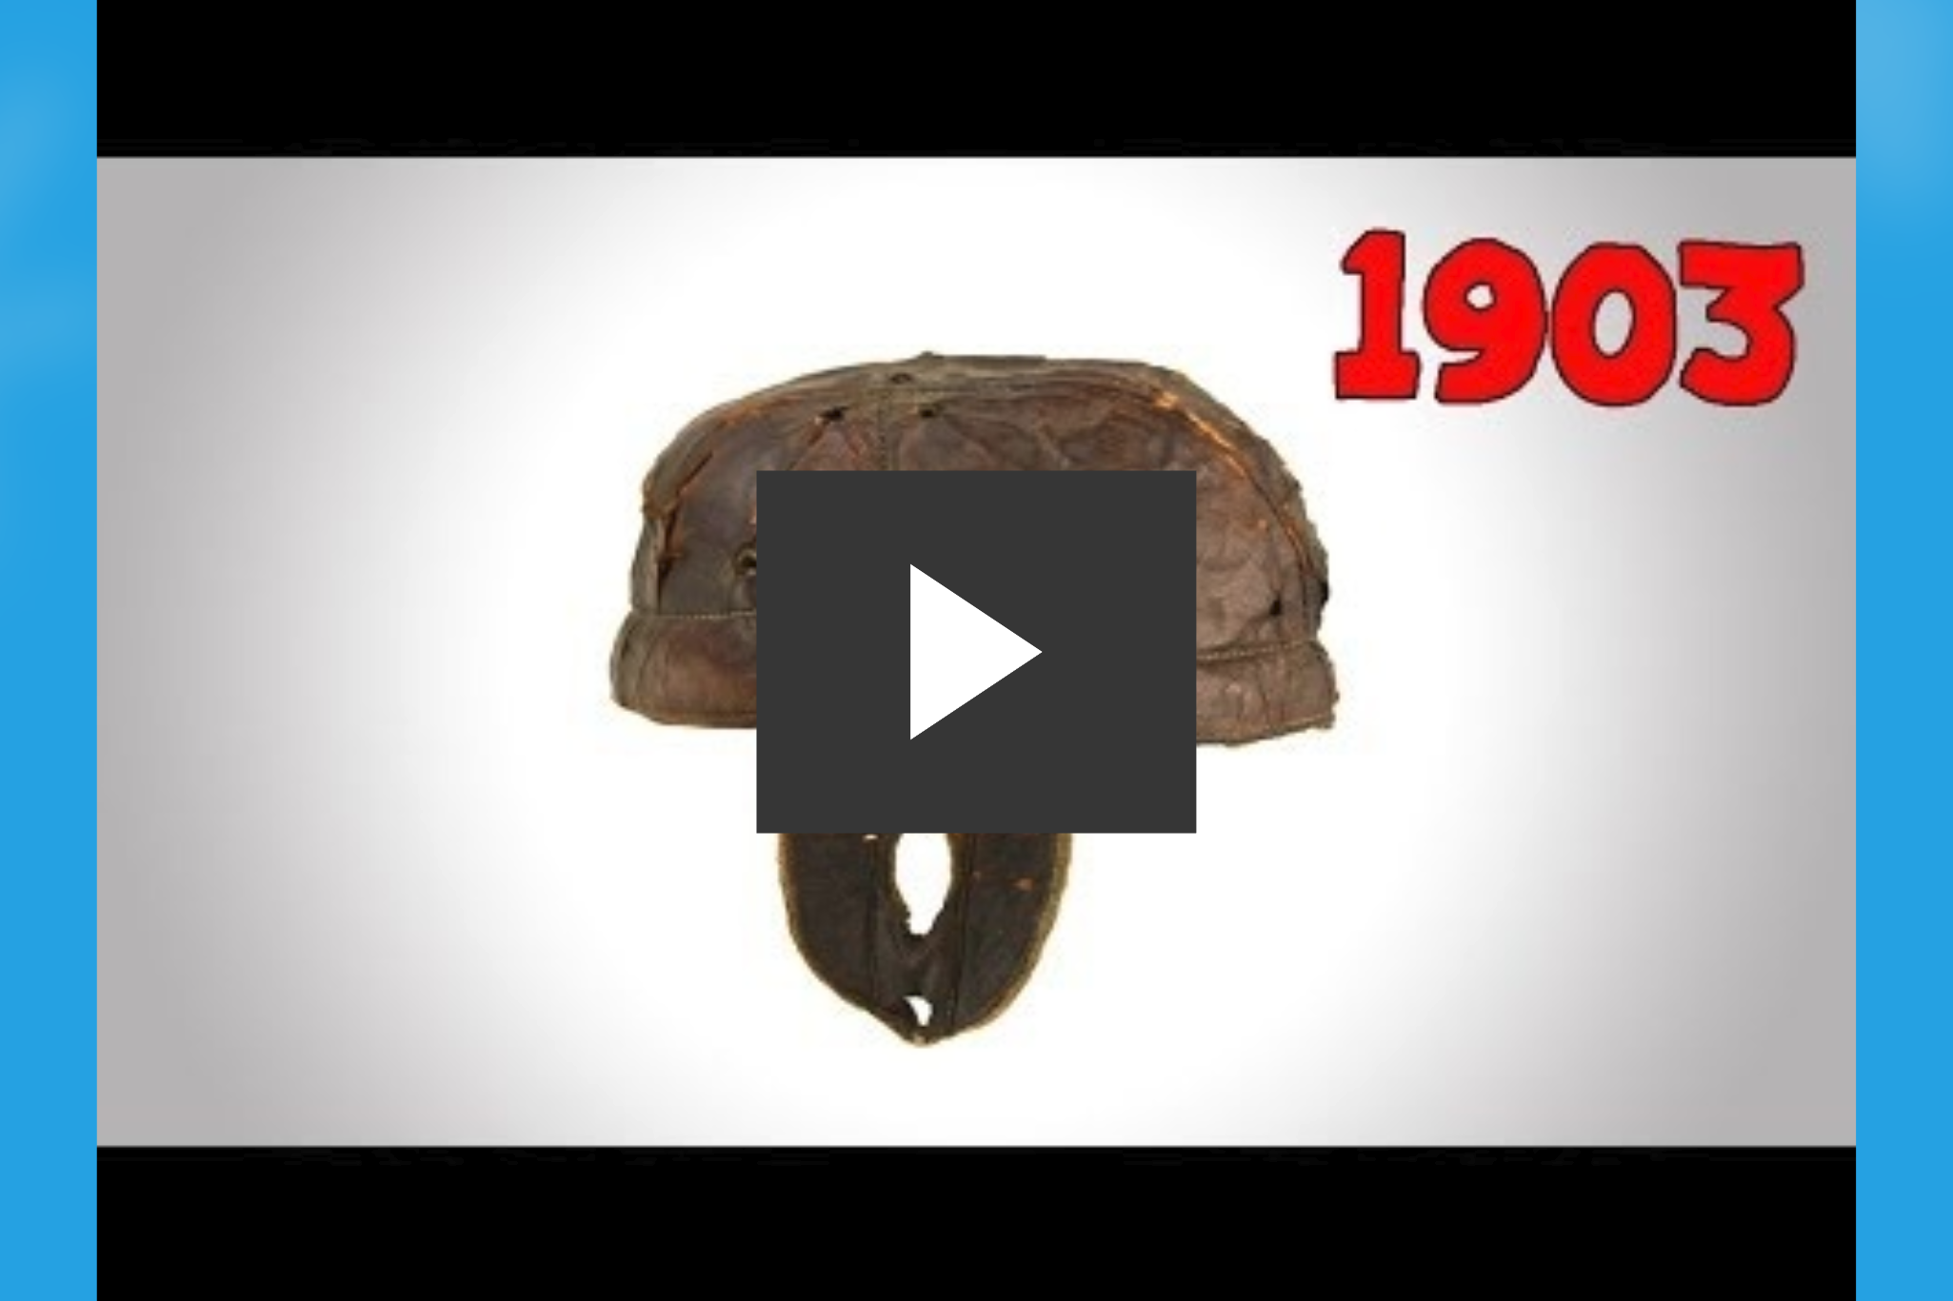
Figure 16. Football helmet design changes slide.
In situated learning environments, “experience is fundamental to understanding” (Choi & Hannafin, p. 61, 1995). Up until this point in the presentation I am setting the foundation for future learning, but I also want to make sure that there is an authentic experience happening where my collaborator can begin to be enculturated into the norms of the design thinking community (Brown, Collins, & Duguid, 1989). For this, I decided to use the d.school’s crash course resources. In this crash course, there is a prompt and the learner goes through the entire design process in 45 minutes, all the way from empathize to prototype. See Figures 17 to 19 for these worksheets.
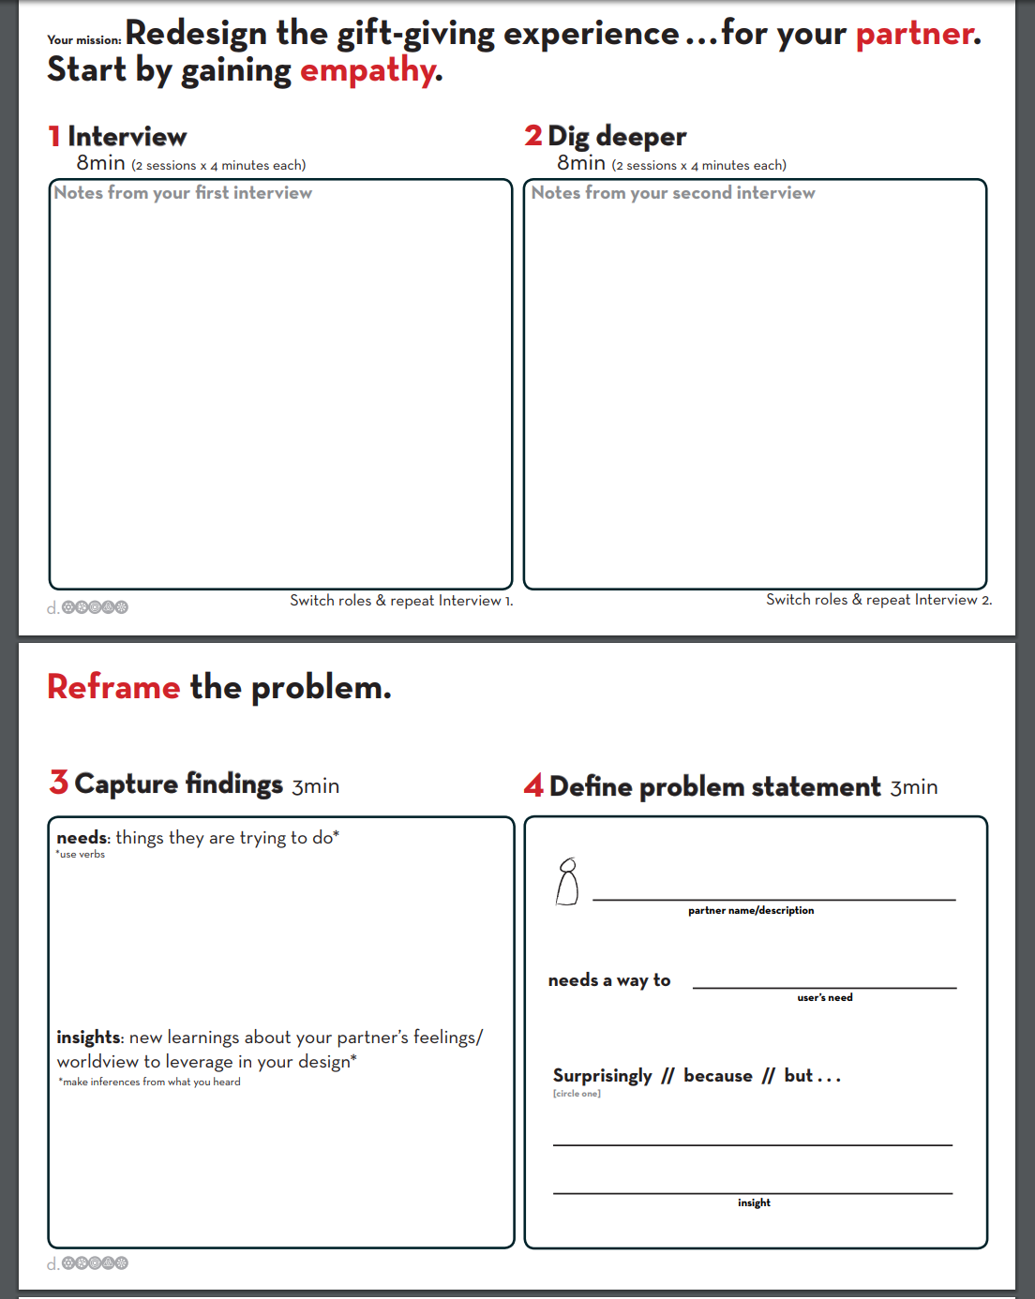
Figure 17. First page of participant worksheet (d.school, n.d.).
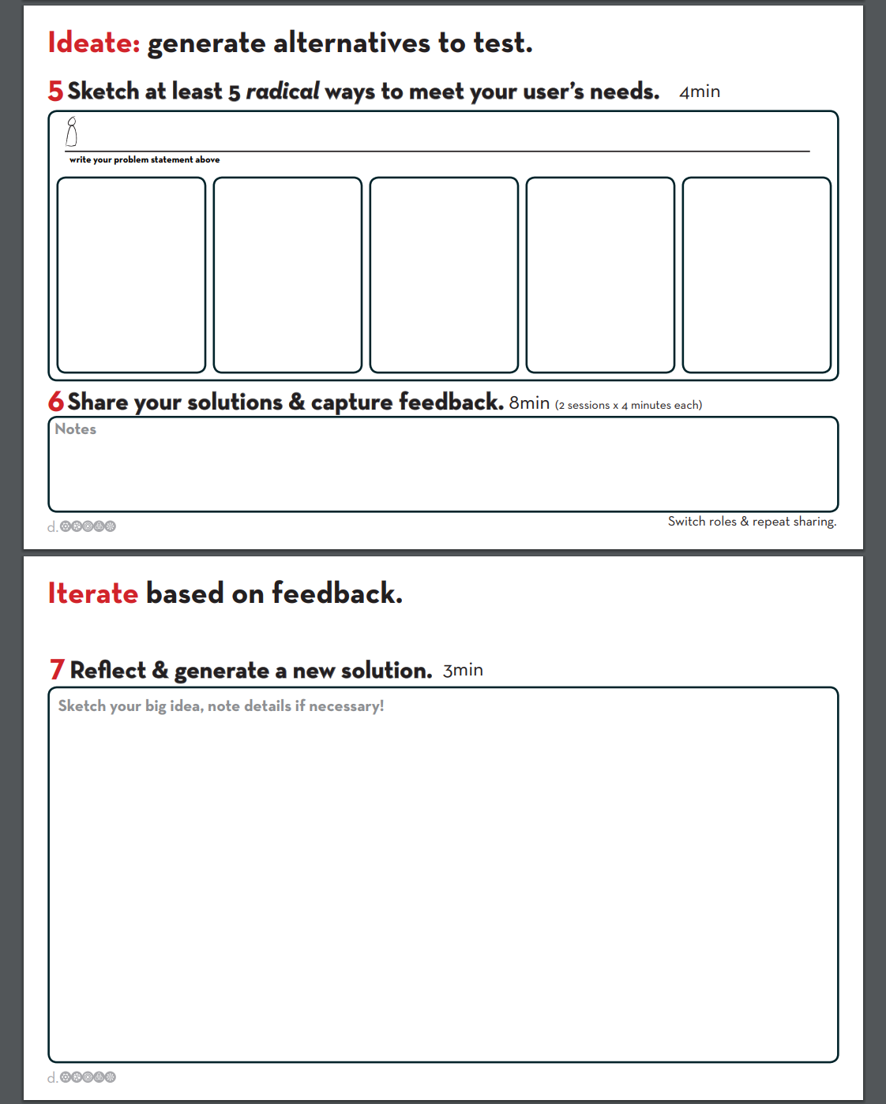
Figure 18. Second page of participant worksheet (d.school, n.d.).
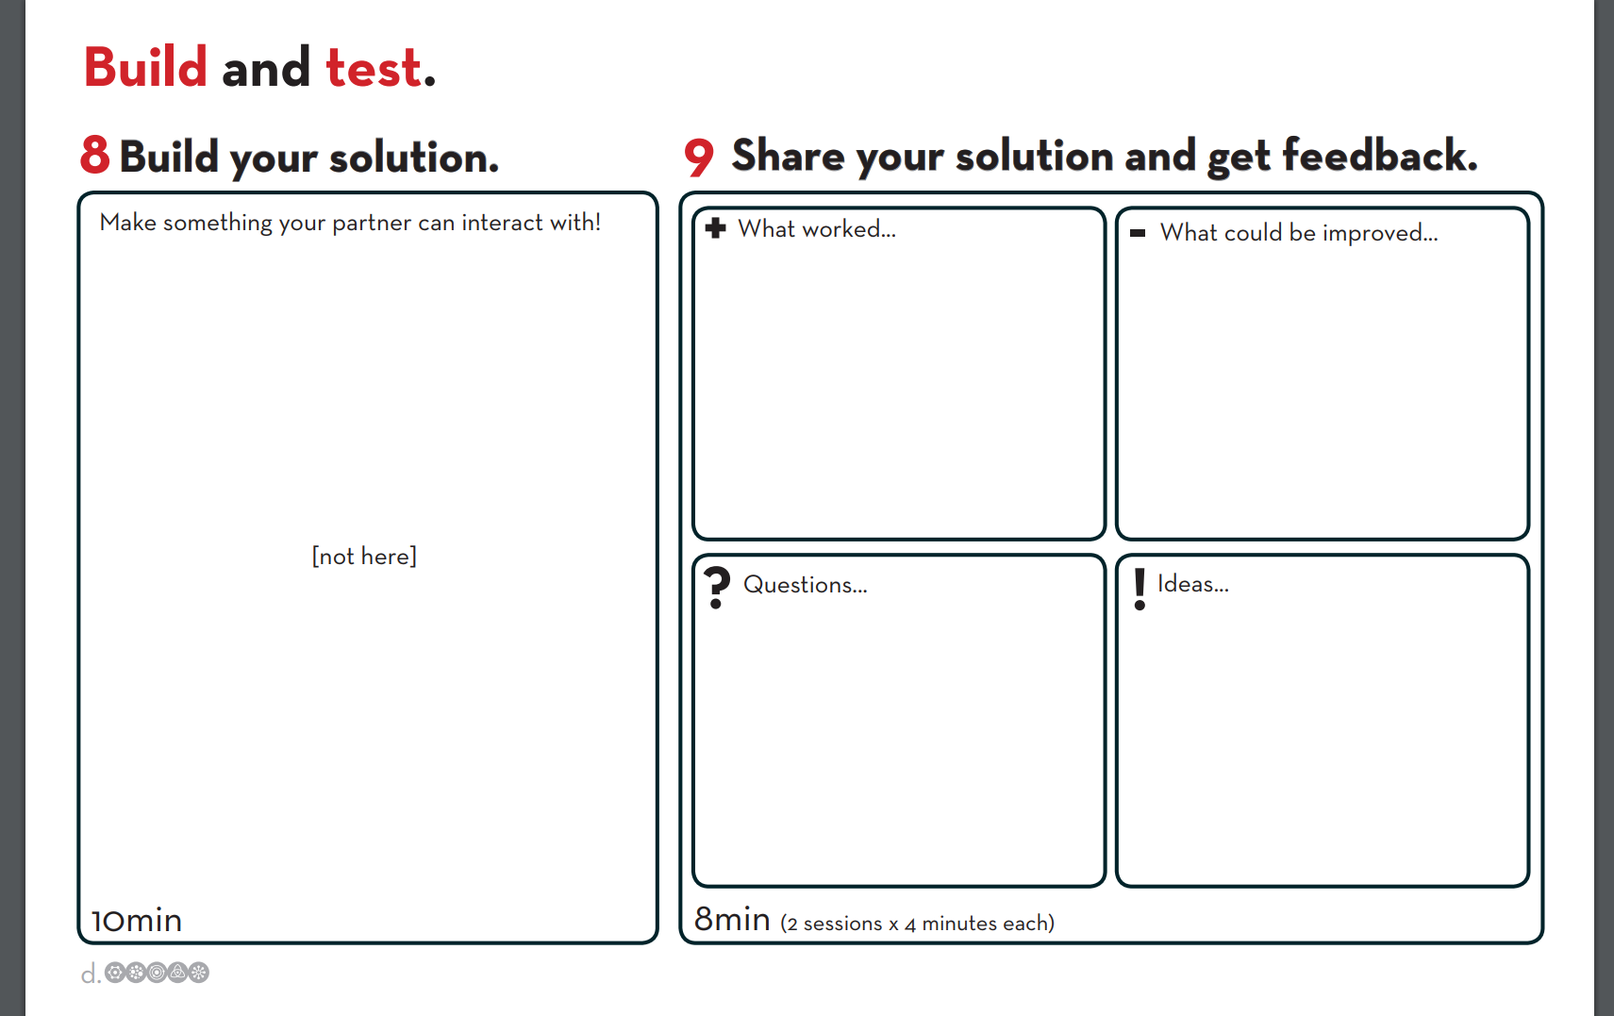
Figure 19. Third page of participant worksheet (d.school, n.d.).
The d.school uses a prompt about gift giving, but I changed it to a shoe buying experience because I know from previous experience that athletes/coaches tend to go through a lot of shoes. “Authentic tasks are more likely to become self-referenced and purposefully engaged by learners”, so hopefully this will connect more with my collaborator (Choi & Hannafin, p. 56, 1995). I decided to end the presentation by discussing the first stage of the process, empathize, in more detail and to model how to use the Google Drive folder. See Figure 20 for this slide.
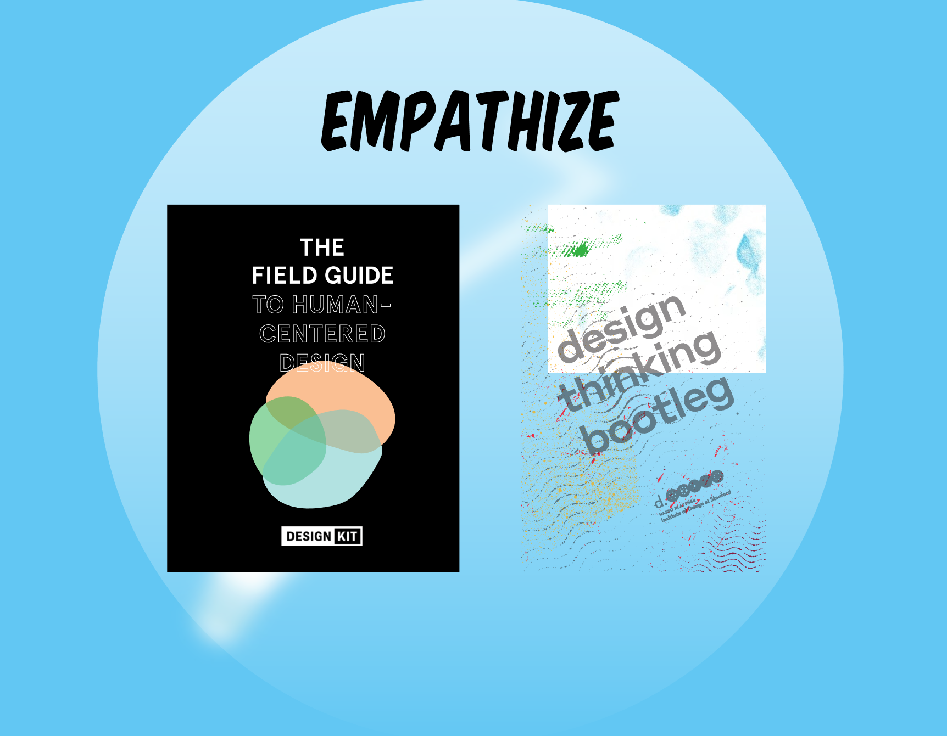
Figure 20. Last slide of design thinking presentation.
One of the most important aspects of this design study is how to assess whether the intervention was successful or not. Cobb, Jackson, and Dunlap (2014) argue that design research methodologies lack a “distinct argumentative grammar” which is needed to legitimize claims and findings (p. 20). They go on to assert that one key to an argumentative grammar is to establish the impact of the design study on what is being investigated (Cobb et al., 2014). To aide in this mission, I intend to use Bielaczyc’s (2013) Social Infrastructure Framework (SIF) and the four dimensions she considers -- Cultural Beliefs, Practices, Socio-Techno-Spatial Relations, and Interaction with the Outside World -- as a way to document changes in my studied classroom before the enactment of the design prototype and during the enactment of the prototype. This will allow for a method of measuring the effect of the design enactment and provide me with an argumentative grammar to justify my claims. See Figures 21 and 22 for Bielaczyc’s (2013) SIF.
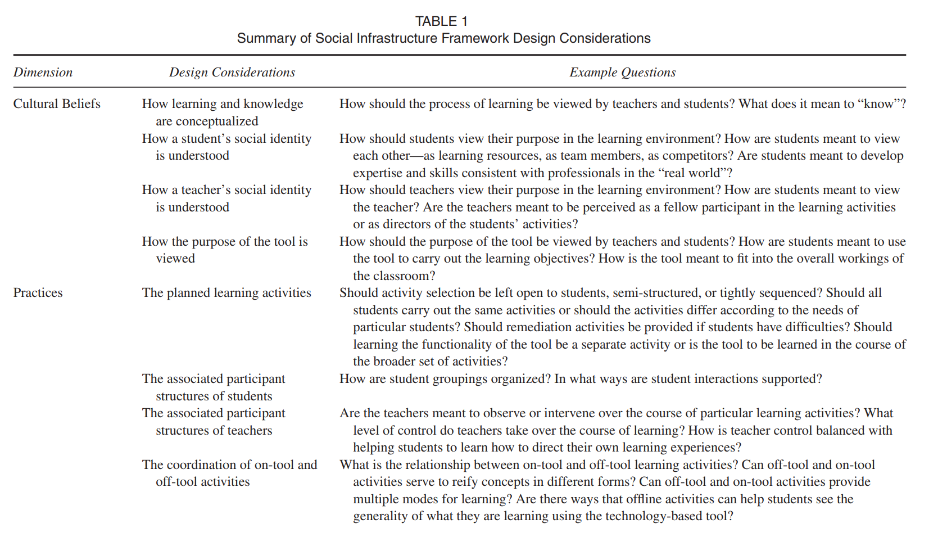
Figure 21. First half of Table 1 for Bielaczyc’s (2013) SIF considerations.
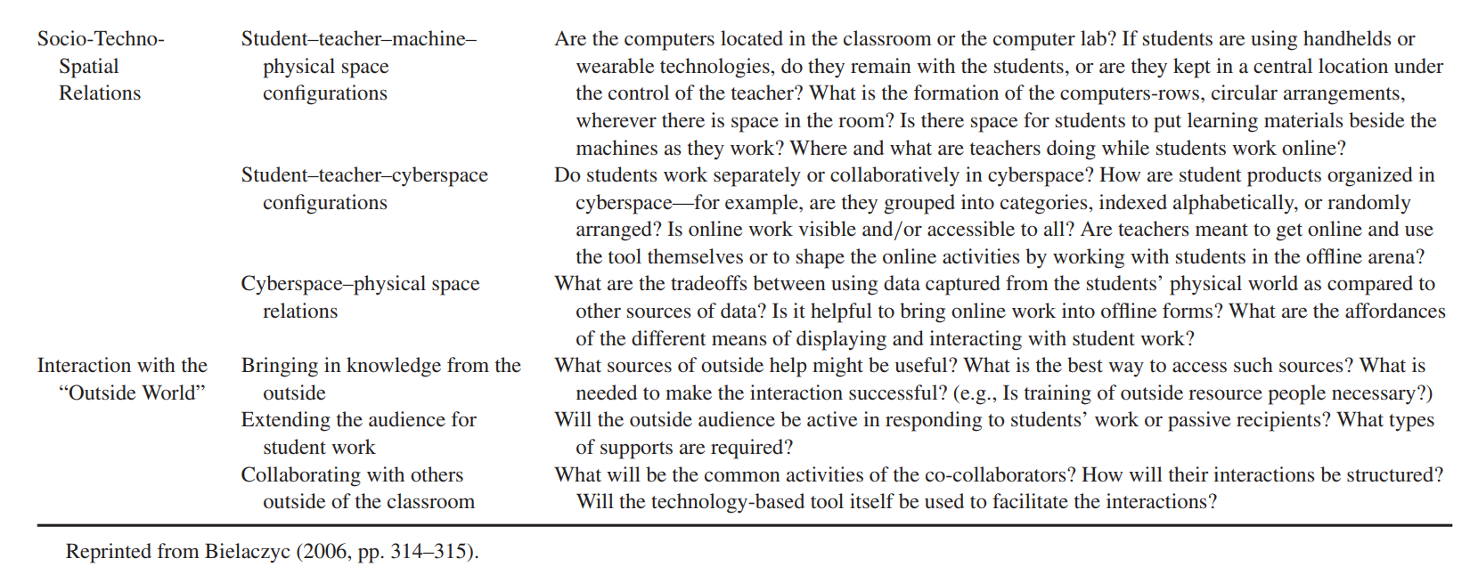
Figure 22. Second half of Table 1 for Bielaczyc’s (2013) SIF considerations.

Design Enactment Report
This report provides a description of the design innovation developed in partnership with a high school history teacher in the southwestern US. It couples’ descriptions with reflection and analysis of the process of developing and enacting the design. The report will begin by describing the participant, outlining the process of data collection and analysis, and exploring the findings in relation to the design innovation. It then provides “an account of the history and evolution of [the] design over time”, the design narrative, written in chronological order (Mor, 2011, p. 58). The design narrative begins with the initial method of introducing design thinking as a process to my collaborator and then proceeds through all five stages of the design process. This focus on the innovation and the design thinking process itself exemplifies the priority of thought and action in both teaching and design thinking. My goals are to make explicit not only how the innovation impacted my collaborators classroom but also the process through which the innovation was developed, and what the implications of these determinations are in regard to design thinking for educators.
Participant
This study involved one participant, whom I refer to as my collaborator; a Caucasian, high-school teacher in the US southwest. He is in his early thirties and this study took place during his fifth-year of teaching. He taught two sections of world history and three sections of American history, as well as coached multiple sports. For this study, we focused on his world history sections. My collaborator felt that working with two sections would be a more appropriate scale for his first attempt at utilizing the design thinking process.

Data Collection
As I stated in my Theoretical Inspiration Statement, rather than assessing my collaborator on what he knows about design thinking and the design process, I am interested in how he and his classroom environment have changed as a result of the use of design thinking and the design process. As Choi and Hannafin (1995) state, an authentic assessment “must be an application rather than a recollection of knowledge” (p.66). Just as assessment focuses on individuals’ actions with knowledge, this analysis considers my collaborator and his students’ actions without and then with a designed innovation. Ultimately, understanding the design thinking process depends on taking action. With that in mind, I will be using Bielaczyc’s (2013) Social Infrastructure Framework (SIF). Bielaczyc developed this framework as “a systematic approach to learning from teachers’ designs in carrying out classroom implementations of a given intervention” (p. 259). The SIF “highlights four dimensions of classroom social structures that influence the type of learning environment created” which are cultural beliefs, practices, social-techno-spatial relations, and interaction with the outside world (p. 266.). Bielaczyc proposes one possible use of this framework as a way to analyze “variations across iterations of teacher’s designs” (p. 267). For the purposes of this design study, I will be using the SIF to characterize the learning environment prior to the implementation of my collaborator’s innovation and during the implementation of the innovation. The innovation that my collaborator developed was a one-week lesson plan to teach the six -isms (conservatism, liberalism, romanticism, realism, capitalism, and socialism) to his two world history sections. I will be looking for points of convergence and divergence between the observations in regard to the four dimensions within the classroom environment. In Table 1 below, I adapted Bielaczyc’s SIF design considerations by including my observations in my collaborator’s classroom before the implementation of the prototype and during implementation.
Table 1.
Observations of Collaborator’s Classroom in Relation to Social Infrastructure Framework Design Considerations (adapted from Bielaczyc, 2013)
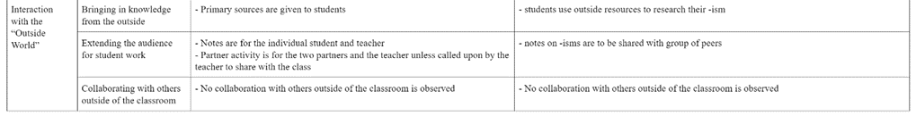
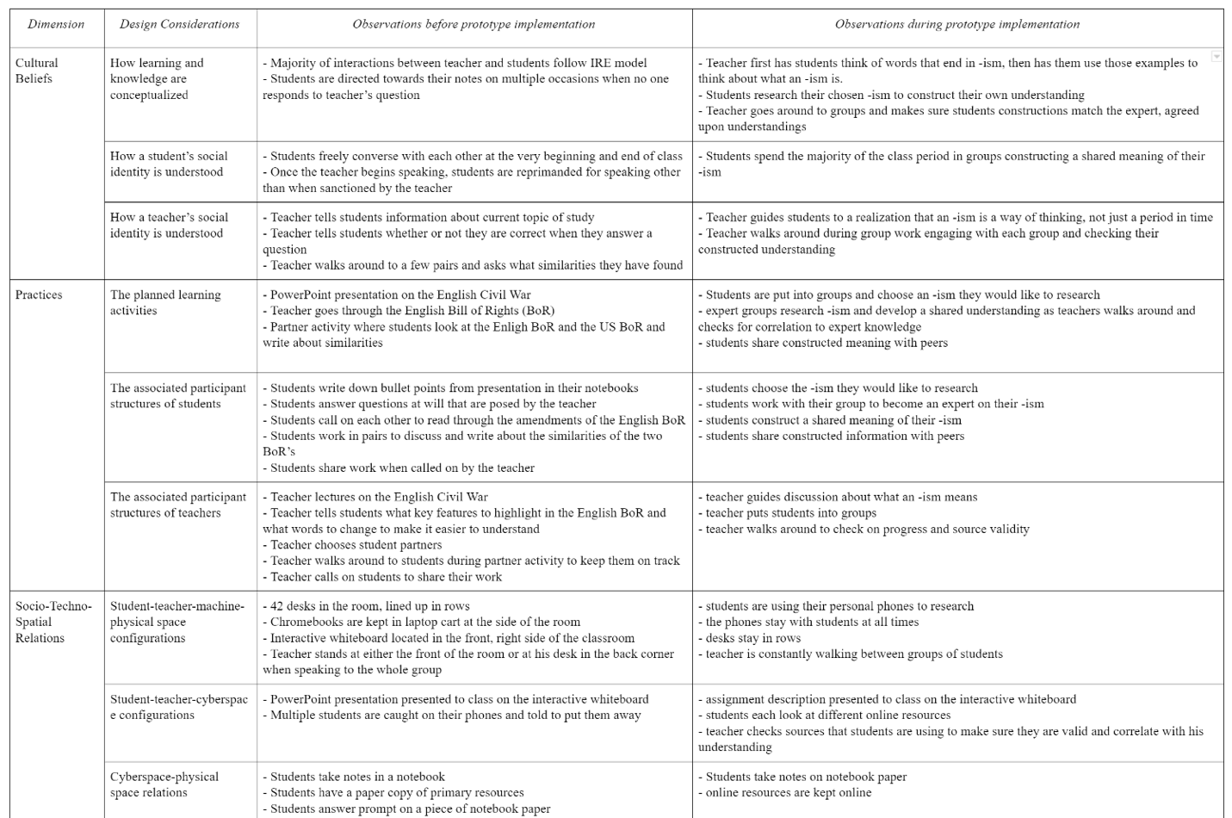

Bielaczyc’s SIF is focused around the use of technology-based tools, so though I believe that most of the design considerations are relevant to the overall infrastructure of the classroom environment when focused on the use of design thinking, there were two considerations that I took off the table. One was ‘how the purpose of the tool is viewed’ and the other is ‘the coordination of on-tool and off-tool activities’.
Data Analysis
For my analysis, I will use observations listed in Table 1, as well as relevant information from field notes, to characterize changes in my collaborator’s classroom before and during innovation implementation in relation to each dimension of the SIF.
Cultural Beliefs Dimension
The main considerations in the cultural beliefs dimension are the conceptualization of knowledge and the social identity of the teacher and the students. In the first observation of my collaborator’s classroom before prototype implementation, a majority of the interactions between the teacher and students followed the Initiate-Respond-Evaluate (IRE) model where the teacher asks a question, a student responds, and the teacher evaluates the response. This type of interaction positions the student as a passive participant (Greeno & Engestrom, 2014). In this environment, the teacher is viewed as the possessor of knowledge whose duty it is to dispense it to students, the consumer (Sfard, 1998). Learning is then viewed as a process where one acquires knowledge, which is seen as the property of the individual. In my observation during the prototype implementation, there were some marked differences. Students spent a majority of the class period working with a group of their peers to research an -ism of their choice and establish a mutually agreed upon definition and summarization of the term. The teacher walked around to the various groups and worked with them to align their understandings with the accepted understandings of the field. In this environment, students are actively participating in the construction of shared knowledge and the teacher is acting as an expert participant who is preserving the practice. So, the environment went from one of students acting as passive participants who are receiving knowledge to one of students actively participating in the shared construction of knowledge.
Practices Dimension
The design considerations in the practices dimension include the planned learning activities as well as the participant structure of both the students and the teacher. In my first observation, the teacher spent the first half of the class period lecturing about the English Civil War while students took notes. Then, he handed out the English Bill of Rights and read through it with students, telling them when to highlight parts or re-write words for comprehension clarification. Next, the teacher had students look at the US Bill of Rights and talked about some of the similarities to the English Bill of Rights. After that, he put students into pairs and had them find three rights that were similar between the bills. Included in the assignment was a sentence prompt for them to follow: “Right # X is similar to Amendment # X because of …”. Once students finished, he called on them to share what they wrote. Again, we have more instances of the IRE model being used which shows a comfort and trust with the practice. This is a tightly sequenced activity where all students are carrying out the same actions. Students spent most of the class period participating individually, with ten minutes allotted for partner work. The teacher was in control over the whole course of the learning. Even when students were given a partner to work with, the similarities had already been discussed and the students spent their time talking about what the teacher had already told them was correct versus analyzing and constructing ideas together.
In the second observation, the teacher opened the class by asking them to write down any words they knew that ended in -ism. He then had them turn to a partner and share their words. He called on students to share out the words and what they mean. After a few students had gone, he asked what the words have in common. One student said they have no idea and the teacher began to explain, but then he stopped himself and said, “Well, I don’t want to go too deep, let me call on someone else before I do that.” This shows that the teacher has recognized the benefits of allowing students to work through their own understandings rather than just being told what the correct answer is. The next student said that it seems like beliefs or value. The teacher said that it cannot be boiled down to one belief and attempts to get the students to go farther but they are struggling. The teacher said, “If it’s not one belief, then it’s ___” and the students fill in the blank by saying multiple. The teacher then goes on to talk about -isms as systems of beliefs. This episode shows an attempt by the teacher to plan activities that have students thinking deeper and analyzing rather simple taking in information that is presented. From there, the teacher had them begin group work on their chosen -ism. Though the activity is still highly structured because the students have a list of required information to include about each -ism and all students are doing the same thing, the teacher is giving more control over to the students. They are in charge of researching their topic and constructing meaning. The teacher is there to guide them in directing their own learning experience. So, the environment went from one where the students mainly work as individuals and the teacher has complete control over the learning environment to one where students mainly work in groups and the teacher has given some control to students over their own learning experience.
Socio-Techno-Spatial Relations
In this dimension, the design considerations are concerned with the dynamic between the teacher, students, technology, cyberspace, and the physical space. In both of my observations, the physical space was the same. There were over forty desks lined up in rows. There was a Chromebook cart off to the side and an interactive whiteboard at the front of the room. In my first observation, the only use of technology was by the teacher. He displayed a PowerPoint presentation on the interactive whiteboard. For the students, there were multiple occasions where they were caught with their phones out and were reprimanded. The teacher spent most of his time either at the front of the room or at his desk in the back of the room. In my second observation, the teacher displayed the assignment description using the interactive whiteboard. The students, though, were also able to use technology. They could either choose to use Chromebooks or their phones to research their -ism. All of them chose to use their phones, so this was technology that belonged to them and stayed in their possession the entire time. The teacher spent most of the class period walking around the room checking in with each group and checking their sources for correlation to expert understandings in the field. So, the environment went from one where the teacher had total control over technology and was the only one allowed to utilize it to an environment where students were allowed to utilize technology and exercised control over it.
Interactions with the “Outside World”
The considerations in this dimension deal with knowledge and people outside of the classroom as well as the audience for student work. In my first observation, students were able to use a primary source, but it was given to them as a paper copy by the teacher. The notes that students were taking were solely for the individual student and the teacher. The work students did during the partner activity was for both partners, and only for others if dictated by the teacher to share. There was no collaboration with others outside of the classroom. In my second observation, students were using outside resources from cyberspace that they found themselves. Their notes on their -ism were shared not only with their expert group but were also used to teach a group of six or seven of their peers. Though for this lesson students had the opportunity to interact with the outside environment and go to the school’s outdoor pavilion to work, they did not collaborate with others outside of their class while outside. So, the environment went from one where students had resources given to them and they did not share their work with others to an environment where they could interact with outside resources themselves through cyberspace and share their work with a group of their peers.
Design Narrative
The following design narrative focuses on the process by which my collaborator develops his innovation as I guide him through the design thinking process. I present a descriptive account of the events as they unfolded throughout the four-month design study. I also offer some analytical insights into the events and reflections on how to improve future iterations of guiding educators through the design process.
Introducing Design Thinking
This design project started with a design presentation to my collaborator in order to define design thinking and discuss the stages involved in the design process. Even this initial step demonstrated interplay between thought and action. Foremost, in response to my presentation, my collaborator’s first question was about how this was any different from what teachers already do. This question took me by surprise because I know that educators are inherently designers and I think of this process as a way to expand and enhance what educators already do. However, reflecting on his question helped me to appreciate several things about my initial actions.
First, his response made clear that I was coming from the perspective of someone who has already conceptualized design thinking. My collaborator, who had never heard the term before, assumed it must be something new and different. Second, I also realized that I set up my design presentation as if it was an entirely new concept. I started off by defining what the term means and how the process works, then went into how it relates to teaching, and followed that with examples. This is a very traditional, linear way to introduce new terms and concepts in education. Appreciating these two points, future iterations of this presentation should start with the brainstorming activity, where we brainstorm ideas for everything teachers design. That way, I am connecting the idea of designing to the problem-solving processes that educators already undertake from the very beginning. Then, with that connection established, I can emphasize that defining and exploring the stages of design thinking just elaborates on and strengthens the problem solving that educators already engage in. I would also switch the presentation order of defining the term and then discussing the process. After I went through the initial slides that defined design thinking as a mindset, as collaborative, as human-centered, and so forth, my collaborator seemed a bit disconnected. I think the presentation started off too abstract and he did not have anything concrete to relate the ideas of design thinking to. I believe it would be more beneficial to first discuss the design process and its stages, and then define the characteristics of design thinking. That way, my collaborator would have something more concrete (i.e. the design stages) to connect the design thinking characteristics to.
Once my collaborator and I got to the brainstorming activity, I could sense his trepidation about considering himself a “designer”. When I first posed the question about what teacher’s design, he immediately wrote down lessons. Lesson plans are such an integral part of teaching and a main focus when learning to become a teacher, that I think educators have a difficult time seeing past them into all the things that they create. I asked him what else they design, and he said he was not sure. So, I wrote down classroom layout. He said, “Ahh, so it’s like anything they decide?” We discussed what goes into making decisions in the classroom, and how making those decisions are essentially designing something. Then he wrote down materials, projects, activities, and resources. Those were still closely related to lesson planning, so I wrote down behavior management and discourse practices to get him thinking outside of just the learning experiences themselves. After that, he wrote down technology and skills. I asked him what he meant by those and he said he designs how technology is used in the classroom and what skills the students are working on. I wrote down classroom atmosphere and bathroom procedures. He saw these and mentioned that rather than just bathroom procedures, teachers really design all the various classroom procedures. I agreed and told him he could change the poster as he wanted, so he crossed out bathroom and wrote classroom. At this point he said, “Basically, we design everything.” Accordingly, he wrote the word everything, circled it, and drew arrows from some items on the board to the word everything. This is the main idea that I wanted him to take away from the brainstorm activity. Even though educators do not typically call themselves designers or even think of themselves as designers, they are in charge of designing most, if not all, aspects of their classroom.
At this point, we moved on to the examples of the design of failed products, including a popular time lapse video documenting the evolution of football helmet designs. When talking about these failed designs, I asked my collaborator why he thought products from such large, lucrative businesses failed. He stated that it was because people did not want them. This led to a discussion about the importance of the user and getting their feedback at all points of the design process. At one point, he said that he was pretty sure these companies would not have put the products on the market without doing some testing. I appreciated this push back, because it shows that he was actively trying to understand and make connections rather than just passively listening and accepting whatever was presented. This prompted a valuable dialogue about the differences between testing interest in an idea or testing whether a product works versus including users needs and feedback in the creation, prototyping, testing, and revision of a design. When framed in this way, my collaborator acknowledged for the first time the depth that the design thinking process necessitated. My collaborator enjoyed the video of the timeline of football helmets and was very knowledgeable about the reasons behind the evolution of the football helmet design. He said it helped him to better understand what I meant when I talked about the ‘needs’ of a user. Reflecting on this conversation, one thing I would change in subsequent iterations is the sole use of tangible products as my examples. After the football helmet video, my collaborator made a comment about design thinking basically being product development. He also told me at a later point that he described design thinking to his students as being similar to product development, but a better version where you are really taking into account the perspectives and feedback of the people you are designing for. Not that it is necessarily an incorrect analogy, but going forward, I would include an example in the presentation that was about an experience rather than just products. That way, educators are not solely thinking in relation to designing tangible objects, but are also thinking about services, programs, or even systems as a whole.
Design Crash Course Challenge
At the end of the design presentation, my collaborator had the opportunity to go through a design crash course challenge – experiencing the entire design process in about an hour. Relating back to the theoretical underpinnings of this study, this was a scaffolded activity where I, the expert, was able to guide my collaborator, the learner, through a complex task which he otherwise would not have had the tools to complete. The design challenge was in relation to the experience of buying shoes. Reiterating a point from above, if I had included an experience example in the design presentation, I think it would have tied in better with this design crash course challenge. The first step of the challenge was to interview me for four minutes. Using the d.school’s Virtual Crash Course Playbook (n.d.), the prompt for this step was to gain empathy through the use of open-ended questions. As he was interviewing me, he mentioned a few ideas he had for solutions. I reminded him that at this point in the process it is about listening and understanding, and that developing ideas comes later. We discussed that it is hard to be open and receptive to users if you already think of solutions before you empathize with them. Being solutions oriented is so ingrained in us as human beings, that I think it can be hard to learn to take a step back, listen, process, and sift through your understanding before ever developing ideas. After this step, my collaborator said he felt like he did not learn anything he would not have guessed on his own. His questions were mostly yes/no or short answer, so it makes sense that he did not gather many insights. The next step was another interview to dig deeper. The prompt for this step was to “dig for stories, feelings, and emotions” by asking ‘why?’ and finding out what is important to the user (d.school, n.d., p. 3). My collaborator felt this step was more helpful and that he developed a better understanding. He even commented, “Wow, I never realized how much information you could get from a story.” That is an integral insight in relation to empathy and the design process in general. As we went along, I tied each step to a stage in the design process. For instance, we discussed these first two steps as being a part of the empathize stage.
The following steps were part of the define stage where my collaborator had to capture his findings and define his problem statement. For this, he had to list some needs and insights from his interviews. He had a hard time differentiating between a need and an insight. Using the d.school’s Virtual Crash Course Playbook (n.d.) prompt, we talked about thinking about the needs as verbs and insights as discoveries that could be useful. This distinction aided his understanding and he ended up focusing on the insight that having shoes which match your outfit and looked good increased feelings of confidence.
At this point, it was time to ideate. The prompt for this step was to think of as many ideas as possible no matter how crazy or extreme they were. My collaborator mostly wanted to write out his ideas, but I encouraged him to try a different medium and attempt to sketch some out. From here, it was time to get feedback on his ideas. An important aspect we discussed was the need to really listen, take in the feedback, and to “fight the urge to defend your ideas” (d.school, p. 4, n.d.). My collaborator struggled with this part and tried to explain the thinking behind some of his ideas, but I gently reminded him that this was just about soaking up the feedback and finding out why the user thinks the way they do. After that, he reflected and generated a new idea. He ended up combining some of his original ideas and adding in aspects from the feedback he received. He expressed an appreciation for this stage, saying that normally he goes through a few ideas in his head and then picks one. However, he said he found it valuable to take the time to put them on paper and get feedback on them before deciding. He thought his new idea was better than any one of his original ideas. Another important insight into the design process!
Then, it was time to prototype and test. The prototype stage is about creating a real-world version of your idea, and then testing it to gather feedback and deepen your understanding for future iterations. I brought a myriad of supplies for my collaborator to choose from to create his prototype. His prototype ended up being a shoe buying app. For the test stage, I interacted as best I could with the prototype and asked questions. From there, he had the opportunity to receive feedback and develop some ideas for revisions. Though the crash course was a decently lengthy process, taking just over an hour in total, I think it was beneficial in familiarizing my collaborator with the design process and provided fundamental insights into the process that you can only gain by going through the process yourself. The one aspect of this activity that I might change is the prompt. Though I like that it is about an experience instead of a specific product, I think there are more universal experiences that could be utilized.
At the end of the design presentation, we went through the schedule, I explained the layout of our shared Google Drive folder, and we discussed the overarching design challenge he was going to embark on. Originally, we discussed it as ‘a challenge within his specific context that is meaningful to him’. I crafted the challenge statement to be purposefully vague because I did not want to limit or stifle his creativity when it came to deciding on a more specific challenge. However, I realized that this was too vague and that the vagueness was hindering his ability to even understand his options. He asked me more than once if this was just about redesigning lessons. We talked about the fact that it could be in relation to lessons but that it did not have to be; it could be in regard to anything within his classroom. So, I edited the phrasing to be ‘an educational challenge within his specific classroom context’.
The introduction to the design thinking process, as well as the design crash course challenge, was beneficial in many ways. My collaborator was able to gain insights into the design thinking process on his own, rather than me explicitly laying it out for him. For instance, the brainstorming activity lead him to realize that teachers design more than just lesson plans, that they design almost every aspect of their classroom. The dig deeper interview stage during the design crash course challenge lead him to see how much information and insights you can gain from listening to peoples’ stories. Having to record and refine his ideas during the crash course challenge also illuminated the benefits of taking the time to really tease out what is integral in your designs. I believe the combination of the design thinking presentation and the design crash course challenge provided a comprehensive introduction to design thinking. It combined foundational subject knowledge, the importance of which I discussed in the Design Statement & Prototype report, as well as an opportunity to go through the design process using a real-world example of a meaningful experience that both my collaborator and I have been through.
Stage 1: Empathize
The first stage of designing thinking is empathize. The empathize stage aides in developing a deeper understanding of who and what you are designing for, in my collaborators case this would be students. I provided my collaborator with reading materials related to methods and how to implement these methods in his classroom. Originally, I had planned on letting my collaborator use the resources I provided to guide himself through the stages and then I would be available to contact if he had any questions. However, during this stage, he said he would feel more comfortable if we set up meetings and went through the stages together. He vocalized that he felt out of his element and that even after reading the provided materials he was not sure where to begin or how to effectively go about using the methods. As an alternative, I brought up the idea of using one or more of his colleagues as a resource, but he did not want to include them. He did not want to add any additional work for his colleagues, and because he was not sure how valuable the process would be, he did not feel comfortable advocating for its use. I thought that was fair, so from that point on we met up regularly and worked through the design stages together. This also illuminates a constraint when it comes to the use of design thinking in education. Educators are constantly pressed for time, and the design thinking process does inherently slow down the decision-making process. However, one way to address this concern is to emphasize the ability of the design thinking process to get to the root of the issue, or the basic needs of students. That allows teachers to focus on what really matters and potentially eliminate the need for more numerous attempts that do not get to the heart of the matter. In relation to the act of guiding educators through the design thinking process, I think involving two or more people in a shared challenge as an introduction to the design process would be the most beneficial. Though my scope was purposefully small for this study, I think that with multiple participants, they could work through some of their questions and concerns regarding strategies and resources together before getting feedback from the design expert. Social interaction is one way for learners to build a deeper understanding and be able to transfer their knowledge into different contexts because collaborators must “actively choose and evaluate strategies, consider resources, and receive feedback” (NRC, 2000, p. 66).
My collaborator decided on two methods to empathize with his students and immerse himself in their perspective. The first method was an interview, which was a shared method between both the d.school’s Design Thinking Bootleg (2018) and IDEO’s Field Guide to Human-Centered Design (2015). We brainstormed some possible questions together. My collaborator tended to lean towards questions that were more direct, such as ‘what is your favorite activity in class’ and then add ‘and why?’ to the end to make it more open-ended. We talked about his insight during the crash course challenge where he was able to gain more valuable information by prompting students for stories. After the meeting, he created an interview protocol using Google Documents and put his final questions in there for me to review. It was a few days after our meeting, and he slipped back into adding ‘and why?’ to the end of less open-ended questions. I think educators are so used to asking students more direct questions for evaluation purposes that it is difficult to disconnect from that line of thinking. As a revision, I would create a handout for educators to keep with hem that has some phrases to use that will aide in making sure questions elicit more stories and emotions. Phrases such as: tell me about ___, how do you feel about ___, explain how/why ____, etc.
The second method my collaborator chose was IDEO’s (2015) card sort activity. The prompt for this activity is to give your user a set of cards with words or images and have them rank the cards in order of preference (IDEO, 2015). My collaborator chose this method because he realized that his interview questions did not evoke the narratives he was looking for and he thought this activity would be a better method for that. With that goal in mind, my collaborator decided to tweak this activity in order to gain more descriptive accounts from the students. So, he decided to use six pictures that to him represented different learning styles. However, instead of telling students what the pictures represented, he first showed the pictures to the students and had them write down what each picture meant to them. He displayed this in his classroom using a PowerPoint slide on the interactive whiteboard, see Figure 23 for the slide.
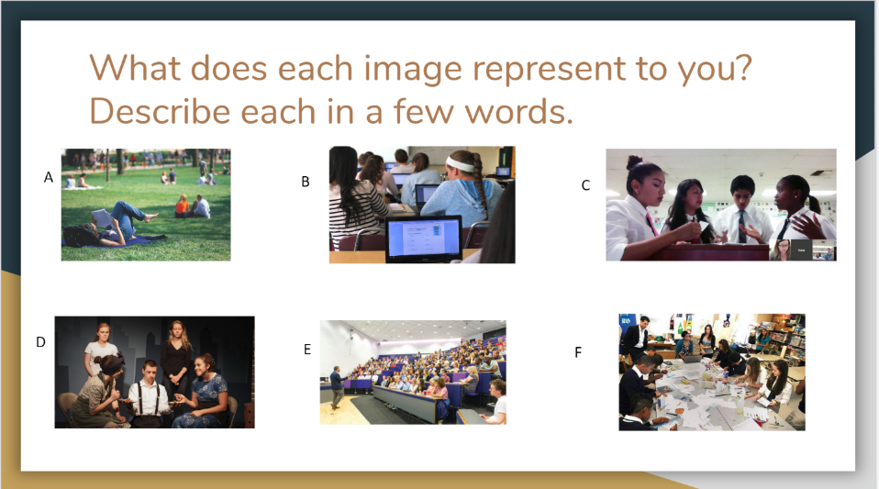
Figure 23. Part one of my collaborator’s card sort activity.
After that, he had students rank the pictures in order of their preference and write a few sentences about why they chose that order, see Figure 24 for this slide.
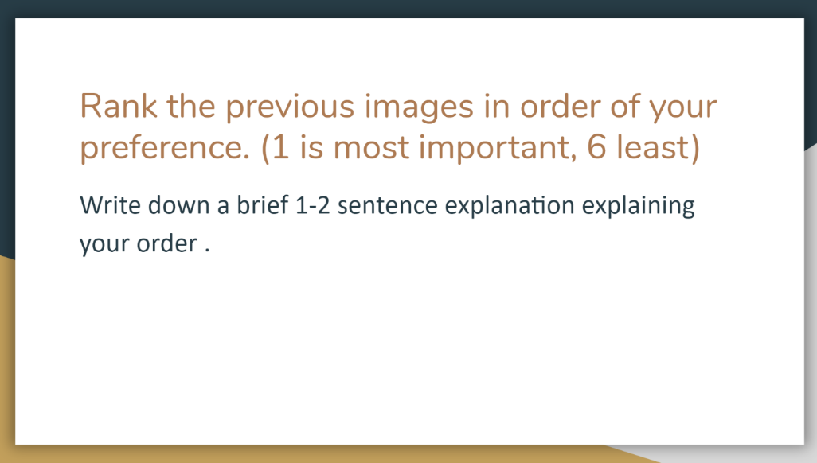
Figure 24. Part two of my collaborator’s card sort activity.
He said his students were a bit confused and felt that the prompt to write down what the pictures meant to them was too open. So, he did end up clarifying the context of the pictures being related to school. My collaborator noted that he felt he gained more insight into the students’ thoughts and opinions about school and their preferred classroom activities from this method than the interview method. He also commented that the students really enjoyed being asked about their views and preferences and that he had never thought to involve them in that way. These insights exhibit the power of the empathize stage, especially in a classroom context. In many other fields where someone is designing for a user, be that products or services, it would be almost incomprehensible to do so without some type of input from users. However, in education, it’s almost unheard of to include students in the creation of a lesson plan, procedure, system, or so forth, from the outset. Here, though, we get a sense that both the students and the teacher thought the inclusion was beneficial. From here, we scheduled a meeting to elaborate on the results of his empathize methods and delve into the next stage of the design process.

Stage 2: Define
My collaborator’s tasks for this stage were to read the provided materials, choose two to three methods that he felt would help him make sense of his findings, work with me to implement the chosen methods, and define his problem statement. The first method he chose was the “How might we” (HMW) questions from the d.school’s Design Thinking Bootleg (2018). He stated that he chose this method because the narrative aspect of the design process intrigued him, and he felt that this method seemed to provide a framework for narratives. In this method, you develop questions that start with “How might we” to address needs of the users. Before we could generate these questions, however, we needed to familiarize ourselves with the students’ responses from the interview and card sort activities. My collaborator had glanced at them as they were turned in, but he felt it would be the best use of time if we dug deeper into them together. The interview responses had been misplaced, so we focused on the card sort responses. We started by splitting the pile of responses in half and each reading through our stack. Out of the two world history classes he teaches, one class has 42 students and one class has 24 students, for a total of about 66 responses. As I discussed in the Situation Analysis Report, the school is made up a large majority of Caucasian students with less than 10% of the school population receiving free and reduced lunch and over one-fourth of students taking advanced placement courses. My collaborators class is not an advanced placement class, but the overall demographics of the school match that of his classroom. As we went along, we pointed out any surprising or interesting responses. One thing that we noticed is that most students wrote down a similar meaning for pictures C and E (refer back to Figure 10 for the pictures). To my collaborator picture C represented using technology to work with other’s outside of the classroom and picture D represented craft-oriented group work where they made a tangible product. However, a majority of the students labeled both pictures simply as group work. Quite a few even mentioned that they did not like Picture E because of the messiness and perceived chaos of the environment. My collaborator commented that on the occasions he did try to do group work, the students had a hard time working together. He said that he knows this is a skill they will need for their future careers, as the world becomes more globalized, the ability to collaborate is essential. Another surprising insight was that many students associated picture B, students using laptops, with state testing. My collaborator said that those standardized tests are taken on computers. I was surprised about the students associating being on a laptop with a test and asked about the use of laptops for classroom purposes. My collaborator said that though they have a Chromebook cart in the room with a class set of Chromebooks, they rarely ever use them. He said that they take up too much time. They must be passed out, students have to log-in, and then he has to get everyone on the correct screen. He also stated that a lot of the time the Chromebooks haven’t been plugged in properly to charge and many of them have a dead battery. He said when he does allow the students to use technology, he usually just has them use their cellphones. Even though many students made this connection to state testing, there were still a lot of students who noticed the technological aspects in pictures B and C and wrote that they would like the opportunity to use technology more often. A third insight we discussed was the mix of responses related to picture D. My collaborator included it to represent drama and theater. Many students saw the picture for what they perceived was happening on the stage, someone who was sad being cheered up by friends or someone being bullied by those around them. My collaborator said that this reminded him of the turmoil students face at this age outside of the classroom. He thought that this was something that most educators do not think about or take into account when managing their classrooms. From here, we decided to graph some of the results to give us a visual representation. We graphed the number of students who chose each picture as either their first or second choice, see Figure 25 for the graph results.
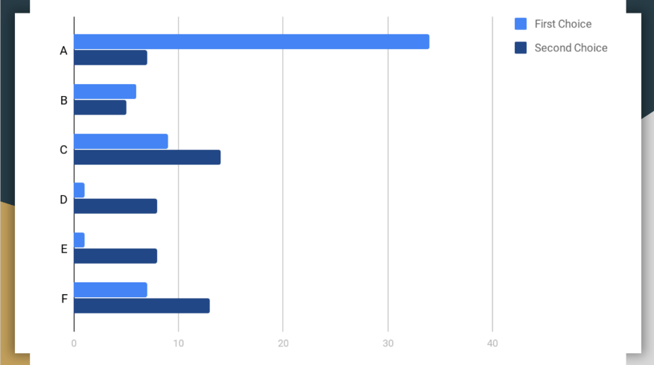
Figure 25. Bar graph showing the number of students who chose each picture as their first or second choice.
This allowed us to see that picture A, a student outside reading, was by far the most popular choice. My collaborator reasoned that this had to with the stress of school. He felt that most students view school and learning as requirements, not something to be done out of curiosity or passion. One aspect I noticed during this collaborative effort to gather insights was that, generally, our thinking aligned in regard to what needs and meaning we were seeing in the students’ responses. My collaborator was very involved in the process and would first share his thoughts before asking for mine. This demonstrates a desire in my collaborator to reflect on his own understanding rather than rely on the expert. With these insights in mind, we looked toward the HMW activity.
The HMW activity begins with the opportunity to loosely define the challenge and point of view being brought to the analysis. Using insights we had gleaned from going through the card sort responses, my collaborator defined his challenge as “broaden teaching methods and practices in a way that is more engaging for today’s students” and the point of view as “modern high school student”. We spent about five minutes brainstorming HMW questions. We then used these questions and insights as a springboard for the next method he chose, d.school’s (2018) Why-How Ladder.
My collaborator stated that he chose the Why-How Ladder method because it seemed to focus more specifically on how to address needs. For this method, you first identify a few needs of the user. The needs that my collaborator identified were; work with others, use technology, and work outside/in a relaxed environment. You write these needs down, ask ‘why?’, and write your thinking above the need. Then you ask ‘why?’ for that new idea, and so on to create a ladder. Subsequently, you start from the top of the ladder you just created and ask ‘how?’ as you go down to gather ideas. Both of us struggled with this activity. My collaborator looked to me as the expert to define exactly how to go about producing the ladder, but I have limited experience with this method and was not confident in how to make sure we produced a meaningful ladder. However, we both gave our best effort and were able to illicit some new observations. One observation that came from the Why-How ladder was the importance of choice. My collaborator felt that students were constantly bombarded with requirements and had such little say in their education and that one way to alleviate this pressure would be to give students more choice. Another observation that stemmed from the need for working with others was the importance of opening oneself up to various perspectives and making connections with those around you. My collaborator also tied this back to the turmoil in student’s lives outside the classroom. If students have a positive environment and connection with classmates, that could impact their feelings and emotions in other aspects of their lives as well. An observation that was also similar to a previous insight was the importance of technological skills in the rapidly evolving, globalized world that the students are part of. We ended our session there and my collaborator was tasked with writing his problem statement and posting it to the Google Drive.
The problem statement my collaborator ended up developing was: How might we broaden the teaching practices in the classroom to make lessons relevant and purposeful in order to create an environment that promotes learning and connection for the modern student. There are a couple substantial differences between this problem statement and the design challenge statement he used to start off the HMW activity. The first difference is that he took out the word engaging and instead wrote relevant and purposeful. This shows a shift in thinking about what is most important in a lesson. He also inserted the word lesson. This seems to show him focusing in a specific aspect of his classroom that he would like to address. Another difference is that he discussed the environment of his classroom and his desire for it to promote connection. This demonstrates a realization that how his students feel in his classroom is important to him. Now it was time to take these insights and use them to jump-start ideas.
Stage 3: Ideate
For this stage in the design process, my collaborator’s tasks were again to read the provided materials, select two or three methods from the materials that he felt would help him utilize insights to generate ideas, and implement them with my assistance. The first method he chose, which is discussed in both d.school (2018) and IDEO (2015), was brainstorming. Before we brainstormed, we looked back over the HWM questions and the Why-How Ladder to refamiliarize ourselves with the insights from the previous stage. Then, we both got a stack of post-it notes. We put ten minutes on a timer and wrote down as many ideas as we could without any thought to constraints. Once the timer went off, we read through our ideas and discussed some preliminary similarities that we noticed. One similarity was that we both mentioned connecting with people outside of the classroom; his ideas being to skype with another history class or engage in an online debate with them and my ideas being to bring in a guest speaker/expert or have students work with outside stakeholders on a project. Another similarity we noted was the idea to use current events or news stories that related to the topic of study. Then, we began to work on the second method he chose. The second method was IDEO’s (2015) Find Themes. In this method, you sort and re-sort your ideas into various categories to find meaningful themes. As we began, my collaborator stated that because we used the needs from our Why-How ladder for inspiration, the ideas all seemed to be categorizable by those needs. We discussed that that was one potential way to categorize them, but part of this method is to try and re-categorize them in various ways to gain insights that might not be apparent otherwise. He politely said that it did not seem to be a good use of our time, but that he would continue to work through it with me. As we shuffled our post-its around, four categories began to emerge. There were ideas that involved students generating or creating something substantial, ideas that involved interaction with people outside of the classroom (or within the classroom if the idea did not also fit in another category), ideas that were small tweaks to what was already happening in the classroom, and ideas that seemed to take the material and make it more relevant to students’ lives. The category about relevancy had the largest number of ideas within it and my collaborator mentioned that even though we have spoken about relevancy throughout other stages of the design process, he did not realize how important he thought it was. He said that seeing this visual display of all the ideas intended to make historical content more relevant to students’ lives made him aware of how strongly he feels about its importance. This seemed like an aha moment for my collaborator. Throughout many different activities he mentioned globalization and the changing career landscape as well as “today’s students” or “the modern student”. This activity, though, seemed to be the push that tied those thoughts together and led him to a realization about the idea of relevancy. My collaborator did say that he did not believe he would have had this revelation if we had not completed the Find Themes method. Going back to my comment about time constraints on educators, this illustrates the advantage of going through the effort to draw out the ideate phase. Otherwise, you still might not have refined your ideas enough to truly meet your users’ needs. Next, my collaborator needed to take these insights and ideas to create a prototype.
Stage 4: Prototype
The task for this stage was to read the provided resources, choose a method to use to aide him in creating a real-world version of his idea, and implement it in order to create a prototype. At this point, my collaborator knew he wanted to revamp his lesson plans. In his district, he is not required to have any kind of formal lesson plan. Therefore, he does not keep written lesson plans. Rather, he has a collection of PowerPoints and primary sources and a mental plan for how he uses them. For that reason, he did not think it was realistic for him to type up a lesson plan just for the purposes of this study. So, for his method, he chose to use the d.school’s (2018) prototype to decide method. In this method, you build multiple prototypes and get feedback on them before moving forward. To do this, he developed some different ideas for how he wanted to change his upcoming lesson on the -isms (liberalism, conservatism, realism, romanticism, capitalism, and socialism). Then, we had a phone conversation where he explained some of the different ideas he had. He knew he wanted to use the jigsaw method where students become experts in different topics and then come together in a group to teach each other about their specific topic. However, he had varying ideas about the logistics of it. Should he do a brief introduction of each -ism first so the students have some background knowledge, or should he let them gather all information on their own? Should he let them choose their groups or put them in groups? Should he assign -isms or let them choose their own? How should technology be involved? He usually does a quiz, essentially a note check, to make sure students are keeping up with their notes. How would he still get a grade for that if they are working in groups? He usually focuses in on romanticism and realism at the end of the unit because they seem most interesting to him and has students find artifacts related to those two -isms. Should he still do that, or should he broaden it to include the other -isms? Our main points of discussion ended up being to keep in mind the major insights we gleaned from the previous design stages, i.e. choice, relevancy, etc. With these insights as the driving force behind his decisions about the lesson, he developed a lesson prototype to test in his classroom.
My collaborators prototype was a one-week lesson plan to teach about the -isms. He was going to begin on Monday by having a brief discussion on words ending in -ism and what that represents. Then he was going to give an overview of the assignment to the students by displaying the assignment directions on the interactive whiteboard. Then, he was going to put the students into groups of six or seven so that there was at least one person for each of the six -isms. Each person in the group would get to choose the -ism they wanted, making sure that all the -isms were represented in their group. Then, he would direct each -ism to a particular spot in the room to form their expertise group. The expertise groups were in charge of researching their -ism, developing a definition, writing a two-paragraph summary of the history of their -ism, and finding two modern examples related to their -ism. He planned for the expertise groups to begin their research on Monday and have Tuesday to finish finding all the required information. On Wednesday, he planned to have the students spend a few minutes reviewing their information with the expertise group and then diving back up into their original group of 6 or 7. Each person in the group would take turns sharing the information they gathered. The other group members would need to write the definition of each -ism and two things they learned about them. They would spend most of the class time on Wednesday doing this and finish up during Thursday’s class. Part of the assignment would include students finding or creating an artifact that represented one of the -isms of their choice. They were to bring this into class on Friday so that the class could have an interactive museum outside in the pavilion. For this activity, one group at a time would have their artifacts showcased while the rest of the class walked around and learned about the artifacts and how they related to the chosen -ism. So, for the rest of the class time on Thursday, my collaborator was going to give them time to write-up a short script about their artifact. Then on Friday, the entire class period would be spent in the pavilion participating in the interactive museum. Now that the prototype was ready, it was time to test it out in his classroom
Stage 5: Test, Feedback & Revision
As with anything that is taking place in real-world, complex environments, there are going to be unforeseen issues that arise and adjustments that need to be made. During the week of testing, my collaborator ended up being sick and was out on Monday. So, that condensed the timetable of the lesson from 5 days to 4 days. Another issue that arose was a change in schedule. The schedule for the sections was changed in order to accommodate for state testing. My collaborator knew this going to happen but did not realize it was happening the week of testing until the Friday before. So, instead of seeing his world history section each day of the week, he saw one section on Tuesday for a double block of time and the other section on Wednesday for a double block of time. On Thursday and Friday, he saw both sections for a normal block of time, but at a different time of day than normal. My collaborator was flexible and adapted as necessary. So, he began the introduction to the assignment on Tuesday for his first world history section.
Throughout the lesson, there were many aspects of revision my collaborator noticed. One thing he noted from the introduction was that the students were confused about the two-group dynamic – the original group of six or seven and then another expertise group. He felt that he spent too much time having to explain this. It surprised me that most of the students seemed to never have participated in a jigsaw activity before. My collaborator said he did not bring up the interactive museum because he did not think there would be time in this adjusted, condensed timetable. He then put the students in their groups, gave them time to choose an -ism, and had them switch into their expertise groups. He commented that he was surprised at how smoothly the students picked their -ism within their groups. He thought there would be issues and he would need to step in and assign -isms for certain people. The students spent the rest of the time in class working with their groups to become experts their chosen -isms. My collaborator did realize that the students were getting bogged down with the idea that their two paragraphs could only be about the history of the -ism. So, he told them it could also include other information and facts. He said this seemed to alleviate some of the stress of the assignment. On Wednesday, he saw his second world history section. One change he made was to not explain the full assignment from the start. He only explained the part about getting into groups of 6 or 7 and choosing an -ism, so that there would be less confusion than the previous day. However, he said there was just as much confusion but in a different way. They did not understand why they were getting into groups and choosing an -ism, so they had a lot of questions and were frustrated by the lack of information. My collaborator then felt like he should have just taken the time to explain the full assignment, and that way the next time this method is used, they would have a better understanding from the beginning. Another change he made was to adjust the requirements for the expertise groups. Instead of requiring two paragraphs about only the history of the -ism, he told them they could include other information or facts about the -ism. He also told them to include two major influential figures related to their -ism. My collaborator said that he usually mentions some influential figures in his notes about the -isms, and he realized he did not want them to miss out on that. Because he did not mention the interactive museum to his first section the previous day, he did not mention it to this section either. On Thursday, my collaborator decided that it was important to do some part of the lesson outside because that was a repeated want from students during the empathize stage. So, he had students in both sections get back into their original group of six or seven and go outside to teach their group about the -ism they researched. They were tasked with completing this by the end of the class period, and he noted that it did feel a bit rushed. On Friday, since they were no longer doing the interactive museum, my collaborator had a whole group discussion recapping the assignment. They spent the remainder of the class period participating in a fish bowl discussion about romanticism and realism. In a fish bowl discussion, there are around six chairs in the middle of the room, labeled the fish bowl. Students in the fish bowl are actively participating in a debate regarding the topic, while students outside of the fish bowl listen. Students are switched in and out of the fish bowl so that everyone gets a chance to participate in the discussion at some point.
An important part of the test phase is to collect feedback from users so that you can refine your solutions. My collaborator was tasked with reading through the provided materials on methods to collect feedback, choosing a method, and gathering feedback from his students. The method that he chose to use was the d.school’s (2018) I like, I wish, What If method. In this method, users complete sentences using the prompted phrase starters. To do this, my collaborator drew a T-chart on the board with three columns: one column for I Like, one column for I Wish, and one column for What If, see Figure 26 for an example chart.
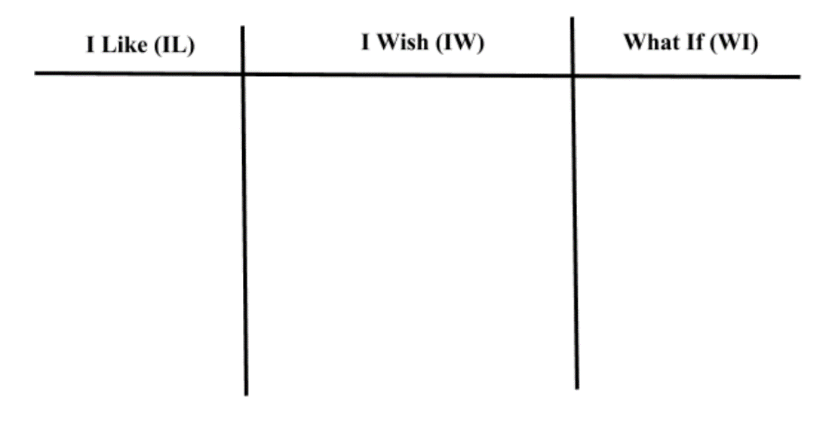
Figure 26. I Like, I Wish, What If example chart of students.
He had students draw the same chart down on a piece of paper and fill in the columns with their thoughts and ideas. My collaborator and I had a meeting to go through the student feedback and look for patterns in the feedback. There were quite a few comments that were common across almost all responses. The first was that students liked getting to work together and work in groups. Another commonality was that students wished for more time to complete the assignments. This was a bit of a sore spot for my collaborator. In his world history classes, he is tasked with teaching them the world’s history starting at early human origins (first human remains, cave-paintings, agricultural revolution, etc.) and ending with globalism in the 2000’s. That is an extraordinary amount of information to pack into a roughly 180-day school year. He says the reason he falls back on lecture style with note-taking is because it is the most efficient way to provide students with all the information he is responsible for covering in a year. He only had one week to teach these six -isms and the activities had to fit within that time frame. However, he said he was happy that the students enjoyed the activity enough that they wanted to put more effort into it. Additional commonalities among the feedback included the desire to choose their own groups and to create some type of tangible product. Most students felt that they would have enjoyed creating some type of poster or PowerPoint presentation with the expertise group instead of just writing paragraphs. An idea that was mentioned in numerous charts was that rather than switching into groups after becoming experts, the students who became experts should teach the whole class at one time. My collaborator thought that idea would help with the time crunch issue and said that he would incorporate it in other lessons. Another commonality was that students liked not having to take the usual notes. Usually, my collaborator goes through a PowerPoint Presentation and students write down all the bullet points. They then have a note’s check, which is basically an open-note quiz, to make sure they are keeping up. My collaborator said he also enjoyed having a different take on the notes than usual. He said the next design challenge he wants to participate in is to find a better way to deal with notes, while still making sure students are keeping up with what they are learning. Overall, he stated that his biggest takeaways from the design process were: 1) The importance of involving students and giving them agency within their own classroom/over their own learning. 2) The importance of ideation and thinking through multiple ideas and the themes and patterns of those ideas so that there is a more well-thought out result.
Conclusion
As is evidenced by the changes in the learning environment between the observation before my collaborator implemented his prototype and during the implementation, design thinking and the use of the design process had an impact. By taking the time to learn about and understand his students, believing in his ability to make a positive change, and by not being afraid to fail, my collaborator was empowered to tackle an issue within his own classroom that was important to him. Though there were many points of revision in the implementation of his prototype, he felt that he gained a lot from the experience. More importantly he said he wants to continue with the design thinking mindset to tackle other aspects of his classroom.
Even with these positive outcomes, there were many lessons learned in regards to engaging educators with design thinking and the design process. One is to introduce design thinking by connecting it to the existing problem-solving strategies of educators. They are more likely to be receptive of an enhancement to their current practices than another “new idea” they need to learn and implement. Another important area that was a challenge with this design study was metacognitive reflection. I had my collaborator fill out a weekly survey, as discussed previously in the Theoretical Inspiration Statement and the Design Statement & Prototype. However, it was not mentioned in this report because there were no reflections of value or substance. The answers were generally short and trivial. This shows that the questions were not provoking enough, there was a misunderstanding about expectations regarding the survey, and/or there was a disconnect between the survey and how my collaborator reflects on his understandings. This is a major point of divergence that I will continue to investigate and revise. Another point of revision that I think is important to make is an adaptation of Bielaczyc’s (2013) SIF for educators. I believe it could provide a valuable framework for teachers to analyze their own classroom environment and open their minds to aspects of their infrastructure that they have never attended to before. Most importantly, there needs to be a plan in place for educators to continue to get support in their design endeavors. For this design study, my collaborator will continue to have access to the provided resources and my contact information for any questions he has. However, for this implementation to be scaled-up, there would need to be supports in place to aide educations in their continued efforts to tackle complex problems using design thinking. Though, I do believe that an awareness of the process and a design thinking mindset of continual growth is a great first step that gives power to educators.

References
Barab, S. (2014). Design-Based Research: A Methodological Toolkit for Engineering Change. In R. K. Sawyer (Ed.), The Cambridge Handbook of the Learning Sciences. (pp. 151 - 170). New York, New York: Cambridge University Press.
Baynes, K. (2009). The RCA Study 'Design in General Education'. Studies In Design Education Craft & Technology, 6(2). Retrieved from https://ojs.lboro.ac.uk/SDEC/article/view/754
Brown, J., Collins, A., & Duguid, P. (1989). Situated Cognition and the Culture of Learning. Educational Researcher, 18(1), 32-42. Retrieved from http://www.jstor.org.ezproxy1.lib.asu.edu/stable/1176008
Bielaczyc, K. (2013). Informing design research: Learning from teachers' designs of social infrastructure. Journal of the Learning Sciences, 22(2), 258-311.
Choi, J., & Hannafin, M. (1995). Situated Cognition and Learning Environments: Roles, Structures, and Implications for Design. Educational Technology Research and Development, 43(2), 53-69. Retrieved from http://www.jstor.org.ezproxy1.lib.asu.edu/stable/30220993
Cobb, P., Confrey, J., DiSessa, A., Lehrer, R., & Schauble, L. (2003). Design experiments in educational research. Educational researcher (pp. 9-13).
Cobb, P., Jackson, K., & Dunlap, C. (2014). Design research: An analysis and critique. In L. D. English & D. Kirshner (Eds.), Handbook of international research in mathematics education (pp. 481–503). New York, NY: Routledge.
d.school. (2018). Design Thinking Bootleg. Retrieved from https://dschool.stanford.edu/resources/design-thinking-bootleg
d.school. (n.d.). Participant Worksheet [PDF file]. Retreived from https://static1.squarespace.com/static/57c6b79629687fde090a0fdd/t/58992ddd46c3c4da5df52911/1486433757845/Participant-Worksheet.pdf
d.school. (n.d.) The Virtual Crash Course Playbook [PDF file]. Retrieved from https://static1.squarespace.com/static/57c6b79629687fde090a0fdd/t/5899326a86e6c0878c6e63f1/1486434929824/crashcourseplaybookfinal3-1-120302015105-phpapp02.pdf
Edglossary. (2013, August 29). Retrieved from https://www.edglossary.org/professional-development/
Garreta‐Domingo, M., Sloep, P. B., & Hernández‐Leo, D. (2018). Human‐centred design to empower “teachers as designers”. British Journal of Educational Technology.
Greeno, J.G., & Engestrom, Y. (2014). Learning in Activity. In R. K. Sawyer (Ed.), The Cambridge Handbook of the Learning Sciences. (pp. 128 - 147). New York, New York: Cambridge University Press.
IDEO. (2014). Design thinking for educators. San Francisco: IDEO. Retrieved from http://www.designthinkingforeducators.com/
IDEO. (2015). The field guide to human-centered design: Design kit. San Francisco: IDEO.
Mor, Y. (2011). Design narratives: an intuitive scientific form for capturing design knowledge in education. In the 6th Chais conference on Instructional Technologies Research (pp. 57-63).
Nathan, M. J., & Sawyer, R. K. (2014). Foundations of the Learning Sciences. In R. K. Sawyer (Ed.), The Cambridge Handbook of the Learning Sciences. (pp. 21 - 43). New York, New York: Cambridge University Press.
National Research Council. (2000). How people learn: Brain, mind, experience, and school: Expanded edition. Washington, D.C.: National Academies Press.
Pendleton-Jullian, A. M., & Brown, J. S. (2015). Design unbound: Evolving design literacy pathways of efficacy. CreateSpace (distributor).
Razzouk, R., & Shute, V. (2012). What is design thinking and why is it important? Review of Educational Research. (pp. 330 – 348).
Reiser, B. J., & Tabak, I. (2014). Scaffolding. In R. K. Sawyer (Ed.), The Cambridge Handbook of the Learning Sciences. (pp. 44 - 62). New York, New York: Cambridge University Press.
Sfard, A. (1998). On two metaphors for learning and the dangers of choosing just one. Educational researcher, 27(2), 4-13.
Waite, S. J., & Pratt, N. (2015). Situated learning (Learning in Situ). In James D. Wright (Ed.), International Encyclopaedia for the Social and Behavioural Sciences. (pp. 5 - 12). Plymouth, UK: Plymouth University.
Winne, P. H., & Azevedo, R. (2014). Metacognition. In R. K. Sawyer (Ed.), The Cambridge Handbook of the Learning Sciences. (pp. 63 - 87). New York, New York: Cambridge University Press.

