Preparing Food with Purpose
A Sustainable Business Plan for the Bodhi



Final Project Report by Kiana Mays
Master of Sustainability Solutions

Arizona State University
Fall 2019
Table of Contents
Abstract 3
Introduction & Background 4
Sustainability Analysis & Solution Development 6
Problem Identification 6
Vision 8
Strategy 9
Project Approach and Intervention Methods 12
Outcomes & Findings 13
Recommendations 13
Energy Efficiency 14
Landfill Diversion 14
Network Creation 15
Education & Inspiration-Making 15
Conclusion 16
Acknowledgments 16
References 18
Appendix 20
SRA Food Made Good Criteria 20
GRA Restaurant Criteria 20
EPA Integrated Waste Management Hierarchy 21
ESG Criteria Used by Sustainable Investors Example 21
Interviews with Bodhi Staff 21
Energy Audit 23
Waste Stream Audit 24
Customer Survey 24
Recycled City Commercial Pricing List for Compost Pick-Up 25

Abstract
In a fast-paced world, Americans enjoy restaurants as a convenient, time-saving alternative to cooking at home. Restaurants also serve as spaces for people to take a break from their hectic schedules and enjoy food in a comfortable environment. While restaurants provide an important value to American society, they also contribute greatly to global sustainability problems. In general, fast-food and fast-casual establishments in the US perpetuate plastic pollution, diet-related health problems, food waste, greenhouse gas emissions, and unsustainable agricultural practices. Health food restaurants typically cater to wealthier demographics, resulting in an accessibility issue for people of lower-income levels. Restaurant owners that have the desire to make their operations more sustainable often times lack the tools needed to taking those first steps. Seeing these challenges as opportunities, I’ve partnered up with The Bodhi, a nutrition-focused fast-casual restaurant in Tempe, to create a 5-year sustainable business plan and consult them in their journey to sustainability. This plan is designed to maintain The Bodhi’s mission of promoting personal wellness while synergistically incorporating and influencing environmental/social stewardship. The findings of this project are informed by an analysis of existing sustainable restaurant frameworks, an energy and waste stream audit of the Bodhi, and a market analysis. Based on these findings, I have made recommendations that can be applied to The Bodhi’s current and future locations. This project has shown that sustainability can be made possible in restaurants, but there is no ‘one size fits all’ solution. What matters in the cases of all successful sustainable restaurants is that all levels of employees are engaged and have a stake in the process. To create organizational change, stakeholders must share a clear vision for the desired future and create a comprehensive strategy to turn aspiration into a reality.

Introduction & Background
Apart from the imperative to eat every day, dining has emotional importance for humans. Where we choose to dine is a direct reflection of ourselves. Whether that choice is one of diet, craving, tradition, budget, or lifestyle, our individual decisions collectively define our world which surrounds us. Restaurants can serve as tools to ignite positive change in the world, shaping consumers into stewards of their bodies and their communities. Eli Feldman, professor at Boston University, said it best when he wrote, “The major events of life, personal and professional, are celebrated in restaurants. Acquaintances become friends around a table in the safe and controlled environment of a restaurant. Individuals become lovers across a restaurant table, sometimes” (Feldman, 2015).

Restaurants are experiencing great pressure to operate more sustainably. With the planet’s resources declining, and consumer demands moving towards higher standards, companies must respond to these trends and pursue more sustainable initiatives regarding food, packaging, and operations. According to the Nielson Company, about three in four Millennials (74 percent) and Generation Z consumers (72 percent) are willing to pay more for sustainable products and services (Nielson Company, 2015). Likewise, investors increasingly believe that companies focused on environment and social goals will outperform their peer businesses (Choi, 2017). Even though many US industries are moving overseas and stores are disappearing to online platforms, restaurant jobs are here to stay. The restaurant industry currently employs 10 percent of the US workforce, and it is estimated that this number will continue to grow, with nearly 15 million people expected to work in the industry by 2024 (Feldman, 2015). There is a significant opportunity for this industry to operate more sustainably and become a catalyst for conscious consumerism.

Sustainability may also be vital to the long-term health and success of the restaurant industry. A study done at Ohio State University found that 60 percent of new restaurants fail in the first year, and 80 percent fail within the first five years (Parsa et. Al., 2005). The industry is facing many challenges today, including slowing financial growth, high operating costs, attracting younger demographics, and employee recruitment and retention (Prigge, 2017). Restaurants have recurring costs including rent, utilities, consumable supplies, and wages. Beverages & food ingredients make up 32 percent of a restaurant’s costs (Crawford, 2019). Food costs for a restaurant are always subject to change due to agricultural/seasonal factors. In local markets, restaurant competition may drive down menu prices due to an abundance of nearby choices (Crawford, 2019). When restaurants base their menu prices solely on their competitors, they may experience a loss of profit due to varying ingredient costs and pressure from local competition.

Incorporating sustainable practices into a restaurant can generate quantitative and qualitative benefits for the business, the community, and the environment. Some of these benefits include lowering operating costs, attracting younger clientele, driving innovation, and enhancing community relations (Prigge, 2017). However, there are barriers to entry that make it challenging for restaurants to adopt sustainable practices. For one, restaurant managers work long, late hours and are trained to increase profitability in a way that makes sustainable practices feel strenuous and counterintuitive. Many restaurants and entire segments of the industry struggle to achieve even five percent profitability (Feldman, 2015). Additionally, people generally think that products and services labeled as sustainable are more expensive (Coburn, 2019). Business owners may feel that pursuing sustainability initiatives may be too expensive for their company, and if they raise their prices, they could drive away current customers (Coburn, 2019). For this reason, it is of vital importance that restaurant owners pursue sustainability initiatives with a holistic understanding of their business operations and a clear strategy of how to execute those initiatives.

The industry has made some strides towards sustainability, but they have been somewhat limited and at times misguided. Most restaurant owners and management have at least a general understanding of why sustainability is important for their business. Whether that means they are eliminating plastic straws or adding automatic hand dryers in their restrooms, they know that sustainability is related to using fewer resources. While it is good that restaurants recognize their levels of waste generated, these initiatives taken by restaurants are typically driven by compliance, such as local waste management laws, building efficiency regulations, or financial savings, as in the case of switching to Energy Star appliances. These types of sustainability initiatives are great first steps towards achieving sustainable operations, as they are comprehendible solutions that produce cost savings. Some restaurants and businesses in general that exaggerate the good that they are doing to market themselves as sustainable. Also known as greenwashing, this form of marketing creates distrust in sustainability by consumers and prevents companies across all industries from making transformational changes that could create better circumstances for their businesses, employees, and the global community.

Achieving true sustainability in the restaurant industry means going beyond eco-efficiency and greenwashing. The dominating economic model of most businesses is generating profits by lowering fiscal costs. A new business model is needed for the restaurant industry to become truly sustainable: one that is transparent, preserves/ restores the natural environment, and strives to empower individuals and their communities. This model requires restaurants to consider the implications of their actions throughout all levels of the restaurant, from sourcing to operations, to waste, and to be adaptable to evolving trends and new generations of clientele. The time is ripe for sustainability in the restaurant industry with the world’s sustainability problems becoming more pressing and younger generations’ consumer tastes moving towards products and services that are better for the planet and society; and yet, there are currently seldom restaurants in the US that operate under a sustainable model. The initial investment and perceived risk of making a foundational change to the business can be intimidating and prevent a restaurant from taking the leap. Sustainability consultants can help bridge that gap and help restaurant owners/ management realize and reap the benefits of sustainable practices.

For this reason, I have spent the past semester working with the Bodhi, a nutrition-focused restaurant in Tempe, to create a sustainable business growth strategy. This plan is designed to maintain the Bodhi’s mission of promoting personal wellness while synergistically incorporating and influencing environmental/social stewardship. The findings of this project are informed by an analysis of existing sustainable restaurant frameworks, an energy and waste stream audit of the Bodhi, and a market analysis. Based on these findings, I have made recommendations that can be applied to The Bodhi’s current and future locations. From these analyses, I found that The Bodhi could generate $2500 in cost savings annually just by switching their incandescent lightbulbs for LED alternatives. I also found that based on the amount of waste generated by the Bodhi, they would need to spend $1350 on compost pick-up annually, so if they used their cost-savings to implement a composting program, they would be operating the program at zero cost in relation to their current business practices. I have made recommendations that can be applied to the Bodhi’s current location and its future developments. The goal is to elevate the Bodhi’s brand to encapsulate inner health as well as sustainability, shaping customers into stewards of their bodies and their communities.

Sustainability Analysis & Solution Development

Problem Identification

Understanding the Current State of Sustainability in the Restaurant Industry

The restaurant industry is hugely important to the American economy and society, yet the current model in which it operates generates exhaustive global problems. Most restaurants and customers do not understand the impact they are making when supporting a restaurant because they might not be initially impacted. True progress towards sustainability cannot occur until the underlying problems are first understood in entirety. The following section highlights sustainability problems in the restaurant industry affecting employees, communities, and the environment.

Sourcing

The disconnected relationship between people and their food allows people to not think about where their food comes from. Most restaurant employees and customers will probably never consider that the lemon slice in their glass of water was most probably shipped from Latin America via air fleet, contributing to atmospheric pollution. The unsustainable rise in demand for unique foods by the western health community has created severe ecological and affordability problems in the countries in which these foods derive. For example, as quinoa has gained popularity in the west, the price of the grain in its home country of Bolivia has skyrocketed, making it unaffordable to locals who once depended on it as a staple to their diets (Blythman, 2013). For these people, imported junk food is now cheaper than their locally grown grain (Blythman, 2013). Additionally, western demands for quinoa have created pressure for farmers to convert diverse farmlands into quinoa monocultures, which may threaten the integrity of the local soil and ecology in the future (Blythman, 2013).

Most restaurants in the US source their ingredients from wholesale distributors who receive their produce from interstate and international sources. More than half of the fresh fruit and almost a third of the fresh vegetables Americans buy come from other countries (Karp, 2017). In Arizona, the largest wholesale produce distributors for restaurants do not keep transparent records of where their produce is sourced from, making it extremely difficult for restaurants to make informed decisions on what ingredients they stock in their stores (Chandler, 2019). Despite this lack of transparency, large-scale produce distributors provide value to restaurants by supplying businesses with a wide variety of produce at a consistent quality and supply for a low cost, making the case for local produce a difficult one to make.

Food Waste

During a dinner rush, the average restaurant employee and customer most likely does not think about the implications of throwing out food scraps, plastic straws/cutlery, and food preparation materials into a trash bin destined for a landfill. This is partly because they are focused on serving their customers and because most restaurants only provide one option for waste disposal. Even though waste becomes forgotten by restaurant staff and patrons once it gets picked up by a collection service, it becomes a larger problem once it reaches a landfill. Landfills are not designed to break down waste. When organic material, such as food and yard scraps, pile up in a landfill, they release bacteria that produce methane gas. Methane is 28 times more potent than carbon dioxide, making it a significant contributor to climate change (Ashford, 2010). Landfill gas also contributes to smog, which can worsen health problems like asthma.

Managing diverse waste streams in a restaurant is a way to lessen the effects of food waste in landfills. Because 74 percent of restaurants’ waste streams are compostable material, incorporating composting into a restaurant’s front-of-house and back-of-house operations could drastically reduce landfill waste and create more positive conditions for local agriculture (Mitchell, 2001). Composting is useful for landscaping, gardening, maintaining the fertility and structure of agricultural land, and can even be used for slope stabilization and brownfield remediation (Mitchell, 2001). However, in most communities in the US, municipal composting programs do not exist. This can make it logistically difficult or costly for a restaurant to implement composting.

Even restaurant management and employees that are aware of the impact of food in landfills have very little control over their waste management methods. With such slim profit margins and no governmental regulations/incentives to prevent food from ending up in landfills, it is not within budget or even considered by the average restaurant to recycle or compost. According to a report conducted by ReFed, a nonprofit in the US focusing on food waste, “every year, American consumers, businesses, and farms spend $218 billion, or 1.3% of GDP, growing, processing, transporting, and disposing food that is never eaten” (Jennings, 2018). Food waste has serious implications, when considering that one in seven Americans are food insecure, landfills are exceeding capacity across the country, and human-caused greenhouse gas emissions are leading climate change (Jennings, 2018).

Employee Turnover

According to the United States Bureau of Labor Statistics (BLS), the annual employee turnover rate in the restaurant industry was 73% in 2016 (BLS, 2018). This was the highest of any industry that year. Evidence suggests that turnover rates are associated with relationships with supervisors, job content, working conditions, and pay (Tracey et al., 2008). Customer experience is the foundation of all restaurant success. Without customers, a restaurant simply would not survive, so it is of utmost importance to create a positive customer experience that inclines people to come back. However, the “customer is always right” model is problematic because it validates the unfair treatment of restaurant workers by restaurant management. In a study conducted in 2014, researchers found that most restaurant employees felt high levels of stress due to customers exhibiting rude or unpleasant behavior (Han et. al., 2016). This stress also led to job-specific psychological strain, high levels of personal distress, and burnout (Han et. al., 2016). As a direct result, people who work in restaurants, specifically in the kitchen, are susceptible to stress-related high blood pressure (Total Food Service, 2019). Another negative physical effect of working in a kitchen is joint, neck, and back pain (Total Food Service, 2019). Indirectly, the stress of working in a kitchen may create or perpetuate unhealthy personal habits for employees such as smoking, substance abuse, unhealthy dietary/sleep patterns, and lack of exercise (Total Food Service, 2019).

There are two implications of employee turnover in the restaurant industry highlighted in the publication, the Cornell Hospitality Quarterly. First, employee turnover may damage the revenue and profitability of a restaurant by compromising the quality and consistency of customer service (Tracey et. al., 2008). Employees who intend to quit may not be motivated to perform at adequate levels. Similarly, it is nearly impossible for new hires to perform at the same level as veteran employees who have mastered their tasks. The stress caused by training new hires and picking up extra work from employees who quit may exacerbate burnout, contributing further to the problem. The second implication mentioned in the journal was that restaurant expenses typically increase because of employee turnover. The average cost for a restaurant to replace a front-of-house employee is typically $5,864 per person (Tracey, et. al., 2008). This number is associated with the productivity loss of the lost employee and the recruitment, selection, orientation, and training of replacement employees (Tracey, et. al., 2008).

Vision
A Sustainable Vision for Small Local Fast-Casual Food Businesses

Making genuine advances towards sustainability in the restaurant industry means going beyond eco-efficiency and greenwashing. A new business model is needed for the restaurant industry to become truly sustainable; one where restaurants and their customers hold each other accountable in their day-to-day activities. This model requires restaurants to consider the implications of their actions throughout all levels of the restaurant, from sourcing to operations, employee treatment, and waste streams. It also requires restaurants to be adaptable to evolving trends and new generations of clientele.

A truly sustainable restaurant industry is not driven solely to survive, or to seek profits at the expense of the environment or people’s wellbeing. It provides spaces for people to connect, receive nourishment and is adaptable to meet the needs of people of all backgrounds and income levels. It does not exclude or exploit those who do not have the financial means to participate, rather, these people are provided with opportunities to work in the industry with a livable wage and explore their creativity in their work. Menu items reflect the true costs of the ingredients, labor, and transportation it takes to create the meal, which means that local, ethically sourced ingredients and supplies are the first resort rather than an exclusionary selling point. Patrons and employees no longer unconsciously discard waste into landfills. They actively work to continuously reduce, reuse, and recycle so that they leave the planet better for the next generation than they received it. The restaurant economy is now accountable for its operations, and its negative externalities have been removed from the economy.

The time is ripe for sustainability in the restaurant industry, yet there are currently few restaurants in the US that operate under a sustainable model. The initial investment and perceived risk of making a foundational change to the business can be intimidating and prevent a restaurant from taking the leap. Sustainability consultants can help bridge that gap and help restaurant owners/ management realize and reap the benefits of sustainable practices.

Strategy
Drawing Good Practices from Existing Frameworks, Organizations, and Rating Systems

There are widely recognized frameworks, organizations, rating systems, and sustainable restaurants that serve as tools and examples to help guide restaurants towards sustainability. However, solutions for a high-end restaurant will not translate for a fast food restaurant or a local fast-casual restaurant. The Bodhi is a local fast-casual establishment with just one location, so I have identified applicable tools and examples that are cohesive to its business model. In the Appendix of this report, a table of these tools, their criteria, and value to this project has been provided.

Green Restaurant Association (GRA)

The Green Restaurant Association (GRA) is a nonprofit in the US focused on making restaurants more environmentally responsible. The GRA Certification Standards is their rating system that focuses on 8 environmental sustainability topics including water efficiency; waste reduction and recycling; sustainable durable goods & building materials; sustainable food; energy; reusable & environmentally preferable disposables; chemical and pollution reduction; and transparency & education (dinegreen.com). The GRA offers free online tools including a sustainability estimate, which helps restaurants discover their sustainability performance baseline (see Appendix of this report). The GRA certification is not holistic, as it focuses solely on environmental sustainability from an operational standpoint. However, this rating system has helped identify the environmental risks and opportunities for sustainable growth with the Bodhi. This is important in my consultancy with the Bodhi as it is a widely accredited tool for lessening restaurants’ impacts on the environment.

Sustainable Restaurant Association (SRA)

One of the largest restaurant sustainability frameworks is the Sustainable Restaurant Association (SRA), which is an organization in the UK that provides advice to restaurants on how to become more sustainable, and provides its members with a network of other businesses that are trying to be more sustainable as well (Canon, 2018). Membership is relatively cheap; however, membership is only available to restaurants in the UK. SRA also has a rating system called Food Made Good, which assesses the sustainability of a restaurant’s internal operations, policies, and influence in the community (thesra.org). Each year, the SRA hosts the Food Made Good Awards, which celebrates the best of sustainable restaurants based on various criteria. In 2018, one of the featured restaurants was from the US. I have used the Food Made Good criteria to shape the vision and thus the recommendations for the Bodhi because of its emphasis on restaurants’ internal relationships and relationships with their communities, in addition to environmental impacts. A list of these criteria is provided in the Appendix of this report.

Slow Food USA

Slow Food USA is an international organization made up of people who advocate for a cultural shift towards food that is good, clean, and fair for all (Slow Food, 2019). This organization has chapters across the globe, connecting local growers, restaurants, and other businesses to support sustainable food systems. Slow Food has a chapter in Phoenix, Arizona. This chapter celebrates native foods such as mesquite, chili, prickly pear and churro lamb (slowfoodphoenix.org). They also work to support and sustain local agricultural producers of vegetables, citrus, peaches, beef and pork (Slow Food Phoenix). The organization is a great support system for restaurants that want to become more sustainable by linking them with forward-thinking foodies. I have recommended that the Bodhi connects with Slow Food Phoenix following the completion of this project so that the owners can continue progressing sustainability at their restaurant. Slow Food Phoenix may help the Bodhi obtain the goal of incorporating more local, sustainable ingredients into their menu or help them continue on their journey towards sustainability.

Environmental Social Governance (ESG)

ESG is a popular set of criteria used by large, publically-traded companies. It helps show investors how a company is operating in regards to environmental, social, and governance criteria. Global restaurant brands like McDonald’s uses ESG to convey their state of sustainability to investors. ESG is a corporate business score to measure a company’s environmental and social impacts and internal governance (Choi, 2017). ESG is a great tool because it is widely recognized and creates pressure for almost all major publicly-traded companies to pursue more ethical practices. Companies and investors are learning that higher ESG ratings typically correlate with better returns and higher cost savings due to risk mitigation (Choi, 2017). ESG is not used by small/privately-owned companies because its purpose is to inform investors. However, I have identified ESG in this report some of the criteria translate to this consultancy with the Bodhi. When the Bodhi expands and eventually becomes a chain, it will transform the business structure into a more uniform, corporate structure, which will require attention to the Governance components outlined in ESG. ESG is a useful tool in understanding the sustainability problems that exist within business. Some of the applicable ESG criteria include water use and conservation, labor relations, community development, and green building. An example of ESG criteria is provided in the Appendix of this report.

B Corp

Another widely accepted sustainability framework used by restaurants is B Corp. B Corp Certification is the only business certification that measures a company’s entire social and environmental performance (bcorporation.net). B Corp creates performance standards and legal structures that are used by thousands of well-known businesses around the world. Some of their member businesses include Ben and Jerry’s, Patagonia, and Tom’s of Maine. There are currently only ten B Corp restaurants in the United States (bcorporation.net). This may be attributed to the high costs of annual membership. B Corp is not the same as a benefit corporation, which is a legal incorporation type. A benefit corporation can become a B Corp only after passing the B Corp certification. Of the ten B Corp restaurants in the US, Commons Company and Boloco were two restaurants that had the most comparable business models to the Bodhi that could serve as inspiration in the design of the Bodhi’s sustainable restaurant plan. Boloco is also a GRA certified restaurant. Case studies for these two restaurants are provided in the final client deliverable.

Local First Arizona (LFA)

LFA is starting a sustainable business catalog to highlight local businesses that are doing right by their communities and the environment. It is uncertain when this catalog will be made available to the public, but LFA is also a great network for the Bodhi to be acquainted with. The Bodhi should consider joining LFA to harness the benefits and resources of this network to continue reaching their sustainability goals.

Recycled City
Because Phoenix does not have a municipal composting service, companies have stepped up to fill the gap in the public sector. Recycled City is a compost pick-up company in Phoenix, Arizona. Businesses and residents can subscribe to their services, for a relatively low charge. Their rates of service can be found in the Appendix of this report.

ZeroFoodprint

ZeroFoodprint is a nonprofit born from the Perennial Farming Initiative (PFI), a California-based organization that supports progressive, responsible, equitable agriculture. Zero Footprint helps restaurants assess, reduce, and offset their carbon footprint (perennialfarming.org). Participating restaurants either go through a verification process to be considered carbon neutral, or they can add a voluntary one percent charge that goes towards legitimate causes helping farmers transition to regenerative farming practices (Barboza, 2019). Most ZeroFoodprint restaurants are in California, and there are currently none in Arizona, so there is an opportunity for the Bodhi to join this cause to help the environment and differentiate its brand from other Arizona restaurants. Because creating influence in a market economy often requires credibility, joining networks like ZeroFoodprint could help the Bodhi earn designation for its efforts.

EPA Integrated Waste Management Hierarchy

The EPA created a waste management hierarchy that describes the most preferred to least preferred methods of waste management. At the top of the hierarchy, source reduction includes the reuse of products and on-site composting. The next step of the hierarchy is community recycling and composting. Further down is combustion with energy recovery. And finally, at the bottom of the hierarchy is disposal through landfill. This hierarchy is a useful tool for getting people to recognize that alternatives to landfill disposal exist and that there are ways in which individuals can reduce their waste impact, which may help the Bodhi team gain a better understanding of the implications of landfill waste. The visual version of this hierarchy has been provided in the sustainable business plan for the Bodhi and is also available in the Appendix of this report.

Life Cycle Assessment
Life Cycle Assessment (LCA) is the factual analysis of a product’s entire life, beginning with the product’s inputs and ending with the disposal (output) of the product (Pre Consultants, n.d.). The International Organization for Standardization (ISO) describes the four main phases of an LCA: 1) goal and scope, 2) inventory analysis, 3) impact assessment, and 4) interpretation. A price tag on an item does not always account for the true cost of that product. The current economic model does not require the cost of goods and services to reflect the environmental and social costs it takes to create them. LCA is a useful tool for helping stakeholders understand the full impact of the products they sell/purchase. LCA can be used in the Bodhi project to help inform restaurant owners and employees about the impact of their menu items.

Project Approach and Intervention Methods
The approach I have taken with this project consists of four main components:
- exploring existing sustainable restaurants, organizations, frameworks, and rating systems to understand the current state of the sustainable restaurant sector;
- collect and analyze data pertaining to the Bodhi’s current operational practices, including sourcing, waste stream, energy, employee relations, and education;
- identify opportunities for brand differentiation and potential partnerships through a sustainability lens; and
- create a sustainable business plan based on this research and my collaborative partnership with the Bodhi.

As mentioned in the literature review of this report, gaining an understanding of the current state of restaurant sustainability in the US was important for shaping my methodology for the project with the Bodhi. It was also important for me to develop the sustainable business plan in collaboration with the owners. In sustainability consulting, establishing buy-in from stakeholders is critical for the success of the consultancy; with no buy-in, organizational transformation doesn’t stand a chance. For this project, I facilitated regular check-in meetings and progress assessments with the owners, Sasha and Fares, and the head of their kitchen staff, Jessica, at the beginning and end of the project. These interviews are included in the Appendix of this report.

I collected data on the Bodhi’s current operations, including their sourcing, waste stream, energy portfolio, employee relations, and community influence. I have conducted an energy audit based on APS’s business energy-efficiency survey, which has shaped recommendations for improving the Bodhi’s energy efficiency and building portfolio for their current and future locations. I have also conducted a life cycle assessment (LCA) of a menu item at the Bodhi. The purpose of the LCA is to help Bodhi stakeholders understand the true environmental and social impact of the food they sell to customers. Another operational assessment I conducted was a waste audit/cost-benefit analysis on compostable waste at the Bodhi. This audit/analysis shows the Bodhi how much waste they are generating and informs the waste-related recommendations.

Being a sustainable restaurant creates brand differentiation from the market and can bring in new clientele and create positive PR for a restaurant. However, as discussed earlier in this report, there are some misconceptions that restaurant owners/consumers hold about sustainability that may create barriers to entry. To address this, I have designed a market segmentation survey, which seeks to gain a better understanding of the clientele that eat at the Bodhi and their understanding/perceptions of sustainability. Based on the findings of this survey, the Bodhi can create sustainability-based educational signage and market to their customers in the most effective way for the restaurant. In addition, I am providing the Bodhi with a market analysis that compares the Bodhi with similar restaurants in the Valley and exemplary sustainable fast-casual restaurants in the US. These assessments will be available in the final client deliverable.

Findings & Outcomes
The following outcomes & findings are derived from the sustainable business plan with the Bodhi. This plan has not yet been completed as of 11/19/19, so the outcomes and findings below represent an in-progress selection.

From the energy audit, I learned that the Bodhi currently uses incandescent lighting throughout the store. In the front-of-house, I counted nearly 50 lightbulbs and calculated that the Bodhi will spend $15,172 in energy expenses associated with lightbulbs and their replacements in the next five years. If the incandescent bulbs were replaced by LEDs, those costs would be reduced to $2,725 for the next five years, with an ROI within the first year. The calculations for these findings can be retrieved from the Appendix of this report.

The Bodhi has nine reach-in refrigerators. While a walk-in refrigerator is a more energy-efficient option, the initial investment is rather high and might not be suitable for the Bodhi’s lease term at their current location. Other energy/cost-saving solutions for reach-in refrigerators exist, such as anti-sweat heater controls ($410 - $550 in annual savings), LED refrigerator lights ($35 - $47 per fridge in annual savings), and Energy Star models ($180 - $240 per unit per year). These cost savings calculations were generated using the APS Business Energy Analyzer.

From the waste stream audit, I discovered that the Bodhi’s juicing operation, which occurs just twice a week, is currently generating roughly 8,400 pounds of organic waste per year. This is equivalent to the weight of two fully grown male hippopotamuses. Using examples that are easy to visualize helps customers become more invested in composting. I have identified juicing waste as an opportunity to pilot a composting waste stream.

In regards to the outcomes of this project, I learned that creating action does not necessarily follow the desire to become more sustainable. In order for people to create sustainability change, they need to be informed, have a specific, unified vision, and clear goals to achieving that vision. I also learned the importance of connecting with people as a consultant. People will not understand the message if the consultant is speaking in terms that the recipient is unfamiliar with. Similarly, and person will not be receptive to a consultant that is criticizing them. It is of utmost importance that a sustainability consultant be patient, personable, and strategic when working with a client.

Recommendations
The following recommendations are derived from the sustainable business plan with the Bodhi. This plan has not yet been completed as of 11/19/19, so the recommendations below represent an in-progress list.

Energy Efficiency
Short-Term
- Install occupancy sensors
  - $33 - $45 annual savings
  - Occupancy sensors turn off lights when spaces such as restrooms, conference rooms, break rooms, and storage areas are not in use.
- Replace all front-of-house lighting with LED bulbs
  - $2,500 annual savings
- Replace refrigerator lighting with LEDs
  - $35 - $47 annual savings
- Inspect doors and windows
  - Gaps around doors and windows waste significant amounts of cooled air. Sealing them can make a difference in both temperature and air quality.
Mid-Term
- Install anti-sweat heater controls on the reach-in refrigerators
  - $410 - $550 annual savings
Long-Term
- Replace the reach-in refrigerators with ENERGY STAR® models
  - $180 - $240 annual savings
- Replace the reach-in freezer with an ENERGY STAR® model
  - $120 - $170 annual savings
- Consider building a walk-in refrigeration unit
  - Walk-ins are more energy-efficient than reach-ins by ~40%

Landfill Diversion
Short-Term
- Begin composting by bringing it to Tooker House composting bins
  - After assessing employee satisfaction with that operation, consider how utilizing a compost pick-up service could benefit the Bodhi
- Rearrange waste receptacles so that they are all side-by-side and easy to understand by customers
- Create colorful, readable signage at waste receptacles to help better steer customers towards correct locations and minimize mistakes
- Reduce waste by encouraging customers to bring in a reusable bowl
Mid-Term
- Begin composting in both front-of-house and back-of-house operations, using a compost pick-up service like Recycled City
  - Use the cost-savings generated from energy savings to invest in composting.
Long-Term
- Find zero-waste packaging alternatives for meal plans/juices/snacks
  - The milkman model can be applied for meals and juices
  - Snacks can be placed from a bulk container to a simple biodegradable bag or into a reusable bag
- At future locations, implement on-site composting, or work collaboratively with a community garden to exchange fresh compost for local produce.

Network Creation
- Take advantage of partnerships with ASU, such as submitting an RFP to have a location in the new ISTB building.
- Join sustainable business networks such as Local First Arizona, Slow Food Phoenix, and the Green Restaurant Association
- Employ ASU students and community volunteers to implement an on-site composting program.

Education & Inspiration-Making
- Create signage around the restaurant and on The Bodhi website with engaging sustainability-related information
- Conduct a market segmentation survey to gauge the Bodhi’s customer demographics’ perceptions of sustainability
  - A sample customer survey is provided in the Appendix of this report

Conclusion
The Bodhi is an establishment that is already breaking the status quo of fast-casual restaurants. With its mission-driven model to serve nutritious, affordable food and education to its customers, the Bodhi has made a name for itself in Tempe and has established a loyal customer following and a body of employees that truly care about their mission. Being a start-up company, the Bodhi needs to plan for their future strategically. Their interest in sustainability can help them improve their operations, become stewards of the community, and further differentiate their brand from competitors. We met our project goal of creating a 5-year sustainable business plan, and I have set the Bodhi up to implement a composting program easily if they want to obtain their goal of 90% landfill diversion in the restaurant. While we had the goal of implementing the composting waste stream, we learned that it required a lot more financial planning and research which set us back. However, with the goal of creating the 5-year sustainable business plan met, I feel confident that the Bodhi has an assortment of resources and networks that can help them grow sustainably beyond this semester. Additionally, I can say with confidence that through the course of this project, my project partners have become exponentially more informed about global sustainability challenges and are equipped with the tools to continue learning and make more conscious decisions as a business and individuals.

Acknowledgments
I would like to thank the owners of the Bodhi, Sasha and Fares, for working with me on this project, and for always being open and receptive to change. You both give me hope for sustainability in the business world.

I would like to thank Paul Prosser and the MSUS committee for providing guidance through the past two semesters and helping shape my project into its final form.

I would like to thank my boss, Steve Russell, for always being understanding, compassionate, and adaptable as I juggled work, school, and life this past year.

I would like to thank my parents for always supporting me and teaching me the value of a strong work ethic and kindness, which has shaped me into the student, professional, and person I am today.

Finally, I would like to thank the School of Sustainability and ASU for providing me with a memorable, transformative 4.5 years. My time here has completely expanded my worldview, brought me countless experiences and life lessons, and has introduced me to lifelong friends.

References
Ashford, M. (2010, August 25). What Happens Inside a Landfill? Retrieved from
https://www.livescience.com/32786-what-happens-inside-a-landfill.html
Barboza, T. (2019, April 24). Coming soon to California restaurants: Carbon neutral meals,
verified by regulators. Retrieved from https://www.latimes.com/local/lanow/la-me-carbon-neutral-restaurants-20190424-story.html
Bureau of Labor Statistics. (2018). JOLTS News Releases. (n.d.). Retrieved from
https://www.bls.gov/jlt/
Blythman, J. (2013, January 16). Can vegans stomach the unpalatable truth about quinoa?
Retrieved from https://www.theguardian.com/commentisfree/2013/jan/16/vegans-stomach-unpalatable-truth-quinoa.
Chandler, T. (2019, March 25). Restaurant Sustainability Interview [In-person interview].
Choi, A. (2017, December 7). Why Sustainable Companies Can Outperform. Retrieved from
https://www.morganstanley.com/access/why-sustainable-companies-can-outperform
Coburn, C. (2019, September 8). Why industry is going green on the quiet. Retrieved from
https://www.theguardian.com/science/2019/sep/08/producers-keep-sustainable-practices-secret.
Crawford, R. (2019, April 15). Restaurant Profitability and Failure Rates: What You Need to
Know. Retrieved from https://www.modernrestaurantmanagement.com/restaurant-profitability-and-failure-rates-what-you-need-to-know/.
Feldman, E. (2015, January 18). Why the Restaurant Industry is the Most Important Industry in
Today's America. Retrieved from https://medium.com/@EliFeldman/why-the-restaurant-industry-is-the-most-important-industry-in-todays-america-6a819f8f0ac9
Green Restaurant Association. (n.d) Retrieved from
http://www.dinegreen.com/certification-standards
Han, Bonn, & Cho. (2016). The relationship between customer incivility, restaurant frontline
service employee burnout and turnover intention. International Journal of Hospitality Management, 52, 97-106.
Jennings, L. (2018, February 08). What restaurants can do to reduce food waste. Retrieved
from https://www.restaurant-hospitality.com/operations/what-restaurants-can-do-reduce-food-waste
Karp, D. (2018, March 13). Most of America's Fruit Is Now Imported. Is That a Bad Thing?
Retrieved from https://www.nytimes.com/2018/03/13/dining/fruit-vegetables-imports.html
Mitchell, M. (2001). On-site composting of restaurant organic waste: Economic, ecological, and
social costs and benefits. University of California: Berkeley, Berkeley.
The Nielson Company. (2015, October 12). The Sustainability Imperative. Retrieved from
https://www.nielsen.com/us/en/insights/reports/2015/the-sustainability-imperative.html
Parsa, H. G., Self, J. T., Njite, D., & King, T. (2005). Why Restaurants Fail. Cornell Hotel and
Restaurant Administration Quarterly, 46(3), 304–322. https://doi.org/10.1177/0010880405275598
Pre Consultants. (n.d.). Life Cycle Assessment: The Basics. Retrieved from https://www.pre-
sustainability.com/sustainability-consulting/lca-methodology-basics.
Prigge, J. (2017, December 15). Restaurant Sustainability: What is it, and why should I care?
Retrieved from https://www.environmentalleader.com/2017/12/time-fire-restaurant-sustainability-heres/
Slow Food USA. (n.d.) Retrieved from https://www.slowfoodusa.org/
The Sustainable Restaurant Association. (n.d.) Retrieved from
https://thesra.org/sustainability-rating/
Total Food Service. (2019, July 18). The Potential Health Risks of Being a Chef. Retrieved from
https://totalfood.com/the-potential-health-risks-of-being-a-chef/.
Tracey, J. B., & Hinkin, T. R. (2008). Contextual Factors and Cost Profiles Associated with
Employee Turnover. Cornell Hospitality Quarterly, 49(1), 12–27. https://doi.org/10.1177/0010880407310191
UCSUSA. (n.d.). Hidden Costs of Industrial Agriculture. Retrieved from
https://www.ucsusa.org/food_and_agriculture/our-failing-food-system/industrial-agriculture/hidden-costs-of-industrial.html
Wiek, A. (2015). Solving Sustainability Problems – Tools for a New Generation of Sustainability
Professionals. School of Sustainability, Arizona State University, Tempe, AZ.

Appendix

SRA Food Made Good Criteria
Each section of criteria has a set of multiple choice questions related to the subject. Each section also includes open ended questions about 1) innovation: how the restaurant uses creative solutions to promote sustainability, and 2) influence: how the restaurant promotes sustainability to its customers and the community.
- Celebrate Local and Seasonal Producers
- Serve More Veg and Better Meat
- Source Fish Responsibly
- Support Global Farmers
- Treat Staff Fairly
- Support the Community
- Feed People Well
- Value Natural Resources
- Reduce Reuse Recycle
- Waste No Food

GRA Restaurant Criteria
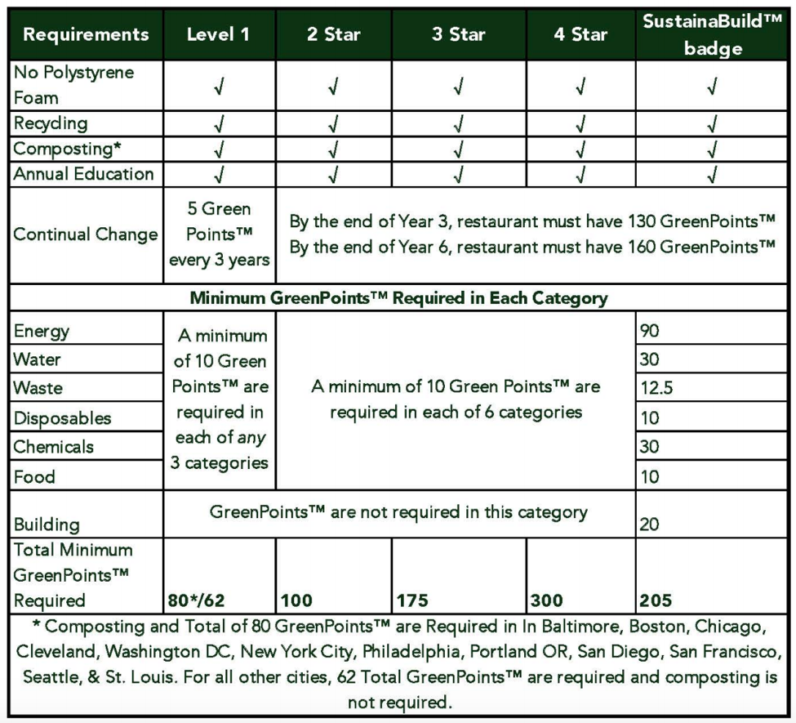
Full list of GRA criteria available at: https://d3656a02-c3a1-4531-9b80-7bd14919d48c.filesusr.com/ugd/4d780f_5a38ce19ffc247d3a0b845f44fe894dd.pdf

EPA Integrated Waste Management Hierarchy
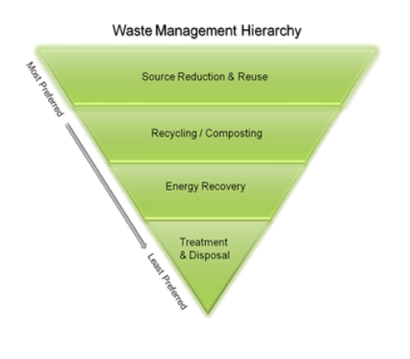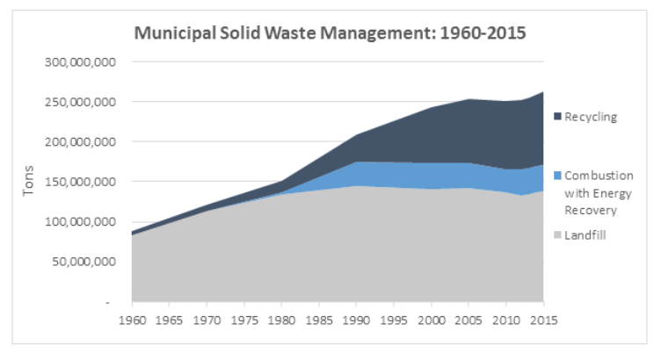

ESG Criteria Used by Sustainable Investors Example
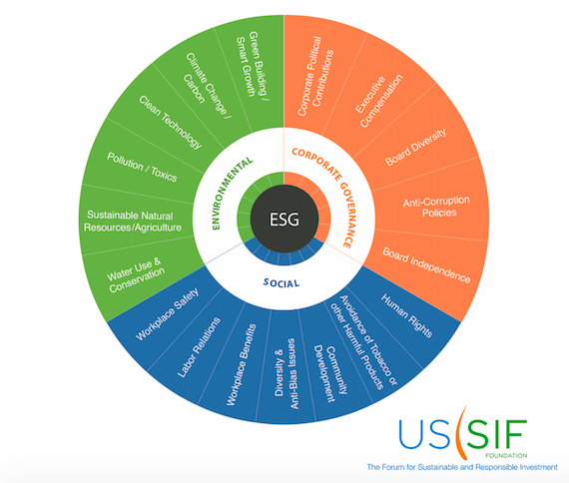

Interviews with Bodhi Staff
Jessica 10/2/19
- What is your personal definition of sustainability?
  - Help save the planet, make it last longer for generations after generations
- Do you care about sustainability in your personal life? Why?
  - I recycle
- How do you think sustainability relates to restaurants?
  - Sometimes good: when waste comes, we’ll know we could cut back costs if we cut back here
  - Sometimes it can add extra burden/ costs on the restaurant
- What are your thoughts on the sustainability project between me and the Bodhi?
  - Thinks it will be good to know how we can tighten it up with waste; can’t use wilted; saves extras from catering to be used on the line
- Are there any challenges you think come with making a restaurant more sustainable?
  - I don’t think so as long as our times are coordinated; no bugs
- In general, what do you envision for the future of the Bodhi?
  - Want to see it grow, would like to see the owners make money; and feed people

Sasha 10/1/19
- What is your personal definition of sustainability?
  - No experience in sustainability; awareness and conscious effort of trying to be conscious of the environment and the effect of products on the environment
- Do you care about sustainability in your personal life? Why?
  - I do now; I didn’t know that I was impacting the earth in a negative at all until my friend opened my eyes to plastic waste (9 straws went to waste). Living in Cali, seeing plastic bag ban. Education on plastic has impacted me. It was not something I sought after myself, until a friend opened my eyes.
  - Every small change leads to a bigger success - nutrition and sustainability
- How do you think sustainability relates to restaurants in general?
  - Restaurants have a huge responsibility in sustainability; I didn’t realize it until the straw thing- triggered us to get compostable bowls. Its challenging for restaurants because margins are so tough- trying to tailor to a bigger population; low cost is attractive to customers. Hard to do when purchasing something of higher quality. There are trendy, expensive restaurants that are sustainable, but it’s difficult to maintain that business model. Big responsibility and a big challenge. Having an expert (point of reference) with knowledge of sustainability is crucial to achieving sustainability. If sustainability was introduced at the beginning it would be easier.
- What are your thoughts on the sustainability project between me and the Bodhi?
  - I love it!! So happy we met for this. Had a friend that was knowledgeable; came in with ideas we were excited about. Even if we can’t afford it right now, with local farms; we have capacity to educate customers about sustainability and nutrition. Becoming a platform of health inside and for sustainability. A lot of things start with education. It’s hard at first, but
    - Have had customers that asked for plastic
- Are there any challenges you think come with making the Bodhi more sustainable?
  - Cost because we are a brand new business. Once we get the education out there (people come to the Bodhi because of the education and wellness feeling sick, high blood sugar), people will think otherwise about their
- In general, what do you envision for the future of the Bodhi?
  - Everywhere!! Not because of personal gain, but because (esp. if we) simple, copy and paste. If we incorporate sustainability now and everywhere, it would be health all around

Energy Audit
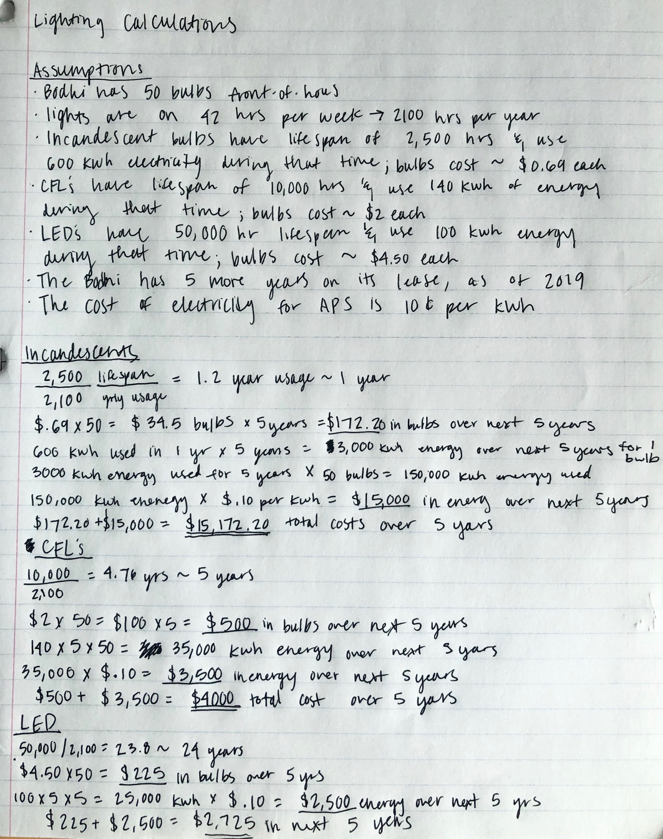

Waste Stream Audit
Back-of-House Waste Audit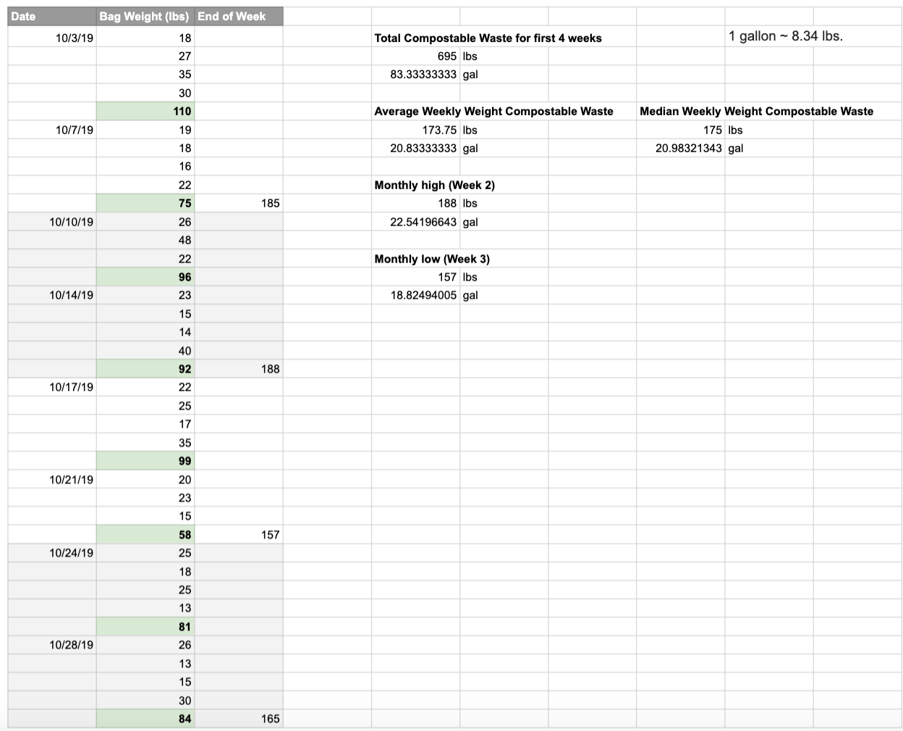

Front-of-House to be completed (11/23/19)

Customer Survey
- Age Range (select one)
  - <18 years old
  - 18-25 years old
  - 26-30
  - 31-40
  - 41-50
  - 51-64
  - 65+
- Gender
  - female
  - male
  - non-binary/third gender
  - prefer to self-describe _______
  - prefer not to say
- Current Occupation (select multiple if applicable)
  - student
  - part-time worker
  - full-time worker
  - prefer to self describe _________
- I eat at the Bodhi because… (select all that apply to you the most)
  - the food is healthy
  - the food is delicious
  - it helps me learn about nutrition
  - I purchase their meal plans
  - I can find food that aligns with my personal nutrition/diet plan
  - it makes me feel energized/improves my mood throughout the day
  - service is fast
  - I enjoy the employees/culture here
  - I enjoy the atmosphere
  - it is close to my work/school/organization
  - it is affordable
  - their food makes me feel good about my appearance
  - They have food that works with my dietary restriction/health restriction
  - The menu and ingredients are easy to understand
- The following questions do not necessarily relate to the Bodhi, but are presented to understand customer perceptions about sustainability (scale of 1 to 5)
  - I have a good understanding about what sustainability is
  - I would choose to eat at a sustainable restaurant over a normal restaurant if I had the choice
  - A sustainable restaurant has to be more expensive than a restaurant that is not
  - sustainability is important to me

Recycled City Commercial Pricing List for Compost Pick-Up
