Business Sustainability
by Leveraging the
Phoenix Green Business Leader Program

April 2019
Ashley Weisman
Alexis Yaple, City of Phoenix Public Works Department
Winslow+Partners

Table of Contents
Abstract 2
Introduction 2
Background 3
Literature Review 4
Summary of essential criteria for successful green business programs 6
Outcomes & Findings 11
Phase 4: Sustainability Strategy Execution 11
Changes to the Current State 11
Phase 5: Green Business Program Analysis 15
Winslow+Partners Case Study 15
Recommendations 18
Green Business Program Practitioner Self-Reflection Assessment 18
Conclusions 19
References 20
Appendix 22

Abstract
It is well-known that social-ecological systems are tremendously influenced by the decisions and actions of businesses. There is also widespread agreement that sustainability standards are necessary in addressing business-as-usual thinking. However, how to guide business transformation by utilizing sustainability standards remains under dispute. The City of Phoenix offers a Green Business Leader Program, which is a voluntary sustainability certification for local businesses to receive recognition for waste diversion, water conservation, energy efficiency, and sustainability awareness. This project leverages the City of Phoenix Green Business Leader Program to help a local architecture and design firm, Winslow+Partners, to implement enough sustainable practices to become Platinum level certified. The final deliverables include the newly implemented practices at Winslow+Partners, a Winslow+Partners Sustainability Guide, and a Green Business Program Practitioner Guide. The Winslow+Partners Sustainability Guide provides a roadmap for the new initiatives to be sustained at Winslow+Partners, which will be added to the employee handbook.
This project challenges the idea that a green business program can create impactful change. Twenty-eight green business programs were analyzed against the Literature Review, and 16 of these programs’ practitioners were informally interviewed. After synthesis of these findings, the Green Business Program Practitioner Guide was created and shared with the green business program practitioners to use to reflect on and improve their programs. The Winslow+Partners experience is also posed as a case study within this guide (Figure 12). This project conducted a comprehensive analysis of green business programs through three perspectives, including the perspective of the business going through the program, through publicly available information, and then through the perspective of the practitioners themselves. It is this project’s intent to help create the most effective green business programs in US history, propelling the US sustainability movement full speed ahead. This study offers an inside look at how businesses and practitioners interact with voluntary sustainability certifications and examines how, and if, a green business program can lead to transformational sustainability. This project asks, can green business certifications create transformational change?

Introduction
Local businesses fuel the culture, perspectives, and lifestyles of the people in our community. These local factors shape consumption patterns, supply and demand, and resource extraction globally, as a part of a single complex, social-ecological system. Many local companies are stuck in business-as-usual thinking and habits, driven by profit, and externalizing their social and environmental costs, with no simple remedy. The status- quo has permitted our local economy to develop into what it is today. Business’ emissions pose urgent threats worldwide, irreversibly surpassing tipping points as they push climate change beyond critical thresholds for survival (Rockstrom et al., 2009). When local businesses contribute waste to landfills, this produces methane, a gas that has 21 times more global warming potential than carbon dioxide (Roseland, 2012, p. 110). As the viability and integrity of ecosystems continues to degrade, so does the ecosystems’ ability to provide services that sustain life.
Locally, Phoenix faces ecological threats that require urgent responses. Extreme drought has depleted main water sources in Phoenix, including the Salt, Verde, and Colorado Rivers, threatening future food security, public health, and economies in the region. Moreover, in the next fifty years, population, consumption, and temperatures in Phoenix are expected to rise. Local businesses must take responsibility for their negative impacts on society not only to protect Phoenicians’ way of life, but to sustain future generations’ ability to survive.

Background
The City of Phoenix Public Works Department recognized the critical need for a business revolution to achieve its Environmental Sustainability Goals (City of Phoenix, 2018), which led to the inception of the Phoenix Green Business Leader Program in January of 2017. Since its inception, the program has certified 65 Phoenix companies as Green Businesses- if they responsibly diverted their waste. However, in September of 2018, the program integrated a more holistic and comprehensive approach to business sustainability. Now, the program has expanded to include two new levels, Gold and Platinum, and delves into not only waste diversion, but includes transportation, water conservation, energy reduction, and other sustainable actions in its criteria. The program allows businesses to self-report by completing a checklist of actions in these categories, and a sustainability specialist schedules a walk-through at the business site to confirm the checklist. Once confirmed, the businesses are certified as Green, Gold, or Platinum depending on the amount of sustainable practices they have implemented. The certified business receives benefits (Figure 1) and are recognized as a Phoenix Green Business Leader.

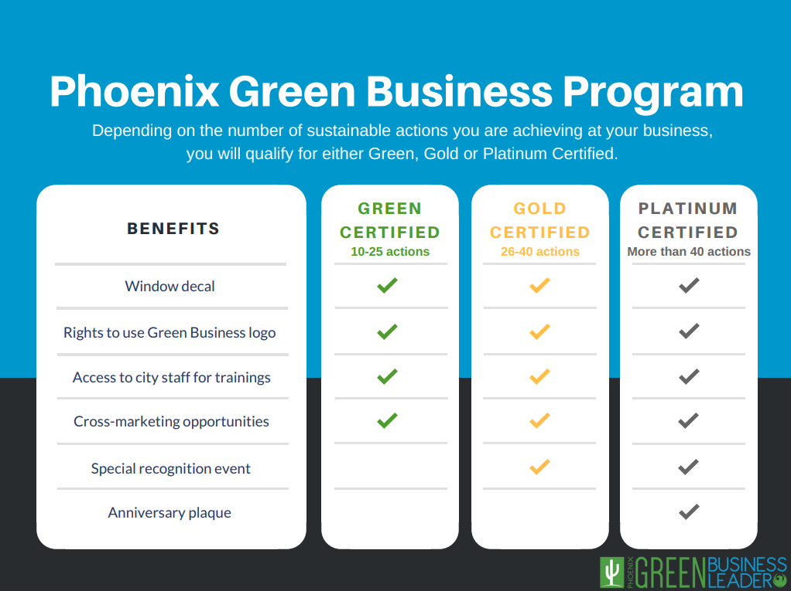
Figure 1: Recognition and benefits chart for the Phoenix Green Business Leader
program (City of Phoenix, 2018).

This project leverages the City of Phoenix Green Business Leader Program by helping a local business, Winslow+Partners, become Platinum level certified. The project partner is Alexis Yaple at the City of Phoenix Public Works Department, and the client is Winslow+Partners, which is an architectural design firm that specializes in innovation think tanks and educational planning. Winslow+Partners is a forward-thinking, socially conscious enterprise. Their slogan is ‘ideas for a changing world’ and their mission is ‘to facilitate change and improve the condition of mankind’ (Winslow+Partners, 2018). The company’s values and process encompasses many sustainability concepts. For example, their Innovation Think Tank utilizes an iterative, adaptable process, and their processes embrace complexity, strategic planning, and social responsibility.
In November 2018, Winslow+Partners had multiple sustainability initiatives, with a score of 25 points in the Green Business Leader Program (Figure 2). This score earns them a Green level certification. This project aims to achieve Platinum certification, and to help their business take sustainability to the next level, both internally and in what they produce for their clients. Thus far, we’ve had great conversations about what sustainability truly means to them and implemented impactful new additions to their business. I can confidently say that the two owners and seven employees are thinking of sustainability in ways that they have never thought of before. Their team is creating a culture of sustainability at the firm and it’s been rewarding to facilitate. In April 2019, the firm achieved Platinum Phoenix Green Business Leader Certification, scoring 51 points on the checklist.
Nevertheless, this project calls the effectiveness of the program into question, for the purpose of continuous program improvement. In a world where greenwashing is common, efficiency standards are lax, and ecological systems are approaching critical thresholds, it is crucial to challenge the program’s ability to create measurable, substantial change. This project conducted a comprehensive analysis of green business programs through three perspectives surrounding the programs. First, the Winslow+Partners experience is posed as a case study (Figure 12). Concurrently, this project analyzed 28 green business programs against the Literature Review via publicly available information, and 16 of these program practitioners were informally interviewed (Figure 3). From these conversations and research, a Green Business Program Practitioner Guide has been created and shared with over 30 programs. It is this project’s intent to help create the most effective green business programs in US history, propelling the US sustainability movement full speed ahead.

Literature Review
The Anthropocene is characterized by the enormous influence that the human race exerts on the Earth (Robbins et al., 2014). Anthropogenic stressors have introduced toxins, invasive species, and accelerated rates of greenhouse gas emissions and resource extraction to the global system. Due to these ecological stressors, ecosystems around the world are losing their ability to maintain their integrity and function. This phenomenon is known as a critical threshold, or the ‘tipping point’ or ‘point of no return’ (Odum & Barrett, 2005; Wiek, 2015). Planetary boundaries define nine critical thresholds that define the safe operating space for humanity to survive (Rockstrom et al., 2009). Our planet is currently surpassing these breaking points, indicated by prolonged drought, species extinction, desertification, eutrophication, and more. Business-as-usual practices exacerbate all nine of the planetary boundaries; thus, strategic sustainable development holds the key to protecting our planet from greater challenges and harm (Robèrt et al., 2013). It is well-known that social-ecological systems are tremendously influenced by the decisions and actions of businesses. There is also widespread agreement in the literature that sustainability standards are necessary in addressing business-as-usual thinking. However, how to guide business transformation by utilizing sustainability standards remains under dispute.
One widespread approach to sustainability standards is through voluntary sustainability certifications and green business directories. Hundreds of these programs exist worldwide across many different sectors, indicating the need for such a tool. There is growing awareness among the general public regarding climate change and exploitation of our planet’s finite resources, driving consumer support of ‘environmentally friendly’ businesses (Harris, 2007). Certifications put this pressure on businesses and increase awareness among consumers. Voluntary certification programs aim to ensure producer compliance, acting as market-based instruments of sustainability governance (Veleva & Ellenbecker, 2000). Many companies do not understand the true scope that sustainability has in their businesses. Surveys demonstrate that many businesses still find the concept of sustainability 'hard to operationalise' (Veleva & Ellenbecker, 2000). Sustainability certifications can be used as an education tool, creating a set of guidelines for companies to follow. Sustainability indicators and criteria can serve as a roadmap for companies that are interested in learning how to apply sustainability into their business (Veleva & Ellenbecker, 2000). Certification criteria exposes company owners to a range of sustainable practices that their business can cover, often that they had never thought of before. However, there is much debate challenging the ability of these certifications to cover the full breadth of sustainability that businesses need to impact large-scale, measurable change.
Common critiques of sustainability certifications are based on their generalized approach, static nature, lack of oversight, mediocre criteria, and difficulty in measurability. Certification criteria should be created by subject matter experts, regional stakeholders, and community members, in partnership with transformational sustainability scientists, to ensure the legitimacy of green business programs. No set of guidelines is applicable to all businesses, in all sectors and regions (Veleva & Ellenbecker, 2000). Simplistic, generalized certification criteria are intended to be relevant and easily understood by a wide audience. However, cross-sectoral certifications are questionable because their general, ambiguous nature cannot account for industry- specific impacts. As demonstrated in vast literature, solutions are not universal, and there is no ‘one size fits all’ solution for businesses (Veleva & Ellenbecker, 2000; Wiek, 2015). Moreover, it is important to address that different regions pose varying environmental and societal threats, limitations, and needs, influencing what businesses should and should not do in specific regions.
Considering the high complexity and uncertainty that the Earth (and businesses) operate under, business certifications should not be awarded indefinitely. As the Earth nears its planetary boundaries, ecological systems are more unpredictable than ever before. Thus, certification criteria should have the ability to change and adapt with these global changes through a periodic review process. Moreover, businesses must be constantly monitored and must be expected to continuously improve. This means that businesses should be asked to renew their certifications periodically, as defined by regional subject matter experts. Most companies have room to grow in terms of sustainability; hence, certification should be considered a process and journey, rather than a static endpoint (Veleva & Ellenbecker, 2000). To assume that all businesses are capable of becoming certified at their current state undermines the purpose of the certification- for businesses to engage in continuous improvement that will lead to organizational change, organizational change that is worthy of special recognition.

With periodic recertification comes more oversight. Enforcement of certification standards is necessary to their legitimacy, and ambiguous and general criteria are more difficult to enforce. Certifications do have the potential to meet substantial sustainability goals, if verification and enforcement mechanisms are in place (Scarlat & Dallemand, 2011). This requires that the certifying agency is completely independent from the organizations being certified (Harris, 2017; Scarlat & Dallemand, 2011). Transparency between the businesses, certification practitioners, and the communities they serve allows for stringent oversight and accountability. Transparency of these programs is controversial when the business’s self-chosen, voluntary sustainability standards are not publicly available. This could mean community members or employees having the ability to expose businesses if they do not comply with their certification commitments. Furthermore, not only does publicly available green business program checklists act as a transparency and enforcement mechanism, but also serves as a public sustainability education tool. Green business programs have the opportunity to create awareness and educate the public, and have the responsibility to take advantage of this opportunity.

There is also concern regarding the difficulty of measurability in certification programs, questioning at what scale these measurements should take place. This measurement is difficult because sustainability problems are complex, and create dispersed effects, across varying temporal and spatial scales, simultaneously. Social, economic, environmental, political, and institutional impacts stem from the business and act on various landscape, local, national, regional, and global scales (Cash et al., 2006). Hence, certifications often lack the ability to provide measurable indicators to the public that demonstrate how the businesses are moving the needle. Furthermore, qualitative and normative indicators can be challenging to measure. For example, certification can foster sustainability implementation at the production site, but the certifications cannot account for the business’s indirect, unintended consequences, such as externalizing its impacts on food security, land use changes, and so on (Marin-Burgos et al., 2015). These indirect effects can be global in scale, having sustainability implications across markets and national borders. These are relevant impacts by the business that are not measured through most certification programs. Nevertheless, the current need of most green business programs is how to provide certified businesses with the means to better measure their on-site impacts, well before delving into downstream impacts.

Many current business sustainability certifications offer only baseline, operational criteria. Different industries have different inputs and outputs, which cannot be ignored when assessing a business’s sustainability. Assessment of a business’s products is crucial for transformational sustainability intervention. This requirement can be enforced through product sustainability certification by external organizations. To get to the very roots of the business, sustainability certifications can delve even deeper into the business, moving past its on-site operational sustainability and delving into its mission, purpose, and products. Companies can discover new ways to tie sustainability into everything they do, without taking away from their main mission. I have identified the following set of key takeaways from the literature to build effective green business programs and outlined them below. ‘Success’ is defined as the program’s ability to move the needle and make impactful, sustainable changes in the business and its community.

Summary of essential criteria for successful green business programs:
- Business certification programs must have specialized criteria for different sectors.
- The certification criteria should be reviewed on a periodic basis to change with ecological limitations and social needs at the community and global level.
- These programs must act as a challenge to ensure continuous improvement, which calls for renewal of their certifications periodically and measurable improvement between periods.
- Enforcement and oversight must be stringent. Hence, the certifying agency and the organizations being certified must work transparently, which calls for achieved certification criteria to be accessible, public information.
- Certifications must cover all three pillars of sustainability. When creating these programs, certification agencies must address the complex, socio-ecological systems in which the business is embedded, beyond business operations, taking various temporal and spatial scales into account.
- In order to be truly transformative, certification programs cannot certify the business, while ignoring its products or services provided. Certification of businesses must incorporate product certification, based on scientifically sound and objective life cycle assessments.
- After improving their operational efficiency by improving their waste, transportation, water, energy, and other sustainable actions, as outlined by the Phoenix Green Business Program, the truly sustainable organizations need to ask themselves more challenging questions, such as:
- Currently, what are the benefits and consequences of our products and services to society and the environment?
- Which of the burning environmental, societal, or economic issues could be resolved by dedicating our wealth of resources, competencies, and talents?
- How can we transform our operations, products, or services to act as direct, measurable solutions (products or services)?
- What can we do individually?
- How can we develop our governance structures to respond more effectively to society’s concerns?
- Where do we need to engage in sector-wide or cross sectoral strategies?
- Where do we need to engage in business activities to bring together the divergent demands of the current economic system and the demands of sustainable development? (Veleva & Ellenbecker, 2000).
The Phoenix Green Business Program certifies businesses that improve their resource management and the culture of sustainability within their businesses. These improvements can move the needle and create impactful change (Figure 5). Operationalizing sustainability often shows economic benefits for businesses as well. For example, PepsiCo’s sustainability programs have saved the company over $375 million since 2010 (Sustainability Report, 2016). Sustainability certification programs must delve deeper into all three components of their triple bottom line, moving past environmental impacts, to social and economic factors (Veleva & Ellenbecker, 2000).
But what about the many businesses that do not volunteer to become certified? Certifications only reach businesses that are willing to volunteer, preaching to the choir and not addressing businesses that are stuck in the status-quo. Every solution proposed in sustainability returns to the need for policy. Veleva and Ellenbecker (2000) explain that companies are much better at measuring aspects of production that are required by law (e.g. lost workday injuries and illness rate, Toxic Release Inventory releases, and number of violations). Certification programs can raise awareness, inform decision-making, and promote accountability and continuous improvement, but it is clear that the programs are only tools and they alone cannot change the current business paradigm. Sustainability leadership, education, and policy are needed, in coordination with industry-specific, stringent, and measurable sustainability certification programs, to keep our planet within its planetary boundaries.

Project Approach and Intervention Methods
The project deliverables include the newly implemented practices at Winslow+Partners, Winslow+Partners Sustainability Guide, and the Green Business Program Practitioner Guide. The Winslow+Partners Sustainability Guide, which will be added to the firm’s employee handbook, will serve as a resource-filled how-to guide, informing how to sustain the newly implemented sustainability practices. After the project’s completion, the Winslow+Partners Sustainability Plan and green office program will be added to the Sustainability Guide. The Green Business Program Practitioner Guide first poses the Winslow+Partners experience as a case study, addressing project outcomes, best practices, and lessons learned (Figure 12). Second, this guide offers self-reflection questions for program practitioners to use to examine and improve their programs, and provides best practices for each of these questions. Each of the best practices highlights one of the programs that was interviewed. The guide aims to showcase the gaps in the green business program realm and share these findings with international green business practitioners. This analysis examines these programs through a critical, holistic lense in a wider sustainability context. This perspective is crucial for a program to become a truly transformational sustainability leadership tool. The final project outcomes are the Winslow+Partners’ new Platinum Phoenix Green Business Leader Certification. Below, I explain the project process in seven phases.
Phase 1: Introductory Meeting & Tour: November 20th, 2018
For the Introductory Meeting & Tour, I met with the business owner and office manager. I reviewed the project and its timeline, they completed the Phoenix Green Business Leader checklist based on their business’s current state, and we discussed which checklist criteria they wanted to include in the Sustainability Strategy. We also set a communication plan and expectations, I obtained the contact information of all employees, and I was taken on a site tour. The tour acted as an opportunity to observe the facility and operations first hand. During this phase, the firm scored 25 points on the Phoenix Green Business Leader checklist.

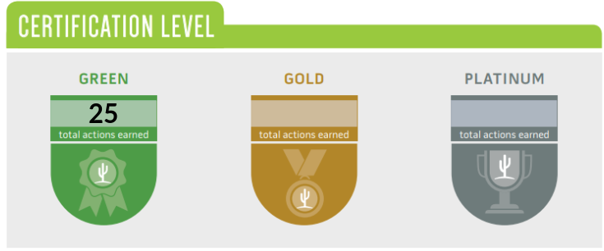
Figure 2: The Winslow+Partners score on the Phoenix Green Business Leader checklist as of November 2018.

Phase 2: Creation of Strategy Proposal: November 20th- December 21st, 2018
Based on what I learned during the Introductory Meeting & Tour, I created a Sustainability Strategy Proposal for the project, formatted as a step-by-step list of action items and timelines. The Phoenix Green Business Leader checklist criteria I chose to focus on was based on the business’ current state and their desired goals. During this phase, I researched our goals’ feasibility and how to execute the Sustainability Strategy.

Phase 3: Strategy Proposal Meeting: December 21st, 2018
Next, the business owner, office manager, and I held a goal setting meeting. During this meeting, we discussed my analysis of their current and desired state, reviewed the Sustainability Strategy Proposal, and edited the Sustainability Strategy Proposal as necessary. I also gained access to necessary information and asked for suggestions that would sustain the newly implemented practices. The Sustainability Strategy is found in the Appendix.

Phase 4: Sustainability Strategy Execution: January 1st- April 19th, 2019
The next phase of the project was the longest in duration as I executed the Sustainability Strategy. During this phase, I updated the business owner on my project progress weekly or biweekly. These progress updates were also used to gain necessary information and permissions, and answer any questions that arose. The Winslow+Partners Sustainability Guide was created during this phase. Visit the Appendix to view the Sustainability Strategy.

Phase 5: Green Business Program Analysis: March 25th- April 19th, 2019
During this phase, research was conducted through the following methodology:
- Researched 28 green business programs via publicly available information and compared the programs against the ‘Summary of essential criteria for successful green business programs’ from the Literature Review.
- Contacted the programs to request an informal interview, and I spoke with 16 different program practitioners. During these conversations, we discussed the ‘Summary of essential criteria for successful green business programs’ found in the Literature Review and how this compared with their program, the successes and challenges of their programs, etc. I promised to share the Green Business Practitioner Guide with the practitioners I spoke with.
- Synthesized the comparisons between all programs and their standing in relation to the Literature Review.
- Created a Green Business Program Practitioner Guide, which includes the Literature Review, a list of questions for practitioners to use to reflect on and improve their programs, and best practices to serve as examples for the list of questions. Each of the best practices highlights one of the 16 green business programs that I met with. See the Appendix for the Employee Informal Interview Questions and .
- Posed the Winslow+Partners experience as a case study in the Green Business Program Practitioner Guide, addressing project outcomes, best practices, employee attitudes, and lessons learned. Visit the Appendix for the Green Business Program Practitioner Research Guide.
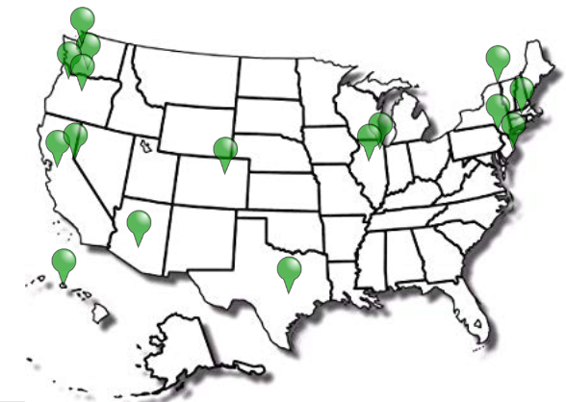
Figure 3: This image shows the 16 green business programs that I met with.

Phase 6: Overview Meeting: April 12th, 2019
All employees participated in the Overview Meeting, where we reviewed and completed the Phoenix Green Business Leader checklist. I presented my progress, gave recommendations, and motivated the employees to continue their sustainable practices and mindset. This meeting had open dialogue to make the company aware of the resources I’ve created for them, to ensure that all new programs are able to be sustained after the project ends. I also answered questions and addressed concerns. We submitted the Phoenix Green Business Leader Program checklist together for the City of Phoenix to review. Additionally, the team and I agreed to continue our work together, starting with the creation of a firm sustainability plan and green office program. This plan will be published on their website.

Phase 7: Phoenix Green Business Leader Program Certification: April 18th, 2019
Per the process of the Program, the City of Phoenix Public Works Department representative (the Project Sponsor) conducted her walk-through of the business to confirm all checklist criteria. I facilitated the site evaluation on Winslow+Partners’ behalf. All prerequisites were met during the walk-through, and scored 51 points on the checklist. Winslow+Partners was officially announced as a certified Platinum Phoenix Green Business Leader.

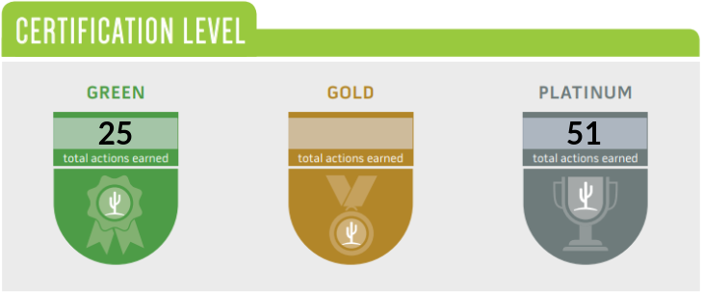
Figure 4: The Winslow+Partners score on the Phoenix Green Business Leader checklist in November 2018 and April 2019.

Outcomes & Findings

Phase 4: Sustainability Strategy Execution

Changes to the Current State
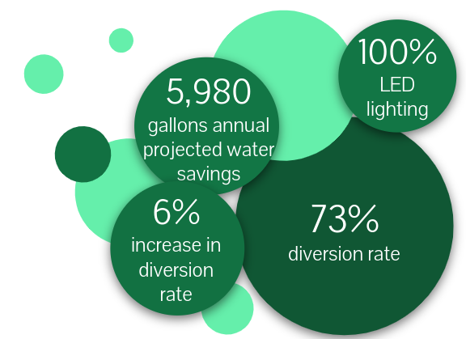
Figure 5: Quantitative results of the project.
Decrease in waste
- Through two waste audits conducted in January and April 2019, office waste decreased by 6%, from a 67% diversion rate to a 73% diversion rate. Compost, soft plastics, and electronic waste bins have been implemented on site. Sustainability trainings, new bin labels, and a PDF sent to employees (to be added to computer desktops for quick reference) reinforced the adoption of the new waste streams. The employees also took a tour of the North Gateway Transfer Station to understand the importance of proper recycling (Figure 9). This strategy intended to dive deeper into the ‘why’ for the new streams, or why the staff should care about their waste. Now, the company hosts zero waste events. The cleaning crew has been engaged with to ensure that the recycling bins are not mistakenly taken to the landfill.
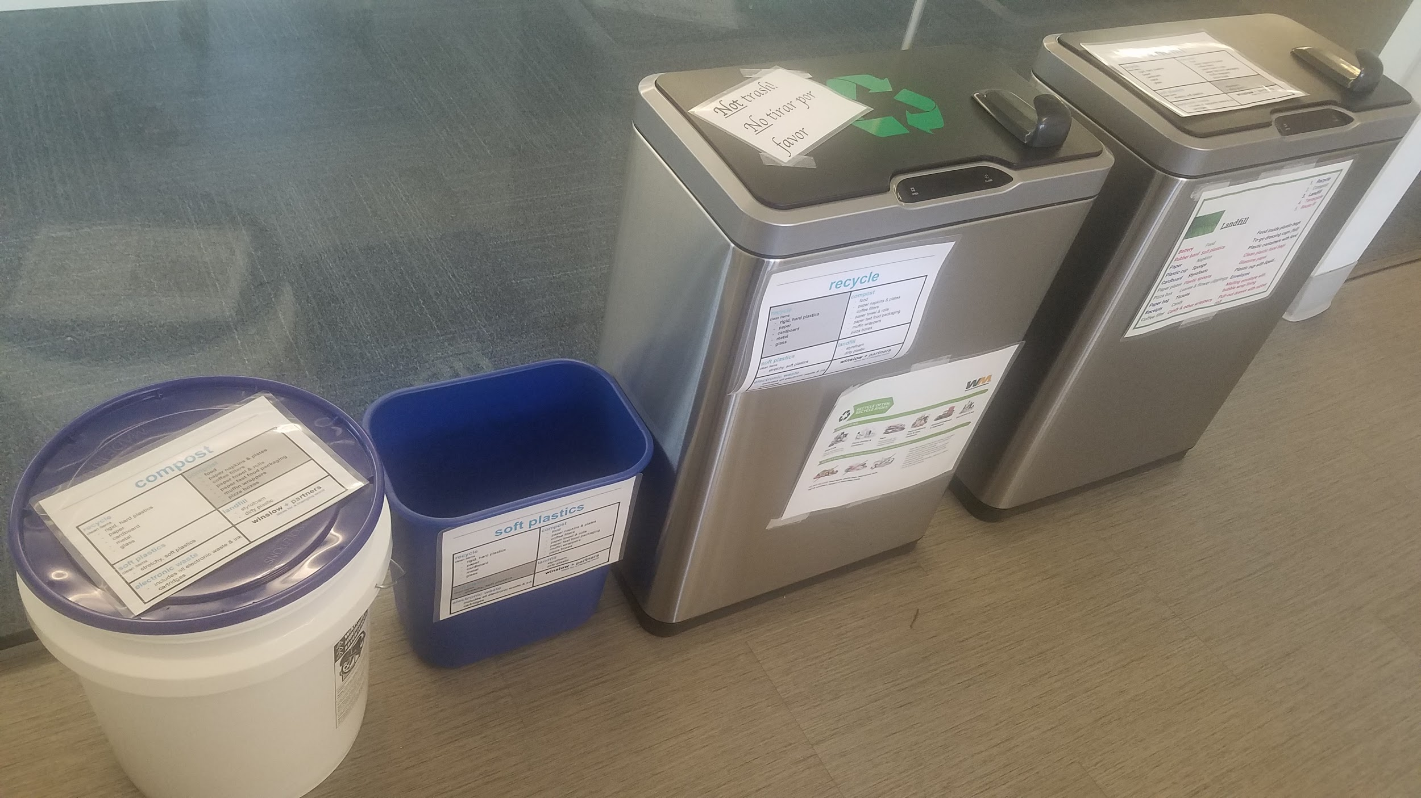
Figure 6: A photo of the waste separation station at Winslow+Partners. From left to right, the photo shows the compost, soft plastics, comingled recycling, and landfill bins. The electronic waste bin is not pictured.
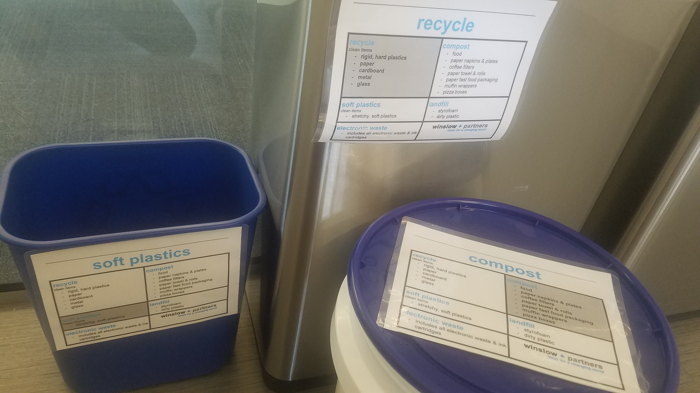
Figure 7: A closer look at the bin labels. These labels are laminated and fit the firm’s brand standards.

Increase in energy efficiency
- Energy efficient lighting: LED light bulbs have replaced all lighting fixtures at the office. The same fluorescent bulb uses 54 watts, while the LED wattage is 25.5 watts, using 53% less energy.
- Energy efficient procedures: Powering down appliances at the end of the work day causes staff to be more conscious of their energy use.
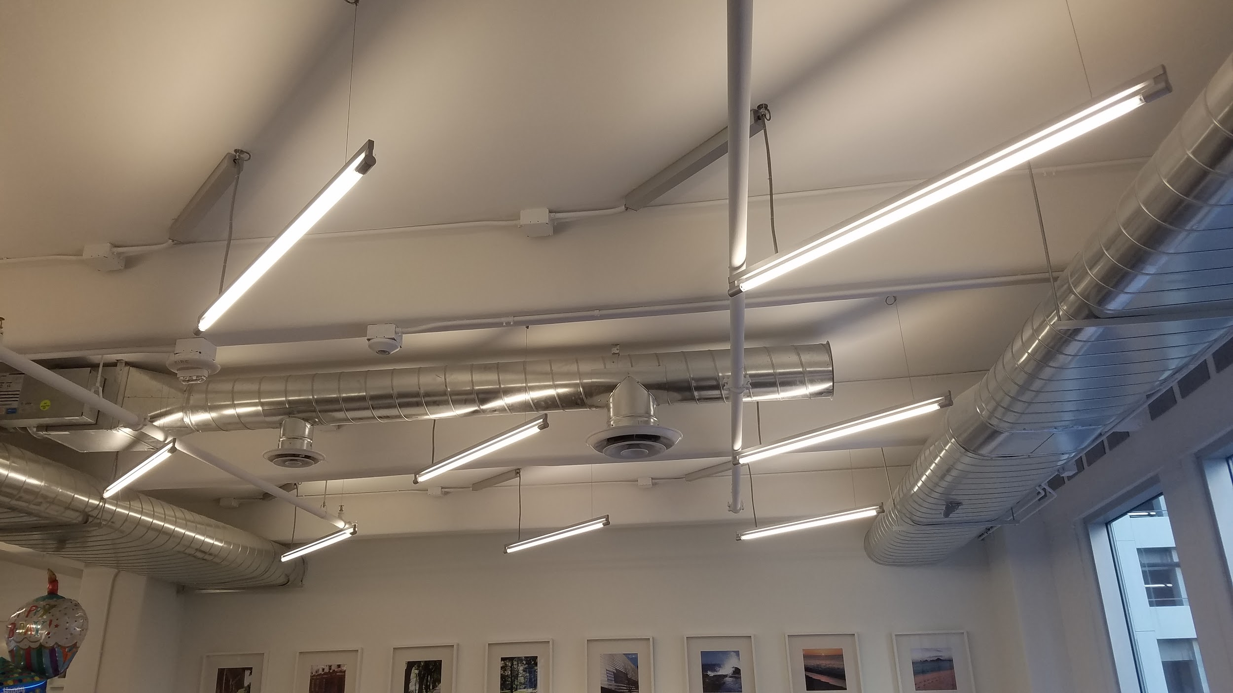
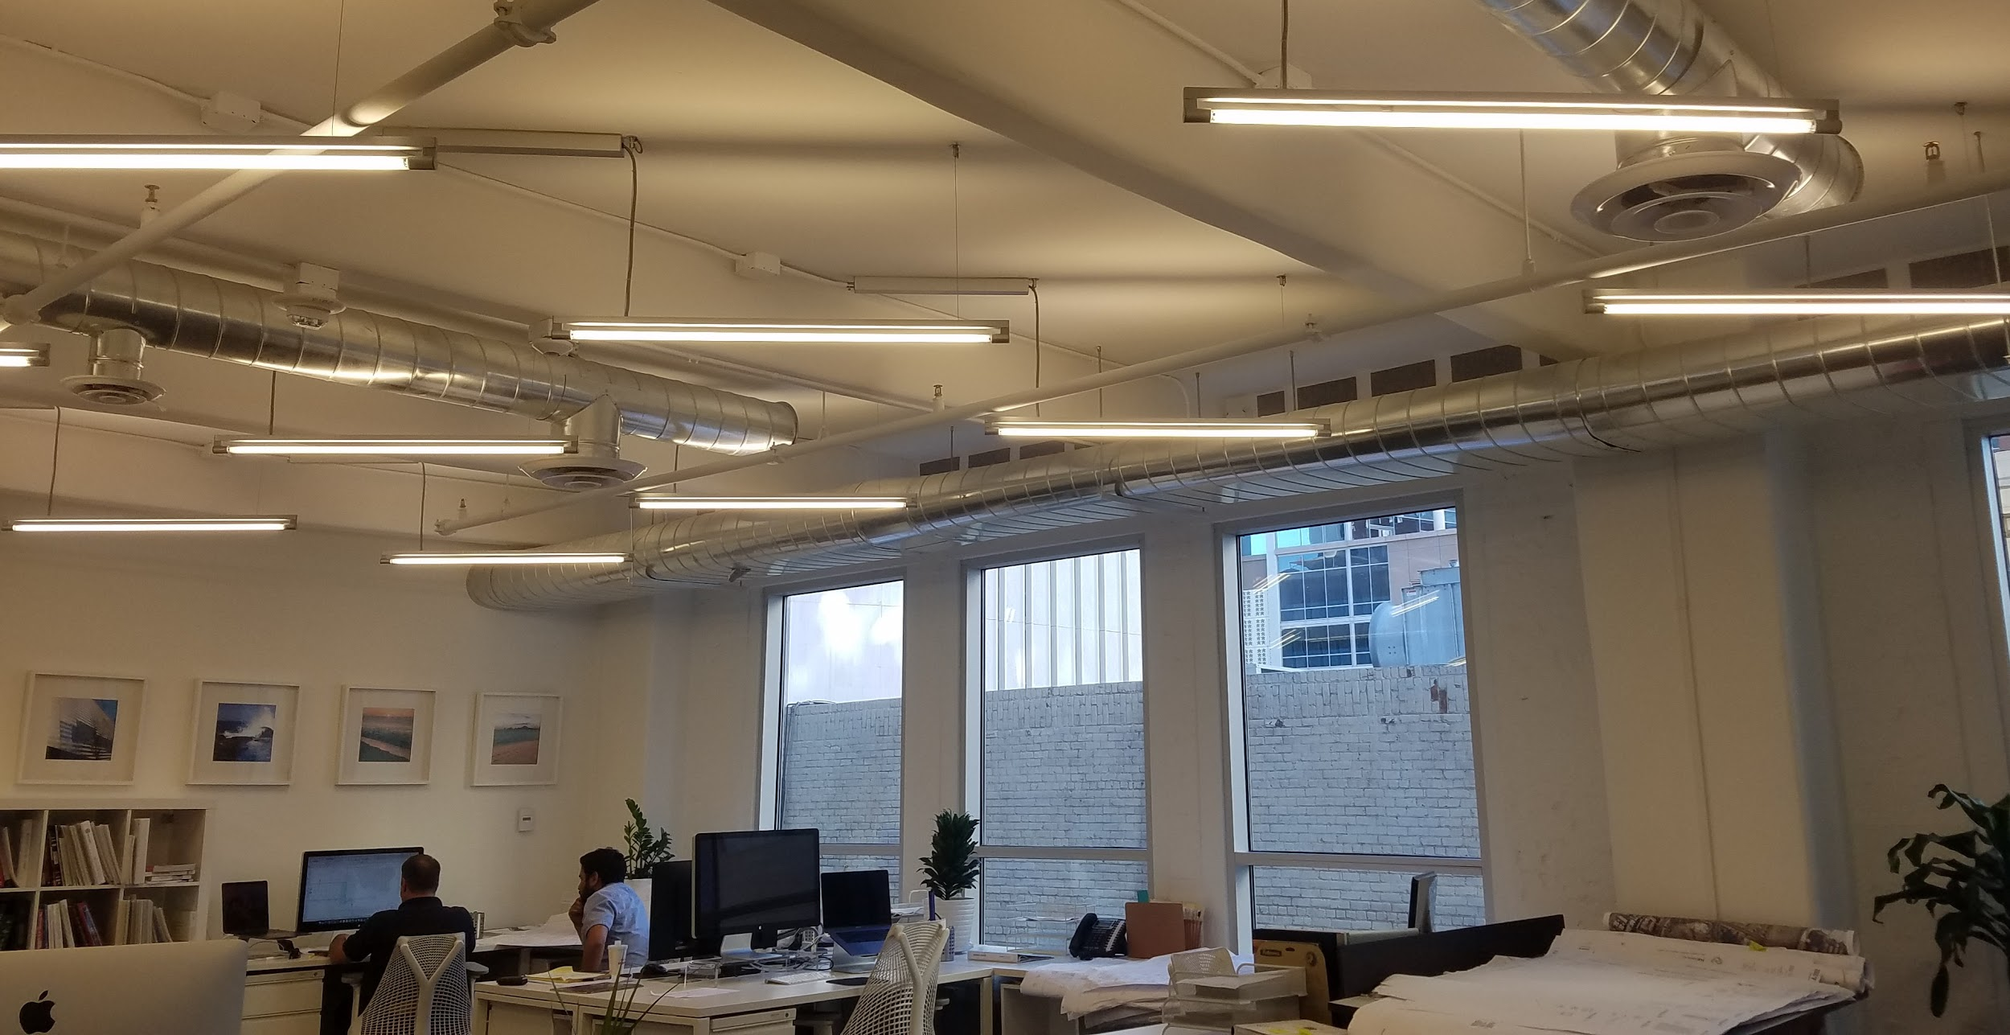
Figures 8 & 9: LED lighting fixtures at the office.
Sustainable procurement
- The firm has committed to buying office supplies from Wist Office Supplies (a local, sustainable company) and Staples, purchasing items such as high recycled-content products, FSC certified paper products, and compostable dinnerware for events. All procurement procedures, outlined by office item, are outlined in the Winslow+Partners Sustainability Guide. Visit the Appendix for to view the guide.
A culture of sustainability among employees
- Winslow+Partners Sustainability Guide: This resource-filled how-to guide gives the resources and information needed to sustain the new sustainability practices. It has been confirmed that this guide will be added to their employee handbook. See the Appendix for to view the guide.
- Winslow+Partners Sustainability Plan: Until now, Winslow+Partners did not have a written roadmap for sustainability in their business. A green office program has been established to meet the goals outlined in this plan. This plan is found within the Winslow+Partners Sustainability Guide. Progress on the Sustainability Plan will continue after the project’s completion.
- Sustainability training & education: Through staff sustainability trainings and emails featuring sustainability concepts, the employees became aware of concepts like the triple bottom line, the Sustainable Development Goals, what a sustainable workplace looks like, and more. Also, peer-reviewed articles were sent to the team to make the case that sustainability is more than environmentalism.
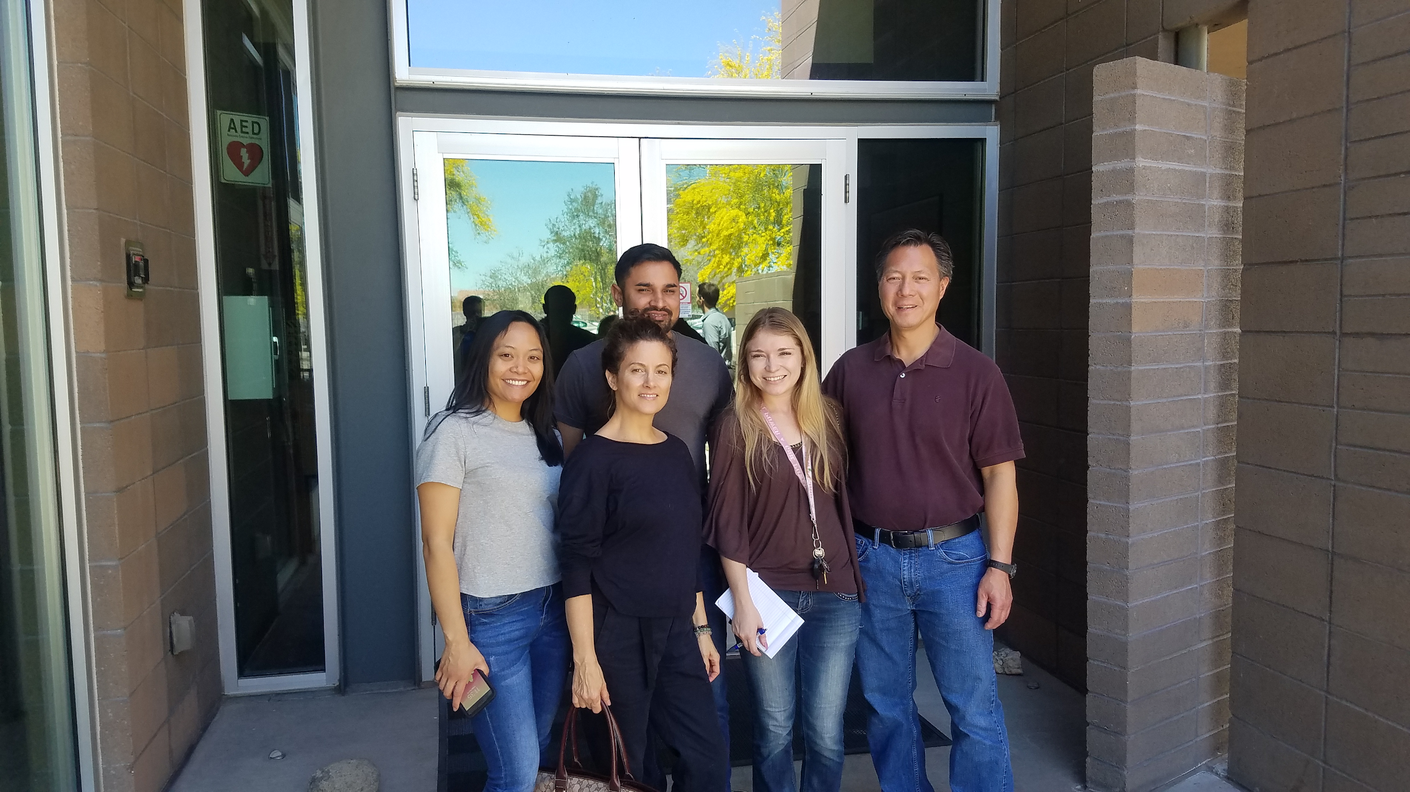
Figure 10: Myself and some of the staff after our tour of the North Gateway Transfer Station, where the team was reminded of the importance of proper recycling.
Sustainability as a part of the Winslow+Partners process & products
  - Sustainability awareness among neighboring businesses: Winslow+Partners facilitates co-creation through interactive brainstorming workshops with their clientele and other stakeholders, called an Innovation Think Tank. The first Sustainability Think Tank was meant to educate local businesses on sustainability and gain interest in the Phoenix Green Business Leader Program. We marketed the session as ‘creating the first sustainable block in Phoenix’. After inviting 12 neighboring businesses to the session; unfortunately, 0 businesses attended. Hence, this session was used to strategize as to what messaging and incentives would make the Sustainability Think Tank more attractive to local business owners. The second Sustainability Think Tank included a local property manager, two local business owners, two Phoenix Green Business Leader Program representatives, and Winslow+Partners staff. This session again focused on how to incentivize and engage more local businesses with the program. The conversation was fruitful for how to move forward with increasing participation in the program and how to implement recycling in buildings that don’t currently offer it. The Sustainability Think Tanks will continue past the project’s completion. Visit the Appendix for for the first Sustainability Think Tank flyer, as the second session did not use a flyer.
  - Sustainability messaging added to website: Winslow+Partners plans to add a new sustainability tab on their website to recognize their sustainability efforts and attract clientele that are aligned with their values. This further supports their commitment to continuing their new sustainability practices at the office well after the project’s completion. The tab will include their Platinum certification sustainability commitments, Sustainability Plan, and a water conservation widget.
  - Water conservation awareness: A water leak check was conducted by the City of Phoenix Water Smart Program. This audit showed a potential 5,980 gallons of water savings per year, which is likely to be a conservative number based on building visitors. The report, including toilet and faucet retrofit recommendations were shared with the building owner and property manager. Visit the Appendix for the Phoenix Water Smart Program Water Audit Report. Additionally, a Water Conservation Tip Widget was added to the sustainability tab on the Winslow+Partners website. The widget displays a new water conservation tip every day. The widget will display a new tip each day of the month, so site visitors can learn new ideas for how to save water.

Figure 11: The Phoenix Water Smart Program logo (City of Phoenix, 2018).
- Sustainability addition to Innovation Think Tank: I participated in an Innovation Think Tank with city planners, developers, and residents. This participation was necessary to understand the Winslow+Partners process, in order to discover how sustainability can be incorporated into the Innovation Think Tanks, which is a main product of the company. This deeper dive into how to add sustainability into the Innovation Think Tanks is a part of the Winslow+Partners Sustainability Plan, found in the Winslow+Partners Sustainability Guide. Visit the Appendix for view the guide.

Phase 5: Green Business Program Analysis

Winslow+Partners Case Study
When conducting informal interviews with the staff, we discussed how the program affected them personally and if the Phoenix Green Business Program was useful. 100% of the staff stated that they would recommend the program to other businesses. Moreover, 100% of the employees reported that they were made aware of new sustainability concepts or adopted a new habit, most notably in the category of waste diversion. This is most likely due to the fact that the staff interacted with waste more than the other sustainability implementations (for example, the LED lighting). The staff interviews also revealed that 100% of the staff thought the certification was easy; however, 100% of the staff said that they wouldn’t have been able to achieve Platinum without external help (i.e. my help). This shows that the level of change we saw at the firm in such a short amount of time was only possible because they had an external person doing most of the work, whose sole responsibility was to implement and maintain these new practices. The interview questions can be found in the Appendix.
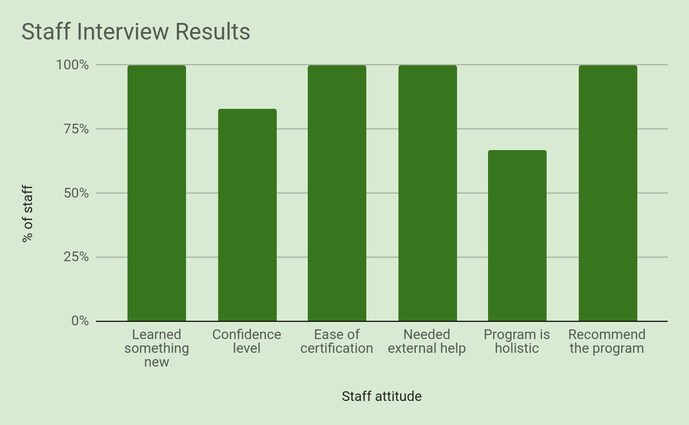
Figure 12: Staff informal interview results, showcasing staff attitudes to the Phoenix Green Business Leader program.
The waste audit in April 2019 showed an outstanding 73% diversion rate in the office. This revealed a 6% increase since the waste audit in January 2019. Throughout the process, the employees were very open to learning how to sort their waste into multiple waste streams. Halfway through the project, the owners showed me a box of approximately ten items in which they needed clarification on which waste bin they belonged to. The staff were also very engaged in the sustainability training I facilitated. During the training, I revealed the most common items found in their waste audit and introduced the potential new bins we could implement (compost and Terracycle). We then played an interactive game asking which of the five categories (compost, recycle, Terracycle, landfill, or reuse) the items belonged to. The game revealed the major gaps and cognitive dissonance in terms of proper waste diversion. The staff stated that they really enjoyed the game, exemplifying how gamification can be used as an effective engagement tool. The Terraycle bin was later replaced with a soft plastics and electronic waste bin, due to the high pricing of the Terracycle service.
The project facilitated sustainability trainings, implemented bin labels (Figure 6 & 7), sent a waste PDF to be added to computer desktops for quick reference, and toured the recycle center (Figure 10) to reinforce the new waste streams. The tour intended to provide staff with a better understanding of the ‘why’ for the new streams, or why they should care about their waste, which is a best practice for behavior change. The staff interviews (Figure 12) revealed that the staff thought the new waste streams were straightforward and easy to continue. This supports that waste diversion services can have a high level of acceptance, if business owners are made aware of these opportunities and you provide many different channels of repetition to reinforce the new bins. In regards to the reinforcement of sustainable procurement, most of the staff did not have the opportunity to engage with this, other than the office manager whom did the purchasing. However, all staff were surprised at the wide range of sustainable materials that are available on the market, again creating a sense of awareness of the green revolution.
A few notable gaps were found within the sustainability practices at the firm, indicating the need for a streamlined set of guidelines: the Winslow+Partners Sustainability Guide. For example, powering down appliances at the end of the work day was refused by the business owner at first, but during Phase 6: Overview Meeting, the closing office managers made known that this practice is a part of their closing procedures. Hence, we added this practice to the Winslow+Partners Sustainability Guide, to ensure that this practice is streamlined no matter who closes the office. Another gap within the sustainability practices of the firm was discovered when the owners and staff insisted that the toilets and faucets are low-flow, but the water leak check reported 5,980 gallons of potential water savings needed. This exemplifies the importance of audits, as the business could mean well and have no idea of the water they are wasting. Another gap was revealed in their understanding of what sustainability means, and that the concept moves far past environmentalism. This gap in understanding is exemplified when 67% of the staff said that they thought the program was holistic, that the sustainability initiatives we’ve implemented through the program are ‘enough’, and that they couldn’t think of anything to add to the program.
The new sustainability implementations at Winslow+Partners was mostly paid for with project funds. I raised $750 for the project through a fundraiser event on January 27th, 2019, and a givebutter campaign. The transition to 100% LED lighting was 33% paid for by the company, which was voluntary (Figure 8 & 9). This external funding source may have implications for the feasibility of the project, as an increase of 26 points on the checklist may not have been feasible in four months if the company had paid for the new sustainability practices themselves. Because I had funds and did not have to wait for the business to make the purchases, I was able to move very quickly. Moreover, I question if some of the new practices would have been tested and experimented with if the business had to spend their own money on the trial and error.
Overall, I do believe that most of the sustainability practices will be continued because employees’ convenience and acceptance is high, but I suspect some procedures may fall through the cracks. In fact, 83% of the staff strongly believed that the sustainability practices in the office would continue after the project’s end. The owners were very keen on winning the participation of the building owner and property manager in their sustainable practices, which fueled their desire for LED lighting, the water leak check, and the energy audit. During the project, it was unclear to me whether the team would want to create a sustainability plan for moving forward, but it was discovered during Phase 6: Overview Meeting that a sustainability plan and green office program would be established. I am continuing my work with the firm well after the project’s completion to help them create and execute these initiatives. The owners were very pleased with the new marketing opportunities posed by the new Sustainability tab on their website. Their firm already had many sustainable practices implemented even before the project, but it had never occurred to them how to talk about their sustainable practices as a compelling narrative. I predict that many of the practices will be sustained as the business holds their new, Platinum Phoenix Green Business Leader Certification with integrity and markets this commitment on their website.
Another initiative that will continue after the project’s completion is the Sustainability Think Tanks. After the first Sustainability Think Tanks unfortunately had zero businesses in attendance, I learned that I spoke to the wrong incentives when speaking to the businesses. When inviting businesses in person, I tried to speak to the economic incentive for businesses to participate. However, I discovered that many of the businesses in downtown Phoenix do not pay their own utilities, as their energy and water bills are covered in their rent. Hence, hundreds of business owners have no idea of how much water and energy they are using, and the financial incentive that the Phoenix Green Business Leader Program offers is almost nonexistent. Like many sustainability problems, this issue goes back to policy and the need for regulations in place to support sustainability transitions. During the second Sustainability Think Tank, we devised a strategy for how to start a recycling program in the building: We plan to share both a compilation of signatures from staff from the different businesses within the building and the City of Phoenix Water Smart Program Water Audit Report (Figure 11) to the building owner and property manager. We will ask to offset the recycling service costs with the annual water savings projected from the Water Audit Report and by reducing our landfill pick up frequency or bin size, as appropriate. Visit the Appendix for the Phoenix Water Smart Program Water Audit Report. We will also gain written testimonials from staff within the building and ask the building owner and property manager to recognize the building’s electricity savings since Winslow+Partners has converted to 100% LED lighting. If this strategy works at the Winslow+Partners building, we will help other buildings to execute this strategy as well.

Recommendations
Through my research, I conclude that green business programs can be used to create impactful change, and the Winslow+Partners case study exemplifies this. However, I do not suggest that all programs guarantee this measurable change. The 16 green business program practitioners I spoke with were very open about their challenges and shortcomings and were very interested in my Green Business Program Practitioner Guide. They granted me access to surveys, provided professional introductions, and were eager to keep a relationship with me. I was also invited to speak at the Green Business Engagement National Network 2020 Summit. The practitioners’ passion and willingness to share and improve their programs gave me much hope for the future for these programs. Based on the publicly available information of 28 green business programs and my informal interviews with 16 green business programs, I’ve identified that the most effective programs answer positively to these questions:
Green Business Program Practitioner Self-Reflection Assessment
- Was the program critiqued by transformational sustainability scientists or other third party subject matter experts?
- Is the criteria updated on a periodic basis to change with socio-ecological needs and limitations?
- Does the program have specialized checklists or criteria for different sectors?
- Is the criteria place-based and specific to the community it’s serving?
- Does the program provide a space for goal setting or a sustainability plan?
- Does the program require a site evaluation and other verification measures? Is it easy or difficult to use the program to greenwash?
- Does the program require certification renewal?
- Does the program require continuous improvement upon certification renewal?
- Does the program conduct additional enforcement and oversight measures to ensure transparency and that certification commitments are upheld?
- Is the achieved certification criteria publicly accessible?
- How does the program act as an education tool for consumers to become more sustainable?
- Does the program incorporate all three pillars of the triple bottom line- Equity, Economy, & Environment?
- Is the program’s criteria holistic and inclusive of all the inputs and outputs of the business? Can a business’s unsustainable products or services be ignored through this certification?
- What is the goal of the program, and does it actually meet this goal? Will the certification criteria move the needle and make substantial impacts?
- Does the program provide resources to the business to measure its impacts?
- Does the program provide resources to support continuous improvement, both through publicly available information and person-to-person contact?
- Does the program attempt to connect green businesses with one another?
- Does the program preach to the choir?
- Is the program accessible to low-income and minority businesses?
My recommendations stem from the ‘Green Business Program Practitioner Self-Reflection Assessment’ questions above, best practice examples, and key critiques from the Literature Review. No program fulfills all of these criteria; other programs meet a varying number. I challenge green business program practitioners to self-reflect and find the gaps in their program against this list of questions and the Literature Review in order to take their programs to the next level. The best practices and questions set forth in the guide are specifically aligned with the gaps I found when researching program websites and talking with program practitioners. It is the hope of this project that the guide puts green business programs into a more inclusive, comprehensive sustainability context, to create measurable, sustainable change. As a matter of fact, the Winslow+Partners case study supports the insights learned from practitioners I’ve spoken with. Visit the Appendix to view the Green Business Program Practitioner Guide.
My recommendations for how to sustain the new sustainability practices are outlined in the Winslow+Partners Sustainability Guide. In order to streamline the new practices, it has been confirmed that the Sustainability Guide will be added to the firm’s employee handbook and onboarding procedures. It has also been confirmed that I will continue to work with the firm well after the project to make progress on their Sustainability Plan and green office program. I strongly suggest that the green office program meetings can be biweekly or monthly. I recommend that every staff member takes part in the Sustainability Plan and green office program, and specific staff members are assigned duties and held accountable to meet these goals. I also suggested that Winslow+Partners inquire about their energy use with the property manager in six months in an attempt to prove that the LED lighting and new energy efficiency procedures saved the building money on its utility bills. Visit the Appendix to view the Winslow+Partners Sustainability Guide.

Conclusions
This project analyzed green business programs from all angles, including the perspective of the business going through the program, through publicly available information, and then through the perspective of the practitioners themselves. A student or group can continue this project by working with a new business and continuing the green business program research from where this project left off. If able to do this project again, I would have interviewed the employees on their sustainability knowledge and habits at the beginning and end of the project in order to gauge the level of sustainability awareness that the program creates. Next, I would require that staff are actively participating in every phase of the project, with weekly meetings for all staff members. During these meetings, I suggest reviewing the criteria checklist and other materials more often with the group, in person, rather than trusting their promise to review the materials on their own time. Constant repetition, communication, and feedback is the key to an effective sustainability consulting and implementation project.
With the Winslow+Partners achievement of Platinum Phoenix Green Business Leader Certification, I conclude that the Program can be used to make substantial, impactful change in a business, with much effort, time, and in some cases, money, invested. In Winslow+Partners’ case, approximately $1,000 was invested, which brings the inclusivity of the program into question. A best practice of behavior change is convenience, which is what I provided for Winslow+Partners by providing the funding source, research, and implementation of the new practices. My research and the Winslow+Partners case study suggest that unless a business has someone that is dedicated to the certification, using the certification as a means to improve a business’s sustainability could be very challenging. These programs can move the needle, but this requires much support from an external source, either through program practitioners or sustainability consultants. The certification currently preaches to the choir, as its current criteria ask for a certain knowledge base and skill set. The certification would appeal to more businesses that are outside of the choir if more resources and explanations were easily accessible to them. In order for the programs to be able to provide substantial resources and ensure continuous improvement in the businesses, these programs need more staff. All of the programs I spoke with are understaffed. This has huge implications for city departments because if cities intend to meet their sustainability goals, then they have to be on the ground engaging with businesses. As green business programs improve at measuring their impacts, I stress that they need to market their program to city leadership as a means to meet the city-wide sustainability goals and they need to hire more staff to do this.
On the other hand, since renewal of certification is not enforced in the Phoenix Green Business Leader Program, the ability of businesses to greenwash is a legitimate concern. Like many reforms and sustainability initiatives, the leadership of the business holds the power over the legitimacy of the certification. By requiring renewal of certification and that certification criteria is publicly available to allow for whistle blowing, this power is put back into the hands of the City of Phoenix and consumers. Moreover, the Phoenix program can be more comprehensive by encompassing more social and economic sustainability criteria and requiring the business’s products to be a part of certification. Overall, the City of Phoenix Green Business Leader Program is responsible for positive sustainability impacts, and should be held responsible for increasing these impacts moving forward.
References
Cash, D.W., Adger, W.N., Berkes, F., Garden, P., Lebel, L., Olsson, P., Pritchard, L., Young, O., 2006. Scale and cross-scale dynamics: governance and information in a multilevel world. Ecol. Soc. 11 (2 C7-8). Retrieved from https://myasucourses.asu.edu/bbcswebdav/pid-19051530-dt-content-rid-135030715_1/courses/2018Fall-T-SOS536-92875/Tendall%20et%20al%202016%20Defining%20Food%20System%20Resilience.pdf
City of Phoenix. (2018). Environmental Sustainability Goals. Retrieved from https://www.phoenix.gov/sustainability/goal
City of Phoenix. (2018). Phoenix Water Smart Program. Retrieved from https://www.phoenix.gov/waterservices/resourcesconservation/yourbusiness
City of Phoenix. (2018). Recognizing Phoenix Businesses Dedicated to Sustainability. Retrieved from https://www.phoenix.gov/publicworks/green-business
Five Colleges Consortium. (2017). Risk Assessment Templates. Retrieved from Five Colleges Consortium: https://www.fivecolleges.edu
Harris, Susan. (2007). Does sustainability sell? Market responses to sustainability certification”. Management of Environmental Quality: An International Journal, Vol. 18 Issue: 1, pp.50-60, https://doi.org/10.1108/14777830710717712
Marin-Burgos, V., Clancy, J., & Lovett, J. (2015). Contesting legitimacy of voluntary sustainability certification schemes: Valuation languages and power asymmetries in the Roundtable on Sustainable Palm Oil in Colombia. Ecological Economics. Retrieved from https://www-sciencedirect-com.ezproxy1.lib.asu.edu/science/article/pii/S0921800914001207
Odum & Barrett. (2005). Fundamentals of Ecology. Fifth edition.
PepsiCo. (2016). Sustainability Report. Retrieved from http://www.pepsico.com/docs/album/sustainability-reporting/pep_csr16_091317.pdf
Robbins, P., Hintz, J., & Moore, Sarah. (2014). Environment & Society: A Critical Introduction. Second edition.
Robèrt, K.-H., G. I. Broman, and G. Basile. (2013). Analyzing the concept of planetary boundaries from a strategic sustainability perspective: how does humanity avoid tipping the planet? Ecology and Society 18(2): 5. Retrieved from http://dx.doi.org/10.5751/ES-05336-180205
Rockström, J., W. Steffen, K. Noone, Å. Persson, F. S. Chapin, III, E. Lambin, T. M. Lenton, M. Scheffer, C. Folke, H. Schellnhuber, B. Nykvist, C. A. De Wit, T. Hughes, S. van der Leeuw, H. Rodhe, S. Sörlin, P. K. Snyder, R. Costanza, U. Svedin, M. Falkenmark, L. Karlberg, R. W. Corell, V. J. Fabry, J. Hansen, B. Walker, D. Liverman, K. Richardson, P. Crutzen, and J. Foley. 2009. Planetary boundaries: exploring the safe operating space for humanity. Ecology and Society 14(2): 32. [online] URL: http://www.ecologyandsociety.org/vol14/iss2/art32/
Roseland, M. (2012). Toward sustainable communities: Solutions for citizens and their governments.
Scarlat, N., & Dallemand, J. (2011). Recent developments of biofuels/bioenergy sustainability certification: A global overview. Energy Policy. Retrieved from https://www-sciencedirect-com.ezproxy1.lib.asu.edu/science/article/pii/S0301421510009390
Veleva, V., & Ellenbecker, M. (2000). A Proposal for Measuring Business Sustainability. Greener Management International, (31), 101. Retrieved from http://search.ebscohost.com.ezproxy1.lib.asu.edu/login.aspx?direct=true&db=eih&AN=4880609&site=ehost-live
Wiek, A. (2015). Solving Sustainability Problems- Tools for a New Generation of Sustainability Professionals. School of Sustainability, Arizona State University, Tempe, AZ.
Winslow + Partners. (2018). Retrieved from https://www.winslow-partners.com.

Appendix
- Project Deliverables
  - Green Business Program Practitioner Guide
  - Winslow+Partners Sustainability Guide
- Green Business Leader Program documents
  - Green Business Leader Checklist: January 19th, 2019
  - Green Business Leader Checklist: April 12th, 2019
- Phase 4: Project Execution documents
  - Sustainability Strategy
  - Phoenix Water Smart Program Water Audit Report
  - Sustainability Think Tank flyer
    - A flyer wasn’t used for the second session.
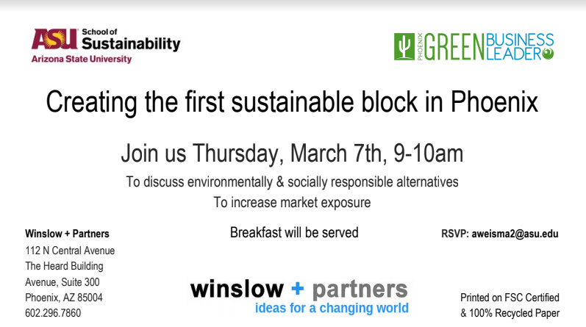
  - Waste Diversion
    - The bin labels went through two iterations. Click here for the final bin labels.
    - The waste PDF went through two iterations. Click here for the final waste PDF that was sent to employees to add to the desktops of their computers as a quick reference.
    - Waste Audit Spreadsheet
  - Project Expenses Spreadsheet
  - Phase 5: Green Business Program Analysis information
    - Informal Employee Interview Questions
      - How did this program affect you personally?
        - Do you feel like you have learned anything new about sustainability or adopted any new habits? Like what?
        - Do you understand what you need to do moving forward or is there anything that you have questions on for me?
        - What is your level of confidence that these new sustainability practices will continue on a scale of 1-5?
      - Is the Green Business Leader Program useful?
        - Do you think this certification was easy or difficult? Why?
        - Do you think the office could have earned Platinum without someone external helping you?
        - Do you think what we have implemented is enough, or is there any other sustainability practices that you’d like to implement that is not in the checklist?
        - Do you have any other suggestions for improvement for the Green Business Leader Program?
        - Would you recommend this program to other businesses? Why?

