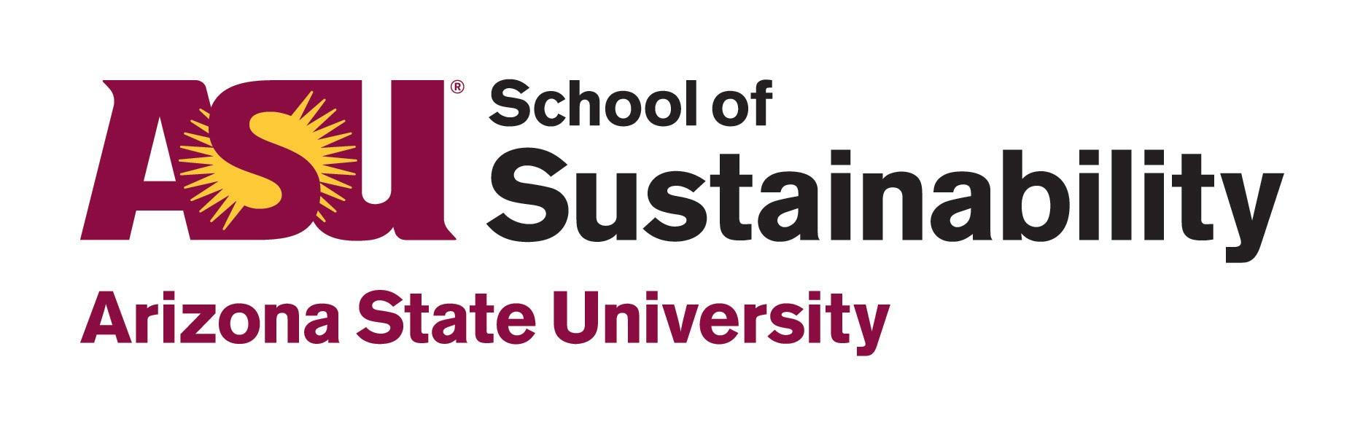
Business Sustainability
by Leveraging the
Phoenix Green Business Leader Program
Executive Summary
April 2019
Ashley Weisman

Local businesses fuel the culture, perspectives, and lifestyles of the people in our community. These local factors shape consumption patterns, supply and demand, and resource extraction globally. It is well-known that social-ecological systems are tremendously influenced by the decisions and actions of businesses. There is also widespread agreement that sustainability standards are necessary in addressing business-as-usual thinking. However, how to guide business transformation by utilizing sustainability standards remains under dispute.
The City of Phoenix offers a Green Business Leader Program, which is a voluntary sustainability certification for local businesses to receive recognition for waste diversion, water conservation, energy efficiency, transportation, and sustainability awareness. This project leverages the City of Phoenix Green Business Leader Program by helping a local business implement enough sustainable practices to become Platinum level certified. The project partner is Alexis Yaple at the City of Phoenix Public Works Department, and the client is Winslow+Partners, an architectural design firm that specializes in Innovation Think Tanks and educational planning. The project was conducted in seven phases.
- Phase 1: Introductory Meeting & Tour
- Phase 2: Creation of Strategy Proposal
- Phase 3: Strategy Proposal Meeting
- Phase 4: Sustainability Strategy Execution
- Phase 5: Green Business Program Analysis
- Phase 6: Overview Meeting
- Phase 7: Phoenix Green Business Leader Program Certification

Before the project, Winslow+Partners had multiple sustainability programs, with a score of 25 points in the Phoenix Green Business Leader Program. By April 2019, the firm achieved 51 points, earning Platinum certification. Project outcomes at Winslow+Partners include:

- Decrease in waste: Through two waste audits conducted in January and April 2019, office waste decreased by 6%, from a 67% diversion rate to a 73% diversion rate. Compost, soft plastics, electronic waste bins have been implemented on site.
- Increase in energy efficiency: All lighting at the office has been converted to LED. The same fluorescent bulb uses 54 watts, while the LED wattage is 25.5 watts, using 53% less energy. Energy-saving practices were adopted as well.
- Sustainable procurement: The firm has committed to purchasing office supplies from local vendors, and purchasing items with high recycled-content and other sustainable products.
- A culture of sustainability among employees: Through staff sustainability trainings and education, awareness at the firm flourished. This culture shift has been facilitated by the Winslow+Partners Sustainability Guide, Winslow+Partners Sustainability Plan, and green office program.
- Sustainability as a part of the Winslow+Partners process & products: Two Sustainability Think Tank sessions were facilitated with other local business owners, property managers, and City representatives to strategize how to implement recycling in the building. The firm also plans to add sustainability messaging to their website. Analysis on how to incorporate sustainability into the firm’s process and products will continue after the project’s completion.
- Water conservation awareness: A water leak check was conducted by the City of Phoenix Water Smart Program. This audit showed a potential 5,980 gallons of water savings per year, which is likely to be a conservative number based on building visitors. This report was shared with building management.
So how did we do it? In summary, the project involved a waste audit at the beginning and end of the project, sustainability trainings, and continuous engagement. The project’s budget was ~$1,000, $750 of which was provided by external project fundraising. The staff interviews revealed that 100% of the staff thought the certification was easy; however, 100% of the staff said that they wouldn’t have been able to achieve Platinum without external help (i.e. my help). The effectiveness of the green business program is called into question, for the purpose of continuous program improvement. In a world where greenwashing is common, efficiency standards are lax, and ecological systems are approaching critical thresholds, it is crucial to challenge the program’s ability to create measurable, substantial change.
Twenty-eight green business programs were analyzed against the Literature Review, and 16 of these programs’ practitioners were informally interviewed. After synthesis of these findings, the Green Business Program Practitioner Guide was created and shared with the program practitioners. This guide provides questions and best practice examples for practitioners to use to reflect on and improve their programs. The Winslow+Partners experience is also posed as a case study within this guide.
This project conducted a comprehensive analysis of green business programs through three perspectives, including the perspective of the business going through the program, through publicly available information, and then through the perspective of the practitioners themselves. It is this project’s intent to help create the most effective green business programs in US history, propelling the US sustainability movement full speed ahead. This study offers an inside look at how businesses and practitioners interact with voluntary sustainability certifications and examines how, and if, a green business program can lead to transformational sustainability. This project asks, can green business certifications create transformational change?

