March 26, 2019
Matthew Waldman
Cultivating Strategic Partnerships in Garden-Based Learning
Martin Luther King Jr. Early Childhood Center and The Farm at South Mountain

Abstract
This project is an exploration of a K-3 Early Childhood Center and the Roosevelt School District’s progress towards the Farm to School movement and focuses on the transformations and strategic partnerships required to maintain gardens as an educational resource over the long term. Martin Luther King Jr. Early Childhood Center is a Title 1 elementary school in South Mountain Village, Phoenix and is the primary research location for this study. South Mountain Village contains a series of urban food deserts which are low-income regions without adequate access to fresh, affordable, and healthy food options. The baseline for the school garden’s integration status was measured through the usage and adaptation of the Garden Resources Education and Environmental Nexus (GREEN) tool for well-integrated school gardens. The school has existing partnerships with the University of Arizona Co-operative Extension, and Farm at South Mountain to help establish their school garden and organize a series of educational field trips centered around sustainable agricultural practices. As a part of this Culminating Experience, I also worked with the Sustainability Teachers Academy to create, plan and execute Sustainability and School Gardening workshop on March 11-12 for teachers, and members of the Farm to School Network across Arizona. The end goal of this project and workshop is to create a framework to cultivate and sustain critical partnerships for farms and schools interested in being a part of the Farm-to-School program in the Phoenix Metropolitan Area.

Table of Contents
Abstract 0
1. Introduction and Background 2
2. Literature Review 4
3. Project Approach and Intervention Methods 8
4. Outcomes/ Findings 9
5. Recommendations 13
6. Conclusion 14
References 15
7. Appendix 17
A. Gantt Chart (Part 2) 0
B. The GREEN Tool Map (Burt et. al, 2016) 1
B. Green Tool Domains (Bert et. al, 2016) 2
C. Manzo Elementary School Calendar Planting Guide (Manzo Ecology, nd.) 3

Introduction and Background
South Mountain Village contains a series of urban food deserts which are low-income regions with inadequate access to fresh, affordable, and healthy food options (USDA, 2009). Families within food deserts tend to have lower levels of education, lower wages and are prone to unemployment (Ploeg, 2016). Food insecurity is the social and economic condition affecting low-income families who receive limited or uncertain access to food. Food deserts have a low density of supermarkets and are underserved from a nutritional aspect due to the high density of fast-food restaurants and convenience stores. Individuals within food deserts are vulnerable to asthma, obesity, diabetes, cardiovascular diseases, malnutrition, and other dietary-related illnesses. The complex challenges of childhood obesity and hunger are national and international public health crises with dispersed impacts that span in physical, psychological, and social dimensions. Studies surrounding the influence of food deserts on populations are targeted at measuring the impact on adults, but school children are increasingly vulnerable (Moore et al., 2015). The presence of food deserts creates severe long-term implications for the growth, health, and development of children.
Additional nutritional knowledge gaps exist for families within food deserts, which negatively effects the impacts derived from the improvements in the accessibility of healthy food options. Higher income individuals benefit from higher access to education and reliable information regarding the benefits of healthy eating and wellness. Intervention points for food insecurity are typically focused on improving the local supply of food options or through government-issued stipends such as the Supplementary Nutrition Assistance Program. An effective strategy for helping low-income families eat more healthily would be to explore the demand-side benefits of health and wellness education (Allcott et al., 2018). School and community gardens create a democratic space for students and the school’s community to learn, gather, and interact together. School gardens build community capacity in food insecure regions through creating an environment that is conducive to engaging in food literacy and develops the knowledge, skills, and tactics for improving the capacity of a community to adapt to food insecurity (Reis, 2015).
Educational gardens have increased their prevalence and in their popularity among schools, families, and children. School gardens offer a valuable hands-on learning tool for educators to incorporate STEM (Science, Technology, Engineering, and Mathematics), Common Core, Next Generation Science, and Arizona’s educational standards. Learning gardens provide schools with a unique opportunity to engage with the community through the means of a living food laboratory. School gardens have been shown to improve test scores and school performance in addition to the levels of physical activity and vegetable consumption for students involved in the program (Roche et al., 2017). However, school gardens vary in the scope, intensity of participation for student, faculty, and community members, and in the amount of integration within the school’s curriculum.
In the past decade, government intervention in the form of policies directed towards the education system in the United States has transformed drastically through the implementation of programs such as the No Child Left Behind Act (NCLB) for elementary and secondary education. The federal government provides concessions based on their performance through the provisions of standardized testing for schools, which account for less than ten percent of funding for public schools. The standardized testing exams are using as a comparison metric for students, teachers, schools and school districts in addition to being required for students to pass for earning a high school diploma (Allen and Guthman, 2006). The NCLB program penalizes schools that are deemed to be underperforming by withholding substantial funds and are tasked with finding measures to reach the baseline threshold for the performance standard with minimal state or federal support.
The Department of Education formed the Farm-to-School program to connect K-12 schools with local farms to ensure that children have access to fresh, healthy, and local food options. Farm-to-School models include additional experiential educational opportunities via the implementation of school gardens. The Farm-to-School program also supports other innovative learning opportunities for inside and outside of the classroom which focuses on nutrition and agriculture-based education. Student participation in gardening activities promotes environmental awareness and has the potential to influence individual and social behaviors. However, it is also important to tailor the garden-based activities to match classroom learning objectives through an integrative approach. The Farm-to-School initiative also supports the procurement of local and seasonal produce to be served in school cafeterias
Alice Waters is a writer, chef at Chez Panisse, educator, food advocate and is the pioneer of the slow food movement and Edible Schoolyard Project. Arizona State University recently hosted Alice Waters through the Julie Anne Wrigley Lecture Series where she presented a talk on; We Are What We Eat: Teaching Slow Food Values in a Fast Food Culture. During the Wrigley talk, Alice spoke of the importance of providing a free sustainable lunch to students K-12, and the importance of using lunch to create educational experiences that tie into the pedagogical approach of place-based learning (Waters, 2019).
School meals present a significant educational opportunity during the 12 years of traditional educational instruction. From the food they are served, children can learn how to lead a healthy life and adopt sustainable food behaviors (Osstindjer et al., 2016). School meals and educational gardens create opportunities for schools to engage in interdisciplinary, sustainability and taste-based curriculums. Schools are compensated from the federal government at a rate of $3.22 per free lunch served, $2.82 for reduced-priced lunches served, and 36 cents per paid lunch (Food and Research Action Center, 2018). The $3.22 per meal reimbursement rate does not include the costs of labor, maintenance, transportation, milk provisions. As a result, the total amount available for food is approximately $1/ per student (Giusti, 2018). The economic constraints and the regulations of nutritional standards for school meals limit the variety and quality of food items produced.
Twenty-five percent of Arizona school districts reported that they participate in Farm-to-School-related activities with 574 engaged schools and at least 48 schools said that they own school gardens (USDA, Farm-to-School Census, 2015). The Farm-to-School census was last updated on October 2015, but the participation of schools in the Farm-to-School program is expected to gain more attention by schools nationwide. The design and integration of educational garden experiences typically follow a goal-oriented approached to either increase academic performance, social development, therapeutic environments, recreational and physical activity or through a combination of these factors.

Martin Luther King Jr. Elementary School (K-3rd) is within the Roosevelt School District and is above the state and district averages regarding the percentage of kids within the school that qualify for reduced or free lunch. In 2010, the average percentage of students within Arizona that are eligible to receive reduced or free lunch was 47 percent, while 97 percent of students at Martin Luther King Jr. Elementary School qualified for reduced or free lunch (Narrative Science, 2010). The elementary school wishes to join the Arizona Farm-to-School movement to ensure that children of all ages have access to healthy, fresh, and affordable food and to integrate the school’s 15 gardening boxes within the school’s curriculum. The Farm at South Mountain is currently working with Martin Luther King Jr. Elementary School to coordinate field trips and other environmental educational experiences. The Farm has also agreed to host a workshop for the schools involved in this project and the Sustainability Teachers’ Academy’s research.
The Sustainability Teachers Academy is a platform for educators to gain the knowledge and resources necessary to implement the science of Sustainability within the K-12 classroom. The academy provides professional development workshops to teachers and is involved with several schools around the valley. The academy is currently researching how to integrate and support garden-based learning in schools within the Phoenix Metro Area. This culminating experience aims to leverage the usage of school gardens at Martin Luther King Jr to create experiential learning modules for K-3 students to teach concepts in gardening that align with the AZ Common Core and Educational Standards for science-based learning. The school wishes to get more use of their stagnant and overgrown garden beds to engage with students and parents in the community to induce social cohesion through the lens of food and gardening.

Literature Review
There is a variety of existing literature and resources to help schools initiate gardening programs. However, many of these resources do not cover the integration strategies for maintaining the garden over the long-term. As a result, this literature review assesses the gaps, barriers, tools, and integration methods for existing resources that support garden-based learning over the long-term. In order to build the schools’ capacity for increasing human and social capital within the existing community, this literary analysis also reviews the concept of asset-based community development and its relationship to schools and community gardens. Literary analysis and data collection in reference to farm-to-school, school gardens, asset-based community development, and gardening frameworks were performed via ASU’s Library One Search engine through use of the keywords “Farm-to-School,” “school gardens,”, “garden-based education,” “environmental education,” “gardening framework,” “asset-based community development,” and “gardening barriers.”
A study on Teachers’ Perspectives on School Gardens as Learning Tools was produced by a group of ASU graduate students enrolled in a course on Food System Sustainability under the direction of Dr. Hallie Eakin, a professor, and Senior Scientist at the School of Sustainability at ASU. The study identified the following as the challenges for teachers interesting in pursuing school gardens for learning activities: difficulty in aligning garden-based learning to curriculum standards, constraints relative to physical and human capital resources involved in maintaining school gardens, finding consistent funding resources, seasonality of crops during the school calendar, gaining administrative support. Their success often depends on highly motivated individuals outside of the community (Eakin et al., 2018). The research suggests that the success of school gardens depends on internal partnerships within the school district for teachers, students, administrators, parents, and volunteers, in addition to external partners who serve as garden caretakers and docents from the non-profit or business sector. External partnerships with Master Gardener’s and the Food Corps were also found to be essential to the success of school gardens.
Teacher’s perceptions of what lesson plans can be incorporated into garden-based learning ultimately determine how the garden will be used relative to the curriculum. Teachers reported that the usage of school gardens could be incorporated to most subject areas; in science, environmental education, mathematics, language arts, art, health and nutrition, ethics, history, and social studies curricula (Demarco et al., 1999). Gardens create an opportunity for students and teachers to create an outdoor environment that is conducive to sparking innovation and creativity. Barriers to teachers and principals using gardens for educational instruction include time constraints, strict testing performance standards, lack of teacher interest, and lack of gardening experience or knowledge (Blair, 2009). The No Child Left Behind standards creates a work environment where teachers are pressured to spend more time on the required subjects for standardized testing and have less time to teach topics in subject areas that are not tested. Policymakers at the State and Federal level view the standards-based approach as a mechanism to improve educational efficiency.
Baseline Assessment Criteria
The Teachers College at Columbia University created a GREEN (Garden Resources, Education, and Environment Nexus) Tool for strengthening existing school gardens. The tool was designed out of an in-depth study of 21 school gardens in New York that research the essential components that make up a well-integrated garden. The study found 18 components needed to establish, integrate, and sustain a school garden (See Appendix, B). The GREEN Tool assesses a garden’s progress to achieving the 18 components through its performance on a self-reported scorecard that is measured on a three-point scale. The components are placed into three separate domain categories garden logistics, student experience, and school culture and are outlined in Figure 1(Burt et al., 2017: Ozer, 2006). The tool also consists of a map that illustrates the timeframe to operationalize the 18 components necessary to create a well-integrated garden (Burt et al., 2016). The research brief for the GREEN tool suggests that schools will need support from community members and organizations to achieve each component. The GREEN tool is an effective mechanism for conducting a baseline measurement of the level of integration of school gardens. Aspects of the tool were adapted to account for the longer growing seasons of Phoenix since the research and development of the GREEN tool occurred in New York City.

Figure 1
GREEN Tool Domains and Components (Burt et al., 2017: Ozer, 2006)
Garden logistics | Student experience | School Culture
Components  - Garden care and upkeep  - Planning and establishing the physical space  - Characteristics of the physical space  - Crop vitality and diversity  - Budgeting and funding  - Networks and outside organizations | Components  - Connection with curriculum  - Time spent in the garden  - Activities  - Engagement  - Tasting opportunities  - Additional learning opportunities | Components  - Administrative support  - Organizational staff structure  - Volunteer and parent involvement  - Social events and activities  - Food environment and policies  - Evaluation and feedback

Asset-based Community Development
The concept of asset-based community development focuses on building the capacity for the community’s existing assets. This approach contrasts with the conventional method of identifying a community’s issues, problems, and assessing their needs (Green & Haines, 2007). The problems, needs, and issues regarding low-income communities are relatively easy to point out due to the gaps in infrastructure, and resources available, however, they are often too broad and complex for communities to tackle overnight. The idea of asset-based community gives light to existing assets within a community, such as a community garden, and provides a means for the community to actualize the positive aspects of the existing assets. These assets can exist in communities under a variety of forms as individuals, organizations or institutions, but assets can also be summarized under the umbrella of the different typologies of capital: physical, human, and social capital (Green & Haines, 2007). The process of asset-based community development can be defined through four primary steps: community organizing, visioning, planning, implementation, and evaluation. Figure 2 is a depiction of the nonlinear relationship associated with the community development processes.

Figure 2
Community Development Process Map (Green & Haines, 2007)
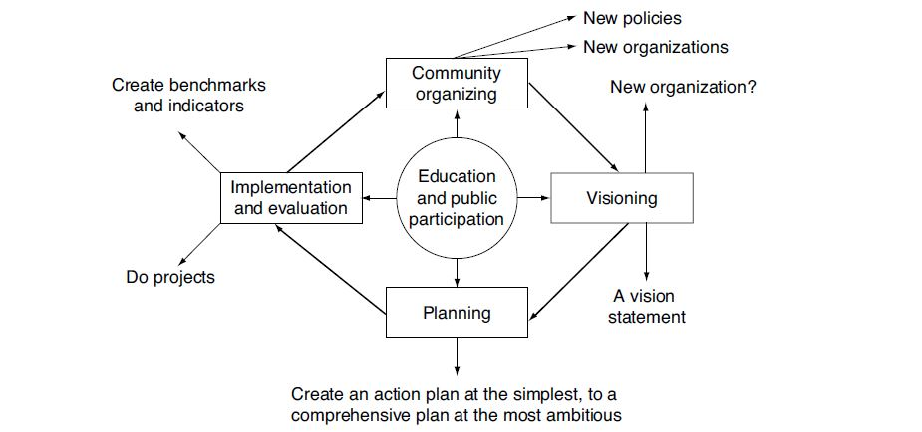

Assets and Resources Derived from Schools and School Gardens
In underserved communities, schools and institutions are invaluable assets that can be used to build alliances to create healthy school systems which turn reinforce the overall health of communities. Active and strategic alliances can be developed in communities through the discovery of shared values and interests between school systems and community development leaders. Schools can offer a variety of assets to the community; however, they can be narrowed down to nine crucial elements associated with a school’s facilities, materials and equipment, purchasing power, employment, courses, teachers, a generation of financial capacity, adult involvement, and through having a constant flux of young people (Kretzman and Mcknight, 1993). It is also essential to consider the asset of locality associated with school systems, as the centrality location of schools has the potential to create pathways to economic and educational development for the community.

School gardens provide a hands-on approach for engaging in the subjects required for standardized testing. The gardens are limited in the number of funding options available to dedicate towards school gardens from state or school districts, which then results in most school gardens to be heavily reliant on grants or donations for funding, technical assistance, materials and they often require physical labor from the school and surrounding community (Ozer, 2006). The sustainability of gardens is dependent upon its ability to retain physical and non-physical resources in the form of materials, committed people, instructional design, and funding sources (Hazzard et al., 2011). The California schools mentioned in Dr. Eric Hazzard’s study benefited from the collaboration between the school’s garden coordinator and teachers to teach content specific to California’s state educational standards.

Arizona School and Community Garden Guides
The Western Growers Foundation produced a useful online document for creating and sustaining school gardens in Arizona to promote learning. The document provides case studies and plans for school gardens in Arizona, methods of linking gardens to the school curriculum, and lists the supplies and possible funding mechanisms for gardens (Western Growers Foundation, 2013). In 2014, Vitalyst Health Foundation and the Arizona Department of Health Services created a resource guide with Arizona State University for fostering sustainable community gardens in Arizona. Schools interested in implementing school gardens would benefit from this resource guide as school gardens are a form of community gardens. The resource guide identifies critical design features for gardens and provides a governing structure, documents for volunteer outreach, and garden lease agreements, as well as tips for fostering a community around the garden (AZHS and Vitalyst, 2015). The Growing Guide was created by the Food Project and the Build-a-Garden Program to provides practical information surrounding garden planning, square foot planting, watering, cultivation, pest management, and fertilization (Monero and Rivadeneira, 2017). Manzo Elementary School created a school garden on a piece of their property that was previously neglected, filled with garbage and overgrown by weeds. The school’s counselor was able to work with a faculty member at the University of Arizona to design a native habitat site, water cisterns for water harvesting, an aquaponics system and a chicken coop (Moore et al., 2015). Manzo Elementary School created a planting schedule that accounts for the breaks, seasons, and months of a school calendar (See Appendix C).

In conclusion, there is a variety of methods and guidelines for integrating school gardens into elementary schools. The Farm-to-School program will be the route of integration for the school garden at Martin Luther King Jr. Elementary School and the baseline of the school’s current integration will be performed by using the GREEN tool and scorecard. The growing guides mentioned in the literary review are adapted to Arizona’s longer growing season and arid climate conditions. The barriers to implementing school gardens for teachers, principals, and school staff include time, lack of gardening knowledge or experience, lack of teacher enthusiasm, and teacher turnover. Future research for school gardens includes assessing the productivity of the Farm-to-School program and creating guides that support school gardens over the long-term.

Project Approach and Intervention Methods
This culminating experience researched and designed guidelines for integrating garden-based learning for schools in the Phoenix Metropolitan Area. Insights were derived from conducting a series of interviews with garden educators, volunteers, master gardeners, and additional stakeholders in Arizona who operate in the organization and integration of school gardens. The culminating experience also researched available educational tools on how to use gardens in an experiential and integrative approach. The asset-based community development approach was used to identify gaps and strategies for developing strategic partnerships for the educational gardens located at the Farm at South Mountain and Martin Luther King Elementary School.
Additional insights were sourced from engaging with stakeholders (principals, teachers, garden managers, master gardeners, school gardening focused organizations, etc.) involved in school gardens in the Phoenix area via the school garden working group hosted by the Sustainability Teacher’s Academy. The baseline garden integration assessment was performed by using the Garden Resources Education and Environmental Nexus (GREEN) Tool from the Teachers College at Columbia University.

The Sustainability Teachers’ Academy at Arizona State University is a valuable resource for teachers wishing to further their school gardens while benefiting from professional development training and workshops related to teaching the topic of Sustainability. Through this project, I worked with the Sustainability Teachers’ Academy and their monthly school gardens working group to develop strategies and tools for implementing garden-based learning into schools and classrooms throughout the Phoenix Metropolitan area. A portion of this project was dedicated to organizing a professional development workshop with the Farm at South Mountain and the Sustainability Teachers’ Academy on March 12th for Arizona Gardens and Sustainability. The workshop featured breakout sessions with garden professionals and educators, garden demonstrations from the Sustainability Teachers Academy, an educational tour of the Farm at South Mountain, and a school garden expo featuring several community organizations in the realm of gardening, permaculture, and agriculture.

This culminating experience also involved stakeholders from the Farm at South Mountain and their fellowship program in helping them work towards implementing a series of workshops and field trips along the lines of the Farm-to-School program with Martin Luther King Jr. Early Childhood Center for the Spring and Fall for 2019. The Farm at South Mountain was interested in how they can leverage their venue space for hosting a garden-based learning workshop. As a part of this project, I helped facilitate the coordination of meetings, planning days, and event execution for the Farm at South Mountain and the Sustainability Teachers Academy.

Nicole Shamblin serves as the current principal of Martin Luther King Jr. Early Childhood Center and previously worked with the farm to plan educational field trips with her former school, Percy L Julian. The Farm at South Mountain was able to accommodate roughly 45 students per field trip and held three field trip days throughout a semester. When working with Percy L Julian, the cohort at the Farm at South Mountain realized that they would need a long-term engagement plan with the school and to identify key concepts that the farm could cover within the scope of garden-based learning. Martin Luther King ECC is also home to gardening plot consisting of 16 raised beds, but during the initial phases of this project, the garden beds were overgrown with Bermuda grass and needed maintenance as well as soil amendments.

Outcomes/ Findings
The strategic partnerships created through this project were derived from leveraging existing research and developments in educational gardens and urban farms in Phoenix as an asset for master gardeners and other professionals to collaborate and teach children and families concepts in sustainability and gardening through applied experiences. The long-term goal for the future state of the educational garden at Martin Luther King Early Childhood Center is to integrate additional learning concepts in finance, nutrition, and cooking to help the community members that are affected by food insecurity in South Mountain Village. The initial focus of the culminating experience was to analyze areas of alignment between the Arizona Curriculum standards and Garden-based learning. However, after connecting and interviewing with subject matter experts across the Phoenix Metropolitan Area and Tucson, through the event at the Farm at South Mountain and educational tours, I learned that the beauty and success around school gardens come from creating a garden culture within the community.

Ultimately, the process of aligning the curriculum standards is outside of the realm of expertise for most gardeners, and the process of gardening has been viewed by teachers as daunting. In my conversations with Moses Thompson, the garden manager of Tucson Unified School District, he described it is within the best interest of school gardens to utilize the skill sets of their teachers, administrators, and support organizations to be focused on the back-end curriculum alignment for their school gardens and work with their garden managers to develop unique opportunities for outdoor engagement. Moses Thompson also mentioned the importance of asking children what their parents do for a living as he discovered that some of the parents were contractors, landscapers, plumbers or had similar assets that made them invaluable volunteers. As a result, the final deliverables given to Martin Luther King Jr. Early Childhood Center is geared towards helping the school outline their goals associated with their garden, which will then influence what curriculum standards they are able to cover in the scope of their garden’s implementation.

According to the Curriculum Development Toolkit provided by the Edible Schoolyard Project (ESY), the process of curriculum development should be an ongoing dialogue between gardeners, administrators, institutions through the creation of a teaching team or steering board. The Edible School Yard project initially drafts lesson plans then runs the produced content through their gardening content team in order to refine the details (ESY, 2017). The curriculum development process for ESY is to facilitate a unique student experience within the kitchen and garden, and at every point of the development process volunteer, students, and administrators are involved.

Once the student experience in the garden is identified, then the curriculum development process shifts to translating the learning objectives to meet the intended garden outcome. For the garden experience to be integrated into a curriculum, the learning objectives must be specific, measurable, attainable and significant (ESY, 2017). The final portion of the iterative process is to consider factors such as seasonality in addition to the time available for the lesson plans. In summary, ESY suggests that the curriculum development process should be an ongoing and collaborative process. Appendix D features the curriculum development tool provided in the Edible Schoolyard Project which can be used as a framework for developing a garden-based education curriculum for social justice.

Figure 3
The GREEN Tool Analysis for Martin Luther King Early Childhood Center

The above image (Figure 3) is the qualitative baseline representation of Martin Luther King Jr. Early Childhood Center’s garden integration status based upon the ranking system provided in the Garden Resources and Environmental Nexus Tool. The domains in this matrix were filled using the garden integration scale provided in Appendix E. Quantitative summary metrics for low=1, moderate=2, and high=3 were used to create a data matrix provided in Appendix F, and the final integration score was based upon the summation of the results. The GREEN Tool defines minimally integrated as ones that receive a total score of 0 to 19, moderately integrated gardens as 20 to 38, and well-integrated gardens receive a score of 38 to 57 (Burt et al., 2016). After performing the preliminary coding scheme, the results of Martin Luther King Jr. ECC’s received a score of 25 which translates to the school’s garden to have a moderate integration status.

Figure 4
Asset Based Community Development Map for Martin Luther King Jr. Early Childhood Center
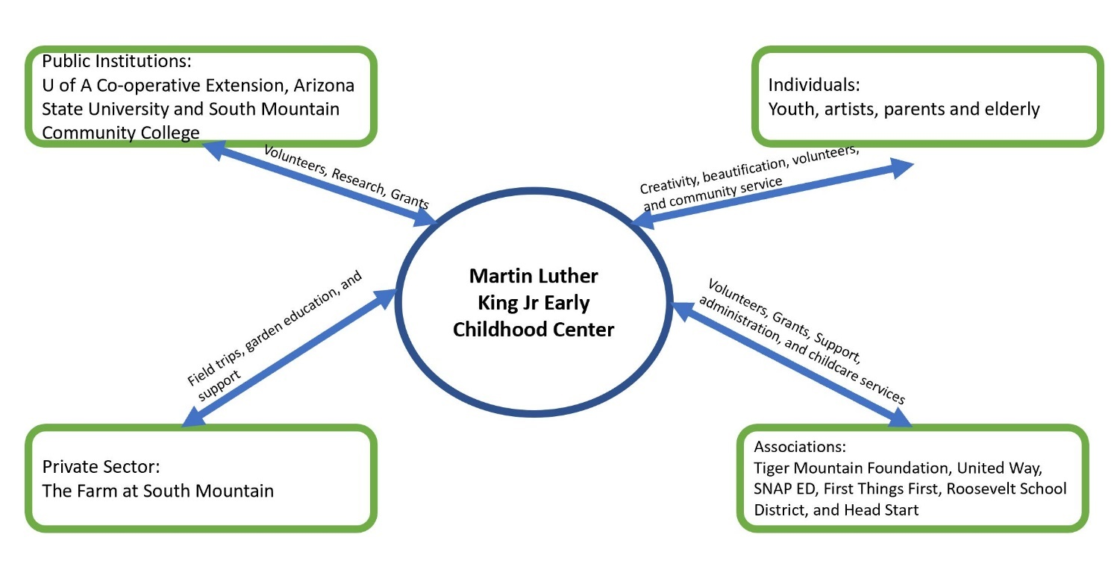

Figure 5
Asset Based Community Development Map for the Farm at South Mountain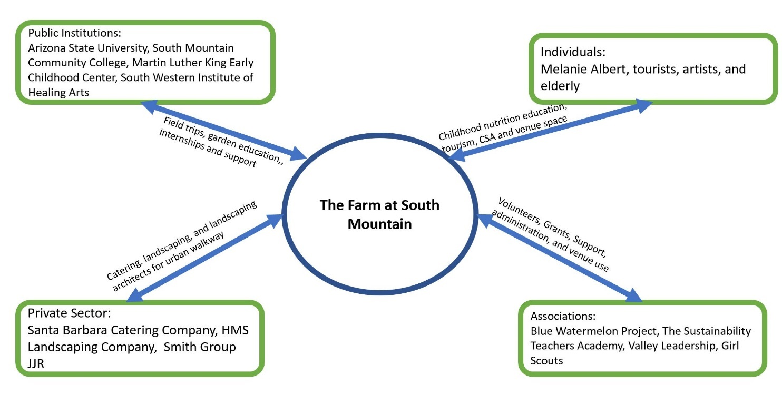

Recommendations
Recommendations for Martin Luther King Early Childhood Center
The garden boxes at Martin Luther King Early Childhood Center were previously burdened with 3 ft of overgrown Bermuda grass. Through this project, the interns at the Farm at South Mountain, Christina Schmidt; and Anna Bartholomew, and I were able to provide volunteers to remove the Bermuda grass and created outdoor educational experiences for over 280 students at the elementary school. In order to sustain the gardening program at Martin Luther King Early Childhood Center, it will be critical for the school to partner with local organizations in nutrition education, and garden-based learning. These connections can be made through leveraging the assets and partnership with the farm at South Mountain as they have an existing network consisting of the Sustainability Teachers Academy, Blue Watermelon Project and Melanie Albert’s program Experience Nutrition. The Mollen Foundation and the Food Corps are additional organizations located in Phoenix that may also be helpful for this project to continue in the future as they provide education and nutrition assistance to school gardens.

In terms of curriculum development, it will be critical for Martin Luther King Jr Early Childhood center to join and review the materials provided via the Edible Schoolyard Project. The creation of a steering committee for the elementary school will be critical for furthering the garden’s integration and creating a plan for the anticipated developments to the be implemented garden in following years. However, it is essential to start simple and finish the restoration of the raised beds before advancing into more complex projects. It will also be useful for the school to reach out to the Arizona Department of Education’s Farm to School network in order to see what educational materials and services the Department provides for schools. For this summer, the plans for the learning garden at Martin Luther King Early Childhood Center

Recommendations for the Farm at South Mountain
The Farm at South Mountain operated as a primary client through their community outreach arm Gather and Grow. Unfortunately, the physical, social, financial and human capital to support Gather and Grow is dependent upon the Farm’s ability to retain exemplary interns and generate profits at the Farm. It is within the Farm’s best interest to declare Gather and Grow as a non-profit in order to compete for grants and raise money to support initiatives similar to the work they have done at Martin Luther King Early Childhood Center. The Farm at South Mountain should leverage their social capital and networks associated with sustainability and garden-based learning to provide an event catered to the teachers at Martin Luther King Early Childhood Center. As the previous Arizona School Gardens and Sustainability event hosted at the Farm at South Mountain unfortunately was not able to include Martin Luther King Jr. Early Childhood Center.

Recommendations for the School of Sustainability and the Sustainability Teachers Academy
The School of Sustainability excels at delivering content for the pedagogical approaches to Sustainability. However, there are very few offered courses that prepare students to transmit their knowledge to a local institution, such as elementary schools. The University of Arizona began offering a program to train students in the various approaches to garden-based learning and have included curriculum development as a primary aspect to their program. The school gardening program through U of A has also created a local network of 25 school gardens that work with Moses Thompson, who serves as the garden manager for Tucson Unified School District. Through this network, the school district was able to provide professional development and training for college students as well as educators interested in bringing garden-based learning to their classrooms. However, a network of this scale does not exist outside of the Sustainability Teachers academy, but there are several interns at the School of Sustainability who are working at schools near Tempe and, some of them currently have gardens or are interested in creating a garden in the future. A partnership between the internships and services offered through the Sustainability Teachers academy and the internship program at the School of Sustainability is an opportunity to create a training and professional development program like U of A and Tucson Unified School District. The School of Sustainability and the Swette Center for Food System Sustainability could also a form of a strategic partnership with the Mary Lou Fulton Teachers College to offer the course on garden-based learning and school gardens.

Conclusion
The results derived from the GREEN Tool matrix proved to be a useful method of establishing a benchmark for the school garden’s initial status as moderately integrated. The asset-based community development approach allowed for the strengths associated with MLK ECC and the Farm at South Mountain to be mapped and visualized according to their networks. The results of both findings are fair and representative of the resources and gaps that the two clients have in order to achieve a well-integrated garden like that of Manzo Elementary School. Further investigations could be made in order to study the network of schools and resources provided by Tucson Unified School district via their relationship with the University of Arizona. After taking the clients on field trips to Tucson Unified School we collectively realized that the steps needed to develop MLK ECC from having moderately integrated gardens to well-integrated gardens come from the entrenchment in the surrounding community. The Farm at South Mountain could facilitate a partnership with Blue Watermelon Project for Martin Luther King Jr. Early Childhood Center, as they are a great organization for engaging students and the community in taste-based learning and gardening. The GREEN Tool was an effective means for deriving a benchmark for the integration status of the school garden. Through this project I was able to facilitate a new strategic partnership with the Farm at South Mountain, the Sustainability Teachers’ Academy, and Martin Luther King Jr. Early Childhood Center. Additional MSUS projects can be developed in terms of taking another assessment of the GREEN Tool after the garden at MLK ECC has finished its current developments, finding inclusive ways to engage the community and neighborhood more in the school garden, and developing a network within the School of Sustainability, the Sweete Center for Sustainability Food Systems and other schools at Arizona State University to help build the capacity of teachers and students interested in garden-based education.

References
Allcott, H., Diamond, R., & Dubé, J.-P. (2017). The Geography of Poverty and Nutrition: Food Deserts and Food Choices Across the United States. Cambridge, MA. https://doi.org/10.3386/w24094
Allen, P., & Guthman, J. (2006). From “old school” to “farm-to-school”: Neoliberalization from the ground up. Agriculture and Human Values, 23(4), 401–415. https://doi.org/10.1007/s10460-006-9019-z
Arizona Department of Health Services and Vitalyst Health Foundation. (2015). Arizona Sustainable Community Garden: Resource Guide. Community Garden Toolkit.
Blair, D. (2010). The Child in the Garden: An Evaluative Review of the Benefits of School Gardening. The Journal of Environmental Education, 40(2), 15–38. https://doi.org/10.3200/JOEE.40.2.15-38
Burt, K. G., Koch, P., & Contento, I. (2017). Development of the GREEN (Garden Resources, Education, and Environment Nexus) Tool: An Evidence-Based Model for School Garden Integration. Journal of the Academy of Nutrition and Dietetics, 117(10), 1517–1527.e4. https://doi.org/10.1016/j.jand.2017.02.008
Burt KG, Koch. PA. Uno, C., and Contento IR. (2016) The GREEN Tool (Garden Resources, Education, and Environment Nexus) For Well-Integrated School Gardens. Laurie M., Tisch Center for Food, Education & Policy at the Program in Nutrition, Teachers College, Columbia University. Research Brief.
Condon, Patrick M.. Design Charrettes for Sustainable Communities, Island Press, 2012. ProQuest Ebook Central, https://ebookcentral-proquest-com.ezproxy1.lib.asu.edu/lib/asulib-ebooks/detail.action?docID=3317482.
DeMarco, L. W., Relf, D., & McDaniel, A. (1999). Integrating gardening into the elementary school curriculum. HortTechnology, 9(2), 276–281.
Food Research and Action Center. (2017). National School Lunch Program. Retrieved from www.FRAC.org
Giusti, D. (2018). Feeding A Million. MAD: Youtube. Retrieved from https://www.youtube.com/watch?v=masuNwQn5Lk
Green, G.P. and Haines, A. (2007) Asset Building and Community Development, 2nd ed., Thousand Oak: Sage.

Kretzmann, McKnight, McKnight, John, and Northwestern University . Institute for Policy Research. Building Communities from the inside out : A Path toward Finding and Mobilizing a Community's Assets. Evanston, IL : Chicago, IL: Asset-Based Community Development Institute, Institute for Policy Research, Northwestern U ; Distributed by ACTA Publications, 1993. Print.
Manzo Ecology. (n.d.). School Calendar Planting Guide. Escuela Manzo.
Moore, S. A., Wilson, J., Kelly-Richards, S., & Marston, S. A. (2015). School Gardens as Sites for Forging Progressive Socioecological Futures. Annals of the Association of American Geographers, 105(2), 407–415. https://doi.org/10.1080/00045608.2014.985627
Moreno, L., & Rivadeneira, M. (2017). Growing Guide: Making the most of your raised bed garden. The Food Project, Build-a-Garden Program (January).
Narrative Science. (2010). Opportunity Gap: Martin Luther King Jr Elementary School. Retrieved, from https://projects.propublica.org/schools/schools/40708000597
Ozer, E. J. (2006). The Effects of School Gardens on Students and Schools: Conceptualization and Considerations for Maximizing Healthy Development. https://doi.org/10.1177/1090198106289002
Ploeg, Michele, . (2016). USDA ERS - Food Deserts. Retrieved from http://www.ers.usda.gov/topics/food-choices-health/food-access/
Reis, K., & Ferreria, J.-A. (2015). Community and School Gardens as Spaces for Learning Social Resilience. Canadian Journal of Environmental Education, 20, 63–77. Retrieved from https://unco.idm.oclc.org/login?url=http://search.ebscohost.com/login.aspx?direct=true&db=eue&AN=123192101&site=ehost-live
Roche, E., Kolodinsky, J. M., Johnson, R. K., Pharis, M., & Banning, J. (2017). School Gardens May Combat Childhood Obesity (Vol. 32). Retrieved from https://www.choosemyplate.gov/MyPlate
Sayed, S., Velderrain, G., Burge, I., Eakin, H., Giraurd, E., Grant, B., Yogya, Y. Teachers’ Perspectives on School Gardens as Learning Tools (2018).
United States Department of Agriculture. (2013). Arizona Districts | The Farm-to-School Census. Retrieved from https://farmtoschoolcensus.fns.usda.gov/find-your-school-district/arizona
United States Department Of Agriculture (USDA). (2009). Access to Affordable and Nutritious Food : Measuring and Understanding Food Deserts and Their Consequences Report to Congress. Economic Research Service, (June).
Waters, Alice. (2019) We Are What We Eat: Teaching Slow Food Values in a Fast Food Culture. Julie Anne Wrigley Lecture Series. Sweete Center for Sustainable Food Systems.
Western Growers Foundation. (2013). Arizona Gardens for Learning.

Appendix
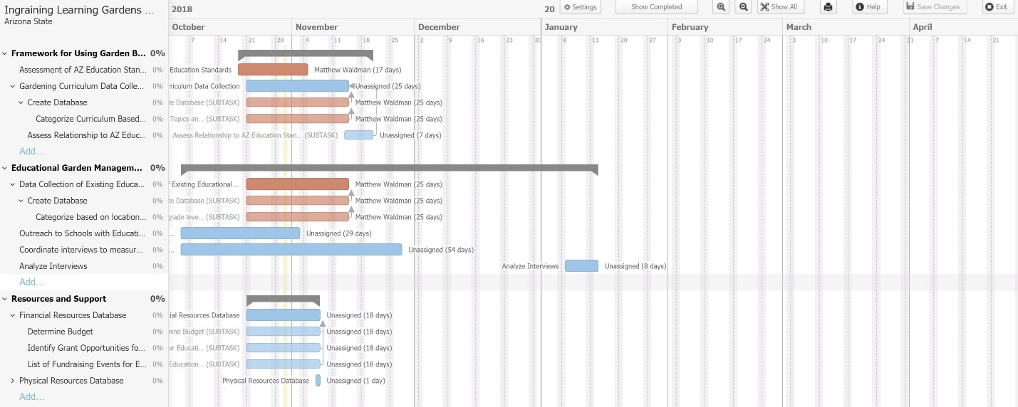
A. Gantt Chart (Part 1)
- Gantt Chart (Part 2)
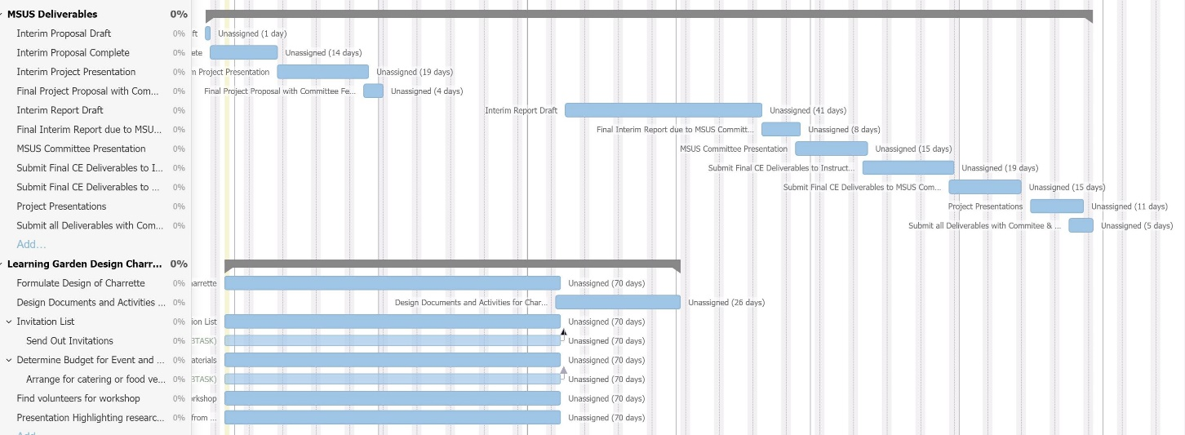

- The GREEN Tool Map (Burt et. al, 2016)
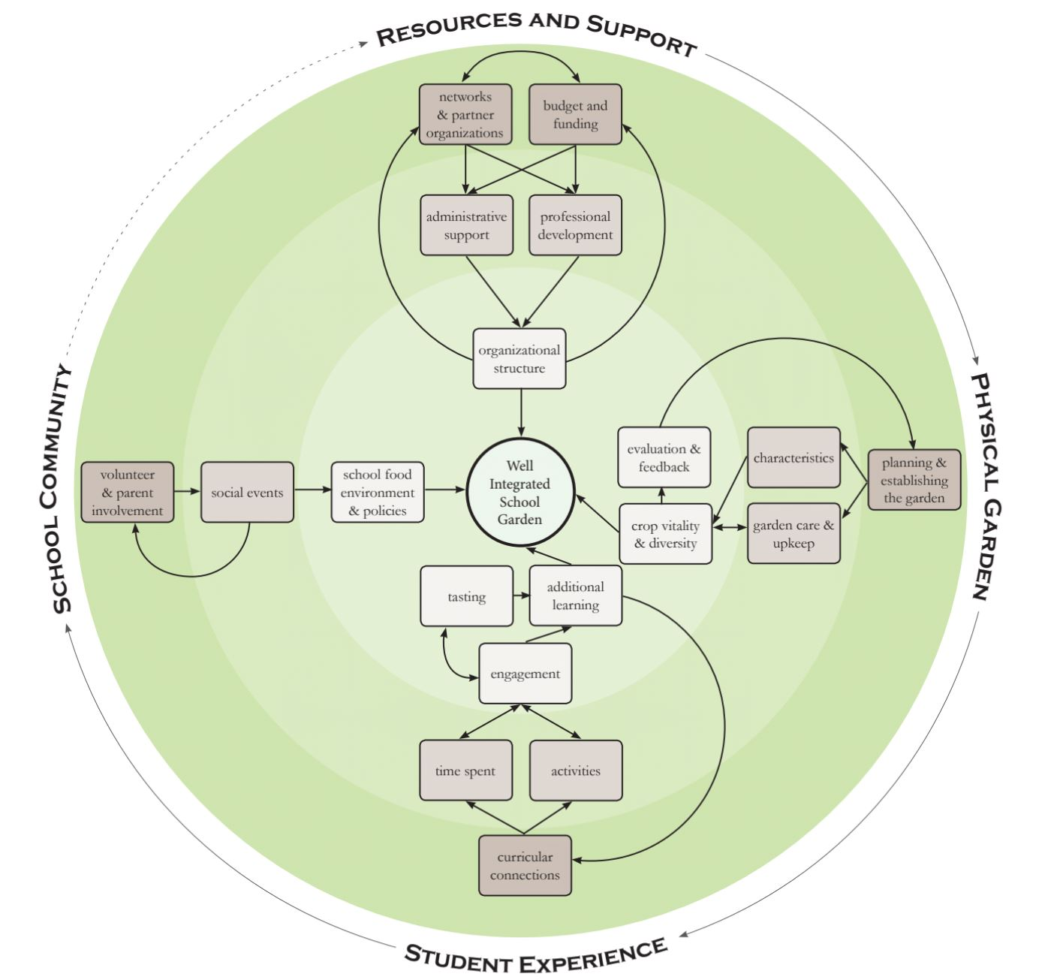

- Green Tool Domains (Bert et. al, 2016)

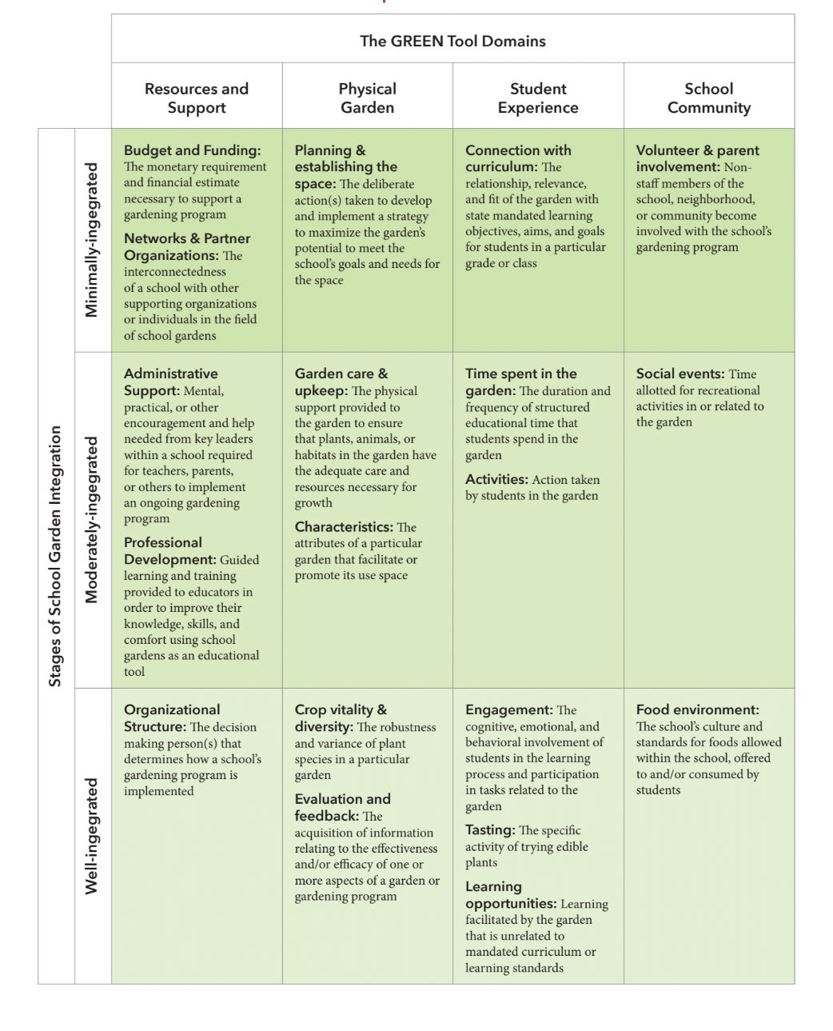

- Manzo Elementary School Calendar Planting Guide (Manzo Ecology, nd.)
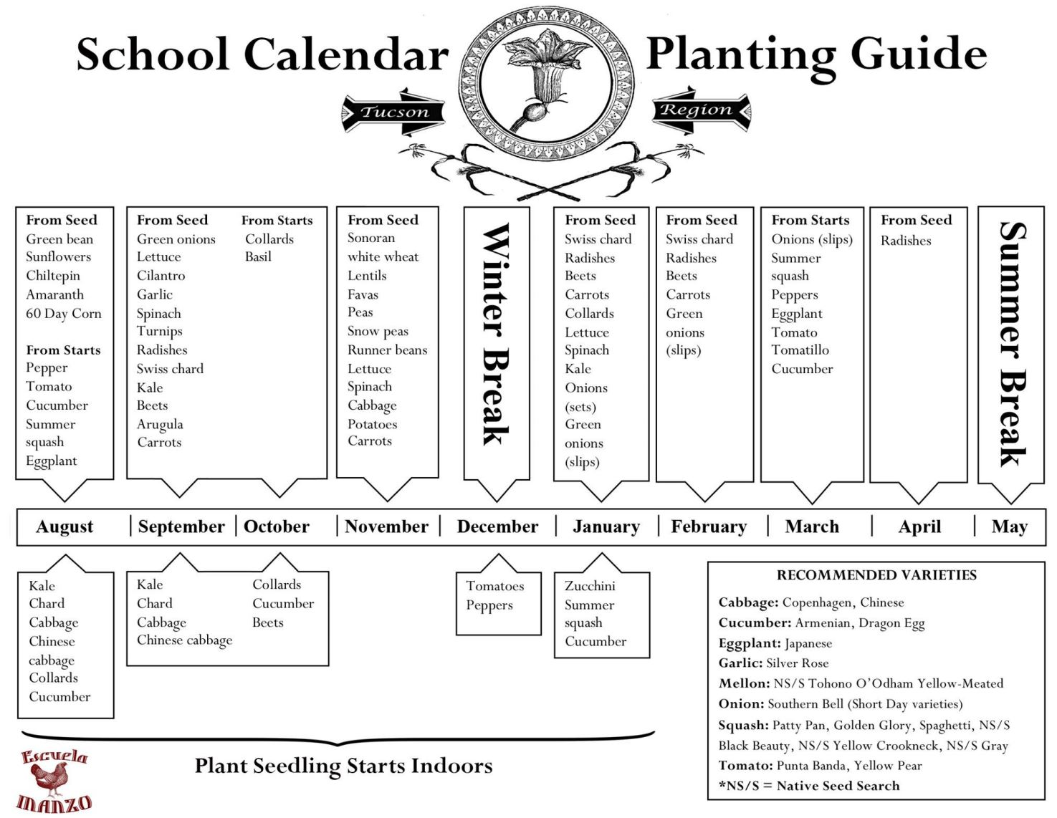

- Edible Schoolyard Curriculum Discussion Tool (ESY, 2017)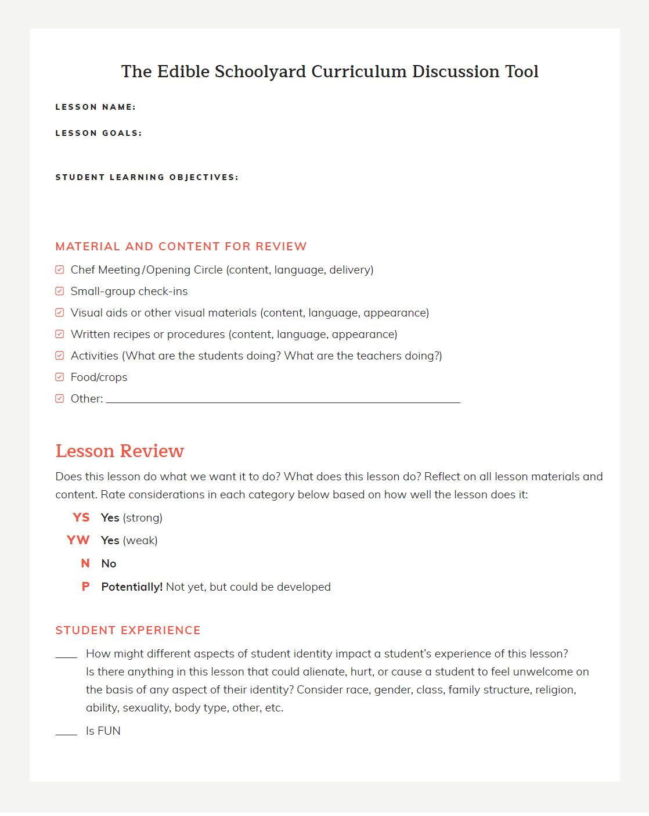

- Green Tool Domain Score Card (Bert et. al, 2016)
Resources & Support Domain | Scoreª
Budget and Funding−The monetary requirement and financial estimate necessary to support a gardening program
- □
Low−actively seeking more funding to meet current year’s needs
- □
Moderate−enough funds to meet yearly needs and raising for future growth
- □
High−in the black (money left over from previous years)
Networks & Partner Organizations−The interconnectedness of a school with other supporting organizations or individuals in the field of school gardens
- □
Low−few outside connections (<3)
- □
Moderate−some outside connections (3 to 4)
- □
High−many outside connections (or connections that meets all needs for logistics/students) (4+)
Administrative Support−Mental, practical, or other encouragement and help needed from key leaders within a school required for teachers, parents, or others to implement an ongoing gardening program
- □
Low−aware but uninvolved administrators (gave project approval but little or no active involvement)
- □
Moderate−some involvement (supportive of garden committee, interested in staying abreast of activities)
- □
High−valued and supported (actively promoting use of the garden to teachers, students and parents)
Professional Development−Guided learning and training provided to educators in order to improve their knowledge, skills, and comfort using school gardens as an educational tool
- □
Low−encouragement by administrators, garden committee, parents, or teachers to facilitate use of the garden (e.g. host meetings, sending emails, having “open garden days”)
- □
Moderate−some professional developments for interested teachers or parents
- □
High−offer professional development sessions or designated time for teachers, parents, or other to develop skills related to the physical garden or connecting it to academics
Organizational Structure−The decision making person(s) that determines how a school’s gardening program is implemented
- □
Low−limited participation in garden committee
- □
Moderate−regular meetings, some people only peripherally involved
- □
High−active committee of members and/or strong outside organization involvement that manages the garden, where tasks are delegated and accomplished
TOTAL DOMAIN SCORE:
Physical Garden Domain | Score
Planning and establishing the physical space−The deliberate action(s) taken to develop and implement a strategy to maximize the garden’s potential to meet the school’s goals and needs for the space
- □
Low−inexperienced gardeners with no plan
- □
Moderate−some experienced gardeners with general plan/goals
- □
High−experienced gardeners and well-developed plan, short and long term goals
Garden care and upkeep −The physical support provided to the garden to ensure that plants, animals, or habitats in the garden have the adequate care and resources necessary for growth
- □
Low−a few people maintain the garden
- □
Moderate−passionate group maintain the garden
- □
High−designated group maintain the garden
Characteristics of the physical−The attributes of a particular garden that facilitate or promote its use space
- □
Low−small space, limited participation
- □
Moderate−large enough to accommodate one class
- □
High−open space for more than one class with available seating
Crop vitality and diversity−The robustness and variance of plant species in a particular garden
- □
Low−limited vitality or diversity
- □
Moderate−some diversity, fairly vital
- □
High−diverse and vital plants
Evaluation and feedback−The acquisition of information relating to the effectiveness and/or efficacy of one or more aspects of a garden or gardening program
- □
Low−no evaluation but open to informal feedback
- □
Moderate−informally collect some data (e.g. weight of harvest)
- □
High−conducted/planning to conduct a formal evaluation
TOTAL DOMAIN SCORE:
Student Experience Domain | Score
Connection with curriculum−The relationship, relevance, and fit of the garden with state mandated learning objectives, aims, and goals for students in a particular grade or class
- □
Low−informally connected to courses (used as enrichment, optional class, or club)
- □
Moderate−formally connected to non-core subjects
- □
High−formally connected to one or more core subjects
Time spent in the garden−The duration and frequency of structured educational time that students spend in the garden
- □
Low−approximately 10 h/y(1×/mo spent in the garden)
- □
Moderate−10 to 30 h/y (1 to 3×/mo)
- □
High−approximately 1×/wk or more (>30 h/y OR through growing season)
Activities−Action taken by students in the garden
- □
Low−activities with little or no connections to learning objectives
- □
Moderate−activities in garden vs classroom with some connections to learning objectives
- □
High−hands-on gardening highly connected to academic study
Engagement−The cognitive, emotional, and behavioral involvement of students in the learning process and participation in tasks related to the garden
- □
Low−students do what is required
- □
Moderate−students express excitement during required activities
- □
High−students go beyond requirements (eg, are inquisitive) and/or express interested in continued participation in the garden
Tasting−The specific activity of trying edible plants
- □
Low−students rarely try foods
- □
Moderate−students taste in the garden and lunchroom regularly (garden to café)
- □
High−students taste at almost or every visit
Learning opportunities−Learning facilitated by the garden that is unrelated to mandated curriculum or learning standards
- □
Low−connections limited to core academics
- □
Moderate−additional topics taught
- □
High−additional topics taught, accompanied by hands-on activities
TOTAL DOMAIN SCORE:
School Community Domain | Score
Volunteer and parent involvement−Non-staff members of the school, neighborhood, or community become involved with the school’s gardening program
- □
Low−support but little involvement (parents are aware of the garden, may help fundraise, or participate in single events)
- □
Moderate−Parent-Teacher Association involved but on limited basis (parents are peripherally involved with garden in an ongoing process)
- □
High−Parent-Teacher Association and other parents/volunteers involvement is ongoing (parents are actively involved and provide support through the garden committee and/or in other vital ways)
Social events−Time allotted for recreational activities in or related to the garden
- □
Low−before, afterschool, elective period participation
- □
Moderate−classroom-wide, non-academic events limited to students
- □
High−school-wide, non-academic events involving families (eg, composting days on weekends, movie nights)
Food environment−The school’s culture and standards for foods allowed within the school, offered to and/or consumed by students
- □
Low−healthy habits promoted in garden only or for unique times (eg, healthy party guidelines)
- □
Moderate−healthy policies in classroom or lunchroom (eg, Wellness in the Schools, Garden to Café)
- □
High−schoolwide, healthy eating policies implemented in classroom and lunchroom
TOTAL DOMAIN SCORE:
TOTAL OVERALL SCORE^{b}:

F: Results from Green Tool

