Jason Tibbetts

April 11,2019

An Adaptive Framework to Assist in the Co-Creation of Sustainable Community Food Systems

Eden Institute LLC

Abstract

The current global food system is not designed to support local populations. It is a complex network of technologies and behaviors that optimize production and distribution, but simultaneously interact to result in many of the sustainability challenges that we face today, particularly when it comes to food insecurity within communities and the resulting health dynamics. Current frameworks intended to guide outside entities working with communities in Maricopa County are generally insufficient to empower these communities to sustainably develop and manage their own local food systems. Many protocols are designed for effective interventions, but community organizers often lack effective pre-community engagement strategies and fail to get target participants to show up to meetings. Primarily, existing protocols and frameworks overly emphasize problems at the expense of identifying what assets the community has to be able to address challenges from within.

For the community engagement piece of the project, existing community engagement protocols and frameworks were compared. The most effective strategies were then selected and combined into a single adaptive framework. Assets Based Community Development, the Sustainable Neighborhood for Happiness Index, and the six types of capital are used as the foundational structure of the Community System Map. A Community Food System map was then organized using a “hub” approach, and the Residential Edible Landscaping map was organized based off of field experience. The nested systems illustrate just how complex the community food system really is. The outcome of the project is the first iteration of an adaptive tool that can be used by for-profit or non-profit organizations to co-create and interdependently manage local community food systems.

Table of Contents

Abstract……………………………………………………………………………………………………………...... | 1
Table of Contents…………………………………………………………………………………………………. | 2
Introduction…………………………………………………………………………………………………………. | 2
Background…………………………………………………………………………………………………………… | 4
Literature Review…………………………………………………………………………………………………. | 6
Project Approach and Intervention Methods……………………………………………………….. | 9
Outcomes and Findings……………………………………………………………………………………….. | 19
Recommendations and Next Steps………………………………………………………………………. | 20
Conclusions…………………………………………………………………………………………………………… | 22
References……………………………….……………………………………………………………………………. | 23
Appendices and Acknowledgements……………………………………………………………………… | 25

Introduction

The proposed project is to develop a tool for the project partner, Eden Institute LLC, to have a clear, but adaptive path in working with communities to assist in the co-creative development and interdependent management of their own sustainable food systems. The targeted sustainability problem is the lack of universal access to healthy, nutritious food. The guiding question is “What strategies can we use to engage with communities for the purpose of co-creating sustainable community food systems centered around edible landscapes?” The geographical areas where I focused my efforts are the parts of North America that still face hunger and malnutrition as a result of the systemic flaws in the current food system, specifically in the Phoenix-metro area and the current areas of interest to Eden Institute.

Eden Institute is a for-profit business that specializes in edible landscape education, design, garden coaching and adapting specific species to the low desert. They work with individual community residents to provide consultation in micro-climate mapping and property productivity potential assessments (internally known as “3P Assessments”), and work co-creatively with residents to develop specific interventions for residential food production through edible landscape design. Eden Institute does not complete any installation projects in-house, but provides an external network of partners to its clients for the completion of the installation phase work. The current client base appears to largely fall into the middle-and higher income strata with financial capital to invest in edible landscape installation, though the target impact population is lower income households who need the access to healthy food the most, but are unable to afford services or sustainable landscape interventions. The organization currently lacks a funding system for these low-income households who desire to implement edible landscapes, and an effective pathway to assist whole communities to reconceptualize and operate their own food systems interdependently.

The purpose of this project is to create an adaptive framework to assist communities in the creation of sustainable community food systems. By creating such a framework, followed by community-specific custom intervention protocols (at some future date), it is anticipated that Eden Institute will be able to extend its level of impact from single residents to whole communities. This is needed to create hyper-localized food market systems and strengthen the means to pay back the initial installation costs and ongoing maintenance of edible landscapes.

To assist in a wider-scale impact, Eden Institute is considering the creation of a non-profit arm called The Backyard Garden Foundation. The purpose of this organization will be to provide micro-loan funding for low-income community members committed to building local community food systems that, through careful design and implementation, have the potential to obtain a return on investment (ROI) at 4-6 years after installation.
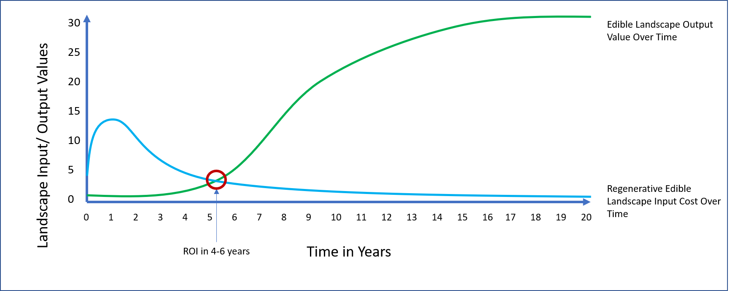
Figure 1: Edible Landscape output versus edible landscape input cost over time. ROI between 4-6 years after installation.

The long-term goals of these community interventions are to leverage landscapes to produce enough food for residential consumption and pay for themselves through selling surplus produce through a viable community market system. These landscapes have the potential to provide social cohesion through food culture and sense of place, create biodiversity hotspots through regenerative ecological landscape design, provide deep aesthetic and biophilic healing value, and enhance environmental vitality through intensifying resource cycling. Achieving these long-term goals would fulfill multiple facets of the three pillars of sustainability. The impetus for this project specifically was to identify ways in which the business (Eden Institute), or a non-profit arm of the business, could be more able to assist low-income communities to grow their own food who have previously been unable to do so due to various barriers.

Background

The current mainstream food system is a highly complex network of individuals, entities, technologies, products, and methods that move food along from production through harvesting, processing, packaging, distribution, marketing, and consumption. The system is primarily organized with an emphasis on optimization and mechanization of the production, maintenance, harvesting, and distribution of food. Food is usually grown in rural areas in large-scale monocultures, and distributed to grocery outlets in urban areas.

Unfortunately these networks interact in ways that result in many negative externalities including production systems that favor foods such as grain crops, and others that are low in nutritive value and result in poor nutrition and life-threatening dietary diseases such as diabetes and other autoimmune diseases (Stoler, 2018). Other challenges that are common side-effects of the industrial food system, of which Maricopa county also take part, include food deserts where individuals have limited access to produce, unsustainable subsidy practices resulting in artificial food prices, vulnerability of production to environmental disturbances, desertification of topsoil, inefficient water usage, and more.

According to 2015 data 15% of the population of Maricopa County reported to be food insecure (worse than the national average at 13.4%), and the highest rate of food insecurity in the state was 26.6% in Apache County (Feeding America, 2018). These are devastating numbers. Unfortunately, the system is supported by policies and powerful agricultural companies and lobbyists and therefore is resilient to change. Existing intervention efforts are isolated and have no transformational effect on the system itself or the social dynamics that surround it. One such example, that arose out of the lack of grocery outlets in Phoenix, is the local non-profit organization Fresh Express, which utilizes retired and retrofitted city buses to bring produce to select food desert areas in Phoenix (Nevarez, 2016). While many local residents appreciate this opportunity, the program organizers were surprised to find that many people living in these areas were so disconnected to healthy produce that they had to start a new initiative to teach them how to use it.

The optimization of the industrial food system model displays a structure that is far from the same aggregation exhibited by natural systems, which by contrast, each exhibit a form of strong modular sustainability and are nested within each other. The industrial food system lacks the ability to supply nutritious, culturally appropriate local food, uses an exorbitant amount of resources, contributes to various pollutions, manifests artificial costs (higher or lower), and generally disconnects people from the food they eat. This project was intended to develop a framework that addressed these gaps in the system by utilizing local food production through edible landscapes, and local distribution channels as a primary means of building sustainable communities.

The Sustainable Community Food System Framework that was designed for this project is modeled after natural systems- it is nested within the larger community system, and is in turn an aggregation of community networks, assets, and other types of capital. Within the community food system are many subsystems, each playing an important role for the overall strength and resilience of the network. The focus of the project was to identify a structure by which Eden Institute could help facilitate the organization of a community system, and from there, a community food system, utilizing edible landscaping as the key. By aggregating food systems at the community level, we would likely see an increase in resilience and restore the health and vitality of communities and the environment.

The industrial food production and distribution system is not set up to support the nutritional needs of local populations. Production has been occurring on a massive scale utilizing extensive agricultural techniques with many tradeoffs. By shrinking and aggregating the production system and switching from extensive to intensive natural agricultural techniques we can increase production capability and bypass the traditional distribution system. Thereby we may reduce the associated costs while avoiding the subsidy system, ultimately resulting in paying the true price for produce. Additionally, food access may also be closer to home, which will reduce food deserts. By developing an aggregated small-scale production system, we can focus on nutritive varieties and production methods while maximizing freshness.

The intensive micro-farming system has been proven profitable by many production companies, most famously Les Jardins de la Grelinette in Quebec, Canada. It’s owner, Jean Martin Fortier, follows a very different agriculture model from the traditional intensive one. By shrinking farm size (to 10 acres), and eliminating fossil fuel and chemical fertilizer consumption on the farm he achieved the opposite of what industrial farmers anticipate. Because he emphasizes the use of human power, his farm has a 60% operation margin due primarily to labor costs. But because his soil cultivating and marketing methods are also different, he achieves a gross income of $100,000 per acre. His produce is sold at affordable prices through local market channels and his take-home pay from farming is $400,000 a year (Fortier, 2014). Intensive agriculture pays off. But financial capital is not the only benefit. His soil is highly fertile and has no runoff, thereby effectively eliminating potential for eutrophication.

We can do the same thing in the desert of the Phoenix metropolitan area on a residential scale, as proven by a local representative of this type of production and marketing system, Justin Rohner, owner of Agriscaping Technologies, a full-service edible landscaping company in Gilbert, Arizona. Justin is often heard saying “We are farming by the square foot, instead of by the acre.” The intensive gardening system has provided him with gross profits as much as $10 per square foot. The math is easy- 2000 square feet of landscape can produce as much as $20,000 in gross annual market value (Tibbetts & Burdge, 2017).

Eden Institute believes that a sustainable food system is one that is in line with the principles of A Healthy, Sustainable Food System as proposed by the American Planning Association (The American Planning Association, 2019). The goal of the framework is to provide a guideline to work with urban communities to co-create a customized food system. The design process and system management will likely involve all community members to the extend they desire, and community members will have access to nutritious, affordable, and culturally significant food. Food is grown and transported within a one-mile radius in environmentally benign or beneficial ways.

Eden Institute’s vision for the future is one in which a community’s six types of capital (social, financial, natural, human, intellectual, and manufactured) are leveraged in such a way that all the problems inherent within communities, particularly in terms of food production, financial stability, environmental sustainability, and physical and social wellbeing, may be solved by the capacities, networks and assets possessed by the individual and collective members of the communities themselves.

While I am aware that the impacts of Eden Institute may not lead to an entire system-wide change, the proposed framework is both adaptable, and in some ways scalable, in its application, to help communities create their own aggregated micro-food systems that will continue to operate in parallel to the existing industrial agricultural food system. As the incumbent system faces inevitable disturbances, a community with their own effective food systems in place may be able to provide all the nutrition that individuals and communities need. Up to this point many methods and frameworks have been attempted, but with poor success. What is needed is a clear path forward; a framework of community engagement that works to build a successful community food system that produces more than it consumes and is adapted to the needs of the community itself.

One common theme coming from community organizers is that often frameworks and protocols for community engagement that include efforts to improve the food situation of communities result in nominal or inconsequential progress (Luz Cordel, 2017). This is usually because they lack the involvement of the individuals that they are intended to assist the most. Community meetings are either empty or are filled by those who do not represent the population in greatest need. Many programs are also applied in ways that do not build community capacity, but rather they are implemented in top-down approaches that leave communities without a voice, or are focused solely on problems and supplemental services “solutions” instead of identifying existing assets and focusing on capacity building. The result of these efforts is the creation of “client” communities that necessitate ongoing assistance.

Literature Review

Community development intervention has been around a long time, but has proven to be largely ineffective because of incongruent or unethical motives (Ulluwishewa, 2017). Only recently have paradigms of community development taken a love and support approach. As a result, information regarding ethical engagement practices are limited, even fewer in regards to developing sustainable and interdependent community food systems, and I found no peer reviewed articles specifically outlining edible landscaping as a key to developing successful community food systems and restoring communities.

Much of the literature addressed the community development aspect of the project. The other parts of my project were to address the community food system specifically, followed by the implementation of edible landscapes on a residential scale and building relationships of trust. Researching each of the subsystems within the community food system was beyond the scope of my project. The two subsystems of my project that I focused on were somewhat underrepresented compared to research on appropriate community development. More research is needed on community food systems and residential landscaping as a means of supporting them.

Civic organizers in the City of Phoenix are addressing the limited options for healthy food. The 2015 Phoenix General Plan “Plan Phoenix” includes a goal to “promote the growth of a healthy, affordable, secure, and sustainable food system that makes healthy food available to all Phoenix residents.” The metrics of this goal include “increasing the number of residents within a ¼ mile of a farmer’s market, community garden, or urban agriculture.” Phoenix’s 2050 Environmental Sustainability Goals include eliminating food deserts, implement or support local farmers' markets in each of the city’s 15 urban villages, increasing urban agriculture, and adopt zoning, land use guidelines, and other policies for an improved food system (Albright & Zima, 2019).

A recent review of the viability of edible landscaping businesses in Arizona conducted by Christopher Robinson at Arizona State University (Robinson, 2017) has shown that edible landscaping businesses focused on various aspects of landscape design, installation, and maintenance are indeed profitable ventures, particularly if the residents and businesses work with local food vendors to sell produce. Because of the advanced skillset required in working with edible plants and design, most ventures charge on average, approximately 25% more than traditional landscape companies and there is generally more demand for services than supply.

According to in-house research statistics presented during a training session hosted by Justin Rohner of the Gilbert, Arizona based company, Agriscaping Technologies, a $15,000 investment into an edible landscape in the Phoenix, metropolitan area, if properly implemented, could achieve a return on investment (ROI) in 4-6 years, followed by an increasing scale of profit as the landscape matures. The productivity of the landscape will top out at about 20 years after its initial installation, at which point the landscape can produce about 1000% of what it consumes annually (Rohner, 2018).

The Agriscaping Technologies business model is based on a “hub” approach to community food system growth- the center of the hub being a community location where classes and workshops can take place, and must include an edible landscape demonstration that can be located at the site or nearby. There are a handful of primary positions that must be filled in order to maintain a successful community food system. The educator position, a residential garden coach, an edible landscape designer, an edible landscape contractor, a garden maintenance professional, and a harvester and marketer (Rohner, 2019). While I have seen the efficiency of this model work firsthand, it primarily targets a customer base of middle and higher-income households because many low-income families simply do not feel that they can afford the input costs of any traditional landscape. As Eden Institute has experienced similar patterns of interaction, this challenge presents an opportunity and is what spurred interest in researching community intervention protocols and frameworks that could be adapted for use by a non-profit arm of Eden Institute in order to expand its impact to local communities who need it the most.

While there are many community engagement protocols and frameworks that have been designed and implemented by civic and municipal organizations, several provide a good foundation for the construction of this framework. One of the principle challenges that is reiterated in the work of community organizers is the lack of participation. Great protocols do not necessarily mean success in implementing community or municipal goals. Many times, despite the implementation of a great protocol, meetings are either empty, or are filled with people that do not represent the populations who most need the assistance (Luz Cordel & Eisenbarth Hager, 2019). Vitalyst Health Foundation’s Pre-Community Engagement Protocol (Luz Cordel, 2017) recognizes and addresses the lack of pre-community engagement in most protocols. It seems that the secret lies in the preparation prior to the workshops and co-creative planning phases. Building trust as a foundation for working relationships is essential for success in effective co-creation strategies, but not all protocols address this need.

Most frameworks for community work focus primarily on a linear path from a problem to an action plan with set targets, to potentially achieve a “solution”. Asset Based Community Development (ABCD) recognizes that first, there is no point at which one “arrives” at a solution, and second, that a problem-centered approach can only create problem-centered interventions and strategies. One of the most important keys to successful community empowerment is to take an inventory of what a community has to offer to address challenges, not what they lack (Kretzman & McKnight, 1993). Much of my approach to developing an adaptive community food system framework is taken from this approach, though the literature here heavily emphasizes an inventory of various aspects of social capital, while other types of capital are weakly represented.

Participatory Impact Pathways Assessment, or PIPA (Douthwaite, 2008), though weaker in the application of a full-scale asset inventory applied in ABCD, is designed primarily for participatory research and empowering community members through knowing what their network capacities are. Through the simple act of assessing what each member has to offer through their network, capacity to address challenges is created. Network assessments are provided as a means to influence increased awareness and leverage points in a system.

The Eco Districts Protocol (Eco Districts, 2018) is designed to help individuals come together to design their communities geo-spatially through the lens of each of its existing resources and desired outcomes. This protocol follows a strict linear progression from problems to action plan to intended results, and does not provide much flexibility for varied outcomes, though is designed well for implementation by city organizers. This protocol has emphasis on the co-creative collaborative interdependence in community input, but lacks the collaborative personal relationship aspect allowing very little adaptation in the structure for varied community needs. Parts of this will be adopted for a basic framework for Eden Institute’s framework, particularly the geo-spatial game method of community asset identification.

The Sustainability Through Happiness Framework (STHF) (Cloutier & Pfeiffer, 2015), and the Sustainable Neighborhoods for Happiness Index (SNHI) (Cloutier, Jambeck, & Scott, 2014) were both valuable frameworks to form the basis of my own framework. These frameworks provided visual organization that I could build upon in my own work. The Sustainability Through Happiness Framework describes a process of organizing community goals beginning with visualization of aspects that would bring happiness. This process builds relationships of trust and establishes a clear purpose prior to the design of any co-creative project. I also expanded upon The Sustainable Neighborhoods for Happiness Index which illustrated categories that were important to include in community work. Finally, I compared these with the subcategories that I derived from the six types of capital (Social, Material, Financial, Human, Intellectual, and Environmental). I ended up with a total of 13 subcategories that became the basis for the Community System map.

There are other frameworks and protocols which may provide helpful insights into the construction of the proposed framework for Eden Institute that have not yet been fully explored, but it is reasonable to believe that there will be additional features that will be valuable additions to the next iteration of this report. Phase IV of the framework has to do with Eden Institute’s standard work procedure in the actual implementation of project installations, for which I will draw on the existing industry knowledge for that section of the protocol. The majority of the research for the proposed protocol will be geared toward the implementation of the first and second phases.

Project Approach and Intervention Methods

My project approach to design the adaptive framework for Eden Institute involved several activities starting with research of visioning techniques to cultivate expanded perceptions of the role of landscapes in neighborhood development and community engagement. I interviewed field professionals involved in both the for-profit sector, as well as the non-profit sector and made site visits to various locations to compare the processes of engagement and implementation of edible landscapes. I also attended several webinars presenting different community engagement strategies and their success stories. One of the primary activities that formed the bulk of the project was the compilation of literature and material followed by a limited comparative review and analysis of several existing protocols, frameworks and toolkits designed for community engagement and co-creative community systems to determine their specific advantages and disadvantages in relation to the intended baseline criteria for my framework.

The baseline criteria for material was that it must first, present a collaborative design feature or process at any or all of the phases of the intervention. (See Figure below).

Phase I: Observation & Inspiration: Building relationships, listening sessions,
Phase II: Formation & Mobilization
Phase III: Organization & Preparation
Phase IV: Project Implementation
Phase V: Calibration & Iteration
Phase VI: Intensification & Escalation

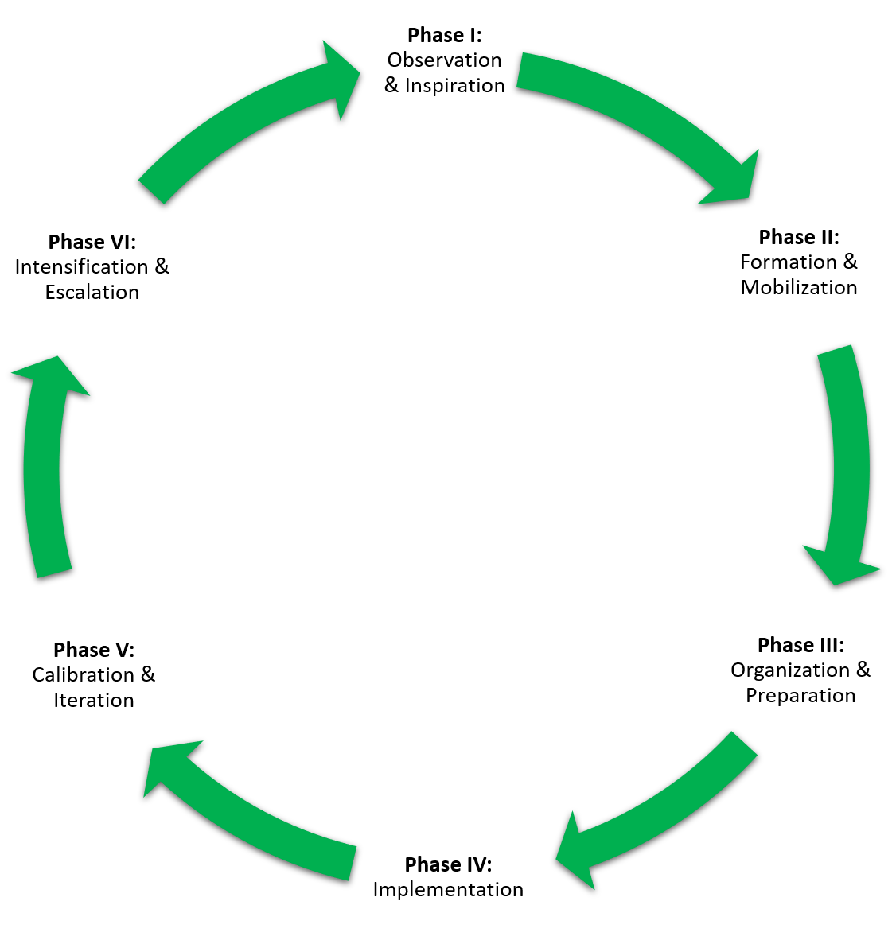
Figure 2: The Intervention Framework (The Community Intervention Phases).
Second, because sustainability and regenerative design are primary foci in this process, the outcome of the engagement and implementation of any intervention must manifest triple-bottom line sustainability results. It must ensure social benefits in the process and outcome of the final system, provide economic and financial stability to the actors, and provide environmental protection and benefit.

My specific intervention method for Eden Institute was to combine and adapt the various existing protocols and frameworks from reviewed literature into the design of a tool for effective community engagement- specifically centered around the co-creation of community food systems. Of particular usefulness was the trust approach represented in the Pre-Community Engagement strategy, as described by Vitalyst Health Foundation for the purpose of setting the stage for effective community intervention. Their approach discussed the common challenge associated with so many community organizers- lack of participation. It is hard to help a community who doesn’t come to meetings. In such a case, there are always underlying challenges associated with a lack of participation that must be addressed through building trust with the community prior to any effective intervention. By strengthening capacity of residents to have ownership over the system, its long-term resiliency is strengthened. The “ladder of engagement” illustrates the level of empowerment that actors in a community experience. (See Fig. 4 below). The phase process part of the framework is intended to provide empowerment and strengthened capacity to the community from the beginning, but more and more of the responsibility will shift to the community as each phase of intervention comes into play.

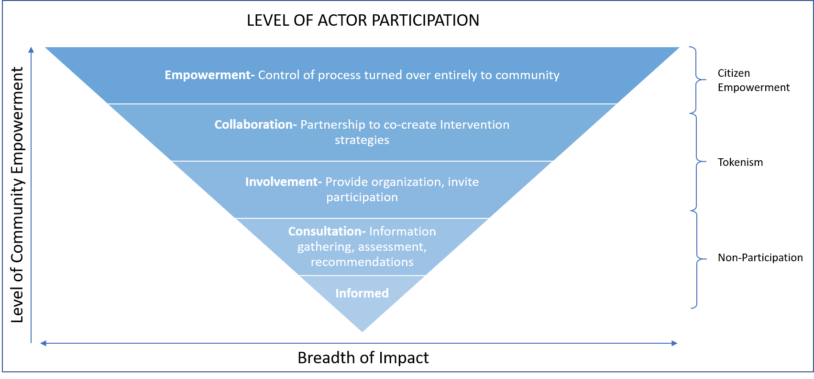
Figure 3: Level of Actor Participation. As the process of intervention progresses through the phases, empowerment is reached and the community takes control of its food system.

Additional strategies that were of particular are provided in the table below. The resources that were chosen to represent aspects of the final protocol contained features that were most appropriate for the collaborative community engagement approach that Eden Institute was looking for, and they were adjusted as needed to allow for the flexible adaptation of community needs.
Table 1: Comparative Analysis of various frameworks and protocols for community development.
A Partial Comparative Review of Community Engagement Protocols and Frameworks
Methods/Methodologies | Engagement Phase | Strength | Weakness
Pre-Community Engagement | Phase I | Collaboration and empowerment focus. Sets the stage for further effective interaction. | Must have follow-up. Has no impact on its own. Collaborative focus takes longer to implement than standard participatory processes.
Asset-Based Community Development | Phase II | Focus on community strengths, not weaknesses | Cumbersome process. Difficult to get full participation in surveys.
Sustainability Through Happiness Framework | Phase I-VI | Focuses on happiness of individuals, which is where one starts. | Is not intended to focus on specific interventions.
Sustainable Neighborhoods for Happiness Index | Phase I | Focuses on 9 subcategories of community development. | Does not address all types of capital. More focus areas needed.
Community Network Mapping | Phase II | Interactive collaboration | Must have follow-up. Has no impact on its own
Listening Sessions | Phase I | Allows full participation and all perspectives. Gets at the root of problems | Generally problem oriented. Can easily go "down a rabbit hole". Not everyone willingly participates and hard to motivate community attendance.
Conflict Resolution Strategies | Phase I & Phase II | Essential component of meeting organizing and facilitation. | Effectiveness and methods are variable depending upon the cultural and social dynamic of meeting.
Systems Dynamics Modeling | Phase II, III, & V | Provides powerful insight into community networks, cause & effects, robustness, etc. | Dependent upon community participation in data research, Objective data gathering is often time consuming and difficult. Sometimes difficult to relay significant trends if actors are not prepared to accept it.
Forecasting | Phase II | Provides insight into anticipatory planning. | Limited in its accuracy.
Participatory Impact Pathways Analysis | Phase I, II, III | Useful tool for participatory research. | Problem emphasis. Normative change framing may be difficult for actors to accept or implement.
Visioning Workshops | Phase II & III | Has the potential to unify communities in their purpose. Effective to envision community vision differences. | Has the potential to divide community purpose. Often implemented in a top-down power structure.
Brainstorming | Phase II | Useful tool to come up with implementation ideas that do not necessitate a single method. | May not allow a concrete direction- "down the rabbit hole" syndrome.
Scenario Planning | Phase II | Nurtures innovative thinking. Stimulates creative thinking and controversial debate. Accepts uncertainty, vagueness. Provides orientation. | Success is contingent on many conditions, continuous revisions, multiple interpretations from vague results. Inadequate for short-term planning.
Back-casting | Phase II | Very effective at providing frameworks to work towards goals. | No guarantee that the vision will actually be met.
Benchmarking | Phase II & III | Establishes baseline for effective goal setting. | Must be carefully applied so as not to let the benchmark and goals take precedence over participants needs.
Developing and Using Community Protocols | Phase II & III | Provides some considerations when designing a protocol for a specific community | Only provides considerations when designing a protocol for specific communities, not a general process.

After organizing and comparing literary material I then organized a basic skeletal structure for the community food system section and the edible landscape section of the document and I provided a detailed approach to addressing project implementation in a residential setting. The edible landscape section of the document first lays out a step-by-step consideration for any sustainable edible landscape installation process starting with identification and integrated pest management (IPM) for perennial invasive weed species and works through the process of installation in a step-by-step fashion that reduces redundancies in work efforts and is based upon field experience.

Some of the most valuable work that I did throughout this entire process, and will be of some of the greatest value to my project partner, was the creation of graphical representations of the systems and process- the visual aspect of the framework. This included 13 subsets to each of three separate systems that were nested within each other (See Figures 5, 6, 7, & 8). After the completion of the illustration of the community system it became apparent that I had spent a great deal of time seeking understanding of the entire system, but the primary focus of my project was concentrated in the embedded community food system and its edible landscape system. These illustrations were invaluable to the ease of comprehending the systems of which I was studying and the framework which I was designing. I also constructed graphs to illustrate the input and cost comparisons of traditional landscapes versus edible landscapes. I identified the massive nature and complexity of the systems in which I am studying, thereby determining the need to limit the scope of my project further to solely consider the community food system and the approach to edible landscaping as a means to achieve community food system sustainability, without going into depth in the methodologies of mobilizing communities themselves. All remaining work on perfecting an adaptive holistic community development protocol will be done later.

In the process of creating the Community System Map, I drew from the six types of capital to identify the primary subcategories and used the SN4HI to compare. When I had completed this process, I had combined Buildings and Infrastructure with Urban Design to create Infrastructure and Design, and added Natural Resources, Environmental Services and Recreation, Tangible Assets, Intellectual Capital, and Human Capacities for a total of 13. I then placed it within the process framework that included the Pre-community Development work done through building trust and relationships, listening sessions, and general observation.

Following the breakout of the individual subcategories of capital that would exist within a community context, I then inserted these subcategories into the phases of the framework. These topics become the baseline for discussions and focus groups within the community. (See Figure 6 below). Meetings may be held at the community level to discuss organization and interacting systems, but each focus group should meet to discuss the particulars of that focus area. From this system is derived 13 subsystems, each with their own networks. For the purpose of this project I will be focusing on the Community Food System, with an additional look into Residential Edible Landscaping as the primary technology that ensures the viability of the Community Food System.
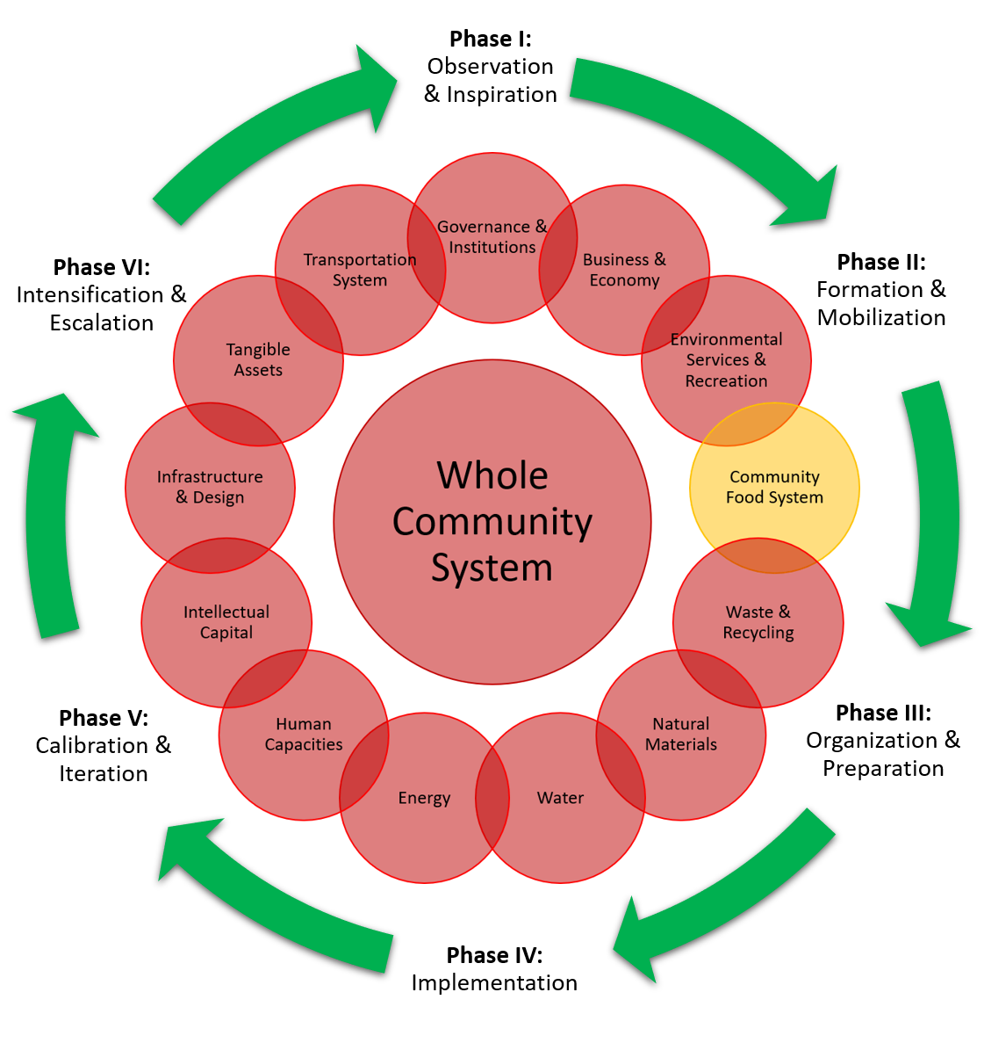
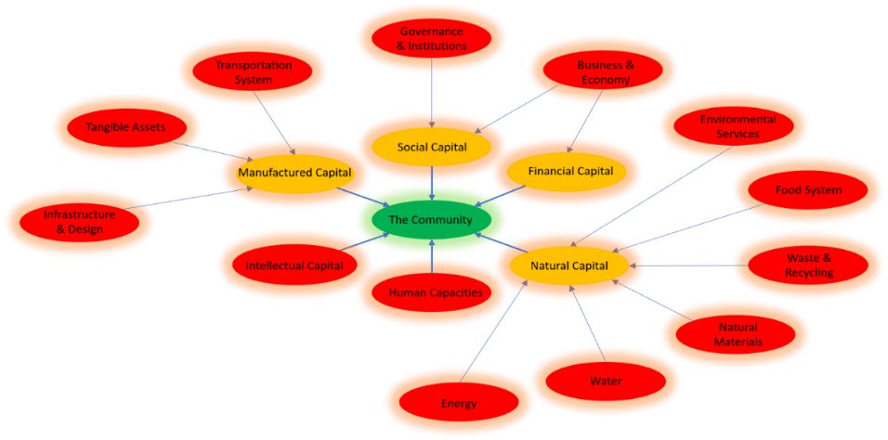
Fig 5: The Whole Community System
Fig 4: Final Focus Areas /Subcategories in red

Because of the sheer complexity and enormity of the global food system, of which the Phoenix metro area is a part, I have no intention of implementing any direct intervention into the global food system, or even the food system at the regional level. However, If the proposed protocol is created correctly, I anticipate that it will provide an improved community engagement approach that will ensure the implementation of long-term sustainable community food systems that will continue to increase in efficiency and social acceptance, while the incumbent system simultaneously continues to deteriorate. The subcategory, or focus area, that I am most interested in has to do with the community food system, which should be culturally supportive, and focused on holistic regenerative design. Many, interconnections to other aspects of the community system exist, but I will focus here. The community food system was divided into its subcategories primarily by roles of actors and necessary assets within that system. (See Figure 6 below). Additional details provided in Appendix A.
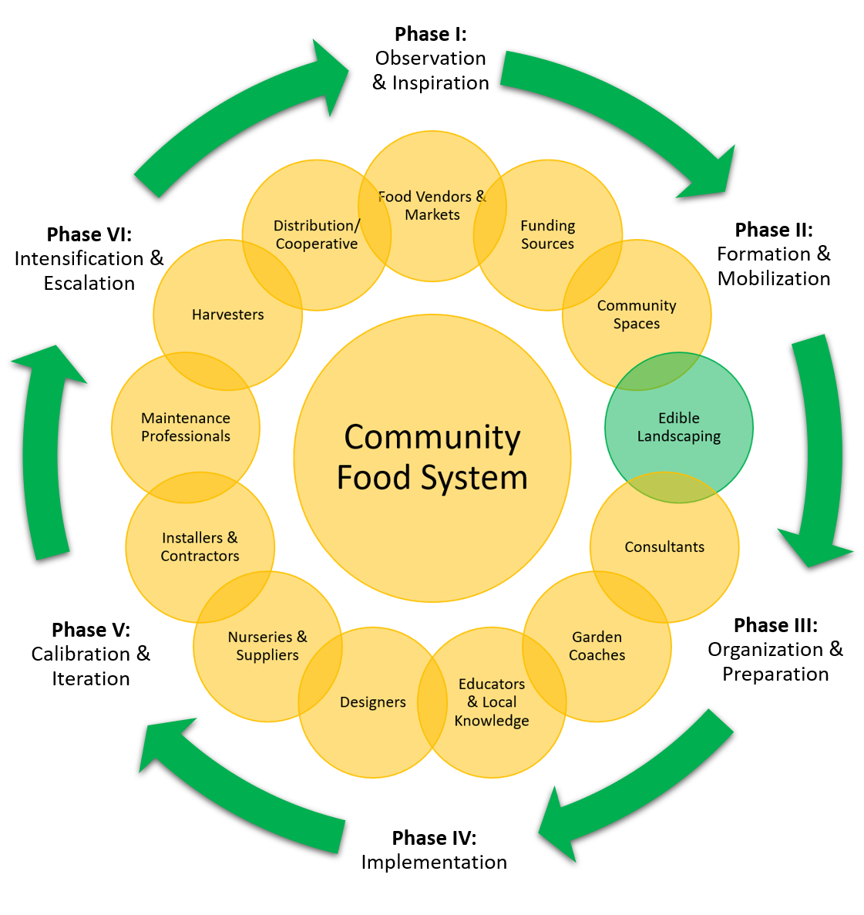
Figure 6: The Community Food System- 13 subcategories represent necessary actors and assets in the system in order to make it work
While the focus of the research for this project was on structuring a pathway to be able to cooperatively design a community food system, and Eden Institute has experience developing successful edible landscapes. The last subsystem that I will focus on here is the Residential Edible Landscaping subsystem. (See Figure 7 below). Additional information provided in Appendix B.
Figure 7: Edible Landscaping subcategories in tentative order of implementation, starting with Observation & Planning.
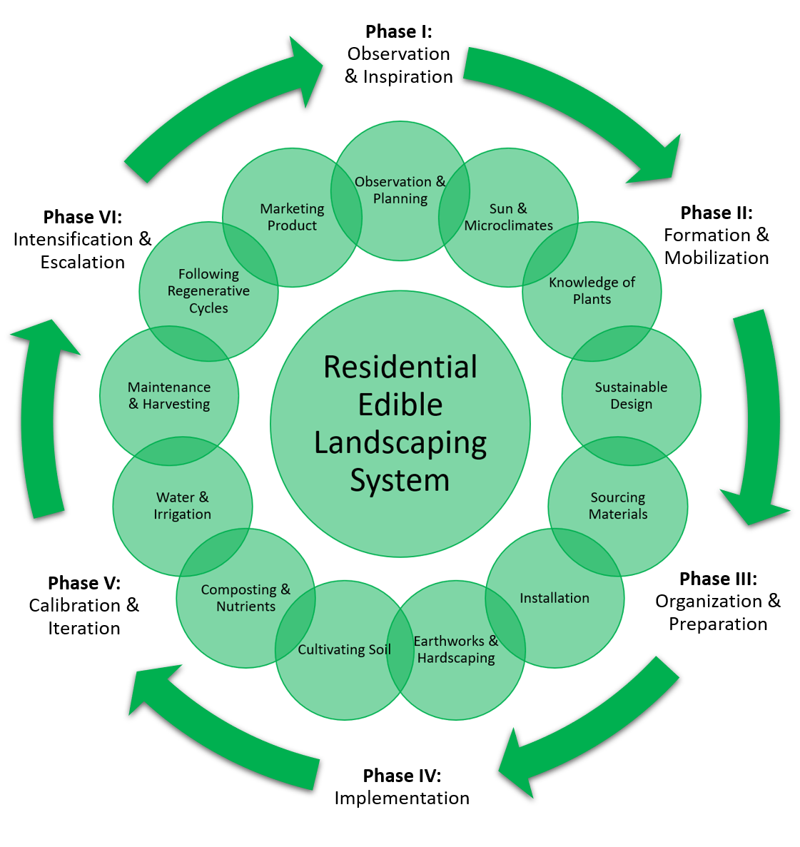
The following graphic Illustrates how the systems are nested within each other. The larger Community System Map contains within it the Community Food System Map, and nested within that is the Residential Edible Landscape System Map (See Figure 8 below). Without having an effective community system in place, it will be impossible for the community food system to take root. The edible landscape likewise cannot pay for itself or have sufficient resources and support for long-term success without a complete community food system in place. The stronger these network connections are, the more robust and resilient the community food system is.

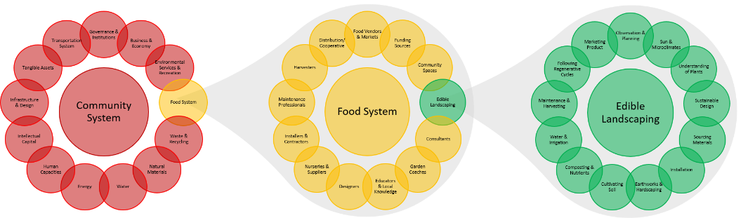
Figure 8: Nested Systems. The Edible Landscaping System is nested within the Community Food System, which is nested within the Whole Community System.

Consultant, Garden Coach, and Designer all work with the resident through the iterative phases starting with observation of natural flows in the system, listening, relationship building, visioning with the resident, asset inventory, brainstorming, and co-design. Once the design is complete and all other planning and a tentative schedule is in place, then it is time to prepare and mobilize the available resources and begin the chosen project. Any contractors used for the project must be contacted and scheduled and work teams assembled. Social media used if necessary, photographer if the resident desires to document the process. When the project is complete it is highly advisable to report on the development of the project by asking questions: Where are things going slow? How many hours for each phase? How is the relationship going with the resident? How are they feeling about the project? How is that going to change the timeframe, cost, or quality? Is there anything that should change? The process must consider all of the various aspects of a sustainable landscape design.

Trust must be built from the individual outward. By building trust with a community champion, it is much easier to make a faster impact within a community. That champion can be found anywhere- an overly active neighbor, a PTO member, a mom of a house-full of kids, who knows all the other neighborhood kids and parents. This system is not just theoretical, but a proven process. When entering the community space, however, we must be first and foremost interested in that person and their culture, immediate needs, and existing knowledge. This is not always easy, or natural. The following is a real-world example of how the process of engagement works.

Community development work is often slow- one person, one relationship at a time. When I first met Terry, I had a hard time understanding her thick Filipino accent. She didn’t open up right away. She shared with me that some others who had helped her in the past still kept in touch. She slowly opened up about her husband, the gardener, who had planted many fruit trees and a huge garden. When he died, so did everything else. In an effort to help her I determined to help her by creating a sample design using some edible plants that grew in the Philippines which I knew would also grow well here. She was ultimately uninspired with the design. I was kind of prepared for this, but I was not prepared for her reasoning. She was concerned about the cost of water usage and maintenance. She didn’t feel like she could afford or manage any more plants than the garden box that she had. So, I went to the local Asian market and bought her a jackfruit. She was ecstatic because she loves jackfruit, but didn’t feel like she could afford it. Once willing to accept gifts, I then brought her a tiny moringa seedling, called “malunggay” in Filipino. When I told her what it was, she got very excited. She recalled memories of her and her sister running through the malunggay forest in the Philippines stripping the leaves off for soup. Had I brought a huge tree I don’t think she would have been prepared for it, but a seedling was unassuming. I knew it would grow fast and provide her with satisfaction. I then brought her five guava air layers (rooted branches), and two more moringa seedlings. But they didn’t grow very fast because they had no water to them. She was then convinced that if she allowed us to install an automatic irrigation system then she wouldn’t need to water every day with a hose. We did so. The process was slow because we had to sift out Bermuda grass as we worked to put in the irrigation lines or it would compete with the new trees. Without having to water so much she felt that she could handle another garden box. After installing a garden box and continuing to inspire her we convinced her to let us plant a few more trees and build a structure to sit under. She ended up giving away much of her produce at the local community center, where she had friends who heard about what we were doing in the neighborhood. One day, as we were working at Terry’s, I saw a plant across the street that I was curious about. I thought that I knew what it was, but I wasn’t sure. I decided to meet the owner. Theresa was from Mexico. She was excited that I knew what it was and she gave me a cutting that is still growing. This started a great friendship and many projects. This process of relationship building with residents took time, but from a community development perspective it provided some valuable lessons. I still keep in contact with Terry after several years and she loves her guavas and moringa trees. If I were to call a community meeting and encourage them to invite their neighbors after building these relationships, there would be a higher chance that some would come because there is an existing sense of trust there.

The Sustainable Community Food System Framework provides an effective order of operations starting with being vulnerable and getting to know the person. The relationship is built one person at a time, often as a result of introduction by other residents with whom we build trust. As opportunities for service come up, we make efforts to use their own paradigms as a “language” to inspire them with new possibilities. The strength and viability of the system lies in the people. As the community grows in confidence with growing food, we can begin to organize. Meetings, networking, and asset mapping are all done after the first phase: observation, inspiration, and formation. This is the pre-community engagement phase. Once that is completed, the next phase is the organization and planning phase, in which we inventory existing networks, capacities, and assets. Over time working through the phases, we can begin to conduct happiness visioning, and other workshops. Residents at some point, install edible landscapes which can pay for themselves. As community cohesion develops (around food) we begin to build a structure for our food system. This may include a local market, sales to local restaurants, distribution cooperatives, and lifestyle changes as the residents need. The process is fairly organic, but must build from the foundations of relationships. This process is proven.

Outcomes/Findings

An assessment of community development methods provided insight and informed the selection of appropriate tools and approaches that may be combined and adapted for co-creative development. Pre-Community Engagement is not so much a framework, as an approach. This approach was considered essential to include in the process, both from an ethical standpoint, as well as from experience with field work. PIPA also provided for capacity building through strengthening resident network knowledge, but is designed primarily for research and is limited to networks and capacities and plays little into the actual work done in communities. As a result, I appealed more to the ABCD approach. This method pursues a clear “checklist” approach to identifying community assets and follows with hands-on application through network connections. However, research into the specific attributes of ABCD proved that it also had shortcomings, as it is designed specifically for identifying social capital, while all other types of capital are weakly represented. It also does not discuss, nor go into great detail about the necessity to strengthen relationships with the social network. Additionally, the depth of inventory as prescribed could potentially be very cumbersome on a community and cause “research burnout” if not implemented in a simple manner. As a result, I developed an adapted version of this process and added a technique found in the Eco District Protocol to conduct community workshops centered around a geo-spatial game to identify their own community assets. This is primarily the only aspect of the Eco District Protocol that was particularly useful compared to the other frameworks. Brainstorming, Back-casting, Happiness Visioning (from STHF), Visioning Workshops, and Scenario Planning, are also all good strategies for working with community members to set goals. Brainstorming allows free-flow thinking, but does not assume a pragmatic approach to visioning. I determined that the process of visioning needed to have a structure that was sustainable, coherent, tangible, plausible, and inspirational. Happiness visioning provides strong inspiration to individuals, but may not be plausible, or produce a pragmatic strategy. As data is collected some form of Systems Dynamics Modeling may inform the process. The problem with modeling a complete community system is that it can be costly and time-consuming. If such an approach is used, time and resources must be carefully calculated. Conflict Resolution strategies also become an important part of working with individuals that come from various backgrounds and paradigms.

I had felt that SN4HI did not cover all the aspects of a community system. By expanding upon the six types of capital (social, material, intellectual, natural, human, and financial), and using the SN4HI as a foundation, I built the Community System Map. The Community Food System Map was designed using the Agriscaping Technologies Hub Approach as a foundation and expanded upon it by identifying all of the roles and resources necessary to build a community food system. Residential Edible Landscaping is imbedded in the Community Food System Map and is the technology that drives the process. Agriscaping Technologies Hub Approach only contained six key players in its hub, but failed to take into consideration other players and resources such as suppliers, the mode of distribution, and funding for communities that are unable to implement sustainable solutions due to the upfront cost associated with it.

Recommendations/ Next Steps

Eden Institute’s current state is one in which the company has the skill set necessary to work with individuals to create sustainable landscapes, but there is no guideline for working with whole communities to create a community food system. When the framework is complete, as it is nearly so, and with the addition of a framework upon which to build customized community protocols, I recommend that Eden Institute launch the first pilot program using this framework as a guide. The first pilot project will inform future iteration strategies.

In the mean-time, I recommend using the first two years (of a ten-year strategy and action plan) to develop resources and initiate pre-community engagement work. This will begin with Eden Institute establishing its online presence and generate residual revenue streams through the use of affiliate marketing and free online blog articles. This will be followed by a completion of a regional climate-specific illustrated reference manual for edible landscape plant species and associated microclimates, and a region-specific companion manual for efficient, aesthetic edible landscaping design utilizing microclimates. Once the necessary tools are completed, it will be important to conduct pre-community engagement strategies in a chosen community. Avenues to approach this can range from talking to individuals on the street, to getting referrals through partner organizations. Once a base of community champions is identified it will be time to organize and establish a Neighborhood Food Association (NFA) board with key stakeholders and identify a meeting location (which may begin on a resident’s porch). This will provide some validity when establishing networks of trust with local organizations, suppliers, and experts. Developing a preliminary community System Dynamics Model at this stage may save some time later on and help organizers identify immediate intervention opportunities.

The second two years would begin with the creation of a demonstration garden that can draw attention through social media and events such as workshops and garden tours. If the community has an HOA this would be an ideal time to partner with them in an effort to raise awareness and support of aesthetic edible landscaping practices. Also, this would be the time to engage with local nurseries to promote the availability of important edible plant material. Many nurseries are reluctant to bring in new plant material that is not a proven sales product yet in the local landscaping industry. The demonstration garden can also provide some plausibility to implementing certain species and promote demand. Connecting producing residents with the existing aggregated market system, Utopian Harvest, which was developed by Agriscaping Technologies, may prove useful in the beginning stages of a community food system. Once a sufficient supply of food is produced from local landscapes it will be time to consider developing a community-owned cooperative distribution system and market channel.

Also, this time period is when Eden Institute will begin implementing its pilot projects while supporting and strengthening local knowledge. This preparation to scale its efforts may take the form of for-profit and altruistic community development activities, as well as the development of the originally planned Backyard Garden Foundation (BGF). The community development activities at this phase can follow the framework and customized community protocols through processes of strengthening co-creative capacity and empowerment. This is when community listening sessions, and visioning and strategy workshops should be a regular occurrence. One such activity for this process that has proven useful for other organizations is a geo-spatial game-based activity for the asset inventory. As community members participate in knowing what assets they have they will be able to be informed through the process of working together to create a viable community food system. Once a series of edible landscapes are installed, the NFA is organized, the market system is initiated, and the remainder of the community food system is designed, built, and interdependently co-managed by residents it will be time to review the model, the engagement process, and design iterations for future projects.

Following the successful co-creation of a community food system, I recommend pursuing a preemptive campaign of sorts to ensure the long-term political viability of these unique systems, as it is likely that they will be the target of marketing attention by big agricultural organizations and grocers associations if they see this system as a threat to their profits. Involving municipal leaders, and making an effort to institutionalize certain aspects of the system will provide security for the community, lobbying power, and a model for other cities to follow. Policies and codes are not always adaptable to such community systems because they are designed to optimize some aspects of safety over others (greywater codes are a case-in-point). At this stage it is essential to promote edible landscaping as an institutional norm and work with officials, urban designers and developers. Once the city provides a plausible example of an effective system it will be time to reach out to state representatives to overcome barriers and craft necessary legislation to protect the viability of such systems.

The future-state BGF organization would be a non-profit arm of Eden Institute, whose purpose is to provide low, or no-interest micro-loans to families who desire to participate in a garden coaching contract program to implement their own residential edible landscape food production with the assistance of a professional edible landscape coach. Coaching contracts should be designed for 11 months and organized in similar fashion to a contract for piano lessons, with onsite skill training, online supplemental educational training, and mutually agreed upon “homework” assignments to be completed by the resident family prior to the next weekly scheduled visit. This process should operate as a co-creative partnership between the coach and the resident family. Total price of the contracts will likely vary, but should include a breakdown structure based on costs associated with a professional co-created landscape design, landscape and plant materials, gig payments to the Eden Institute Certified Contract Partners (formerly “consultants”) for the coaching contract, and supplemental educational courses. Any subcontract work completed outside of this contract should require additional funding provided by the resident, though BGF may assist with sourcing additional funding. The targeted landscape installation cost should be 30% and no more than 60% of a traditional landscape installation by cutting out the installation contractors, and instead receiving skill and lifestyle training directly from the garden coach and supplemental courses and doing the majority of the work themselves with the help of a community workshop group participating in onsite skills training and time-banking.

In the deliberation of organizational structures that would most benefit individuals it was apparent that a funding system that required return payment was important to build accountability and capacity among participants, though grant awards may be considered on the basis of need, merit, and availability. Micro-loans should be provided for a payback time period equal or greater than the calculated ROI period of the landscape determined during the design process. Return profits to the organization should primarily come from the marketing system for the food produced at the residence throughout the payback period and would be re-banked into the non-profit organization as part of a perpetual funding program. Total payback will require the lowest interest rate possible, as the primary goal is to provide a financial means for participants to accomplish their edible landscape goals, not for the organization to make a great amount of money on this venture.

Conclusions

The results of my investigation into community development strategies and frameworks indicate that there is no system that provides a perfect path to community food system sustainability, but by aggregating and adapting several methods an effective framework and subsequent customized protocol can be created. Based on my research, the co-creation of food systems is possible as long as there is interest in each of the primary roles within a functional food system. Without community member interest in those roles, the only way that a food system can be built and sustained is by bringing in outside professionals and resources. Many barriers exist in implementing community food systems, primarily in the realm of perceptions. Patience and love must be exercised when working with individuals, and an acknowledgement that they are coming from different cultures and life experiences that put them in unique mindsets. The results of any intervention process, when done in love, are emergent, but can be powerful. The answer to my original question “what strategies can we use to engage with communities for the purpose of co-creating sustainable community food systems centered around edible landscapes?” is as multi-faceted as the question itself. There are many possibilities, the most effective interventions are going to depend upon the general culture of a particular community and the specific relationships of trust that are built between the residents and the facilitators. Ultimately, of course, the goal is to be able to build capacity and hand-off control of this system to the residents themselves. At this point it is important to complete the framework and develop a custom protocol for a community to begin actual engagement to allow it to be refined and evolve. In addition, more insight from case studies and groundwork would be valuable to draw upon, as the research that I found the most useful came from actual interaction with residents during the execution of strategies for community intervention. More research and insight into case studies of localized community food systems is needed. There is definitely opportunity to improve upon the project to create an adaptive framework for assisting in the development of community food systems. Other students wishing to participate in accessing or adding to this project should contact Jason at jason@edeninstitute.net for additional information.

References

Albright, R., & Zima, B. (2019). Brownfields to Healthfields: Community Health. Presentation, Phoenix City Manager's Office, Office of Environmental Programs, Phoenix. Retrieved February 2019
Cloutier, S., & Pfeiffer, D. (2015). Sustainability Through Happiness: A Framework for Sustainable Development. Sustainable Development. doi:10.1002/sd.1593
Cloutier, S., Jambeck, J., & Scott, N. (2014, May). The Sustainable Neighborhoods for Happiness Index (SNHI): A metric for assessing a community's sustainability and potential influence on happiness. (Elsevier, Ed.) Ecological Indicators, 40(May 2014), 147-152. Retrieved February 2019, from https://www.sciencedirect.com/science/article/pii/S1470160X1400020X
Douthwaite, B. (2008). Participatory Impact Pathways Analysis. In Fighting Poverty Through Sustainable Water Use (pp. 381-386). Retrieved February 2019, from https://cgspace.cgiar.org/bitstream/handle/10568/33649/11.5%20Participatory%20impact%20pathway%20analysis.pdf?sequence=1
Eco Districts. (2018). Eco Districts Protocol: The Standard for Urban and Community Development. Protocol, EcoDistricts, Portland. Retrieved February 2019, from www.ecodistricts.org
Feeding America. (2018). Food Insecurity in the United States. Retrieved October 2018, from Feeding America: http://map.feedingamerica.org
Fortier, J. M. (2014). The Market Gardiner. Gabriola Island, British Columbia, Canada: New Society Publishers.
Kretzman, J., & McKnight, J. (1993). Building Communities From the Inside Out: A Path Toward Finding and Mobilizing a Community's Assets. (N. U. School of Education and Social Policy, Ed.) Evanston, Illinois: The Asset Based Community Development Institute.
Luz Cordel, S. (2017). Pre-Community Engagement Toolkit. All Voices Consulting & Vitalyst Health Foundation. Phoenix: Vitalyst Health Foundation. Retrieved February 2019, from Vitalyst Health Foundation: Pre-Community Engagement Toolkit: http://vitalysthealth.org/wp-content/uploads/2017/12/ETOD-Comm-Engagement.pdf
Luz Cordel, S., & Eisenbarth Hager, C. (2019). Pre-Community Engagement: Setting the Stage for Authentic Community Engagement. PDF, Vitalyst Health Foundation, Phoenix. Retrieved February 2019, from http://vitalysthealth.org/wp-content/uploads/VitalystSpark-PreCommunityEngagement.pdf
Nevarez, G. (2016, April 26). Fresh Express Bus Brings Produce to "Food Deserts" in Phoenix and Tempe. Phoenix New Times. Retrieved from http://www.phoenixnewtimes.com/news/fresh-express-bus-brings-produce-to-food-deserts-in-phoenix-and-tempe-8256755
Robinson, C. (2017). Examining the Business Case and Models for Sustainable Multifunctional Edible Landscaping Enterprises in the Phoenix Metro Area. Sustainability. Retrieved October 2018, from https://repository.asu.edu/attachments/194775/content/Examining%20the%20Business%20Case_2017.pdf
Rohner, J. (2018). ACE Training 2018. Presentation, Agriscaping Technologies, Gilbert. Retrieved January 2018
Rohner, J. (2019). ACE Revamp 2019. Presentation, Agriscaping Technologies, Gilbert. Retrieved January 2019
Stoler, D. R. (2018, March 06). Are Grains Destroying Your Health? Psychology Today. Retrieved March 2019, from https://www.psychologytoday.com/us/blog/the-resilient-brain/201803/are-grains-destroying-your-health
The American Planning Association. (2019). Principles of a Healthy, Sustainable Food System. American Planning Association, Planning and Community Health Center. Retrieved March 2019, from https://www.planning.org/nationalcenters/health/foodprinciples.htm
Tibbetts, J., & Burdge, I. (2017). Interview with Justin Rohner. Gilbert, Arizona.
Ulluwishewa, R. (2017, July 18). Development Aid as a Gift of Love: Reinventing Aid on a Spiritual Foundation. PROBLEMY EKOROZWOJU- Problems of Sustainable Development, 12(2), 109-118. Retrieved March 2019, from https://papers.ssrn.com/abstract=3000819

Appendices and Acknowledgements

Appendix A: The Community Food System Map:

- Community Spaces- Central locations are important for gathering, education, and garden demonstration.
- Edible Landscaping- This, combined with market channels, is the primary key to make the community food system work.
- Consultants- Are responsible for collect information from residents and provide unbiased productivity assessment and offer insight into various involvement options for residents to take.
- Garden Coaches- Work co-creatively with residents to design and construct edible landscapes.
- Educators & Local Knowledge- Educators provide guidance on regionally adapted species and environmentally sound practices
- Designers- Work with residents to produce landscape renderings for the purposes of inspiration and to produce accurate cost analyses for contractors
- Nurseries & Suppliers- Provide edible landscape material. Relationships built with suppliers may improve local availability of specific plant material.
- Installers & Contractors- Provide professional assistance for projects, particularly with earthworks, electrical, and greywater plumbing.
- Maintenance Professionals- Trained in maintenance of edible landscaping. Certifications for such skills and established networks are available.
- Harvesters- Trained to harvest produce in season and follow local and national food safety laws for good handling practices.
- Distributors- provide transportation to local markets and vendor channels, CSA’s, etc. A community cooperative distribution system may be considered.
- Food Vendors & Market Channels- Retail restaurants, local markets, and CSA’s that are trained in food safety laws, and provide a legal entity under which produce may be sold on consignment (some Phoenix metro market channels may have as high as 99% of produce is sold)
- Funding Sources- Additional funding sources may be available or needed

Appendix B: The Residential Edible Landscape Map or Process

- Observation & Planning- Unfamiliar landscapes may take time to see the flows. The more unfamiliar, the longer the time. Two years of diligent observation is usually sufficient. Most individuals cannot wait that long. Understand the basic macro-climate- heat and cold maximums and minimums, average first and last frost dates, soil type, history, when and where the wind blows, etc.
- Sun & Microclimates- Microclimate mapping is a valuable tool to prepare to do a landscape design. Understand where the sun falls, the wind blows, the heat and cold concentrates, and where the shade is. Utilize a digital sun mapping system to know when and how the longest and shortest days affect the landscape.
- Knowledge of plants- Utilizing the experience individuals (especially older ones) of local gardeners, farmers, nurserymen, as well as land-grant university information and modern organic methods, and new cultivars. Eden Institute will provide basic resources, but the resident will need to make decisions about what they want.
- Sustainable Design- Design with water harvesting in mind- “Slow, spread, sink”. Identify and utilize all sources of rainwater, greywater, condensation, etc. Use a carbon-based coarse mulch to hold in moisture and increase ecological activity starting with at the microbial level. Implement other principles of sustainable design. Permaculture theory is a good place to start.
- Sourcing Materials- Start by identifying the design that you want and the assets that you have. Then the resident and coach will work together to identify sources of needed materials and plants. Often seasonal plant sales or scion exchanges are a good source of hard-to-find plant material.
- Installation- Installation can be done by hired local professionals (start with local neighborhood networks), or done by resident. Skill training via a garden coach and online coursework is available.
- Earthworks & Hardscaping- Eden Institute highly recommends conducting all earthworks and hardscaping before planting and installing irrigation. If a pond is desired, it should happen in this phase of the installation process. Hardscaping projects must prepare for future irrigation and electrical lines with sleeves under paving.
- Cultivating Soil- Probably one of the most important things for success in growing things is having good soil. Utilize good soil amendments such as biochar (which holds in water and nutrients), azomite and rock dust for mineral availability, compost, and manures to make up the majority of amendment. Other amendments include a living mulch- consider deep roots, nitrogen fixers, and species cycling (root- fruit- bean- green). Soil needs consistent cultivation for 8 years to achieve optimum performance.
- Composting & Nutrients- Composting is a way of life. All organic matter is cycled back to the earth. The faster this is done; the faster life will grow on the property.
- Water & Irrigation- After all water cycling methods are leveraged and the landscape plan demands more water, after or during the hardscaping process is the ideal time to install irrigation lines and timers. Eden Institute highly recommends automating irrigation systems in the desert. Consider installing in-line fertigation systems as well.
- Maintenance & Harvesting- Hire or train to be able to manage the maintenance and harvesting of the landscape’s produce.
- Following Regenerative Cycles- Plant, harvest, trim, graft, propagate, etc. should all follow natural cycles. Consider duplicating patterns found in nature.
- Marketing Product- Utilize local market channels to begin paying for the landscape as soon as possible. Creative labeling helps sell!

Special thanks is owed to many people, but particularly Justin Rohner of Agriscaping Technologies for helping me work through the process of a community food system, and of Darren Chapman of Tiger Mountain Foundation for allowing me to see how community action and a community food shed works first hand by allowing me to ride along with him for several hours and pick his brain. For Paul Prosser for helping me to see what I had gotten myself into and how to conceptualize it. Scott Cloutier for being both a mentor and a friend, and willing to take time to review and critique my work. Biggest thanks of all go to my wife, Marin, for all the meals at the desk, encouraging words, and hours that she had to run things on her own.

