The Bee Business:
Determining the Practicality of Marketing Almond Honey for Bee Farmers that Participate in Almond Pollination

MSUS Culminating Experience Final Report
Kellie Rorex
4/26/2019

Abstract
Almonds are California’s second most profitable agricultural product bringing in over 21 billion dollars in economic revenue every year (Almond Honey, n.d.). However, the success of the almond industry depends on pollination services offered by hundreds of bee farmers from around the United States. Although profitable for the bee farming business, almond pollination services provide an unsustainable business model for bee farmers. Bee farmers that participate in almond pollination are usually dependent on the revenue made from the two-week pollination services their bees provide in early February.
To combat the inefficiencies of pollination services for almonds, this project looks at diversifying income for bee farmers that participate in almond pollination by determining the practicality of marketing almond honey for cosmetic uses and uncovering new buyers. Almond honey is usually considered a useless byproduct from almond pollination and is wasted due to its bitter taste and marginal yields per hive. However, by building a new business model incorporating almond honey sales, farmers could diversify revenue streams and make up lost profits during almond pollination season. Minimizing the waste produced by almond pollination is also one of the project partners goals to make their business model more efficient and socially sustainable.
By building a current bee farming business model the entire bee business was analyzed for inefficiencies and opportunities. A cost-benefit analysis was then performed to determine the best scenario to extract almond honey to sell for cosmetic purposes. The cost-benefit analysis also helped build a new business model and BPM (business process management) that determined the price range almond honey could be sold at, buyers, and logistics.
Almond honey proved to be of interest to buyers and ways to sell and market the product was uncovered, however, the amount of almond honey produced by each farmer was too minimal to make a large difference in diversifying revenue streams for individual bee businesses. Though the project was unable to determine a more resilient and sustainable business model for bee farmers, it was able to introduce new business partners between beauty supply buyers and bee farmers as well as minimize almond honey waste.
Table of Contents
Abstract……………………………………………………………………………………………………………………………………2
Table of Contents……………………………………………………………………………………………………………………..3
Introduction and Background…………………………………………………………………………………………………..4
Literature Review…………………………………………………………………………………………………………………….7
Current Conditions………………………………………………………………………………………………………………….10
Project Approach and Intervention Methods………………………………………………………………………….15
Implementation……………………………………………………………………………………………………………………..18
Typical Bee Farming Business Model………………………………………………………………………………….19
Cost-Benefit Analysis………………………………………………………………………………………………………….22
New Business Model with Almond Honey………………………………………………………………………….25
BPM…………………………………………………………………………………………………………………………………..26
Results and Discussion…………………………………………………………………………………………………………..32
Conclusion……………………………………………………………………………………………………………………………..33
Appendix………………………………………………………………………………………………………………………………..35
Works Cited…………………………………………………………………………………………………………………………….41

Hives being placed in the almond orchards.
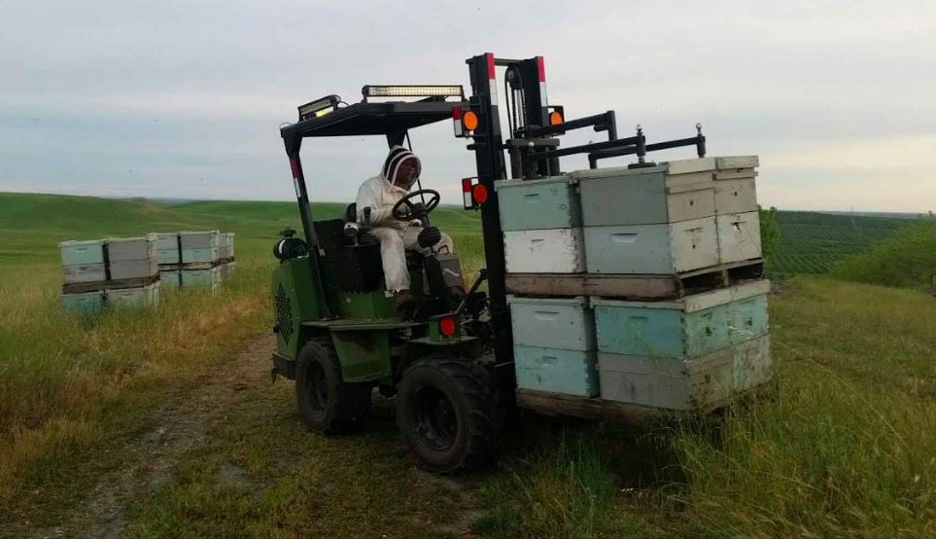
Introduction and Background
Every year in early February migratory bee farmers head to California for the annual almond pollination. Millions of hives are brought to the almond orchards and, as a byproduct of pollination, they create almond honey. Unlike the sweet flavor and smooth texture other honey varieties have, almond honey is very coarse and bitter. As a result, almond honey is thrown out because it is not marketable as edible. As the bee’s complete almond pollination bee farmers take their hives and migrate to the other crops that requires pollination services. Once pollination season is complete farmers return home and have their bees focus on nectar extraction. Nectar Extraction yields a sweet honey that the farmer can bottle and sell throughout the year until the next year’s almond pollination.
The profits from almond pollination season are very enticing to bee farmers. To remain competitive, they are compelled to raise at least 500 hives to start the season, and transport them long distances. Then they have to maximize their hive investment over less profitable crops for the remainder of the pollination season, often at a loss of profit and bees. Two externalities result from transporting bees long distances: many bees die from the stress of travel, and large amounts of CO2 are generated.
Migratory bee farming has both large-scale and small-scale sustainability issues. The occupation is becoming a large-scale sustainability issue because bee farming is becoming more and more risky with colony collapse from mites, pesticide use, and disease. Without bees, plant biodiversity all over the world would be diminished and people’s diets would be significantly changed. This is because 30% of the worlds crops and 90% of the worlds wild plant vegetation is dependent on bee pollination (Sass).
Bee farmers and scientist have been witnessing bee populations dwindle the past few decades, mostly from colony collapse. Colony collapse is where normal, healthy honey bees abandon their hives suddenly and disappear. Since 1990, over 25% of managed bee populations all over the world have disappeared (Sass). This has affected agriculture economies, human, and plant populations all over the world. With the disappearance of honey bees, the agriculture sector worldwide is losing around $5.7 billion dollars per a year (Sass). Communities are losing access to multiple bee pollinated plants such as apples and blueberries, and farms that are producing are increasing the prices for their crops. In addition, wild vegetation is also at risk. Diverse plant species are also declining and in accumulation with increased prices on healthy fruit and vegetables that are dependent on bee pollination, a global social issue emerges.
These large-scale sustainability issues are also linked to major sustainability concerns such as global warming, habitat loss, and pesticide use because they are the three main factors that are believed to be directly associated with colony collapse and stress in hives. With more hive stress, the more vulnerable the bees become to disease and mites. If bees continue to be stressed not only by the previously mentioned factors but by almond pollination, farmers will either be unable to afford to keep up with pollination demand and hive counts, or almonds will no longer be pollinated at the scale they are today. Almonds are a huge cash crop for California, and a fall in almond production could have great affects in the United States food system overall.
Migratory bee farming has small scale sustainability issues in that the bee farmers collectively throw out large amounts of almond honey every season, making the entire process wasteful and inefficient. Migratory bee keeping business models also rely solely on almond pollination service fees making their entire industry and business model risky and vulnerable to changes in crop production and colony health which is a growing problem worldwide.
Project partners are interested in uncovering ways that they can diversify their income and decrease waste in their business models to make their businesses more resilient and maintain hive counts year-round. There are no clear solutions to this complex sustainability problem but the first step is to analyze where one could start to increase income for bee farmers and how that increase can help bees.
Additional sales from honey are usually used to maintain or increase hive counts and spread revenue opportunities throughout the year. With added income from almond honey sales, bee farmers can utilize what all or some of their bees have been creating for months and use it to diversify sources of revenue.
Honey, regardless of flavor, has been used in many products such as lotion and hair products due to its antibacterial and antioxidant rich properties. The goal of this project was to analyze the costs and benefits of bottling almond honey to sell for purposes other than food and to bridge a connection between the bee farms and almond honey buyers, such as those that can use it in beauty products.
This project focused on minimizing waste and creating a more sustainable business model for bee farmers by discovering alternative outlets for almond honey. This is an important project in that it will help sustain bee farmers, global bee populations, and the global food supply chain. Additionally, the results of this project add to a growing field reevaluating wasted agricultural byproducts.
Environmentally this project involves building sustainable hive counts for bee farmers at a time when bees are experiencing multiple issues such as colony collapse and disease. In addition, this project will look at one of the migratory bee businesses social costs, i.e. wasted almond honey, and find a new marketable use for it to build a stronger economic and environmental business model. Economically this project protects and sustains bee farming by increasing honey sales that will be used to increase hive counts. It also will allow bee farmers to create new revenue streams and build a new customer base. Lastly, this problem touches on equity by helping bee farmers gain more benefits from the stressful and risky business of almond pollination.

Hives being unloaded from a flatbed truck.
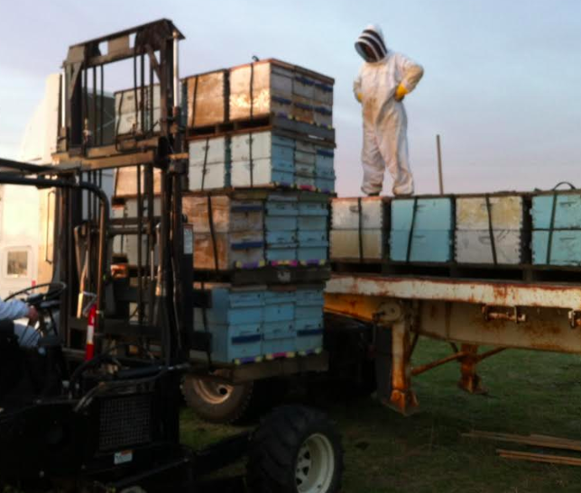
Literature Review
Almond pollination is the start of the season for bee farmers and it is usually the most stressful time of year due to competition and seasonal stress from trying to increase hive counts from winter losses (Rucker et al., 2012). Many bee farmers only participate in the California almond pollination because of its large payout for pollination services that sustain their businesses year long. Usually when bees are pollinating flowers they are also extracting nectar to make honey, or food for their hive. The farmer then takes excess honey, bottles it, and sells it for extra income. However, farmers who attend almond pollination usually discard any excess honey because it is bitter in taste and is unmarketable for human consumption (So Where is All the Almond Honey?, 2013). The farmers then move on to nectar extraction for the remainder of the year to increase honey production for increased honey sales. This process costs almost as much as the revenue received from honey sales. This business model is highly unsustainable because it is dependent on only two streams of revenue from two variable commodities, almond production and honey production. It is also highly wasteful and is not optimally efficient.
Almond crops are dependent on bee pollination in order to produce quality nuts and abundant yields, however, bee farmers and hive counts are also dependent on almond orchards for pollination fees (Cheung, 1973). Bee farmers make the majority of their yearly income through pollination fees, with the highest fees being paid by the almond industry (Cheung, 1973). This is because almond orchards require more hives per acre than other pollination plants and almonds, a multibillion dollar a year industry, depends solely on bees for pollination (Champetier, 2010). The large amount of money bee farmers receive from almond pollination goes towards building up hive counts from seasonal, natural, and exhaustion loss as well as the travel expenses and other costs bee farmers pay out through pollination and honey season, including personal income.
Almond pollination begins in mid-February and lasts for about three weeks. After almond pollination is done, bee farmers will travel to other pollination sites or take their bees to fields or other farms for nectar extraction (Regan, 2017). Nectar extraction is the beginning stages of honey making which is the bee farmers secondary, and less lucrative form of income after almond pollination. Nectar extraction is usually less lucrative for bee farmers because they are either getting paid very little or nothing at all to place their apiaries on a crop farmers land in order to produce flavorful honey for the market (Cheung, 1973). Extraction fees, bottling and labeling, limit profits on sales from honey sales. Consequently, farmers rarely do better than breaking even on honey production.
Depending on the bee farmers calendar and the soft fruit and blossom schedule for a particular year, a bee farmer could provide pollination services and receive both pollination fees and nectar for honey production (Cheung, 1973). However, the pollination fees would be minimal compared to dryer blossoms such as almond flowers. This is mainly because soft fruit does not solely depend on honey bee pollination and bee farmers aren’t compensated as much because their bees are getting nectar instead of money in the process. Therefore, bee farmers would still be exerting their bees and their business for their smaller secondary income to grow minimally.
Many bee farmers participate in almond pollination because it is the only source of income that can sustain their migratory businesses year long. Bee farmers from early February till late September are on the road with their bees traveling from farm to field either pollinating crops or extracting nectar for honey production. Blossom season is relatively quick for crops and therefore, farmers and their bees do not stay in pollination fields for more than a few weeks. Travelling can be costly and exhausting for farmer and bees and the number of variables and costs are always different. Therefore, the most significant way to increase income for bee farmers would be to increase honey sales during pollination time for high paying crops such as almonds.
Currently, not a lot of research is being done on almond honey use, or byproducts from bee keeping. Most research is on the economics of bee keeping, pollination and nectar extraction fees. When looking at eco-ingredient supply stores there are several almond honey products for sale which shows that there is a use for almond honey and a market for it (Almond Honey, n.d.). Honey contains antioxidants and is an anti-inflammatory that can be used for multiple purposes regardless of taste (Pletcher, 2015). One such use for bitter honey is to use it in hair, skin, or other beauty products, where the health benefits can still be utilized. Therefore, to increase revenue, farmers who participate in almond pollination should market almond honey to beauty supply stores. This will diversify their revenue streams and contribute to more environmentally friendly products. Their businesses will be more sustainable and they can be an example of how other agro-economies can build business models around agricultural byproducts.

Hives in an almond orchard.
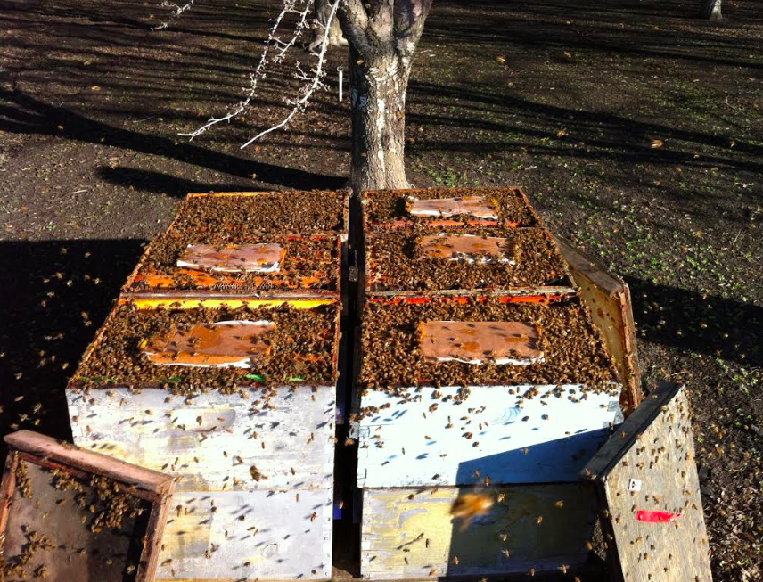
Current Conditions
A migratory bee farmers year is divided into four seasons; early spring, late spring, summer, and winter. Early spring begins in February with almond and cherry pollination. It is at this time that pollination fees are at their highest and the bee farmers income is the most lucrative. In late spring, bee farmers travel to farms where their bees can pollinate soft fruits such as strawberries and blueberries. Pollination fees are still received during late spring due to the dependence of some fruit on bee pollination. However, pollination service prices are much lower than they are for almond pollination because not as many bees are required for pollination. Late spring and summer are when bees are making the most honey and bee farmers are paid very little or nothing at all by crop farmers because they are getting honey in return and late season crops do not depend on bee pollination. In addition, not as many hives are needed per an acre with later season crops, making pollination service fee income much lower. After migratory bee farmers complete their trips in the summer, they head back to their wintering grounds to extract and bottle honey and do maintenance on colony health (Rucker et al., 2012).
A migratory bee farmers income is dependent on almond pollination fees, non-honey pollination fees, and honey sales. These fees correspond with the bee keeping season (early spring – almond pollination fees, late spring – non-honey pollination fees, and summer – honey sales) but also correspond to the amount of money being made each season. The bee farmers income starts out high and drops towards the end of the year. Looking at figure 1, taken from Rucker et al.’s 2012 paper, “Honey Bee Pollination Markets and the Internalization of Reciprocal Benefits”, one can see the stark difference between early season crops such as almonds, non-honey/mid-season crops such as cranberries, and honey/late season crops like clover.

Figure 1: Average Pollination Fee per Crop in 2012

(Rucker et al., 2012)

Through interviews with migratory bee farmers, it is believed that the bee farming business is dependent on almond pollination services. The belief is brought on not only by the high price per hive, where in 2017 pollination fees per a hive for almond pollination were around $185, but also because of the hive density required to pollinate almond orchards (Goodrich, 2018). Previously mentioned it takes about 2 hives to pollinate an acre of almond orchards. Compared to other non-honey crops as well as honey crops the number is doubled. Almonds are also more dependent on honey bee pollination than later season crops as well because of their dry flowers (Cheung, 1973). Without bee pollination almonds will not be produced, which leaves almond farmers to pay almost any amount for pollination services.

Figure 2: Hive Densities per Crop
0 .5 1 1.5 2 2.5
(Rucker et al., 2012)

Looking at figure 2, based on densities, more hives in the start of the season are beneficial for almond pollination and cranberry pollination. However, while traveling, competition between bee farmers grows more intense because less bees are needed for pollination, and the large number of hives the farmer started out with are more difficult to place. This situation can sometimes increase the distances traveled by a bee farmer to move their bees to a new field, or can make pollination fees drop when the crop farmer pays whichever bee farmer will take the lowest pollination fee. In addition, migratory bee farmers must do a lot of colony maintenance on the road and will suffer from loss and theft along the way. This makes the process of bee keeping much more expensive. In addition, travel costs such as diesel, hotels, food, and supplies can be very expensive.
During interviews with bee farmers, it was suggested that the early and late spring seasons can be very wasteful. This is because during the early spring, bees are pollinating almond flowers which do not produce sweet edible honey. After two to three weeks in the almond orchard’s bees are sent to other dry flowering plants such as apples, and later focus on other non-honey making crops. During these first two seasons, farmers are discarding honey that is being made because it is either inedible or the farmer is too busy on the road to extract it. On average, one hive can produce about 40 pounds of honey every year (Kramer, 2018). With 52 weeks in a year that is just under one pound of honey made a week per one hive or colony. When a bee farmer starts bee season with 800 hives for almond pollination, assuming they continue to use 800 hives for the rest of the season (8 months or 34 weeks at 0.77 pounds of honey a week) and all hives are producing, over 20,000 pounds of honey can be made just during bee season (See appendix A).
Currently, however, bee farmers interviewed are not producing anywhere near this amount of honey because they do not constantly use 800 hives for every crop they extract nectar from and bees are eating the honey for food as well. The rest of the season bee farmers will split their hives to focus on non-almond pollination and nectar extraction for honey production. In addition, the quantity of honey varies depending on crop, crop availability, hive numbers, weather, and many other variables. Using a rather boastful estimate from farmers interviewed, every hive used in nectar extraction will make about 15 pounds of honey every season. On average around 200 hives will be used for nectar extraction, making possible honey production at 3,000 pounds a year. The rest of the farmers bees will continue non-almond pollination, where the farmer will make more money than they would focusing solely on honey production.
Extracting honey can be very expensive and time consuming, especially with a large number of hives. A small number of hives is used for nectar extraction for two reasons. One because collecting honeycombs and extracting honey is very labor and time intensive. Collecting and extracting honey from 800+ hives would take a lot of time and be very expensive for both the farmer and the consumer. Second, even if a farmer could extract thousands of pounds of honey they would not be able to sell that amount of honey at a competitive price to their normal market.
This situation brings an interesting opportunity for farmers that participate in almond pollination. Almond pollination allows farmers to use the majority or all of their bees, who while pollinating almonds are making honey. Almond pollination also allows the farmer to ask for high pollination fees from almond farmers to cover all expenses such as hiring pollination service companies to place and monitor bees in almond orchards. If bee farmers increased their pollination services to include paying pollination service companies to extract honey while taking the bees out of the orchard, almond honey could be bottled and less honey would be thrown out and wasted. However, it is assumed that if farmers receive almond honey in return for almond pollination services, then the pollination fee will go down. Fortunately for bee farmers, because almonds are completely dependent on bee pollination and require greater densities of bees than any other crop, the pollination fee would not go down. According to pollination companies interviewed, the demand for almond pollination services are almost entirely inelastic in economic terms.
The idea of being able to bottle and sell almond honey during a bee farmers most intense use of his hives and for a price that is partially subsidized by increased pollination service fees for almonds, is what led project partners to investigate further how this could work and who they could sell inedible almond honey too. After consumption, honey is used for medicinal care and beauty products. Therefore, this project focused on the feasibility of marketing inedible almond honey to the beauty industry. The goals of this project are to move bee farmers away from differential seasonal pay based off of bee activity, and to increase honey sales throughout the year to make bee farming more economically sustainable and less wasteful.

Night time hive delivery to the almond orchards.
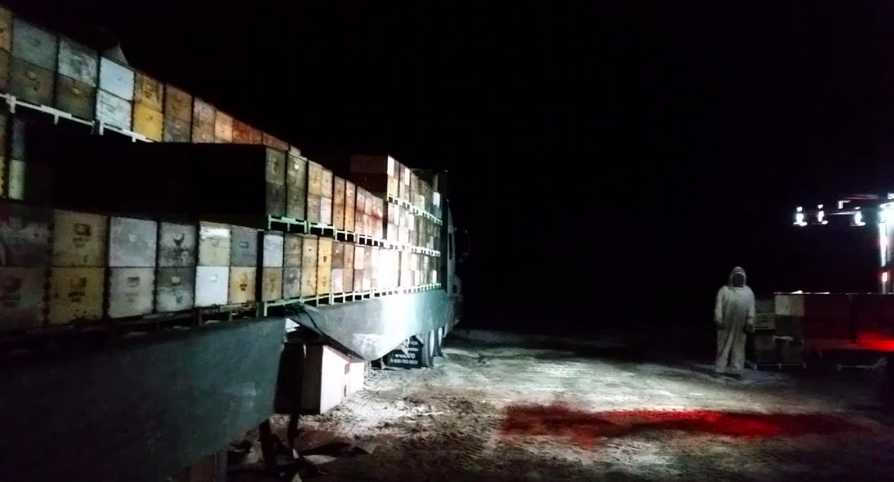

Project Approach and Intervention Methods
In order to understand the sustainability issues within almond pollination this project first determined what the typical bee farming and pollination services business model looked like. A business model is used by businesses to understand their product, their competitors, their customers, and overall their businesses better. It allows for the analysis of the entire business and helps better spot deficiencies and possible solutions. The almond pollination service business model was created by shadowing and interviewing a project partner bee farmer that participates in almond pollination in California. Using the Canvas Business Modeling Template (See figure 3), I was able to map out what a typical pollination service business model looked like.

Figure 3: The Canvas Business Modeling Template
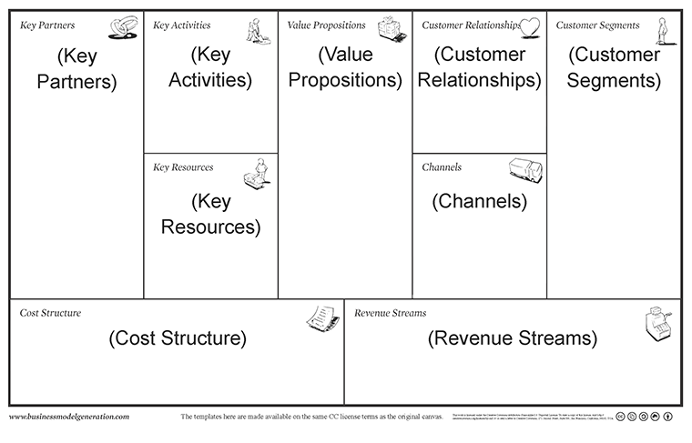
This also helped me understand the pros and cons of the bee business as well as the processes these farmers go through to prepare for almond pollination and then come back from it.
Next, I analyzed the current business model and did a cost-benefit analysis of bottling almond honey and selling it. Costs were determined by interviewing and speaking with both project partners and conducting research on pricing for different types of honey (See figure 4).

Figure 4: Average Retail Price Per Pound of typical Honey from Bee Culture magazine
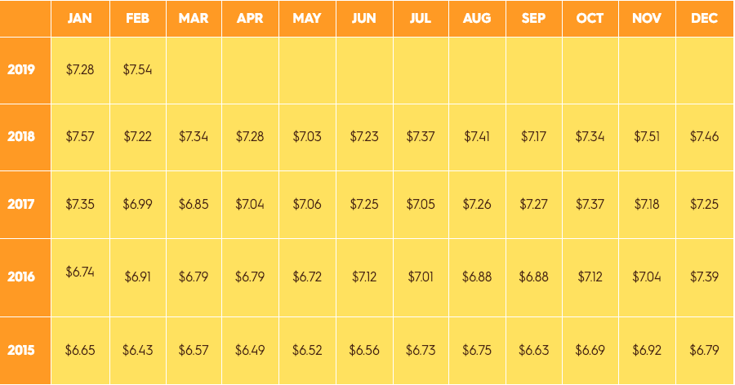

Benefits were determined by impacts (less waste), business connections and revenue streams created, as well as benefits assumed by farmers and companies involved in almond pollination.
After creating the cost benefit analysis of bottling almond honey a new business model was created using the Canvas Business Modeling Template again. The new business model allowed me to create a Business Process Management (BPM) System (See Figure 5) that farmers will be able to implement in order to sell almond honey as a beauty product ingredient. A BPM is a tool used in project management to optimize, improve, and analyze business processes, such as almond pollination. To close out the project I delivered the final project report with my created business model, BPM, list of supply buyers, and list of next steps to my clients.

Figure 5: Example BPM Template
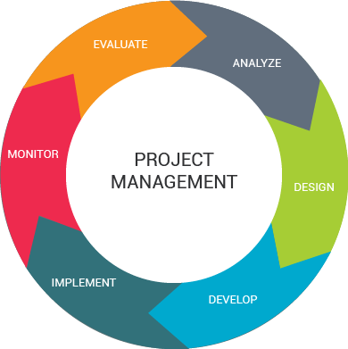
Source: Software Clip Art Project BPM https://dumielauxepices.net/wallpaper-3134942

8-frame bee boxes holding thousands of bees
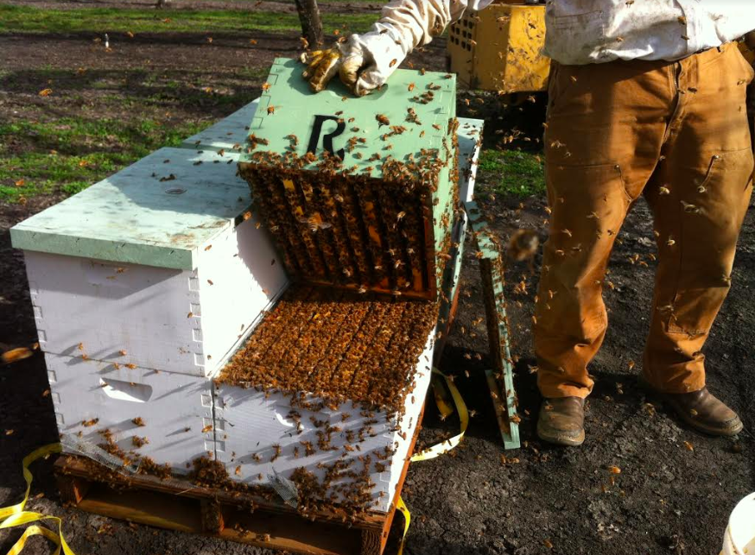
Implementation
The Arizona bee business analyzed for this project uses an almond pollination service company to pick up around 800 hives and transfer and place them into California almond orchards for two weeks in February. The bee farmer then has the pollination company bring back his hives where he splits them into two groups. One group will stay in Arizona until wildflower season begins in the state, or will wait for wildflower season in Colorado to begin nectar extraction. The other group will be put onto a rented flatbed truck and will travel to Oregon, Washington, and the Dakotas working on non-almond pollination services. This group of bees, through stress, travel and theft, will be replenished with stock from the first group as the season goes on. During the summer season, bees in the second group will head home and join the first group in nectar extraction to make honey. Then, when most blossoms have died, all bees will retire to the wintering grounds for the rest of the year.
Figure 6 shows a basic business model for bee farmers that participate in almond pollination. It was created by interviewing both project partners and following the Arizona bee farmer’s seasonal summary above.

Figure 6: Business Model Canvas – Typical Bee Farmer Business Model
Key Partners  Farmers – Pollination Services (Almonds and non-almonds)  Pollination service companies for almond pollination  Truck rental companies  Farmers – Nectar Extraction Services (Soft Fruit, Grasses, Clover)  Supplier – Bee/Hive supplies  Supplier – Honey bottling supplies  Buyers – Edible honey buyers | Key Activities  Maintain hive counts  Migratory pollination services for multiple crops a season  Sell edible honey | Value Propositions  Farmers need or depend on pollinators  People enjoy eating honey or using honey for other purposes. |  | Customer Relationships  Direct customer interaction – monitor hives personally  Use pollination service company during crop season  Direct customer interaction – farmers markets during late spring and summer  Online interactions – sell honey online or have crop farmers use website to order services  Seek out crop farmers through word of mouth or pollination service coordinators | Customer Segments  Buyers of edible honey  Farmers that need/depend on pollination services.
Key Resources
Large number of hives
Almond pollination participation
Edible honey
Flatbed trucks/pollination service company
Extraction equipment
Channels
Direct customer interaction (farmers markets and bringing bees to farms)
Online (business website and Instagram)
Referrals
Cost Structure  Travel, maintaining hive counts, hive supplies, bottling supplies |  |  | Revenue Streams  Pollination services (almond and non-almond) honey sales
Social & Environmental Cost  Intense travel and honey waste |  |  | Social & Environmental Benefit  Maintain bee populations and maintain almond yields
Components Identified by Project Partners:
- Key Partners: Key partners are the key people the bee farmer interacts with both for income and costs in their business.
- Key Activities: Key activities are the actions taken by the bee business to be competitive as well as a viable business.
- Key Resources: Key resources are the resources that are needed to do key activities such as having a large number of hives for maximum pollination service profits (Cowan, n.d.). In addition, participation in almond pollination is listed as a key resource because the pollination fees from almond pollination are believed by the bee farmer to be required to stay in business.
- Value Propositions: Value propositions are the reasons why customers interact with the business.
- Customer Relationships: Customer relationships are the ways in which the bee business and their customers interact.
- Customer Segments: Customer segments, are the businesses main customers.
- Channels: Channels are the ways the bee business delivers and sells their products. (An example of the difference between a channel and a customer relationship is that a customer relationship would be direct interaction with crop farmers when placing bees and a channel would be direct interaction with honey buyers at a farmer’s market.
- Revenue Streams: Revenue streams are straightforward and are the activities done by the business that make the company money.
- Cost Structure: The cost structure includes all the costs the business pays to perform activities that contribute to revenue streams.
- Social & Environmental Costs and Benefits: Social and environmental costs and benefits are included in the business model and show what the bee farmer believes are the unsustainable and sustainable practices of their business. For example, a social and environmental costs is the amount of travel the bee farmer does between pollination fields as well as the honey wasted every season when bees are on the road.

Because bee farming is a migratory profession, the only social and environmental cost project partners identified that their businesses can try to correct is the waste that is produced during pollination season, particularly almond-pollination season when most of their bees are working on making something that will be thrown out. Almond honey, because it is distasteful, cannot be sold to the farmers usual honey buyers. However, it still maintains the same benefits such as antioxidants, vitamins, and amino acids that other honey has (Burt's Bees Ingredients - Honey, n.d.). Thus, this project focused on determining the marketability of almond honey to beauty supply companies.
To determine the marketability of almond honey to beauty supply companies a cost-benefit analysis was done listing both social/environmental and economic factors. As mentioned previously, benefits were determined by impacts (less waste) and business connections and revenue streams created. Costs included waste (time), new expenditures, and any loss of revenue. Figure 7 below was created with the help of this project’s bee farming partner through informal interviews and shows potential costs and benefits of bottling almond honey to sell. The cost-benefit analysis also shows two scenarios that were determined to be the only scenarios that would allow bee farmers to obtain almond honey after almond season.
By looking at figure 7, it is believed by the farmer that the costs, although less or equal in number, are more intense and far outweigh the benefits suggesting that bottling and selling almond honey should not be done. However, by listing potential costs, the business owner can determine ways to mitigate the costs so that the benefits become far greater.
As mentioned previously, the costs and benefits were first separated into two scenarios. The two scenarios were chosen because they were the only options that allowed the farmer to maintain most of the same processes they already carry out during almond season. The first scenario involves the pollination service provider, or an alternative company, extracting honey for the farmer while completing almond pollination in California. The other scenario involves having the farmer extract the honey themselves back home. By speaking with both project partners, this service would incur two to three fees, a labor fee per a hive, an extraction fee, and potentially a new frame fee if the process needed to be expedited. An expedited service would be more expensive but preferable to the farmer so that they could remain on schedule with their pollination services schedule.

Figure 7: Cost-Benefit Analysis of Bottling Almond Honey for Beauty Supply Sales
Costs | Benefits
Scenario 1 | Scenario 1
Pay pollination service company to remove honey combs and extract honey | Pay pollination service company to remove honey combs and extract honey
- An added fee will be applied for this service | - Less honey wasted
- Will delay migration schedule and miss out on pollination service fees for other early season crops | - Potential increase in honey sales
- More money spent on bulk bottling | - New market created
- More energy spent on finding buyers and marketing special type of honey | - New value proposition: beauty product ingredient sales and new customer segments
- Potential that almond honey is not marketable due to cheaper alternatives (edible honey or beeswax) | - Encourage use of “unusable” agricultural byproducts
 | - Potential to increase hive counts with added income from honey sales early on in season.
Scenario 2 | Scenario 2
Remove and extract honey once hives return home | Remove and extract honey once hives return home
- Will delay migration schedule and miss out on pollination service fees for other early season crops | - Less honey wasted
- Will need to remove honey comb and put bees in new boxes (time waste and new expenses) or wait for honey to be extracted to replace frames (time waste) | - Potential increase in honey sales
- More money spent on bottling more honey and labeling it | - New market created
- More energy spent on finding buyers and marketing special type of honey | - Encourage use of “unusable” agricultural byproducts
- Potential that almond honey is not marketable due to cheaper alternatives | - Potential to increase hive counts with added income from honey sales early on in season.

The pollination service company that was interviewed for this project unfortunately could not determine a price for this service because they do not provide extraction services and do not have the resources. However, by explaining the process of how honey is extracted, it can be assumed that the fees would be somewhat high for the service and more difficult to mitigate as a total cost of bottling and selling almond honey.
To extract honey the frames in the bee boxes are removed and beeswax is taken off of the honey cells (Greens, 2014). The frames are then put into an extractor and spun until the honey has collected at the bottom of the machine. The honey is then filtered and left for a few days to settle and allow for separation of honey and non-honey product. Once the honey has settled, the film on top is removed and the honey is either bottled immediately, or stored in 5-gallon buckets.
In order for the pollination service provider to provide honey extraction services the company would need to determine which farmers bees will be going through the extraction process (when every farmer brings on average 800 hives), then remove around 7-10 frames per a hive. Removing the beeswax from the honey comb is usually done by hand and an extractor, or multiple extractors, would need to be purchased to spin out the honey. It would also be difficult for the pollination service company to keep different farmers hives and honey separate from each other. Therefore, the extraction process most likely will not be done by the pollination service company and would need a new extraction company which does not exist. In addition, even if this type of company existed the total time to remove bees and replace the frames would delay pollination services for other early season crops which is missed revenue for the bee farmer.
Moving to scenario two which still includes the time delay in pollination schedules a mitigation technique could be used to remove some of the costs in bottling almond honey. Since farmers already split their returning hives into two groups, one to continue to early season crop pollination, the others to await wildflower season, half of the hives could be used for almond honey extraction and the other half could continue business as usual and travel to other pollination crops. This situation allows for very little if any extra work on the bee business’ part. There will be no more delays, and the almond honey is usually thrown out or left in the hives already. There would be the need for more purchased bee food but since the price is so low, it was left out as a cost because it is so minimal. In addition, since hives are regularly checked, the least productive hives, or the ones with the least almond honey, can be put on the truck for non-almond pollination services, and the more productive hives can stay for extraction. This process would leave the only costs being the additional bottling costs, additional energy spent on marketing almond honey or finding buyers, and the potential that almond honey will not sell. Two of these costs, however, are further examined in this report to determine how big of a cost they may be.
Benefits are the same regardless of scenario and mainly depend on adding a new value proposition, new/increased revenue streams, adding a new customer segment, and decreasing waste and increasing hive counts with added income. These benefits were then used to build a new business model that adds almond honey sales as a new product (See figure 8).

Figure 8: Business Model Canvas – Typical Bee Farmer Business Model + Almond Honey
Key Partners  Farmers – Pollination Services (Almonds)  Farmers – Nectar Extraction Services (Soft Fruit, Grasses, Clover)  Supplier – Bee/Hive supplies  Supplier – Honey bottling supplies  Buyers – Edible honey buyers  Buyers – Almond honey for beauty products | Key Activities  Maintain hive counts  Migratory pollination services for multiple crops a season  Sell edible honey  Sell Almond honey | Value Propositions  Farmers need or depend on pollinators  People enjoy eating honey or using honey for other purposes.  Need for honey for use in beauty supplies |  | Customer Relationships  Direct customer interaction – monitor hives personally  Use pollination service company during crop season  Direct customer interaction – farmers markets during late spring and summer  Online interactions – sell honey online or have crop farmers use website to order services  Seek out crop farmers through word of mouth or pollination service coordinators  Seek out beauty companies that use almond honey | Customer Segments  Buyers of edible honey  Farmers that need/depend on pollination services.  Buyers of almond honey for beauty products
Key Resources
Large number of hives
Almond pollination participation
Edible honey
Flatbed trucks/pollination service company
Extraction equipment
Almond honey
Channels
Direct customer interaction (farmers markets and bringing bees to farms)
Online (business website and Instagram)
Referrals
Cost Structure  Travel, maintaining hive counts, hive supplies, bottling supplies |  |  | Revenue Streams  Pollination services (almond and non-almond) honey sales (almond and non-almond)
Social & Environmental Cost  Intense travel and less honey wasted |  |  | Social & Environmental Benefit  Maintain bee populations (greater) and maintain almond yields, use of wasted almond honey, encourage use of agricultural byproducts

The new business model was created in order to help build the BPM (See figure 9) which helps determine and improve upon a business strategy such as selling almond honey. The BPM has six steps and moves through the process of extracting and selling almond honey. For this project the implantation and monitoring steps will not be used because implementation and monitoring are outside the time frame for this project. Project partners are also interested in the design and development of selling almond honey before they attempt to implement or monitor the actuality of extracting almond honey for selling purposes.

Figure 9: BPM

Evaluation
The first step is evaluation and considers what part of the bee farming business model can be improved upon. For this project we are targeting the wasted honey from almond season. We have determined there is significant waste due to the large number of hives each farmer brings to almond pollination every year. We have also discovered that there are both costs and benefits to extracting and selling almond honey but have evaluated possible scenarios where costs can be mitigated or minimalized. However, an analysis of the product, the bee farm, and the buyer must be done in order to design and develop an approach to selling almond honey that is profitable for the farmer, decreases almond honey waste, and can be implemented in the future by bee farmers that participate in almond pollination.
Analyze
First, to understand if a bee farmer can sell almond honey it must be determined how much almond honey can be extracted. Using scenario two from the cost-benefit analysis, where the farmer brings home his hives and splits them, taking around 500 on the road for pollination services and leaving round 300 for nectar extraction, it can be assumed that only the hives left can be extracted for almond honey. Looking at appendix B: How Much Almond Honey Can be Bottled and Sold, we can see that the estimate of almond honey available in the hive for extraction is about a quarter pound, which is much less than other crops due to the dryness of the almond flower. Therefore, with 300 hives being extracted, the farmer can produce about 75 pounds of almond honey to sell.
After the honey has been extracted it costs about $0.88 to bottle one pound of almond honey (See appendix C-2). Therefore with 75 pounds of almond honey it would cost the farmer around $66 total to bottle each pound. However, when speaking with honey buyers, most buyers purchase honey in 5-pound buckets because they use large quantities to make things such as shampoo and facial care products. Therefore, this price could be mitigated if bee farmers only sold almond honey in bulk. In addition, one of the supply buyers interviewed disclosed that she brings back the buckets and bottles she purchased full of honey so that she can get a small discount on the product, something that could be utilized by the project partner bee farmer.
Looking at the buyer’s side, the average price per a 5-pound bucket of typical honey purchased is around $50. To make almond honey competitive it would have to be less than or equal to this price. In addition, it would have to compete with beeswax, which is used more frequently in beauty products for skin. The average price paid for 5-pounds of beeswax by beauty supply buyers interviewed is around $60 and therefore, almond honey in the same quantity should never go above this price.
Lastly, it is important to consider the practicality of extracting almond honey that cannot be sold for more than the price of typical honey or beeswax. The purpose behind this project is to understand the waste in almond pollination, as well as to determine a use for wasted honey that will help the farmer increase their profits, diversify their revenue streams, and introduce the bee business to new supply buyers. Looking at Figure 10 and 11 we can see that the assumption that almond pollination services dominate the profitability of bee farming is correct. But we can also determine that 75-pounds of added almond honey sales will not dramatically change this data (See appendix D-2).

Figure 10: Gross Revenue and Expenses by Revenue Stream

Figure 11: Revenue Stream – Percentage of Total Income (Gross)

In addition, most bee farmers keep the almond honey in the hives to feed their bees so they do not have to use additives during transition periods. Therefore, the main question is whether it is practical to increase labor and disrupt the current business model to sell 75-pounds of almond honey. To answer this question several honey supply buyers that own shops using honey in beauty products were interviewed on their interest in buying almond honey. The majority interviewed would buy almond honey if it were less than the current price they were paying for typical honey. Three shops were interested in the honey because they believed in reducing waste and supported the idea of using discarded honey. All businesses interviewed however, were most excited about building a business connection between the supplier and their businesses, especially with local bee farmers. Therefore, the answer is yes, if the bee farmer sees a benefit in adding more key partners into their business model, with a social and environmental goal of reducing honey waste in their businesses.
Design and Develop
Although the analysis shows that selling almond honey will not diversify income as much as was originally hoped for, almond honey has the potential to connect new customers with bee farmers. Therefore, the design and development stage focused on processes that allow for better customer interaction and better products for the customer. The BPM design and development phases allow for a visualization of the process that has been uncovered earlier to extract and sell almond honey and connect bee farmers with honey buyers. It also showed optimization steps and next steps for the bee farmer. In addition to selling directly to the buyer, the project partner is interested in looking into the potential of a co-op for bee products such as typical honey, almond honey, and beeswax. Both of these processes have different advantages for the customer.
The figure below shows the time frame and process of extracting and bottling almond honey. Selling almond honey directly to a buyer would create direct customer interactions that allow for relationship building. The bee farmer also receives all profits and does not have to pay any other fees besides extraction costs and bottling costs. If the bee farmer decides to participate in a co-op there would be less competition between farmers with the same products (Cooperative Benefits, 1990). In addition, there is the possibility for almond honey to be sold at a higher price than it would be sold if the farmer directly sold the product to the customer. Co-op’s have also shown to be helpful in developing new markets for new products, which would be beneficial for almond honey due to its reputation of being unusable (Cooperative Benefits, 1990). However, co-ops do not have strong customer relationships between individual farmers and buyers. They also include more fees and processes for the farmer.

Figure 12: Business Model Design with Almond Honey Sales.
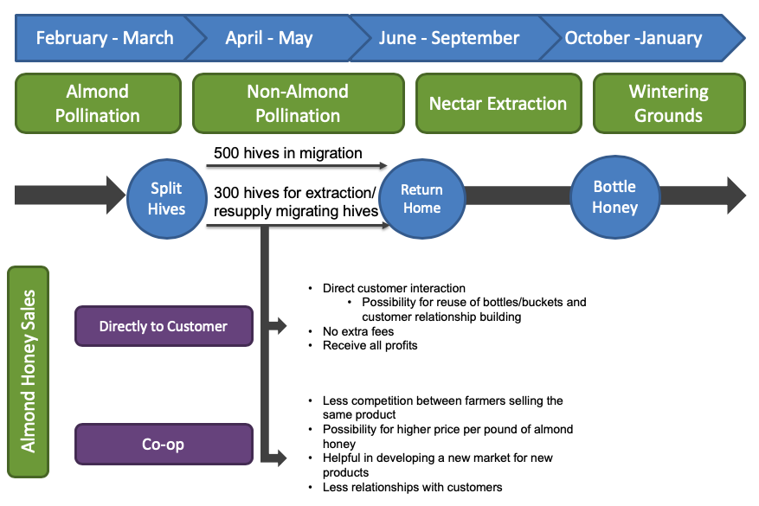
The design is followed the development of this process which includes next steps to implement the findings in this report and to test out the logistics and practicality.
Next Steps: Sell Directly to Customer
- Contact list of buyers supplied by this project
- Create buyer-seller relationship with typical honey sales and beeswax for remainder of current season
- Extract almond honey in February 2020
- Monitor success, failures of extraction process
- Send samples to supply buyers
- Monitor their happiness with product
- Determine if extraction process and product review are worth new business model
- If yes, continue new process.
- If no, maintain customer relationships but do not extract almond honey
Next Steps: Co-op
- Contact local bee association to determine if a co-op exists in the region or if there is member interest
- Determine how much almond honey can be produced from each farmer in co-op
- Create a pilot project for all farmers to extract some almond honey
- Determine successes and failures
- If successful, send samples to supplied list of buyers and others
- Determine happiness with product from buyer’s perspective
- If buyers are happy with product determine pricing for 5-pound buckets of almond honey
- Extract almond honey in February 2021
The success of both of these processes is determined based on two factors. The real-life implementation of extracting almond honey to sell, and the reception of the product by buyers. If this project were to be extended then the BPM would include the implementation and monitoring stages that would help perfect this business scenario and determine if almond honey extraction is worth it economically. Through the analysis, the individual farmer cannot diversify their revenue streams with almond honey sales alone, but they can create new connections with honey buyers. It is dependent on the bee farmer to understand the results of this project and determine if the venture is worth it.

The end of almond season. Pollination service worker reloading hives onto trucks.
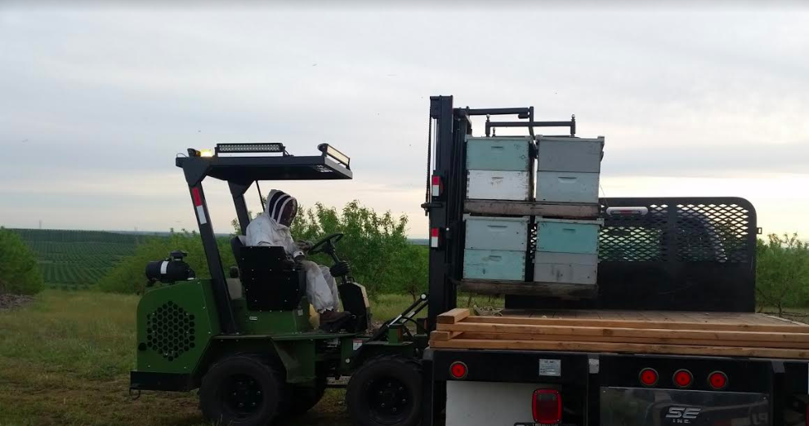

Results and Discussion
Through the BPM process we have discovered that bottling and selling almond honey does not diversify income to the point that bee farmers that participate in almond pollination are less dependent on almond pollination service fees. Selling almond honey is possible but only adds very little extra income that could be used to increase and maintain hive counts. This means that the bee business remains an unstable and unsustainable business economically. Waste is minimized with almond honey extraction but other early season crops such as cherries and apples also leave bees to produce honey that is usually thrown out or absorbed into later season crop honey. Unfortunately, with cherry and apple honey, the farmer does not have the ability to go home and leave some hives behind for honey extraction like they can with almond honey.
However, the BPM process has led to new connections between supplier and buyer. The Arizona bee business now has the contact information for several local honey buyers that are not only interested in almond honey, but typical honey and beeswax. Although this process did not find almond honey to be the answer to solving the migratory bee farmers waste and almond pollination dependency issues, it does bring up new ideas and opportunities for those in the bee industry. Some of these opportunities include a co-op for almond honey and other early season honey, as well as beeswax. Other opportunities include the possibility of an extraction business, similar to the pollination service companies in California that help place hives in almond orchards, where honey is extracted at the end of almond season from participating hives and sold for the farmer through the extraction business for a fee. Lastly, there is the possibility that farmers can earn extra income by starting a hive sponsorship program, where a donor sponsors a hive monthly or yearly and in return gets a bottle of honey from the hive. These sponsors could help increase and maintain hive counts as well as help honey bee conservation.
If this project were to be extended or redone, the marketability and practicality of extracting all early season crops should be the main focus. This would increase honey sales and be able to provide more yield of cheaper non-typical honey for buyers. However, the more honey made could potentially cause a decrease in pollination fees paid by crop farmers. Therefore, the project should focus on pricing, logistics, and include a pilot project for feasibility. Hopefully by implementing a pilot project, it will be possible to uncover ways to mitigate all early-season honey waste, and uncover ways the bee business could move away from almond pollination fees dominating their yearly revenue and be a more resilient and sustainable business.
Farmers picking up their hives from the almond orchards at the end of almond season.
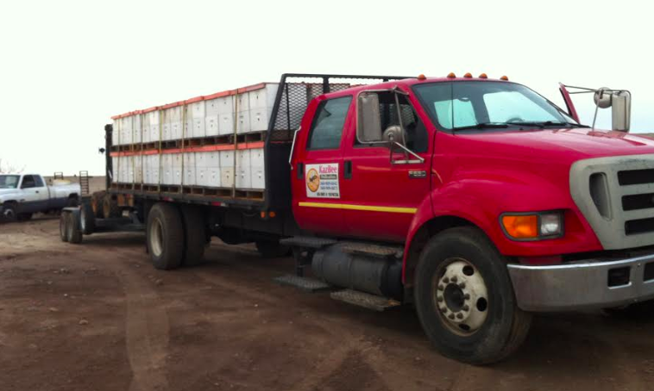
Conclusion
The main goals of this project were to diversify revenue streams for an Arizona bee business that is dependent on almond pollination fees and to minimize waste in the almond pollination business in order to become a more sustainable and resilient business. These small-scale goals would help increase income for farmers that would help maintain and build up hive counts that are lost during bee season and also aid in honey bee conservation at a time when honey bees are experiencing hive collapse and disease.
Long-term goals for this project were to inspire other agricultural businesses to reevaluate their wasted byproducts and determine a way to reduce waste in their business models. Evaluating a business’s waste through business modeling allows companies to see how to use waste in an alternative way that could save money or create new sources of revenue and even help develop a new market that is based off of natural byproducts that are usually considered waste. Unfortunately, almond honey extraction and almond honey sales are not enough to completely diversify the bee business’s revenue streams but the idea does create less waste in the industry and did uncover new potential buyers of products the business already makes.

Appendix
Appendix A: Pounds of Honey a Week
Pounds of honey per year on average per hive |  |  | 40
Weeks in a year |  |  | 52
Weeks in a season | February - September |  | 34
lbs/wk | 40/52 |  | 0.77
# of viable hives |  |  | 800
Lbs of honey a season per 800 hives | 34 x 0.77 x 800 |  | 20,923

Appendix B: How Much Almond Honey Can be Bottled and Sold?
Number of hives sent to Almond Pollination | 800
Number of hives left home for nectar extraction or number of hives not needed for next most profitable pollination service | 300
Approximate lbs of almond honey per a hive (using 7-10 frames) | 0.25
Pounds of almond honey extracted using bees left at home | 75

Appendix C-1: How much does it cost to bottle honey?
Jar | 15.95 for 24 1 lb jars | $ 0.66
Label | .17 cents per label | $ 0.17
Extraction Labor (if not done byself) | $11/hour
Number of hives extracted per hour | 3.5
Number of hives extracted per season | 800
Total Labor cost | (800/3.5)*11 | $ 2,514.29
Pounds of honey a season |  | 20,923
Labor cost per pound of honey | total labor cost/lbs of honey a season | 0.12
Bottling cost per a pound of honey | jar+label+labor | 0.95

Appendix C-2: How much does it cost to bottle almond honey?
Jar | 15.95 for 24 1 lb jars | $ 0.66
Label | .17 cents per label | $ 0.17
Extraction Labor (if not done byself) | $11/hour
Number of hives extracted per hour | 3.5
Number of hives extracted per season | 300
Total Labor cost | (300/3.5)*11 | $ 942.86
Pounds of honey a season |  | 20,923
Labor cost per pound of honey | total labor cost/lbs of honey a season | 0.05
Bottling cost per a pound of honey | jar+label+labor | 0.88

Appendix D-1: Profits and Expenses
 | Revenue | Expenses & Costs | Net Profit
Almond Pollination | $ 148,000.00 | 18,304 | $ 129,696
Non-Almond Polination | $ 61,050.00 | 56340 | $ 4,710
Honey Sales | $ 1,464.00 | 190.00 | $ 1,274
Total | $ 210,514.00 | 74,834.0 | $ 135,680.00

Almond pollination revenue is the number of hives a farmer brings multiplied by the pollination fee that year (2019 pollination fee is $185/hive)
Almond pollination expenses and costs are the pollination service fee per hive ($17) multiplied by the number of hives brought to almond pollination (800) plus freight fee of 5.88 multiplied by number of hives (800)
Non-almond pollination revenue is blueberry pollination fee multiplied by number of hives used plus clover pollination fee multiplied number of hives used plus cherry pollination fee multiplied by number hives used plus squash pollination fee multiplied by number of hives used
Non-almond pollination expenses and costs are gas + truck rental + food + lodging
 | Average gas price in US * miles traveled | 3.00/gallon | 4500 mi
 | Truck rental | 100*238 days
 | Food ($20/day*238 days)
 | average lodging (60/day*238)
Honey Sales revenue is about 200 lbs of honey sold a year at the 2018 average price per lb of edible honey pricing 7.32
Honey sales expenses and costs are bottling cost per pound of honey multiplied by pounds of honey usually sold

Appendix D-2: Profits and Expenses with Almond Honey
 |  | Revenue | Expenses & Costs |  | Net Profit
Almond Pollination |  | $ 148,000.00 | 18,304 |  | 129,696
Non-Almond Pollination |  | $ 61,050.00 | 56340 |  | $ 4,710
Honey Sales |  | $ 2,013.00 | 190.00 |  | 1,823
Total |  | $ 211,063.00 | 74,834.0 |  | $ 136,229.00
Appendix E-1*: Average price of typical honey in 5-pound buckets
55 | Quote 1
45 | Quote 2
47 | Quote 3
44 | Quote 4
58 | Quote 5
44 | Quote 6
49 | Average
Appendix E-2*: Average price of beeswax
58 | Quote 1
60 | Quote 2
62 | Quote 3
60 | Quote 4
55 | Quote 5
55 | Quote 6
58 | Average

*Estimates based off of interviews

Appendix F: Honey Supply Buyer Interview Questions Number of interviewees: 6
What kind of products do you make/sell that use honey?
Are there alternatives to honey that you use that are cheaper or more expensive?
Where do you get your honey from? Do you have a supplier?
How much honey do you use a year for products?
Would you consider using discarded almond honey? (Explain almond honey process)
Do you think using "unusable" honey could be a successful marketing tactic for a product you sell?
How much do you pay for honey?
How much do you pay for beeswax?
Are you interested in this project and building a business connection with farmers that participate in almond pollination?
Is there anything else you would like me to know wither bout your business or the supplier’s side?

Works Cited
Almond Honey. (n.d.). Retrieved from The Bee Folks: www.beefolks.com/shopdisplayproducts.asp?id=71&cat=Almond+Honey
Boers, D. (n.d.). Beyond the Risk Matrix. Retrieved from https://www.thereliabilityblog.com/2017/09/13/beyond-the-risk-matrix/
Burt's Bees Ingredients - Honey. (n.d.). Retrieved from Burt's Bee's: www.burtsbees.com/content/ingredients-honey/ingredients-Honey.html?navlvl=5.
Business Process Management. (n.d.). Retrieved October 2018, from dumielauxepices.net/wallpaper-3134942
Cheung, S. N. (1973). The Fable of the Bees: An Economic Investigation. The Journal of Law & Economics, 16(1), 11-33.
(1990). Cooperative Benefits and Limitations: Farmer Cooperatives in the United States. United States Department of Agriculture. Retrieved from United States Department of Agriculture.
Cowan, A. (n.d.). The 20 Minute Business Plan: Business Model Canvas Made Easy. Retrieved from Cowan+: www.alexandercowan.com/business-model-canvas-templates/.
Goodrich, B. (2018, January 1). 2018 Almond Pollination Market Outlook: Demand, Supply, and Contracts. Bee Culture the Magazine of American Bee Keeping.
Greens, L. (2014, October). How to Extract Honey from Honeycomb. YouTube.
Kramer, M. H. (2018, October 3). How to Make Money with Beekeeping: Theres Much More to it than Honey. Retrieved from The Balance Careers: www.thebalancecareers.com/making-money-with-bees-125660
Pletcher, P. (2015, February 9). The Top 6 Raw Honey Benefits. Retrieved from Healthline: www.healthline.com/health/food-nutrition/top-raw-honey-benefits
Regan, S. (2017, July 20). How Capitalism Saved the Bees. PERC, 36(2).
Ribes, A. C. (2010). The Bioeconomics of Pollination in Agriculture. Dissertation, Davis.
Rucker, R. R., & Thurman, M. B. (2012, July 1). Honey Bee Pollination Markets and the Internalization of Reciprical Benefits. American Journal of Agricultural Economics, 9(4), 956-977.
Sass, J. (n.d.). Why We Need Bees: Nature’s Tiny Workers Put Food on Our Tables. Natural Resources Defense Council.
So Where is All the Almond Honey? (2013, February 6). Retrieved from Slide Ridge Bee Notes: Slideridge.wordpress.com/2013/02/06/so-where-is-all-the-almond-honey/
What Does it Mean to Be a Sustainable Business? (2012). In The Sustainable Business Case Book. Saylor Academy.

