Exploring Opportunities for Woody Biomass Utilization in Coconino County, Arizona

Caitlin Paulus
April 12, 2019
Coconino County Forest Stakeholders

Abstract
In northern Arizona, the removal of woody biomass from forested land has garnered a high level of interest as threats of catastrophic wildfires have increased in recent years. Although there has been a great deal of vocal support for forest restoration, efforts on the ground are often stalled by complex federal contracting systems, a weak logging and sawmill industry, low-quality timber, and inabilities to guarantee long-term biomass supplies to processers. These barriers are exceedingly apparent in in the Flagstaff area, where the vast majority of forested land falls under the jurisdiction of the federal government and little infrastructure exists for wood product industries. In order to address these obstacles, forest stakeholders in Coconino County are actively searching for enterprises to utilize material that urgently needs to be removed from the surrounding forests. This project aimed to assist stakeholders in this endeavor by identifying and researching a number of practical and innovative woody biomass utilization enterprises that are suited to the existing regional infrastructure. While there are a variety of ways to process biomass, this project focuses on the following four end products because of their ability to use residual materials from harvest and sawmill operations, their low-tech nature, and the end product’s proximity to potential markets: biochar, compost, wood-plastic composites, and mushroom cultivation. Each of these products, and the processes used to create them, were analyzed and evaluated using a sustainable enterprise framework, and the final results were summarized in a portfolio for stakeholders in the region to review. Although this project offered just a glimpse of what is possible, the ultimate aim was to foster collaborative conversations regarding how forest restoration residues can be used in sustainable and innovative ways.

Table of Contents

Introduction and Background..................................................................................................................... 3
Literature Review....................................................................................................................................... 4
Project Approach and Intervention Methods............................................................................................ 15
Project Outcomes...................................................................................................................................... 16
Recommendations..................................................................................................................................... 18
Conclusions............................................................................................................................................... 19
Appendix A: TSE Framework Evaluation................................................................................................ 21
Appendix B: System Maps....................................................................................................................... 22
Acknowledgements................................................................................................................................... 27
References................................................................................................................................................. 28

Introduction and Background
Forests in the southwestern United States face a number of critical issues, many of which stem from post-European intervention and settlement. Ecosystems that once thrived with natural fire regimes are now choked by overgrowth and encroaching development. Historic fires in this region, caused by lightning and indigenous people, cleared underbrush, created habitat, increased soil fertility, and allowed large, old-growth trees to thrive. Without fire, these forests have become overcrowded with small-diameter trees and brush (also known as woody biomass) which often results in increased rates of pest infestation and disease, lowered water tables, and fire-hazardous conditions (Fretwell, 1999). These issues are compounded in heavily populated and arid regions such as Arizona, where prolonged drought and reduced snowfall are the new normal.
Beyond the visible devastation of high-intensity fire, there are a number of unseen, delayed, and dispersed impacts related to these events. Reduced air quality can result in long-term respiratory issues for immediate and distant vulnerable populations. Infrastructure damage to roads, power lines, and fiber-optic cables can take months to fix, and is often extremely costly for taxpayers. Destroyed structures and homes can displace entire communities, and strain emergency response resources across the region. Watersheds impacted by wildfires can severely affect downstream systems by introducing ash and other particulates into waterways which are costly and energy intensive to remove. Landscape-level fire can reduce water infiltration abilities for the entire watershed, and increase erosion rates which often result in land and mudslides and flooding. Additionally, damage estimates for wildfires are frequently underestimated due to their complicated and misunderstood effects, which can negatively impact budget allocations and policy decisions.
In order to reduce the risk of catastrophic wildfire, removing woody biomass (commonly achieved through mechanical thinning processes and prescribed fire) from Southwestern forests has become the primary focus of restoration efforts (Brown, 2002). Additionally, thinning projects are often used to promote ecological forest restoration, improve watershed and habitat features, increase employment opportunities, and aid in rural community development. Forest stakeholders in Coconino County, located in northern Arizona, have been at the forefront of innovative restoration efforts for over a decade. However, while there are a number of ongoing and planned restoration projects in the county, a key obstacle has remained throughout the years: what to do with the material that is removed from the forests. Both the United States Forest Service (USFS) and the stakeholders in Coconino County have long recognized that there is more biomass in the northern Arizona forests than there are uses for it, an obstacle that has stalled thinning projects year after year. For this reason, city officials and forest managers are actively looking for enterprises and industries to make use of this abundant material and further promote essential restoration projects throughout the region.
This project, in coordination with various stakeholders in Coconino County, aimed to identify and research potential biomass utilization enterprises that can best utilize a variety of slash materials removed during forest restoration projects. The identification of such enterprises has garnered a high level of interest in the region, particularly at Northern Arizona University located in Flagstaff, but there has yet to be a concentrated effort to examine the diversity of possibilities through a sustainability lens.
The primary stakeholders consulted throughout this project were Matt Millar (Flagstaff Watershed Protection Project), John Saltonstall (Flagstaff Economic Development Department), Jay Smith (Coconino County Forest Restoration Director), and Ann Anderson (Beale Mountain Forestry) – among others. With their support and the assistance of numerous subject matter experts in northern Arizona, this project concluded in the creation of a written report for interested stakeholders in the region and a presentation in Flagstaff for city and county officials. The report introduced the biomass problem facing Coconino County, provided background information regarding current and future forest restoration efforts in the region, and explored four potential biomass utilization enterprises by including the following information: business descriptions, enterprise system maps, required inputs, market analyses, potential community partners, funding requirements, and major constraints. By bridging the gap between ecological forest management, sustainability theory, and economic development, the primary goal of this project was to explore innovative biomass enterprises and inspire solutions for an urgent, and growing, problem.

Literature Review
Healthy forests are essential for a number of reasons, with the capture and storage of water, habitat protection, and carbon sequestration being of particular significance in future climate change scenarios. However, despite their universal recognition as providers of vital ecosystem services, their degradation has progressively threatened the people and infrastructures that depend on them. In the western United States, the declining health of forests has primarily been attributed to a century of fire suppression policies, shrinking federal budget allocations for ecological management, an increasing wildland-urban interface, and climate change (Noss et al, 2006; Vilsack, 2014; Radeloff et al, 2018). Combined, these factors have led to increased levels of woody biomass in many Southwestern forests, which is a critical driver of devasting wildfires and reduced ecosystem functions.
In the early 1900’s total fire suppression policies were enacted to protect the nation’s growing population and timber resources, and there was little research to support an alternative pathway. However, many of the forests and species the USFS was established to protect had evolved with fire, and therefore required some degree of burning for seed release, nutrient cycling, and habitat creation (United States Geological Survey, 1999). Historically, forested areas in the American Southwest consisted of native, spatially distributed trees and brush with intermittent meadows; a composition which reduced erosion rates and increased watershed capabilities. This was primarily due to frequent fires (of both low and high intensity) which removed clutter on the forest floor, eradicated invasive plant species, reduced diseased and infested tree stands, and shaped forest structures (Fire Ecology, 2009). Without historical fire regimes and with the addition of intensive grazing, these forests have become homogenous and overgrown, and are now largely composed of densely populated small-diameter trees and thick brush (Noss et al, 2006). Under these conditions, forested ecosystems are unable to provide maximum levels of ecosystem services and pose serious threats to populations and infrastructure near the wildland-urban interface.
In order to address the growing problem of biomass accumulation, numerous government agencies, non-government organizations (NGO’s), and environmental groups have agreed that forests need to be thinned in order to replicate pre-European settlement conditions. Since the reintroduction of landscape level fire remains too controversial and dangerous to employ, management officials have long argued that a combination of mechanical thinning and prescribed burning can effectively reduce wildfire risks by removing surface overgrowth and increasing the spatial distribution between trees (Stephens et al, 2012). Furthermore, removing small, densely populated trees has been shown to reduce competition for water and nutrients among plants, lessen evapotranspiration rates thus increasing the infiltration of watersheds, and decrease “ladder fuels” which allow fires to easily reach the forest canopy and escalate tree mortality (Kuehler, 2015).
Simplistically speaking, forest thinning efforts consist of three parts: harvesting timber, removing woody biomass, and processing the material. In Coconino County, like much of the Southwestern United States, there are several obstacles preventing the successful implementation these phases. These obstacles include the extensiveness of federal land in the region, the marginal value of standing timber, the lack of existing sawmills, and the lack of a biomass processing industry.
The City of Flagstaff, the largest city in the region, and all adjacent land falls within the borders of the Coconino National Forest. In order to remove biomass material from a United States National Forest, an enterprise must obtain one of three contracts: timber sale, service, or stewardship (Forest Service Contracting, 2006). For timber sale contracts, the USFS will appraise a piece of federal land, publish a sale advertisement in local media outlets, provide a due date for bids, and award the permit to the highest bidder. The money from the sale is then deposited into the USFS’s regional forest fund where the timber will be harvested from, and the winner of the bid typically has two to ten years to fulfill the contract (Forest Service Contracting, 2006). These sale contracts, because of the nature of the wood they are extracting, are typically dependent on being within close proximity to a sawmill and established infrastructure in order for the permit sale to be profitable for the harvester. In the Flagstaff region this is a major constraint. While the National Forests in northern Arizona were once the most intensively harvested in the country, the passing of strict environmental laws in the 1990’s, the listing of the Mexican spotted owl as a threatened species in 1993, and the migration of rural populations to southern cities greatly diminished the timber industry in the region (Sheridan, 2012). Service and stewardship contracts, while beneficial for restoration efforts, limit the ability of the purchaser to process and sell any products from the contract area. Service contracts are generally awarded by the USFS to small businesses to perform specific activities for payment such as watershed and stream restoration, trail maintenance, pre-commercial thinning, and tree planting (Forest Service Contracting, 2006). Stewardship contracts are designed to achieve land management objectives on a local scale by working with government agencies, tribal governments, and various stakeholder groups. In instances where the value of the goods (removed forest products) exceeds the costs of the services (forest restoration) the excess profits are retained by the USFS to establish additional stewardship contracts; therefore, there is no opportunity for the contracted organization to sell any harvested products (Stewardship Contracting, n.d.). To summarize, timber contracts are essentially the only method an enterprise can use to obtain saleable logs or woody biomass from federal land. However, these contracts are not made available on a regular basis, are competitive to obtain, and do not guarantee a steady stream of material for the amount of time a new enterprise would need to satisfy primary investors.
Another obstacle for restoration efforts in the region is the quality and size of trees in most forest stands. Ponderosa pines dominant Coconino County, and therefore are the primary timber species harvested during thinning projects. Like many Southwestern forests, the exclusion of natural fire regimes and the addition of intensive grazing in northern Arizona resulted in increased densities of small-diameter and stunted stands (Sheridan, 2012). To illustrate this point, a regional case study from 1999 found an increase in forest density from 60 trees per hectare in 1876 to 3,000 trees per hectare in 1992 (Lowell & Green, 2001). Due to a number of localized factors, these small-diameter pines are marginally valued compared to their counterparts in other parts of the country. According to the 2015 Flagstaff Forest Stewardship Plan, small-diameter (6 to 11 inches) ponderosa pine logs in the region are valued at $300 per thousand board feet, $50 less per unit than identical species and grade logs obtained from the Pacific Northwest (Forest Stewardship Plan, 2015).
Predominantly low quality and small-diameter timber in the region have slowed restoration efforts in two ways: by reducing the efficiency of harvesting operations and by discouraging the reestablishment of a lumber industry. Estimates from a 2008 analysis of the Coconino National Forest found that harvest costs ranged from $893 to $1,533 per acre, and increased to $944 to $1,899 per acre when woody biomass disposal was included in the calculations (Selig et al, 2010). Taking into account that an acre of mechanical thinning typically yields 2,400 to 14,400 board feet of lumber (depending stock density and geographic constraints), harvestable ponderosa pine logs in Coconino County can be valued at approximately $720 to $4,300 per acre (Selig et al, 2010). However, due to the size and quality of timber in the region, higher range prices are likely unattainable in most circumstances. Using these estimates, harvesters must consider the very real possibility that the cost of thinning will not be covered by the sale of timber. As one would expect, this inefficiency has discouraged the creation of sawmills in recent decades. According to a forestry stakeholder group in northern Arizona, the lack of harvest, milling, and manufacturing infrastructure is one of the largest constraints to meeting the demand for restoration activities in the state (Selig et al, 2010).
A recent example of how industry deficiencies have affected restoration efforts has been unfolding over the last seven years in the Flagstaff area. The Four Forest Restoration Initiative (4FRI), a collaborative restoration project created by the USFS, has unfortunately failed to live up to its promises despite a high level of multi-stakeholder engagement. The monumental effort, which aims to mechanically thin 50,000 acres a year in four federal forests across Arizona from 2010 to 2030, had only treated 119,564 acres by the end of 2018 – over 330,000 acres less than the project had set out to restore by that time (4FRI Monthly Update, 2018). When 4FRI began, it was assumed that the lumber milling industry would flock back to Arizona when word spread that the largest USFS timber contract in history had been approved. However, due to the low value of pine timber and the lack of existing infrastructure in the northwestern region those assumptions were never realized (Sevigny, 2018). According to a 4FRI stakeholder group, if the project is able to realize its goal of restoring 50,000 acres of forest a year, mills in northern Arizona would need to process approximately 1.3 million green tons of logs annually (Whiting, 2018). While there were plans by a major contract holder to build and operate an industrial sized processing plant in the early years of 4FRI, there is currently only one sawmill operating in the northern portion of the state, and it only processes “salvaged” timber. Furthermore, thinning efforts at this scale would generate an additional 1.1 million green tons of logging slash annually, which would cost the USFS over $1.5 million to dispose of every year, likely by burning it (Whiting, 2018).
While there is a great deal of interest in the state to process woody biomass instead of setting it ablaze, a number of barriers have historically prevented this from occurring. In addition to the efficiency and harvesting cost concerns shared by the timber industry, woody biomass currently has little commercial value, processing conventionally requires large-scale investment, and existing supply chains are weak (Nicholls et al, 2018). Currently, the only technology available to utilize biomass at an industrial scale is as a feedstock for bioenergy production, which has been discussed at great lengths in northern Arizona, globally, and throughout the literature. Bioenergy is generally regarded as a renewable energy, due to the nature of the feedstock and its ability to regenerate (White, 2010). The rising popularity of bioenergy has largely been associated with its supposed ability to reduce dependencies on fossil fuels, utilize waste materials from a variety of industries, and improve the carbon sequestration capabilities of forests by partnering with restoration efforts. While there is an abundance of research to support these claims, numerous concerns remain regarding its widespread use, especially in regions such as Coconino County. Some of these concerns include the use of natural resource stocks for the primary intent of creating energy (harvesting raw timber for feedstocks instead of using forest residues), the sweeping removal of logging residues from forest floors to meet feedstock demands (leftover residues are important sources of nutrients for plants and animals), organizational difficulties (the cooperation of numerous stakeholders is required to establish a successful plant), and public skepticism (White, 2010). Furthermore, bioenergy plants typically require sizeable investments, electrical grid infrastructure, and large plots of land appropriately zoned to operate on – which are sparse in the region. While there are ongoing studies in northern Arizona regarding the feasibility of this endeavor, the aforementioned challenges exclude bioenergy production from the scope of this project.
Since the removal of woody biomass and the creation of logging slash are necessary components of forest restoration and wildfire hazard reduction projects, it is both abundant and relatively inexpensive in regions where these efforts are ongoing. In the literature, high costs associated with harvesting, transporting and processing biomass are commonly cited barriers to its utilization; implying the only way for an organization to be profitable and aid restoration efforts is at an industrial scale and with the use of high-tech machinery (Woody Biomass Utilization Strategy, 2008). However, many researchers fail to consider the impact multiple small to medium scale enterprises can have in a singular region by purchasing woody biomass directly from harvesters or sawmills; potentially collaborating with one another to do so. In locations with tens of thousands of acres proposed for thinning over the next decade, such as Coconino County, a stream of slash material is both reliable and cost effective. As previously stated, woody biomass is commonly burned in the forest, or if a sawmill has the capabilities, is converted into low-value chips and mulch at the processing site. Therefore, if enterprises are willing to pay more for this material than it would cost for harvesters or mills to dispose of it, they can effectively secure their place in a growing, and increasingly desirable, industry (J. Smith, personal communication, February 4, 2019).
In response to the demand for healthier and less hazardous forests, innovative opportunities for biomass utilization have gained global interest. However, the aforementioned constraints have slowed the industry’s progress in many regions, including northern Arizona. In order to navigate these barriers, new enterprises need to adapt to the current economic and social environment. Insights gleaned from informational interviews with forestry management officials in Coconino County suggest potential methods to mitigate these constraints will likely need to include some combination of selecting low-technology processing methods, forming partnerships with existing restoration projects and local businesses, utilizing primarily milling residuals and slash materials, focusing on local and state markets, creating environmentally sustainable products, and developing marketing strategies targeted at promoting local restoration efforts. Products such as biochar, compost, wood-plastic composites, and mushroom cultivation have the potential to address the aforementioned methods. Additionally, each of these products can be created by utilizing logging slash, employ low to medium tech machinery, and are in close proximity to growing markets. Therefore, the enterprises that would result in the creation of these products would have the capacity, for the most part, to navigate the previously mentioned regional barriers in Coconino County.
Biochar is a porous, carbon-based, solid material produced by the decomposition of biomass in the absence of oxygen, and is most commonly used as a soil amendment (Daful & Chandrarante, 2018). Although there are some discrepancies in the literature regarding how exactly biochar improves soil fertility, research has demonstrated that its application has the ability to increase soil organic matter, improve water holding capacity, increase aeration, neutralize the pH of acidic soils, and improve microbial properties necessary for healthy ecological systems (Ronsse et al, 2013). Due to its ability to improve the water holding capacity of soils, biochar is quickly becoming an increasingly sought-after additive for agriculturalists and municipalities, yet little industry exists to support the growing demand. While a recent report concluded the U.S. biochar industry produces 35,000 to 70,000 tons per year, the market potential is estimated to be over 3 billion tons annually (Dhungana, 2019). To further expound upon the product’s usefulness, a study conducted by the Water Resources Research Center at the University of Arizona found that biochar produced from pine chips can absorb twice its weight in water, and has the ability to extend the survivability of Bermuda grass up to a month in drought conditions (Artiola & Wardell, 2017). In dry regions in particular, there appears to be an untapped market for biochar which can easily be filled in northern Arizona.
For such an effective soil amendment, biochar is relatively simple to create – especially when compared to the manufacturing of synthetic fertilizers and soil amendments. The process used to create biochar is called pyrolysis, which is defined as “the thermal degradation of biomass in the absence of oxygen to produce condensable vapors, gases, and charcoal” (Comparative Study on Existing Biochar Plants, n.d.). Generally speaking, there are two kinds of pyrolysis: fast and slow. Fast pyrolysis reactors quickly rise to high temperatures, generally require fine particle biomass as a feedstock, and are designed to maximize the production of syngas (Garcia-Perez et al, 2010). In contrast, slow pyrolysis reactors are heated gradually to slightly lower temperatures, are able to accept large diameter particles (such as wood chips) and are intended to maximize the production of biochar, not syngas (Methods for Producing Biochar, 2011). In order to utilize woody biomass removed by forest restoration projects to create biochar in Coconino County, slow pyrolysis is the clear choice.
Due to the rising interest in biochar, researchers and entrepreneurs across the world have developed a number of manufacturing technologies aimed at increasing production efficiency, decreasing costs, and meeting stricter environmental standards. While many reactors have remained in the research and development phases due to high investment costs associated with unproven technologies, multiple enterprises and educational institutions have made promising strides. Currently there are a number of reactors on the market ranging from rudimentary steel drums to complex mobile systems. For the purpose of sustainably utilizing woody biomass in Coconino County, two particular manufacturing companies stood out in the research: ROI Equipment and Biochar Solutions Inc. The Mobile Air Curtain Carbonizer manufactured by ROI Equipment provides an enterprise with the ability to process un-chipped biomass at the restoration site (Environsaver 350, n.d.); and Biochar Solutions Inc.’s production equipment allows for two-stage continuous processing with the capture of heat and gas in the first stage used in the second (Biochar Solutions Production Equipment, n.d.). The main constraint to marketing and selling biochar is the necessity for uniformity in the end product, especially when it comes to certification. However, since the majority planned forest restoration projects in northern Arizona involve small-diameter ponderosa pine, the consistency issue is unlikely to be a factor. Overall, biochar presents a promising solution for utilizing nearly all residual biomass generated from restoration projects, from tree tops to ground brush.
Similar to biochar creation, a compost enterprise would be feasible in the region due to its ability to utilize the majority of restoration residue and Coconino County’s general proximity to agricultural and municipal users. Composting is defined as the “aerobic decomposition of organic materials by micro-organisms under controlled conditions into a soil-like substance” (Sherman, 1999). While contestation exists regarding the use of pine slash as a compost feedstock, research has shown that with proper processing and the addition of high-nitrogen components, the creation of a high value product is achievable. A study conducted by Washington State University in 2015 found that pine needles, which have historically been regarded as a feedstock to avoid in compost because of their low pH and waxy outer surface, decomposed in several weeks with the appropriate processing and labor inputs (McConnell & Kohlhauff, 2015). Furthermore, the study concluded the final compost comprised of only needles was pH-neutral, and is an appropriate carbon input for further composting with a carbon to nitrogen ratio of approximately 110:1 (McConnell & Kohlhauff, 2015). Ideally, additives should have a ratio of 30:1 to reach a marketable compost ratio of 10:1 (Cornell Composting, 1996). However, with the addition of nitrogen rich substances such as food waste (15-20:1) or manure (5-25:1), as well as the pre-chipping of biomass to reduce particle size, high-value compost creation from pine slash is feasible.
The notion of composting forest biomass was concretized in northern Arizona in 2015 when the USFS awarded a $242,965 grant and $252,852 in cooperative funding to Good Earth Power AZ (the largest contract awardee of the 4FRI project) to establish a composting site in Williams, Arizona (Wood Products Markets Grants, 2015). According to the grant description, Good Earth Power AZ predicted 60,000 tons of compost could be processed annually based on their anticipated biomass removal under the massive USFS contract (Wood Products Markets Grants, 2015). However, as previously discussed the organization failed to reach their anticipated thinning goals due to a number of regional barriers, and the composting center was never established. Regardless, the notion that the USFS would award such a large sum of money to a forest biomass composting project speaks to its viability if done at the proper scale, with the appropriate enterprise. Furthermore, there is a growing market for compost, particularly of the organic variety, in the United States as the organic food movement continues to grow (Organic Fertilizer Market, 2019). However, compost production, if done improperly, can also leach volatile compounds into groundwater reservoirs or produce harmful runoff during weather events. In order to address this contamination issue, as well as the seasonal dependence of outdoor composting, indoor composting was presented as an intriguing opportunity in the literature. One company in particular, A & M Composting located in Pennsylvania, has developed an indoor, closed loop, and environmentally safe facility to convert organic waste materials into high value compost using active windrows (A & M Composting, n.d.). This system, while costlier and larger than traditional outdoor windrows, ensures there will be no noxious odors or water contamination, and is able to produce a more uniform product by providing a controlled environment. For Coconino County, a region in which the incorporated cities experience some of the heaviest snowfalls in the United States, indoor composting is not only be ideal, but necessary.
With the acknowledgement of weather conditions in the region, the ability to process woody biomass indoors may be a key constraint for an enterprise to successfully aid forest restoration projects. The production of wood plastic composites (WPC’s) would fit these parameters. WPC’s very in type and production methods, but are generally referred to as equal mixtures of “thermoplastic polymers and small wood particles” and are typically used for decking, home siding, picnic tables, benches, fencing, and other outdoor uses (Taylor et al, 2019). Regarded as a low maintenance alternative to lumber products, the market for WPC’s is forecasted to grow at a compounded rate of 14.43 percent over the next five years, and has been on an upward trajectory since the 1990’s (Goldsberry, 2016). Some of the most attractive features of this product include its ability to incorporate recycled plastics and wood industry waste into its manufacturing. Additionally, the hybrid substance is deemed as a sustainable building material due to its low-maintenance requirements, reduced carbon footprint compared to traditional lumber production, and potential for further recycling (Taylor et al, 2019). On the other hand, the production of WPC’s requires large amounts of energy and virgin plastics are predominantly used, which can lessen the product’s environmental performance (Taylor et al, 2019). However, there are a number of opportunities to address these issues with modern technology, such as the use of renewable energy and dedication to processing only post-consumer plastics.
In order to create a consistent and marketable product, WPC’s need to be manufactured using uniform inputs – both plastics and wood particles. The first step in creating WPC’s from forest restoration residuals is to grind biomass into wood flour (Taylor et al, 2019). In order to maintain a consistent input in both size and chemical structure, only clean chips, or biomass free of barks, needles, and sap, can be used (Hietala, 2011). In the context of aiding forest restoration, likely only de-barked small-diameter timber and clean sawdust can be used as an input material, unlike the previously mentioned enterprises which could utilize all harvested biomass. While this will constrain an enterprises’ ability to consume all kinds of slash materials, as previously mentioned there is a large amount of unmerchantable timber in the region that needs to be removed from forests. The next step is to obtain uniform polymers, or plastics, with processing temperatures lower than 392 degrees Fahrenheit (Hietala, 2011). Although this may seem like a daunting task, and the reason why virgin plastics are often used, there are highly recognized companies using recycled plastics to make WPC’s in the United States. For example, the New Mexico based enterprise Altree uses recycled milk jugs as a polymer input, as well as wood chips harvested from non-commercial timber (Altree, 2019). After wood flour and thermoplastic polymers are obtained, the two substrates are integrated with additional of chemical additives in a “compounder” (Taylor et al, 2019). Additives such as lubricants, colorants, UV inhibitors, biocides, and coupling agents are included to increase the compatibility of the inputs as well as the durability of the final product (Taylor et al, 2019). During this process a pellet-type material is formed, which can either be stored or immediately heated, extruded, molded, and cut to create a WPC product (Taylor et al, 2019). Due to the degree of technology required, the largest barrier to establishing a WPC facility in Coconino County would likely be the cost of purchasing and operating equipment. According to a 2011 study, the capital investment of two extruders would be over 18 million dollars – excluding operational costs (Taylor et al, 2019). However, with market growth expected to increase and the relatively low cost of input materials in the region, a WPC manufacturing facility in northern Arizona could still be profitable with the right investment and management.
An enterprise with a much lower capital investment, greater ability to utilize different kinds of logging slash, and increased environmental benefits of the end product is mycelium cultivation for mycoremediation. Mycoremediation, also known as fungal bioremediation, is “the process of using fungi to improve the ecological health of a site by either degrading contaminants or sequestering them for removal” (Durr, 2016). While the entire fungus organism is commonly referred to as a “mushroom,” the edible portion is the only fruiting body. Mycelium, which is commonly regarded as the root structure of fungus and the topic of this discussion, is the part of the organism that “secretes digestive enzymes” and has the ability to aid in mycoremediation (Durr, 2016). The natural methods employed by fungi, which subsequently can help address anthropogenically caused problems, are expressed as biodegradation, biosorption, and bioconversion (Kulshreshtha et al, 2014). While there is little substantive literature regarding how an enterprise would cultivate mycelium for mycoremediation, especially using pine slash, two inferences can be made regarding its feasibility: there is a definite need for the bioremediation of contaminated soil and water systems and commercial production is possible using a pine substrate.
First, is the growing necessity for bioremediation in the United States. According to the Environmental Protection Agency (EPA), there are currently 1,317 Superfund sites located across the country (Johnson, 2017). These sites, typically characterized by the chemical and heavy metal contamination of soil and water, pose serious threats to ecosystem and human health. Despite the exhaustingly researched correlation between exposure to lead, arsenic, and mercury, and negative health impacts, the EPA’s website is surprisingly vague regarding what the government is actually doing to clean these sites. However, there are a number of studies which detail how multiple varieties of mushrooms can extract environmental pollutants in different ways. In a study from 2014, researchers determined that certain mushroom species are able to degrade plastics, radioactive waste, and crude oil; while others are able to absorb and remove copper, lead, cadmium, and other heavy metals from soils and waterways (Kulshreshtha et al, 2014). Furthermore, certain fungi have also been successful in degrading pesticides, herbicides, and fungicides; which may provide a cost-effective way to improve damaged agroecosystems (Pandey, Prabha & Negi, 2018). There is a clear environmental contamination problem in the United States, be it from industrial chemicals, oil spills, or agricultural chemicals, and there is mounting researching showing mycelium can provide a natural means of remediation. Therefore, it can be inferred that a market exists for a mycoremediation product that has the ability to improve human and ecological health in a sustainable manner.
The second inference from the literature regarding the potential of a mycoremediation enterprise in northern Arizona comes from a singular report from a USFS mycologist. Although there is little published information regarding the feasibility of using pine wood as a substrate for mushroom cultivation, the 2002 study conducted by Suki Croan details how conifer wood chips can be treated to promote the growth of Pleurotus, or oyster, mushrooms (Croan, 2002). Oyster mushrooms are a white-rot fungus, and in addition to being edible they are easy to grow, mycelium cultures are commercially available, and they are one of the most widely studied varietals for the mycoremediation of soils contaminated with heavy metals and crude oil (Croan, 2002). According to this study, in order to cultivate oyster mycelium and fruiting mushrooms on a pine sawdust substrate, wood chips were first be treated with an “extractive-degrading fungi” (Croan, 2002). This was done to remove the high concentration of resin present in pine wood, which can be toxic to certain kinds of fungi and prevent mycelium growth. After treatment, chips were dried, ground into sawdust, mixed with nutrient substrates, and inoculated with Pleurotus spores (Croan, 2002). After incubating for one to three weeks at a low temperature, the mycelial growth covered the surface of the substrate. For a commercial mycoremediation enterprise that intends to sell a multiple-use product, it can be inferred from the study that the mycelium-sawdust substrate should be mixed with pasteurized straw at an approximate 20:80 wet weight ratio and packaged immediately (Croan, 2002). With the addition of delayed-release nutrients, and by maintaining the packaged product in a cool environment, the mycelium will postpone fruiting until it reaches its final outdoor environment. While this process may sound complicated and laborious, in a commercial setting with continuous inputs it can be rather efficient. Furthermore, the enterprise that would produce such a product would use minimal energy (only what is necessary for environmental cooling), employ a closed loop system, and the “post mushroom substrate” derived from excess pine-based growing medium could be sold to a composting facility as a nutrient rich and partially decomposed input material (Kulshreshtha & Sharma, 2014). Not only would a mycoremediation enterprise address critical environmental contamination problems across the United States, but by utilizing woody biomass derived from restoration projects it would help improve forest ecology in the region.
While the lack of a woody biomass industry in northern Arizona can be viewed as a barrier to forest restoration, it also presents numerous opportunities to utilize an otherwise wasted material. The creation of small to medium scale biomass enterprises in the Flagstaff region has the potential to create jobs, promote the application of sustainability theory in an historically “old-fashioned” industry, stimulate the demand for and profitability of forest restoration, and support the creation of environmentally beneficial products that, in many cases, can replace the use of synthetic alternatives.

Project Approach and Intervention Methods
The purpose of this project was to identify, research, and explore business scenarios for small to medium scale enterprises focused on the utilization of woody biomass generated from forest restoration projects. In order to organize the vast amount of knowledge and perspectives regarding this subject, I first conducted a critical literature review comprised of peer reviewed online sources and informational interviews with subject matter experts in northern Arizona. The literature review was organized into the following categories: a recent history of forestry in Coconino County, current and proposed restoration projects in the region and selected woody biomass utilization opportunities. Within the utilization research, I focused on identifying historical business structures, inputs needed on a per year basis, market trends, potential community partners, funding requirements, and major barriers to success. With insights gained from the literature, the following enterprise opportunities were chosen to be researched for this project: biochar, compost, wood-plastic composites, and mushroom cultivation. These opportunities were selected because of their ability to utilize residual materials from harvest and sawmill operations, their low to medium-tech nature, and the end product’s proximity to potential markets.
The goal of this project was to provide local stakeholders with an analysis of the diversity of opportunities that exist to utilize woody biomass outside of bioenergy and bio-oil production. In order to analyze to what degree each enterprise could embody core sustainability principles, and communicate those findings in a visual interpretation, I implemented an adaptation of Dr. Arnim Wiek and Dr. George Basille’s “Transformational Sustainable Enterprise (TSE) Framework” This framework was chosen because of its sustainability-focused criteria and its inclusion of system maps for a visual component. The system maps included steering and managing practices, operations, intended and unintended products, end users, and allocation of profits (Wiek & Basille, 2018). These visual aids were a particularly important part of the final portfolio, as they provided a synthesized depiction of the enterprises. The evaluative component of the framework consists of answering a number of questions (or criteria) related to the sustainability performance of the organization’s product, operational processes (with subcategories in environmental, human and social, and financial and economic performance), and managing and steering processes (Wiek & Basille, 2018). Since this section was originally developed to analyze a currently operating enterprise, I chose to reverse the implementation of the framework and used it to organize my research, identify gaps, and build my final analyses. With the information obtained from the analyses, individual reports for each scenario were written and included in the final portfolio of opportunities.

Project Outcomes
The profitable utilization of woody biomass has become a core concern in northern Arizona, as well as much of the western United States. While there is ongoing research concerning innovative uses of woody biomass throughout the world, sparse information exists regarding how small to medium scale enterprises (SMEs) can support forest restoration projects by purchasing residual material from loggers and by organizing in alternative business structures that benefit the local economy, environment, and community. As this project progressed, it became clear that the research was bridging a gap between forestry, sustainability, and business economics – three paths which rarely cross when developing private sector solutions to public sector problems. At the least, this research and the interest garnered by it in Coconino County represents the growing necessity for interdisciplinary collaboration in the Southwest. At the most, this research will spark communication and innovation among forestry professionals in northern Arizona that feel trapped by the barriers to restoration in the region, and provide concrete evidence of viable biomass utilization industries.
Throughout the course of this project, several key findings were reiterated throughout the literature and in interviews with forestry professionals in northern Arizona. Pertaining to regional forest restoration, the following insights were repeated: collaboration between stakeholders is imperative, the establishment of sawmills is a critical first step in building a wood products industry, and the low value of timber and the expensive nature of mechanically thinning steep slope terrain make logging nearly unprofitable. Regarding biomass utilization, several key points were also echoed: there is more material in the region than there are current uses for it, biomass utilization is a growing concern both in Arizona and the western United States, and Coconino County, with all of its opportunities and deficits, is entirely suited for the creation of a diverse wood products industry.
After researching the four specific biomass utilization opportunities detailed in this process, several insights were also illuminated. First, is the high degree of importance that must be placed on regional barriers while researching and recommending potential utilization opportunities. While this may seem obvious, a number of elements were unearthed during this study that were not identified at the beginning of the project. Factors such as zoning requirements and available land, distance between logging and processing sites, the effect of short and unreliable USFS timber contracts on input material acquisition, and the proximity of end users deeply influence the feasibility of new enterprises. Among other things, these barriers can prevent, or derail, a utilization business from establishing in the region. Using this observation, the four opportunities researched by this project were selected because of their ability to address, at least in part, the majority of these problems. Additionally, the TSE Framework was used to not only identify gaps in the research, but develop business scenarios which also address a number of core sustainability principles. The chart in Appendix A displays the four opportunities cross referenced with the 36 criteria illustrated in the framework. In order to address uncertainty in the data that was collected, a color code was used to depict if the criteria were sufficiently met, if there were multiple opportunities available, or if there was insufficient information presented in the literature. Ultimately, the table was used to inform a report regarding each enterprise, detailing potential business structures, required inputs, performance of the end product(s), potential community partners, funding requirements, and major barriers to success. Market analysis and similar business models currently in operation were also included in the final report. For additional visual representations, system maps of each enterprise are located in Appendix B.
The ultimate goal of this project was to develop a portfolio of potential enterprises stakeholders in Coconino County could reference while evaluating biomass utilization opportunities in the future. In order to synthesize this information, the TSE Framework was also used to develop system maps for each enterprise. The system maps located in Appendix B provided consolidated information regarding each enterprise’s input materials, steering and managing processes, operating processes, intended outputs and externalities, distribution and end users, and the allocation of profits. In order to fit the project’s requirements, this part of the TSE Framework was also adapted to depict multiple opportunities in the steering, managing, and operating processes.

Recommendations
While there are no specific recommendations presented in the final portfolio, my hope is that this project will foster conversations regarding how forest restoration residues can be used in sustainable and innovative ways. This project’s aim was not to endorse certain behaviors, but rather to add new insights to a growing body of research regarding innovative ways to utilize woody biomass. Throughout northern Arizona, dedicated forestry professionals and university researchers are working diligently to address the biomass accumulation problem in the region’s forests. The research compiled for this project aimed to provide a glimpse into the biomass utilization opportunities currently feasible in the region using a sustainability lens, rather than a finite list of solutions. However, while not its intention, the project concluded in the following observations regarding forest restoration and biomass utilization in Coconino County. First, the absence of a logging industry in the region is primarily due to legislation passed in the 1980’s to prevent the exploitation of public land. Second, the lack of sawmills in northern Arizona is one of the largest barriers to forest restoration. Third, the lack of industry revival in northern Arizona, despite the growing need, is mainly due to the low value of timber and the expensive nature of steep slope and helicopter logging. Fourth, the uncertain nature and limited duration of USFS timber harvesting contracts make the consistent acquisition of woody biomass difficult for enterprises that would depend inputs year-round to be successful. Fifth, in order for enterprises to base their input material on purchases of woody biomass from logging contractors, they must be able to pay more than it would cost a logger to dispose of it. Sixth, since less than one percent of Coconino County is zoned for heavy industrial use, certain biomass utilization enterprises will be more difficult to establish than others, particularly a WPC facilty. Each of these insights, while not recommendations, are important for economic developers and entrepreneurs to understand and explore before they invest in these undertakings.
Drawing from these observations, several suggestions can be made regarding establishing woody biomass enterprises in Coconino County. First, the creation of a sawmill is crucial to forest restoration projects and a potential wood product industry in the region. Once a sawmill is established, the pace of restoration will likely increase, biomass enterprises will have a steadier supply of input material, and there will be a greater capacity to develop a cluster of integrated enterprises. However, due to the low value of standing timber, in order for a sawmill to be profitable it would likely need to employ machinery that could process small-diameter logs in addition to larger timber. Second, in order to purchase woody biomass from logging contractors, it needs to be profitable for both parties to be sustainable. Additionally, the price of this material may change based on the cost of thinning for the logger (i.e. helicopter logging is much more expensive than hand crews), meaning purchasers need to be somewhat flexible with their budgets. Third, encouraging a cluster of enterprises, rather than a single organization, may be more profitable and efficient. For some of the enterprises researched, such as mushroom cultivation and compost, there is potential for a mutually beneficial relationship. Woody biomass broken down by the mycelium of fruiting mushrooms has the properties to be a valuable compost feedstock, and the finished compost can be used by mushroom farmers as a nutrient-dense substrate additive. Outside of this kind of collaboration, there are a number of opportunities for enterprises to partner with other local organizations. For example, a compost enterprise could partner with Northern Arizona University (NAU) to obtain green waste or a local rancher to obtain bedding and manure. In the first scenario, NAU would benefit by diverting food waste from landfills and gain insights regarding the amount of waste produced on campus. In the second scenario, a rancher would benefit if the composting enterprise picked up the material directly from his or her location, thus eliminating the price of its disposal while earning profits in the process. Following this model, economic developers can aid entrepreneurs in developing a constellation of mutually beneficial enterprises and create strong relationships between local institutions and communities.

Conclusions
The need for forest restoration in northern Arizona is well recognized, yet economic and industrial deficits in the region present continuously stall efforts. This presents an interesting dilemma for practitioners and agencies in the region. In Coconino County, like much of the Southwest, wildfire risks and the impacts associated with them are reaching historical levels. Year after year, the threat of wildfire and post-fire flooding is shown to heavily outweigh the cost of forest restoration; after adding the increased benefits accrued from healthy forests and subtracting the impacts of fire damage, loss of life, increased insurance rates, and habitat loss, restoration efforts should be well-supported, well-funded, and well-executed. However, in this region that is often not the case. Constraints to thinning in Coconino County are complex and diverse, yet their potential solutions are rather simple. The creation of a large-scale sawmill (the construction of one by a 4FRI contractor is currently underway), the determination of environmental entrepreneurs, and support from the local government for biomass utilization enterprises, among other things, have the ability to improve the pace and scale of restoration in northern Arizona.
One of the primary conclusions of this project, in the authors eyes, is that this area of research is growing both in importance and relevance, as shown in the interest this topic generated among professionals in Coconino County. While there is no direct jumping off point for another student to continue this exact project’s research, there are a number of opportunities to explore these or other enterprises in more detail. The project’s final deliverable was a portfolio of multiple options, but any of them could be researched to a greater depth or from a different viewpoint. Additionally, a focused analysis of markets and/or end users of wood products could be a very fruitful project for a future MSUS student to aid practitioners in northern Arizona.

Appendix A

TSE Framework Evaluation

Appendix B

System Map: Biochar – Mobile Pyrolysis

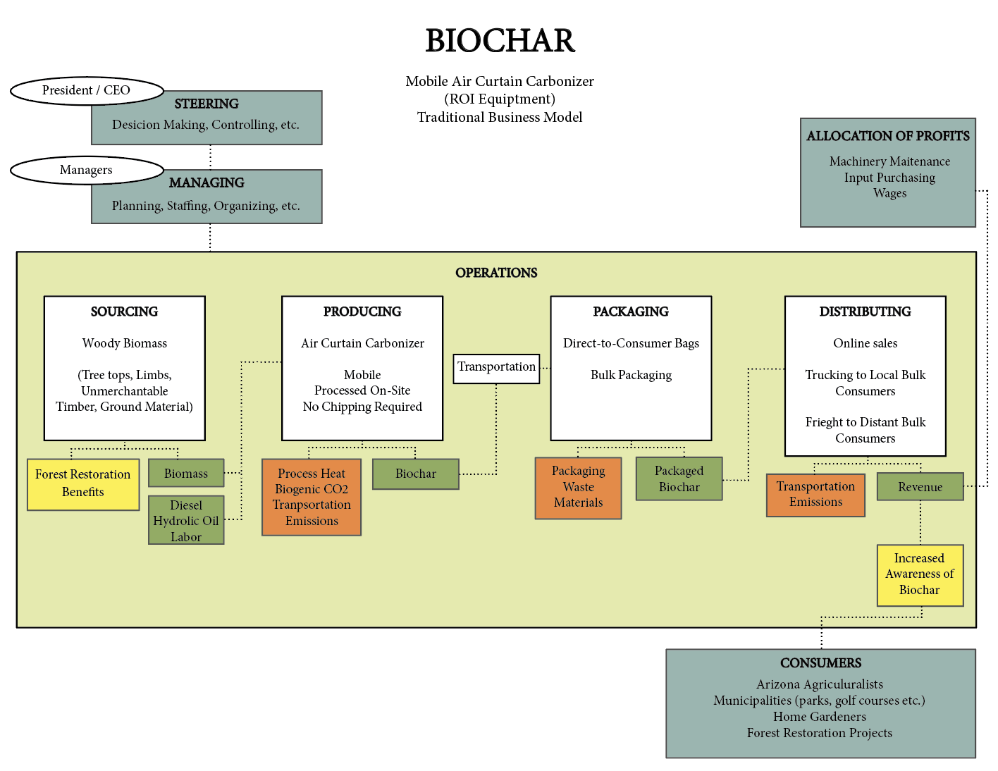

System Map: Biochar – Stationary Pyrolysis

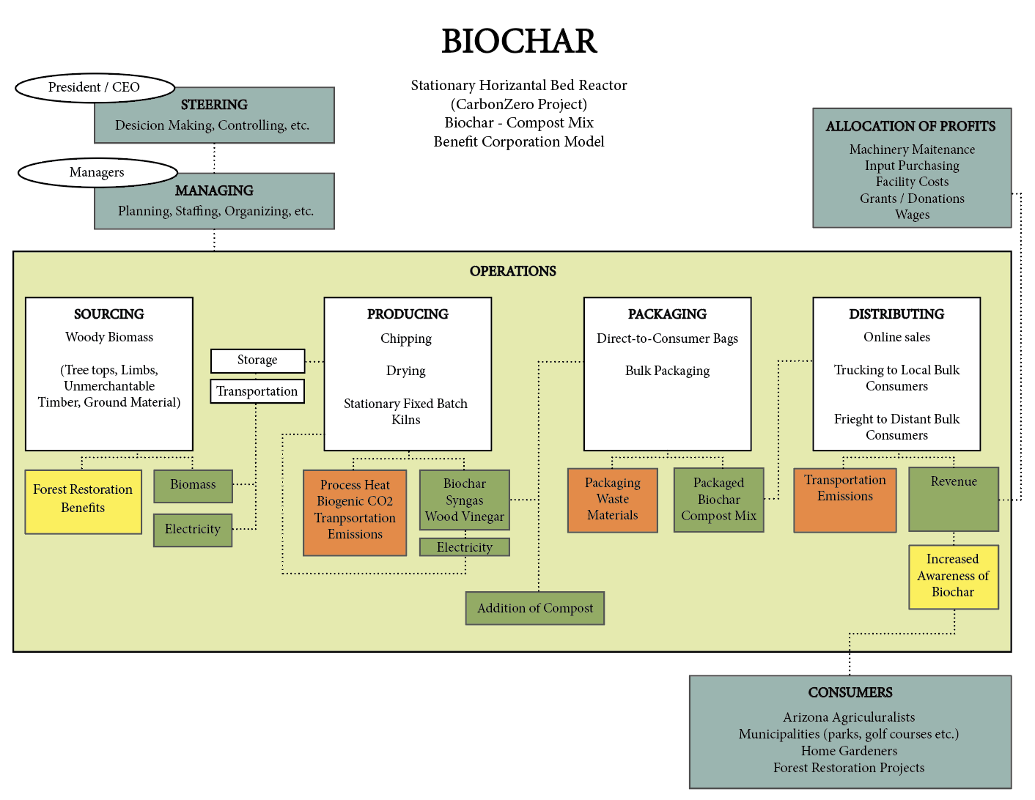

System Map: Compost

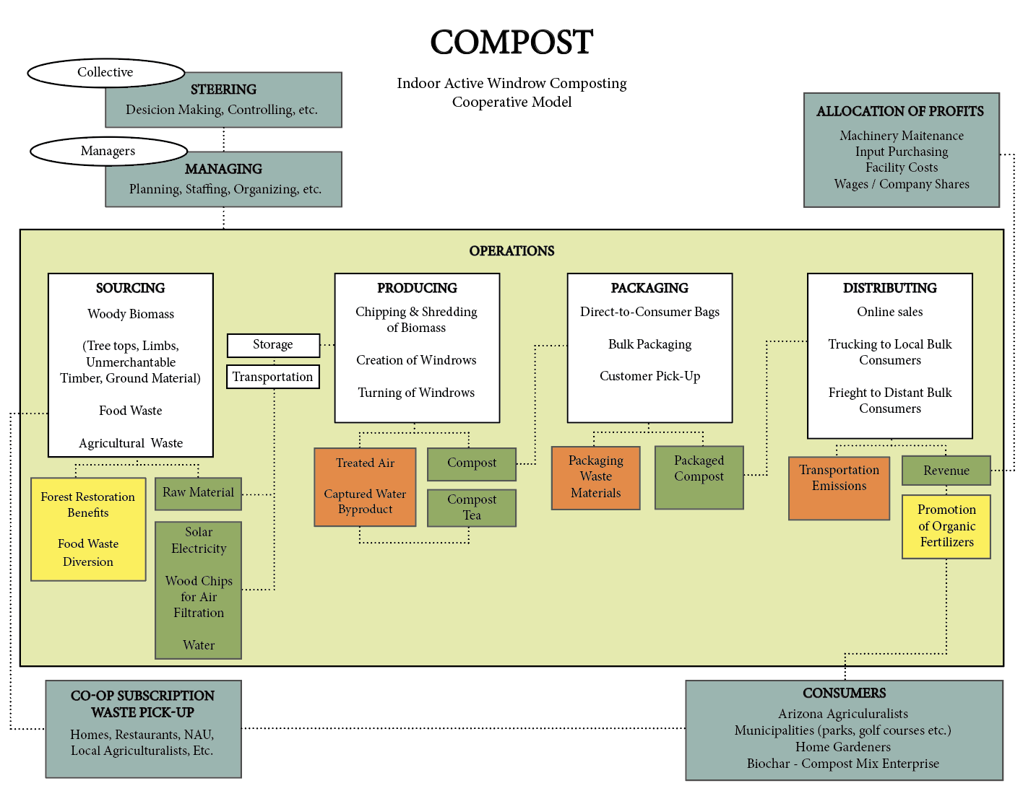

System Map: Wood Plastic Composites (WPC’s)

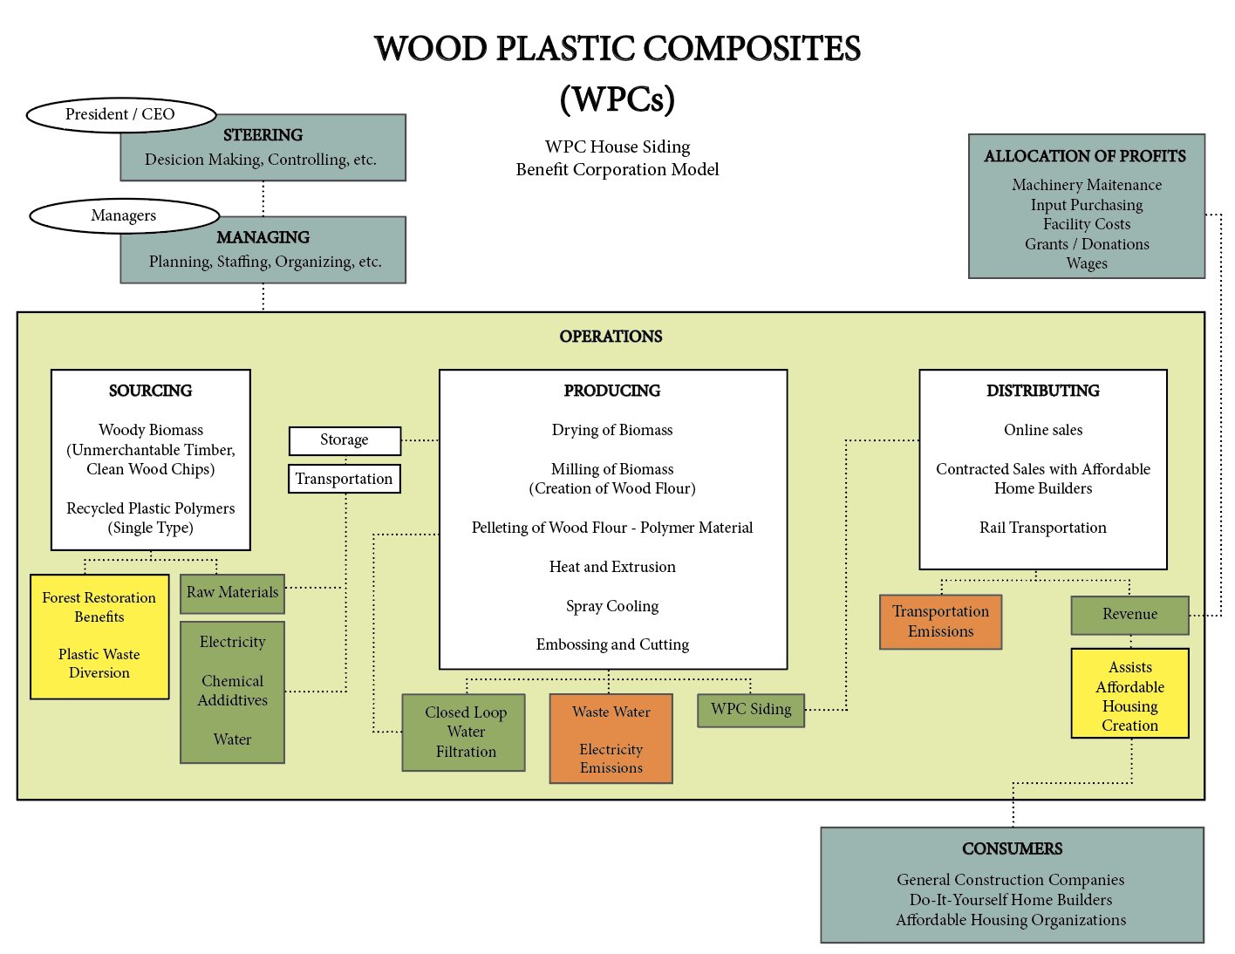

System Map: Mushroom Cultivation – Mycoremediation

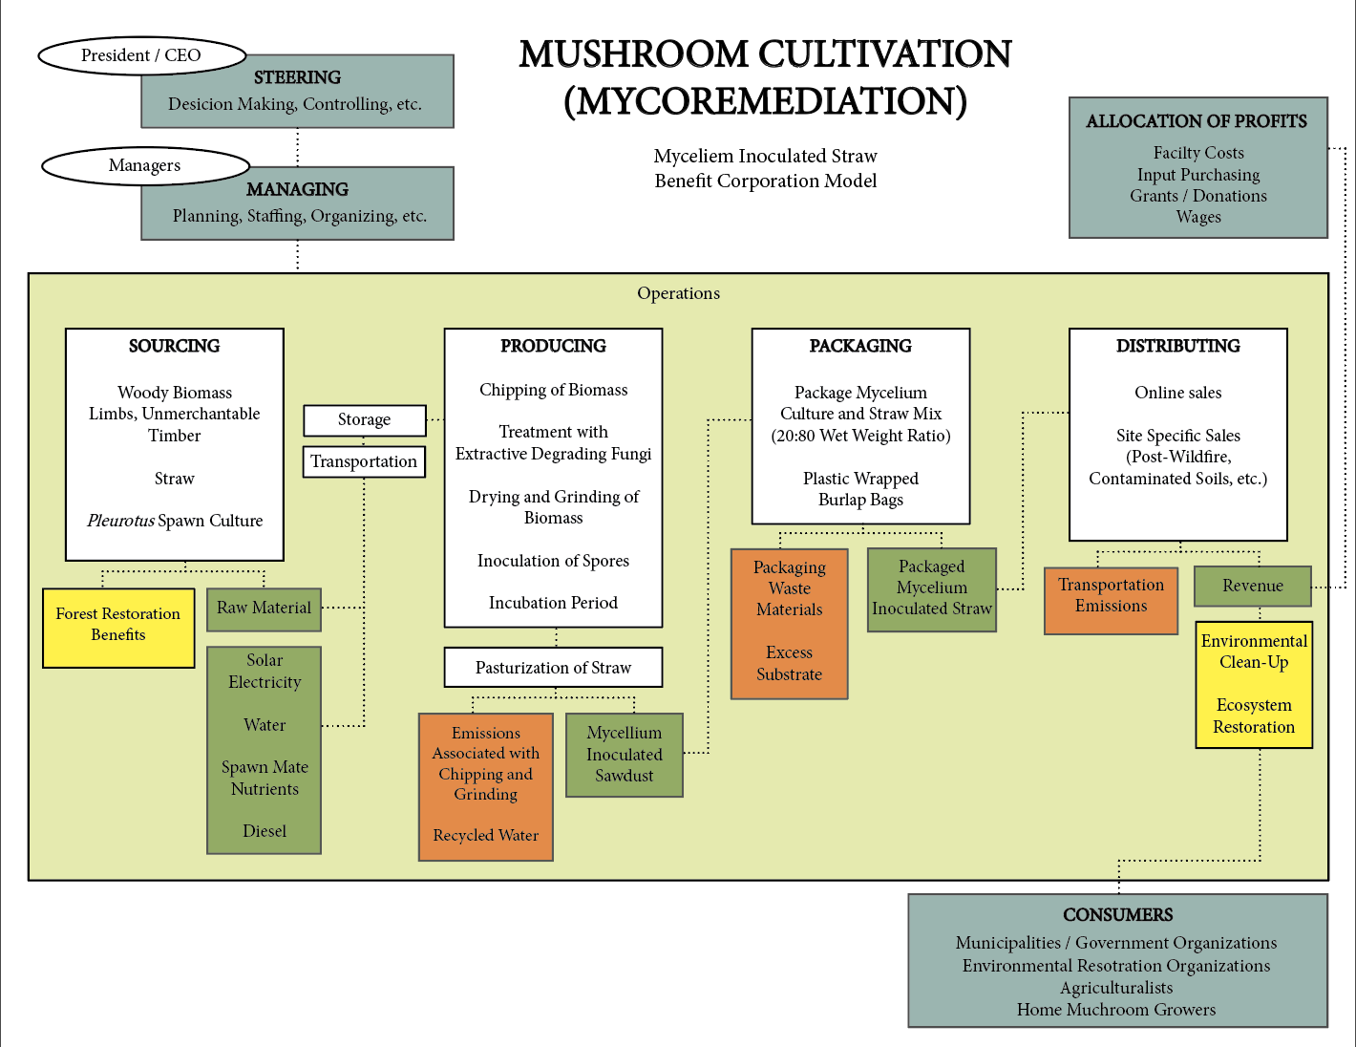

Acknowledgements
In order to successfully accomplish this project, I relied on the input and feedback from a number of stakeholders in northern Arizona. I would like to thank Matt Millar, Bruce Grecco, Jay Smith, Ann Anderson, Ann Mottek, John Saltonstall, and Dr. Han-Sup Han for their time and interest in my research. I would also like to thank my father, Robert Paulus, because it was from a conversation with him regarding his experiences with forest restoration as a Battalion Chief for Cal Fire that the idea for this project was created.
References
4FRI Monthly Update. (2018, October). Retrieved from https://www.fs.usda.gov/Internet/FSE_DOCUMENTS/fseprd602572.pdf
Altree. (2019). Retrieved from http://www.altree.com/about-us/
Arizona State Forestry Division, Flagstaff District Office. (2015, June 30). Forest Stewardship Plan: Observation Mesa. Retrieved from https://www.flagstaff.az.gov/DocumentCenter/View/48308/Observatory-Mesa-Stewardship-Plan-FINAL-9-30-2015?bidId=
Artiola, J., & Wordell, L. (2017). Guide to Making and Using Biochar for Gardens in Southern Arizona (Rep. No. AZ1752). Retrieved https://extension.arizona.edu/sites/extension.arizona.edu/files/pubs/az1752-2017.pdf
Biochar Production Equipment. (n.d.). Retrieved from http://www.biocharsolutions.com/biochar-production-equipment.html
Brown, R. (2002). Thinning, Fire, and Forest Restoration (Rep.). Retrieved https://defenders.org/sites/default/files/publications/thinning_fire_and_forest_restoration.pdf
Cornell Composting. (n.d.). Retrieved from http://compost.css.cornell.edu/chemistry.html
Croan, S. (2004). Conversion of Conifer Wastes into Edible and Medicinal Mushrooms (United States, Unites States Forest Service, Forest Products Lab). Retrieved from https://www.fpl.fs.fed.us/documnts/pdf2004/fpl_2004_croan001.pdf
Daful, A. G., & Chandraratne, M. R. (2018). Biochar Production From Biomass Waste-Derived Material. Reference Module in Materials Science and Materials Engineering. doi:10.1016/b978-0-12-803581-8.11249-4
Durr, L. (2016). Mycoremediation Project: Using Mycelium to Clean Up Diesel- Contaminated Soil in Orleans, California [Scholarly project]. Retrieved from https://fungaiafarm.com/wp-content/uploads/2014/07/MycoremediationReport_FungaiaFarm_2016.pdf
Envirosaver 350 | Advanced Wood Debris Conversion System. (n.d.). Retrieved from https://roi-equipment.com/envirosaver-350/
Fire Ecology. (2009). Retrieved from http://www.pacificbio.org/initiatives/fire/fire_ecology.html
Forest Service Contracting: A Basic Guide for Restoration Practitioners [PDF]. (2006, June). Flagstaff: Ecological Restoration Institute at Northern Arizona University.
Fretwell, H. (2018, February 23). Do We Get What We Pay For? Retrieved from https://www.perc.org/1999/01/01/do-we-get-what-we-pay-for-2/
Garcia-Perez M., T. Lewis, C. E. Kruger, 2010. Methods for Producing Biochar and Advanced Biofuels in Washington State. Part 1: Literature Review of Pyrolysis Reactors. First Project Report. Department of Biological Systems Engineering and the Center for Sustaining Agriculture and Natural Resources, Washington State University, Pullman, WA, 137 pp.
Goldsberry, C. (2016, March 02). Double-digit growth forecast for wood-plastic composites. Retrieved from https://www.plasticstoday.com/building-construction/double-digit-growth-forecast-wood-plastic-composites/98480242324008
Hietala, M. (2011). Extrusion processing of wood raw materials for use in wood-polymer composites (Doctoral dissertation, Lulea University of Technology, 2011) [Abstract]. Retrieved from https://www.diva-portal.org/smash/get/diva2:999890/FULLTEXT01.pdf
Johnson, D. (2017, March 22). Superfund Sites: 1,317 US Spots Where Toxic Waste Was Dumped. Retrieved from http://time.com/4695109/superfund-sites-toxic-waste-locations/
Kuehler, N. (2015, April 30). Re: Why Thinning Forests Can Be Good [Web log comment].
Retrieved from https://www.nationalforests.org/blog/why-thinning-helps-the-forest
Kulshreshtha, S., Mathur, N., & Bhatnagar, P. (2014). Mushroom as a product and their role in mycoremediation. AMB Express, 4, 29. doi:10.1186/s13568-014-0029-8
Kulshreshtha, S., & Sharma, K. (2014). Perspectives of Bioremediation through Mushroom Cultivation. Journal of Bioremediation & Biodegradation, 05(05). doi:10.4172/2155-6199.1000e154
Lowell, E., & Green, D. (2001). Lumber Recovery From Small-Diameter Ponderosa Pine From Flagstaff, Arizona. United States Forest Service.
McConnel, S. (2015, December 21). Ponderosa Pine Needles: Techniques for Successful Composting. Retrieved from https://foreststewardshipnotes.wordpress.com/2015/12/21/ponderosa-pine-needles-techniques-for-successful-composting/
Nicholls, D., Halbrook, J., Benedum, M., Han, H., Lowell, E., Becker, D., & Barbour, R. (2018). Socioeconomic Constraints to Biomass Removal from Forest Lands for Fire Risk Reduction in the Western U.S. Forests,9(5), 264. doi:10.3390/f9050264
Noss, R., Franklin, J., & Baker, W. (2006). Ecology and Management of Fire-prone Forests of the Western United States (Rep.). Arlington.
Organic Fertilizer Market: Global Industry Analysis and Opportunity Assessment 2016-2026. (2019, June). Retrieved from https://www.futuremarketinsights.com/reports/organic-fertilizer-market
Pandey, C., Prabha, D., & Negi, Y. K. (2018). Mycoremediation of Common Agricultural Pesticides. Fungal Biology Mycoremediation and Environmental Sustainability, 155-179. doi:10.1007/978-3-319-77386-5_6
Patton-Mallory, M. (2008). Woody biomass utilization strategy. Washington D.C.: U.S. Dept. of Agriculture. Retrieved from https://www.fs.fed.us/woodybiomass/strategy/documents/FS_WoodyBiomassStrategy.pdf.
Radeloff, V., Helmers, D., Kramer, H., & Mockrin, M. (2018). Rapid growth of the US wildland-urban interface raises wildfire risk. PNAS. doi:10.1073
Ronsse, F., Hecke, S. V., Dickinson, D., & Prins, W. (2012). Production and characterization of slow pyrolysis biochar: Influence of feedstock type and pyrolysis conditions. GCB Bioenergy, 5(2), 104-115. doi:10.1111/gcbb.12018
Selig, M., Vosick, D., & Seidenberg, J. (2010). Four Forest Restoration Initiative Landscape Strategy: Economics and Utilization Analysis(Rep.). Flagstaff: Four Forest Restoration Initiative Stakeholder Group.
Sevigny, M. (2018, March 2). Thinning the Forest, Part 2: Economics. Retrieved from https://www.knau.org/post/thinning-forest-part-2-economics
Sheridan, T. (2012). Arizona: A History, Revised Edition[Revised]. Tuscon, AZ: University of Arizona Press.
Sherman, R. (1999). Large Scale Organic Materials Composting (Publication). North Carolina Cooperative Extension Service.
Taylor, A., Yadama, V., Englund, K., & Harper, D. (n.d.). Wood Plastic Composites - A Primer (Rep. No. PB 1179). Retrieved https://ag.tennessee.edu/fwf/Documents/ATaylor/Wood-plastic-composites-primer_PB1779.pdf
United States Geological Survey. (1999, September 22). USGS Studies Wildfire Ecology in The
Western United States. ScienceDaily. Retrieved October 25, 2018 from www.sciencedaily.com/releases/1999/09/990922050418.htm
Vilsack, T. (2014, August 20). New Report Shows Budget Impact of Rising Firefighting Costs. Retrieved
from https://www.usda.gov/media/press-releases/2014/08/20/new-report-shows-budget-impact-rising-firefighting-costs
White, E. M. (2010). Woody biomass for bioenergy and biofuels in the United States: A briefing paper. Portland, OR: U.S. Dept. of Agriculture, Forest Service, Pacific Northwest Research Station.
Whiting, J. (2018). 4FRI Stakeholder Group Comments to the Docket Inquiry into the Role of Forest Bioenergy in Arizona(Rep.). 4FRI Stakeholder Group.
Wood Products Markets Grants. (2015). Retrieved from https://apps.fs.usda.gov/nicportal/WPM/dspProjectDetailReport.cfm?ID=305

