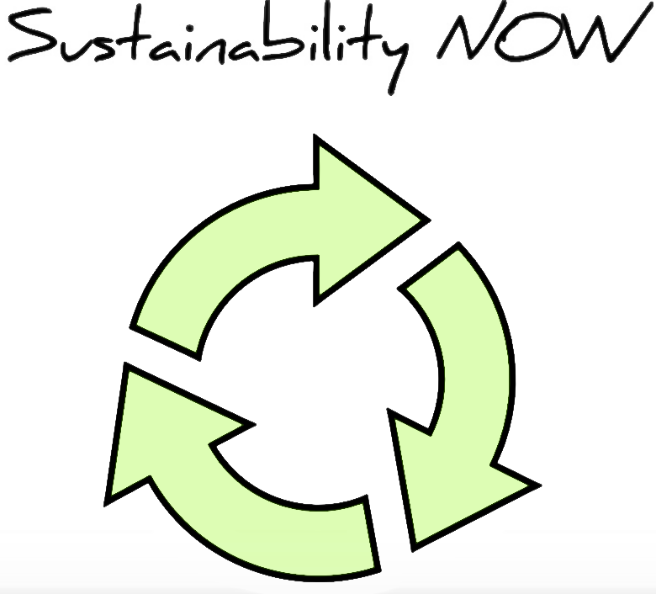
Table of Contents
Abstract 2
Backstory 3
Identify the Problem & Contextualize Challenges: Threats & Opportunities 4
Threats 4
Opportunities 6
Framing your Vision 7
Identify the Shared Goals, Gaps & Draft the Value Proposition 9
Tiers & Recognizing Your Starting Point 11
Develop the Strategy (FSSD, sSWOT & Stakeholder Mapping) 12
Planning for Execution: Work Breakdown Structure and the Gantt Chart 15
Feasibility Study: Infrastructure, Fiscal Impact & Risk Analysis 15
Knowing your Audience in a ‘God-like’ Way 17
Communications: Plan & Strategy 18
Expect the Unexpected 19
Navigating Organizational Change 20
Collaboration Catalyzes Solutions 22
Next Steps: Ritualizing and Scaling your Initiative 22
Results & Conclusion 23
References 26
Appendices 29

Abstract

In the Monterey Peninsula Unified School District (MPUSD), we ask our students to ‘dream big and dare greatly,’ but threats like climate change, population growth, and technological automation are threatening the realization of those dreams. Therefore, we must implement Sustainability NOW—an interdisciplinary, project-based curriculum that can help us address these threats while improving our local educational system. Sustainability NOW is an innovative, project-based, and STEM-centered curriculum that represents a strategic lever for the Educational Partnership Center (EPC) in achieving expanded outcomes that benefit the greater social good. But Sustainability NOW is more than a curriculum, it is a full-fledged organizational strategy. This report illustrates how a sustainability education program was designed and strategically mapped for MPUSD and the EPC.

Backstory

In 2016, Climate Central published an article projecting 2017 as the hottest year on record in over 130 years (Thompson, 2016). As I read the article, I started thinking about Al Gore’s An Inconvenient Truth, a film that was released in 2006. In that moment, I realized how time had escaped me. The threats that the film addressed, once austere and distant—were manifesting before my eyes. I felt a sense of urgency, a call to action—but I worked in education—and I struggled to find a connection—I asked myself: what does college access have to do with sustainability?
In 2016, I was settling in and starting to excel as a professional. I am an Assistant Director for two college access programs housed out of UC Santa Cruz’s Educational Partnership Center that serve underrepresented youth en route to postsecondary access, acceptance and persistence. All was well, but that article haunted me. I started thinking about all of the work that was being done to advance principles of equity and it hit me. I saw the gap. In my quest to make the world a better place, I had failed to realize that a prerequisite was having a world left to save. I said to myself: nothing about educational equity makes sense except in the light of sustainability.
If I learned one thing from the volatility of 2016, it was that I must never stop fighting for the change I want to see in the world. I let myself feel that urgency, and it propelled me to action. I started thinking about sustainability and how it applies to college access programs—how I could marry the concepts and impact social good on a larger scale. I had to do something outside of the norm and think differently. This inner dialogue led to the development of Sustainability NOW, an innovative, project-based, and STEM-centered curriculum that represents a strategic lever for the Educational Partnership Center (EPC) in achieving expanded outcomes that benefit the greater social good. But Sustainability NOW is more than a curriculum, it is a full-fledged organizational strategy for the EPC and educational service providers alike.

Identify the Problem & Contextualize Challenges: Threats & Opportunities

Research is key to framing threats and opportunities. It can be daunting knowing where to start, but it is best to pursue the low-hanging fruit and build from that point. In my case, I knew with the utmost certainty that inequity exists. The reality is that access to an education and its returns is more concentrated among the children of wealthy families (Hill, 2015) and the gap is widening. We live in an imperfect society, but every child deserves a fair shot at achieving their goals and the data is clear—“over a lifetime, a Bachelor’s degree is worth $2.8 million” which equates to “75 percent more than that earned by high school graduates” (Carneval, et al., n.d.). I was confident that postsecondary access, acceptance and persistence is paramount to future generations thriving in a global market. I knew this, but in the Fall of 2016, I started questioning whether my work toward increasing the number of underrepresented students enrolled in college was enough—was I truly working to prepare these students for a bright future even in light of socioenvironmental and economic challenges that I knew existed and would invariably affect their livelihood? Even if students are prepared to access and persist in postsecondary education, will that stop threats like climate change, population growth and technological automation from adversely impacting their lives? It was a big idea, but I started by first assessing threats and opportunities in the context of our ‘business as usual.’

Threats

The first step was conducting research to identify the threats that were facing our service regions and constituencies. For example, living in Monterey, California, I was confident that climate change was threatening the viability of our service regions and would soon have significant effects on the socioeconomic well-being of Monterey County. According to Dr. George Basile, a leading researcher and expert in the field of sustainability, the world has experienced 90 percent of the hottest years on record in the past two decades (G. Basile, personal communication, 2013), with 17 of the 18 warmest years occurring since 2001 (Sengupta, 2018). Additionally, the average “global carbon dioxide concentration has risen by 38 percent from the pre-industrial level, and almost all is due to human emissions” (G. Basile, personal communication, 2013). As of 2017, CO2 levels in the atmosphere are at the highest levels they have been in the last 800,000 years (Sengupta, 2018). Emissions have grown to such a degree that if we stopped emitting C02 today, it would take several hundred years before the majority of human emissions were removed from the atmosphere (Ritchie & Roser, 2018). The effects of climate change, namely the rise of CO2 emissions, increasing temperatures, and rising sea levels directly impact the communities that we serve. But this threat is not limited to environmental impacts. According to a report entitled “Risky Business: The Economic Risks of Climate Change in the United States - A Climate Assessment for the United States,” the US “economy faces multiple significant risks from climate change” (2017, p.7). The report covers the threats posed by climate change, like rising sea levels that will overwhelm coastal economies, erasing properties and a significant portion of GDP for states like California. The report also states that “80 percent of California’s GDP comes from coastal counties” (p.38), projecting a significant rise in sea levels by the year 2100, that will destroy 80 percent of the state’s economy (p.38). Monterey County, and the agricultural industry therein, are vital to the local economy. In fact, “agriculture contributes over $4.49 billion per year to Monterey County’s economic output, with a total estimated impact of over $8.1 billion on the local economy” (Facts, Figures & FAQs, n.d.). Additionally, “nearly 1 in 4 households relies on income related to agriculture which supports 76,054 jobs” (n.d.). And, as acknowledged in the “Risky Business” report, “the worst health impacts will be felt among the poor—many of whom work or even live outdoors or can’t afford air-conditioning” (2017, p.17). Climate change, then, directly impacts the economic viability of our service regions. 1 in 4 households in Monterey County rely on income from agriculture, so our constituencies will definitely feel the effects in our local socioeconomic environment.
The next threat is population growth. Global population will reach 9.7 billion by 2050 and 11 billion by 2100, but experts agree that our planet cannot sustain such unfettered population growth (Cumming, 2016). Dwindling resources and the scarcity of vital natural resources like water, which the World Economic Forum rated as a threat second “only to ‘major systemic financial failure’” (Winston, 2014, p.45) present a significant challenge. On a local level, the Public Policy Institute of California acknowledges that “one of every eight US residents lives in California” and that “by 2050, California’s population is projected to reach 50 million people” (n.d.). Over the past three years, enrollment in partner school districts that we serve in Seaside and Marina has skyrocketed. In 2011-2012, enrollment was at 1,572. In 2015-2016, enrollment reached 1,943. Over the span of three academic years, enrollment has increased by 23.6 percent. What this means is less instructional efficacy. This translates to poor academic performance, and, ultimately, fewer deserving and prepared students in postsecondary education.
The final threat is the rise of technological automation. The Global Risks Report of 2017 states that “47 percent of US jobs are at risk of automation, affecting over 80 percent of low-income workers” (p.25). Increasingly, “human labor is being displaced by automation, robotics and artificial intelligence” (p.35). In California, 63 percent of tasks currently performed are at risk of automation in the near future. More specifically, 1 in 4 households rely on income generated from agriculture in Monterey County, but the industry could be fully automated in as few as ten years (Niksa, 2018). In concluding my research, I was convinced that education and training programs are paramount to stalling this disastrous trend. By researching through a local and global lens, I was preparing myself to craft an informed and compelling call to action. But I was not sure how to get there—I needed to identify how I could impact these tangible threats in the context of my work in the Educational Partnership Center—and the solution arrived by thinking about opportunities for how I could achieve that.

Opportunities

After conducting research to outline threats to service regions and constituencies I was prepared to identify opportunities for change. The Educational Partnership Center’s greatest strength is our capacity to outreach, program, and address socioeconomic equity issues for our constituencies. The lever for change, in this case, was our programmatic medium—considering how we were engaging students in their learning—and the need for innovation in Mathematics and Sciences instruction is dire. California Assessment of Student Performance and Progress (CAASPP) data reveals that 62 percent of students statewide failed to meet standards in Mathematics and Science (CAASPP, 2017). More specifically, 74 percent of students in the Monterey Peninsula School District, our partner district, failed to meet standards in Mathematics and Science (2017). These data points suggest that a lack of agency in these disciplines is contributing to high-failure rates for students. Additionally, 55 percent more students fail lecture-based courses in these disciplines than courses taught with active or project-based learning components (Freeman, et. al., 2014). What this suggests is that by designing a curriculum that engages students in their learning, and inspires them to impact these threats on a local level, we can simultaneously increase their academic performance while educating them on threats facing our collective livelihood—inspiring future generations to impact these challenges on a local level. This idea, coupled with an organizational component seeking to raise EPC’s sustainable development so that we could ‘walk-the-talk,’ comprised the foundation of what would become: Sustainability NOW.

Framing your Vision

Peter Senge reminds us that “few, if any, forces in human affairs are as powerful as shared vision” (2009, p.192). A vision is a clear view of the future we seek to create. It is glimpse of that reality we are trying to manifest. The most comprehensive way to frame a vision is to draft a complete project proposal wherein a clear view of the future is outlined. To start, it is helpful to use the And, But, Therefore (ABT) method in succinctly stating the problem, engaging the reader with the anxiety the conflict generates, and offering a solution. For Sustainability NOW, the following ABT was drafted:
We ask our students to ‘dream big and dare greatly,’ but threats like climate change, population growth, and technological automation are threatening the realization of those dreams. Therefore, we must implement Sustainability NOW—an interdisciplinary, project-based curriculum that can help us address these threats while improving our local educational system.
After combing through countless sources in the research stage, condensing the message and learning to succinctly communicate the problem and solution was invaluable. By clearly outlining a vision and mission statement, we were better prepared to enroll stakeholders in Sustainability NOW. Peter Senge describes the difference between selling and enrolling in The Fifth Discipline. Selling, according to Senge, means getting someone to do something that they might not want to do, whereas enrolling implies free choice (2009, p.203). By enrolling stakeholders in our vision, we are more likely to succeed. That is because the level of commitment is fortified by free choice and desire to impact a shared goal. But how do we enroll stakeholders? It starts by creating a vision that pulls your audience to action. While vision statements should be clear and concise, mission statements should outline ‘why’ and ‘how’ for the initiative. Examples from Sustainability NOW are below:

Vision Statement
Every student will be prepared and inspired to implement solutions to global and local socioenvironmental crises en route to postsecondary access and acceptance.

Mission Statement
Sustainability NOW, an interdisciplinary, project-based curriculum, generates agency in student learning, motivating and empowering students of diverse backgrounds to positively impact the most pressing socioenvironmental challenges of our time. Sustainability NOW will address these critical threats while improving our local educational system.

To further frame the vision, we needed measurable goals and objectives so our organization and stakeholders could assess the value and impact of the initiative. In setting goals for Sustainability NOW, I considered our students, our community, and my organization:
Sustainability NOW Performance Measures & Timeline
Goal 1: Increase Cohort Student Sustainability Knowledge & Ambition
PM 1 | Implement ‘Sustainability NOW’ curriculum with 15% of cohort students | Fall 2018
PM 2 | Increase Sustainability Content Knowledge by 10 percentage points over baseline (pre-survey) | Fall 2018
PM 3 | Increase Sustainability Ambition of Cohort Students by 10 percentage points over baseline (pre-survey) | Fall 2018
PM 4 | Implement a hands-on project with participating students (i.e. Solar Charging Stations) as the culminating experience of the curriculum. | Fall 2018
Goal 2: Increase STEM partnerships with Public & Private Organizations
PM 1 | Secure 1 additional STEM focused partner for collaborative programming with GEAR UP Projects | Spring 2017
Goal 3: Walk the Talk: Infuse Sustainability into the EPC via Awareness/Education programs
PM 1 | Launch and Obtain Green Office Certification for EPC Headquarters (GOC) | Spring 2017
PM 2 | Secure buy-in of partner districts outside of my service region (Monterey County) to implement the ‘Sustainability NOW’ curriculum in future service years beyond 2019 (Pajaro Valley/South Monterey County) | Spring 2019

Peter Senge outlines some steps for enrolling stakeholders in The Fifth Discipline, acknowledging that as creators of a vision, we need to be enrolled ourselves (2009, p.207). What this translates to is considering every key stakeholder in the formation of these goals. Not only were we seeking to improve students’ academic performance and generate agency in their learning, we were seeking to create lasting change by involving community partners and walking the talk ourselves. Considering the holistic nature of our goals is critical to drafting a framework that has a chance to inspire real change.
The final piece of framing the vision was drafting a roadmap with short-term wins and long-term gains for all parties involved. This was extremely helpful in showing stakeholders how goals and objectives for Sustainability NOW could be achieved over time. Examples from Sustainability NOW are outlined below:

Mile-markers
- Fall 2018, pilot curriculum implemented with 15 percent of the GEAR UP cohort (Target: 128 students)
- Fall 2019, curriculum adopted district-wide
- Fall 2020, expanded partnerships with organizations like MEarth / development of elective course offerings in sustainable agriculture
- Fall 2021, expansion of Sustainability NOW into additional partner districts (Pajaro Valley/South Monterey County)

Short-term wins
- Pilot implementation
- Campus projects (solar charging stations / culminating experiences)

Long-term gains
- MPUSD and the EPC’s increased sustainable development
- Students’ increased academic performance / Fulfillment of MPUSD’s Local Control Accountability Plan / A-G Goal
- Expanded community partnerships & course offerings

Identify the Shared Goals, Gaps & Draft the Value Proposition

After identifying threats and opportunities via research and outlining a framework for Sustainability NOW’s implementation, it was time to propose the value of the initiative to all parties involved. In the case of Sustainability NOW, the Monterey Peninsula Unified School District (MPUSD) is the Educational Partnership Center’s (EPC) primary partner in the region. This partner is committed to increasing student achievement and eliminating performance gaps. MPUSD’s Local Control Accountability Plan (LCAP) champions interdisciplinary approaches to curriculum and instruction. The LCAP also seeks to engage students in deep learning that prepares them to solve the challenges of the 21st century, with the ultimate goal of having 85 percent of its students graduate prepared for college and career. At the EPC, our primary goal is to build college-bound communities that improve student learning and increase college-going rates among traditionally non-college-going students and families (https://epc.ucsc.edu). There is alignment in these goals, but a gap was identified, and it ties back to the programmatic medium for how we are seeking to engage and prepare students en route to solving the challenges of the 21st century.
Sustainability NOW impacts shared goals and objectives. It works to impact both MPUSD’s goals of improving student learning and eliminating performance gaps and the EPC’s goals of increasing students’ postsecondary eligibility. Going into the latter stages of planning with these shared goals and impacts in mind helps craft a compelling narrative that moves stakeholders toward action.
Sustainability NOW Value Proposition
Context | EPC, as a service provider, must maintain operational viability by altering service models to respond to both college access and sustainability issues that threaten the vibrancy and well-being of service regions/constituencies.
Situation | CAASP Assessment Data reveals that 62% of students statewide failed to meet standards in Mathematics and Science. More specifically, 74% of students in MPUSD failed to meet standards in Mathematics and Science (CAASPP, 2017).  55% more students fail lecture-based STEM classes than courses taught with active or project-based learning components (Freeman, et al., 2014).
Connection | These data points suggest that a lack of academic agency in STEM disciplines is contributing to high-failure rates for students. The EPC can impact this by developing programs that foster and cultivate academic agency via project-based learning in STEM disciplines.
Pitch | Sustainability NOW, a project-based, STEM-centered curriculum can impact MPUSD’s goals of increasing student performance in Mathematics and Science.
Collaboration | District-wide implementation of Sustainability NOW.
The ‘Win-Win’ | - The district-wide implementation of Sustainability NOW will help improve outcomes for students and eliminate performance gaps—addressing a key goal for MPUSD. It will also impact a salient strategic principle for MPUSD by cultivating capacity in school leaders, teachers, and support staff to create engaging, rigorous, and student-centered learning opportunities in every classroom, every day. Sustainability NOW also represents a systems-level approach to supporting the vibrancy of the EPC’s constituencies by increasing the academic performance and postsecondary eligibility of students while simultaneously addressing the sustainable development of our organization, partners, and service region.

But Sustainability NOW does more than impact shared goals and objectives—it serves the greater good. This is a critical concept, because in order for any organization to remain a competitive and effective service provider, we must adapt and innovate. In “Creating sustainable entrepreneurship,” Bradley Parrish and Fiona Tilley remind us that “for sustainability entrepreneurship to ever be more than an occasional happy contingency in which profitable market opportunities happen to align with the contribution to an ecological or social good, such contributions must be integrated into the very purpose of an organization” (2011, p.103). Educational organizations and service providers must work to “support wider social and ecological systems as they support the organization’s own continued survival” (p.106). In order to manifest the change we seek to deliver, we must design and implement programs “positioned between the micro concerns of [our] stakeholders and the macro functions of the social-ecological systems” (p.109).

Tiers & Recognizing Your Starting Point

Before a strategic framework can be outlined, free from inherent biases, we needed to identify and rank our organization with respect to its Sustainability Ambition (G. Basile, personal communication, 2013). There are four Tiers of Sustainability Ambition:
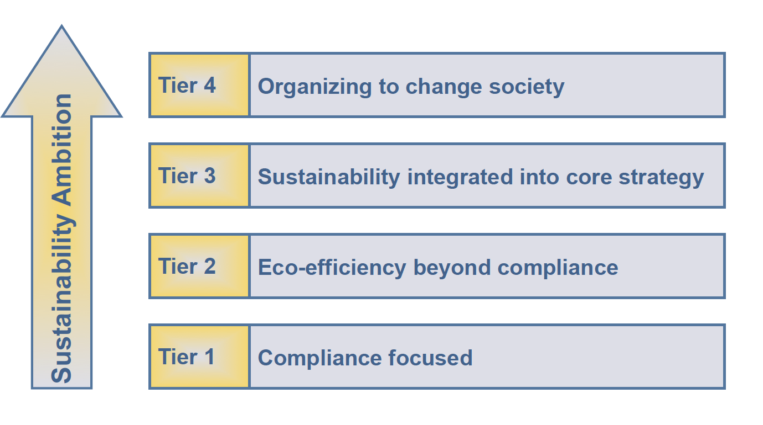

Organizations in Tier 1 are focused solely on compliance and are primarily motivated by growth and profit. Tier 2 organizations are beyond-compliance in that they consider supply webs and life cycles of products or services—in short, they are concerned with growth and profit, but also efficiency. Tier 3 organizations seek to integrate sustainability into growth and profit—they consider the principles of sustainability as a management paradigm. Lastly, Tier 4 organizations focus on organizing to change society—they recognize that our organizations and businesses are really a subset of the biosphere, not the other way around. In mapping an organization’s Sustainability Ambition, one will be more prepared to systemically address intervention points and strategies to rise to another tier of sustainable development.
UCSC is a ‘Tier 2’ organization in that it is responding to issues through a lens of CO2 emissions and increasing energy efficiency. UCSC recently joined the regional Climate Action Compact (CAC) (Sustainability, 2017) and has launched a Sustainability Plan through 2022 that covers transportation, recycling and waste management, eco-friendly purchasing guidelines, water use/conservation, and habitat/watershed preservation. UCSC has also committed to carbon neutrality by the year 2025. While these are important goals, they are more reflective of “business
management and resource management” (Basile, 2013). The measures, while comprehensive, do not incorporate elements of sustainability as a ‘management paradigm’ like a ‘Tier 3’ or ‘Tier 4’ organizations (Basile, 2013). ‘Tier 2’ is a great place to start, but UCSC is a large institution, serving over 18,000 students annually. More specifically, the EPC, housed within the Division of Undergraduate Education, serves approximately 3,000 primary and secondary students in the neighboring counties of Monterey and Watsonville. So, speaking strategically, it is important to consider the impact that the EPC is having on increasing UCSC’s ‘Sustainability Ambition’ and charting a course forward to impact sustainability challenges and opportunities more directly.

Develop the Strategy (FSSD, sSWOT & Stakeholder Mapping)

As stated in the Business of Sustainability: Trends, Policies, Practices and Stories of Success “application of the Framework for Strategic Sustainable Development (FSSD) allows a business to take actions aimed at reaction to current challenges and identify and design out high-risk activities that may lead directly to either new sustainability challenges” (McNall, et al., 2011, p.16). The FSSD outlines an organization’s purpose, its measures of success, and uncovers its values and priorities. It is organized as follows:
- The “system” level identifies stakeholders and operational boundaries
- The “principles for success” level defines organizational success
- The “strategic principles” level outlines an organization’s core values
- The “actions” level identifies specific tactics developed to reach success
- The “tools” level outlines the resources one can use to achieve success
The EPC’s FSSD has been included in the Appendices section for reference. Ultimately, the FSSD helps us frame our arguments and strategies for sustainability in a business-case—giving us a roadmap to ascend to another tier of Sustainability Ambition as an organization. This is because in order to be successful in increasing our ‘Sustainability Ambition,’ we need to analyze our ‘micro-climate’ and organizational goals to impact matters of sustainability in the same way that UCSC, as an institution, has addressed ‘macro-climate’ issues like CO2 emissions reduction. The FSSD is a critical resource in doing so as it allows us to pinpoint sustainability issues in our immediate environment and service model. Another great tool for strategically approaching the challenges outlined in the FSSD is the Sustainability sSWOT, or (Sustainability Strengths, Weaknesses, Opportunities & Threats) chart.
The sSWOT helps organizations “work across internal departments, as well as suppliers, customers, or other stakeholders on strategies to create and sustain long-term value” in the application of their sustainable development strategies ("sSWOT | World Resources Institute," n.d.). The goal of the sSWOT is to be both specific and far-reaching, in that it “encourages teams to consider broader connections and opportunities for collaboration inside and outside the company” (n.d.). The Educational Partnership Center’s (EPC) sSWOT has been included in the Appendices section for reference, however, a sSWOT can be established by adhering to these steps:
- Identify a specific output and/or specific question
- Identify socio-environmental challenges
- Identify threats to continuing with ‘business as usual’
- Identify opportunities for partnership-driven solutions
- Identify organizational strengths (to leverage with partners)
- Identify organizational weaknesses (to address with partners)
- Prioritize strategies
- Identify where to act (via partnerships)
(Metzger, et al., 2012).
In the case of the EPC, the base of our sSWOT table identifies the ‘Who/What’ wherein we identify stakeholders and contextualize ‘Environmental Challenges/Trends,’ which, in this case, are the threats of climate change, population growth, and technological automation. The next level of the sSWOT goes on to identify ‘Threats’ and ‘Opportunities’ wherein we can see that our immediate threat is the sustainability of services in the context of the ‘Environmental Challenges/Trends’ we face. Equally important, however, is that we simultaneously identify the opportunities that we have to initiate action, which in this case is the platform of engagement that is tied to our goal of increasing college access and acceptance.
The next level focuses on our ‘Strengths’ and ‘Weaknesses.’ The EPC has strengths in the existing human capital within our organization, but also the strength of current partnerships and our reputation as an effective catalyst for change given that over the last 17 years, our organization has been awarded eight GEAR UP grants resulting in over $48 million in funding. Our continued success gives us additional points of leverage in influencing change. The ‘Weaknesses’ section of the sSWOT speaks to shared challenges of College Access Programs (CAPs) in our region, in that they will invariably be subject to the same challenges identified. This is helpful to consider, as we can leverage these shared challenges and new partnerships to work collectively toward solutions.
The final section of the sSWOT covers ‘Prioritization’ and ‘Action.’ In terms of prioritizing, we must use our platform of engagement with stakeholders and constituents to create awareness of sustainability challenges while simultaneously programming to increase college access and acceptance rates. We can do this by forming new ‘Green’ partnerships and focusing on STEM programming like the Sustainability ‘NOW’ curriculum. Lastly, we identify ways in which we can ‘Act’ to advance our sustainable development and ascension up the ‘Sustainability Ambition’ ladder. The sSWOT identifies near-term goals like implementing the ‘Green Office Certification’ program at EPC, mid-term goals like implementing the Sustainability ‘NOW’ curriculum, and long-term goals like writing more proposals for STEM centered/environmental education grants that we can tie to the existing programmatic structures/deliverables of programs like GEAR UP. Once a sSWOT has been developed, it can drive opportunities to collaborate with stakeholders to impact shared challenges.
Stakeholder mapping is also an important step to understanding who our key stakeholders are, where they come from, and what they are looking for in relationship to our business (Baddache & Morris, 2011). By mapping stakeholders, we will be better prepared to speak to shared interests and concerns. It starts by considering stakeholders via their expertise, willingness to engage and the value that they offer the initiative. But in order to map stakeholders, we must first conduct a stakeholder analysis. A stakeholder analysis considers the following, ranked as either High, Medium or Low:
- Contribution to the project (High, Medium, or Low)
- The legitimacy of the initiative’s impact on this partner (High, Medium, or Low)
- Willingness to engage in the initiative (High, Medium, or Low)
- The necessity of the stakeholders’ involvement in the initiative (High, Medium, or Low)

Once stakeholders are analyzed according to these criteria, they can be mapped so that relevant interests, concerns and positions can be more easily identified en route to strategic collaboration and long-term impact. An example of Sustainability NOW’s Stakeholder Analysis and Mapping can be found in the Appendices section for reference.

Planning for Execution: Work Breakdown Structure and the Gantt Chart

Once an initiative and strategic framework have been established, it is necessary to outline a plan for execution (Tate & Martin, 2010). There are two tools that I will focus on that were critical in planning out the implementation of Sustainability NOW. The first is the Work Breakdown Structure (WBS). The WBS outlines tasks associated with the initiative and who will be accountable for the fulfillment of those tasks. The tasks should be aligned with the initiative’s final and interim deliverables.
The Gantt Chart outlines major activities associated with the initiative on a timeline of implementation (Tate & Martin, 2010). A Gantt Chart lists all major activities associated with the initiative relative to the timeframe in which it will take to fulfill these activities. A sample Gantt Chart for Sustainability NOW is included in the Appendices section for reference. The key consideration for both of these tools is that they are malleable and will shift over time. Part of ensuring that we are successful in launching projects of this scale is realizing that we will need to pivot as challenges arise. Continuously revisiting the WBS and Gantt Chart throughout the design and implementation of a large-scale initiative like Sustainability NOW will ensure that one can pivot when needed without sacrificing strategic considerations along the way.

Feasibility Study: Infrastructure, Fiscal Impact & Risk Analysis

Once a strategic framework has been established that considers the needs of stakeholders, considerations must be made regarding an initiative’s infrastructure, fiscal impact, and risk. One way to approach this is by drafting a Feasibility Study. A Feasibility Study considers organizational research, infrastructure, fiscal impact and risk analysis for the initiative at hand. It is the final step prior to the roll-out and implementation stage. To craft a compelling and useful Feasibility Study, we needed to identify primary audiences for the initiative and indicate whether they are internal (e.g. organizational) or external (non-organizational). In the case of Sustainability NOW, there were three primary audiences: the EPC and its staff (internal), GEAR UP cohort students (external), and the Monterey Peninsula Unified School District (external). Next, one should identify whether the initiative is Business to Business (B2B) or Business to Consumer (B2C). In the case of Sustainability NOW, it is B2C in that the project served cohort students directly—which is in alignment with our organization’s mission. However, it is also B2B because the curriculum is slated to become a free resource on the EPC’s website available to other businesses and practitioners.
Special attention should also be paid to any externalities. Externalities could be considerations like how the project can be managed in the future if the scale expands beyond what was initially projected. For example, with Sustainability NOW, we implemented the curriculum with GEAR UP students, a program that relies on federal funding. As such, funding and commitments with staff time cannot be made uniformly in future years, so a key externality to consider was how to scale the initiative for future years without relying on grant funding. This led to seeking partners and collaborators that could help absorb some funding commitments and tasks in future years as GEAR UP funding expires.
As stated above, there are three central elements of the Feasibility Study. The study should address the project’s infrastructure, fiscal impact, and it must include a risk analysis. In considering infrastructure, the project-lead should identify what tools and resources already exist that the initiative can build upon. In the case of Sustainability NOW, the curriculum and initiative were built into the academic calendar. Also, given that our partner school sites in MPUSD are ‘New Tech’ school sites that champion technology, the curriculum was designed to consider this infrastructure, with it being transcribed to ‘Google-Sites’ for ease of access. MPUSD encourages the use of technology in instruction at every level. This was a win-win, in that it simultaneously lowered the ecological impact of the initiative. It was also necessary to outline expenses for the initiative by completing a budget and spending plan for organizational review and approval.
The final step was drafting a Risk Analysis. Risk analyses “improve the probability of project success” by determining an acceptable level of risk associated with specific tasks or elements of a project (Tate & Martin, 2010). I have included a sample Risk Analysis in the Appendices section for reference. For Sustainability NOW, I identified ten potential risks, ranging from delays in revising the curriculum to failure to deliver key organizational components of the initiative, like the EPC failing to obtain Green Office Certification. This was helpful as it allowed our organization and stakeholders to project relevant risks that could derail the project’s successful implementation. In drafting a risk analysis, we considered the variance of risk—asking questions like: is the risk related to the scope of the project overall, cost, or schedule of implementation? By asking detailed questions like this, we were able to accurately identify solutions to the risks identified.

Knowing your Audience in a ‘God-like’ Way

Park Howell, a leader in marketing and the craft of storytelling, states that we need to understand our audiences in a ‘God-like’ way in order to initiate and sustain the change we seek to deliver (P. Howell, personal communication, 2018). In so doing, we can produce “meaningful content that empowers customers and moves them to action” (P. Howell, personal communication, 2017). Part of the challenge incumbent upon sustainability professionals is identifying our audiences in order to create a “meaningful and emotional business story that connects with [our] audience on their terms” (2017).
One way to understand audiences in a ‘God-like’ way is to develop audience personas and classify these audiences on the Adoption Curve Scale. To create personas, we interviewed stakeholders—determining their motivations, what is important to them personally and professionally, and how likely they were to be involved in Sustainability NOW. By doing so, we were able to categorize our stakeholders on the Adoption Curve Scale, which consists of the following:
- Innovators: brave people pulling for change and willing to take risks
- Early Adopters: thoughtful people willing to accept a change before the majority
- Early Majority: thoughtful people careful about embracing change and will accept a change before the majority
- Late Majority: skeptics that will only accept change once the majority has accepted
- Laggard: critical to new ideas and will only accept it when it has become mainstream

Sustainability NOW has three primary audiences. The EPC (internal) and MPUSD (external) are both comprised of Early Adopters because they are progressive educators committed to student success. Sustainability NOW’s third audience, cohort students (external), also fall into this category. This is because cohort students represent what Park Howell refers to as ‘the Aspirationals’ (P. Howell, personal communication, 2017). ‘The Aspirationals’ are comprised of Millennials—and they believe they have a responsibility to support products and services that are good for the environment and society. They care about issues that are detrimentally affecting the environment and will welcome a campaign of awareness and call to action. Understanding our audiences is critical to gaining the buy-in of key stakeholders. By conducting audience personas and classifying our audiences according to the Adoption Curve Scale, we ensured that our messaging and communication connected to shared values and beliefs.

Communications: Plan & Strategy

In the short-term, Sustainability NOW required bi-weekly and monthly check-in meetings with regular, ad hoc, and liaison stakeholders. These communication channels ensured that the initiative was launched and completed by the end of the Fall 2018 semester. However, communications needed to expand beyond the planning and implementation stages to work towards the ritualization of this initiative.
The first step was developing a Communications Plan that was aligned with stakeholders’ preferred communication channels to ensure that all project communications were effective. The goal of a Communications Plan is to be a personalized, specific strategy, so it should be tailored to the primary audience. A good Communications Plan proactively identifies and addresses communication gaps. MPUSD’s leadership is often bogged down with data and numbers, which can detract from the root of the project’s success—the human element and ‘why’ behind the initiative. Leveraging social media to fill gaps in communications was critical in garnering the support needed to ritualize Sustainability NOW’s positive impact on students in the years to come.
For Sustainability NOW, we created visually engaging newsletters that highlighted student success stories. These stories were broadcast widely via social media outlets. To engage students, I ensured that updates were shared via Instragram. To ensure my strategy was on point, I researched social media use by age group. For example, Instagram was appropriate for student communications as nearly 60 percent of Instagram users are 29 years old or younger ("Social Media Demographics to Inform a Better Segmentation Strategy," 2017). Linkedin and Facebook, on the other hand, were more appropriate for partner communications. Sustainability NOW’ Communication Plan is shown below:
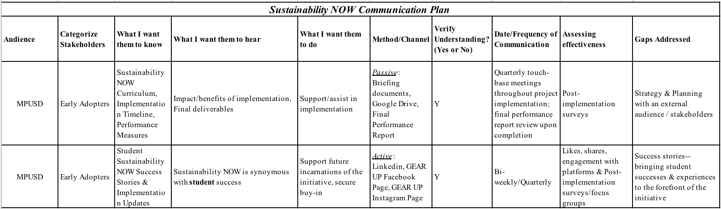
At the conclusion of the project, a Final Performance Report (FPR) was prepared that summarized outcomes and analyzed Sustainability NOW’s efficacy. The report covered progress made toward impacting each goal, objective and performance measure. But it is not enough to prove efficacy—we must ritualize our success to keep momentum going and social media channels can help us get there.
One way to fully leverage social media is by creating a Social Media Editorial Calendar. This tool is helpful in strategically planning communications that can shared with relevant stakeholders. A Social Media Editorial Calendar is helpful in mapping out these communications to keep the conversation alive. An exercise like this is critical to building and sustaining momentum.

Expect the Unexpected
Despite every attempt to strategically lay a structured foundation and timeline for the implementation of any project, delays and unforeseen conflicts will invariably arise. In the case of Sustainability NOW, our primary challenge was trying to adhere to the instructional timelines. These instructional timelines were planned for with the input of stakeholders, but despite getting their feedback and weaving their input into the strategy, we experienced several delays from the initial timeline due to changes in the master schedule at our service sites. Changes to the master schedule affected which teachers would be implementing the curriculum. Pivoting and being flexible in situations like this was of paramount importance, as the EPC and our programs aim to be a service provider for our constituencies, so we had to adapt and respond to their needs in our quest to implement a program like Sustainability NOW.
To overcome these challenges, we ensured that we adhered to our schedule of planning meetings with key stakeholders like members of administrative and leadership teams at each school site. We met frequently throughout the planning and implementation stages of Sustainability NOW which made unforeseen changes like this easier to navigate given that it allowed channels of communication to stay open. Once we were notified of master schedule changes in September, we re-trained newly assigned secondary teachers on the curriculum and moved implementation back at one site to accommodate the changes. Glitches like this, albeit planned for, can affect morale—so it is important to reinforce the vision of the project whenever there is an opportunity to do so in strategic planning meetings.

Navigating Organizational Change

Sustainability NOW represented a change in our programmatic framework and was therefore subject to resistance, given that it was a departure from what was familiar and comfortable. JP Kotter, a Harvard Professor of leadership, designed a change management model that is helpful to consider in navigating change.
Studies have shown that over 65 percent of organizational changes in a workplace fail (Weiss, 2011, p.164). Organizational change primarily fails due to a lack of strategy, communication, and open dialogue with stakeholders (p.172). By adhering to Kotter’s model for change, we were better positioned to both create and sustain the change we were seeking to deliver:
- Establishing a sense of urgency
  - Actionable Steps:
    - Capture the attention of critical stakeholders / articulate the urgency
      - Sustainability NOW Project Proposal
      - Outline goals & objectives of Sustainability NOW
      - Draft / finalize curriculum & pre/post surveys based on organizational & stakeholder feedback

- Creating a guiding coalition to implement changes
  - Actionable Steps:
    - Establish guiding coalition (Regular, Ad Hoc + Liaisons)
    - Secure an additional STEM-focused programming partner for GEAR UP
    - Establish strategic tools for project implementation/organizational sustainable development:
        - Gantt Chart (Sustainability NOW)
        - FSSD (Educational Partnership Center)
        - sSWOT (Educational Partnership Center)

- Developing a vision and strategy
  - Actionable Steps:
    - Draft & Finalize Sustainability NOW Vision Statement in coordination with team & stakeholders
    - Draft & Finalize Sustainability NOW Mission Statement in coordination with team & stakeholders

- Communicating that vision and strategy to stakeholders
  - Actionable Steps:
    - Communications Plan
    - Social Media Editorial Calendar
    - Utilize Communications Plan/Social Media Editorial Calendar beyond pilot year of 18-19

- Empowering employees for broad-based action
  - Actionable Steps:
    - Supporting the vision: Green Office Certification (Walk-the-talk)
    - Supporting the vision: Sustainability NOW implementation EPC staff training
    - Implement pilot curriculum with 15 percent of the GEAR UP cohort

- Generating short-term wins
  - Actionable Steps:
    - Sharing Green Office Certification Results / Divisional Newsletter Spotlight
    - Final Performance Report for Sustainability NOW Pilot (Pre/Post Survey Data)

- Consolidating gains while producing more changes
  - Actionable Steps:
    - Sustainability NOW adopted district-wide (MPUSD)
    - Expansion of Sustainability NOW into additional partner districts (Pajaro Valley/South Monterey County)

- Anchoring these new approaches in an organization’s culture
  - Actionable Steps:
    - Uploading curriculum / training resources to Educational Partnership Center’s website as a free resource
    - Bi-annual Green Office Recertification
    - Expanded partnership with MEarth / development of elective course offerings in sustainable agriculture

Collaboration Catalyzes Solutions

Andrew Winston, author of The big pivot: radically practical strategies for a hotter, scarcer, and more open world, reminds us that the ‘mega’ challenges we face are just that—mega—and that “no single person, organization, or country can solve them alone” (2014, p.211). MIT Sloan surveyed nearly 4,000 corporate executives and managers across 113 countries about the state of sustainability collaborations to produce a report entitled Joining forces: collaboration and leadership for sustainability. 90 percent of respondents indicated that there is a need to collaborate on matters of sustainability, with the number of companies having sustainability as a top-management agenda item increasing from 46 percent in 2010 to 65 percent in 2014 (Kiron, et al., 2015, pp.5-6). Put simply, “as sustainability issues have become more global and pivotal to success, companies are realizing that they can’t go it alone” (p.3). Moreover, “companies that have sustainability as a top management agenda item are twice as likely to collaborate strategically than companies in which sustainability is only somewhat or not important” and “the more collaboration a company engages in, the more successful its sustainability collaborations are reported to be” (pp.9-11).
What this boils down to is that collaboration is critical to ensuring the sustainable success of an initiative. But knowing when to collaborate and with whom is equally as important. In the case of Sustainability NOW, there was collaboration occurring in the implementation of the curriculum, but it was also at play in its scaling and ritualization.

Next Steps: Ritualizing and Scaling your Initiative

In order to ritualize and scale an initiative, it is helpful to refer back to the ‘Act’ section of the Framework for Strategic Sustainable Development (FSSD). In the case of Sustainability NOW, this section of the FSSD listed expanding partnerships/programming as a means to achieve increased sustainable development, because we must expand our offerings beyond educational strategies and programing to create lasting change.
In surveying prospective partners, it made sense to collaborate with MEarth. MEarth is an environmental sustainability education program that inspires youth and adults alike to be better stewards of our communities and environment. They provide hands-on, experiential learning opportunities to schools, county agencies, partner nonprofits, local businesses, and interested citizens throughout Monterey County. It is also an organic farm that offers employment and internship opportunities to residents of Monterey County.
In looking for common ground that was relevant to Sustainability NOW, I discovered that MEarth offers a Community Connect program that gives community members instructional workshops on sustainable agriculture, community restoration events, eco-volunteerism and career opportunities. Additionally, a neighboring district has partnered with MEarth to implement credit-bearing elective course offerings on sustainable agriculture. It represents the perfect partnership for further scaling Sustainability NOW as it is another way for our students to become immersed in the practice and language of sustainability.
The prospective partnership identified above allows the EPC to work past programming for awareness and work toward programming for lasting change by equipping students and families with tools to make their everyday lives more sustainable. It can also help MEarth impact their goals of increased community engagement via these programs. Lastly, it helps the district by increasing course offerings and career pathway opportunities. Collaborations must address a ‘win-win’ for all parties involved, so it pays to be selective and strategic in identifying partners.

Results & Conclusion

According to Tate & Martin, closeout procedures should commence when “the customer accepts the final deliverable” (2010, p.163). A closeout report should be prepared that includes customer, stakeholder, and the project sponsor’s feedback. The closeout report also includes the final project status report and “recommendations for improvement” (p.163). It is worth noting that the feedback element of this process is critical, and the objective should be to “learn as much as possible” by “listen[ing] with the intent to understand” and “without being defensive” (p.167) so as to receive unfiltered feedback that can genuinely assist in evaluating the efficacy of strategies/processes for future incarnations of the event or service. As such, we should endeavor to review this portion of the closeout process often until unfiltered/constructive feedback can be applied to the narrative portions of the closeout report. Ultimately, this process will not conclude until the closeout report is reviewed and approved by the project sponsor and the findings are distributed to key stakeholders.
For Sustainability NOW, I have prepared a Final Performance Report for Sustainability NOW that shows the progress we have made in impacting goals and objectives for the project. This involves analyzing students’ pre-and-post survey data. The results of the initiative are included below:
Sustainability NOW Performance Measures Milestones & Progress
Goal 1: Increase Cohort Student Sustainability Knowledge |  | Exceeded, Met, Nearly Met, Not Met
PM 1 | Implement ‘Sustainability NOW’ curriculum with 15% of cohort students | Exceeded  137 / 850 cohort students = 16% of cohort reached
PM 2 | Increase Sustainability Content Knowledge by 10 percentage points over baseline (pre-survey) | Nearly Met (9% Increase)  Baseline: 508 correct responses (pre-survey)/685 responses = 74%  Post-program: 570 correct responses (pre-survey)/685 responses = 83%
PM 3 | Increase Sustainability Ambition of Cohort Students by 10 percentage points over baseline (pre-survey) | Nearly Met (9% Increase)  Baseline: 36% 49 of 137 of participating students surveyed (pre-program) aspired to impact matters of sustainability.  Post-program: 44% 61 of 137 participating students surveyed (post-program) aspired to impact matters of sustainability.
PM 4 | Implement a hands-on project with participating students (i.e. Solar Charging Stations) as the culminating experience of the curriculum. | Met  Seaside HS: Solar Charging Stations / MEarth Organic Farm Tour & Gardening Project  Marina HS: Marina Waste Facility Tour / Career Pathways
Goal 2: Increase STEM partnerships with Public & Private Organizations
PM 1 | Secure 1 additional STEM focused partner for collaborative programming with GEAR UP Projects | Met  Secured Lyceum of the Monterey County in 2017
Goal 3: Walk the Talk: Infuse Sustainability into the EPC via Awareness/Education programs
PM 1 | Launch and Obtain Green Office Certification for EPC Headquarters (GOC) | Met
PM 2 | Secure buy-in of partner districts outside of my service region (Monterey County) to implement the ‘Sustainability NOW’ curriculum in future service years beyond 2019 (Pajaro Valley/South Monterey County) | Met  Presented on Sustainability NOW at an EPC all-staff meeting in Spring ’19 to scale Sustainability NOW to neighboring partner districts & district-wide in MPUSD

Sustainability challenges are often “seen as a broad collection of environmental and social challenges and reactive responses” and “like an elephant spied through the woods, whatever part is glimpsed often dominates the perspective” (McNall, et al., 2011, p.3). Given its sheer complexity and scale, it is easy to get lost in the vast web that is sustainability. It is an idea that opens the curriculum of Sustainability NOW because it is an indisputable truth. Sustainability requires a collective commitment across a litany of sectors, so our lever for change ultimately rests in our ability to advance these principles within the context of our expertise. As such, the success of a sustainability initiative will rest upon one’s ability to connect the organization’s mission to the principles of sustainability—selecting a path that will affect change on a micro and macro level by way of the organization’s own vested interest in success.

References

About EPC. (2013). Retrieved from https://epc.ucsc.edu/about/index.html

About Us. (n.d.). Monterey Peninsula Unified School District. Retrieved from

https://www.mpusd.net/apps/pages/index.jsp?uREC_ID=1019885&type=d&pREC_ID=1

305113.

Baddache, F. & Morris, J. (2011). BSR’s Five-Step Approach to Stakeholder Engagement.

Retrieved from https://www.bsr.org/en/our-insights/report-view/bsrs-five-step-approach-

to-stakeholder-engagement

Bond-Hill, C. (2015). “Income Inequality and Higher Education.” Retrieved November

03, 2017, from http://www.acenet.edu/the-presidency/columns-and-

features/Pages/Income-Inequality-and-Higher-Education.aspx

California's Political Geography - Public Policy Institute of California. (n.d.). Retrieved from

http://www.ppic.org/publication/californias-political-geography/

Carnevale, A., Rose, S., & Cheah, B. (n.d.). “The college payoff: education, occupations, &

lifetime earnings” (Rep.).

doi:https://www2.ed.gov/policy/highered/reg/hearulemaking/2011/collegepayoff.pdf

Cumming, V. (2016). How many people can our planet really support? Retrieved from

http://www.bbc.com/earth/story/20160311-how-many-people-can-our-planet-really

support

Facts, Figures & FAQs. (n.d.). Retrieved September 09, 2017, from

http://montereycfb.com/index.php?page=facts-figures-faqs

Freeman, S. et al. (2014). Active learning increases student performance in science,

engineering, and mathematics. Retrieved from:

http://www.pnas.org/content/early/2014/05/08/1319030111?sid=8c66e8e4-8eea-

4989-b252-fab804e80328

Kiron, D. et al. (2015). Joining forces: collaboration and leadership for sustainability.
Retrieved from: https://sloanreview.mit.edu/projects/joining-forces/
McNall, S. G., Hershauer, J. C. & Basile, G. (2011). Business of Sustainability: Trends, Policies,

Practices and Stories of Success. Volumes I and II. Santa Barbara, CA: Praeger.

Metzger, E. et al. (2012). sSWOT: a sustainability SWOT. Retrieved from

http://pdf.wri.org/sustainability_swot_user_guide.pdf

Monterey Peninsula Unified Smarter Balanced Results – CAASPP Reporting (CA Dept of

Education). (2017). Retrieved from

https://caaspp.cde.ca.gov/sb2017/ViewReport?ps=true&lstTestYear=2017&lstTestType

=B&lstGroup=1&lstCounty=27&lstDistrict=66092-000&lstSchool=0000000

Niksa, M. (2018). Agriculture leaders predict farms in California, Salinas Valley will be fully

automated in 10 years with help from drones, machine harvesting. Silicon Valley

Business Journal. Retrieved from

https://www.bizjournals.com/sanjose/news/2018/06/29/california-farming-forecast-

automation-agtech.html

Parrish, B. & Trilley, F. (2011). Creating sustainable entrepreneurship. The business of

sustainability: trends policies, practices, and stories of success (pp.103-118). Santa

Barbara, CA: Praeger.

Risky Business: The Economic Risks of Climate Change in the United States - A Climate

Assessment for the United States. (2017). Retrieved August 30, 2017, from

http://riskybusiness.org/report/national/

Ritchie, H. & Roser, M. (2018). C02 and other Greenhouse Gas Emissions. Retrieved from

https://ourworldindata.org/co2-and-other-greenhouse-gas-emissions

Senge, P. M. (2009). The fifth discipline: The art and practice of the learning organization. New

York: Currency Doubleday.

Sengupta, S. (2018). 2018 Is Shaping Up to Be the Fourth-Hottest Year. Yet We're Still Not

Prepared for Global Warming. Retrieved from

https://www.nytimes.com/2018/08/09/climate/summer-heat-global-warming.html

Social Media Demographics to Inform a Better Segmentation Strategy. (2017).

Retrieved from https://sproutsocial.com/insights/new-social-media-demographics/

State Smarter Balanced Results – CAASPP Reporting (CA Dept of Education). (2017).

Retrieved from

https://caaspp.cde.ca.gov/sb2017/ViewReport?ps=true&lstTestYear=&lstTestType=B&ls

tCounty=00&lstDistrict=00000&lstSchool=0000000

sSWOT World Resources Institute. (n.d.). Retrieved from http://www.wri.org/publication/sswot

Tate, K., & Martin, P. K. (2010). The project management memory jogger. Salem, NH:

GOAL/QPC.

Thompson, A. (2016). Heat Is On for 2017. Retrieved from

http://www.climatecentral.org/news/heat-is-on-for-2017-21011

Weiss, J. W. (2011). An introduction to leadership. Bridgepoint Education.
Winston, A. S. (2014). The Big Pivot: Radically Practical Strategies for a Hotter, Scarcer, and

More Open World. Boston: Harvard Business Review Press.

Appendices

Gantt Chart (Sustainability NOW)
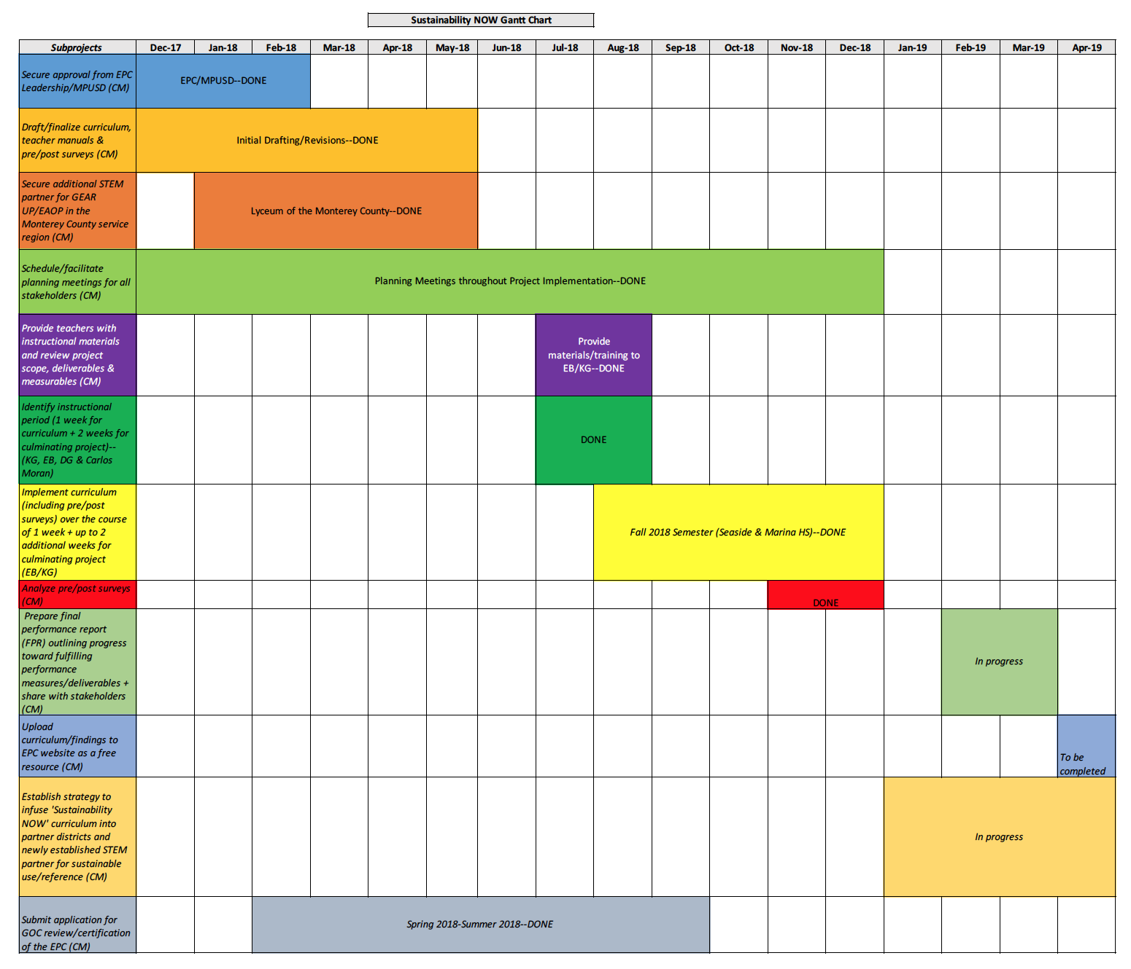

Framework for Strategic Sustainable Development (EPC)
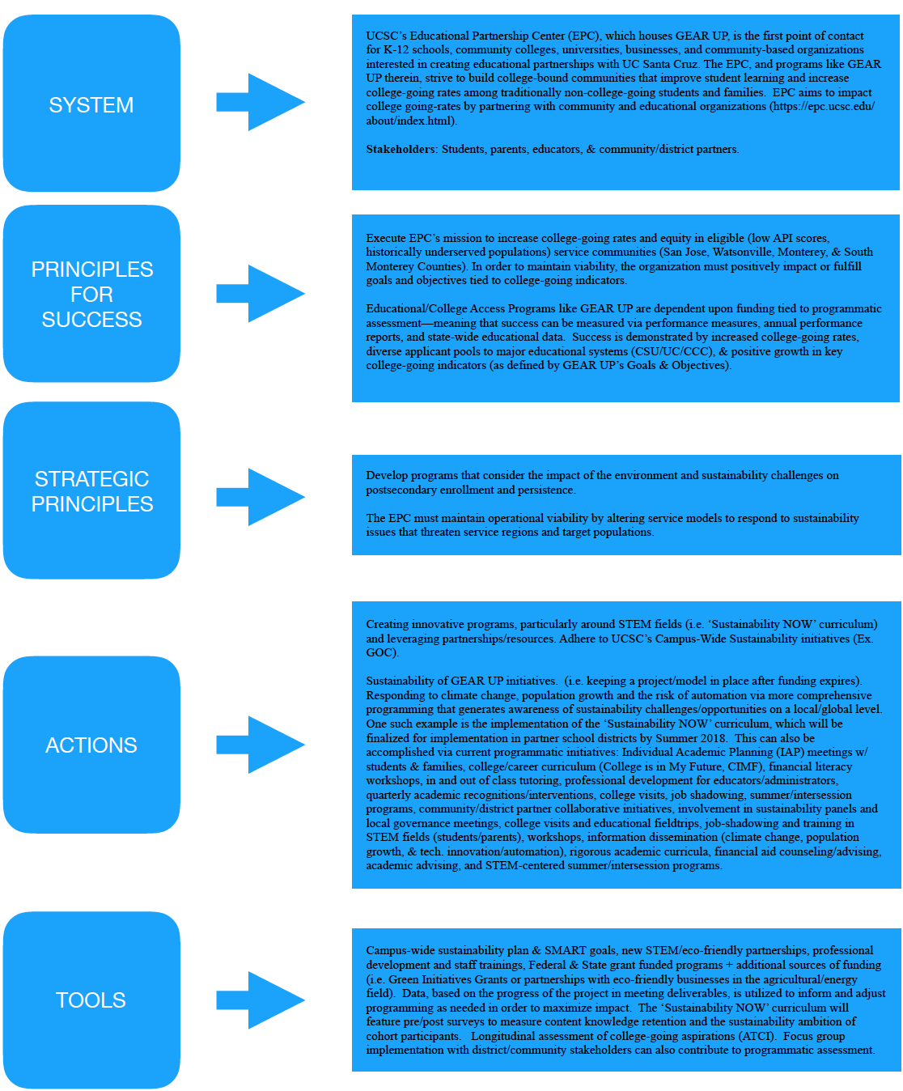

sSWOT (EPC)

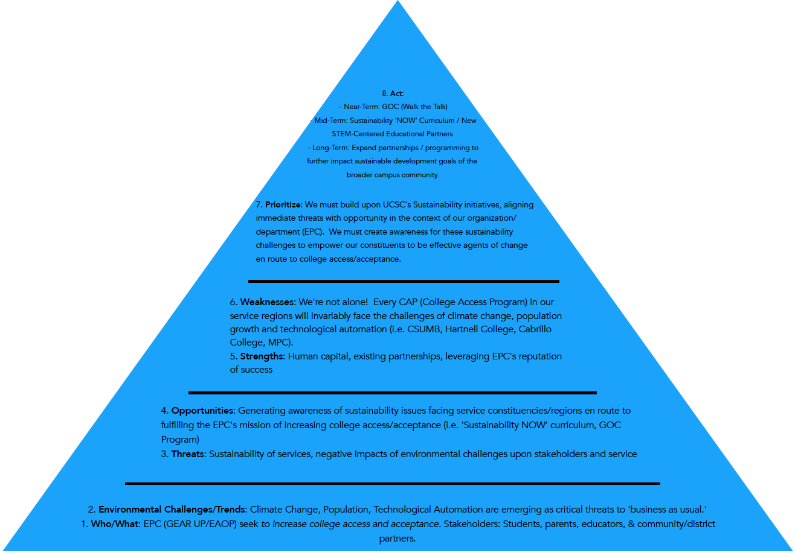

Stakeholder Analysis (Sustainability NOW)
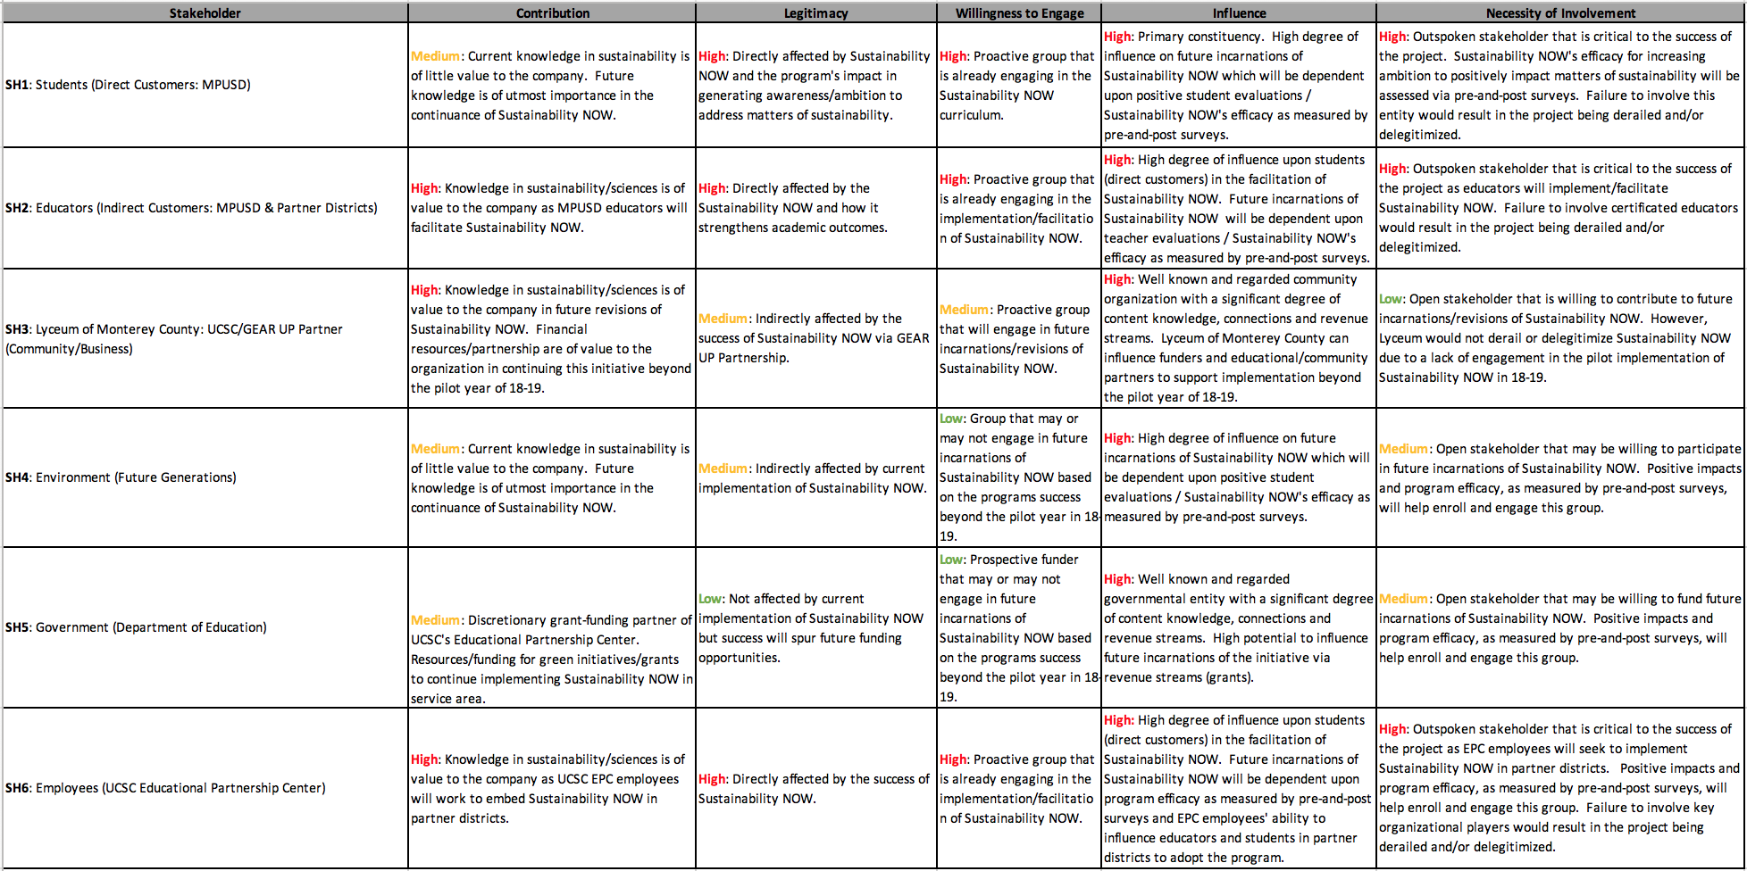

Stakeholder Mapping (Sustainability NOW)

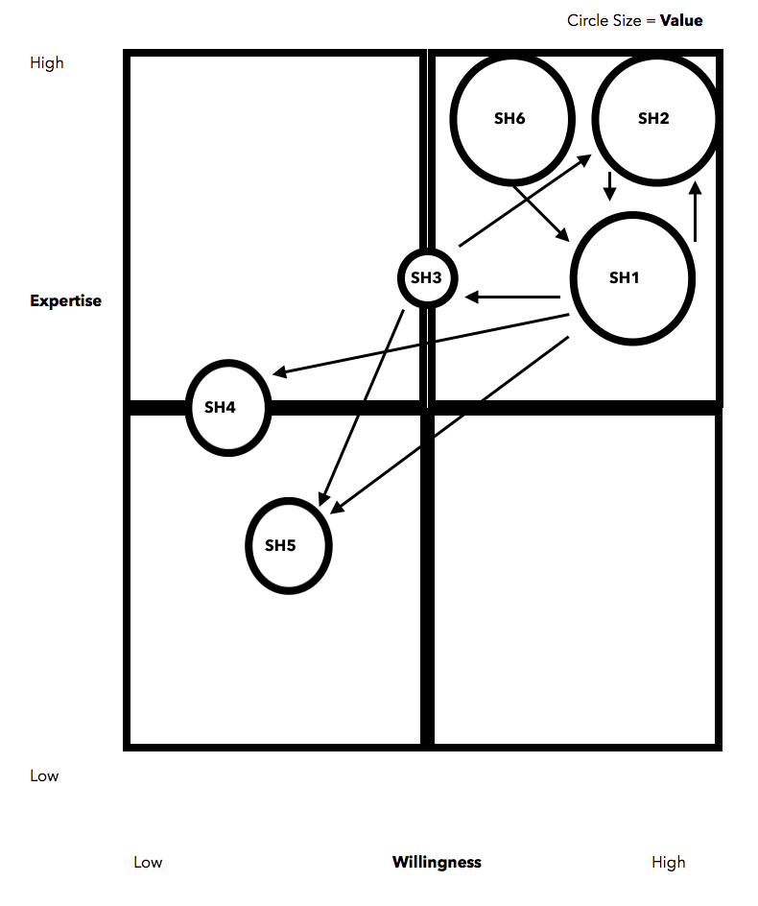

Green Office Assessment and Recommendation Report: Educational Partnership Office
University of California, Santa Cruz, Spring 2018

Green Office Certification would like to thank you for allowing us to assess your current and potential sustainable office practices. We believe that sustainability is about a healthy environment, smart economics, and cooperative communities. Your willingness to accept feedback from our team shows that you are committed to making a positive impact within the UCSC community, which is an important aspect of sustainability on this campus. We hope that this assessment and recommendation report will encourage office practices that will support the health of the environment.

Assessment and Scoring
Offices are not measured against truly sustainable practices such as zero waste, but rather by office practice standards based on what is currently attainable. Given these parameters, offices have the opportunity to move toward sustainability by improving their daily practices. Therefore, offices on the UCSC campus are rated on the scale of Excellent to Poor with the understanding that if excellence is achieved, room for improvement toward sustainability continues to exist.

Green Office Certifications are given in four tiers (lowest tier being 1, highest tier being 4)
TIER | AWARD LEVEL | POINTS
TIER 4 | TREE | 90-100%
TIER 3 | SAPLING | 75-89%
TIER 2 | SPROUT | 41-74%
TIER 1 | SEED | 30-40%

Scoring Guideline (highest to lowest)
- Excellent (91%-100%) - Most or all attainable sustainable office practices are implemented. Room for improvement continues to exist.
- Very Good (75%-90%) - Incorporation of many sustainable office practices; more can be done to achieve excellence.
- Good (59%-74%) - Average inclusion of functional sustainable office practices.
- Fair (41%-58%) - Many more sustainable office practices can be integrated with the few currently in use.
- Poor (0.0%-40%) - Indicates the majority of the simple, generally recognized sustainable office practices are not currently in use.
Area of Assessment | Points | % | Score (Poor-Excellent)
Purchasing | 16/23 | 69% | Good
Recycling/Waste | 28/28 | 100% | Excellent
Paper/Printing | 15/17 | 88% | Very Good
Computers | 10.06/20 | 50% | Fair
Energy | 12/24 | 50% | Fair
Lighting | 11/11 | 100% | Excellent
Travel & Transportation | 10.75/17 | 63% | Good
Kitchen and Shared Areas | 14/17 | 82% | Very Good
Water | 12/13 | 92% | Excellent
Participation & Development | 4/4 | 100% | Excellent
Green Events | 9/12 | 75% | Very Good
TOTAL SCORE and Ranking | 141/188 | 75% | Sapling

Energy Assessment
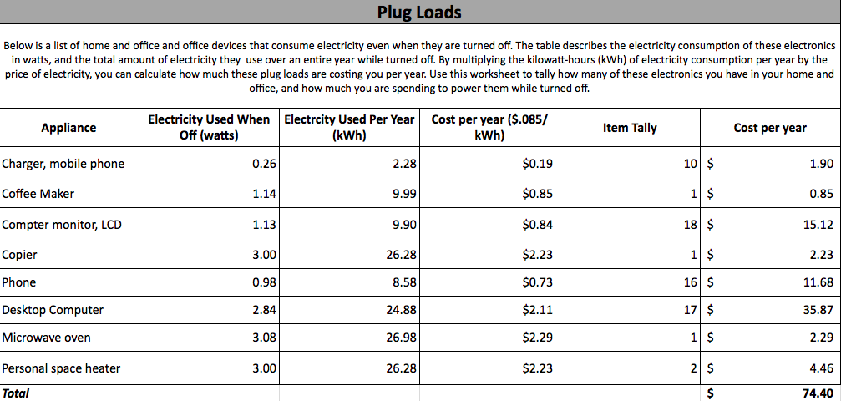

Waste Assessment

Trash
- Some pieces of paper and post it notes were found in the trash that should be recycled
- Paper towels were found that can be composted
Recycling
- A straw was found in the recycling, which should be in the trash.
- Spoons and paper towels were found in the recycling, which are compostable.

Top Five Recommended Changes

The five highest impact changes your offices can easily make to be more sustainable:
- Consider removing printers located in individual offices/cubicles.
- Consider putting screen savers on all computers.
- Make sure to turn power strips off at the end of each day.
- Consider having the office delamped by calling Physical Plant.
- Consider always using reusable cups, dishes, utensils at events.

More detailed recommendation follows later in this report.

Immediate Sustainable Changes with help from GOC

Please list resources (services, equipment, etc.) that GOC can provide
- Can provide smart strips
- Can provide 3-gallon recycling bins
- Can provide signage
- Can provide contacts to green training events

Please let Green Office Certification know if there is anything else you need special assistance with in order to make positive sustainable changes.

Future Education Opportunity

Green Office Certification would love to arrange a time to continue the education of your staff about sustainable office and lifestyle practices. We can tailor this opportunity to meet the specific needs and wants of your office as well as fit it within a timeline chosen by you. For example, we could prepare a 20-minute presentation for your monthly staff meeting on the topic that your office members are interested in the most. If you would like more information on sustainability related learning opportunities please contact us: greenoff@ucsc.edu

Recommendations Report: Category Breakdown

Purchasing
Points: 16/23
Percentage: 69%
Score: Good

Positive Existing Behaviors:
- Purchasing in your department is centralized through one person.
- The office reuses office supplies.
- Office members use reusable totes when shopping.

Recommendations:
- Have all purchasers read the Green Purchasing Guide
- Have all office members complete the UCSC Greenwashing Training
- Have the office purchase 100% post-consumer waste paper.
- Have purchasers always use the Environmentally Preferable Products list when making purchases on Cruzbuy.

Recycling and Waste
Points: 28/28
Percentage: 100%
Score: Excellent

Positive Existing Behaviors:
- The office recycles ink/toner cartridges or uses refillable cartridges.
- The office has a system to recycle batteries.
- The office disposes of electronic equipment through the campus E-waste Program.
- All office staff receives paychecks via direct deposit
- All office staff receives electronic W2 tax forms.
- The office has a recycling bin near each printer/copier

Paper and Printing
Points: 15/17
Percentage: 88%
Score: Very Good

Positive Existing Behaviors:
- Toner saving is selected as the default printing setting on all computers
- Scratch paper is collected and available for the whole office to use
- Office members always print double sided
- Printers/copiers/fax machines are on energy save mode

Recommendations:
- Remove printers located in individual offices/cubicles

Computers
Points: 10.06/20
Percentage: 50%
Score: Fair

Positive Existing Behavior:
- The office uses EPEAT when purchasing computers.
- All computers are plugged into power strips.
- Computer screens are turned off when they are not in use.
- Devices not needed are disabled on computers.

Recommendations:
- Contact the designated IT person in your office to discuss the most efficient. energy settings for your office.
- Set computers to the lowest possible brightness setting.
- Make sure all computers have screen savers.
- Implement the use of smart strips/ecostrips.
- Place reminders in the office to turn off personal computers.

Energy
Points: 12/24
Percentage: 50%
Score: Fair

Positive Existing Behavior:
- Power strips are easily accessible in the office.
- Printers/copiers/fax machines are plugged into power strips.
- Hardware is shared when applicable.
- The office has reminders near exits to turn off all appliances or power strips.

Recommendations:
- Turn power strips off at the end of each day.
- Make sure all computers and printers are Energy Star
- Place signage next to the thermostat to encourage layering rather than adjusting temperatures.

Lighting
Points: 11/11
Percentage: 100%
Score: Excellent

Positive Existing Behavior:
- All lights are turned off at the end of the day.
- The office uses CFLs or LEDs in applicable light fixtures.
- The office uses natural lighting when possible.

Recommendations:
- De-lamp individual offices.
- Post reminders near the exits to turn off the lights.

Travel and Transportation
Points: 10.75/17
Percentage: 63%
Score: Good

Positive Existing Behaviors:
- The office uses video and teleconferencing in lieu of travel when possible
- Office members use alternative methods of transportation (i.e. biking, bus, carpool) when travelling between meetings throughout campus.
- Office members use Connexxus to book campus related airfare.

Recommendations:
- Consider always using alternative methods of transportation when traveling on campus

Kitchen and Shared Areas
Points: 14/17
Percentage: 82%
Score: Very Good

Positive Existing Behaviors:
- Staff use reusable mugs and/or containers
- There are clearly marked mixed recycling bins in the kitchen and all common areas
- The office offers reusable plates, cups, and silverware in the kitchen.
- In the kitchen the office uses biodegradable, non-toxic, or non-oil-based dishwashing soap.
- The office offers reusable towels for drying hands and dishes.

Recommendations:
- Make sure none of the staff purchases bottled water.

Water
Points: 12/13
Percentage: 92%
Score: Excellent

Positive Existing Behaviors:
- Staff members know how to identify and report a leak
- Staff turn off the sink when washing their hands
- Office members do not shower at the office.
- The office has reminders to practice water saving techniques near all faucets.
Recommendations:
- Make sure staff turn off sink when washing dishes.

Participation & Development
Points: 4/4
Percentage: 100%
Score: Excellent

Positive Existing Behaviors:
- The office has planned an event centered around sustainability.
- The office has encouraged other offices to participate in a GOC assessment.

Recommendations:
- Have all staff sign up for the Sustainability Office Newsletter
- Have staff attend a sustainability event

Green Events
Points: 9/12
Percentage: 75%
Score: Very Good

Positive Existing Behaviors:
- Mixed recycling bins are offered and adequately labeled at events.
- Compost bins are available and adequately labeled at events.

Recommendations:
- Always offer reusable cups, dishes, utensils at events.
- Always purchase food in bulk for events.
Sustainability NOW Lesson Plan

Unit 1 Title: Introduction—What is Sustainability?

Grade Level: 9-12

Summative Prompt/Essential Question: What is Sustainability?

Standards:

Earth and Human Activity
- HS-ESS3-3: Create a computational simulation to illustrate the relationships among management of natural resources, the sustainability of human populations, and biodiversity.
- HS-ESS3–5: Analyze geoscience data and the results from global climate models to make an evidence-based forecast of the current rate of global or regional climate change and associated future impacts to Earth systems.
Duration: 50 minutes

Unit 1—Introduction: What is Sustainability?

Learning Goals
- Students will demonstrate their knowledge and sustainability ambition via a pre-assessment.
- Students will be able to define sustainability in both an academic and personal context.
- Students will observe the effects of resource depletion in the context of sustainability.

Materials/Activities

- Sustainability NOW Pre-Assessment
- Sustainability NOW Student Workbook
- “Sustainability Easily Explained” Video
https://www.youtube.com/watch?v=_5r4loXPyx8
- 1 roll of masking or painter’s tape
- 2 sets of chopsticks or sticks of some kind
- Assorted snacks or candy
- 2 Cups or bowls

Teacher & Student Actions

- Distribute pre-assessments—Content Knowledge & Sustainability Ambition Surveys (10 minutes)
- Distribute ‘Sustainability NOW’ Student Workbooks.
- Refer to Unit 1 in ‘Sustainability NOW’ Workbook.
  - Instruct students to read the unit (5 minutes)
- Students will then view the “Sustainability Easily Explained” Video (5 minutes)
- Activity—Fishing/Sustenance Exercise in Sustainability (10 minutes)
  - Divide students into two groups
  - Draw a lake on floor (large enough for two groups to gather on each side) with the masking or painter’s tape.
  - Scatter the snacks or candy into the ‘lake’ (approximately double the amount of candy or snacks per total participants)
  - Provide students with an overview of the situation:
    - The two ‘tribes’ of students live next to this lake and share the resources (fish) for their own sustenance.
    - Each group must choose a designated ‘Fisherperson’ whose goal is to capture 1 snack or piece of candy for everyone in their group.
    - Rules:
      - The fisherperson can only use 1 set of chopsticks to capture their ‘fish’ and cannot go into the lake or cross the tape.
  - After explaining the rules/guidelines above, instruct students to ‘fish’ for 1 minute, observing to ensure that students are adhering to the rules and guidelines.
  - Then, replenish the ‘lake,’ adding about 1-2 snacks or pieces of candy to what’s already left in the lake for each participant.

  - Instruct ‘fisherpersons’ to fish once more for 1 minute.
    - Rules:
      - Fisherpersons can now put one foot into the lake and use their hands to sweep fish out of the lake area.
  - After replenishing the lake one last time for 1 minute (same parameters as above), instruct the fisherperson to harvest the lake one final time.
    - Rules:
      - Fisherpersons can now use their hands, chopsticks, and a solo cup to shovel fish out of the lake.

At this point in the activity, the ‘lake’ will become sparsely populated, allowing students to see the effects of over-harvesting/hunting and the environment’s inability to keep pace with the devastation in its regeneration of resources.

- Group Activity/Reflection: divide students into groups and have students discuss/complete the reflection in their ‘Sustainability NOW’ workbook (10 minutes)
  - What happened to the population of ‘fish’ in the lake when the fisher person was given more tools to fish?
  - As our global population increases and new technologies/tools make processes like fishing easier, do you think this can do more harm than good? Why or why not?
- Individual Journal Reflection: at the conclusion of Unit, students will answer the following question in their ‘Sustainability NOW’ journal reflection (10 minutes)
  - What does sustainability mean to you?

References

Sustainability Easily Explained. (2012, July 25). Retrieved December 06, 2017, from
https://www.youtube.com/watch?v=_5r4loXPyx8

Unit 2 Title: Climate Change

Grade Level: 9-12

Summative Prompt/Essential Question: How does Climate Change affect matters of sustainability in a global and local context?

Standards:
Earth and Human Activity
- HS NGSS Storyline (Based on CA State Standards): Ecosystem Stability & the Response to Climate Change. Students use computer models to investigate how Earth’s systems respond to changes, including climate change. They make specific forecasts and design solutions to mitigate the impacts of these changes on the biosphere.
- HS-ESS3–5: Analyze geoscience data and the results from global climate models to make an evidence-based forecast of the current rate of global or regional climate change and associated future impacts to Earth systems.
- HS-ESS3-6 Use a computational representation to illustrate the relationships among Earth systems and how those relationships are being modified due to human activity.

Planning and Carrying Out Investigations
- HS-PS2-5: Plan and conduct an investigation individually and collaboratively to produce data to serve as the basis for evidence, and in the design: decide on types, how much, and accuracy of data needed to produce reliable measurements and consider limitations on the precision of the data (e.g., number of trials, cost, risk, time), and refine the design accordingly.

Analyzing and Interpreting Data
- HS-PS2-1: Analyze data using tools, technologies, and/or models (e.g., computational, mathematical) in order to make valid and reliable scientific claims or determine an optimal design solution.

Duration: 50 minutes

Learning Goals
- Students will understand the relationship between the carbon cycle, CO2 emissions, and human activity associated with climate change.
- Students will understand the local effects of climate change in the form of ocean acidification and its correlation to climate change.

Materials/Activities

- Sustainability NOW Student Workbook
- https://www.climateinteractive.org/tools/climate-bathtub-simulation/

Teacher & Student Actions
- Refer to Unit 2 in ‘Sustainability NOW’ Workbook.
  - Instruct students to read the unit (5 minutes)
  - Distinguish Climate vs. Weather as covered in the student workbook (5 minutes)
- Activity: Climate Bathtub Simulation (15 minutes)
  - Purpose:
    - This exercise will allow students to explore what happens if we cap carbon emissions at current levels, encourage their unlimited use, or reduce them. Students will use this simple animated simulation of the global carbon system to explore the relationship between carbon emissions and atmospheric CO2.
  - Direct students to the following link: https://www.climateinteractive.org/tools/climate-bathtub-simulation/
  - Explain the basics of the carbon cycle:
    - The carbon cycle is how the earth redistributes or ‘spreads-out’ carbon.
    - Plants use both carbon dioxide and sunlight to make their food—a process called photosynthesis. Plants retain this carbon dioxide, and when they die, this carbon dioxide becomes fossil fuels like coal and oil over millions of years.
    - This is a natural process of redistribution. However, when we burn fossil fuels, the carbon dioxide travels into the atmosphere. If too much accumulates, it acts like a blanket, trapping the carbon dioxide in our atmosphere, which increases temperatures and correlates with climate change.
  - Explain the bathtub and its parts (i.e. Inflow=emissions, outflow= removals, & water in tub = CO2 in the atmosphere.
  - Next, press play on the simulation and pause the video around 1970. A good question to ask students at this point is why the CO2 levels are increasing (because we are emitting more CO2). Explain to students that more carbon is going in than coming out—stress this point throughout the activity. Emissions exceed removals.
  - Hit play once more until 2007 or so. Again, emissions are exceeding removals.
  - Next, divide students into manageable groups. Write the following ‘challenge’ on the board:
    - Choose a future that will keep CO2 levels below 450ppm
    - After about 5 minutes, students will discover that there is no way to prevent the tub from overflowing other than reducing the levels of CO2 in the atmosphere.
    - Ask students to complete the following discussion questions individually:
What happened when you selected the ‘Allow Increased CO2 Emissions’ option? Is that option or choice sustainable? What are some real-life examples of ‘Allowing Increased CO2 Emissions’?
ii. What happened when you selected the ‘Level off CO2 Emissions’ option? Is that option or choice sustainable? What are some real-life examples of ‘Leveling off CO2 Emissions’?
iii. What happened when you selected the ‘Reduce CO2 Emissions’ option? Is that option or choice sustainable? What are some real-life examples of ‘Reducing CO2 Emissions’?
iv. Is there a correct answer with respect to these options? What should we do?

After the Climate Bathtub Simulation activity, students will remain in their groups for a closing lab on one of the local effects of climate change, ocean acidification.

Learning Goals
- Students will understand the local effects of climate change in the form of ocean acidification and its correlation to climate change.

Materials/Activities
- Several Pyrex beakers, at least 6 inches tall with an opening of at least 4 inches wide
- Water, freshwater or seawater
- pH indicator paper or meters
- Red Cabbage Juice indicator
  - To create a red cabbage indicator, chop ½ red cabbage and simmer it in water until the cabbage loses its color. Cool, then strain the cabbage water into a glass jar and store it in the fridge until ready for use. Key: Acidic solutions, red=pH 2, purple=pH 4; neutral: violet pH 6, blue pH 8; basic, blue-green=pH 10 and lastly green-yellow=pH 12).
- Dry ice (only the instructor will touch the dry ice)
- Gloves, goggles, tongs
- Hammer and/or screw driver to chip dry ice
- Ice chest to store dry ice

- Activity: Local Effects of Climate Change, Ocean Acidification (20 minutes)
  - First, divide students into groups.
  - Next, write the following steps on the whiteboard:
    - Pour water into the Pyrex beakers until approximately ½ full
    - Use the pH strip or meter to assess the pH (document this in the Sustainability ‘NOW’ workbook.
    - Add cabbage juice to water (should change the color to a bluish-purple)
    - Test the pH again, noting the results in the workbook. Take a picture of the solution with your cell phone to refer to later
    - Ask your instructor to put a piece of dry ice into the mixture and observe the effects, taking notes in your Sustainability NOW workbooks.
    - While the dry ice is being added, explain to students that dry ice is a form of solid carbon dioxide and that the effect they’re observing is called sublimation, or changing from a solid to a gas.
    - Conclude the lab by lecturing on the following points:
      - When carbon dioxide (dry ice) is added to water, the process of sublimation begins, which represents what is happening to our oceans are carbon dioxide levels continue to build on planet earth. Connect this to the earlier activity, there’s no outlet for the level of carbon emissions we’re experiencing—that means the carbon is trapped in our atmosphere and oceans. Effectively, the process that students are observing is our oceans becoming more acidic as a result of this excess carbon.
- Clean-up (10 minutes)

References

Climate Bathtub Simulation. (2017, July 11). Retrieved December 06, 2017, from https://www.climateinteractive.org/tools/climate-bathtub-simulation/

Climate Kids. (n.d.). Retrieved December 06, 2017, from https://climatekids.nasa.gov/climate-change-meaning/

Jones, D. et al. (2007, July 19). Climate Bathtub Sim Coach Notes and FAQs. Retrieved December 5, 2017, from https://www.climateinteractive.org/wp-content/uploads/2014/01/Climate_Bathtub_Sim_Facilitator_Guide.pdf

Ocean Acidification Demonstration. (n.d.). Lecture. Retrieved December 5, 2017, from http://www.cisanctuary.org/ocean-acidification/PDFs-WorkshopPage/Hands_on_acivities/OA_dry_ice_demo.pdf

Resource Issues: Climate Change. (n.d.). Retrieved December 06, 2017, from https://montereybay.noaa.gov/resourcepro/resmanissues/climatechange.html

Unit 3 Title: Population Growth

Grade Level: 9-12

Summative Prompt/Essential Question: How does population growth affect matters of sustainability in a global and local context?

Standards:
Earth and Human Activity
- HS-ESS3-3: Create a computational simulation to illustrate the relationships among management of natural resources, the sustainability of human populations, and biodiversity.

Ecosystems: Interactions, Energy, and Dynamics
- HS-LS2-1: Use mathematical and/or computational representations to support explanations of factors that affect carrying capacity of ecosystems at different scales.
Duration: 50 minutes

Learning Goals
- Students will be able to identify changes in global population over the past 2,000 years and identify reasons why unfettered population growth can impact matters of sustainability in a local and global context.

Materials/Activities

- Sustainability NOW Student Workbook
- http://www.populationeducation.org/content/world-population-video
- http://worldpopulationhistory.org/map/1/mercator/1/0/25/
- Whiteboard or Butcher Paper (Discussion Question Share-Back)
- Butcher Paper for Group Posters (enough for several small groups)

Teacher & Student Actions
- Begin by showing the World Population Video at the link above (10 minutes)
- Divide students into groups to answer the following question in their Sustainability NOW workbooks. In answering the question, students can refer to the corresponding ‘map’ at the following link: http://worldpopulationhistory.org/map/1/mercator/1/0/25/

  - When did you notice the most growth in global population? Identify 3 events, scientific/technological innovations, and social changes contributed to rise in global population.

- Students will then present their answers to the class, selecting one team member to write the responses on the whiteboard.
- Once students have answered the discussions questions, ask the students to remain in their groups. Students will then research the effect of population growth in a local context. Ask students to find one article online that demonstrates the effect of population growth on the local environment (Bay Area, Santa Cruz, or Monterey).
- Once students have identified an article, they will summarize the findings in a brief presentation accompanied by a poster wherein students can work together to showcase their creativity/artistic abilities.
  - Guidelines:
    - Every group must create a poster that creatively expresses the main point of their article.
    - Every group must present their findings to the class and offer a potential solution for the aforementioned ‘local’ challenge associated with population growth.
    - At the conclusion of the presentations, students will select a group that offered the best solution to said challenge.
References

(2015, October 02). Retrieved December 06, 2017, from http://www.populationeducation.org/content/world-population-video

World Population History. (n.d.). Retrieved December 06, 2017, from http://worldpopulationhistory.org/map/1/mercator/1/0/25/

Unit 4 Title: Technological Automation

Grade Level: 9-12

Summative Prompt/Essential Question: How does technological automation affect matters of sustainability in a global and local context?

Standards:
HS Engineering and Design
- HS-ETS1-1: Analyze a major global challenge to specify qualitative and quantitative criteria and constraints for solutions that account for societal needs and wants.

Duration: 50 minutes

Unit 4: Technological Automation

Learning Goals
- Students will be able to identify specific industries that will be impacted by the threat of automation in a local and global context.

Materials/Activities

- Sustainability NOW Student Workbook
- “Job losses due to automation could hit retail industry hardest” CBS This Morning Video https://youtu.be/_hERITbwSy4
- KQED Video (For Breakout Groups)
  - https://ww2.kqed.org/education/2016/05/13/will-robots-replace-us-at-work/

Teacher & Student Actions

- Begin by showing students the “Job losses due to automation could hit retail industry hardest” CBS This Morning Video https://youtu.be/_hERITbwSy4 (5 minutes)
- Divide students into break-out groups.
- Once students are in groups, refer to Unit 4 in their ‘Sustainability NOW’ Workbook.
  - Instruct students to read the unit and watch the KQED Video (10 minutes)
- Students will research the effect of automation in the local context (35 minutes)
  - Refer students to this example: https://www.bizjournals.com/sanjose/news/2017/06/06/salinas-valley-agriculture-tech-farming-robots.html
  - Guidelines:
    - Once students have identified an industry, they will complete the concept map in their Sustainability ‘NOW’ Workbook.
Instructions:
      - In the center of the map, name the industry that will be affected by technological automation.
      - After listing your industry, please identify three potential causes for automation in the industry you identified (ex. Labor shortage) on the top row.
      - After listing causes, please work with your group to determine three potential impacts (ex. Loss of Employment/Wages) on the bottom row.
    - Once complete, students will share their concept map with their peers.
References

Job losses due to automation could hit retail industry hardest [Video file]. (n.d.). Retrieved December 5, 2017, from https://youtu.be/_hERITbwSy4

Rotman, D. (2015, June 16). Who Will Own the Robots? Https://www.technologyreview.com. Retrieved December 5, 2017, from https://www.technologyreview.com/s/538401/who-will-own-the-robots/

Schaber, Olivia. (2017, June 6). “Robots take over traditional farming practices, but not jobs, in
the 'Silicon Valley of agriculture’” . Retrieved September 09, 2017, from https://www.bizjournals.com/sanjose/news/2017/06/06/salinas-valley-agriculture-tech-
farming-robots.html

Unit 5 Title: Finding Your Voice

Grade Level: 9-12

Summative Prompt/Essential Question: How can we impact matters of sustainability (Climate Change, Population Growth & Technological Automation) in the local context? How do we advance the narrative toward solutions?

Standards:
Weather and Climate
- HS-ESS2-6 & HS-ESS2-4: Changes in the atmosphere due to human activity have increased carbon dioxide concentrations and thus affect climate.

Duration: 50 minutes

Learning Goals
- Students will demonstrate their knowledge and sustainability ambition via a post-assessment.
- Students will be able to identify their carbon footprint, and outline steps to reduce their impact on the environment in a local context.
- Students will understand how to utilize collaboration and cooperation as means by which to advance their goals/objectives.

Materials/Activities

- Sustainability NOW Student Workbook
- http://myfootprint.org/en/visitor_information/
- http://myfootprint.org/en/take_action/reduce_your_footprint/
- https://www.youtube.com/watch?v=eRLJscAlk1M
- 2 Red/Green Cards (One-side red, the other side green)

Teacher & Student Actions
- Students will begin by taking the “My Carbon Footprint” Assessment (10 minutes)
  - Once students receive their ‘Ecological Footprint,’ instruct them to document it in their ‘Sustainability NOW’ workbook.
- Next, students will click the ‘Reduce your Footprint’ button, which will take them to the following link: http://myfootprint.org/en/take_action/reduce_your_footprint/
- Using the examples listed, students will then complete the ‘Reducing Your Footprint’ Reflection Question in the ‘Sustainability NOW’ workbook (10 minutes)
- Activity: Red-Green Game (20 minutes)
  - Purpose: The goal of this game is to teach students that by communicating and collaborating with one another, we are more likely to achieve shared goals and objectives. Students will understand that operating purely on self-interest works against mutual goals and objectives.

  - Divide the classroom into two groups of students and have them form a line, with each line facing one another. Explain the Red-Green Game:
    - The player at the head of each line will be given a card that is red on one side and green on the other.
    - Every person in line will have a chance to compete against his or her counterpart in the opposing team's line.
    - Students will take turns showing one side of the card to the opposing team member, with the instructor observing which color each student chooses to show.
    - There are two rounds.
    - They will be awarded points depending upon the side of the card they show and the side their opponent shows as follows:
      - If you show green and your opponent shows green, you each get 3 points.
      - If you show green and your opponent shows red, you get 1 point, your opponent gets 4 points.
      - If you show red and your opponent shows green, you get 4 points, your opponent gets 1 point.
      - If you both show red, you each get 2 points.
    - Rules:
      - No clarifying questions will be answered outside of these rules.
      - No talking unless the instructor permits it.
      - Both teams try to score as many points as possible.
    - Start the Game:
      - First Round: Students will go through one cycle, with every student having a chance to choose which color they elect to show. The instructor will tally the results as they game goes.
      - Once the first round is complete, scores will be tallied. In general, students tend to show red because their chances of scoring more points is higher.
      - Students now have an opportunity to strategize with their peers for approximately 5 minutes.
      - Second Round: Students will once again go through one cycle, with every student having a chance to choose which color they elect to show. The instructor will continue to tally the results.
      - Once the second round is complete, complete the tally. In general, students tend to select green, as it is more consistent in points awarded. This is because students have had an opportunity to strategize and realize that by showing green, and cooperating/communicating with one another, they can ensure their collective or mutual success.

- Next, show the video “Dear Future Generations” Video (5 minutes) https://www.youtube.com/watch?v=eRLJscAlk1M
  - Stop the video at 4:50
- Instruct the students to complete the Sustainability NOW Post-Assessment.
- Individual Journal Reflection: at the conclusion of Unit, students will read “Unit 5: Finding your Voice” and answer the same question addressed in Unit 1 journal reflection (10 minutes)
  - What does sustainability mean to you?

References

Ea, P. (2015, April 20). Dear Future Generations: Sorry. Retrieved December 06, 2017, from https://www.youtube.com/watch?v=eRLJscAlk1M

My Ecological Footprint. (n.d.). Retrieved December 06, 2017, from http://myfootprint.org/

Shapiro, D. (n.d.). Teaching about Teaching Sustainability. Lecture. Retrieved December 5, 2017, from https://serc.carleton.edu/bioregion/examples/59400.html

