Mackenzie McGuffie
April 10th, 2019
Five Year Sustainability at Valley Metro
Valley Metro

Abstract
Public transportation is inherently sustainable, however more needs to be done to improve the infrastructure of a city and positively impact the livelihoods of those living in the transit service area. In the Phoenix Metropolitan area, Valley Metro begun sustainability action in 2011, however there have been a variety of challenges in accomplishing sustainability goals: a lack of sustainability knowledge in the agency, overly ambitious plans, restricted time and resources, and limited employee engagement. As a result, no plan has ever been completed. It has been almost five years since the last sustainability plan was finalized and it was time for Valley Metro to learn from the past and create new objectives.
For a more successful 2019 plan, information on transit and local city sustainability programs was compiled and studied to better understand plan formations and goals in Arizona and around the country. A sustainability action team has been established to engage and inform employees in every division about sustainability. With research, an engagement plan, and the knowledge of a sustainability professional, Valley Metro will create an impactful plan with attainable goals for the next five years. A sound sustainability program for Phoenix Metropolitan’s public transportation provider will provide resilience to future environmental problems, increased awareness of sustainability throughout the area, and enhance the lives of the public for years to come.
Table of Contents
Abstract 1
Introduction and Background 3
Literature Review 5
Project Approach and Intervention Methods 7
Outcomes/Findings 8
Recommendations 9
Conclusions 9
Appendices 10
Appendix I: Summary of the Transit Sustainability Programs in the Ten Largest Cities in the United States 10
Appendix II: Sustainability Initiatives and Teams in Valley Metro Member Cities 12
Appendix III: Survey Results 14
Appendix IV: APTA Sustainability Framework 20
References 22

Introduction and Background
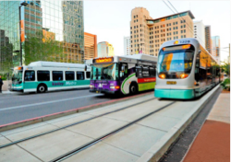
The project partner for this applied project is Valley Metro. Valley Metro is the unified brand under which the majority of public transportation is operated in the Phoenix Metropolitan area, and member cities include Chandler, Glendale, Mesa, Phoenix, and Tempe along with thirteen smaller cities. Valley Metro operates the light rail, 61 bus routes, and the paratransit program (ADA transportation). The agency constantly works on improving connectivity throughout the valley by expanding services. Valley Metro has a sustainability commitment though the American Public Transportation Association (APTA) that they signed onto in 2011. The commitment requires that Valley Metro include a strategic goal for sustainability, have a sustainability champion, establish an outreach program, and partake in annual sustainability reporting. Upon starting my internship at Valley Metro, they had recently accomplished their strategic goal and did not have any active outreach.
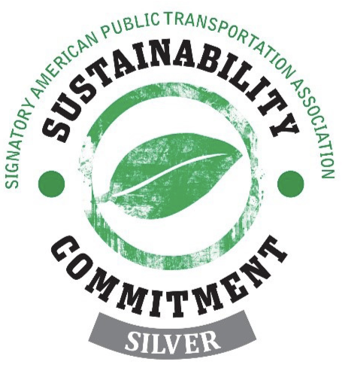
In addition to the four APTA core principles, Valley Metro obtained APTA Silver recognition in June 2018 for previous sustainability action, however achieving this recognition level requires that the agency commit to future sustainability action—and upon receiving Silver there was no plan for this future action. The agency formerly had a sustainability action plan in 2014, but just enough of the goals were achieved to reach Silver and the plan is no longer relevant. A new sustainability plan was needed to fulfill the APTA commitment and keep sustainability efforts moving forward.
Not only is sustainability needed to maintain agency commitments, but sustainability is necessary to the future of the Phoenix area. Continuing sustainability at Valley Metro is urgent because their transit system is expanding rapidly with multiple new transit extensions in the next five years. Sustainability needs to be considered now before more infrastructure is built, new riders are attained, the agency grows, and more government money is spent.
According to the US Environmental Protection Agency, the waste generation rate in 1960 was 2.68 pounds per person per day; by 2015 this number rose to 4.48 pounds (US EPA, 2016). As per the 2018 APTA Utility Inventory Report, Valley Metro produced 438 tons of waste and successfully diverts 15 percent of this waste from the landfill (Valley Metro, 2019). The waste diversion rate has increased by 9 percent from FY2014 to FY2018, however the amount of waste produced by the agency has risen by 23 percent in this timeframe. This shows that Valley Metro is doing more to contribute to this national problem than to fight it, and new strategies need to be enacted to change this.
Not creating a sustainability plan that addresses infrastructure could also be threatening to people and the community. Without transit infrastructure improvements, problems such as flash flooding and extreme heat will be significant impacts when using transit. Valley Metro’s services result in 27,000 cars being taken off the road daily. 52 percent of Valley Metro’s riders are choice riders—meaning that they own cars but choose to use transit (Valley Metro, 2018b). If waiting for transit were to become extremely uncomfortable due to weather, these riders may reconsider their choice and instead drive their cars. This would drastically increase the criteria air pollution and fossil fuel consumption in the Phoenix Metro area because the primary emissions come from cars. As reported by the Maricopa Associations of Governments (MAG), there are 127 metric tons of nitrous oxide emitted each day and cars account for 49 percent of emissions (MAG, 2016). Nitrous oxide, a form of ozone pollution, increases health impacts like wheezing, throat irritation, increases the risk of infection, and can even cause chronic diseases like asthma (MAG, 2016).
Without sustainability education efforts towards transit riders, a massive opportunity is missed to inform Arizonans on climate change and how to live more sustainably. Valley Metro had over 66 million boardings in fiscal year 2018 (Valley Metro, 2018a). The organization also has a presence in eighteen cities in Maricopa County. If Valley Metro were to present themselves as advocates for the environment, this messaging could reach the entire valley.
Sustainability at Valley Metro is a complex problem with no simple solution to due to the many departments, multiple facilities, thousands of users, hundreds of vehicles, and spread out infrastructure. Therefore, a five-year sustainability plan is needed to move them in the right direction. Valley Metro has a sizable ridership, they develop infrastructure throughout the region, and they operate off federal money and tax dollars. The impact that Valley Metro has on society, the economy, and the environment means a strong sustainability program could have a very positive impact on the region.
With this project, Valley Metro will have a clear and realistic path toward increasing sustainability in Phoenix’s transit network. Five Year Sustainability at Valley Metro is important because creating sustainability plans has been a challenge for Valley Metro in the past eight years. Some of the reasons that sustainability planning has been challenging are as follows:
- Valley Metro has not had a member of the team specializing in sustainability until the start of this project. A lack of sustainability expertise resulted in actions being written into plans that were not feasible to accomplish. Good ideas were written into plans, but without a dedicated staff member or funding, these ideas were not able to become realities.
- Previous methods for plan formation created tension among staff because the task was time consuming and brainstorming sessions lead to disagreements. In previous years, the group would get together to brainstorm, and oftentimes the brainstorming led to disagreements which lowered morale then resulted in the team less involved.
- It was difficult for staff to dedicate time to plan formation when none of them had sustainability as a part of their job description and were busy with their job responsibilities.
Overall, Valley Metro’s two previous sustainability programs had a low success rates due to miscommunication, incomplete planning, limited time, and lack of sustainability knowledge.

Literature Review
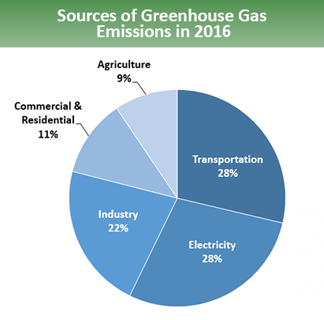
According to the Greenhouse Gas Inventory Report by the Environmental Protection Agency, the transportation sector accounted for 28% of greenhouse gas emissions in 2016 (Figure 1). When looking at the most sustainable modes to move people in regard to greenhouse gas emissions, public transportation is almost always the best way to do this. National averages show that light rail systems and bus transit produce 62% and 33% lower greenhouse gas emissions per passenger mile than an average single-occupancy vehicle (Federal Transit Administration, 2010).
Environmental Protection Agency Reported Sources of Greenhouse Gas Emissions in 2016
Buses produce less greenhouse gases than single-occupancy vehicles because of their ability to move many people at once, and with new technologies, they are working towards emitting even less. Hybrid electric buses are making their way into the Phoenix area and other places in the country such as Chicago, Seattle, and Dallas (Federal Transit Administration, 2018). There are even more efficient in preventing greenhouse gas emissions in the public transportation sector. New technologies such as hydrogen fuel cell buses--which can run for almost 18 hours and have a sole byproduct of water--and electric buses are entering the scene in areas like San Antonio, Texas and Stark County, Ohio (United States Department of Transportation, 2015).
Light rail systems produce fewer greenhouse gases too, and like buses they continue to move in a greener direction. Being powered by electricity means that the source of electricity generation is a determining factor for the sustainability of a light rail system. Arizona is still utilizing unsustainable sources such as natural gas, nuclear, and coal, however the state is starting to close coal plants and has a goal for 15 percent renewable sources by 2030. This isn’t just happening in Arizona, these are trends that can be seen throughout the country. Public transit is already helping combat climate change, and more is being done to make this sector increasingly sustainable.
Sustainability programs within transit are also becoming increasingly common and well-practiced, which is further contributing to the sustainability of this industry. For a list of the largest ten cities in the United States’ sustainability practices and objectives within their public transportation agencies, please see Appendix I.
In addition to examining other transit agencies, Valley Metro’s member cities and agencies were also examined to paint a picture of how local governments are addressing sustainability. This was compiled by reaching out to cities to find if they had an active sustainability plan/program and a sustainability team and by looking online for publicly available data. Please see Appendix II for the complete list of city teams and initiatives.
Take Away Messages
One takeaway from this research is that Valley Metro appears not to value sustainability when looking at publicly available information. There is documentation that shows Valley Metro’s achievements but they are only available through APTA’s member portion of their website or available internally at Valley Metro. If the same research were done to assess Valley Metro’s sustainability commitment, publicly available information would conclude that Valley Metro does not have a sustainability program. This shows that the updated sustainability plan needs to include ways to showcase previous and current sustainability efforts.
Another takeaway from this research was that sustainability programs happen in a variety of ways. Some agencies have dedicated departments, others have interdisciplinary teams, and one even practiced sustainability by partnering with another organization that created a plan for the transit agency to follow. There doesn’t appear to be a standard way to create a transit sustainability program.

Project Approach and Intervention Methods
I first approached this plan by presenting the concept of a five-year program to the executive leadership team on October 4th and received approval. Since I am the lowest level employee in Valley Metro and I am aiming to develop a program to be followed by everyone, I needed strong support from the executive team. Since approval, I have given two presentations to staff, one to the capital and service development division (the largest division in Valley Metro) and to all of the managers. An email has also been sent to all staff by the COO informing people of our sustainability plan update and asking them to complete a sustainability survey. Over 150 surveys out of 300 have been completed (for survey results, see Appendix III). Once staff was informed, I assembled a sustainability action team (referred to throughout this document as the SAT) consisting of primarily managers. The SAT serves two purposes:
- Oversee the creation of the written plan by providing monthly feedback to ensure that actions are favorable to the agency and not beyond the work capacity of employees
- Carry out or delegate agreed-upon action items and complete them over the span of five years
The SAT has had three meetings so far. The first meeting on January 14th was held to inform the team of the process for running the meetings and what our goals are. Below was my strategy for engaging the team and protocol for running the meetings:
- I researched twenty different sustainability actions and the actions have been separated into three categories.
- The team was emailed the proposed action items prior to the meeting for their review. I created an email group for the team. To add an action item, the team added the action item to the template and sends it back out to the team.
- The team came to the monthly meeting prepared to discuss the action items and make a decision on which ones they vote to push forward and which ones to eliminate.
- The team then voted on the items, and approved action items were written into the plan.
- I wrote the plan and then presented to leadership for final approval on the actions.
The above strategy worked well because instead of expecting staff to generate ideas for sustainability actions, they instead learned about them and voiced opinions based off of presented information.
The framework that is being used to evaluate this project is the APTA Sustainability Commitment Framework. This is the framework used to determine what sustainability level a transit agency is at (ranked Bronze, Silver, Gold, and Platinum). Though getting to the next APTA level is not a goal of Valley Metro, using this framework will indicate improvements in the sustainability program by looking at core principle compliance, the number of action items completed, sustainability indicator improvements, and stretch goals. Please see Appendix III for details on the framework.

Outcomes/Findings
Creating a new sustainability program for Valley Metro has helped the agency discover a couple of things. The biggest discovery that they made is that they need a staff member to be working on their sustainability program full time. The agency has recognized that previous efforts have fallen short because the time commitment needed for sustainability is large and current staff is not able to take this on. Running a sustainability program couldn’t solely be done through the internship because (1) the part time nature of the position does not provide enough time to run a sustainability program and (2) Valley Metro needs consistency in project manager as the plan progresses. As a result, they have decided to create a position for a full-time sustainability coordinator to manage and carry out this plan.
Another project discovery was that many sustainable actions can’t be committed to quite yet. As the project was in its early phases, the intent was to commit to certain actions and have them done in the following five years. As the project progressed, it became evident that many of these actions needed to be researched further and tested as pilot projects before any sort of commitment could be made. That discovery changed the nature of some of the action items and shifted the verbiage from “commit” to “assess the feasibility.”
Lastly, after working with the sustainability action team it became clear that the action plan needs to focus on outreach and education. The outreach component of the plan contains the most actions because future sustainability cannot be easily taken if employees do not understand what sustainability is and why it is important to all aspects of the agency.

Recommendations
Recommendations made to the project partner are reflected in Valley Metro’s Sustainability Action Plan 2019.

Conclusions
As a result of the project, Valley Metro has a redefined sustainability program. This applied project provided Valley Metro with a plan for making the public transportation system as sustainable as it can be. The agency now has a plan with strategies that put the agency in better alignment with local government initiatives and transportation agencies around the country. Without this project, there is no telling when this would have gotten done. This applied project also prompted Valley Metro to make a sustainability professional part of their team for the first time ever. With a full time staff member, this plan will not fall to the backburner like in previous years and will instead have a much higher chance at meeting its goals. This project will not only drive Valley Metro to maintain the APTA sustainability commitment, but address relevant sustainability problems. Enacting Sustainability Action Plan 2019 will bring new procedures, practices, and knowledge to Valley Metro that will keep sustainability a part of the agency for years to come. This applied project is nearing the end, but the real project is just beginning.

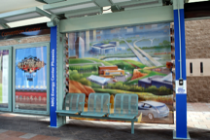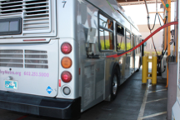

Appendices

Appendix I: Summary of the Transit Sustainability Programs in the Ten Largest Cities in the United States
- New York: Known by many as the most sustainable city in the United States, the Metropolitan Transit Authority (MTA) recognizes six environmental issues pertaining to transit: climate change, energy, carbon, materials flow, water, and smart growth. Each issue has a task force, current projects, and future projects to increase sustainability in each area. Some of their notable projects include creating the MTA Green Building Program, transitioning to a green bus fleet, and a robust transit-oriented development program. Their website also offers a Transit Effect Calculator, where users learn the impact that their transit rides have on the environment (Metro Transit Authority, 2018).
- Los Angeles: LA Metro has a large sustainability program that focuses on county wide planning and environmental compliance, and they rely on their sustainability council to advise in development of their sustainability goals. They focus on water, air quality, energy, and waste and have policies that regulate their practices in those categories. One unique feature of their program is their emphasis on green construction practices including construction and demolition debris recycling and reuse policies. LA Metro is an APTA Platinum recipient. (LA Metro, 2018).
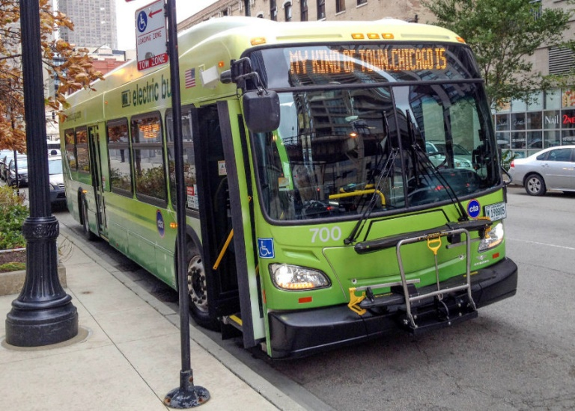
- Chicago: The Chicago Transit Authority (CTA) has sustainability goals of clean vehicles, multimodal integration, efficient facilities, and recycling. Unlike other transit agencies on this list, they do not have a sustainability program and instead incorporate these projects into relevant departments. CTA’s biggest emphasis is on providing clean vehicles through innovative technologies. Their train system utilizes regenerative braking, which captures the energy from braking, stores it in a lithium ion battery, then uses the energy to power the trains. CTA has also been procuring hybrid, ultra-low sulfur diesel, and all electric buses since 2003 (Figure 1). CTA is an APTA Sustainability signatory and a member of the Chicago Climate Action Agreement (Chicago Transit Authority, 2017).
Figure 1: Electric Bus Used in Chicago, Illinois
- Houston: METRO transit authority in Houston is the only one of the ten largest cities in America that does not have a sustainability program or goals according to publicly available data. However, it is interesting to note that METRO has more information on their website about the environmental benefits of transit than Valley Metro (Metro Transit Authority, 2018).
- Philadelphia: The Southeastern Pennsylvania Transportation Authority (SEPTA) has a strong and established sustainability program. SEPTA uses the three pillar approach to sustainability and sets goals within those categories. Since defining their first sets of action in 2011, the agency has put out annual reports on the status of their goals and updates them every four years. Some distinct ways they have incorporated sustainability into transit is by hosting farmers markets at transit centers/stations and setting goals to preserve open land. SEPTA is an APTA Gold recipient. (Southeastern Pennsylvania Transportation Authority, 2018).
- Phoenix: See introduction for details
- San Antonio: VIA Metropolitan Transit does not have a sustainability program, but like Chicago they have accomplished action and set goals that are carried out in the applicable departments. VIA focuses on energy efficiency, water treatment, and greening their fleet with electric and hybrid buses, but their emphasis is on environmental and sustainability management. They are ISO 14001 certified and practice sustainability within their management systems (VIA, 2017).
- San Diego: San Diego Metropolitan Transit System (SDMTS) addresses sustainability in a slightly different way than the rest of these cities. Instead of having their own sustainability program, they collaborate with the San Diego Association of Governments and follow the Sustainable Communities Strategy in their work. Their sustainability efforts focus on walkability, biking, and transit oriented development and unfortunately ignores issues such as climate change, water, and waste. Much is being done to improve sustainability, but this plan lacks the identification of some key issues (San Diego Association of Governments, 2016).
- Dallas: Dallas Area Rapid Transit (DART) has a sustainability plan that reflects the conservative nature of the area. Their sustainability goals focus around utility reductions and sustainable procurement to reduce spending in the short and long term. DART has made improvements in their energy and water use and has transitioned much of their bus fleet to hybrid and electric buses, however their sustainability action is primarily fueled by cost savings. DART is an APTA Bronze recipient (American Public Transportation Association, 2009).
- San Jose: Santa Clara Valley Transportation Authority (VTA) has a sustainability program that centers around utility usages, green fleets, and greenhouse gas emissions. They publish annual reports on their progress, identify areas of improvement, and introduce new projects. One notable area VTA strives to improve is with preserving open land within the community. VTA has a sustainability team that oversees these projects and develops new goals. VTA is an APTA Gold recipient (Santa Clara Valley Transportation Authority, 2017).

Appendix II: Sustainability Initiatives and Teams in Valley Metro Member Cities
City | Sustainability Initiatives | Team
Avondale | Municipal sustainability plan | Water Sustainability Manager
Buckeye | - | -
Chandler | Green building program, more solar | -
El Mirage | - | -
Fountain Hills | - | -
Gilbert | Green Gilbert Citizen Advisory Panel: 25 community members that work with environmental compliance team to create outreach methods and events to promote sustainability in Gilbert. | Sustainability Director coordinates new program with 9 others in public works.
Glendale | Go Green Incentives: (1) Conserve water, (2) save energy, (3) recycle, (4) travel green, (5) green business | Conservation & Sustainable Living Division: 1 manager, 2 fulltime 2 part-time
Goodyear | Promotes sustainability in Strategic Plan FY21 | -
Maricopa County | - | -
Mesa | Green Living Events & Education, Solar Pilot Program, Earth Day Campaign | Development and Sustainability Department: 15 employees, mix of part and fulltime
Peoria | Sustainability Plan | Economic Efficiency and Sustainability Manager, Sustainability and Conservation Inspection
Phoenix | 2050 Sustainability Goals to become carbon neutral city, yearly sustainability reports | - Zero Waste: (5) fulltime  - Environmental Quality & Sustainability Committee: (2) chairs  - Sustainability & Environmental Programs: (3) fulltime (1) part-time  - Circular economy project manager: (1) fulltime  Total: 12
Scottsdale | - | -
Surprise | - | -
Tempe | Climate Action Plan, Sourcing 100% of electricity from renewable sources by 2035 | - Sustainability director (1)  - Sustainability commissioners (2), commission members (11 volunteers)  - Student sustainability researchers (4)  - Water conservation team (2+)  - Horticulture/local food (2+)  - Recycling (3)  Total Paid: 14  Total Including Volunteers: 25
Tolleson | - | -
Wickenburg | - | -
Youngtown | - | -

Appendix III: Survey Results

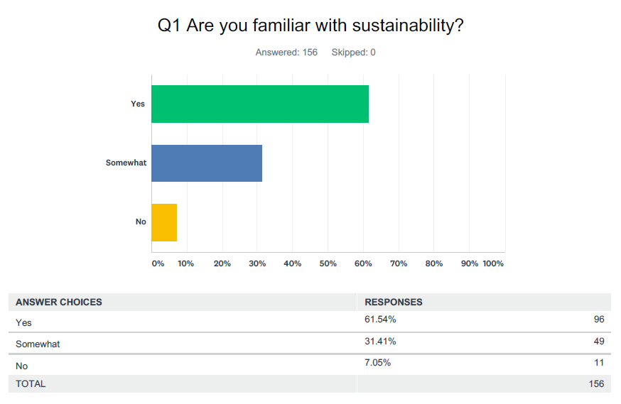
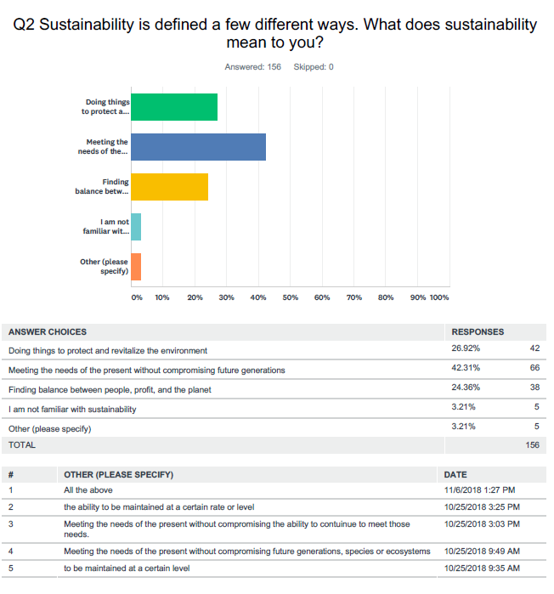
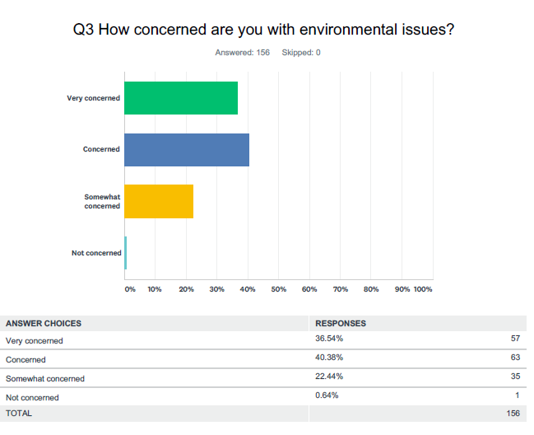
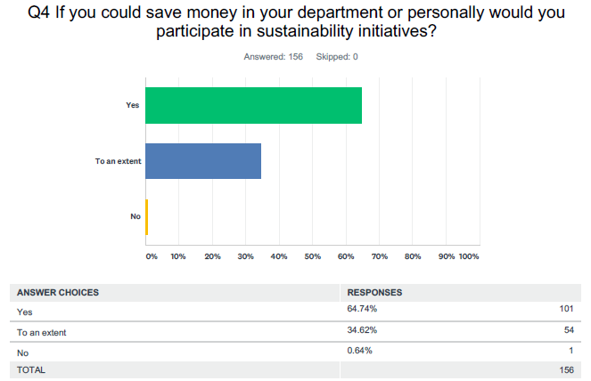

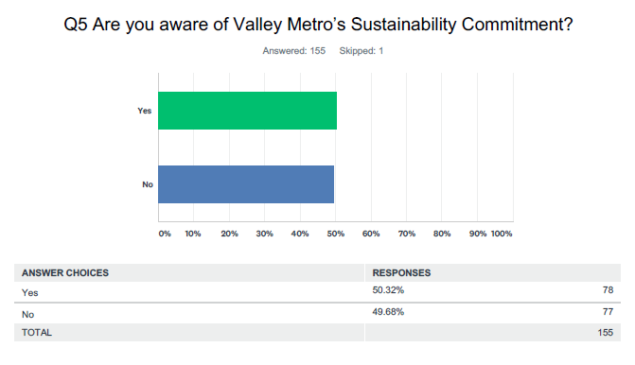

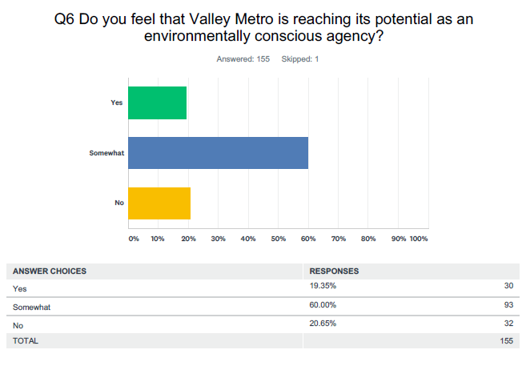

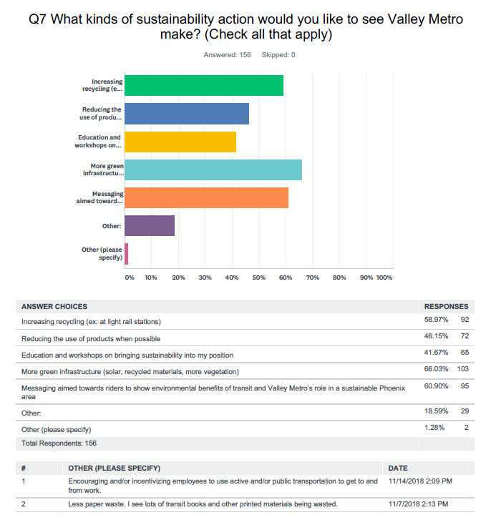

Appendix IV: APTA Sustainability Framework

The APTA Sustainability Commitment is a program created by the American Public Transportation Association that member organizations voluntarily join to show responsibility to operating an environmentally conscious transit service.
Core Principles
APTA Core Principles are the standards that transit agencies in the APTA Sustainability Commitment agree to follow.
- Make sustainability part of your organization’s strategic objectives
- Identify a sustainability champion along with the necessary resources
- Establish an outreach program
- Undertake annual utility usage inventory
Action Items
Action items are achievements realizable in the short-to medium-term (1-2 years). They are individually distinct actions chosen by the signatory to complete in addition to the core principles of the commitment. They typically address operations, maintenance and capital, products and services and education and outreach with a view to achieving economic, environmental and social sustainability objectives. Action items can focus on all or a single part of an organization or facility. Some of Valley Metro’s former accomplished action items are
- Installing water recycling equipment for vehicle washing at bus and rail facilities
- Window tinting on all fleet vehicles
- Paperless inspection of fleet vehicles through ZONAR
- Installing solar panels at the Operations and Maintenance Center

Sustainability Indicators
The American Public Transportation Association requires their sustainability members to monitor eight different sustainability indicators and strive improvements in these areas. The sustainability indicators that Valley Metro is required to report are
- Water
- Criteria Air Pollution
- Greenhouse gas emissions
- Greenhouse gas savings because of the existence of transit
- Energy Use (electricity and fuel)
- Waste
- Recycling
- Operating Expense

Stretch Goals
Stretch goals are programmatic, policy-related or process goals realizable in the long term (3-5 years). They are individually distinct goals chosen by the signatory to complete in addition to the core principles of the commitment. They should challenge organizations striving for Silver, Gold or Platinum recognition to realize a significant difference in the way they function as a whole.
APTA Sustainability Requirements by Recognition Level
 | Core Principles |  | Action Items |  | Baseline Reductions per Indicator |  | Stretch Goals
 | Require | Commit to | Require | Commit to | Require | Commit to | Require | Commit to
Entry |  | 
Bronze |  |  | 5  | +5 |  | +2 at 2%
Silver |  |  | 10  | +10 | 2 at 2%  | +2 at 5%  +2 at 2% |  | +3
Gold |  |  | 20  | +20 | 2 at 5%   2 at 2%  | +2 at 10%  +2 at 5%  All other at 2% | 3  | +3
Platinum |  |  | 40  |  | 2 at 10%   2 at 5%   All other at 2%  | +2 at 20%  +2 at 10%  All other at 5% | 6  | +3

References
American Public Transportation Association. (2009). DART Sustainability Framework Plan. Retrieved from www.apta.com/resources/hottopics/sustainability/Documents/DART%20Sust%20Framework%20Plan_120412%20FINAL.pdf.
Chicago Transit Authority. (2017). Going Green and the Environment. www.transitchicago.com/environment/.
Federal Transit Administration. (2018). Fiscal Year 2018 Low or No-Emission (Low-No) Bus Program Projects. Retrieved from www.transit.dot.gov/funding/grants/fiscal-year-2018-low-or-no-emission-low-no-bus-program-projects.
Federal Transit Administration. (2010). Public Transportation’s Role in Responding to Climate Change. Retrieved from https://www.transit.dot.gov/sites/fta.dot.gov/files/docs/PublicTransportationsRoleInRespondingToClimateChange2010.pdf
LA Metro. (2018). LA Metro Sustainability Projects. Retrieved from https://www.metro.net/projects/sustainability/
Maricopa Association of Governments (MAG). 2017. Eight-Hour Ozone Moderate Area Plan for the Maricopa Nonattainment Area. Published Dec 2016.
Metro Transit Authority. (2018). Sustainability and the MTA. Retrieved from http://www.web.mta.info/sustainability/index.html.
San Diego Association of Governments. (2016). Sustainable Communities Strategy. Retrieved from www.sandag.org/index.asp?projectid=349&fuseaction=projects.detail.
Santa Clara Valley Transportation Authority. (2017). 2017 Sustainability Report. Retrieved from www.vtaorgcontent.s3-us-west-1.amazonaws.com/Site_Content/2017SustRp.pdf.
Southeastern Pennsylvania Transportation Authority. (2018). Sep-tainable 2020. Retrieved from http://www.septa.org/sustain/pdf/2018-02-septainable-report.pdf
United States Department of Transportation. (2015). Low or No Emission Vehicle Program - 5339(c). Retrieved from www.transit.dot.gov/funding/grants/lowno.
United States Environmental Protection Agency. (2018). Inventory of U.S. Greenhouse Gas Emissions and Sinks. Retrieved from www.epa.gov/ghgemissions/inventory-us-greenhouse-gas-emissions-and-sinks
Valley Metro. (2018a). Annual Ridership Report FY2018. https://www.valleymetro.org/sites/default/files/uploads/event-resources/fy_2017-2018_annual_ridership_report_0.pdf
Valley Metro. (2018b). Connecting Communities and Enhancing Lives: A Quality of Life Report. https://www.valleymetro.org/sites/default/files/uploads/event-resources/quality_of_life_report_12-3-18_-_final_reduced.pdf
Valley Metro. (2019). American Public Transportation Association Sustainability Reporting FY2018.
VIA Metropolitan Transit. (2017). Environmental Commitment. Retrieved from www.viainfo.net/about-via/.
United States Environmental Protection Agency. (2016). National Overview: Facts and Figures on Materials, Wastes and Recycling. https://www.epa.gov/facts-and-figures-about-materials-waste-and- recycling/national-overview-facts-and-figures-materials#Trends1960-Today

