Abstract
The power that local communities have to cause change all over the world should never be underestimated. Communities have the ability to make businesses thrive, or die by simply choosing to support, or not support. Conversely, it seems that many communities today have lost their voice, and they have lost their connection with each other. For any community development project to last, it must first meet the needs of the surrounding communities. Projects must offer value and benefits that translate across and consider community environmental concerns, economic inequalities, and cultural ideologies in order to be sustainable and last. Mathews County is a rural farming community in South Eastern Virginia and has a population of roughly 8,800 residents. The purpose of this project was to address community issues by organizing and developing solutions that focused on the economic, social, and environmental pillars within.

Keywords: Sustainability, Community, Change Agents, Think Global, Act Local

Outline
Introduction
Chapter 1: My School Garden Journey
The Garden Connection
Getting Started… and Starting Over
Finding the Right Communication Channel
Using Feedback to Create Value
Collaboration and Creating Momentum
The Community Effect
Chapter 2: Current Project Status
Planning a School Garden
Work Breakout Schedule
Gantt charts
Conclusion and Final Thoughts

Introduction
Abraham Lincoln said, “The philosophy of the classroom in one generation will be the philosophy of government in the next.” Public schools in this country need to reset their values away from standardized testing, and instead focus on the physical, emotional, and social health of children. “GROW! Together Mathews County,” a sustainably rooted community-based organization developed a local school-community partnership focused on improving the lives of its citizens, and of school education. According to STAR Communities, the definition of a sustainable community is one that promotes a healthy environment, serves the well-being of community members, and solves local problems using innovation, community feedback and collaboration. This project adhered to those principals of sustainable development, and inspired community activism and advocacy by using a values-based approach, storytelling, and collaboration via social media. This project was initially supposed to be about implementing a school garden, but it developed serendipitously into a story of community empowerment FOR school gardens. This paper provides advice on how to mobilize a community to support a sustainable idea, which from experience, was the absolute hardest part this project. By sharing lessons learned, project strategies, and the real-life application of “Think Global, act local,” the hope is to inspire many others to be a change agent with their communities as well. Out of all the school garden stories, guides, and step by step directories out on the internet, none of them discuss how they achieve community support. This paper is for anyone starting a school garden from the ground up.

Chapter 1: My School Garden Journey
The Garden Connection
I found myself at 33 years old, missing something in my life. I just lost my mom, and a few years before that, I lost my dad. I really miss them. I miss being able to go to them and ask questions, and I miss hearing about how they grew up, and I miss having them as my support network. I will always miss them, and I will treasure the knowledge and the love they shared with me, so I tried to find a project where I could honor their memory and build a better future for the next generation.
I started gardening around 8 years old, when my family moved to Virginia. My dad grew up farming in Wisconsin, and my mom loved anything that was outside. Every spring, my parents would require that we, my four sisters and I, pitch in and help with the garden. Of course, we would complain, whine, cry, fake injuries, whatever we had to do to get out of going outside and helping (being bratty city kids and all). I guess we would have rather sit inside and watch TV all day. My dad was actually patient with all of us though, and he would gently coax us into picking up a shovel and helping. I guess he remembered the feeling of being made to help as a child, having to wake up at 5 am to help milk the cows, gather the hay, all before walking a mile to get to school on time.
The garden to us children was almost like an interruption to our lives, as if as if we had more exciting things to do. For my parents, the garden was as important as a means to supplement their income and help feed our family. I have to admit, nothing tasted better than fresh cucumbers and tomatoes from the garden. Self-grown everything seems to always taste better, sweeter, fresher.
One night my dad and I were in the garden picking the last of the summer tomatoes, and I remember asking him “Dad, why do you love gardening so much?” He looked at me and said “Lydia, when you grow something, with your own hands, it gives you an appreciation for the Earth, for life. It changes the way you look at the world, you have to be patient, and everything grows in its own time.” I have remembered that conversation for 25 years, and it was not until both my parents passed away, that I started thinking about gardening again. I started to remember all kinds of valuable lessons that we taught in the garden. Lessons about patience, and taking care of each other, the importance of being self-sufficient, and how we can contribute to help others. Therefore, I knew that I needed to preserve the importance of gardening and pass on its value to the next generation. A garden is a place where you learn and grow as a person as well. A place where information and knowledge is shared across generations, and across all life experiences. Everyone should experience a garden, if you haven’t, you are missing out on something so special.
When you share your story, the human spirit connects emotionally, and that connection creates a memory, and can even change people’s minds. A great storyteller can evoke feelings of happiness, fear, excitement etc., and when you connect those emotional feelings with an audience’s emotions, your story then becomes their story, and they will open their minds to your call to action.

Getting Started… and Starting Over
When this project began, initially the idea was to get school stakeholders to 1) see that the current anti-bullying programs could be improved 2) understand the need for a holistic solution and 3) present a school garden as a solution to help eradicate bullying behaviors in schools. What was not realized at the time this project began, was the need for a network of supporters. Schools might recognize a school garden programs value, but that did not mean it would be implemented. This project needed more support, we needed community support. The initial project of just getting schools to adopt this idea of a school garden to combat bullying, had to be re-strategized so that it had the support in place to not only meet the schools need, but meet the needs of the community as a whole.
Finding the Right Communication Channel
I must admit, I thought I could just talk with School stakeholders, and get them to buy into a school garden idea as a way to combat bulling, childhood obesity in young children. I figured “What school would NOT want to care about that cause?!” I was sure, it would be easy to get the schools onboard. Well, I failed, a bunch of times taking this approach. Let me explain, I reached out to one stakeholder, a Science teacher, via email, very professionally, I had my elevator speech prepared and written perfectly, never heard back. Maybe the email servers were down? Nope. I reached out a few more schools, no one would even acknowledge my emails. I tried one last time, another Science teacher, the leader of the Sustainability club at the middle school, I sent the email, and she responded! We were exchanging emails back and forth, and eventually we set up a phone meeting to discuss a school garden option at her school. When we got on the phone, I was so nervous, I started to talk about the benefits of a school garden at about 100 MPH. Not only did I overload my audience with information, I completely overwhelmed her I think, and I never really listened to her values, or her concerns. While I believe she already knew the benefits of a school garden, I lost her trust when I was talk talk talking, and I wasn’t asking questions, and trying to find out more about her. I essentially went in to the meeting having a script in my head already, instead of finding out what my audience needed from me. As one can imagine, I never heard back from her after that.
Lesson Learned- Meet with Community Members, and Provide Takeaways
Obviously, the email/ phone meeting approach was not the correct channel to meet my stakeholders. I decided to change my approach and started attending community events in Mathews County to actually meet, face to face, with community members to talk with them about a school garden. Before I met with them, I created a takeaway for them to remember our meeting by. I took a pack of organic heirloom vegetable seeds, taped my email and contact information, and included a link to a garden interest survey. With the seed packets in hand, I introduced myself, said I was a graduate student, and I stated that I was trying to gauge community interest in a school garden, and asked them if they would like to give feedback. I was amazed at how the tables turned; I was received completely differently after changing my approach. These community members were very warm, and inquisitive, and they started to share their stories about gardening with me. They loved this project, and they wanted to know more!
Using Feedback to Create Value
Mathews community feedback was used to identify problems or concerns that mattered most to Mathew’s residents. The survey was anonymous, online, accessible by mobile phone. It was easy to analyze the immediate trends and did not require qualitative or quantitative software. Google forms tallied up the answers automatically and displayed reflected community concerns visually. 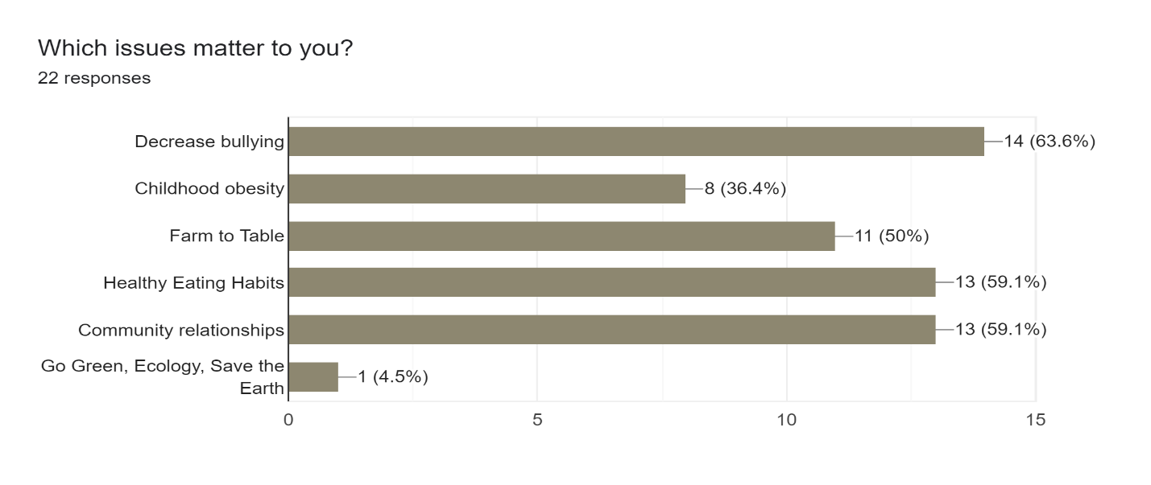
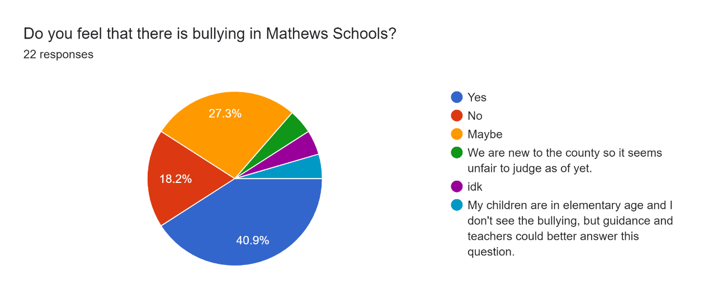
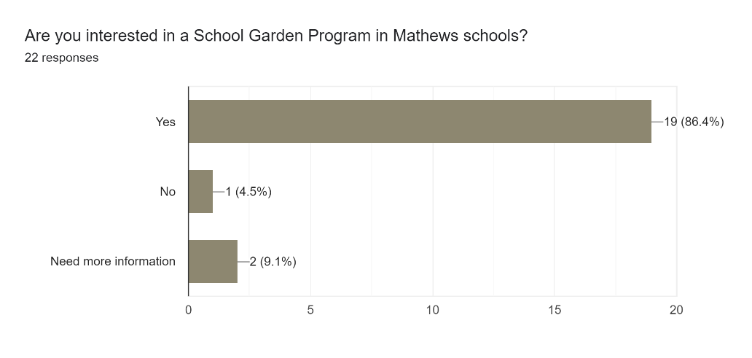
From this feedback, I utilized a “value- based” approach to connect the values Mathews felt were important, to the values of a school garden. This approach was chosen because it allowed for the community to personally connect and care about this project and allowed for the project to be tailored and adjusted if there was a value mismatch somewhere. Feedback was crucial for audience investment.
Collaboration and Creating Momentum
To collaborate with interested community members, social media, specifically Facebook was the ideal option. GROW! Together Mathews County Virginia Facebook page was created to offer a place to share resources, reach multiple audiences, gain support, exchange ideas, and as a way for the School garden project to continue to receive feedback from the community. As for getting the message out to the community, for 10 dollars we purchased a “boost” within Facebook of our page’s mission statement so that it could attract more supporters. It seemed overnight, that the number of followers in the community and support tripled, from 3 followers to over 40! In addition, there are 15 members in the Mathews County Garden Team, a group of Mathews community members that are helping to plan, secure funding, and have volunteered to assist in implementing the school garden!
The Community Effect
After the community joined the garden group, that is where we began to tackle the challenge of school stakeholder buy-in, and funding. One of the group members happen to be the wife of the Board of Supervisors for Mathews County. The Board of Supervisors overlook all aspects of the county such as school policies, community issues, and environmental preservation. During a Supervisors meeting, the group member’s husband brought up our school garden initiative, and the need for funding to the superintendent of Mathews public schools. After he finished speaking, the Superintendent agreed to apply for the USDA Farm to School Planning Grant! We as community members could not ourselves apply for this grant because of federal grant requirements. This is why collaboration with community is so important, alone we may not have the network or the know how to make things happen, but with collaboration, a community is able to do more!
Chapter 2: Current Project Status
Planning a School Garden

Since Mathews Community voiced their top concerns as being bullying, children learning healthy eating habits, and community relationships, a school garden was decided by the team to be a great place to start. According to research there is a positive correlation between school gardens and the increase in children’s vegetable and fruit intake. “Children who are familiar with growing their own food tend to eat more fruits and vegetables” (Bell, Dyment, pg. 81), and these children tend to continue nutritious eating and a love of gardening as adults. “Gardening during childhood exposes children to positive social interactions and can often lead to a lifetime of gardening” (Gross, Lane, pg. 230). The website “Whole Kids Foundation.Org” has an entire website that highlights different successful applications of school gardens whether that be connecting with other children, building a worm farm, working together to build the planter boxes, and coming together as a community (Wholekidsfoundation.org)
Although currently there is no direct literature that addresses school gardens benefitting an anti-bullying program, studies do show how community gardens led to an overall reduction in violent and non-violent crime in the nearby neighborhoods, and an overall increase in the feeling of safety among residents (The American Community Gardening Association, 2009). In addition, studies show that children who learn in gardens are more likely to accept people different from themselves (Dyment & Bell, 2006). Additionally, students between the ages of 7 and 11 years old that participated in a garden program, showed an increase in self-understanding, interpersonal skills, cooperative skills, and an increase in vegetable consumption when compared to non-gardening students. (Robinson & Zajicek, 2005).
Conclusion and Final Thoughts
In conclusion, this project did not end with a garden, but it is slowly accomplishing milestones everyday with the partnerships the Mathews community is creating. Community support is so important to any project, and from experience, takes the most amount of time and energy. In order to gain community support for a sustainable project, first there must be meaningful communication through direct face to face interactions. Next there must be a feedback system in place, and lastly the values of the community members must be tied to the benefits and values of the project. Using social media to attract more support is a great idea. There you can express the project mission and encourage followers to get involved and spread your message. Importantly, sharing and hearing other stories is important to establish trust with your stakeholders. When I first began, I thought this was just going to be a school garden project to address bullying in schools, but it turned out to be much much more.

Strengths  Community Gardens have been proven to decrease violence in neighborhoods  Growing Vegetables make kids interested in veggies  Community support  Support of superintendent  Cheap with a lot of benefits  Mathews is a farming town already  I believe in this project | Weakness  No direct literature supporting school gardens reduce bullying  Maybe the children lose interest  I work all the time and will need garden support from community  School might not want to incorporate veggies into cafeteria
Opportunities  Could be ground breaking for anti-bully programs  Might save lives  Improve health in community  Improve community relationships  Improve quality of life and happiness  Bring extra money into the school  Better education  Better peer understanding and empathy | Threats  School changes their mind  Garden is abandoned after some time  Bullying gets worse or persists  Veggies are wasted in the cafeteria  No composting program  Community looses interest  No funding
SWOT analysis of School Gardens in Mathews Public Schools
Work Breakout Schedule School Gardens (WBS) (deliverables) | Garden Planning Phases
Phase I | Phase III
Attend Community events and find time to travel and meet community members | Get Buy in from school administrators/ apply for funding with their support
Interview community members/ parents and teachers (PTA) | Site Survey of school garden area-record materials needed
- Supply informational brochure for them to take home | Cost estimate of materials/ try to ask for community donations of goods if possible
- Use Facebook to get in contact and try to gain support | Secure seed donations and ask kids to compete on design 4 garden layout
-Get feedback about garden and document concerns, hopes, questions | Set up an onsite garden specialist to oversee operation
Phase II | -Create application for volunteers
Reach out to community garden/ school garden organizations for support collaboration and information | Design a compost plan to separate decomposable goods from non-biodegradable
-Research the existing organizations that focus on urban gardening, school gardens, | Use food waste for the garden/ start prepping soil
Incorporate Fresh Veggies into Cafeteria  Phase IV | Garden Execution Phase  Phase V
Walk through of cafeteria and food inventory, working environment limitations | Get children involved in picking and tending to garden for educational purposes
Interview person in charge of school lunches | -Could be Incorporated during Physical education
Share info on Connection between plant-based diets and behavior in children | -Could be Incorporated during science class
Find out food budget for school | -Getting kids learning outside of the classroom is fun for them
Find market price of produce vs. growing price (yield divided by price of seeds) | Make an exciting case for vegetable tasting better when you grow them organically
Design a fun colorful menu with school with fresh veggies | -Follow the “if they grow it, they are curious to try it” idea
Use locally produced vegetables in local school cafeteria while garden is growing | Propose an Education plan from Farm to School Network to teach children about growing/vegetables
Keep record of tonnage of veggie eaten b4 and after garden implementation | Use garden plans to teach children about inclusion and teamwork
Feedback after every phase******** | -Follow the “if they grow it, they are curious to try it” idea
Document progress and feedback | Collaborate with other school teachers to develop the education plans for the garden
Videotape garden milestone to share on social media | -Interview teachers to find out how they can incorporate garden fundamentals into
Weekly feedback reports | classroom curriculum
-progress, observations, interviews | -Interview children to see what they already think about gardens and experiences with growing
 | -Interview questions during classroom time with kids
 | -Teachers administering questions while I write down kids’ feedback

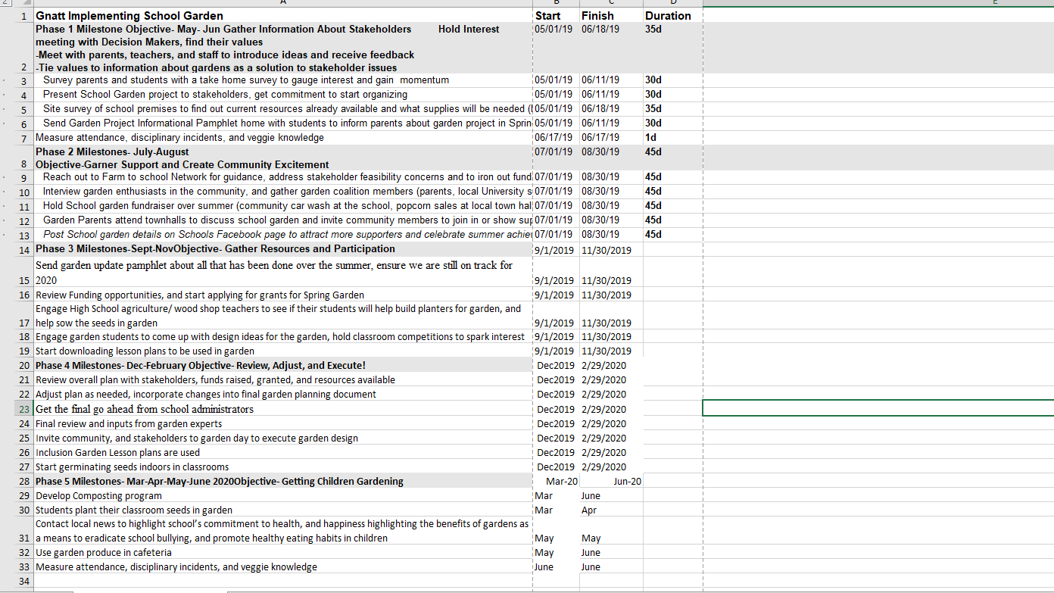
Original Gantt Chart Dates and Duration are subject to change!!!!
**Items 1-16 COMPLETED!
References:

American Community Gardening Association, 2009. Promoting Community Gardening Through
Research: A Survey. Community Greening Review, 41.
Bell, A. C., & Dyment, J. E. 2008. Grounds for health: The intersection of green school grounds and health-promoting schools. Environmental Education Research, 14(1): 77-90.
Canaris, I. 1995. Growing foods for growing minds: Integrating gardening and nutrition education into the total curriculum. Children’s Environments 12(2): 134-142.
Dirks, A. E., & Orvis, K. 2005. An evaluation of the junior master gardener program in third grade classrooms.
Dyment, J. E., & Bell, A. C. 2006. Our garden is colour blind, inclusive and warm: Reflections on green school grounds and social inclusion. International Journal of Inclusive Education 12(2): 169-183.
Gross, H., & Lane, N. 2007. Landscapes of the lifespan: Exploring accounts of own gardens and gardening. Journal of Environmental Psychology 27(3): 225-241.
Guerrero, Amoreena. 2016 “ Increasing Inclusion in the School Garden: A Resource Packet for Garden Educators,” Accessed online at: https://www.schoolgardenproject.org/wpcontent/uploads/2017/02/Increasing-Inclusion-in-the-School-Garden.pdf
Habib, D., & Doherty, K. 2007. Beyond the garden: Impacts of a school garden program on 3rd and 4th graders. Seeds of Solidarity: 2-14.
HellBrake, (2015). <i>Top 10 Funding Opportunities & Grants for School Gardens</i>. October 22, 2018 from http://blog.zipgrow.com/top-10-funding-opportunities-grants-for-schoolgardens/)
HortTechnology,15(3): 439-443. http://horttech.ashspublications.org
Klemmer, C. D., Waliczek, T. M., & Kajicek, J. M. 2005. Growing minds: The effect of a school gardening program on the science achievement of elementary students. HortTechnology 15(3): 448-452.
Litt, J.S., Soobader, M., Turbin, M.S., Hale, J., Buchenau, M., Marshall, J.A. The influences of social involvement, neighborhood aesthetics and community garden participation on fruit and vegetable consumption. The American Journal of Public Health. 101 (2011) 1466-1473.
Litt, J.S., et al., Community gardens in the city: A characterization of Denver’s garden infrastructure, awareness, use, and practices (Manuscript In preparation, 2012).
Morris, J., & Zidenberg-Cherr, S. 2002. Garden-enhanced nutrition curriculum improves fourthgrade school children’s knowledge of nutrition and preference for vegetables. Journal of the American Dietetic Association, 102(1), 91-93.
Ozer, E.J (2007). The Effects of School Gardens on Students. Health Education & Behavior, 34,
846-863. Retrieved from DOI: 10.1177/109019810628900
Robinson, C. W., & Zajicek, J. M. 2005. Growing minds: The effect of a one-year school garden program on six constructs of life skills of elementary school children. HortTechnology 15(3): 453-457.
Skelly, S. M., & Bradley, J. C. 2000. The importance of school gardens as perceived by Florida elementary school teachers.
Stevelos, JoAnn, MS, MPH. 2013 “Bullying, Bullycide, and Childhood Obesity,” Obesity Action Coalition; Accessed Online at : https://www.obesityaction.org/community/article-library/bullying-bullycide-and-childhood-obesity/
Waliczek, T. M., Bradley, J.C., & Zajicek, J.M. (2001). The Effect of School Gardens on Children’s Interpersonal Relationships and Attitudes Toward School. [Electronic version]. Hortechnology
Whole Kids Foundation.Org (2014). Retrieved from https://www.wholekidsfoundation.org/about/school-success-stories/school-gardenssucess-stories
Bully-Is Bullying a Problem? Attn General Mark R. Herring, Virginia. Gov Website; https://www.oag.state.va.us/programs-initiatives/bullying

