Kayla Kutter
Spring 2019
Arizona State University: Electric Vehicle Program
University Sustainability Practices

Abstract
One solution to the problems of poor air quality in Phoenix, Arizona and global climate change is to alter the way the population uses transportation. In the US, around one-fifth of all carbon dioxide (CO₂) emissions are due to cars and trucks used for transportation and the increasing level of CO₂ emissions is exacerbating our impact on the climate and is causing a shift in climate. By switching from combustion engine vehicles to public transportation, electric vehicles, or going entirely vehicle-less, the amount of CO₂ being released into the atmosphere every day will be decreased and overall air quality within cities will improve. If public transportation, riding a bicycle or walking is not an option, electric vehicles (EVs) are ideal as a lower-carbon emitting option over traditional combustion engines when they are recharged using renewable energy sources, like solar.
To encourage the adoption of EVs, this project pushed to overcome a few of the traditional barriers to adoption – initial cost, charging station infrastructure, and education about EVs. First, charging infrastructure was installed on all four ASU campuses. Then, to discover the biggest barriers to EV adoption, a literature review was conducted to develop a general understanding of barriers which guided the creation of survey questions. This survey was distributed to all staff and faculty at ASU (over 9,500 individuals) and received over 1,400 responses. To begin building the EV program at ASU, other universities with EV programs were interviewed to learn best practices and to understand what is most effective in encouraging EV adoption on campus. The responses determined that ASU needs to: 1. Install more charging stations on campus; 2. Offer premium parking for EV/hybrid users or a discounted parking pass or free charging; 3. Add charging stations to ASU interactive map; and 4. Develop an incentive program with EV dealerships. The project built partnerships with EV dealerships to lower the initial costs associated with buying and leasing EVs. Finally, to increase awareness of EVs, the dealership partners brought EVs to campus for a demonstration day paired with Earth Day.
The ASU EV program will reduce barriers to EV adoption to help reduce CO₂ emissions related to transportation at the ASU campuses and improve city air quality.
Table of Contents
1. Abstract 1
2. Introduction and Background 3
3. Literature Review 4
4. Project Approach and Intervention Methods 8
5. Outcomes and Findings 10
6. Recommendations 15
7. Conclusions 15
8. Literature Review References 17
9. Appendices and Acknowledgments 18

Introduction and Background
Arizona has experienced some of the hottest summers on record and has seen increasingly violent and damaging storms caused by global climate change (Johnson, 2017). Phoenix has poor air quality partly due to emissions from transportation. To combat global changing climate and local air quality problems, a multifaceted approach will be necessary to reduce CO₂ emissions and to better improve air quality through lowered transportation emissions.
One solution to the problems of poor air quality and climate change is to change the way the population uses transportation. In the US, around one-fifth of all carbon dioxide (CO₂) emissions are due to cars and trucks used for transportation (Fast Facts on Transportation Greenhouse Gas Emissions, 2016). The increasing level of CO₂ emissions is exacerbating our impact on the climate and is causing a shift in climate. By switching from internal combustion engine vehicles (ICEVs) to public transportation, electric vehicles, or going entirely vehicle-less, the amount of CO₂ being released into the atmosphere every day will be decreased. If public transportation, riding a bicycle or walking are not possible options; electric vehicles (EVs) are ideal as a lower-carbon emitting option over traditional combustion engines. EVs are non-carbon emitting during the use phase of their life cycle when they are recharged using renewable energy sources, like wind or solar (Nealer, Reichmuth, & Anair, 2015).
Manufacturing a light-duty EV with an 84-mile range results in about 15% more emissions than manufacturing an equivalent gasoline vehicle. For larger, longer-range EVs (with more than 250 miles in a single charge), the manufacturing emissions can be as much as 68% higher. These differences change as soon as the cars are driven. Battery electric cars (BEVs) make up for their higher manufacturing emissions within eighteen months of driving—shorter range models can offset the extra emissions within six months—and continue to outperform gasoline cars until the end of their lives (Nealer, Reichmuth, & Anair, 2015).
Arizona State University’s (ASU) charging stations are solar powered and thus, do not emit carbon. To encourage the use of electric vehicles, ASU must have charging stations available. By providing charging stations, EV users will not have to fear running out of charge on their drive to and from campus and users who live in apartment buildings or places they cannot install a charging station will have access to charging infrastructure. ASU is working with manufacturers and dealerships to make buying an electric car more attractive and accessible to ASU staff/faculty/students.
The initial purchasing costs is typically cited as being the primary barrier to EV adoption. However, there are other reasons besides the initial purchasing cost that hinder users from purchasing EVs like lack of available charging infrastructure, lack of information, and socio-economic factors. I investigated other reasons that prevent EV adoption by ASU students/staff/faculty.

Literature Review
Electric vehicles (EVs) represent a culmination of science and engineering with the potential to reduce greenhouse gas emissions and alleviate some of the drivers of climate change as well as improve air quality in urban locations. As of 2010, the transport sector accounted for 6.7 Gt of emitted CO₂ (about 22% of the world’s total emissions) and is expected to grow to around 40% by the year 2035 (IEA, 2012). To avoid a 2.4-6.4 °C global increase in temperature from 1990 levels by the end of the century, the transportation sector will have to undergo a massive transformation. EVs are one possible choice to reduce CO₂ but require external stimulations like emissions regulations, rising fuel prices, or financial incentives (Sierzchula et al., 2014, pp 183). To be able to reach the mass market, EV purchasing subsidies are identified as being a necessity. However, EVs are slow to take off, and adoption rates remain low. With low adoption rates, EVs are unable to have a significant environmental impact (Nealer, Reichmuth, & Anair, 2015). For widespread adoption, there needs to be enough demand within the niche EV market to encourage manufacturers to continue developing and selling cars.
Sierzchula et al., (2014) examined EV adoption in 30 countries in 2012. They found that financial incentives, charging infrastructure, and the local presence of production facilities were statistically significant factors and that socio-demographic variables like income and education levels were not significant in adoption rates. They sought to identify if the decision to buy or not to buy an EV was due to the technology itself (includes the battery cost, driving range, and charging time), demographics of the consumer, infrastructure, fuel prices or electricity costs. The price of an EV is highly dependent on the cost of the battery and remains a significant obstacle to widespread EV adoption (Sierzchula, Bakker, Maat, & van Wee, 2014, p. 185). Because the driving range is dependent on the size of the battery, the range cannot increase without a large price increase using a larger battery. Charging time increases with battery size as well. Where most internal combustion engine vehicles (ICEVs) can refuel in around 4 minutes, EVs require about 30 minutes with a fast charging station or up to several hours of charging using a 110 or 220 V outlet (Saxton, 2013). The context – fuel prices or electricity costs – are also important factors when considering adoption rates. High fuel prices push consumers away from ICEVs and towards EVs (Dijk, Orsato, & Kemp, 2013). Sierzchula et al. (2014) found both charging infrastructure and financial incentives are important to EV adoption, but alone, neither can ensure high adoption rates. Among the studied country’s EV programs, financial incentives, charging infrastructure, and local presence of production facilities were positively correlated with EV market share in that country. They suggest charging infrastructure had the highest effect on EV adoption.
A recent study conducted by three professors in the W.P. Carey School of Business at ASU showed how even when receiving a large rebate from the government, consumers won’t behave in expected ways (Faller, 2019). People are more likely to upgrade their car if the rebates had been smaller and if instead, they had been offered as straight discounts – not a trade-in refund. They came to this conclusion by studying the results of the $3 billion “Cash for Clunkers” program initiated in 2009 after the recession. The program was intended to stimulate spending as well as increase energy efficiency and safety by encouraging people to upgrade to new cars. The ASU team found that offering the program as a rebate instead of a straight discount encouraged people to spend less money on an upgrade because they thought of difference as “savings” and were less likely to spend it. The team then analyzed spending habits after the recession by looking at transactional data from local dealerships in 2017. When a dealer gave more money than the trade-in was worth, it had a negative impact on whether people upgraded between the trade-in and a new purchase. This result indicates that a straight discount from dealerships would be a beneficial way to encourage consumers to “upgrade” and purchase a more expensive electric vehicle if they see the value.
The DOE performed a literature review on plug-in electric vehicle (PEV) policy effectiveness and examined 18 different EV studies (Zhou, Levin, & Plotkin, 2016). They found that PEV adoption is greatest when multiple actions are taken in parallel including direct cost reductions, regulations and mandates, infrastructure investments, and non-monetary benefits to vehicle owners (HOV or parking access). Incentives are most successful when paired with awareness campaigns to expand focus on making EVs more affordable and attractive as well as informing consumers about charging infrastructure. Multiple studies within the DOE report cited top EV adoption cities had a combination of higher charging infrastructure per capita, greater consumer incentives, and better model availability (Zhou, 2016). Policies reducing the high up-front costs of PEVs can also promote early market growth. The initial high costs of EVs are considered a significant barrier to EV adoption. It is also important to ensure incentives exist for those who lease PEVs.
Lutsey et al., (2015) identify public charging infrastructure availability as a significant impact on PEV adoption. They concluded that policy is driving accelerated PEV adoption in several US cities. The number of charging stations (both level 2 and DC) per person, city monetized benefits, and other non-monetized city benefits all are positively correlated with higher EV adoption. City monetized benefits include vehicle purchasing incentives, parking benefits, financing options, utility home charging incentives, and utility preferential charging rates. Non-monetized city benefits include carpool lane access and preferred parking space access. They noted that if one of the three drivers are missing (charging infrastructure, EV model availability, large financial incentives), the others are less likely to promote EV adoption alone.
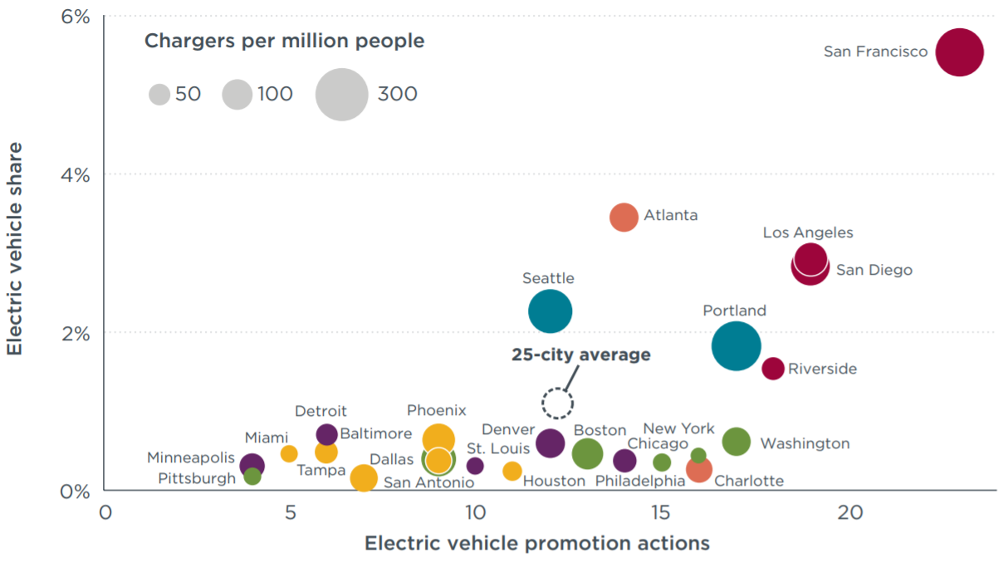
Figure 1: Electric vehicle promotion, charging infrastructure, and EV share of new vehicles in 2014 in the 25 most populous U.S. cities (Lutsey, Searle, Chambliss, & Bandivadekar, 2015).
Lutsey et al., (2015) performed their analysis by examining the 25 most populous U.S. cities to compare EV adoption activities on the state, city, and utility level. Using a criterion for investigating 30 possible actions (10 state actions, 14 city-level actions, and six utility actions). In Phoenix in 2014, only nine of the possible measures have been achieved (two state actions, four city-level actions, and three utility actions):
- State fee reduction of testing exemption
- State home charger incentive, support
- City carpool lane (HOV access)
- City-owned EV chargers
- U.S. DOE EV Project key area
- Workplace charging
- Utility charging pilot or other research
- Utility website, informational materials
- Other utility outreach activity
The twenty-one actions Phoenix and the state of Arizona have not yet addressed are:
- State zero emission vehicle (ZEV) program
- State battery electric vehicle (BEV) purchase subsidy
- State plug-in hybrid electric vehicle (PHEV) purchase subsidy
- State public charging
- State parking benefit
- State fleet purchasing incentive
- State manufacturing incentive
- State low carbon fuel policy
- City vehicle purchasing subsidy
- City parking benefit
- City fleet purchasing
- City car sharing program link
- City electric vehicle strategy
- City website or informational material
- City outreach or education events
- City EV supply equipment financing
- Streamlined EVSE permitting process
- EV-ready building code
- Utility preferential rates EV charging
- Utility home charging support
- Utility cost comparison tool
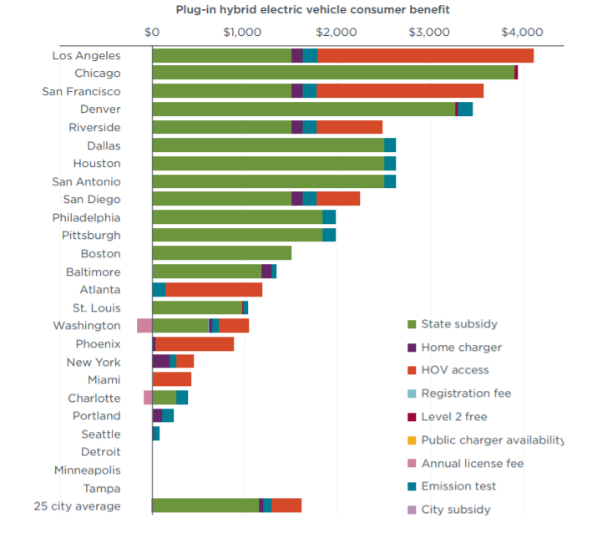
Figure 2: Summary of plug-in hybrid EV consumer benefits from electric vehicle policy actions across the 25 most populous U.S. cities in 2014 (Lutsey, Searle, Chambliss, & Bandivadekar, 2015).
In comparison to other cities with higher adoption rates, San Francisco has accomplished 23 of the 30 possible actions and Los Angeles with 19 of the possible 30. Each of those cities has higher EV adoption rates than Phoenix.
In conclusion, it is clear that policies addressing the initial cost of purchasing or leasing EVs, availability of public charging infrastructure, and other non-monetary incentives will be most impactful in EV adoption rates. Other important adoption factors include the availability of a variety of EV models, good public knowledge about charging locations and availability, and vehicle dealership willingness to prioritize EV sales.

Project Approach and Intervention Methods
This project intended to reduce GHG emissions and improve air quality around the ASU campus by reducing the number of ICEVs being driven to campus, increasing the number of EV drivers through incentives and increased accessibility of charging stations, and advertise charging station infrastructure locations. The approach chosen is supported by the actions discussed in the literature review that compared US city EV policies. While Phoenix and the Arizona Department of Transportation do a good job supporting EV adoption through HOV lane access, it does not offer a vehicle purchasing subsidy or incentive. Lutsey et al. (2015) also identified the importance of offering charging station infrastructure. While the city of Phoenix may do this, the ASU campuses had not offered functional charging infrastructure until January 2019.
Beginning in March 2018, I wrote a business plan for University Sustainability Practices (USP) and ASU to apply for necessary funds for electric vehicle charging stations through Parking and Transportation Services capital funds and their installation. With a partnership between USP and Parking & Transportation (P&T), we held meetings with ChargePoint (a charging infrastructure company) to select the number of viable charging stations and locations on all four campuses. Previously, P&T laid conduit to prepare for charging station installation across the proposed charging station locations. While charging stations were being installed, I conducted surveys over the phone with other campuses to understand what they were doing to increase electric vehicle adoption. The University of California San Diego (UCSD) was the most inspiring campus EV program because they had moved beyond the traditional model of simply installing charging stations and had become leaders in the field of EV development. They began by initiating partnerships with local EV dealerships which eventually grew to a partnership including the entire UC system. Then, they worked with vehicle grid integration (VGI) technology manufacturers to pilot using the EVs as bidirectionally connected batteries with their microgrid. Very few other universities are testing VGI technologies or working with technology manufacturers to do so.
I also surveyed staff and faculty of ASU to understand why they would or would not adopt an electric vehicle and to understand what resources they would need to encourage them to do so. I applied for Institutional Review Board (IRB) approval at the end of 2018 and then distributed the survey to over 9,500 staff and faculty at the beginning of January 2019. The survey responses helped to solidify the ASU EV program approach. The questions from the survey are included in the appendix, and the results are included in the outcomes/findings section.
In tangent to work done from the university side, I also wanted to have a more holistic understanding of the EV market to get a better perspective from other players in the market. As a research analyst for Navigant Consulting, I began in January 2019 to publish a report on electric vehicles in higher education. The report was officially published in April 2019 and is directed at universities, EV manufacturers, car dealerships, and the EV industry as a whole. It highlights how universities are key future players in the widespread adoption of electric vehicles and outlines strategies manufacturers can use to build partnerships.
Moving forward, a program to incentivize electric vehicle adoption (one of the 30 suggested actions) was created to eliminate one of the barriers to EV adoption. I worked with contacts at local dealerships in the Phoenix/Tempe area to set up an incentive program for students/staff/faculty to make electric vehicles more affordable. The benefit to the dealership is an increased customer base. ASU is home to around 130,000 people between all four campuses, and postings on the ASU Employee Benefits goods & services website includes information of the partnerships with dealerships and what financial savings are available to them when purchasing or leasing an electric vehicle.
As I am aware that the initial purchasing cost is not the only barrier to EV adoption, as indicated through the literature review and the survey results, I also prepared a plan to continue the ASU EV Program beyond the work already accomplished (listed in the recommendations section). This further work can either be picked up by USP or another sustainability student in the future. The final piece of my project was connecting our new dealership partners to Earth Day celebrations to highlight alternative transportation options. The goal of the celebration was to build awareness around different types of electric vehicles as well as increase education of EV benefits by allowing people on campus to ask the dealerships questions about the EVs and look at the vehicles first hand.
My deliverables are: the survey results highlighting key findings, a finalized list of incentives coordinated between dealerships for ASU staff/faculty/students, a list of further recommendations given to USP which will list other reasons for EV adoption prevention and next steps that can be taken to increase EV adoption. The steps I took were:
1. Meet with USP and P&T to discover the current number of EVs on campus (this number is not currently tracked but a question will be added to ASU parking registration passes to start tracking the number), determine the current demand for EV charging access, calculate the growth rate of EVs over the next ten years to decide how many charging stations will be needed initially and see how quickly that number will need to grow (March 2018)
2. Write a business plan to obtain funding for charging station installation (March 2018)
3. Install charging stations on campus (September 2018 – April 2019)
4. Perform a literature review of work already done to discover barriers preventing EV adoption (the literature review informed the survey questions) (October 2018)
5. Write IRB for survey participants (November 2018)
6. Survey electric vehicle current users as well as potential users to determine barriers preventing EV adoption specific to ASU (January 2018)
7. Write a plan outlining the top barriers to EV adoption with steps to overcome obstacles with a timeline (January 2019)
8. Work with dealerships in the Tempe/Phoenix area to create a list of purchasing incentives for students/staff/faculty wanting to buy an EV (January - March 2019)
9. Post list of incentives on staff/faculty goods and services with help from ASU HR and communications staff (March 2019)
10. Present deliverables (survey highlights, list of incentives as well as steps moving forward to eliminate barriers to EV adoption on campus) to the leadership team of USP (March 2019)
11. Publish analyst insight report on electric vehicles in higher education to show how the industry can work with universities to build up the EV market (April 2019)
12. Assist with the Earth Day EV demonstration to build EV awareness and highlight new dealership partnerships (April 2019)
13. Present final deliverables to MSUS committee (April 2019)

To achieve my goals, I utilized partnerships within USP, P&T, ASU faculty, UCSD EV incentive model, Navigant Consulting, and the teachers of this class for guidance. Survey questions are included in the appendix.

Outcomes and Findings
The staff and faculty survey was very successful because I had a much larger number of participants than originally expected. I had hoped to receive one or two hundred responses but instead, was advised by ASU communications to distribute the survey to all staff and faculty with a parking pass (around 9,500 individuals). I received over 1,400 responses which gives me a 98% confidence interval. Of the 1,400 respondents, 96.6% of vehicle drivers own their vehicle, 80.2% indicated that they owned their own home, 53.8% have access to a plug within 15 feet of their parking space at their home, and 8.6% indicated that they already own a plug-in electric vehicle. Comparatively, in 2018 only 0.35% of vehicles in Arizona were plug-in electric vehicles (including battery electric vehicles and plug-in hybrid electric vehicles), according to Navigant Research’s report on EV geographic forecast for North America (Soat, 2018). The number of current PEV owners was surprising because many of owners indicated they did not drive their PEV to campus because of the lack of charging stations. With such a simple fix, ASU had been creating a barrier to EV use by waiting so long to install new charging stations. The massive disparity between current PEV adoption statewide versus at the university level indicates positive factors for PEV adoption potential. Survey participants also responded about what would have to change for them to purchase an EV. About 20% of participants mentioned increased charging locations, another 20% mentioned issues related to costs and incentives, and several others mentioned issues like waiting for battery technology to improve and driving range to increase.
Throughout the survey, participants also left many comments in addition to their answers. A small sample of the comments:
“Working remote, telecommuting, flexible work schedule should be encouraged and supported by ASU far more than buying/leasing an EV. I consider owning an EV more of a luxury and personal statement rather than a viable solution on a personal level. The upfront cost of the car and overall cost of ownership far exceeds that compared to the many alternate commuting options available. Owning/leasing an EV at this time is low on my priority.”
“ASU, the leader in Sustainability, needs to do far more to support electric vehicle use!”

“Hi, I park in the Tyler Garage. Would ASU offer informational sessions about the ASU Electric Vehicle Program and the costs and would it be possible to park in the Tyler Garage and charge the electric car (or is there a hybrid version)? Thanks.”

“I like my electric vehicle. But I don't drive it to ASU because of the lack of charging stations (changed this semester-thanks!) and because I have to move the car after it's charged. I don't always have time to do that. Being more transparent and giving faculty/staff/students more info about it would be helpful (an email or something).”

“Would love to see some ASU-specific incentives and programs to get more people taking the EV leap. I could use some plausible excuses to talk myself and my spouse into this!”

“Free parking for EV would be a significant incentive. Parking and Charging would be even better.”

“Would like to see ASU offer incentives to employees who take public transportation.”

“Blink Chargers cost way too much to utilize in anything but a crisis. Please put more plugs in at the parking garages and make the cost of charging break-even, not a profit center. It costs around 11 cents per kWh to charge at home; please don't make people pay 2 to 4 x this amount at school.”
There were a lot of very positive comments as well as a few negative ones, as expected. From the literature review, campus program phone surveys, the staff, and faculty survey, and general feedback, I developed a few key takeaways. The literature review highlighted the need for policies addressing the initial cost of purchasing or leasing EVs (especially direct discounts on new vehicle purchases), increased availability of public charging infrastructure, and other non-monetary incentives as most impactful ways to increase EV adoption rates. Other important adoption factors include the availability of a variety of EV models, good public knowledge about charging locations and availability, and vehicle dealership willingness to prioritize EV sales. The survey and the literature review also highlighted other options outside of the EV program to reduce CO₂ emissions like increased telecommuting opportunities. Through my project, I addressed some of these barriers.
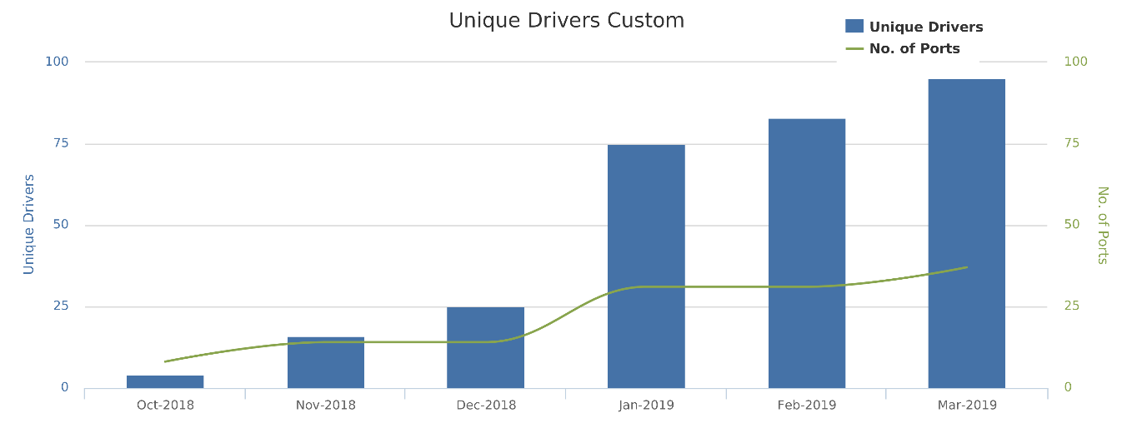
Figure 3: Unique drivers using the ChargePoint charging stations in the last year. Source: ChargePoint
The installed charging stations have shown an increase in the number of EVs being driven to campus. ChargePoint provides a dashboard for the university to monitor charging station use, track energy used, and view average use. Figure 3 shows the increased number of unique drivers (does not include drivers that charge their vehicle more than once) using the charging stations on campus. There appears to be a direct correlation with increased number of charging stations and an increased number of unique drivers. However, this correlation does not give any insight into new EV purchases because this may be showing existing EV owners charging their vehicle on campus.
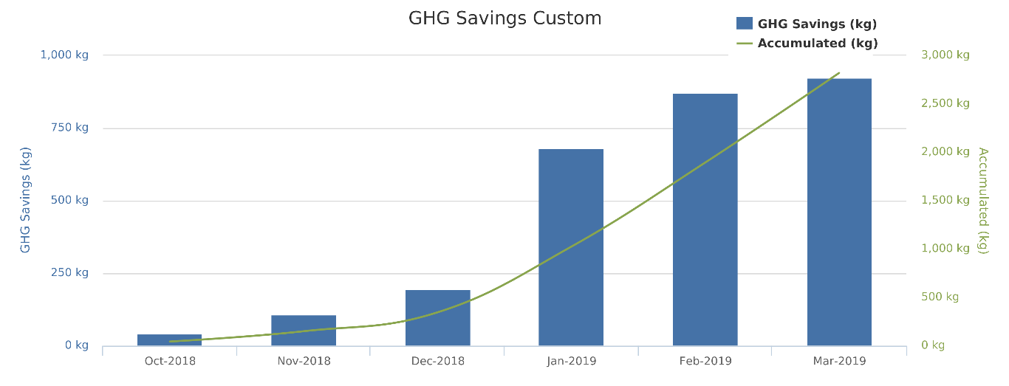
Figure 4: Greenhouse gas emissions savings from EV charging over using an internal combustion engine vehicle in the last year. Source: ChargePoint
I secured incentives with three different dealerships: Chapman Chevy, Chapman BMW, and Larry H. Miller Nissan. They provided reduced pricing options for purchasing and leasing of five different EV models: Chevy Volt, Chevy Bolt EV, BMW i3, BMW 530e, and the Nissan Leaf. The incentive program doesn’t cover all EVs on the market, but it does give a good start and covers a range of prices, brands, and model options. The incentives were posted on the ASU employee goods and services benefits page.
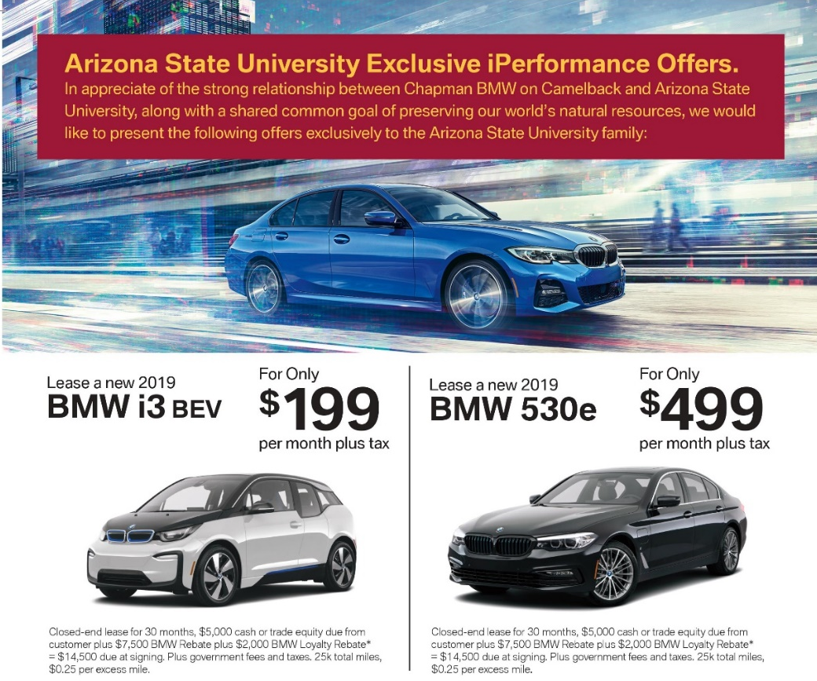
Figure 5: The ASU leasing incentive flyer offered by BMW
To build awareness and offer education on EVs, the Earth Day EV Demonstration brought together the partner dealerships and their offerings to allow people on campus to look at the EVs and ask questions. My role in the demonstration day was mostly around connecting the dealership partners with the Earth Day organizers. ASU community member participation in this event was very low, reinforcing the need for substantial and creative marketing and communications in order to increase awareness of the program. ASU community members suffer from information overload and so trying to get messages approved, delivered, and seen is challenging.
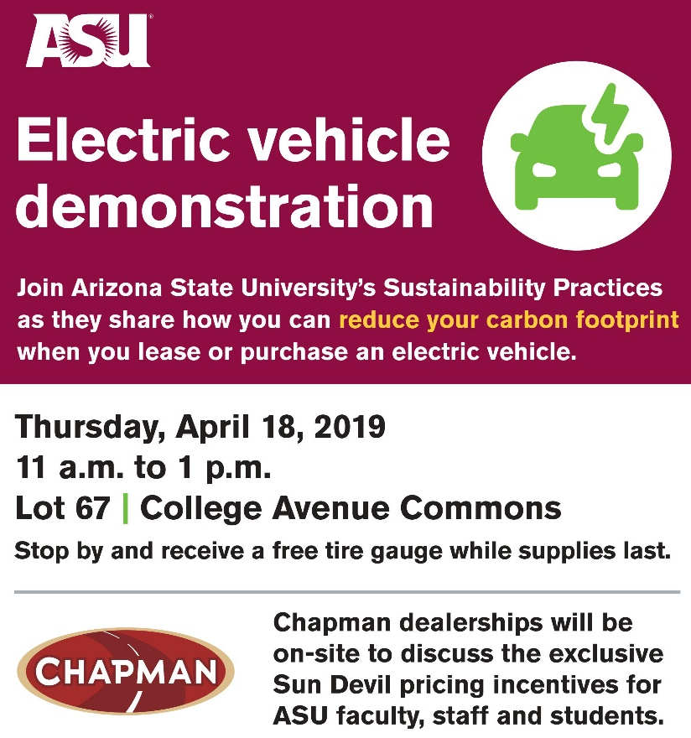
Figure 6: ASU EV Demonstration Day Advertisement
Finally, I published a report on electric vehicles in higher education with Navigant Consulting. This was a more general overview of the EV market in the United States and how it can be expanded through partnerships with universities. If EVs are going to reach mass adoption rates, manufacturers, dealerships, charging infrastructure companies, battery development companies, universities, and others in the tech industry (like VGI, autonomous vehicle, wireless charging developers) are all going to need to coordinate together. The paper I published was intended to offer solutions on how to build those needed partnerships. The top barriers to EV adoption at ASU and other universities, in general, can be mitigated through manufacturer-university partnerships. Companies focused on charging infrastructure can expand to more campuses, dealerships can build incentive programs with universities to reduce the initial costs, and manufacturers can expand their research efforts in partnership with universities.

Recommendations
The EV program was a great start, but there was not enough time to evaluate the success of the program. A follow-up project could include continuing to work with USP and P&T to track the number of EVs coming to campus and see if the number increases over time now that some of the barriers have been reduced. With this evaluation, the program could either push forward if it is found to be successful or it could change course and try a new tactic if EV numbers on campus did not increase.
The dealership incentive program could be expanded to include other brands (Tesla, Ford, Mercedes/Smart, etc.). Tesla may be the hardest brand to build an incentive program with because there is such a high level of demand for their vehicles. I did not reach out beyond the three chosen partners because I wanted to test working with them first to see if it was going to help increase the number of EVs on campus.
Alternatively, or in tandem, the incentive program could continue to follow UCSD’s model and build relationships with manufacturers doing VGI testing on campuses. While they have the advantage of operating on their own microgrid, which takes out the entire process of needing to work with a local utility, ASU could still potentially fit into the research partnership mold as well because of the strong research capabilities.
Another step after encouraging the electrification of students, staff, and faculty vehicles would also be to electrify ASU’s fleet. ASU uses over 70 vehicles in maintenance and operations and could be electrified. This process would necessitate strong partnerships with the facilities department, P&T, and others.
This program also did not include evaluations of energy use and understanding how the increased energy use on campus affects solar usage. If there was a dramatic spike in energy demand from EV charging, does that mean solar being used for other functions on campus was reduced? Does this mean ASU should invest more heavily in solar installation on campus to compensate for the increased energy demand? An energy evaluation would be useful in evaluating next steps.

Conclusions
Overall, the ASU Electric Vehicle Program is a success. However, it is important to remember that EVs are only one small piece of the solution to combat climate change and improve urban air quality. A multifaceted approach involving a complete transformation in the transportation sector which encourages public transportation, walking, biking, telecommuting options, and non-emitting sources of transportation is ideal. EVs are a piece of the CO₂ emissions reduction puzzle and are most effective when charged with clean energy sources as well.
Further work beyond what was done this year includes expanding the dealership incentive program, partnering with manufacturers doing VGI testing on campuses, evaluating the success of the program by monitoring the number of EVs being driven to campus or purchased from our partner dealerships, electrification of the ASU fleet, and monitoring of energy use due to increased energy demands.

Literature Review References

Dijk, M., Orsato, R., & Kemp, R. (2013). The emergence of an electric mobility trajectory. Energy Policy, 52, 135-145.
Faller, M. B. (2019, March 18). 'Cash for Clunkers' rebates were too high to prompt car upgrades, study discovers. Retrieved from Arizona State University Now: https://asunow.asu.edu/20190315-discoveries-asu-research-finds-even-windfall-buyers-act-surprising-ways?utm_campaign=ASU_Now+3-19-19&utm_medium=email&utm_source=ASU%20Now&utm_term=ASU&utm_content=%20https%3a%2f%2fasunow.asu.edu%2f20190315-discoveries-asu-
Fast Facts on Transportation Greenhouse Gas Emissions. (2016). Retrieved from EPA: https://www.epa.gov/greenvehicles/fast-facts-transportation-greenhouse-gas-emissions
IEA. (2012). World Energy Outlook 2012. OECD/IEA, Paris.
Johnson, W. (2017, July 7). Phoenix breaks 112-year-old heat record. Retrieved from AZ Central: https://www.azcentral.com/story/news/local/phoenix-weather/2017/07/07/phoenix-ties-112-year-old-heat-record/460738001/
Lutsey, N., Searle, S., Chambliss, S., & Bandivadekar, A. (2015). Assessment of leading PEV promotion activities in United States cities. International Council on Clean Transportation. Retrieved from https://www.theicct.org/sites/default/files/publications/ICCT_EV-promotion-US-cities_20150729.pdf
Nealer, R., Reichmuth, D., & Anair, D. (2015). Cleaner Cars from Cradle to Grave. The Unin of Concerned Scientists. Retrieved from https://www.ucsusa.org/clean-vehicles/electric-vehicles/life-cycle-ev-emissions
Saxton, T. (2013). Understanding Electric Vehicle Charging. Plug in America. Retrieved from http:// www.pluginamerica.org/drivers-seat/understanding-electric-vehicle-charging
Sierzchula, W., Bakker, S., Maat, K., & van Wee, B. (2014). The influence of financial incentives and other socio-economic factors. Energy Policy, 68, 183-194. Retrieved from http://dx.doi.org/10.1016/j.enpol.2014.01.043
Soat, R. (2018). Market Data: EV Geographic Forecasts - North America. Navigant Research. Retrieved from https://www.navigantresearch.com/reports/market-data-ev-geographic-forecasts-north-america
Zhou, Y., Levin, T., & Plotkin, S. (2016). Plug-in Electric Vehicle Policy. Department of Energy. Retrieved from https://www.energy.gov/sites/prod/files/2017/01/f34/Plug-In%20Electric%20Vehicle%20Policy%20Effectiveness%20Literature%20Review.pdf

Appendices and Acknowledgments

Acknowledgments: Thank you to all my partners for all their help over the last year!
University Sustainability Practices – Michael Dalrymple, Corey Hawkey, JoEllen Alberhasky, Susan Norton
Parking and Transportation – Raymond Humbert
Dealerships – Lauren Pond (Chapman Chevy), Robert Cashatt (Chapman BMW), Adam Holt and Juan Jacobo (Larry H. Miller Nissan)
ASU Communications - Aaron Bryant, Clayton Taylor
Navigant Consulting – Scott Shepard, Raquel Soat
Instructors - Paul Prosser, Caroline Harrison

Survey Questions (not all participants received all questions depending on their answers given)
- University Sustainability Practices and Parking and Transit Services at Arizona State University are expanding support for electric vehicles on campus. This survey is for staff and faculty at ASU and asks questions relating to personal electric vehicle purchase or lease decisions to better understand barriers to adoption and the potential to overcome such barriers. All questions are optional but help to develop the campus’ sustainability strategy. This survey takes approximately 7 minutes to complete.

By completing this survey, you are consenting to allow ASU to use the answers collected to develop an electric vehicle program. All questions are presented in English. You have the right not to answer any question, and to stop participation at any time. Your participation in this study is voluntary. If you choose not to participate or to withdraw from the study at any time, there will be no penalty, you must be 18 or older to participate in the study. There are no foreseeable risks or discomforts to your participation. Your responses will be anonymous. The results of this study may be used in reports, presentations, or publications but your name will not be used.

If you have any questions concerning the research study, please contact the research team at JoEllen.Alberhasky@asu.edu. If you have any questions about your rights as a subject/participant in this research, or if you feel you have been placed at risk, you can contact the Chair of the Human Subjects Institutional Review Board, through the ASU Office of Research Integrity and Assurance, at 480-965-6788.
- What is your job at ASU?
  - Faculty
  - Staff (Full-time or Part-time)
- On average, how many miles is your daily round trip commute to and from work?
  - Less than 1 mile
  - 1 to ≤ 4 miles
  - 5 to ≤ 9 miles
  - 10 to ≤ 19 miles
  - 20 to ≤ 29 miles
  - 30 to ≤ 39 miles
  - 40 miles or more
- Which days of the week do you commute to work?
  - Sunday
  - Monday
  - Tuesday
  - Wednesday
  - Thursday
  - Friday
  - Saturday
- Which mode(s) of transportation do you use to get to work?
  - Personally owned vehicle
  - Walking
  - Biking
  - Public transportation
  - Rideshare (Lyft/Uber)
  - Telecommute
  - Other
- Thinking of the vehicle you drive most often, do you…
  - Own a vehicle
  - Lease a vehicle
  - I do not have a vehicle
- Do you currently own or lease a non-plug in hybrid electric vehicle?
  - Yes, I own a non-plug in hybrid electric vehicle
  - Yes, I lease a non-plug in hybrid electric vehicle
  - No
- Do you currently own or lease a plug-in electric vehicle? (Including plug-in hybrid electric vehicles or battery electric vehicles)
  - Yes, I own a plug-in hybrid electric vehicle
  - Yes, I lease a plug-in hybrid electric vehicle
  - No
- Do you drive your plug-in electric vehicle to ASU?
  - Yes
  - No
- Why or why not?
- What are the reasons you chose to purchase or lease a plug-in electric vehicle? (Choose up to four answers)
  - Upfront cost
  - Total cost of ownership
  - Sustainability Reasons
  - The look/status symbol
  - Cost of electricity vs. the cost of gas
  - State subsidies
  - Federal tax incentives
  - Range of battery
  - Other
- What are the reasons you did not choose to purchase or lease a plug-in electric vehicle? (Choose up to four answers)
  - Upfront cost
  - Total cost of ownership
  - Maintenance
  - Passenger or cargo capacity
  - Brand loyalty
  - Lack of charging stations
  - Charging times
  - Waiting for technology to improve
  - Battery range
  - Cost of replacement batteries
  - Aesthetics (the way the vehicle looks including color availability)
  - Did not have enough information about EVs to consider purchasing
  - EVs were not widely available when I was purchasing my current vehicle
  - Did not think about buying an EV during my last vehicle purchase
  - Other
- How much do you spend on gas in an average week
  - Less than $10
  - $10 to $24
  - $25 to $49
  - $50 to $74
  - $75 to $99
  - $100 or more
- If you were to consider getting a plug-in electric vehicle, would you do so by purchasing or leasing the vehicle?
  - Purchasing
  - Leasing
  - Unsure
  - I would not consider getting a plug-in electric vehicle
- What would have to change in order for you to consider purchasing a leasing a plug-in electric vehicle as your next vehicle?
  - Increase the number of public charging stations
  - Better state or federal purchasing incentives
  - Informational sessions to learn more about EVs
  - Larger vehicle size
  - Quicker charging times
  - Increased driving range
  - More secondhand EVs available
  - More electric vehicle model choices
  - Other
- Please indicate whether you plan to purchase or lease any new or used vehicle in the next…
  - 6 months
  - 1 year
  - 2 years
  - 3 years
  - 4 years
  - 5+ years
  - No plan to buy or lease a new vehicle
- When purchasing or leasing any new or used vehicle, please rank your top considerations. (Drag and drop your answers to put them in order)
  - Brand
  - Color
  - Cost or monthly payments
  - Engine size/horsepower
  - Features/technology
  - Gas mileage
  - Insurance costs
  - Looks/aesthetics
  - Maintenance/operating cost
  - Safety/reliability
  - Size/cargo room
  - Size/seating capacity
  - Other
- How familiar are you with different types of electric vehicles? (Ex: BMW i3, Nissan Leaf, Tesla Model S, Mitsubishi i-MiEV, etc.)
  - Extremely familiar
  - Very familiar
  - Moderately familiar
  - Slightly familiar
  - Not familiar at all
- At your place of residence, is there an outlet within 15 feet of the parking space?
  - Yes
  - Maybe
  - No
- Do you currently own or rent your home?
  - Rent
  - Own
  - Other
- Which of the following best describes your current type of housing?
  - Apartment
  - House
  - Townhouse/condo
  - Other
- What is your highest level of education?
  - Some high school, no diploma
  - High school graduate, diploma or the equivalent (for example GED)
  - Some college credit, no degree
  - Trade/technical/vocational training
  - Associate degree
  - Bachelor’s degree
  - Master’s degree
  - Professional degree
  - Doctorate degree
  - Prefer not to answer
- Which of the following categories best describes your household pre-tax income in 2017?
  - Less than $25,000
  - $25,000 to $49,999
  - $50,000 to $74,000
  - $75,000 to $99,999
  - $100,000 to $124,999
  - $125,000 to $149,000
  - $150,000 to $199,999
  - $200,0000 or more
  - Prefer not to answer
- What is your current age?
  - 18-29
  - 30-39
  - 40-49
  - 50-59
  - 60-69
  - 70+
  - Prefer not to answer
- What is your gender?
  - Male
  - Females
  - Non-binary/third gender
  - Prefer to self-describe
  - Prefer not to answer
- Thank you for your participation. Please email JoEllen.Alberhasky@asu.edu with any questions or suggestions regarding the ASU Electric Vehicle Program. Is there anything else you would like to add?

The report is published on Navigant’s website: https://www.navigantresearch.com/reports/shared-and-electrified-mobility-starts-in-higher-education

