Maddy Doyle

April 26, 2019

ReEnvision Waste at SRP

Salt River Project

Abstract
Waste management within the office represents a major sustainability problem for many corporations. Salt River Project (SRP) faces unique challenges at Coronado Generating Station (CGS) and the employee recreation facility Project Employee Recreation Facility (PERA). Addressing major waste streams at CGS involved shifting perspectives, adapting current infrastructure, and incorporating recycling into employee resources. Composting represented an easy to communicate and effective solution to minimizing waste at the newly remodeled PERA club, where the emphasis of the site is employee training, events, and catering. Employee engagement at both sites was based on the evidence based 6 step approach to implementing sustainable practices, including sparking initial engagement, forming working sustainability teams (Green Teams) and communicating effectively (Russo & Hoffman, 2008). These efforts helped bring sustainable initiatives and efforts to sites that are otherwise overlooked by SRP sustainability and employee engagement efforts. Further, these two sites modeled how sustainable change can be made in existing facilities as well as how sustainability can help model new facility infrastructure and marketing. The project was evaluated based on the Corporate Sustainability Management System framework in order to identify strengths, weaknesses, and areas for improvement.

Table of Contents

- Introduction and Background
- Literature Review
- Project Approach and Intervention Methods
- Outcomes/Findings
- Recommendations
- Conclusions
- References
- Appendix
- Acknowledgements

Introduction and Background
Salt River Project (SRP) has a recycling and waste management program known as ReEnvision Waste. Access to various sites and lack of employee engagement have prevented the program from being implemented at all SRP facilities. There are two sites that have had very little interaction with current sustainability programs, and therefore represent my target.
The first is Coronado Generating Station (CGS) in St. Johns, Arizona; previous attempts at recycling at this facility were halted by the lack of local recycling companies in the area. Employees are environmentally minded and were already pushing to start recycling various products, yet these same employees could not see the connection between environmental stewardship and sustainability. This was identified as a high priority site as the onsite landfill is filling up at an increasing rate with no waste alternative identified.
The second facility is SRP’s Project Employees Recreation Association (PERA) club, a facility that hosts various events that include both SRP employees and thousands of visitors. PERA is currently under renovation with the new major facility opening in November, but the smaller Skills Training Center officially opened on March 1, 2019. This presented an ideal opportunity to install new programs and infrastructure.
Changing solid waste behavior, especially in regard to recycling and composting is problematic for many large organizations. SRP has rolled out the simple solution: the installation of recycling containers with signs indicating what goes in each container. However, this problem proves more complex as an overall reluctance to change behavior organizationally is leading to underutilized and contaminated recycling streams. Further, the organizational aversion to embrace recycling as part of the job function has meant that educational efforts have proved futile. Unsustainable material use, including landfilling of plastics causes environmental degradation that is detrimental to cityscapes worldwide. Additionally, landfilling is a financial burden whereas recycling of materials can bring value to a company. These effects are seen in the workplace as well as dispersed in the homes of the thousands of SRP employees.
SRP has indicated that waste as a pressing issue by pledging to reduce their waste by at least half by 2035. There is even discussion of making this a more ambitious goal of reducing waste by 75% or even “striving for zero waste” in the coming years. Finding a solution to the reluctance of corporate change required flexibility and repetition. Working toward a solution gave me the opportunity to lead a corporate project and navigate the business environment.
My vision included the establishment of new waste management practices and building community collaboration and excitement in order to help reach or surpass the SRP 2035 goal of 50% waste reduction. I brought integrated recycling to CGS and composting initiatives to PERA Club through program design, implementation, and education of internal employee groups. These efforts helped to open the minds of SRP employees to both sustainability in the work place as well as in their homes.

Literature Review
Sustainability is a multifaceted field that requires consideration of environmental, economic, and social fields. In order to address the sustainability of SRP’s office waste, waste management strategies were employed. Waste management strategies including recycling and composting are an integral part of transitioning to a circular economy (Preston, 2012), a movement that is a major focus in the field of sustainability.
“Recycling policies are becoming increasingly prominent generally and plastic water bottle recycling is at the forefront of many recycling policy initiatives,”(Viscusi, Huber, & Bell, 2011). There is monetary incentives to recycle for the corporation as many recyclable goods can be sold off for profit (Viscusi et al., 2011). Recycling its self therefore represents the environmental and economic aspects of sustainability.
Composting is a vital piece of establishing a circular economy. By working with Recycled City composting, SRP’s compostable waste is converted to nutrients used to grow produce for Phoenix food deserts (European Compost Network, 2019). This solution allowed the largest waste stream at the PERA club to become a beneficial part of Phoenix sustainability efforts.
Intricate factors are involved in whether an individual chooses to participate in waste management, including, personal attitudes and perception of social norms (Viscusi et al., 2011). Social norms were be addressed in the engagement of employees according to successful employee engagement and environmental change models. Hoffman establishes a 6 step process toward sustainable change within corporations: 1) Establish a sense of urgency, 2) form a powerful guiding coalition, 3) create a vision, 4) communicate the vision, 5) empower others to act, 6) plan for and create short-term wins, 7), consolidate improvements and produce still more change, and 8) institutionalize new approaches (Russo & Hoffman, 2008). Each of these steps were addressed through the SRP 2035 framework, Bring Your Own Bottle (BYOB) program, Green Team, review and corrective action efforts (Kotter, 2007).
The vision and communication of the programs were modeled based on the aspects of successful environmental public service announcements (Bator & Cialdini, 2000). Communications were targeted based on the background attitude and behaviors of the target audience (Bator & Cialdini, 2000). A vital piece of my communication schema was providing information based on “just in time” theory (Nahum-Shani, Hekler, & Spruijt-Metz, 2015). Providing messaging at the location of the recycling, landfill, or compost receptacles has helped employees sort effectively. Building these communications and visions as a team helped to empower the Green Team to continue bringing in even more sustainability efforts to their site. Further, having a team dedicated and knowledgeable about making changes helped identify room for improvement in the projects and opportunities for further change (Russo & Willard, 2008).
The framework of sustainability through happiness was employed within the Green Team to build out the connections of the Green Team as well as accelerate the sustainable change from the project (Cloutier & Deirdre Pfeiffer, 2015). The Green Team continues to be an asset to build on social capital thus empowering the sharing and potential changing of the social norms at SRP (Cloutier & Deirdre Pfeiffer, 2015).
The Corporate Sustainability Management System has been used to evaluate the project and SRP’s overall waste efforts (Azapagic, 2003). Each of the five steps have been evaluated for their impact on the both the site and overall impact of the project. Review and corrective action will continue through the work of the Sustainability Policy and Programs group in order to ensure that each waste solution continues to provide an appropriate solution at its respective site.

Project Approach and Intervention Methods
My project was initiated by the manager of the Sustainability Policy and Programs group, Marc Campbell in order to round out our office waste program and fill in gaps where they exist. His encouragement came from the executive backing of these initiatives in the form of the SRP 2035 framework. This framework, passed in October 2017 has opened the door for sustainability projects. Executive endorsement also gave me access to materials and funding in order to get needed materials and install infrastructure.
I underwent a stepwise process based on behavior change and sustainable change models (Bator & Cialdini, 2000) (Kotter, 2007). The first step was to talk to people at each of the locations about their current sustainability programs and where they see need for improvements or change.
Discussions with CGS and PERA employees helped to guide my work at the beginning of the project. Extending these conversations and engaging the with various facilities allowed me to determine what specific adaptations on current infrastructure would be valuable for each site. For PERA, my work was focused on the Skills Training Center as the facility opened during the timeline of my project. For both the larger PERA Club as well as the Skills Training Center composting was identified as the best solution to deal with the food centered waste. Coordination with catering staff allowed me to identify alternatives to plastic materials that are compostable and could be easily traded into the catering scheme. Recycled City was chosen to service this site as SRP works closely with them already to provide paper towel composting at various facilities. Additionally, a proposal for composting for PERA kitchen and the larger event site was drafted for the site opening in November.
At the same time, I contacted Waste Management (WM) and Republic Services about servicing CGS. I also conducted research into other options for recycling pick up, unfortunately, Republic Services (and may other companies) did not offer service to this remote site. However, WM offered an open-ended contract. This contract starts with recyclables going to Surprise, Arizona to be sorted at Waste Management’s major facility but leaves room for SRP to shift the destination of the material away from this location if a more sustainable option is identified. The flexibility of the contract meant that SRP was excited about WM servicing recyclables at CGS.
Various meetings with internal groups within SRP helped to secure permissions to install infrastructure and garner excitement for upcoming changes to each respective site. Additionally, I worked closely with Mark Prein, a sustainability group (“Green Team”) member, at CGS to help bring employees together for meetings onsite at CGS. In order to communicate my vision with CGS manager Rudy Navarro, I created a formal proposal to address recycling at the facility. This proposal included quotes from WM as well as graphic work and communication plans (see appendix). The proposal underwent revisions after discussions with CGS managers and was accepted on March 14.
At PERA club, members to the Green Team were recruited via word of mouth as well as digital advertising via digital posters. To get employees excited about sustainability program engagement I gave employees stainless steel reusable water bottles and reusable bamboo utensils to replace single use plastics in the workplace. I used the excitement from this simple switch in order to motivate employees and executives to create forward momentum for change. I also leveraged stories from existing Green Team projects in order to build enthusiasm and early engagement with each group.
The group of motivated individuals that came out of project interactions formed into an onsite Green Team for each respective facility. The new Green Team members received training on the sustainability programs available at SRP and some of the initiatives employees are undertaking. The training provided the teams with the information necessary to tackle current sustainability issues and will give them the ability to address problems in the future. The PERA Green Team was started as of February 19th at the Green Team gathering where project groups were formed, educated on current sustainability issues, interacted with their peers and various sustainability ideas. The PERA Green Team has the endorsement of one of its members, Marcia Beat who is in charge of events and operations of the PERA facility. At CGS, endorsement was granted by plant manager Rudy Navarro and therefore has a huge impact on the Green Team’s ability to work closely with employees during their day to day jobs. Navarro’s endorsement was embraced by employees at CGS as 11 people showed up to be trained as Green Team members, an astounding 6% of the total plant employee population. These teams have become an asset to get programs started both with infrastructure and employee education.
Launching the new waste management process at these facilities was a difficult step. I used the expertise from my coworkers to get Waste Management and Recycled City coordinated and ready for on time installation. I worked alongside my team to revamp and recreate our recycling and composting messaging and its format, with a focus on images and catchy messaging. Further, we ensured that the bins fit SRP’s aesthetic standards yet are still visible and easy to use. I executed the delivery and installation of infrastructure for PERA while we had the bins shipped to CGS, as we arrived via plane.
Assessment of each site’s progress and interaction with new infrastructure was conducted through visual inspection as well as via an employee survey.

FIGURE 1: Survey Results
Figure 1 shows the survey results in 0-100 scale. Interaction indicates how often employees interacted with the program (where 100 is daily, and 0 is never). Sentiment indicates how well employees thought the program addressed waste at their facility on a 0-100 scale. Confidence is an indication on how confident employees are in their ability to sort waste. And communication is an indication of how well employees thought the program was communicated. Data was normalized to a 0-100 scale for all questions. For more information see Table 4 in the Appendix.

The survey at the PERA Skills Training Center showed that the average employee is interacting with the system more than once a week. Additionally, employees feel that the program is addressing waste well (an average rating score of 77/100). Employees rated feeling somewhat confident or above with their ability to sort composting with communication of the program rated at 3.8/5. They did indicate a need for additional communication which was anticipated and was quickly addressed with additional educational meetings. There were no additional ideas on how waste could be reduced. Overall the program has been well received by employees but the survey reinforced efforts to continue communication over the long term.
Alternatively, survey results from CGS showed room for big improvements in both communication and perception. Interaction with the program is still high with an average rating of 71/100, indicating between daily and weekly interactions. Confidence in the ability to sort is still high with 86% of employees surveyed showing confidence. Employees felt that the program could have been communicated better than an average score of 3.06/5. The most common comment received from employees was questioning where the recycled material was going. While there were very few ideas on how to move forward, the survey showed that email communications are valued and continued education on site will be necessary.
Continued engagement of the Green Team during and after waste management implementation has helped keep the project alive and thriving into the future. This process was initiated by giving a yearly topic and mission for Green Team members to chase. The Sustainable Development Goals were utilized to motivate ideas and inspiration. Allowing groups to tackle sub-projects and interest projects will help them become autonomous. Showing measurable differences made by sustainability efforts will help engage not only the employees but executives as well.
Finally, the Sustainability Policy and Programs group has dedicated to maintain the installed infrastructure as well as continue to work with both sites to reduce overall waste. By committing to recycling, composting, and reducing the amount of waste produced at each site, SRP is making strides toward becoming a more sustainable company.

Outcomes/Findings

Bring Your Own Bottle
The Bring Your Own Bottle (BYOB) challenge posed the first challenges and findings. While the BYOB challenge was well received at the new Skills Training Center facility, there was huge pushback from the CGS managers when asked to adopt the bottles. I credit this as one of the first instances that showed the differences between working at a new site in relation to an established one.
At the Skills Training Center, employees were elated by the idea that they would get a free bottle for the simple act of eliminating plastic water bottles. One employee commented that he thought the challenge was “like Christmas” as they were getting a new facility as well as the bottle. Importantly, the manager of the facility was highly supportive of the initiative and pledged that he would not order single use water bottles for the facility. With capacity to hold 100 visitors a day and 12 employees, the BYOB initiative has saved an estimated 336 water bottles a day (based on the average water bottle usage around SRP). This pledge alone equates to an estimated 154,000 water bottles and $71,000 are saved per year. See Appendix for more information.
In contrast, despite having ample infrastructure for refilling bottles, many managers at CGS found the BYOB challenge to be needless and unfunctional for the daily operations of the plant. Even though I encouraged them to allow small groups of employees to take the challenge at a time, only a few small groups adopted the challenge. I found that employees that work mostly from an office or desk were most likely to adopt the challenge. While I continue to promote the BYOB challenge through the Green Team at CGS, many do not find the reusable bottles as convenient as the single use bottles they are accustomed to.

Changing Corporate Culture Through Employee Engagement
Upon starting a waste management project, many of the subject matter experts felt my biggest challenge would be to build momentum behind the program. I feel that the success of my project is owed to two factors: the SRP 2035 sustainability initiative and the power of an individual. SRP 2035 has revolutionized the work in sustainability at SRP as the movement is backed by more than just a 5-person team. By establishing the 2035 goals, SRP as a corporation has garnered support for sustainability from the top down. The top down support meant that as I proposed new ways to reduce waste to landfill at SRP, I had the support of not only the manager of Sustainability Policy and Programs, but also the Director of Environmental Services and Sustainability and the managers of both sites I worked at. These layers of support allowed me to bypass what may have been a very long internal proposal process and reach out to the sites right away to start conversations about my plans for their waste. While executive support definitely helped kickstart my project, I believe that having this project within the time limit of my culminating experience incentivized not only myself but others to keep momentum along the way. While there were many points where miscommunication and complications would have typically slowed the project down, having the dedicated time to work on these programs meant that I was able to continue pushing forward. Eventually, my efforts led to the completion of infrastructure installations right on time for the Skills Training Center opening and the completion of surveys at CGS in time to be included in this study.
Working in a corporate setting posed other challenges. The deployment of bins at CGS was delayed due to deliveries not occurring at the time and place contractors had agreed upon. Having to rely on others to coordinate various parts of the program installation meant that timelines were not executed as planned. Additionally, working within the corporate setting often meant waiting for responses and work to be evaluated or accepted by others. Delays in response continually threatened to interrupt my project but hard work and the understanding of site managers allowed the project to continue in a timely manner.
In the past, single stream recycling was applauded as the fix all solution for waste at SRP facilities. Even though this system did garner positive attention from some, many felt that the program was too complicated and difficult to follow. I believe my work at CGS and PERA goes to prove that waste can be more thoroughly addressed if the site’s needs are assessed and adapted to. This project also showed how positive reactions and outcomes can come from a simple process. The employee survey from both sites showed that while there is a general understanding of the program, there is still communication gaps to be filled. Importantly, employees need to establish a deeper connection to the system to increase their understanding and sorting skills. Additionally, another avenue of communication is needed for visitors at the Skills Training Center and the general sentiment toward the program is low at CGS. To address continued communication and visitor engagement the Sustainability Team is continuing work to add a short lesson on sustainability at the beginning of every meeting. In addition, the story of recyclables at CGS is being written as a way to help employees connect with the program and help them understand the value of the program. See Table 1 in the appendix for more information on employee interactions.
The true completion of this project for me meant that I could shift major efforts to other sites while the internal Green Team maintains control over the sustainability of their facility. I believe that the PERA Green Team has succeeded. The Green Team has taken over the proposal for addressing waste in the new PERA kitchen and other Green Team members are focused on addressing soft plastic waste at their facility. This effort shows an institutionalization of the new program and therefore a completion of the final step of Hoffman’s change model (Russo & Hoffman, 2008). I have also started the robust CGS Green Team down a similar path as they are working to develop a list of potential projects ideas. Efforts at CGS are still focused on the consolidation of improvements step of Hoffman’s model and therefore still have ground to cover (Russo & Hoffman, 2008).
Much of the work behind the initial process set out by the Corporate Sustainability Management System (Azapagic, 2003) was accomplished by the SRP 2035 corporate sustainability goals. Step 1, sustainable development policy, in its entirety was accomplished by the SRP 2035 goals and framework, again demonstrating how important these corporate goals were to accomplishing my project. My project therefore began at step 2, planning. Most of the identification of resources, responsibilities, actions, and objectives was completed as a part of my project proposal with the help of School of Sustainability faculty and my SRP coworkers. In the next step of implementation, I was able to identify the waste streams to address, the tools and methods required, as well as train Green Team members and overcome barriers to the implementation. One of the notable barriers was the short time frame in which I had to complete the project, pushing me to expedite much of the work and collaboration involved throughout the life of the project. Communication, step 4, was focused on internal communication, in which I have seen great responses through my survey results (see appendix). My project did lack the external communication or sustainable reporting; however, the successes of efforts at CGS and PERA will be included in future sustainability reports from within the SRP Sustainability Policy and Programs group. At the PERA site, my project was able to complete a round of review and corrective action, step 5, as a result of the survey analysis and additional training. However, at CGS, review is underway as survey results helped inform future work and the anticipated need for additional infrastructure. Overall, this project aligned closely with the goals, methods, and process set out by Azapagic and continuing to follow the framework will help inform not only future work at these sites but also the future of the SRP 2035 goals.
This project gave insight into the conflicting nature of sustainability and an energy enterprise such as SRP. While the SRP 2035 goals encourage momentum in the direction of sustainability, there is still a significant conflict that prevent SRP from becoming truly sustainable. By altering earth’s natural energy for human purposes, the system is by definition unsustainable. However, SRP’s commitment to the community and safety will continue to lead the company in the right direction.

Recommendations
This project showed that there are a few simple components necessary in order to jump start sustainable change: executive support, employee interest, and certainly a project manager. Continuation of work may include reevaluating the waste system for other SRP facilities one facility at a time and deciding how to best address the site. CGS and PERA both serve as examples of how employee engagement is a vital piece to creating change in a meaningful way. In order to continue creating change, the Sustainability Policy and Programs group should be expanded as to give more human resources toward these initiatives.
The most important modification SRP will need to undergo in order to become a sustainable organization is incorporating sustainability into the culture of the company. To execute on this SRP needs to show advancements and progress on their 2035 goals and ensure that every employee is interacting with these goals in some way.

Conclusions
My project was initiated with a two-part mission: first establishing more sustainable waste habits for three specific facilities, and more importantly, modeling how these changes can be made in an impactful way through employee engagement practices. Despite being unable to interact with the SRP Sky Harbor Hangar, I feel that I succeeded in both of these goals.
By focusing on employee engagement through leveraging and building Green Team members, I was able to both establish programs in a timely manner as well as educate employees and begin to change stigmas and opinions about sustainability. While my ultimate goal was to have an onsite Green Team able to tackle problems independently, the outcome of collaboration between the Green Teams and the Sustainability Policy and Programs group has allowed for improved practices and communication from both sides. The resulting relationship established communication schema that have already had implications at my project sites in terms of sentiment toward sustainability, as indicated by survey results.
The implementation of the BYOB challenge was one portion of the project that did not follow my initial plan. I found that despite not being ubiquitously adopted, using the challenge as a way to initiate the conversation for sustainability was effective and helped garner positive direction for my discussions. The number of people that embraced the challenge also shows that even employees resistant to change are excited to take on this type of initiative. I found that top down acceptance of the challenge is necessary to create the type of change I envisioned. To help move in a sustainable direction, small scale sustainability efforts need to continue to show how easy and cost-effective small changes can be. Still, I am pleased to see the monetary savings from the Bring Your Own Bottle challenge and hope that as the effects of this project and the Green Team continues, more single use plastic can be eliminated and more money can be saved.
I knew that there would be hesitation and push back when implementing waste programs as employees are always hesitant to accept change. They survey results however show that there are positive sentiments around the program. Survey results for CGS are pending delays outside of my control from the communications team. I found that communicating openly and via as a multitude of channels was the most important aspect of my work. In developing communications, I ensured that the program became easy to understand any questions could be answered directly at the bin. I credit the positive results to these insights and decisions in communication.
To improve survey results and similar projects in the future on site visits and face to face communication should be prioritized. I found much better and more meaningful results at the PERA Club in part because of my ability to visit the site a multitude of times and to interact with employees on multiple occasions. In addition, the employees I did have face to face interactions with at CGS showed much more positive feeling toward the program after even short conversations
Future work could be extended on by evaluating how waste can be reduced at the PERA Club as well as CGS. SRP has an additional 20 sites across the valley, each with unique waste problems. By examining each site and working through the process presented in my work at PERA and CGS, waste can continue to be reduced at SRP.

References
Azapagic, A. (2003). Systems Approach to Corporate Sustainability: A General Management Framework. Process Safety and Environmental Protection, 81(5), 303–316. https://doi.org/10.1205/095758203770224342
Bator, R. J., & Cialdini, R. B. (2000). The Application of Persuasion Theory to the Development Of Effective Proenvironmental Public Service Announcements. 15.
Cloutier, S., & Deirdre Pfeiffer. (2015, June 22). Sustainability Through Happiness: A Framework for Sustainable Development -. Retrieved November 30, 2018, from https://onlinelibrary-wiley-com.ezproxy1.lib.asu.edu/doi/full/10.1002/sd.1593
European Compost Network. (2019). Biowaste in the Circular Economy. Retrieved February 12, 2019, from European Compost Network website: https://www.compostnetwork.info/policy/circular-economy/
Kotter, J. P. (2007, January 1). Leading Change: Why Transformation Efforts Fail. Harvard Business Review, (January 2007). Retrieved from https://hbr.org/2007/01/leading-change-why-transformation-efforts-fail
Nahum-Shani, I., Hekler, E. B., & Spruijt-Metz, D. (2015). Building health behavior models to guide the development of just-in-time adaptive interventions: A pragmatic framework. Health Psychology, 34(Suppl), 1209–1219. http://dx.doi.org.ezproxy1.lib.asu.edu/10.1037/hea0000306
Preston, F. (2012). A Global Redesign? Shaping the Circular Economy (p. 20) [Briefing Paper]. Retrieved from Royal Institute of international Affairs website: https://s3.amazonaws.com/academia.edu.documents/32547802/A_global_redesign_-_shaping_the_circular_economy.pdf?AWSAccessKeyId=AKIAIWOWYYGZ2Y53UL3A&Expires=1539810289&Signature=skeM51Isu5WT0eeUaIDXuJDVAw4%3D&response-content-disposition=inline%3B%20filename%3Dbriefing_paper_A_Global_Redesign_Shaping.pdf
Russo, M. V., & Hoffman, A. J. (2008). Environmental Management. In SAGE Publications Inc (pp. 151–190). Retrieved from https://us.sagepub.com/en-us/nam/environmental-management/book231706
Russo, M. V., & Willard, R. (2008). Environmental Management. In SAGE Publications Inc (pp. 169–190). Retrieved from https://us.sagepub.com/en-us/nam/environmental-management/book231706
Viscusi, W. K., Huber, J., & Bell, J. (2011). Promoting Recycling: Private Values, Social Norms, and Economic Incentives. The American Economic Review; Nashville, 101(3), 65–70. http://dx.doi.org.ezproxy1.lib.asu.edu/10.1257/aer.101.3.65

Appendix
Data Tables

Meeting and Interaction Data

Table 1: Tracking the interaction with SRP employees
Date | Meeting | Number of people involved
10/29/19 | Hangar Visit | 5
2/5/19 | CGS Manager Meeting 1 | 12
11/21/2018, 1-7-19 | PERA Waste Meetings | 5
2/14/19 | PERA Green Team | 5
11/30/18 | Cardboard Recycling | 3
12/11/18 | Wood Waste at CGS | 3
1/8/19 | Manager Meeting CGS (Rudy Navarro) | 1
2/5/19 | CGS Purchasing Meeting | 3
2/8/19 | SRP Purchasing Meeting | 1
1/7/2019, 2/20/19 | Green Team brainstorming | 1
3/5/19 | STC Employee Meeting | 12
3/26/19 | CGS Manager Meeting 2 | 15
3/26/19 | CGS Green Team 101 | 13
3/26/19 | CGS Open House | 30
3/26/19 | CGS Zachry Meeting | 10
 | TOTALS | 119

Table 2: BYOB Savings
BYOB challenge | Participants
PERA administration employees | 5
PERA STC employees | 12
PERA STC facility pledge | 100
CGS Coyote Cafe employees | 6
CGS Environmental Group | 6
CGS Zachry Janitorial | 12
TOTAL | 141
Average bottles used per day | 3
# of bottles saved per year | 154395
Monetary Savings per year | $71,022

Table 3: Skills Training Center Visual Inspection of Program Sorting
Bin # | Location | Sorting Level (3 = well sorted, 1= poorly sorted)
1 | office | 3
2 | office | 3
3 | office | 3
4 | office | 1
5 | office | 3
6 | breakroom | 3
7 | classroom 1 | 3
8 | classroom 2 | 3
9 | classroom 3 | 3
10 | classroom 4 | 3
11 | classroom 5 | 3
12 | classroom 6 | 2
 |  | Average: 2.75

Table 4: Survey Results
Question/Format |  | PERA Skills Training Center | CGS
Total responses |  | 12 | 15
1) How often do you interact with the new composting [recycling] program? | Average | 83 | 71
Format: sliding scale 0= never, 50= weekly, 100=daily | Analysis | Interaction is happening for most on a daily basis with a few exceptions. High interactions is a good indicator that the program is proving a valuable way to divert waste. | Results varied highly for this question. Some are using the bins very often while others are not using the bins at all. Future work will be focused on helping all employees feel comfortable using the recycling system.
2) How well do you feel the new program addresses waste at your facility? | Average | 77 | 43
Format: sliding scale0= not well, 100= very well | Analysis | Most people feel that composting is addressing a valuable waste stream. However there are a few negative opinions and connotations I will address. | Sentiment is much lower for this facility. Helping employees see the difference the program is making by publishing this information will hep this move up over time.
3) How confident do you feel in your ability to sort compostable [recyclable] items? | Average | Somewhat confident | somewhat confident
Format: multiple choice | Percentage confidence. | 92% somewhat confident or above | 86% somewhat confident or above
 | Analysis | The mean of this data is the somewhat confident. This shows that while people feel comfortable in the system but there is still more to be learned. | The mean of this data is very confident. This shows communication has been sufficient enough to educate employees on the waste streams.
4) How effectively do you feel the composting [recycling] program has been communicated? | Average | 3.8 | 3.06
1-5 scale | Analysis | Most of the survey participants feel that that the survey has reached an average or above score. However, work will continue to be done in order to continue communicating and engaging with the facility. | Most of the participants felt that there is room to continue improving communication. Because I was not able to reach every employee in person, I expected this score to be low. Future efforts will be focused on educating all employees.
5) Please indicate any communication you feel should be added to the program. | common responses | increase communication for visitors | Increase email reminders and communicate about where the recyclable goods are going.
free response text box | Analysis | Current infrastructure is not yet sufficient to teach visitors how to use the program. This is being addressed through the education of visitors in short "Sustainability Minute" | The email reminders that are being sent are appreciated and efficient. Future reminders should include information on where the recyclable goods are going.
6) Please enter any questions or concerns you have about the program | Helpful responses | Further composting education | Where is the recycling going? How do we get more people sorting correctly?
free response text box | Analysis | Because multiple forms of infrastructure exist at the bin, furthering the understanding of employees will require furthering their education on what composting is and why it matters. | Concerns about how other employees are sorting need to be addressed. I will be leveraging the Green Team to do this. Information on where the recycling is going needs to be published.
7) The sustainability team is interested in various ways waste can be reduced in the daily operations of the Skills Training Center [Coronado Generating Station]. Please use the space below to indicate any ideas you may have to help reduce waste around the facility. | Helpful responses | Communicate with vendors to bring in more sustainable products. | Use paper shredders for waste.
free response text box | Analysis | There are no current ideas from the employees at this facility. However, the Sustainability group has been working on establishing waste reducing strategies (such as reusable utensils) at this facility. | There is very few ideas generated by this question. Again concern was expressed on the destination of materials, which will be addressed in upcoming communications.

Images
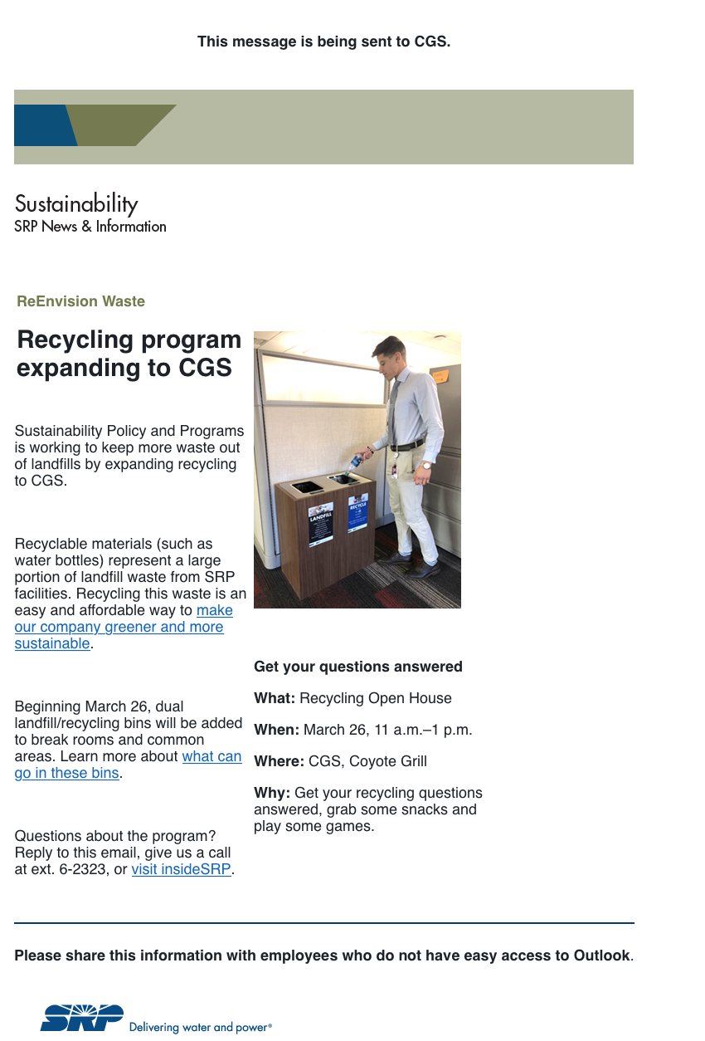
Figure 1: Email sent to CGS employees to communicate the start of the recycling program and the open house.
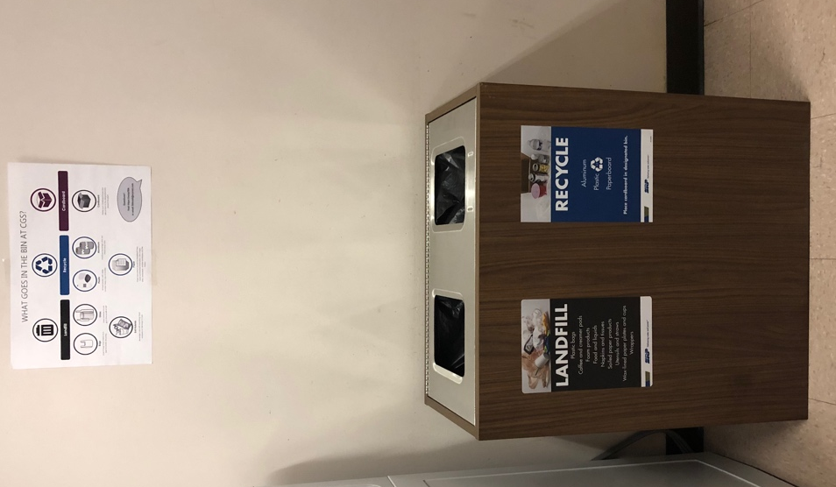  Figure 2: CGS Bin Deployed in the warehouse breakroom. Posters above the bins help employees learn how to sort waste | 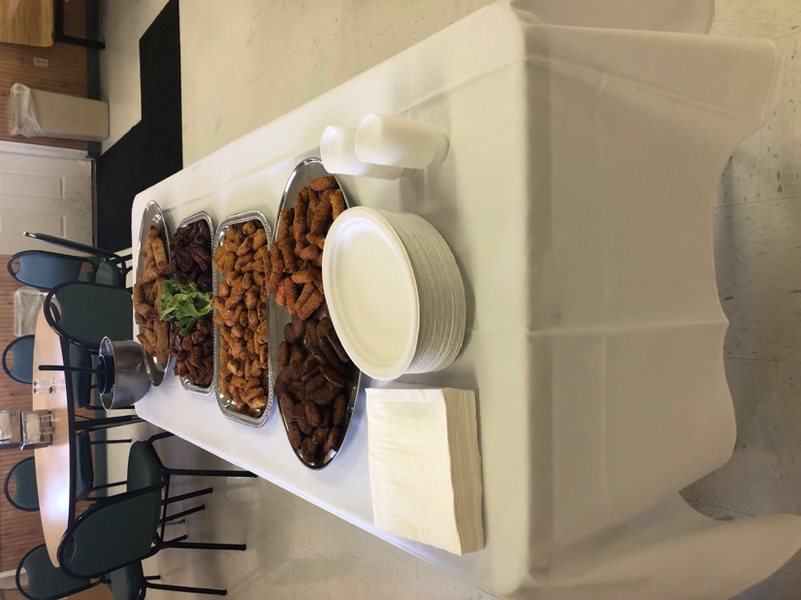  Figure 4: CGS Open House food set up. Delicious fried food helped entice employees to come talk about recycling. A total of 30 people enjoyed these snacks and played our sorting game.
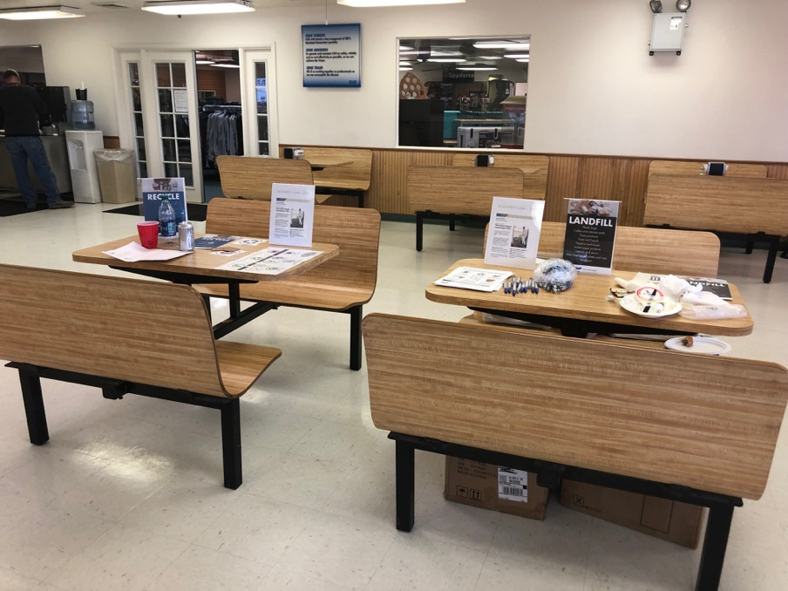
Figure 3: Table set up for CGS Open house with information and materials for both recycling and landfill.

.
SRP Deliverables:
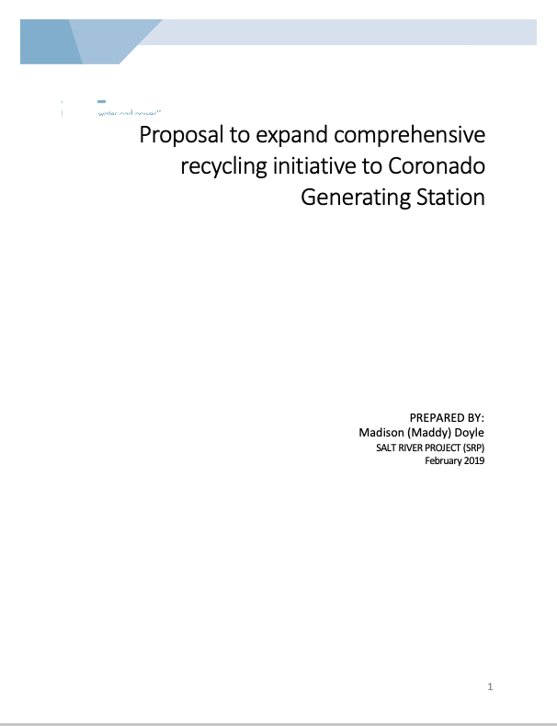
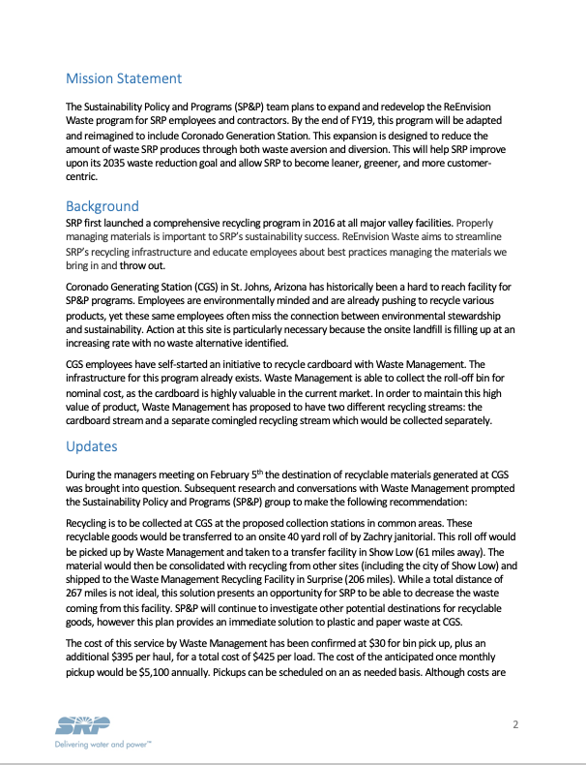
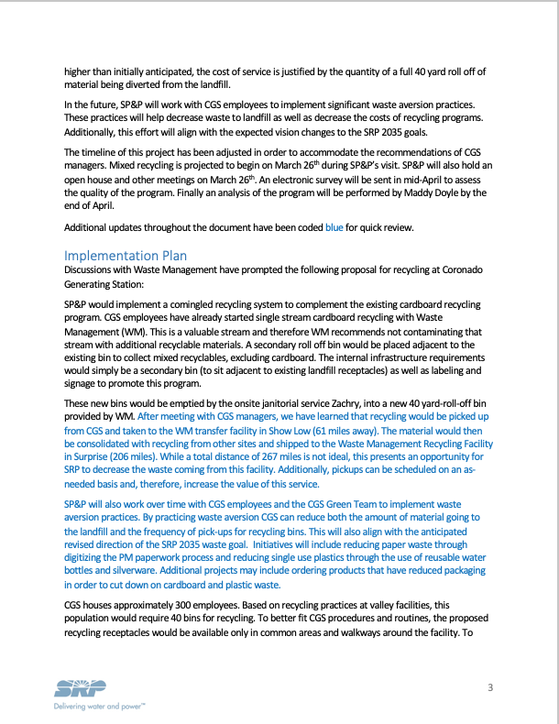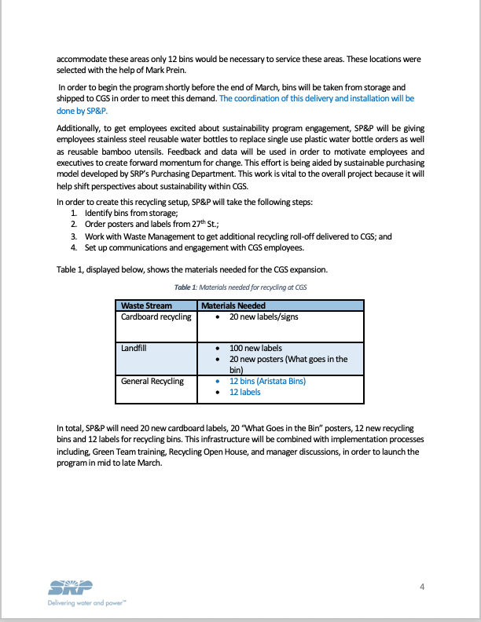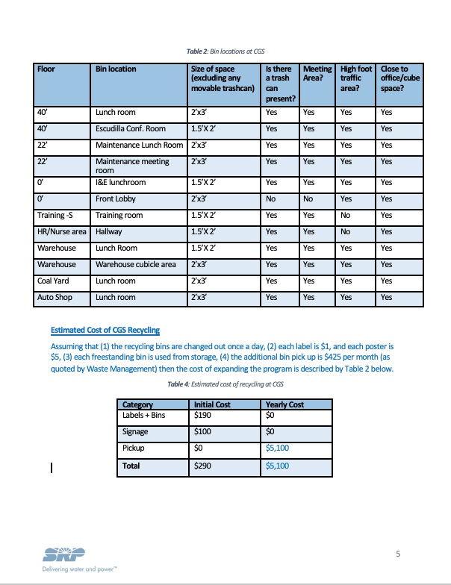

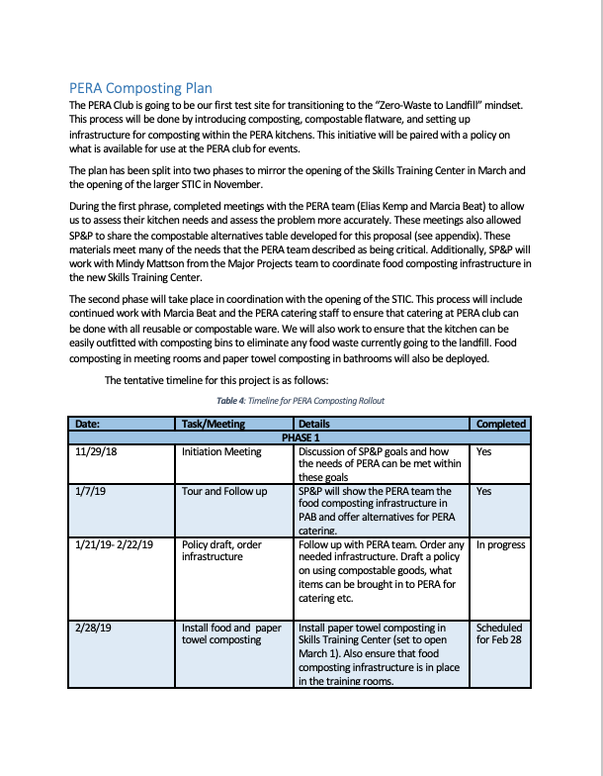
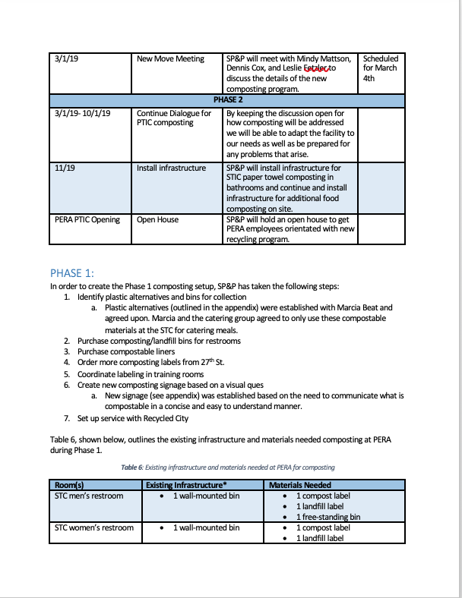
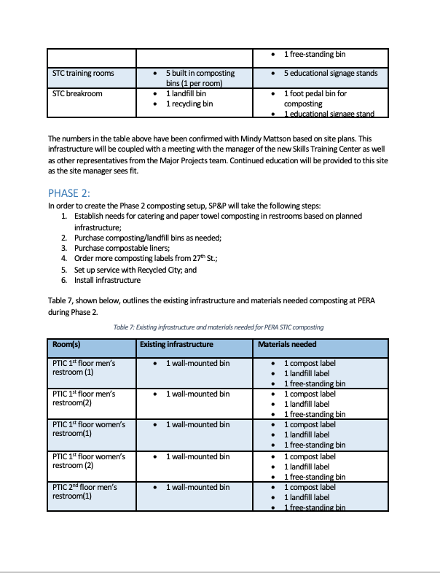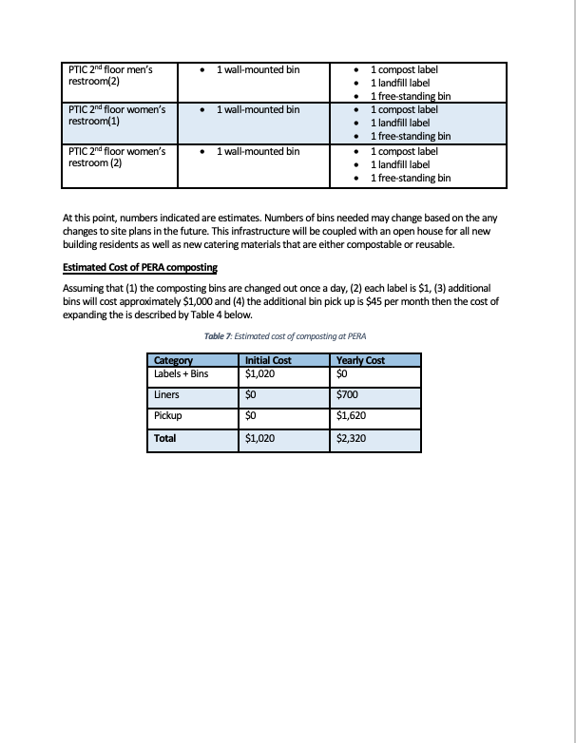
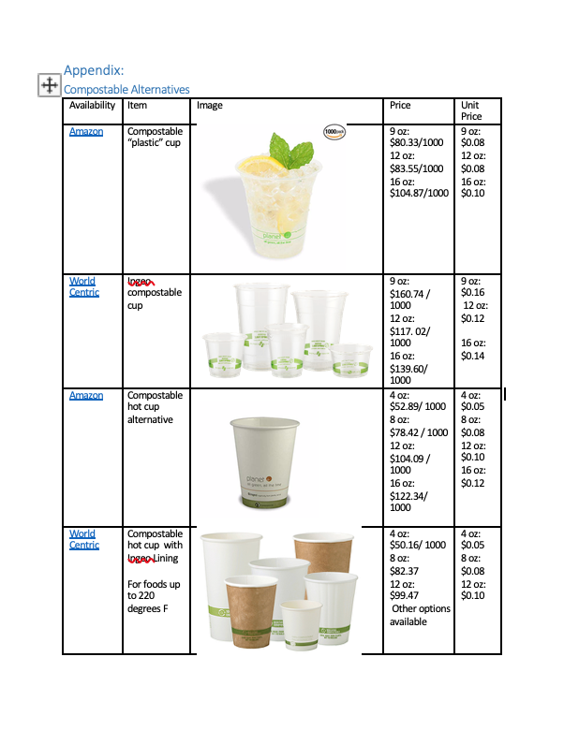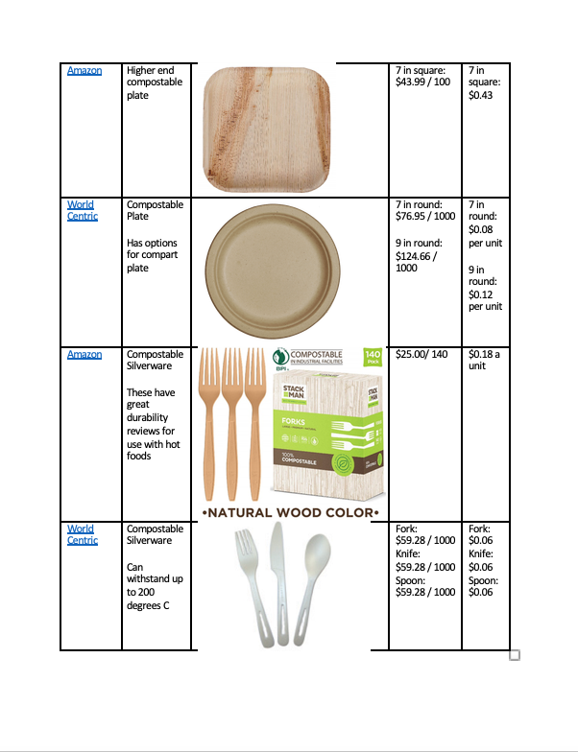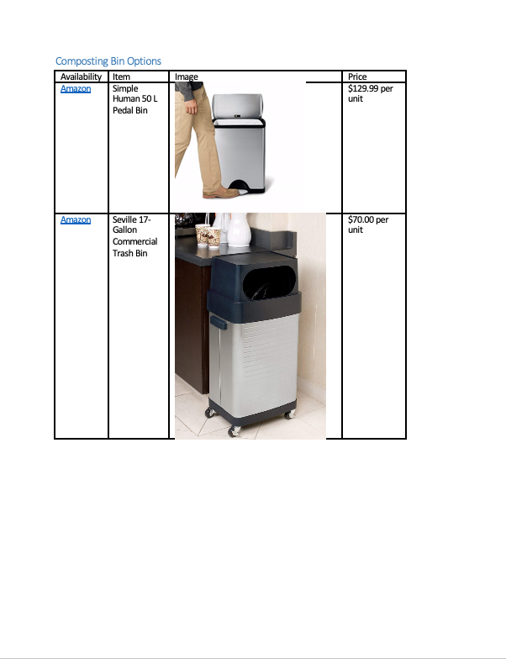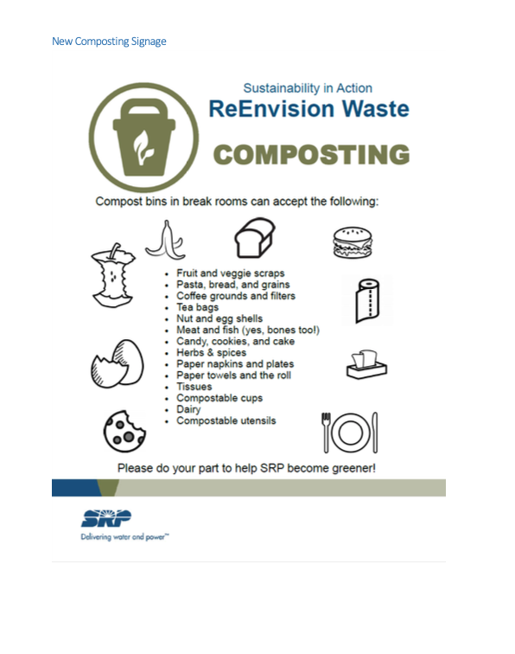

Acknowledgements
I would like to thank Paul Prosser as well as the MSUS Committee for their guidance, revisions and help in this process. Additionally, I want to thank my boss Marc Campbell, coworkers Tony Perez, Ana Lopez, and Derly Herrera for informational and editing support. Finally, thank you to all of the Subject Matter Experts whom guided this work including Dr. Nicole Darnall and Kaylee Shallet.
The number of people that helped me during this project are innumerable. Thank you to all that helped me make this project a success.
Finally, thank you to Salt River Project and Arizona State University for encouraging this project and giving me the resources I needed to complete this project.

