Abstract

While the term sustainability is commonly used in 2019, in 1950, it was sparsely uttered. To understand how Contento Recycling LLC became Central New York’s leader in sustainable development, you must go back to Gerald Contento Sr, and the year 1950. This was the year my grandfather started our family’s vehicle dismantling and scrap metal recycling business. Over the course of the next 70 years, Contento’s and now, Contento Recycling, has evolved into a leader in recycling and environmental work in Central New York. To see how I created a sustainable business enterprise, you must analyze my family’s past. My family’s history provides a roadmap to a more sustainable future.
When I established Contento Recycling LLC in 2017, it was poised to be Central New York’s first ever construction and demolition debris recycling business. I was tasked with the challenge that many sustainability professionals are tasked with and that was to show the community why they should stop taking their construction debris to the landfill, and instead bring it to my recycling center for processing, recycling, and landfill diversion. Over the last several years I applied for state grant funding, spread awareness about my new business, designed and constructed a material recovery facility, outfitted equipment, and trained staff. I now have a facility that accepts about 40 tons of mixed C&D debris per day, and diverts about 20% of that from the landfill.
On a more personal level, I learned a tremendous amount about dealing with change management. I’ve learned a lot about business development, and some keys to success when building a business. I’ve figured out how to help my employees and customers grow. I’ve learned to be more patient and flexible with my business endeavors. I have a much clearer vision of what I want for my business and for myself. I have developed a rousing optimism on the impact that my business, and myself can have on the sustainable development of Central New York. I will be a leader in environmental stewardship and partner with other people and organizations who want to work towards a more sustainable future.

A Legacy of Junk: The Evolution of Contento Recycling

One man’s trash is another man’s treasure. Most everyone in the world has heard that phrase or some variation of it. In a little town, in Central New York, a man embodied this philosophy as well as possibly any single person the world over. Gerald Contento Sr. was a poor Italian immigrant, a World War II vet, and a junk man. Born into a very grim, Great Depression Era United States, Gerald was forced to work after he finished the 2nd grade. One of an eventual 8 children, he worked on a farm from the time he was 8 years old, until he was drafted into the United States Military in World War II. After helping the United States fight for the world’s freedom, Gerald returned to Cortland, New York where he started his career as a man who would do jobs that no one else wanted to do. You might be wondering what this means. Gerald understood that in order to contribute to society, he had to learn a skill or trade. Instead of doing that, he learned dozens. From vehicle dismantling, to demolition, construction, utility work, farming, recycling, and the list goes on and on, Gerald was a man who did it all, especially the odd jobs that others shied away from.
If you traveled back to the 1950s/60s in Marty McFly’s DeLorean, and tried to start a conversation about sustainability, people would look at you like you had three heads. Long before the term sustainability, Gerald was demolishing buildings by hand and saving the lumber to reuse. He was building a business around stripping usable parts off of salvage vehicles in order to resell them. When he thought he was being frugal, and others called him cheap, he was really just a pioneer of sustainability long before most people ever knew of its importance. Stemming from his impoverished upbringing, Gerald had an appreciation for repurposing, reusing, and recycling that people in his era didn’t have. A mentality that stemmed out of pure necessity for one man, would eventually become one of the most pivotal needs in the 21st century.
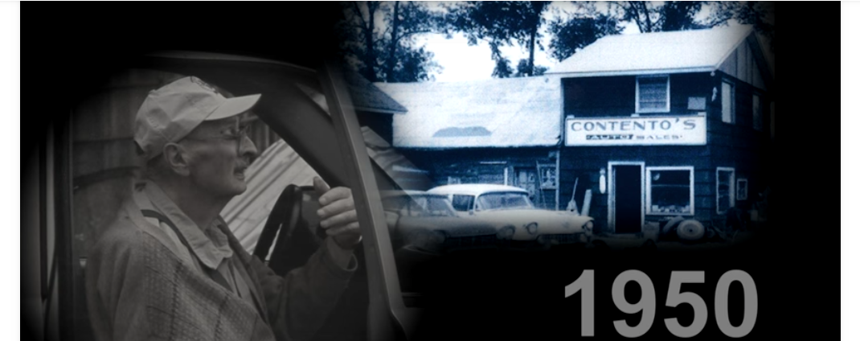
In order to truly understand the principle of sustainability as I see it, you have to understand how I personally shaped my point of view. If you flash forward almost 70 years, to 2019, my grandfather, Gerald Sr, and my father, Gerald Jr, have built a scrap metal recycling, demolition, trucking, and environmental remediation business that serves the greater Central New York State region. We offer our services with the dedication that only a small business can provide, and capabilities that typically only come from a larger business. When I graduated from Rochester Institute of Technology with a degree from the Saunders College of Business, I returned home to Cortland to add the next piece to our business. In 2018, after two and a half years of planning, building, marketing, and funding, we added a construction and demolition debris recycling center to our arsenal. While Sr is no longer with us, his spirit embodies the fundamental goal of the C&D recycling center. The objective is to reduce waste by sorting through construction and demolition debris, reusing anything possible, and recycling the rest. The residual material that is not recyclable would even be turned into a beneficial, processed material, that landfills could use in a number of positive ways. While the idea of C&D recycling is not new, and our operation pales in comparison to many larger operations around the world, it is the beginning of our contribution to sustainable materials management in our small sliver of New York State.

(Gerald Contento Sr. gazes upon the site of Contento’s original auto salvage yard)

A Deeper Look into C&D Recycling:

The New York State Department of Environmental Conservation defines Construction & Demolition debris as:
Construction and demolition debris is uncontaminated solid waste resulting from the construction, remodeling, repair and demolition of utilities, structures and roads; and uncontaminated solid waste resulting from land clearing. Such waste includes, but is not limited to:
- Bricks, concrete and other masonry materials
- Soil and rock
- Wood (including painted, treated and coated wood and wood products)
- Land clearing debris
- Wall coverings, plaster, drywall, plumbing fixtures, non-asbestos insulation
- Roofing shingles and other roof coverings
- Asphaltic pavement
- Glass
- Plastics that are not sealed in a manner that conceals other wastes
- Empty buckets ten gallons or less in size and having no more than one inch of residue remaining on the bottom
- Electrical wiring and components containing no hazardous liquids, and pipe and metals that are incidental to any of the above.

In New York State there are over 200 registered C&D processing facilities that hold a NYS DEC 360 permit, however most of those facilities are focused only on wood waste, or hard fill materials. Of those 200 facilities, less than 10, receive previously unsorted, or unprocessed C&D debris with the intention of sorting and recycling the mixed debris. None are within nearly 100 miles of Contento Recycling’s facility.

As a result of my experiences in life, and my journey to build a sustainable business I have developed some core principles about becoming a leader in sustainability:
- Sustainable development requires change, and change requires patience and persistence.
- True leadership often requires you to challenge the status quo.
- Sustainability does not have a one-size fits all template for success.
- Use data to develop informed decisions, but don’t obsess over it.

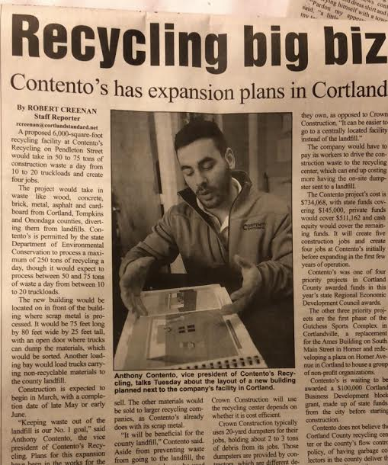
“Vision without execution, is hallucination”
-Thomas Edison

Sustainable Development requires change, and change requires patience, and persistence.

In order to be a powerful sustainability change agent, you have to be persuasive. Now, to be persuasive does not mean to be untruthful. Persuasion is about saying things in a manner that will influence people to a desired outcome. However, being persuasive is helpful, but the key to ushering in change, is to be persistent. Each person is motivated by different factors and if you want to know how to motivate people, you have to know what makes them tick. As I began trying to implement my C&D recycling project, I received some pushback from people around the organization. What was most challenging for me was that the pushback was generally not because people did not understand C&D recycling, it was not that they didn’t think it was smart from a business standpoint, it was merely because people inherently are afraid of change. They were afraid of how their own jobs would change as a result of this new endeavor. I knew I had to find a way to reframe their mindsets. However, doing that is easier said than done. I started strategizing ways to get people excited and educated about C&D recycling.
One way to rally people around your cause is to create a shared vision. Peter
Senge, in The Fifth Discipline, states, “At its simplest level, a shared vision is the answer to the question, what do we want to create? Just as personal visions are pictures or images people carry in their heads and hearts, so too are shared visions pictures that people throughout an organization carry. They create a sense of commonality that permeates the organization and gives coherence to diverse activities” (Senge 2006). Essentially, shared vision is achieved when all the members of a team or organization can work independently towards the same goal. For example, Contento Recycling’s vision is to be Central New York’s leading family owned recycling business, that serves the community with a wide variety of recycling services, while maintaining a friendly interpersonal relationship with all of its customers. By being transparent about a company’s vision and communicating it throughout the organization, we can create shared vision.
I think many people can have their work derailed by being impatient, and if there is anything I’ve learned from my own personal journey its that there may not be a single trait more important than patience. Having patience with your goals, patience with people, and patience with yourself, allows you to continually grow and move towards your goals. In business, and in life, it takes time for you to see progress. However, once you begin to see progress towards your goals, its infectious. In the sustainability realm in specific, patience is a key virtue because many of the mega problems we aim to remedy, will take years to solve. More so than that, some of these issues will never actually be totally solved, but we can certainly lessen their severity.

True leadership often requires you to challenge the status quo.

Upper level management of large corporations are often weary of straying too far from the status quo. Stressed by maximizing returns for shareholders, they have been very often afraid to make a decision or implement an initiative that might potentially take away from the highly coveted shareholder returns. Well, because of the hard work of the early adopters of sustainable business, this fear is slowly starting to dissipate. People like Ray Anderson, former CEO of Interface, pioneered sustainable business in the early 1990s, a time when many people hadn’t even heard of the term sustainability. Ray understood something in the early 90s that would take many global corporations twenty plus years to figure out. Ray realized that you could have a global corporation that drives profitability without sacrificing environmental protection, or health and safety. At the time, to focus on anything but maximizing profits for shareholders was absurd. “Sales executive Kenn Rickman recalled, our first response was sympathy, because we all loved Ray and it was quite clear that he had snapped under the pressure of running the company.” (Greenbiz 2014). Ray Anderson was a heretic; he defied the status quo of corporate business practices and laid the foundation for triple-bottom line thinking and sustainable business enterprise.
I often think of Ray, as I developed the project for Contento Recycling. I often thought of what I could do to separate myself from existing national recycling and waste management businesses. I think the answer to the question may be much more simple than I thought. By building a sustainable enterprise, based on leveraging three generations of expertise, and offering all of our customers the personal, small-town feeling that is so commonly lost in today’s world, Contento Recycling has the ability to become Central New York’s leader in sustainable development.
As consumers become more aware of the impacts of the products that they are using, we are seeing a huge rise in wholesome businesses that are sustainably sourcing their materials, and doing good things for the environment. From little organic vegetable stands, to billion dollar corporations, sustainable businesses are starting to gain traction and receive praise for doing the right thing by the environment, by people, and not sacrificing profitability.

Sustainability does not have one-size fits all template for success.

During my last three years of research, funding, and project implementation, it has become shockingly evident that different geographic areas, different business sectors, and different communities all have different solutions to similar problems. Consider the push to move away from fossil fuels to renewable energy as an example. Solar panels may be a stellar option in Arizona, the sunniest state in the US, however in Washington or Alaska, solar panels may not be a viable renewable energy solution. When I first began researching and developing a business plan for my C&D recycling center I found a facility in Niagara Falls, NY that is very similar to how I was looking to set up my facility. I made the 3-and-a-half-hour trip out to Triad Recycling’s facility and met with the man who oversees their recycling operations. After Ken showed me around their facilities, we chatted for a minute and he instilled upon me that the best way to be successful in the C&D recycling business is to capitalize on what your area has to offer. He used an example of the DuPont factory that was right now the road from them. DuPont generates a larger amount of plastic residue waste as a result of their manufacturing operations. Triad installed a small machine that grinds the plastic waste they receive from Dupont into small beads in which they actually sell back to Elmer’s glue to be used in the production of new glue. I learned that if you want to be successful in being a leader of sustainable development, you have to look out into your community, or the area which you want to affect, and find out what their needs are. Just because an initiative is successful for one business doesn’t always guarantee it will work for you.
This is a valuable lesson that I learned early on in my sustainability journey. Since then I have been trying to apply this by looking at what sustainability issues my area has. I have begun building relationships with Cortland State University, Cornell University, Ithaca College, other local factories, and businesses. Because of my family’s relationships in scrap metal recycling, I have been able to get my foot in the door at many of these places.
More so than just serving the Central New York Community with recycling services, I envision Contento Recycling evolving into a full-scale sustainability and environmental consulting business in the future. As a part of a 5-year plan, I foresee there being a huge opportunity in my area to come up with specific sustainability plans for businesses that include solid waste management, recycling, reuse, reduction, and LEED initiative programs. Establishing Contento Recycling as an expert in these fields will only prove to be more and more of an advantage compared to any of our competitors. Any professional waste hauling company can deliver a business a roll-off container, but in the future Contento Recycling will be the only business in this area that can look at a business from the inside out, identify areas of wastefulness, and areas where there is an opportunity to increase the company’s triple-bottom line. This includes areas of opportunity to expand sales of products and services, areas where a company can decrease environmental impact, be more complaint with regulations, increase the health and safety of their employees, and even more. Contento recycling will offer the full package of a triple-bottom line business philosophy.

Use data to develop informed decisions, but don’t obsess over it.

Any new business endeavor takes a tremendous amount of research before it gets started, perseverance to get up and running, and diligence to grow in a sustainable manor. It sometimes requires patience to not try and do too much right away. It takes discipline, careful planning, and the ability to be flexible in order to succeed. It is easy to get sidetracked on your quest to a sustainable business enterprise, but Timothy Mohin offers some strategies on how to stay focused. Mohin, in his book, Changing Business from the Inside Out, talks about key performance indicators (KPIs) and how they can help you keep measure your progress on achieving your goals. Mohin claims that KPIs “..are the critical few ‘key’ measures of success for each of the objectives in your strategy” (Mohin 2012). For example, Contento Recycling has a few metrics for success or KPIs such as:
- Number of haulers contracted to dispose of C&D debris with Contento Recycling.
- C&D throughput of recycling center (tons).
- C&D diverted from landfill (tons).
- Percentage of C&D diverted from landfill (%).
- Total Amount of recycled products made from diverted C&D debris: recycled concrete aggregate, top soil, mulch, compost, animal bedding, biomass, erosion socks, gypsum board “speedy dry”, etc. (tons).
- Amount of beneficial use material made for landfill (tons).
- Amount of Central New York businesses, universities, municipalities, and residents served.

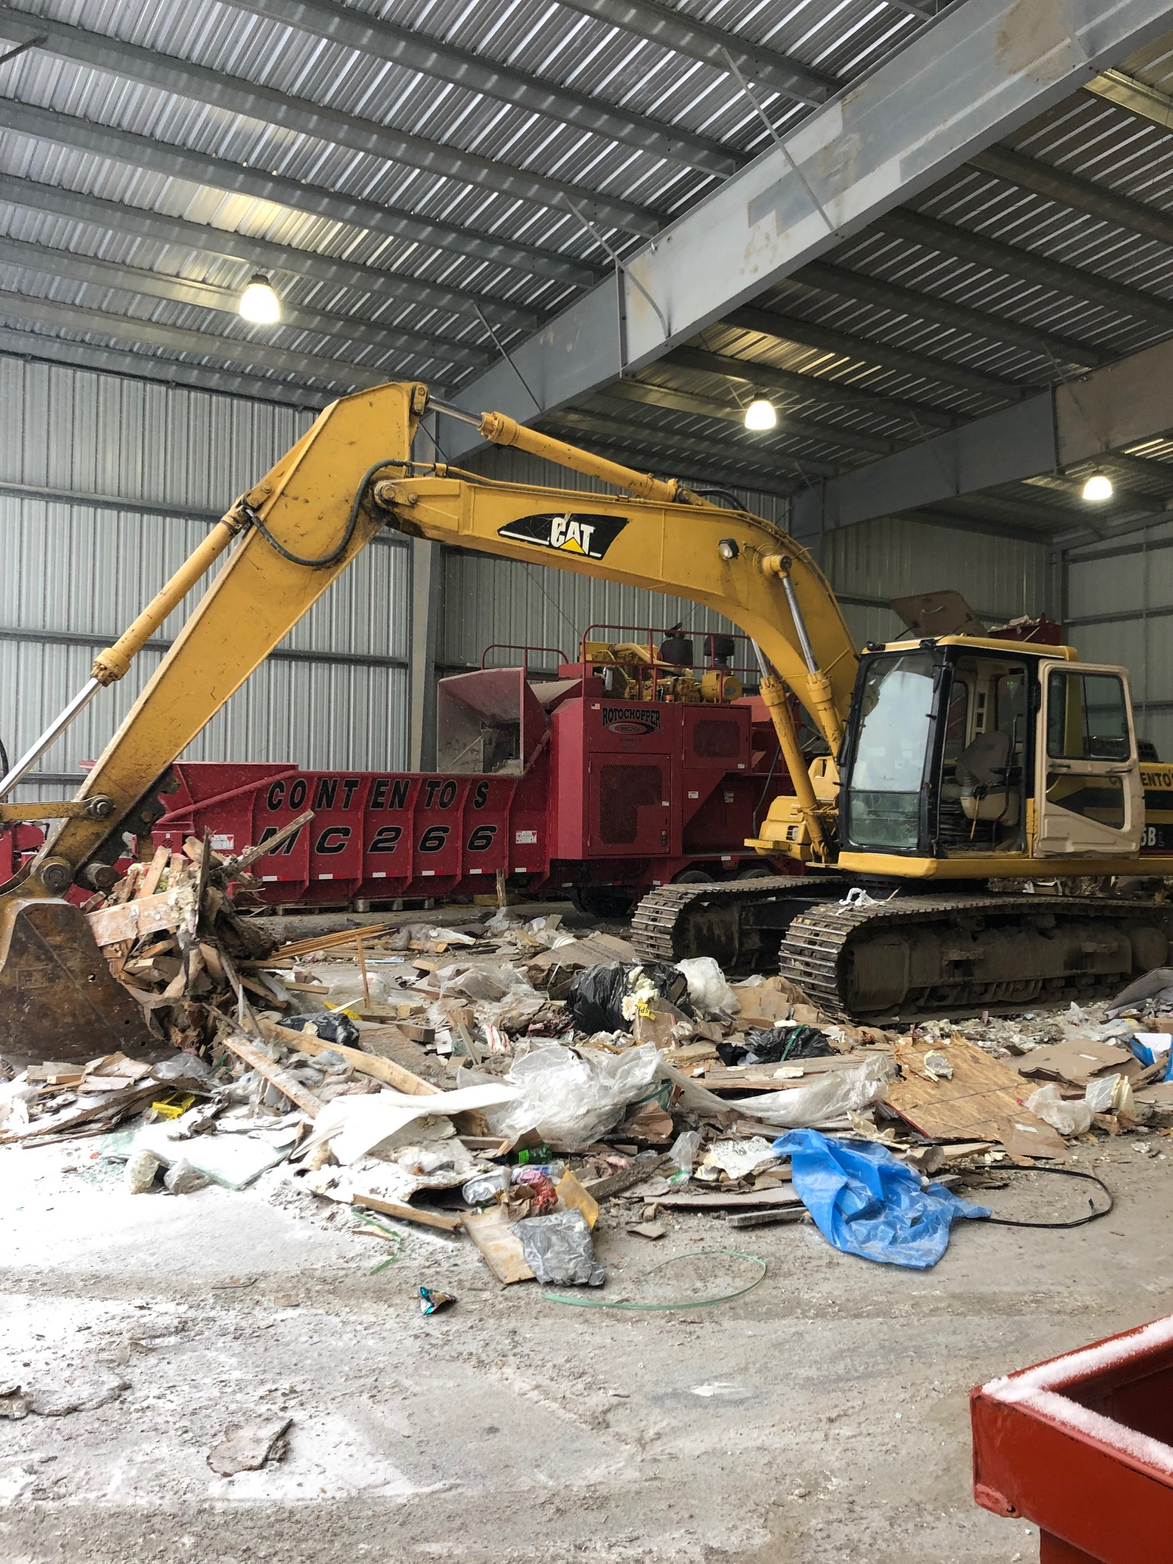
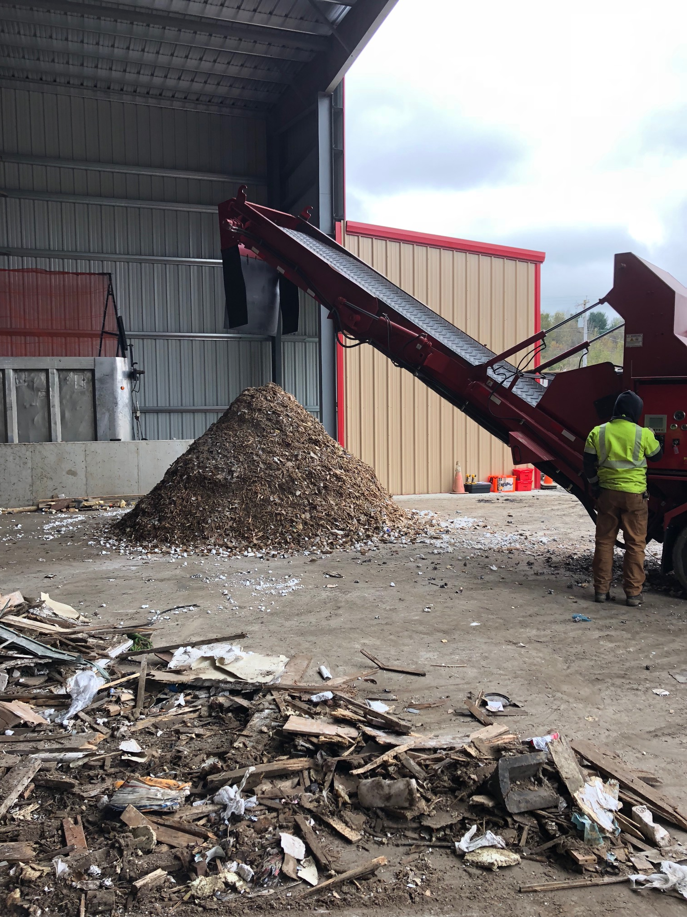
Example of beneficial use material generated by grinding sorted C&D (left).
Example of C&D being processed on the tipping floor of the recycling center (right).

Tracking these KPIs will provide a powerful picture of weather your business is headed down the right path or not. However I feel that you should not obsess over them. Even more so, you should be careful to not get tunnel vision because KPI’s can be constantly changing. What was a major goal or KPI for Contento Recycling this year, may not be nearly as important next year. When companies or individuals focus too in depth on data, they can miss crucial opportunities. Data can sometimes stifle creativity. It’s important to find that very delicate balance between the two. While Mohin explains how data, and KPI’s can keep you focused, open-mindedness to all potential opportunities keeps you from overlooking any potential areas for growth and improvement. Joseph Campbell, one of history’s most formidable storytellers once said, “We must be willing to get rid of the life we’ve planned, so as to have the life that is waiting for us.” This is the philosophy I bring into my business and my personal life. One of the most difficult parts about running a recycling business is that much of your profitability relies upon the value of your extracted recyclables. This volatility is one of the factors crushing single-stream recyclers (paper, cardboard, plastics, etc.), and scrap metal recyclers. When you rely so much on the value of your recyclables, it makes you vulnerable. For this reason I am always entertaining ways to make Contento Recycling more diverse. This is another area where relying on data can fail you. Trying to predict market shifts is a dangerous game, and with today’s global political instability, relying solely on trends and predictions can be a major hindrance.

What’s next for Contento Recycling?
At this point in my sustainability journey I have successfully researched, funded, and implemented a construction and demolition debris recycling facility.The business has been operational since October 1, 2018 and has two full time employees, in addition to its two founders. Contento Recycling is the first ever full-scale construction and demolition debris processing facility in the greater Central New York region. The facility has received over 500 tons of C&D debris since opening and has generated between 100-200 tons of processed C&D material for beneficial use at the Cortland County Landfill. Every week Contento Recycling is securing more and more disposal contracts from local area waste haulers, contractors, and individuals. All of the necessary infrastructure and equipment is in place to Contento Recycling to efficiently process large quantities of C&D debris. So what is next for Contento Recycling?

Short Term (roughly 1 year):
In the next year Contento Recycling aims to have at least 4 fulltime employees. I anticipate that with 4 fulltime employees on staff Contento Recycling’s C&D recycling operations will be getting close to optimal efficiency. By the time 4 people are necessary, we will have secured enough disposal contracts to have a large enough daily flow of C&D to keep everyone busy and productive. I would anticipate that this would be around 40-50 tons per day. At this point Contento Recycling will be utilized as largely the exclusive facility for C&D disposal in Central New York. At this point I hope to achieve at minimum a 20% diversion rate, meaning 10 out of every 50 tons of C&D is diverted from the landfill waste steam. In addition, at minimum 80% of the residual C&D waste after diversion is turned into a beneficial use material for Cortland County Landfill, and others.

Long Term (roughly 5 years):
Within the next 5 years I hope to grow Contento Recycling to at least an 8-fulltime-employee company. My C&D recycling center will be the exclusive C&D disposal spot in Central New York, or at least for as large of an area that is logistically feasible. At this point I would potentially even like to have facilitated legislation that no C&D debris can be landfilled or incinerated before being sent through a processing facility first. Not only does this present a significant financial opportunity, but it also makes sense from an environmental standpoint. The C&D recycling center well have reached its maximum efficiency meaning it is accepting as much C&D debris per day as it can efficiently handle and recycle and any additional tonnage would result in less material being recycled. This means that we will be exploring a new facility to move into, and new technology that will help us process more material, and increase our diversion rate.
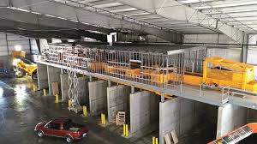
Example of a larger, more technologically advanced C&D processing facility that Contento Recycling would like to expand to after roughly 5 years.

In addition to a larger facility that could handle more throughput and divert more material, Contento Recycling would also like to be serving their customers with full-scale sustainability and environmental services. This would include services that cover all the bases of a sustainable triple-bottom line.

Throughout the last several years I’ve learned more than I ever thought was possible. I learned about business, I learned about people, I saw first hand what it takes to be a leader, and just how challenging that is some times. I struggled with changing the way people think, and how they operate. I learned how to be creative, and resillient, and I certainly have had my patience pushed to the limit. I learned that sustainability is for more than just “tree-huggers”. I’ve grappled with how to make people understand how sustianbility benefits every person, and every business. I learned things about myself that I never knew. I’ve changed the entire perspective on how I view life and I realized that the world is constantly changing. I relaized that I want to dedicate my life to making sure that I’m on the right side of enacting change. I learned that you don’t have to choose between being an environmentalist and being a businessman. And most of all, I learned that fundementally I am a problem solver, and I destined to help lead people towards a better future for themselves, their families, and this planet as a whole.

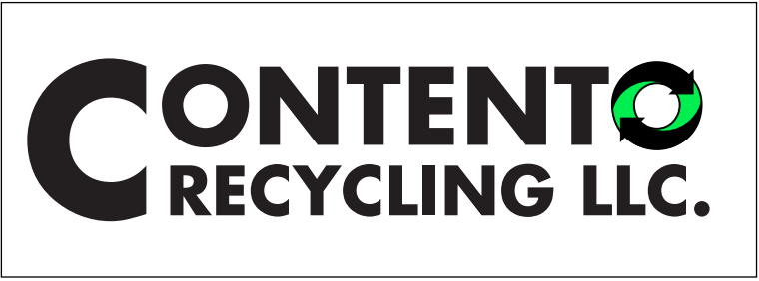

“We cannot solve problems with the same kind of thinking we used to create them”
-Albert Einstein

References:
Davis, M. (2014, September 03). 20 years later, Interface looks back on Ray Anderson's legacy. Retrieved from https://www.greenbiz.com/blog/2014/09/03/20-years-later-interface-looks-back-ray-andersons-legacy

Mohin, T. J. (2012). Changing business from the inside out: A treehuggers guide to working in corporations. San Francisco: Berrett Koehler.

Senge, P. M. (2006). The Fifth Discipline: The Art and Practice of the Learning Organization. New York, NY: Currency.

Tate, K., & Martin, P. K. (2010). The Project Management Memory Jogger. Salem, NH: GOAL/QPC.

