`

People Over Petro;
The Fight Against the Ohio River Valley Petrochemical Hub
Kathleen Collins
Arizona State University School of Sustainability

Table of Contents
BACKGROUND 2
PLANNING AND BUILDING THE CAMPAIGN 5
GETTING THE LAY OF THE LAND AND CREATING SMART GOALS 10
IDENTIFYING OUR AUDIENCE 12
POWER MAPPING AND FINDING YOUR ALLIES 12
RECRUITING AND ACTIVATING VOLUNTEERS 14
BUILDING A COALITION OF SUPPORT 14
ENGAGING WITH DECISION MAKERS 15
KEEPING THE MOMENTUM AND GETTING THE WIN 16

ABSTRACT:
The trend couldn’t be clearer. The White House is doing everything it can to reverse the economic, social, and environmental progress bringing the age of fossil fuels to an end. From subsidies for the dying coal industry to gutting regulations on air pollution, recent actions by the president and his cabinet show every intention of turning the dial on our energy policy back a full 30 years (Barba, 2017). Now, the fossil fuel industry is turning to a new strategy: building ethane cracker plants. These facilities turn fracked gas into plastics and – just as important – create more infrastructures for fossil fuels. All in places like the Ohio River Valley where communities are fighting hard to leave natural gas and the impacts of dirty energy behind.

The good news is that more and more communities see these plants for what they are: a wrong turn back to the dark days of dirty energy degrading community health, driving climate change and polluting the air, water, and soil we all share. With our planet’s future and the health of their families all on the line, everyday activists in communities throughout the Ohio River Basin are now banding together to fight back. You can too.

BACKGROUND

I strongly believe that it is fundamental that we as a society fight for the preservation and conservation of our natural habitats for future generations. As a conservationist, scientist, environmentalist, and a concerned citizen, it is abundantly clear to me that if we continue on our current path of destruction, we run a high chance of irreparably harming the quality of life for our future generations.

I’ve always cared deeply about our natural environment- it’s hard not to be when you grow up in a small upstate New York town that is nestled between the mesmerizing Adirondacks and the illustrious Lake Champlain. It seemed that no matter where my family and I were, I always found myself fascinated by my surrounding environment. My fascination for the beauty that is nature quickly transformed into a deeply rooted passion for conservation, which I’ve dedicatedly followed to this day.

This passion took me to the University of New England up in Biddeford, Maine where I double majored in Marine Science and Secondary Education. While there, my research was focused on marine debris, sustainability, and educational outreach. Soon after I graduated, I moved to Washington, D.C. to pursue a career in environmental policy and conservation. After a few years of pouring every ounce of my passion in my career, I worked my way up to be the associate director of a small marine conservation nonprofit.

In this role, I relentlessly fought a passionate fight, with the assistance of a strong coalition, against offshore oil drilling on the East Coast until the appropriate protections were passed in 2016. Although, this fight was emotionally and physically draining, I felt in my core that it was essential in order to protect the coastal communities and the adjacent marine ecosystems. During this time at Blue Frontier, I began to fully comprehend the connection between the offshore oil drilling I was so passionately fighting against, the terrestrial drilling and manufacturing that I was all too familiar with from my home state of New York, and the plastic pollution I studied during my undergraduate studies. I soon realized that I needed to take my fight to a larger stage; there was room for me to make a difference at a larger scale.

In my pursuit to do just that, I landed in my current role as the Campaign Strategist at the Climate Reality Project. Founded in 2006 by former US Vice President Al Gore, The Climate Reality Project’s mission is to catalyze a global solution to the climate crisis by making urgent action a necessity across every level of society. Our dynamic communications initiatives connect climate and behavioral science with the emotional power of well-told stories, bringing climate change to individuals and communities everywhere and shaping discussions. Our signature activist program, the Climate Reality Leadership Corps, has trained and mobilized over 19,000 citizen leaders worldwide on climate science, communications, and organizing since its inception in 2006. To date, the campaign I’ve constructed in this role, against the petrochemical build out in the Ohio River Valley, has helped elevate the health and economic impacts of petrochemicals, plastic pollution, and specifically ethane cracker facilities, in a way that many traditional regional environmental campaigns simply could not.

It all started when we were approached back in the spring of 2017 to hold a Climate Reality Corps training in Pittsburgh. The hope was that a training of our magnitude would create a critical mass of environmentally conscious community members who would be better poised to help fight the significant environmental injustices occurring in the region. Leading coalition members and stakeholders in the area were aware that the threat of the petrochemical hub was looming, as state officials continued talks with foreign fossil fuel entities, such as Shell Oil Company, there was a clear need greater awareness.

As the training was planned, strong relationships with key organizations in the area were built and the possibility of this complex being built on the vulnerability and dirty past of the Ohio River Valley became ever more alarming. In light of the looming threat, The Climate Reality Project opted to create a targeted regional campaign opposing the Ohio River Valley petrochemical buildout and chose to put me on as point. As soon as I was put on the campaign, I immediately began conducting copious amounts of background research in my process of constructing an impactful and just campaign plan built around community education and mobilization. At the same time, I began the process of hiring two dedicate, regional organizers based in the Pittsburgh area, which is the epicenter of the buildout.

As my team of dedicated regional organizers and I have faced the petrochemical buildout, I have provided leadership and guidance around our multifaceted approach, which hinges on the continuous recruitment and mobilization of our trained activists from our regional chapters. The regional chapters I’ve chosen for my team focus on are representative of 790 Climate Reality Leaders and 366 additional members in Pennsylvania, Ohio, West Virginia and Kentucky who work to raise local awareness on the issue through community meetings, media outreach, community education, coalition building, and presentations.

I have empowered my team to get creative with their approach for recruiting, engaging, and empowering the general public in areas without adequate chapter reach to take action against the petrochemical buildout. The primary focus, that I’ve built in to our on-the-ground organizing, is on educating and advocating for local community rights and protections in the areas where petrochemical industry operations have secured all of the necessary permits. Additionally, I’ve built out the campaign to call upon lessons learned from areas that historically have been taken advantage of by the petrochemical industry. While the Ohio River Valley is familiar with the impacts of other dirty fossil fuel industries’, petrochemical plants are a whole different beast that brings new health and environmental risks.

PLANNING AND BUILDING THE CAMPAIGN
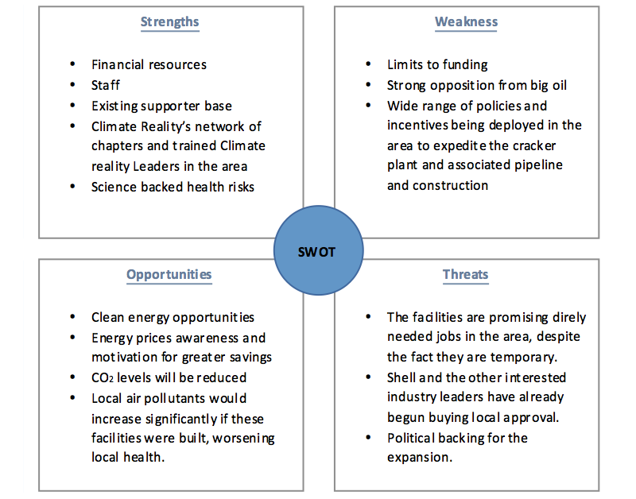
Once we agreed to officially take on this battle, I immediately dove into conducting a comprehensive review of petrochemicals as well as the background of the fossil fuel industry in the region. Only then, I felt that I could sit down and build out the elements for the campaign. I really wanted to ensure that I utilized the strengths and resources that we had at the Climate Reality Project to the best of my ability. I began by creating a SWOT analysis for the project as well as Gantt chart to keep myself accountable and the project on track so that I was able to create and implement the campaign in a strategic fashion.

Figure 1: SWOT Analysis for People Over Petro; The Fight Against the Ohio River Valley Petrochemical Hub
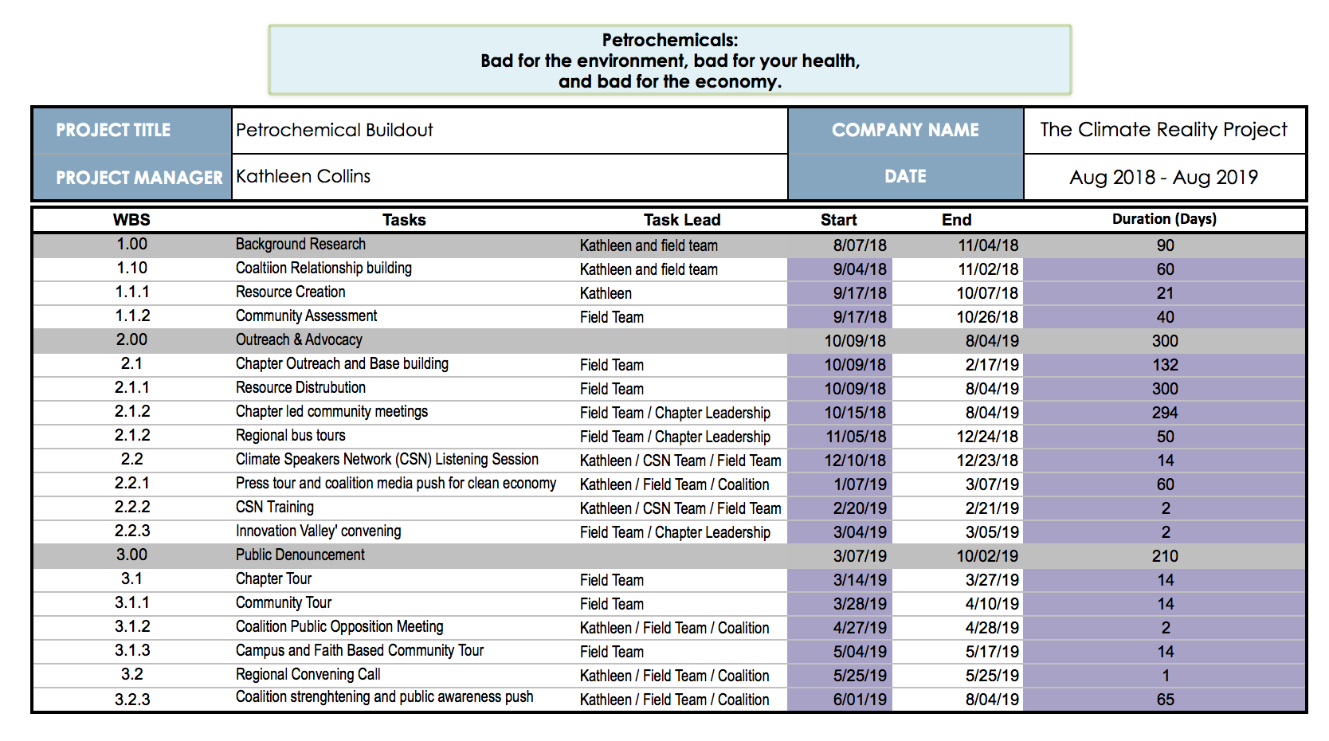
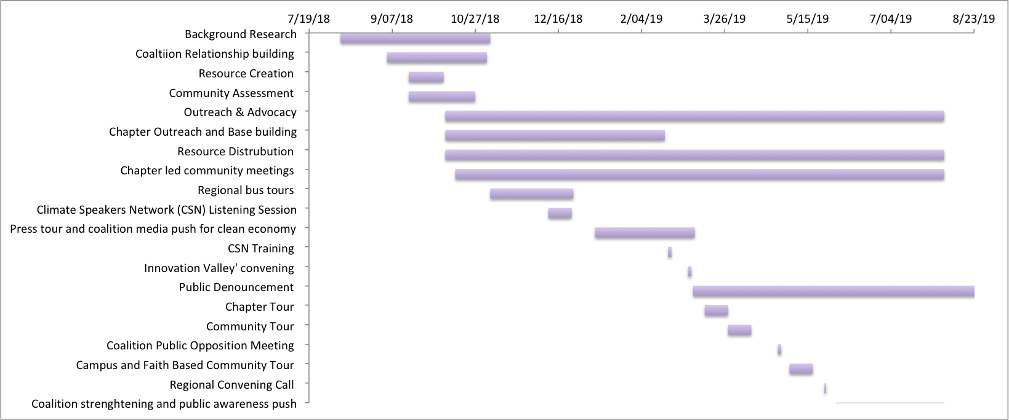
Figure 2 and 3: Gantt chart for People Over Petro; The Fight Against the Ohio River Valley Petrochemical Hub

With my own accountability measures in place, I was ready to dive into creating the campaign plan itself. But before I could truly dive into polishing the campaign plan, I had to build my team out and they also had to do their own background research to truly understand the true nature of the petrochemical complex and specifically, ethane cracker plants.

In the fall of 2018 I recruited, hired, and trained two highly qualified regional organizers, Briann and Flynn. They were both born and raised in the tri-state area of PA, OH, and WV and currently reside in Pittsburgh – the epicenter of our work. Both Briann and Flynn are skilled organizers but at the time, lacked the technical knowledge of petrochemicals, much like me, so we all had our work cut out for us. During our collective preliminary research on the industry we found out some key facts on petrochemicals in general and ethane cracker plants, detailed below, that deeply informed our campaign creation and buildout.

- Ethane cracker plants are the fossil fuel industry’s latest endeavor to continue taking advantage of vulnerable, historically disenfranchised, communities by securing them into a dirty energy economy. Ethane cracker plants bring extensive supporting infrastructure to the area, which further pollutes local air and waterways with toxic chemicals. These chemicals are proven to contribute to variety of potentially fatal health problems, while also worsening our climate crisis and slowing the transition to renewables (Leiter, 2017).
- In its full life cycle, ethane cracking emits 840 kg of CO₂ per ton of ethylene (Ghanta, Fehey, & Subramaniam, 2013). The Shell plant currently under construction in Beaver County, PA, a mere 30 miles from Pittsburgh, is expected to produce 1.6 million tons of ethylene, resulting in 1.34 MMT CO₂ emissions (Stonesifer, 2017). This is equivalent to introducing over 290,000 cars on the road (EPA, n.d.).
- Besides the climate impacts, building and operating cracker plants is incredibly dangerous for the health and well being of nearby communities. The danger comes from many directions. Large petrochemical facilities like cracker plants produce sizable unplanned releases of carcinogens like benzene and other toxic pollutants (Sharma et al., 2017). Emergencies at ethane cracker plants have included fires, explosions, and evacuations, leading to injuries and even deaths (Sharma et al., 2017).
- Fracking waste and byproducts are known to commonly leak into the ground water sources, evaporate into the surrounding airways, and leach into soil (Stone, 2017). These byproducts are linked to a number of health impacts, which have recently gotten the attention of not only public health officials and scientists, but also the media, including Forbes magazine (Stone, 2017).
- The plastics industry is planning to construct their manufacturing plants close to the cracker plants so that they have easy access to the raw materials needed to produce (Sharma et al., 2017). Each of those plants will create their own dangerous emissions. Additional cracker plant locations and the increased fracking and pipeline activity could lead to a ‘cancer alley’ in the Ohio River Valley similar to the so-called cancer allies down south.
- ‘Cancer Alley’ is an area along the Mississippi River between Baton Rouge and New Orleans, in the River Parishes of Louisiana, which contains numerous industrial plants (Colten, 2006). Locations in this area with clusters of cancer patients have been covered by the various news outlets and media platforms, leading to its now infamous name.
- While the national average is 206 deaths per 100,000 individuals, Louisiana's rate was elevated at 237.3 deaths per 100,000 individuals (Singer, 2011). At the same time, the death rate from cancer in the cancer alley area was higher than the rest of Louisiana, as well as the national average (Roger, 2015). A study by Gregory Berry from 2013, found that in the case of Cancer Alley, when local communities were provided with increased awareness of the risk, justice, and environmental pollution imposed by these facilities, as well as readily available access to a supportive activist constituency, there was elevated political and social power within the empowered communities (Berry, 2013).
From the research my team and I conducted, I laid out a piecemeal approach to disrupting the buildout, starting with the permitting process. Construction of fossil fuel infrastructure, like ethane cracker plants and their supporting pipelines, require a series of permits from federal, state, and local government agencies. Traditionally, these permitting processes have multiple opportunities for public input and can be influenced by pressure from activists, politicians, and concerned citizens. I knew this was where my team and I should focus the majority of our volunteer driven efforts.
However, I also knew that before we could attempt to influence the permitting process, both my team and I needed to do our research on the unique, regional dynamics and get prepared for the fight ahead. In order to stop these dangerous climate-polluting facilities, we needed to understand the lay of the land, including: what the problem was, how local communities would be impacted, and why was it that the problem was so urgent. I then worked with my team towards identifying the solution to the problem by setting specific, measurable, achievable, and time-bound (SMART) goals. Next my team and I got to know our audience as well as our opponents. All the while, I was pulling from lessons learned from other areas where these battles have been forged; specifically down in the gulf coast, which greatly strengthen our argument for a cleaner, healthier future.
I had my team start by researching the history of heavy industry and fossil fuels in Pennsylvania, Ohio, and West Virginia, as well as the political and regulatory framework involved in approving facilities like ethane cracker plants, and the public perception of climate action and industry in the region. I structured it so that we started with the big picture and worked our way towards individual frontline communities. I focused on how the region currently experiences the impacts of climate change and how it’s projected to be impact in the future. I referred to studies and surveys conducted in the area as well as The Yale Climate Opinion Maps to inform my team on how local communities felt about climate change and climate action. My team also gained a deeper understanding of the regional complexities when we reached out to grassroots community organizations and organizers who were already on the ground working around these issues.
Likewise, while planning our campaign, I prioritized finding out if the states or local communities were historically friendly to fossil fuel development- they were. I had my team also research the parent companies who were looking to build in the Ohio River Valley to learn more about their history in the area, so that we could better gauge where we might have allies as well as enemies. Getting a full grasp on how the local municipal government is interacting with these fossil fuel entities was and still is critical.
Finally, with the context of fossil fuel infrastructure in the area, we then needed to understand and tap into the active campaigns to stop the construction of this facility. As one of our last steps in this process, I had my team familiarize themselves with the opportunities for our volunteers to take local action and how to educate others to take action, whether it is giving a presentation, tabling at a festival or farmers market or writing a letter to the editor.

GETTING THE LAY OF THE LAND AND CREATING SMART GOALS
Next, I took the time to map out what the exact problem was that we wanted to focus on. Narrowing it down from the buildout as a whole helped to inform our SMART goals. I soon found that it was essential in this step to also learn about the local communities. From my team’s experience, people in the community are more likely to respond positively if they understand what the plant means for them and their health. It was important to consider whom we were targeting and the interests we had with them by asking ourselves questions like:
- Who in the community will our campaign focus on?
- Who will be the most impacted by this ethane cracker plant?
- Which communities’ livelihoods and homes will be directly impacted?
- Are there constituents that we haven’t interacted with before that we need to be sure to loop in?
Next, I had my team then moved on to identifying why this is an urgent problem in the communities that needed to be addressed quickly. In doing this, a timeline was established during which the permits will be approved or denied, thereby allowing the ethane cracker plant to be built. As soon as we had a complete timeline, it was time to get the word out about why this was such bad deal for the region before the permits are issued. At the same time, I empowered my team to use creative thinking tactics as we focused our efforts of discovering the solution to the problem. We needed to consider: how it could be done, what the public could do to express their disinterest in having this new infrastructure in their backyard, and what opportunities were available for public input.
It was then time to create our vision, mission, and strategic objectives, to better inform our SMART goals. Specifically, I chose to focus on the exact victory we wanted to achieve. This victory couldn’t have just been to solve the climate crisis, but rather, we needed to keep it focused on say preventing the construction of the petrochemical complex by drumming up public opposition that causes necessary permits to be denied and greater community awareness. I made sure to also clearly define specific short-term and intermediate goals that needed to be hit in order to reach this overall campaign goal.
I knew up front what success would look like and what metrics would be used for measurement. I also acknowledged that short-term and intermediate goals success may look different and that many of our successes would be measured in short-term wins. For example, we have goals set around the number of volunteers we get out to any given town hall on the cracker plant build out as well as the number of presentations given to local communities or decision makers on the implications of ethane cracker plants. Additionally, we measured one of our intermediate successes when our coalition was able to delay the permit process on the Falcon pipeline by demanding that further environmental impact statement be conducted. The high level structures of our campaign plan is as follows:
Vision: To continuously activate our masses of regional Climate Reality Leaders to actively and publicly oppose dangerous climate-polluting petrochemical facilities like ethane cracker plants, storage wells and pipelines from being built in the Ohio River Valley.
Mission: My team of regional organizers and I will support, organize and empower local Climate Reality Leaders who are engaged in these issues to build their campaign plans and recruit volunteers and chapter members to aid in these efforts. We will motivate our volunteers to conduct vast educational outreach to local communities to ensure they fully grasp the severity of the proposed petrochemical build out and understand the clean resource alternatives.
Strategic Objectives: Our three overarching objectives are as follows:
- Limit the development of new sources of carbon pollution.
- Raise awareness of the negative effects of climate pollution on health and well-being
- Help to create a narrative for a clean economy in the Tri-State region

IDENTIFYING OUR AUDIENCE
After our goals were set, it was time to identify our audience. Audience targeting, in my opinion, is key to having a successful campaign. In order to do this, my team and I researched the people and places that were likely to be impacted the most, who exactly could influence them, and how we could best reach them. Not surprisingly, our general audience turned out to be primarily composed of members of frontline communities. I knew it was important for my team to keep in mind that community members of frontline communities can be unique targets and that there historically have been and will continue to be barriers when connecting with these community.
For example, in many instances, the potential economic opportunity promised is so great that the health impacts are overlooked in many of the communities we are working in. It was essential that my team made a compelling case with a strong narrative when making connections in these communities by using their own personal stories and remaining empathetic. While these communities were in need of education on these issues and greater advocacy for their own stories, it was also important for me to be mindful of existing organizations or groups working in the area on other complementary issues - these groups turned out to be our strongest allies.

POWER MAPPING AND FINDING YOUR ALLIES

Creating a power map was of great help at this point in our campaign planning. Power mapping is a way to visually understand the relationships in the local community and how they can influence our audience. By creating and understanding the various community power maps, I could start strategizing on how we would move those relationships in favor of our goal. Another tool that was helpful was the Spectrum of Allies. While running this campaign, I found that often it was easy to speak of people in two groups: those who are with us on the issue and those who are not, but we needed to remain mindful that it was not often so cut and dry.

The fact is that people often lay along a spectrum between support and opposition. The communities our work focuses on could be broken down into categories along this spectrum, in the end, this breakdown helped to inform our various tactics. The Spectrum of Allies also provided insight into how people could be moved, our audience included, along the spectrum, with the goal of making them active allies. I had to come to terms with the reality that it was unlikely someone who was in active opposition to the goal would move all the way over to an active ally in one jump. However, my team was able to prove in various occasions that it is possible to move someone who is neutral to passive ally through strategic tactics and actions.

In this step of my planning, I also made sure to take the time to get acquainted with our opponents. Identifying our opponents’ strengths, weaknesses, arguments, and constituencies was incredibly important in the long run. I believe that this tactic is especially critical in campaigns addressing large-scale fossil fuel construction projects because it’s necessary to ensure that our messaging is respectful of the livelihoods of those who are dependent on these facilities, so that we could effectively advocate for a just transition that supports the entire community.

During this process, it was easy to view the people and groups actively or passively opposing our goal as the enemy. However, we needed to move away from this line of thinking. Ultimately, I know that we will likely never be on the same side as the large, multinational fossil fuel companies advocating for profit over people and planet, but it was crucial that my team and I did not see the local community member who support these facilities as the enemy. Instead, I needed to ensure that we took the time to better understand their goals, motivations, and arguments.

To do that, we referred back to our background research to identify who was relying on the construction of this facility for short-or long-term employment. I did everything in my power to not belittle this. These dependent communities need to work to pay the rent, support their families, and prosper. Short-term and permanent employment with these facilities is a viable way to do that, but there is a useful distinction between the two. In order to be prepared to respectfully approach this, I had my team do our due diligence by looking into alternative employment opportunities available for these communities if and when the construction facility gets delayed or canceled. While in this step of our campaign planning, I made sure to take into consideration how the current economic system adversely affects these workers and what motivates them to do their jobs.

RECRUITING AND ACTIVATING VOLUNTEERS
Once our campaign plan was solidified, it was time to recruit and organize volunteers. Luckily, we operate under a distributed organizing model through our regional chapters. When engaging our chapters, I have my team go through the entire process laid out above with each chapter to set their own individual campaign plans through a series of individualized one-on-one meetings. At this step in the process of working with our chapters we advocate for them to diversify their chapter membership and influence by reaching out to as many different groups as possible, including environmental, religious, and student groups.
Having a clear campaign story and ask proved helpful when spreading the messaging out to our chapters and their members. When talking about cracker plants, it can get complicated fast. So, I crafted our messaging in such a way to make sure it focuses on the large-scale problem: the climate crisis and health impacts, the solution: preventing or delaying the construction of a climate-polluting facility, and what individuals could do to help: better educate their communities and speak up for the community rights when speaking with decision makers.

BUILDING A COALITION OF SUPPORT
Another tool that helped to keep our campaign on the right path was plugging into existing coalitions in the area. As often times, when campaigning to block construction of fossil fuel infrastructure, we want buy-in from diverse groups across the community and region. By bringing together voices from all parts of the community helped to make sure we were addressing everyone’s needs to the best of our ability.
In our experience, I’ve found that often, environmental issues and campaigns silo each other and operate without collaboration or communication. This is not only an inefficient use of resources like time, volunteers, and funding - it also doesn’t lead to meaningful and long-lasting change, in our opinion. Winning our campaign and creating meaningful change can take time and be frustrating but, in the end, the local communities will be stronger for it. The same concept applies to coalition building. It can be time-consuming and might be challenging due to competing goals and conflicting personalities, but in fights like these, as seen in countless examples, coalitions are often the most effective tools for organizing the entire community.

ENGAGING WITH DECISION MAKERS
With all of the above-mentioned resources in our tool belt of success, I had my team start advocating for our volunteers to start working with local decision-makers. By communicating with local decision makers, our regional organizers and our chapters were able to introduce themselves and our campaign as a way to let their concerns be known. Our volunteers went in making the strong ask for the decision-maker’s support for keeping the cracker plant out of the shared communities. Meaningful social change almost always faces initial resistance and setbacks. These changes can be uncomfortable and involve upending the status quo. For our campaign, we found the typical barriers to change encountered so far to be:
- Social barriers: lack of community support, social norms, and group conformity.
- Cultural barriers: tradition, culture, customs, and religion.
- Economic barriers: lack of property rights, corruption, and fiscal infrastructure.
- Political barriers: ideology and values.
Overcoming these obstacles hasn’t always been easy and has required creative solutions. I have worked with my team to create a plan to overcome these barriers by acknowledging the challenge, regrouping, and revisiting the plan. We always remain transparent with the people working with us on the campaign about the nature of the setback or challenge we were facing. Next, I have us regroup by reaching out to all of our coalition partners to set up a time to meet and talk about next steps.
Whenever my team faced a challenge of significant magnitude, I found it was key to include the entire community in the process. By approaching the issue with an open perspective, my team as able to remain mindful to include constituents from diverse communities, including communities of color, low-income communities, and even people whose economic security relies on plants like these, to be sure their possible solutions are reflected. To take this a step further, after major challenges, I also went out and solicited feedback from a range of community groups and people with a stake in the issue to better gauge our approach. When we have needed to regroup, I go have back and revisit our campaign plan to see what, if anything, needs to change. I reviewed each part of the plan to keep what’s still relevant, and scrap or rework what doesn’t fit the new context of the campaign.
To be successful in this step, I’ve also made sure that we are prepared to get the win. If construction of the cracker plant is stymied either permanently or indefinitely, I want my team to be prepared to celebrate that victory in a way that doesn’t gloat to the people who were hoping this plant would mean a job.

KEEPING THE MOMENTUM AND GETTING THE WIN
Even though our campaign is still very much in the process of moving forward, and will continue to be for quite a while, I have a plan laid out for when we do win. I plan to have my team and our volunteers send thank you emails, post about it on social media, and host a press event to celebrate, while being sure our messaging includes language about a just transition for fossil fuel employees. By getting the win, we will have not only won our campaign, but we will have sent a signal that climate polluting fossil fuel infrastructure is a thing of the past.
We’ll be standing up for the values we believe in and the planet we share. We’ll be sure to share not just that we’ve won, but what the human health and environmental impacts are that we’ve prevented. I plan on sharing the news far and wide and pitching to statewide and national media sources. We’ll also celebrate the region’s commitment to climate action through social media marketing – because when word gets out, more and more people will want to be part of the success.
We at Climate Reality are very realistic, in that, we know it’s unlikely that we will actually stop the construction of this new petrochemical complex, especially if we go it alone. Because of this, I have built this campaign around coalition movements towards short-term wins such as delaying the permitting process of a supporting pipeline through further scientific inquiries on issued deficiency letters. With small wins such as this, which are relatively easy to attain in comparison, my team and I will be able to keep the momentum going while making incremental changes.

Knowing that the fight will be long and hard, I encourage our trained Climate Reality Leaders to be the change their community’s needs. They use their skills to empower their fellow community members to go out and take action. I advocate for them to take lessons learned from their past experiences, other community organizers, and reputable organizations and use it to educate others. Together, we can create a future generation of conservationist that is so desperately needed. By mobilize the masses; we stand a chance to transition the future towards healthier communities based on cleaner energy alternatives.

It would be unrealistic to believe that the necessary large, systemic changes will occur quickly given proven resistance from conservative governmental arenas and monetary motivations stemming from the oil industry. That will not stop us and shouldn’t stop you from taking on a similar fight in your community. We will continue to fight and to push for healthy and thriving communities free of petrochemical facilities that our future generations deserve.

As a global society we are at a tipping point, something needs to change with public environmental education and engagement in order to preserve our environment and the health of our future generations. Without this change, we are facing a society riddled with unknowns.
By mobilizing communities to spread awareness in the threatened areas, we stand a chance to save the economic, health, and environmental future of these key areas.

With your support, communities can champion the necessary skills to aid in creating this call to action of the masses to become aware of the potential health, economic, and environmental impacts of these proposed facilities. There will need to be a strong demonstration through public displays, education programs, advocacy and other means showing that policies should be based upon proven science not just financial incentives.

I am confident that this can be done; we can pull together to create a greener, more sustainable future. But we cannot do it without passionate people like you. Will you step up and help us win this fight?

References:
Barba, A., 2017. Trump’s busy year on energy and environment. NPR. Retrieved from: https://www.npr.org/2017/12/22/570548757/trumps-busy-year-on-energy-and-environment
Berry, G. R. (2003). Organizing Against Multinational Corporate Power In Cancer Alley. Organization & Environment,16(1), 3-33. doi:10.1177/1086026602250213
Colten, C. E. (2006). Diamond: A Struggle for Environmental Justice in Louisiana’s Chemical Corridor (review). Southeastern Geographer, 46(2), 330-331. doi:10.1353/sgo.2006.0020
EPA., n.d., Greenhouse Gas Emissions from a Typical Passenger Vehicle. Environmental Protection Agency. Retrieved from: https://www.epa.gov/greenvehicles/greenhouse-gas-emissions-typical-passenger-vehicle
Ghanta, M., Fehey, D.,Subramaniam, B., 2013. Environmental impacts of ethylene production from diverse feedstock and energy sources. Appl Petrochem Res (2014) 4:167-179.
Leiter, L., 2017. A Formulate for disaster: calculating risk at the Ethane Cracker. Fracktracker Alliance. Retrieved from: https://www.fractracker.org/2017/02/formula-disaster-ethane-cracker/
Roger, H. 2015. Erasing Mossville: How pollution killed a Louisiana town. The Intercept. Retrieved from:
https://theintercept.com/2015/11/04/erasing-mossville-how-pollution-killed-a-louisiana-town/
Sharma, A., Sharma, P., Tyagi, R., & Dixit, A. (2017). Hazardous Effects of Petrochemical Industries: A Review. Recent Advances in Petrochemical Science, 3(2). doi:10.19080/rapsci.2017.03.555607
Singer, M. (2011). Down Cancer Alley: The Lived Experience of Health and Environmental Suffering in Louisiana’s Chemical Corridor. Medical Anthropology Quarterly,25(2), 141-163.doi:10.1111/j.1548-1387.2011.01154.x
Stone, J. 2017. Fracking is dangerous to your health – here’s why. Forbes Magazine. Retrieved from: https://www.forbes.com/sites/judystone/2017/02/23/fracking-is-dangerous-to-your-health-heres-why/#1e349a65945f
Stonesifer, J., 2017. Shell officially starts construction on $6 billion ethane cracker plant. The Times. Retrieved from: http://www.timesonline.com/news/20171108/shell-officially-starts-construction-on-6-billion-ethane-cracker-plant

