“Time to Reconnect”: High school students’ perspectives of a nature-based school landscape

Introduction

For much of history, humans have been deeply connected with and in respect of nature both physically and psychologically. In the modern era, humanity’s relationship to the natural world has eroded (Pyle, 2003). The widespread environmental degradation characterizing the Anthropocene is a call to address a deteriorating human-nature relationship. Recent literature has expressed the need to reconnect people with nature to address root causes of sustainability problems and foster transformations (Ives et al., 2018; Abson et al., 2017). Such interventions must include youth and future generations, as decreasing opportunities to experience the natural world and increasing opportunities to experience the virtual world are further separating youth from nature (Abson et al., 2017; Louv, 2008). A lack of nature connectedness in our youth has clear implications for sustainability and underscores the need for interventions aimed at reconnecting youth with nature. Primary and secondary education is a particularly valuable leverage point for such interventions because childhood experiences with nature often shape values, beliefs, and behaviors toward the environment (Kahn, 2007). While studies have examined the impact of school landscapes on youth’s mental and physical wellbeing (Chawla et al., 2014; Li & Sullivan, 2016), research has not yet explored how school landscapes may connect you with nature.
Our research explores a nature-based school landscape for themes of connection with nature through a qualitative study of 12th grade students attending Desert Marigold School in South Phoenix. Desert Marigold practices Waldorf educational philosophy which considers natural environments fundamental to learning and development. The study used qualitative methods to allow students to visually communicate their perspectives of the school’s campus and garden through photography and artistic renderings. Students then verbally described and discussed their products in a series group interviews. Data were then coded and analyzed for themes of connection with nature expressed in the literature. The results illustrate students connect with nature in a variety of ways through the school’s campus and pedagogical approach.

Disconnection from Nature

Scholars from numerous fields have identified disconnection from nature as a root cause for human actions and behaviors negatively impacting the natural world. Wicked sustainability problems, such as climate change, biodiversity loss, and deforestation, are considered by some a consequence of anthropocentricism (Nisbet, Zelenski, & Murphy, 2009; Zylstra, Knight, Esler, & Le Grange, 2014). Humans, as inherently part of nature, can never truly be separate from it; however, contemporary social systems are physically and psychologically distant from nature (Ives et al., 2017; Seppelt & Cumming, 2016). There is wide discussion on whether this is a consequence of societal changes or a symptom of anthropocentric worldviews.
Thoughts on the origins of the separation of humans from nature differ widely across fields. White (1967) argues that the root of Western culture’s anthropocentrism lies in Judeo-Christian mythology, because it is founded on a dualism between humanity and nature and explicitly gives humans dominion over the natural world. Twentieth century ecologists, such as Leopold (1949) and Naess (1973), similarly contend this disconnection from nature is symptomatic of basic philosophical and ethical notions that position humans above non-human nature. Others maintain that the advent of agriculture was humanity’s first step outside of nature (Quinn, 1992; Scull, 1999), while some contend it is a consequence of capitalism and neoliberal economic policies (Pyle, 2003; Seppelt & Cumming, 2016). In sustainability science, scholars posit technological and economic origins for the separation of humans from nature, instead of religious or philosophical dilemmas, given its relationship to globalization and increasing complexity (Ives et al., 2018).
Consumerism, globalization, virtual technology, and urbanism perpetuate the human-nature dichotomy. The culture birthed out of capitalism in the West has given rise to substantial consumption that is disproportionate to local resources (Pyle, 2003). An increasingly global economy allows for unsustainable consumption patterns as societies are less dependent on local natural resources, “allowing people to forget about the realities of ecosystem change and uncertainty” (Seppelt & Cumming, 2016, p. 1646). Increasing the physical distance between humans and the resources they depend on masks the ecological impacts of consumption from view, or causes ‘inattention nature blindness’ (Zylstra et al., 2014). Similarly, virtual technology “finds its apotheosis at the expense of the real” (Pyle, 2003, p. 206) orienting people toward experiences with screens instead of nature. For example, Pergams & Zaradic (2006) showed a correlation between a 16-year downtrend in national park visits in the US and increasing use of electronic media. Urbanization and limited access to green spaces also disconnect humans from nature (Cumming et al., 2014; Tam, 2013), especially children (Pyle, 1993).
In addition to being ushered into unsustainable consumption patterns (Soga & Gaston, 2016), children are increasingly disconnected from nature through ‘extinction of experience’ (Pyle, 1993). Urbanization diminishes opportunities for direct engagement with natural environments, which may reduce children’s ability to comprehend the complexity of ecological systems and their importance for the health and well-being of people and the planet (Pyle, 2003). Children may not develop emotional bonds with nature without direct interaction with natural areas in childhood, and such bonds have been shown to influence environmentally responsible behavior (Mayer & Frantz, 2004; Wells & Lekies, 2006). Further, psychologist Peter Kahn hypothesizes people tend to develop a baseline for the environment in childhood, and as more children grow up in urbanized areas this baseline steadily shifts toward environmental degradation as the norm (2007). This phenomenon, termed ‘environmental generational amnesia’, is symptomatic of increasing urbanization and the extinction of experience (Kahn, 2007). Thus, decreasing opportunities for direct contact with nature is the primary contributor to the spread of ‘nature-deficit disorder’ (Louv, 2008), which has far-reaching ramifications for sustainability.
The growing separation between children and nature has clear implications for sustainability. Without direct experience with nature, children may not develop deep connections with nature foundational for environmentally responsible behavior (ERB) and biodiversity conservation (Miller, 2005). Further, future generations disconnected from nature are likely to perpetuate and exacerbate values, beliefs, and behaviors contrary to sustainability (Abson et al., 2016)/ As the stability of critical Earth System functions become increasingly uncertain and the surpassing of irreversible tipping points grows more certain (Steffen et al., 2011), fostering deep connections with nature in youth and future generations is fundamental for the long-term survival of humanity. Such efforts require swift and targeted treatment of ‘nature-deficit-disorder’ in children. Despite its importance, few scholars explicitly address disconnection from nature in general populations or in youth when discussing pathways toward sustainability.

Connection with Nature for Sustainability

A focus on nature connectedness for sustainability is beneficial because it broadly addresses the separation of human and natural systems with potential for interventions at multiple scales and depths. Literature focused on human-nature connectedness has described various interrelated dimensions that can characterize connections with nature. Examples for the literature include Mayer and Frantz’s (2004) conceptualization of nature connectedness an “experiential sense of oneness with the natural world” (p. 504), which reflects Leopold’s (1949) land ethic and Naess’ (1995) concept of the ‘ecological self’. Nisbet et al’s (2009) nature relatedness scale, in considering Wilson’s (1984) biophilia hypothesis, includes people’s affinity with non-human animals as part of nature connectedness, along with concern for the environment and participation in nature-related activities regularly. Similarly, Cheng & Monroe (2012) define nature connectedness as consisting of four dimensions: a sense of responsibility for the environment, empathy for its creatures, enjoyment of nature, and a sense of oneness with nature. These studies and others have shown a strong relationship between nature connectedness and environmentally responsible behavior (Zylstra et al., 2014).
Research from a variety of fields has shown positive outcomes associated with nature connectedness relevant to sustainability. Studies relative to physical and mental health have shown connection with nature can promote stress reduction, immune function, physical activity, and social connectedness (Frumkin et al., 2017), demonstrating its importance for personal wellbeing or inner sustainability (). In the fields of conservation biology and psychology, literature illustrates nature connectedness can influence attitudes, values, beliefs, and behaviors toward the environment (Zylstra et al., 2014). For example, Kals et al. (1999) demonstrated a causal link between emotional affinity toward nature and nature-protective behavior, and Mayer and Frantz (2004) similarly discovered a feeling of connectedness to nature can motivate environmental concern and ecological behavior. Other studies have added additional support finding strong correlations between environmentally responsible behavior (ERB) and nature connectedness (Nisbet, Zelenski, & Murphy, 2011; Tam, 2013). These outcomes have obvious implications for sustainability as it is inherently concerned with strengthening the relationship between human and natural systems (Steffen et al., 2011).
The concept of coupled social-ecological systems represents a cognitive connection to nature at a societal scale. The purpose of coupling social and ecological systems is to facilitate an awareness of the interconnectedness between human systems and the environment, which lays a foundation for a sense of responsibility to the environment. Sustainability literature often tries to link social and ecological systems through economic concepts like natural capital and ecosystem services. While these concepts are useful for environmental management of social-ecological systems (Daily, 1997; Liu et al., 2015), they have been criticized as paradoxically reinforcing disconnected social and ecological systems (status quo) because nature is framed in a purely anthropocentric context (Schroeter, van der Zanden, & van Oudenhoven, 2014; Silvertown, 2015). Connection to nature, as a more fundamental concept characterizing human-nature relationships, is not intrinsically anthropocentric and may be more capable of addressing root causes of sustainability problems (Ives et al., 2018).
In considering connecting humans with nature for sustainability outcomes, a clear definition of what connection with nature is and how it can be operationalized is necessary. As stated above, connection with nature has been characterized by various dimensions, such as a recognition of the self in nature, emotional relationships to nature, awareness of human impacts on the environment, and enjoyment of nature (Cheng & Monroe, 2012; Nisbet et al., 2009). After reviewing relevant literature, Ives et al. (2017) identified five themes in which connection with nature is operationalized: material, experiential, cognitive, emotional, and philosophical (see Table 1). These themes are not mutually exclusive as they are often interrelated, which is beneficial for cross-sector interventions. For example, studies have shown affective connections to nature are predictors of subjective well-being in addition to cultivating ecological awareness of actions and behaviors (Nisbet et al., 2014). Additionally, these themes are spread across individual and societal scales allowing for multi-scalar interventions (Ives et al., 2018).
Twentieth century proposals to connect people with nature for a sustainable future, such as the land ethic (Leopold, 1949) and deep ecology (Naess, 1973), have intuitive appeal but lack the empirical evidence needed to validate and foster practical applications for sustainability. More recent and emerging research, however, continues to provide support for methods and practice. Sustainability science can contribute by focusing research efforts on “reconnecting people with nature…as a treatment for key sustainability challenges” (Ives et al., 2018, p. 1393).

Table 1 Descriptions of different types of nature connection (reproduced from Ives et al., 2018)
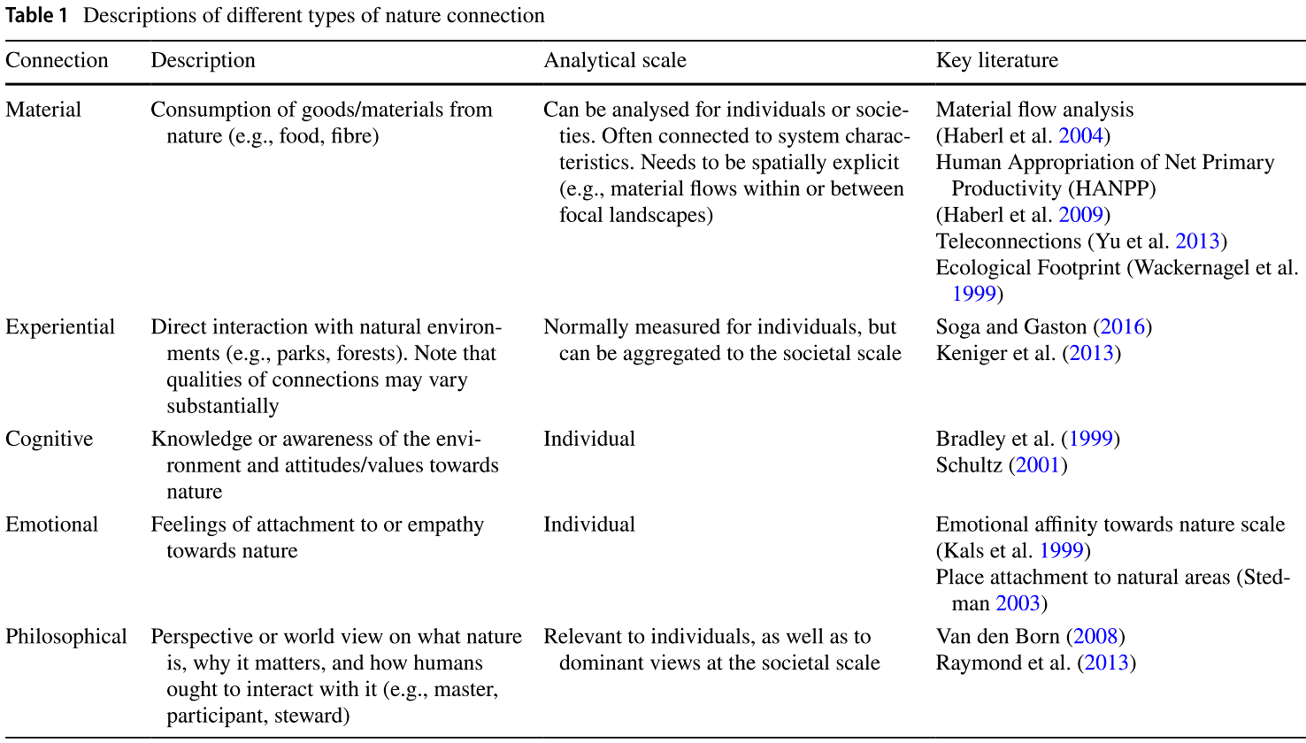
Sustainability transformations require intervention points that target primary drivers of human development. Abson et al (2017) critiqued sustainability interventions, arguing that greater attention should be paid to ‘deep leverage points’ targeting the root causes of unsustainability. They identify three such leverage points, the first of which is reconnecting people with nature because, “the functioning of a system is influenced by the degree to which humanity’s reliance on the natural world is acknowledged, and the extent to which a close relationship with nature is identified as essential to a ‘good life’” (Abson et al., 2017, p. 34). Ives et al. (2018) propose similar ideas stating that emotional and philosophical connections with nature can foster the deep leverage needed for fundamental systemic change.
This study explores some of these concepts by exploring how 12th grade students connect with nature through a nature-based school landscape. The research sought to understand how students perceive the school’s campus and garden and what meaning they find in each. The primary research questions were: How do 12th grade students attending a school with a nature-based landscape connect with nature? How do they perceive the school’s campus and garden? What places on campus do they find meaningful? What does the garden mean to them? Which, if any, of the five themes of connection with nature are present in their perspectives?

Research Site and Context

A qualitative analysis was conducted with 12th grade students from Desert Marigold School (DMS) in South Phoenix. DMS is a public-charter school that offers preschool – 12th grade education inspired by Waldorf educational philosophy. This pedagogical approach, developed by Rudolf Steiner in the early 1900s, states that education should track children’s natural inclinations for learning and development to allow discovery of their unique paths through life (Thomas, 2009). Viewing education as an art form, Waldorf schools typically implement an array of artistic practices, such as painting, poetry, and music, to augment the curriculum (Thomas, 2009). Steiner also recognized the importance of agriculture and its relationship to the environment and considered gardens an essential part of Waldorf curriculum (Steiner, 1995). DMS’s three-acre biodynamic garden supports the philosophy and curriculum as grade levels K – 8th are actively engaged in the garden to varying degrees.
Activities and lessons taught in the garden vary by grade level and tend to become more sophisticated in middle school grade levels. Elementary grade levels often participate in planting, harvesting, preparing, and cooking crops. Certain grade levels up to 5th grade have a designated row of crops they are tasked with maintaining. Middle school grade levels are tasked with developing and implementing various garden projects. For example, in 2017 the 8th grade class designed and built a cob seating area for garden events. Grades 9th-12th do not regularly incorporate garden-based lessons, however, occasional visits to the garden are part of certain science lessons such as herbology and botany. Further, tower gardening is used as a teaching tool in science and sustainability classes.
Currently, there are 75 high school students enrolled at DMS, 14 of which are 12th graders. The 12th grade curriculum is diverse and covers traditional topics such as literature, math, and science, as well as courses various courses related to the arts. The science portion of the curriculum includes two sustainability courses adapted from Arizona State University’s School of Sustainability (SOS): SOS 110 (Sustainable World) and SOS 111 (Sustainable Cities). 11 of the 14 students participated in this study; one student was absent at the time of the study’s implementation, and two did not return consent forms. The sample included 7 female participants and 4 male. While this is a small sample size, the data collected revealed valuable insights to the potential of nature-based school landscapes to connect youth with nature.

Methods

This study used four qualitative data sources to uncover how high school students perceive the school’s campus and garden, paying close attention to the five themes of connection with nature: ﻿(a) material, (b) cognitive, (c) experiential, (d) emotional, and (e) philosophical. While there is significant overlap between each of these themes (Ives et al., 2017), specific criteria shown in Table 2 allowed for an analysis of each theme.

- Survey data: Students were first asked to fill out a 16-question survey (see appendix) consisting of multiple choice and short answer questions. The purpose of the survey was to collect contextual data, such as gender, number of years as a student at DMS, and the extent to which DMS’s garden have been part of their education. Additional questions addressed potential covariables that may contribute to a student’s connectedness with nature. Cheng & Monroe (2012) identified family values and experiences in nature as potential covariables. To account for these, the survey asked how much time, on average, the student spends in nature each week outside of school, if they have a garden at home, and if anyone in the student’s household self-identifies as an environmentalist and/or is a member of an environmental organization.

- Photography: Drawing inspiration from photovoice, photography was used to allow participants to visually depict their perspectives of the school’s campus and garden. Joyce (2018) used photovoice to measure how connected students felt to their school because it “﻿offers a unique way to explore school connectedness and uncover areas related to connectedness that may not be captured by surveys” (p. 211). For this reason, photography was a good fit for this proposed study; however, the specific procedures of photovoice were not employed because this study was not explicitly concerned with influencing decision-making (Wang & Burris, 1997). Students were given two specific prompts for their photographs, the first asking for photographs of the campus and the second asking for photographs of the garden. We assumed the garden would be a primary space for nature connectedness and to test this hypothesis, the first prompt asked students to photograph places meaningful anywhere on the school grounds. Students were allotted 30 minutes of regular class time to take photographs with their smart phones, at the end of which they were asked to choose one photograph to upload to a folder titled ‘Prompt 1’ on a portable thumb drive. The second prompt sought to elicit students’ perspectives of the garden specifically, and thus asked for photographs of places and/or items meaningful in the school’s garden. Students were then allotted an additional 30 minutes to take photographs and choose one photograph to upload to a folder titled ‘Prompt 2’ on the portable thumb drive. Students were asked to refrain from taking photographs of other children or adults to avoid invasion of privacy. No such photographs were submitted allowing all 22 photographs to be analyzed.

- Artistic renderings: Students were given two hours of class time to create an artistic rendering, using a medium of their choice, depicting what the garden means to them. Drawing is a form of artistic rendering that has been used in scientific studies related to students perceptions of school gardens (Zuiker & Wright, 2015). Similar to photovoice, artistic renderings may capture important subtleties and nuances other methods may not. Reith (1997) remarks that drawings ﻿are “believed to reflect a subject’s mental representations and conceptual knowledge about the objects they draw” (p. 61). Drawing can be valuable for any age student given that “﻿drawings become more accurate and detailed as children’s mental models of the world become more extensive and differentiated (Reith, 1997, p. 61). Waldorf education considers art such as drawings important for self-expression, and students are regularly engaged in artistic activities. Using artistic renderings provided a valuable qualitative data to compliment the photovoice data.

- Group interviews: Students were asked to participate in group interviews to caption their photographs and artistic renderings and answer specific research questions. Two group interviews were conducted, each approximately one hour in duration, with students’ photographs (4x6 prints) and artistic renderings displayed. Students were asked to answer four questions for each item: 1) Describe your photo/artistic rendering. 2) What is happening in your picture/artistic rendering? 3) Why did you decide to take a picture of this or create an artistic rendering of this? 4) What does this picture/artistic rendering tell us about your perception of DMS and/or the school’s garden? These questions were adapted from the PHOTO prompt used successfully in photovoice projects (Schoon, Eakin, Szkupinski-quiroga, & Wharton, 2012). Each session was audio recorded and transcribed.

Data Analysis

The data analysis focused on coding the group interviews in which students’ described their visual media. The photographs and artwork were not independently analyzed because of time constraints and the students’ provided rich detail on their media making independent analysis unnecessary. Codes were pulled from the group interviews and used the students’ own words. These codes were then categorized into the five themes of connection with nature. Due to the interconnectivity between themes it was necessary to develop specific criteria for each (see Table 2). Further, some statements from students elicited multiple connections (e.g. experiential and emotional). In such instances, the statement was categorized according to the theme most relevant to the student’s perspective. The first round of coding used In Vivo coding to ensure the students’ perspectives were accurately represented through their own words (Strauss, 1987). For example, “there are other things on this planet besides people” was the code for statements demonstrative of an awareness of how human behavior impacts non-human life. These In Vivo codes were then grouped into a priori categories from the literature (the five themes of connection with nature) through holistic coding. The resulting groups of codes were then divided into two separate codebooks, one for statements about the school’s campus and the other for statements originating about the school’s garden. We did so to assess the school’s campus as a covariable and identify potential relationships between the school’s garden and overall grounds. For example, “very close to nature” denoted statements about the school’s campus incorporating nature to a high degree, while “we work with nature” denoted statements about embracing native flora and fauna in the school’s garden.
Survey data was analyzed for information on other covariables, such as family values, years enrolled at DMS, and the extent to which the garden was part of their education. Codes were then cross referenced with this data to identify potential relationships with students’ perspectives.

Table 2 Criteria for categorizing statements of connection with nature
Connection | Description | Criteria
Material | Consumption of goods/materials from nature (e.g. food, fibre) | Recognition of goods/materials coming from nature
Cognitive | Knowledge or awareness of the environment and attitudes/values toward nature | Mental processing of human impacts on the environment and/or expressing specific attitudes/values about nature
Experiential | Direct interaction with natural environments (e.g. forests, parks) | Describing the experience of connecting with nature through direct contact
Emotional | Feelings of attachment to or empathy toward nature | Expressions of felt emotions with nature
Philosophical | Perspective or worldview of what nature is, why it matters, and how humans ought to interact with it (e.g. master, participant, steward) | Ontological and/or ethical statements about nature

Results

Survey data indicating the extent to which the garden was part of the students’ education varied considerably depending on the grade level they began attending DMS. The 7 students who started at DMS in 4th grade or earlier estimated they spent an average of 250 hours in the garden in total. Another student, whom started in 7th grade, estimated 141 total hours spent in the garden, while the remaining three students, enrolling in 9th grade or later, estimated 9 hours total in the garden. When asked to rank the extent to which the garden was part of their education, students enrolled in 4th grade or earlier responded ‘to some extent’ or ‘to a great extent’, while the remaining four students chose ‘to very little extent’. No students marked ‘none’ for this question indicating all students has some experience with garden-based learning. Responses to lessons learned differed depending on when the student began attending school at DMS and reflected the school’s explicit use of garden-based learning in grades K-8 only. Six of the eight students starting in 7th grade or earlier wrote ‘planting’, ‘harvesting’, ‘composting’, ‘biodynamic farming’, or similar terms. The additional two wrote broader lessons: ‘discipline’, ‘teamwork’, ‘wonder’, ‘mental strength’, ‘endurance’, ‘compassion’, ‘responsibility’, ‘practicality’ and ‘connectivity’. The three remaining students enrolled in 9th grade or later responded: ‘botany’, ‘tower gardening’, and ‘trim trees’. The visual data and group interviews elicited connections with nature across the five themes - material, cognitive, experiential, emotional, and philosophical - to varying degrees.

- Material

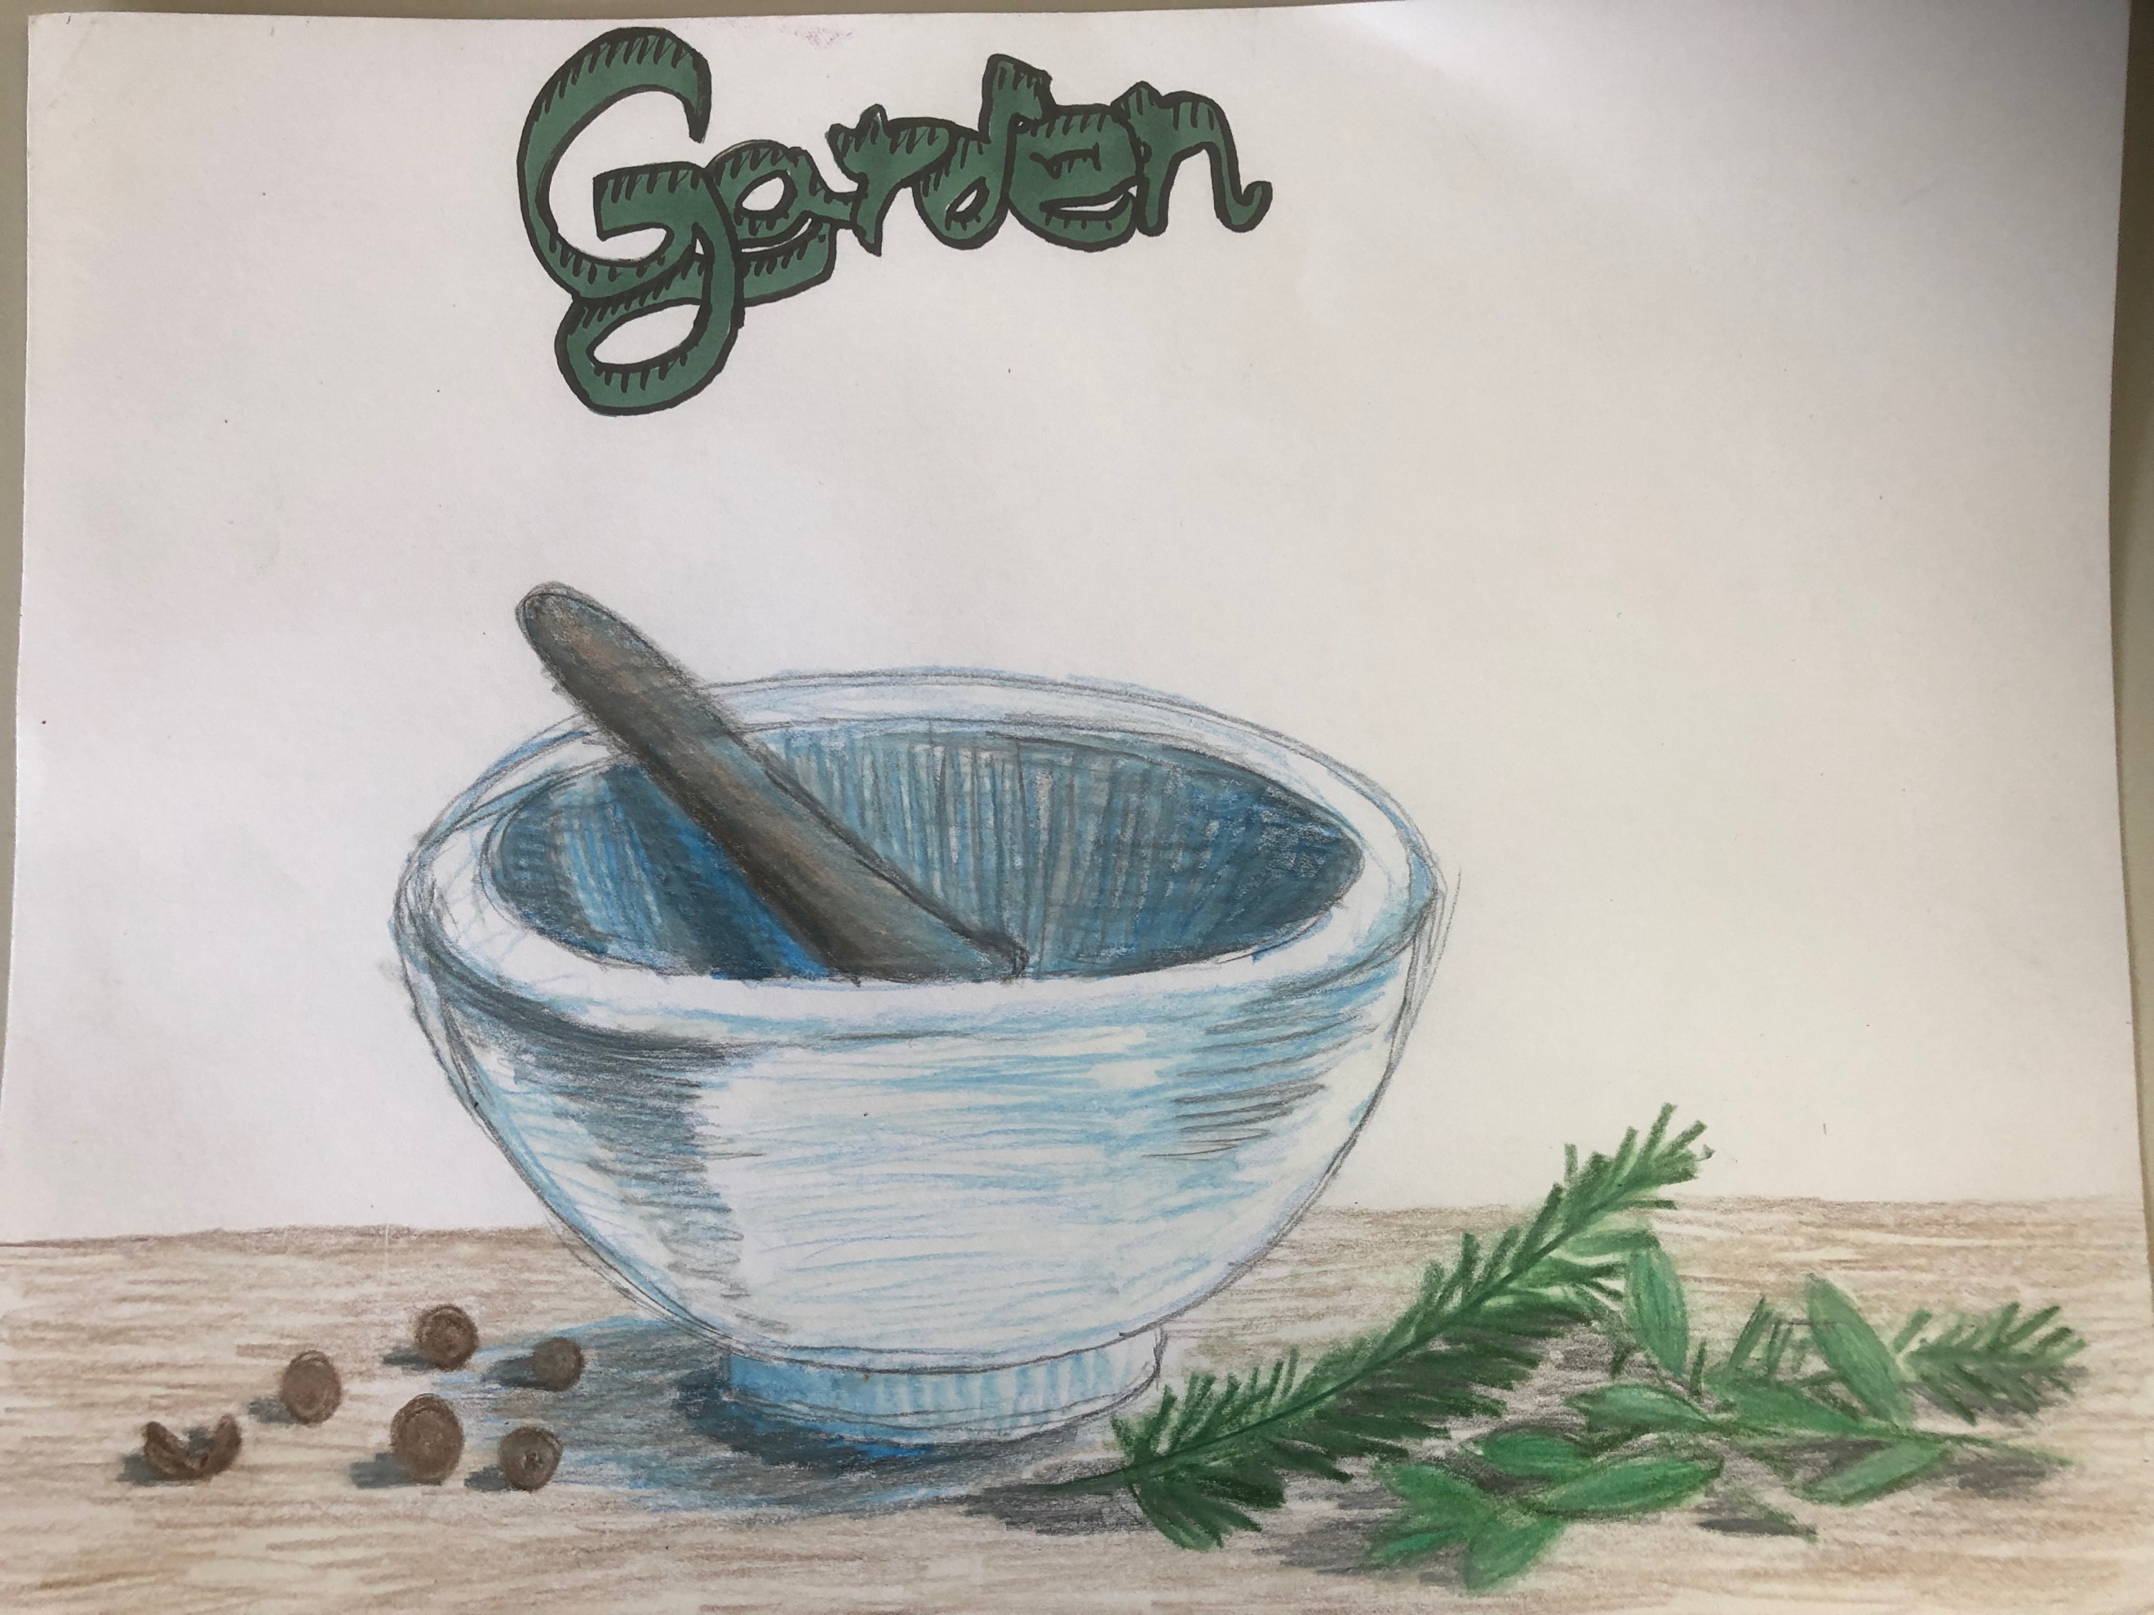
Material connections with nature were represented in several students’ perspectives on the school’s garden as a teaching tool. In response to a survey question asking respondents to describe lessons learned in the garden, three respondents listed ‘harvesting’ or implied consumption. Understanding food as a resource from nature was articulated further in the group interviews and visual media. One participant, in describing their photograph of a row of food crops, talked about the importance of “see[ing] how the food that you're eating grows from…a tiny seed,” emphasizing the connection between the garden and food for human consumption. Other students shared similar sentiments indicating the garden facilitated a recognition that food comes from the Earth. Four photographs of the garden showcased food crops as the primary subject and three artistic renderings depicted material themes. For example, one student drew a mortar and pestle with herbs around it (Figure 1), indicating the grinding of herbs from the garden for material use. Students discussed material connections during their discussions in speaking of the required resources to grow food and the challenges associated with doing so successfully.
Figure 1 Illustration of a mortar and pestle used for grinding herbs with the word ‘garden’ above it.
In describing his photograph of a Palo Verde tree in the garden, a participant discussed seasonality and the inherent variability it brings to food production. The Palo Verde tree symbolized “how the landscape itself takes in the seasons,” which can either “throw a wrench into” the gardens viability or allow it to “blossom really magnificently.” In describing how natural cycles affect food production, he demonstrates material awareness of the food and nature relationship. Another student photographed the school’s tower garden and emphasized the role such technology can play in reducing resource inputs to grow food. Specifically, “it uses 90% less water and it has a 30% larger crop yield,” which he described as “really important” for future food production. This demonstrates a conscious connection between food production and natural resources, as well as an attitude that such resources should be conserved.

- Cognitive
Values, beliefs, and attitudes about the environment were implicit in the majority of the students’ perspectives on the school’s garden. This is reflected in the survey data with eight of the 11 participants self-identifying as environmentalists. Further, a student described her photograph of a small bridge over a large pothole filled with water as a metaphor for the way “we don’t try to work around life, we work with it” in the garden, which she expressed as important because “I get depressed if there is not nature around and I think that benefits people.” Her statement, in addition to implying an emotional connection with nature for mental well-being, primarily elicits a cognitive connection with nature as beneficial for humanity’s well-being. Another student expressed similar values toward nature in describing the garden as a “rare” place abundant with greenery uncharacteristic of Arizona. She went on to compare it with other places, such as “downtown Phoenix, which is just like cement and brown buildings and just so pale and gross looking,” and other schools which “look like prisons.” Her attitude is indicative of a belief that cities and schools should be more physically connected with nature through natural spaces.
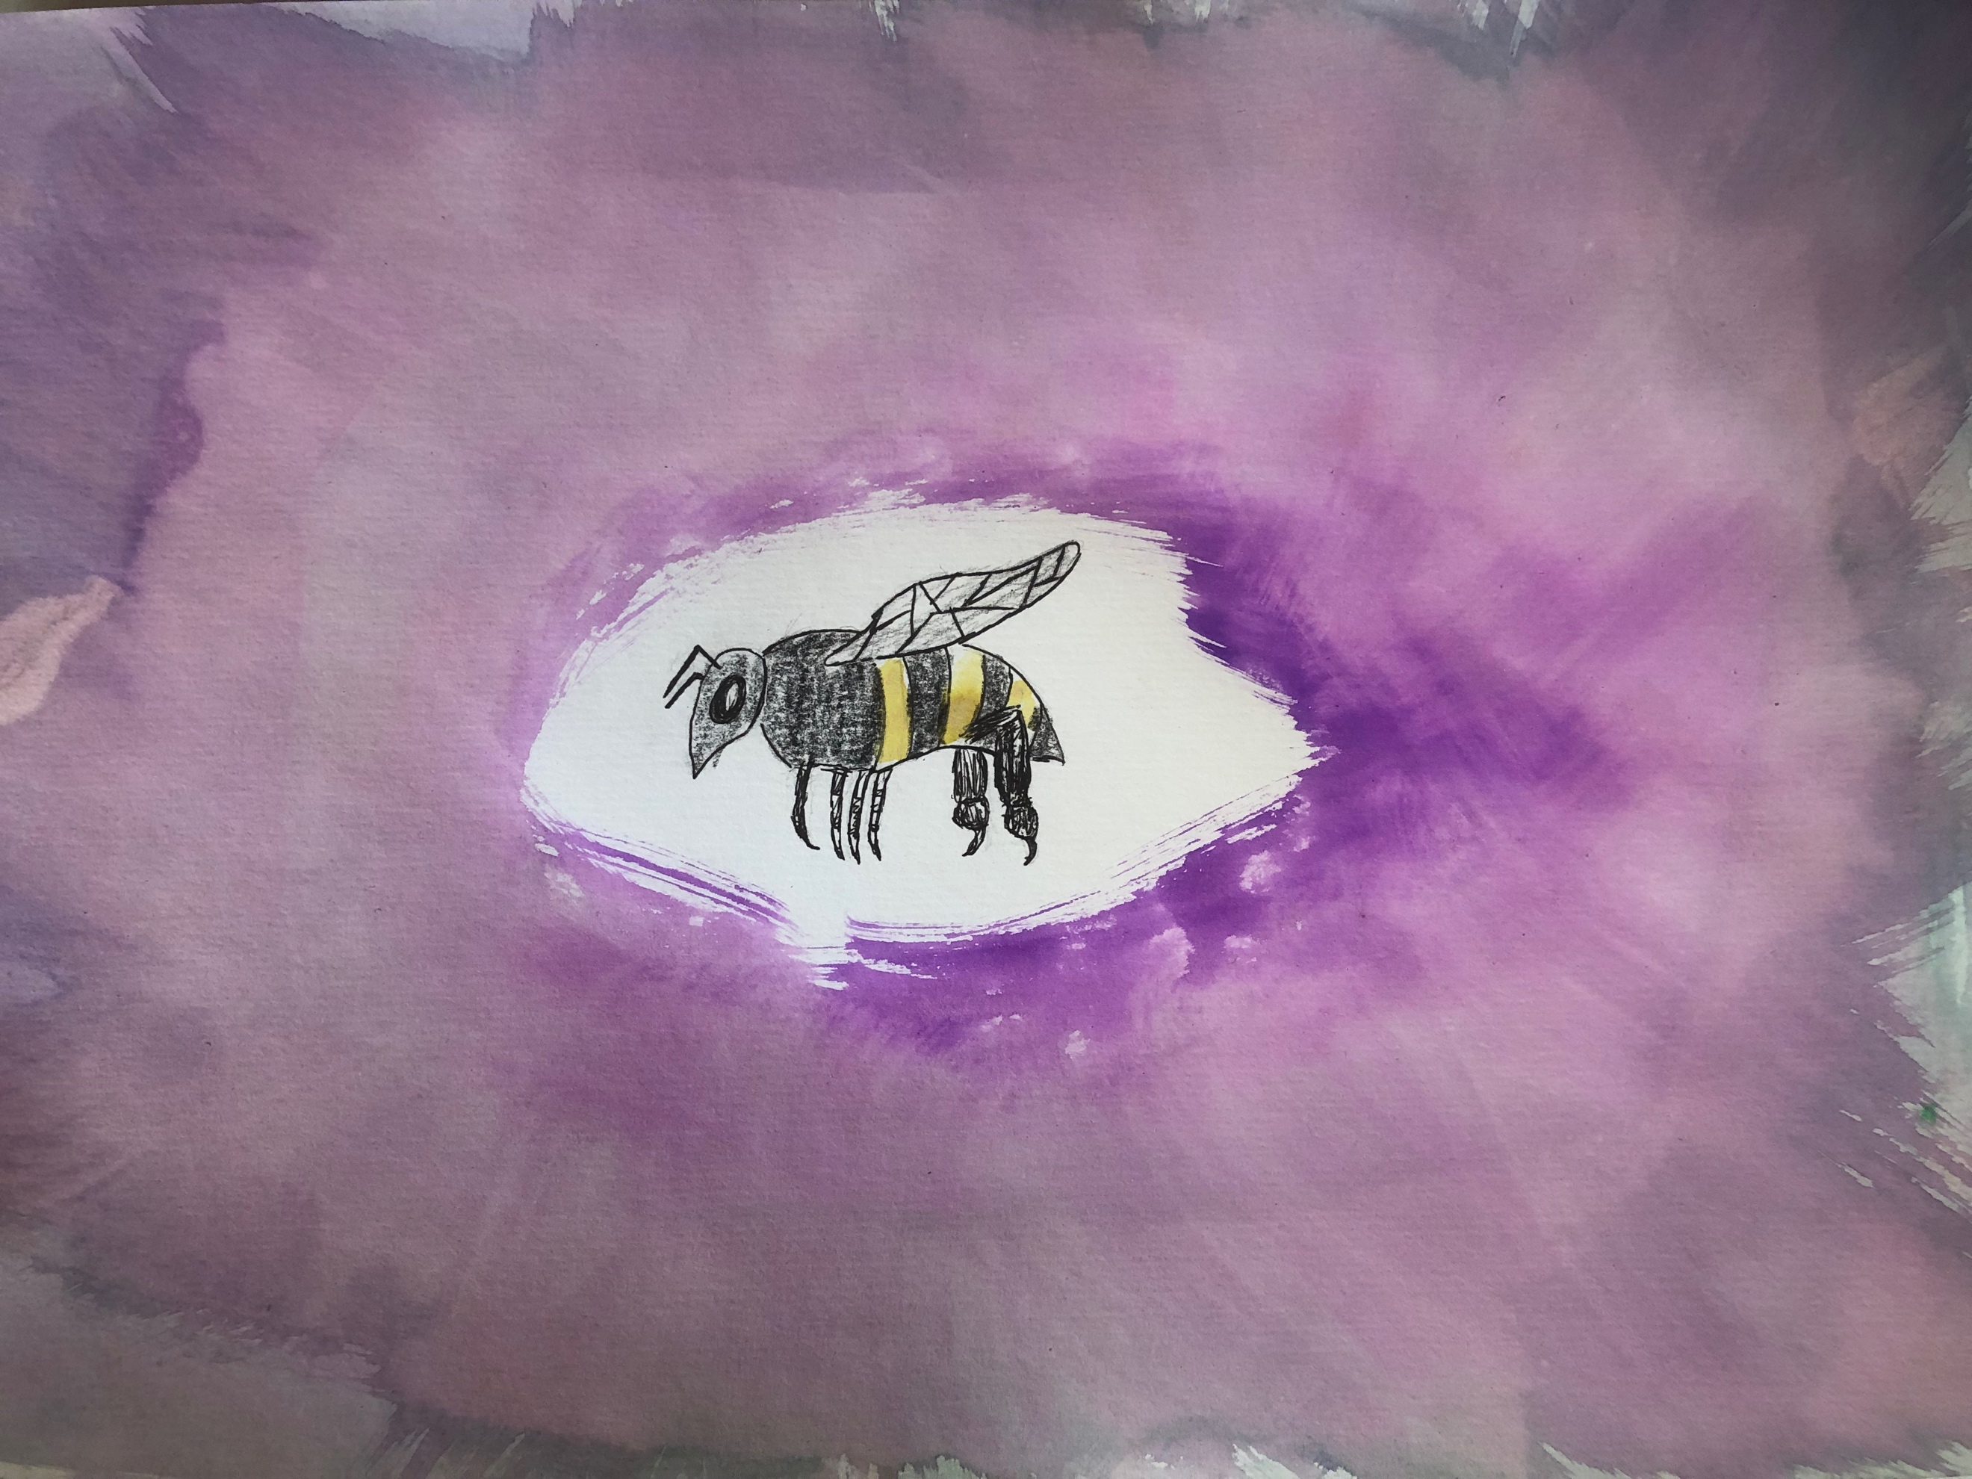
Students’ perspectives also demonstrated a cognitive awareness of ecological systems. For example, one student painted a picture (Figure 2) of a honey bee given their role in pollinating food crops. In recalling a period when bee boxes were kept near the garden, he expressed becoming aware of the “the little things,” and how they “really keep the big things going.” He went on to explain how the “small little ecosystem” of the garden is a metaphor for the planetary ecosystem humanity is embedded in, demonstrating ecological awareness across scales. His discussion identifies a link between the material and cognitive dimensions of connection with nature. Comprehending the necessity of bees for food production seems to have facilitated an awareness of the interconnectedness of ecosystems. Even seemingly “little things” play an important role in the viability of “big things”. Similarly, the above students, in describing seasonality and considering limited natural resources, expressed awareness of natural systems and their connectedness to social systems. Further, another student wrote ‘connectivity’ as one lesson learned in the garden on the survey, and another described the garden as “a place that fosters all life,” both of which indirectly convey ecological awareness to some degree.
Figure 2 Honeybee with a watercolor background that "represents the diversity of all the things you have growing in the garden."

- Experiential
Each photograph and artistic rendering of the garden was either inspired by past experiences in the garden or such memories were brought out during the group discussions. Many students characterized their experiences in the garden as “fun”, “refreshing”, “unique”, and “friendship building”, which were not necessarily tied to nature in a broader sense. However, students who described experiences in the garden as “calming” or “relaxing” extended this connection to nature in general. Two students in particular provided rich detail on personal experiences in the garden relative to well-being that influenced their experiential connection with nature. A student enrolled at DMS since 3rd grade painted a picture of a large shade tree in the garden with the words “time to reconnect” underneath it. When asked why she wrote these words under the tree she replied the garden has always been a place for her to experience inner peace:

“It's that moment in which you get to like dig your hands back into the Earth and…not really think about other things… You kind of have to be present in the garden…and it's just like a moment to like reconnect…back to being in nature and…think about the world around you.”

This eloquent description captures a deep experiential connection with nature for mental well-being. Another student shared a similar experiential connection to nature for mental well-being influenced by personal experiences in the garden:

“Especially as I get older and older, I have an understanding and a respect for the amount of time that I always needed to be alone. And especially now it's like it's so hard to get that time when you can be alone and just sort of think and be away from people but be in a place of good thought, which is like in nature. And so that [the garden] gives that to me. That's what the garden does for me now. That's what it did for me back then as well.”

These statements speak to the role the garden plays in facilitating experiential connections with nature, which may cultivate affective relationships with nature for inner peace.

- Emotional
Strong emotional bonds with the garden were implicit in many students’ perspectives through the use of words such as “love” in describing their photographs. Two students in particular used love in reference to trees and flowers in the garden. Emotional relationships were clearly illustrated by students identifying the garden as a reflection of the self. For example, one student described her painting of the garden as reflecting a “muddle of emotions” representing the “highs and lows” she has physically experienced there. A particular event involving “senseless murder” of gophers produced negative emotions, while “pick[ing] flowers”, “hang[ing] out with friends”, and learning the consequences of “not planning” lead her to conclude “overall it's a positive perception”. She correlated this cyclical relationship between positive and negative emotions from the garden with life more generally:

“The garden could either be one of the most chaotic and dangerous things at DMS, but it also has the capacity to be really thoroughly planned and just beautiful and like extremely fruitful and yielding and I find that it like really matters like what you put into it…I sort of like that, that balance between like what we control and what we can't and it's still beautiful either way. The garden is what you necessarily put into it sort of like life”

While her story illustrates how experiences in the garden cultivated a range of emotions and taught her “life lessons”, correlating her personal growth with growth in the garden implies a sense of oneness characteristic of an affective relationship. Other students echoed this emotional connection with statements such as, “I’ve seen it grow as I’ve grown myself.” One student related the transitioning of a flower from bud to bloom to “a transition from high school to adulthood… when it's like safe, in a [flower]bud to being open and vulnerable to everything because you don't have any protection anymore.” Later, in discussing the importance of knowing where food comes from, he stated “we need to have an understanding of it in order for us to like take care of our bodies and take care of this planet.” This expression of care for the self as connected to care for the planet clearly posits a feeling of oneness with the planet representative of an emotional connection with nature.

- Philosophical
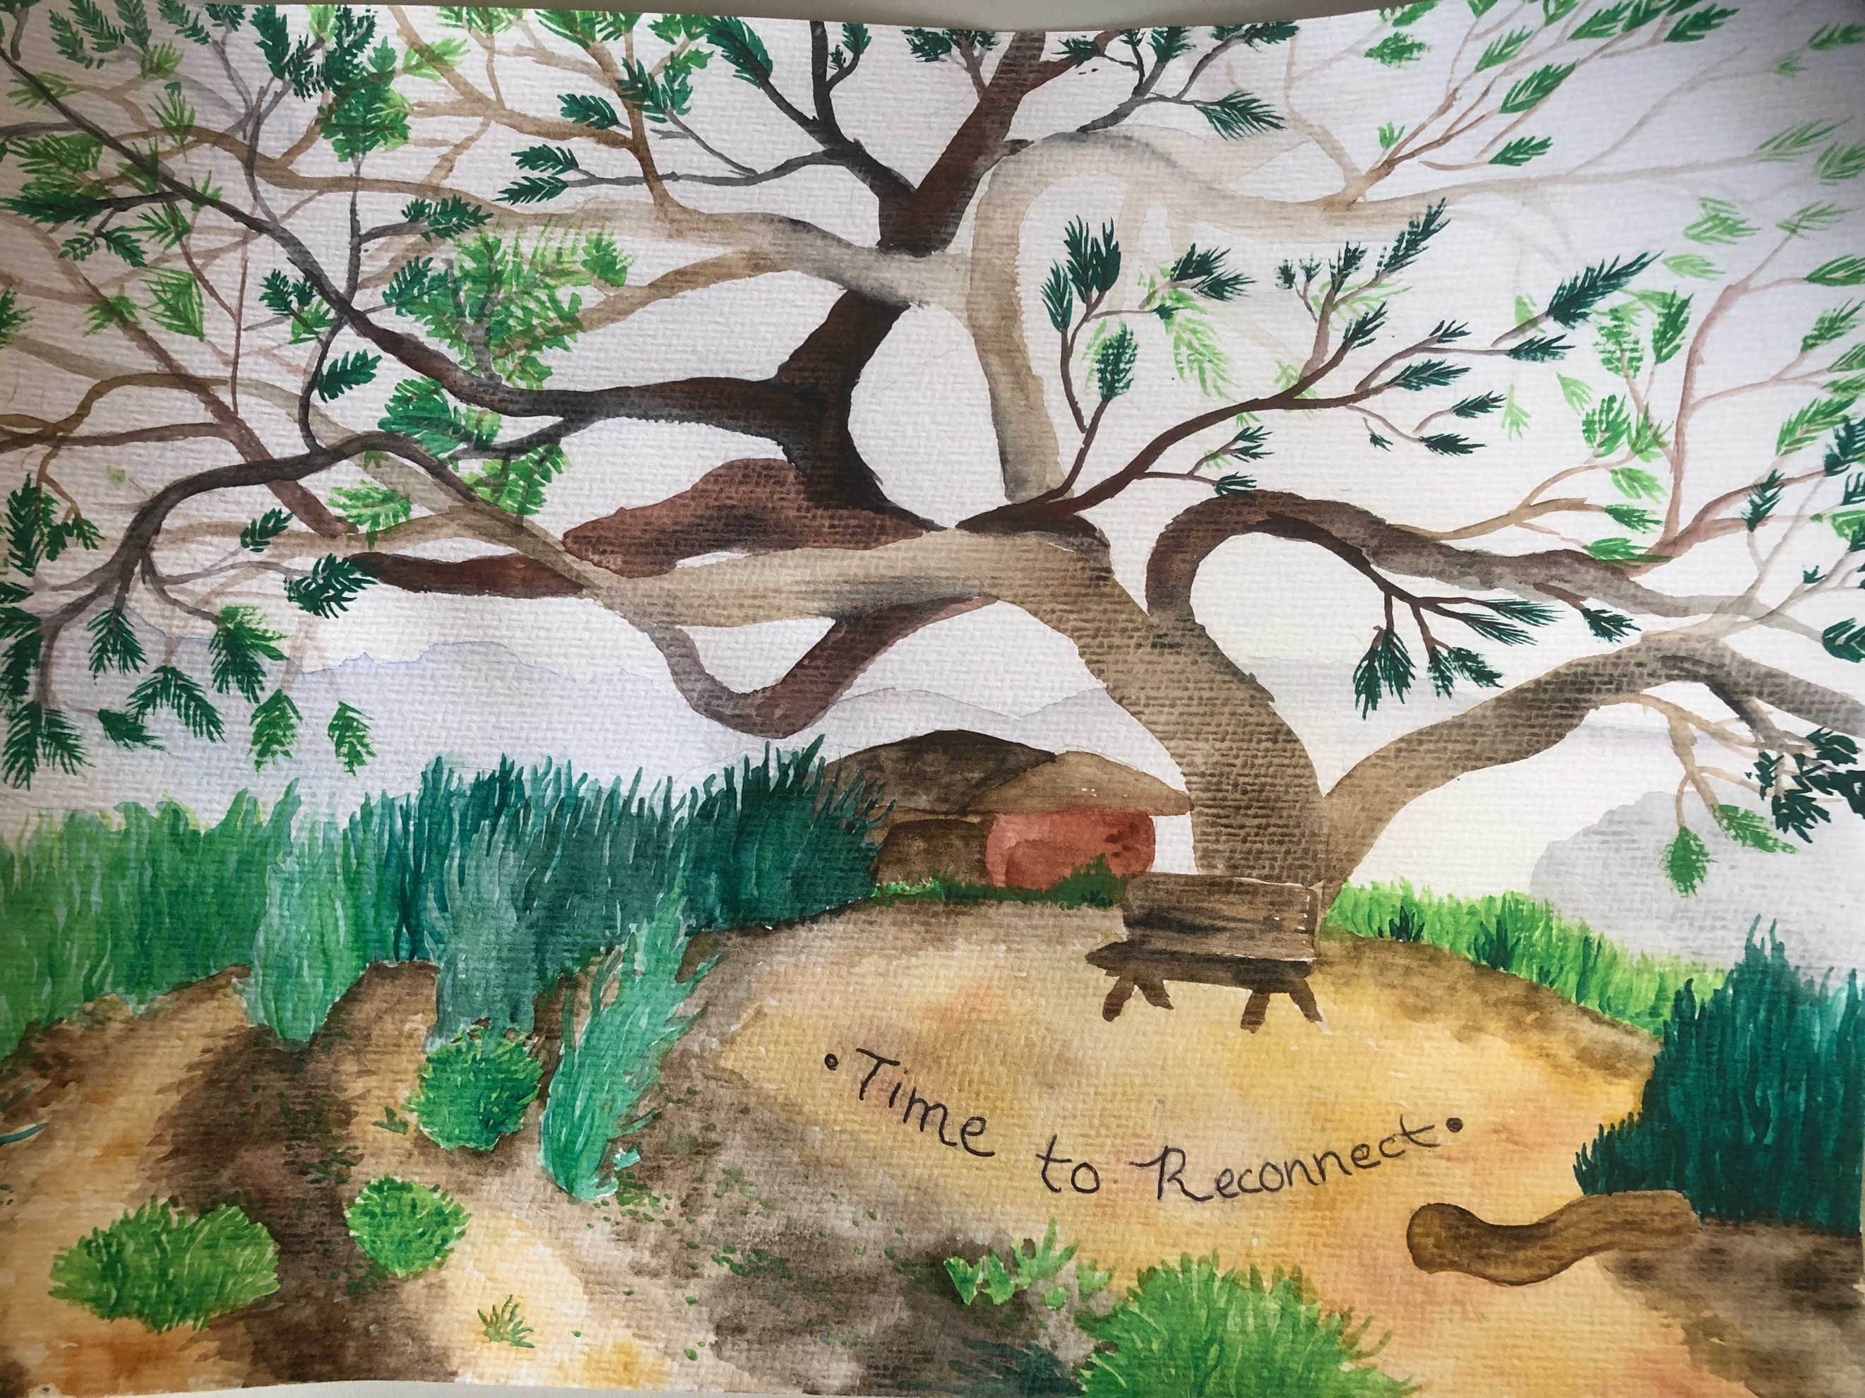
Philosophical connections with nature were present in two students’ perspectives. The artist of Figure 3 decided to paint a portrait of a particularly large shade tree in the garden because: “trees mean knowledge…and it just has this idea of just like, come and sit under my branches and just like take in the world around you.” Her statement assigns intrinsic value to trees as mentors for humans and is indicative of an ontological view of nature as conscious and intelligent. Another student described a similar philosophical connection in stating humans “come from it [nature]…it’s important to understand like kind of your roots…to understand that there are other things on the planet besides people and having respect for all of that is really important.” Thus, his fundamental belief about the origins of humanity inspires an ethical view of humans as stewards of nature. It should be noted this particular student mentioned strong family values toward the environment, which likely influenced his philosophical view of nature.
Figure 3 Illustration of a prominent tree in the garden representing "knowledge" and "time to reconnect."

Contributing Factors

Both survey data and the students’ perspectives indicated family values influenced their connection with nature, while one student remarked how his family’s profession, poultry farming, motivated his certain types of nature connectedness. Survey data indicated the majority of participants’ families valued the environment. Nine students have gardens at home (though only three reported spending time in the home garden), seven said at least one person in their household self-identified as an environmentalist, and four reported at least one household member belonged to an environmental organization, such as the Sierra Club. Two students explicitly referenced family values (“my mom is a hippie” and “I grew up on a poultry farm”) during group discussions. The student who drew Figure 1 explained “my mom’s a hippie” in discussing his mom’s use of herbs from their home garden. He also wrote ‘we all love the environment’ on the survey question about household members self-identifying as environmentalists. Another student talked about his family’s poultry farm and how it contributed to his love for chickens and a vegan diet.
Farm animals housed on the school’s campus were represented in four of the photographs for the first Photovoice prompt. Each of these four students elicited empathetic relationships with animals in describing their photos. Students’ exclaimed, “I love animals” and “getting to hang out with animals is a therapeutic thing.” Two students also remarked the farm animals were the first thing they noticed when starting at the school and caring for them “made me want to come to school.” The school’s campus also has a pond area with a variety of plant species around it, as well as several species of trees growing throughout the school grounds. In describing their photographs of the campus, four students explicitly mentioned appreciation for how the campus is “very close to nature” and provided “so much freedom” for exploration on a regular basis. One student speaking of how the campus “incorporate[s] nature”, stated the “very inclusive and well-rounded curriculum” encouraged “walks and sometimes even meditations by the like pond”. His statement demonstrates the school’s campus and educational philosophy promote experiential connections with nature. Another student recalled experiential connections with nature from living in Washington state, because it fostered an appreciation of “forests and trees”. Thus, these contributing factors necessitate consideration on the role of school landscapes in the students’ connections with nature.

Discussion

Our results contribute to the literature in illustrating how this school’s nature-based landscape connects 12th grade students with nature, showing positive support for nature based school landscapes as an intervention to reconnect youth with nature. Students’ perspectives of the garden at DMS echoed other studies in demonstrating environmental awareness, knowledge of food production, increased pleasure, and empathy for non-human species as outcomes of garden-based learning (Ozer, 2007; Blair, 2010; Williams & Dixon, 2013). Similar to Chawla et al.’s (2014) study on high school student’s perspectives of gardens, we found strong cognitive and emotional relationships representative of oneness with nature. This is important because emotional and cognitive connections may be fundamental to shifting anthropocentric worldviews toward ontological frameworks promoting stewardship instead of dominion (Zylstra et al., 2014). Interventions capable of addressing deep leverage points, such as worldviews, are vital for sustainability transformations (Abson et al., 2017), and nature-based school landscapes may be an important tool for cultivating such shifts.
However, more research is needed to explore the extent to which covariables influence students’ human-nature relationship. Our research indicated multiple covariables, especially family values and experiences in nature outside of the school’s garden, may have influenced students’ connectedness with nature. This supports previous studies that also recognized these covariables (Cheng & Monroe, 2012). While this study did not aim to explore such covariables in detail, students’ perspectives provided some insight. The two students who explicitly referenced family values (“my mom’s a hippie” and “I grew up on a poultry farm”) implied considerable influence on their human-nature relationship. The student whom talked about his mom’s use of herbs from the garden for teas and remedies also wrote “we all love the environment” on a survey question about family values. Thus, his philosophy of stewardship (“respect for all”) was likely more influenced by his family’s values than the school’s garden. This is especially probable because this particular student was not enrolled at DMS until 9th grade. The student raised on a poultry farm expressed strong material and cognitive connections with nature in highlighting the potential of tower gardening for sustainable food production. Though not voiced, this may have also influenced his awareness of the material connection food has with the environment, impacts food production has on natural resources, and the plight of small-scale farmers. He did make explicit mention of how his family’s profession cultivated a strong emotional connection with nature by fostering empathy for animals and practicing veganism.
His statements also draw attention to the role non-human animals can play in fostering connections with nature. Three other students, in discussing their perspectives of the school’s campus, implied the farm animals were significant in cultivating empathy for nature. The school’s incorporation of animal husbandry into the curriculum created strong empathetic relationships between the students and the animals, which they extended out to non-human animals in general (“I love animals”). Other studies on nature connectedness have identified such relationships with animals as indicative of an emotional connection with nature (Cheng & Monroe, 2012). Our results provide support for this claim and suggest that including animal husbandry in school curriculums may encourage emotional relationships with nature. The school’s use of animal husbandry and gardening in the curriculum may be motivating factors for parents’ deciding to enroll their children at DMS.
Choosing to enroll children at DMS could, in itself, represent family values related to the human-nature relationship since green space is woven throughout the school’s campus with curricula encouraging experiences in nature. Photographs and descriptions of students’ perspectives of the campus support this claim. Statements from students about the campus being “very close to nature” and having “so much freedom” to explore it regularly imply direct interaction with natural spaces contributed to their human-nature relationships. Students expressed experiential connections in the school’s pond and other areas of campus, such as a green space where picnics are often held. In contrast to the ‘extinction of experience’ often associated with urban areas (Pyle, 1993), DMS offers abundant opportunities to experience nature despite its location in a dense metropolitan area. The students’ perspectives illustrate the school’s campus and educational philosophy promote experiences in nature, which can be a catalyst for psychological connectedness with nature (Whitburn et al., 2018). This was similarly expressed by another student who described how living in Washington state contributed to her appreciation of “forests and trees”. Thus, this study supports claims of experiences in nature as essential to fostering cognitive, emotional, and philosophical connections with nature (Miller, 2005; R. M. Pyle, 2003; Soga & Gaston, 2016).
The students’ perspectives indicated both the school’s campus and garden play pivotal roles in giving students opportunities for direct interaction with nature. The findings suggest students’ experiences in the garden influenced cognitive, material, emotional, and to a lesser degree, philosophical connections with nature. Other studies evaluating the effects of growing food for personal consumption have shown increased material, cognitive, and emotional connections with nature (Bendt, Barthel, & Colding, 2013; Hawkes & Acott, 2013). Food production, because of its inherent material connections with nature, is representative of cognitive beliefs and attitudes toward the environment. The specific methods employed for food production in the garden will influence the degree to which the human-nature relationship can be strengthened. DMS, in practicing biodynamic farming, promotes food production as environmental stewardship (“we work with it”), which increases the potential of the garden to foster deep connections with nature. Since biodynamic farming does not use chemical fertilizers or pesticides in food production (Reganold, 1995), it may also influence students’ consumption preferences toward food healthy for the body and the environment.
Two students’ made statements supporting this claim, with one student favoring the lack of pesticides in the garden because “we don’t need to be adding a ton of crap into our food.” The other student described a preference for eating food from the garden over the grocery store because, “you know exactly what’s going into it.” Adding that food from the grocery store “could be organic or whatnot but could also be being sprayed with preservatives.” These students’ preferences for food produced without pesticides or preservatives may be outcomes specific to the use of biodynamic farming in the garden; however, the students’ families may also play a role given food consumption is often shaped by family practices. Other studies have shown school gardens can increase fruit and vegetable consumption in youth (Blair, 2010; Ratcliffe, Merrigan, Rogers, & Goldberg, 2011), however, they do not address the type of produce purchased. Garden-based learning programs that use conventional cultivation methods, or do not emphasize ecologically oriented methods, may reinforce consumption of conventional produce negatively impacting the environment.

Limitations and Bias

The Waldorf pedagogical philosophy and unique campus of DMS limit the generalizability of these results. However, nature-based school landscapes are understudied in literature on connection with nature, as well as sustainability literature and despite relevance to each. This study could have been more robust if the students were segregated into two groups, students who had completed 4+ years of primary school at DMS and those who joined later. Doing so would add validity to the school’s campus and garden as catalysts for connecting children with nature. Additional research is needed to further understand possible outcomes for sustainability specific to nature-based school landscapes. A comparative study with public schools is needed. The small sample size of this study limits its breadth; however, it permitted extensive qualitative data collection and direct interaction with students.
Further, researcher bias is important to acknowledge. A member of the research team has children enrolled in the school, and another member regularly volunteers in the school’s garden. Thus, the researchers have a clear bias in this study which influences how data was collected and analyzed.

Conclusion

Recent calls for reconnecting people with nature for sustainability recognize the role education can play in leveraging sustainability transformations. This is especially important in adolescence, and equipping schools with nature-based landscapes may present youth valuable opportunities to connect with nature. Our study demonstrates this potential through 12th grade students’ perspectives on Desert Marigold’s nature-based school landscape . The findings also provide insight on the influence of additional factors in students’ connections with nature and highlight the importance such factors may have for sustainability outcomes. Additional research is needed to further explore the role of contributing factors, such as family values, and how these may or may not influence students’ connections with nature for sustainability.

Works Cited
Abson, D. J., Fischer, J., Leventon, J., Newig, J., Schomerus, T., Vilsmaier, U., … Lang, D. J. (2017). Leverage points for sustainability transformation. Ambio, 46(1), 30–39. https://doi.org/10.1007/s13280-016-0800-y
Bendt, P., Barthel, S., & Colding, J. (2013). Civic greening and environmental learning in public-access community gardens in Berlin. Landscape and Urban Planning, 109(1), 18–30. https://doi.org/https://doi.org/10.1016/j.landurbplan.2012.10.003
Blair, D. (2010). The Child in the Garden: An Evaluative Review of the Benefits of School Gardening. The Journal of Environmental Education, 40(2), 15–38. https://doi.org/10.3200/JOEE.40.2.15-38
Chawla, L., Keena, K., Pevec, I., & Stanley, E. (2014). Green schoolyards as havens from stress and resources for resilience in childhood and adolescence. Health and Place, 28, 1–13. https://doi.org/10.1016/j.healthplace.2014.03.001
Cheng, J. C. H., & Monroe, M. C. (2012). Connection to nature: Children’s affective attitude toward nature. Environment and Behavior, 44(1), 31–49. https://doi.org/10.1177/0013916510385082
Clements, R. (2004). An Investigation of the Status of Outdoor Play. Contemporary Issues in Early Childhood, 5(1), 68–80. https://doi.org/10.2304/ciec.2004.5.1.10
Costanza, R. (2000). Social goals and the valuation of ecosystem services. Ecosystems, 3(1), 4–10. https://doi.org/10.1007/s100210000002
Cumming, G. S., Buerkert, A., Hoffmann, E. M., Schlecht, E., von Cramon-Taubadel, S., & Tscharntke, T. (2014). Implications of agricultural transitions and urbanization for ecosystem services. Nature, 515, 50. Retrieved from https://doi.org/10.1038/nature13945
Daily, G. (1997). Nature’s services: societal dependence on natural ecosystems. Washington D.C.: Island Press.
Ernst, J., & Theimer, S. (2011). Evaluating the effects of environmental education programming on connectedness to nature. Environmental Education Research, 17(5), 577–598. https://doi.org/10.1080/13504622.2011.565119
Folke, C., Jansson, Å., Rockström, J., Olsson, P., Carpenter, S. R., Chapin, F. S., … Westley, F. (2011). Reconnecting to the Biosphere. AMBIO, 40(7), 719. https://doi.org/10.1007/s13280-011-0184-y
Hawkes, F. M., & Acott, T. G. (2013). People, environment and place: the function and significance of human hybrid relationships at an allotment in South East England. Local Environment, 18(10), 1117–1133. https://doi.org/10.1080/13549839.2013.787590
Hofferth, S. L., & Sandberg, J. F. (2001). Changes in American children’s time, 1981–1997. Advances in Life Course Research, 6, 193–229. https://doi.org/https://doi.org/10.1016/S1040-2608(01)80011-3
Ives, C. D., Abson, D. J., von Wehrden, H., Dorninger, C., Klaniecki, K., & Fischer, J. (2018). Reconnecting with nature for sustainability. Sustainability Science, 13(5), 1389–1397. https://doi.org/10.1007/s11625-018-0542-9
Ives, C. D., Giusti, M., Fischer, J., Abson, D. J., Klaniecki, K., Dorninger, C., … von Wehrden, H. (2017). Human–nature connection: a multidisciplinary review. Current Opinion in Environmental Sustainability, 26–27(May), 106–113. https://doi.org/10.1016/j.cosust.2017.05.005
Joyce, H. D. (2018). Using Photovoice to Explore School Connection and Disconnection. Children and Schools, 40(4), 211–219. https://doi.org/10.1093/cs/cdy021
Kahn, P. H. (2007). The Child ’ s Environmental Amnesia — It ’ s Ours. Children, Your and Envvironments, 17(2), 199–207.
Kals, E., Schumacher, D., & Montada, L. (1999). Emotional Affinity toward Nature as a Motivational Basis to Protect Nature. Environment and Behavior, 31(2), 178–202. https://doi.org/10.1177/00139169921972056
Krettenauer, T. (2017). Pro-Environmental Behavior and Adolescent Moral Development, 27(3), 581–593. https://doi.org/10.1111/jora.12300
Leopold A. (1949). A Sand County Almanac. New York: Oxford University Press.
Lin, B. B., Fuller, R. A., Bush, R., Gaston, K. J., & Shanahan, D. F. (2014). Opportunity or Orientation? Who Uses Urban Parks and Why. PLOS ONE, 9(1), e87422. Retrieved from https://doi.org/10.1371/journal.pone.0087422
Liu, J., Mooney, H., Hull, V., Davis, S. J., Gaskell, J., Hertel, T., … Li, S. (2015). Systems integration for global sustainability. Science, 347(6225). https://doi.org/10.1126/science.1258832
Louv, D. (2008). Last Child in the Woods: Saving our children from nature-deficit disorder. Chapel Hill: Algonquin Books.
Mayer, F. S., & Frantz, C. M. P. (2004). The connectedness to nature scale: A measure of individuals’ feeling in community with nature. Journal of Environmental Psychology, 24(4), 503–515. https://doi.org/10.1016/j.jenvp.2004.10.001
Miller, J. R. (2005). Biodiversity conservation and the extinction of experience. Trends in Ecology and Evolution, 20(8), 430–434. https://doi.org/10.1016/j.tree.2005.05.013
Nabhan, G. P., & Trimble, S. (1994). The geography of childhood: Why children need wild spaces. Boston: Beacon Press.
Naess, A. (1973). The shallow and the deep ecology movements. Inquiry, 16(95–100).
Nisbet, E. K., Zelenski, J. M., & Murphy, S. A. (2009). The Nature Relatedness Scale Linking Individuals’ Connection With Nature to Environmental Concern and Behavior, 715–740.
Nisbet, E. K., Zelenski, J. M., & Murphy, S. A. (2011). Happiness is in our Nature: Exploring Nature Relatedness as a Contributor to Subjective Well-Being. Journal of Happiness Studies, 12(2), 303–322. https://doi.org/10.1007/s10902-010-9197-7
Ozer, E. J. (2007). The effects of school gardens on students and schools: Conceptualization and considerations for maximizing healthy development. Health Education and Behavior, 34(6), 846–863. https://doi.org/10.1177/1090198106289002
Pergams, O. R. W., & Zaradic, P. A. (2006). Is love of nature in the US becoming love of electronic media? 16-year downtrend in national park visits explained by watching movies, playing video games, internet use, and oil prices. Journal of Environmental Management, 80(4), 387–393. https://doi.org/https://doi.org/10.1016/j.jenvman.2006.02.001
Pyle, R. (1993). The thunder tree: lessons from an urban wildland. Boston: Houghton Mifflin.
Pyle, R. M. (2003). Nature matrix: Reconnecting people and nature. Oryx, 37(2), 206–214. https://doi.org/10.1017/S0030605303000383
Quinn, D. (1992). Ishmael. New York: Bantam/Turner Books.
Ratcliffe, M. M., Merrigan, K. A., Rogers, B. L., & Goldberg, J. P. (2011). The Effects of School Garden Experiences on Middle School–Aged Students’ Knowledge, Attitudes, and Behaviors Associated With Vegetable Consumption. Health Promotion Practice, 12(1), 36–43. https://doi.org/10.1177/1524839909349182
Reed, K., Duncan, J. M., Lucier-Greer, M., Fixelle, C., & Ferraro, A. J. (2016). Helicopter Parenting and Emerging Adult Self-Efficacy: Implications for Mental and Physical Health. Journal of Child and Family Studies, 25(10), 3136–3149. https://doi.org/10.1007/s10826-016-0466-x
Reganold, J. P. (1995). Soil quality and profitability of biodynamic and conventional farming systems: A review. American Journal of Alternative Agriculture, 10(1), 36–45. https://doi.org/DOI: 10.1017/S088918930000610X
Reith, E. (1997). Drawing Development. In Child development in art (Kindler). A. M.
Schoon, B., Eakin, H., Szkupinski-quiroga, S., & Wharton, C. (2012). Youth Perspectives and Future Visions for Community Food Security: An Applied Approach to Participatory Research in Phoenix, Arizona. Arizona State University.
Schroeter, M., van der Zanden, E., & van Oudenhoven, A. (2014). Ecosystem services as a contested concept: a synthesis of critique and counter-arguments. Conserv Lett, (7), 514–523.
Scull, J. (1999). The Separation from More-than-human Nature. Retrieved February 22, 2019, from https://www.ecopsychology.org/the-separation-from-more-than-human-nature/
Seppelt, R., & Cumming, G. S. (2016). Humanity’s distance to nature: time for environmental austerity? Landscape Ecology, 31(8), 1645–1651. https://doi.org/10.1007/s10980-016-0423-5
Shannon McMullen. (2016). Gardens, Machines and Education, 46(5), 488–489. https://doi.org/10.1162/Leon
Silvertown, J. (2015). Have Ecosystem Services Been Oversold? Trends in Ecology & Evolution, 30(11), 641–648. https://doi.org/10.1016/j.tree.2015.08.007
Soga, M., & Gaston, K. J. (2016). Extinction of experience: the loss of human — nature interactions, 14(2), 94–101. https://doi.org/10.1002/fee.l225
Steffen, W., Deutsch, L., Zalasiewicz, J., Williams, M., Richardson, K., Crumley, C., … Svedin, U. (2011). The Anthropocene : From Global Change to Planetary Stewardship, 739–761. https://doi.org/10.1007/s13280-011-0185-x
Strauss, A. L. (1987). Qualitative analysis for social scientists. New York: Cambridge University Press.
Tam, K. (2013). Concepts and measures related to connection to nature : Similarities and differences. Journal of Environmental Psychology, 34, 64–78. https://doi.org/10.1016/j.jenvp.2013.01.004
Thomas, T. G. (2009). Encyclopedia of the Social and Cultural Foundations of Education Active Learning. Encyclopedia of the Social and Cultural Foundations of Education, 13–15. https://doi.org/10.4135/9781412963992.n96
White, L. (1967). The Historical Roots of Our Ecologic Crisis Published by : American Association for the Advancement of Science Stable URL : http://www.jstor.org/stable/1720120 The Historical Roots of Our Ecologic Crisis. American Association for the Advancement of Science, 155(3767), 1203–1207. https://doi.org/10.1080/08109020802657453
Williams, D. R., & Dixon, P. S. (2013). Impact of Garden-Based Learning on Academic Outcomes in Schools : Synthesis of Research Between 1990 and 2010, 83(2), 211–235. https://doi.org/10.3102/0034654313475824
Wray-lake, L., Flanagan, C. A., & Osgood, D. W. (2010). Examining Trends in Adolescent Environmental Attitudes, Beliefs, and Behaviors Across Three Decades, 61–85.
Wray-Lake, L., Metzger, A., & Syvertsen, A. K. (2017). Testing multidimensional models of youth civic engagement: Model comparisons, measurement invariance, and age differences. Applied Developmental Science, 21(4), 266–284. https://doi.org/10.1080/10888691.2016.1205495
Zelenski, J. M., & Nisbet, E. K. (2014). Happiness and Feeling Connected : The Distinct Role of Nature Relatedness. https://doi.org/10.1177/0013916512451901
Zuiker, S. J., & Wright, K. (2015). Learning in and beyond school gardens with cyber-physical systems. Interactive Learning Environments, 23(5), 556–577. https://doi.org/10.1080/10494820.2015.1063512
Zylstra, M. J., Knight, A. T., Esler, K. J., & Le Grange, L. L. L. (2014). Connectedness as a Core Conservation Concern : An Interdisciplinary Review of Theory and a Call for Practice, 119–143. https://doi.org/10.1007/s40362-014-0021-3

