Tari Wager
April 26th, 2019
Sustainability Consultation Report:
Shepley Bulfinch

- Abstract
Buildings have many negative effects on the environment and people. The development industry needs to reduce those impacts to improve sustainable outcomes. Opportunities for the biggest gains in sustainable development begin with design professionals like Shepley Bullfinch, a national architectural firm. The firm is engaged in this project to assess current sustainability performance in business operations and design processes. This project includes a three-part sustainability assessment of the firm, stakeholder engagement session using the ABCD-procedure of the Framework for Strategic Sustainable Development (FSSD) (Broman, 2017), and an assessment of three peer firms for comparison. The final deliverable of this project is a sustainability consultant report which compiles all of the information gathered about Shepley Bulfinch and the three peer firms, a writeup of the engagement session, an example of what a sustainable architecture firm could look like, and recommendations and resources to implement sustainability principles and strategies. The outcomes of this project found opportunities for improvement and provided recommendations for strategic action for the firm. This project has the potential to help Shepley Bulfinch become more sustainable in business operations and positively affect millions of square feet of buildings through their design and development process.

- Table of Contents

- Abstract 1
- Table of Contents 2
- Introduction and Background 4
- Literature Review 5
- Project Approach and Intervention Methods 6
Business Sustainability Assessment 7
Firm Sustainability Engagement 8
- Outcomes/Findings 9
Business Sustainability Assessment: Shepley Bulfinch 10
Business Sustainability Assessment: Lake | Flato 13
Business Sustainability Assessment: Gensler 16
Business Sustainability Assessment: WRNS Studio 19
Summary of Business Sustainability Assessments 23
Sustainability Engagement Session: Shepley Bulfinch 24
Vision of a Sustainable Architecture Firm (SAF) 26
- Recommendations 26
Company Culture 26
Education 27
Marketing/Branding 27
Business Operations 27
- Conclusions 28
- Appendices and Acknowledgements 29
Appendix A: Copy of Sustainability Consultation Report: Shepley Bulfinch 29
Acknowledgments 69
- References 69

- Introduction and Background
The building design and construction industry plays an important role in satisfying the needs of society, enhancing the quality of life, and contributing to the economic growth of a country. However, it has been heavily criticized for being a major contributor to carbon emissions, environmental degradation, and global warming due to its utilization of a large proportion of natural resources and energy consumption (Doan, 2017).
Building design and construction directly affects the environment, economy, and human health. Polluted air is the number one environmental cause of premature mortality worldwide. Concentrations of some pollution indicators can be 2-5 times higher indoors compared to outdoors (IWBI, 2017). The average American spends 90% of their time indoors (Sethi, 2018). Building materials, ventilation system design, finishes, furniture, and equipment (FF&E) have the potential to positively or negatively affect human health.
The building sector is a large consumer of environmental resources and a force in the economy. The industry consumes 33% of global resources, 16% of global freshwater withdrawals, 25% of wood harvested, and 40% of all raw materials. The building industry also generates a large amount of construction and demolition waste, accounting for 40% of total solid waste in developed countries. The construction sector is responsible for major energy consumption, accounting for 40-50% of all energy usage and anthropogenic greenhouse gas emissions globally (Doan, 2017). In the United States, private construction spending reached around 899 billion dollars in 2016. New construction is forecast to reach over 1.4 trillion dollars by 2021 (Laporte, 2018). In addition to the new construction, approximately two-thirds of the building area that exists today will still exist in 2050 (Architecture 2030, n.d.). Design and construction decisions have long lasting and far reaching effects.
The creation of a building is a highly complex process, involving many stakeholders. The client or developer initiates the project, then teams of architects, designers, specialists, and consultants create and document plans for the building. Contractors, subcontractors, and laborers bring the plans into reality. Usually, the selection and specification of materials and FF&E falls to the design team. Vendors and product reps support design teams and can influence selections. The design of the building and FF&E selection are often ultimately determined by the client’s budget and needs, the preferences of the design team and contractors, and by building and city code, zoning and permitting requirements. There are no simple solutions to spark lasting change in the building industry.
To create a sustainable building, all parties have to be in agreement. Materials need to be sourced from sustainable locations. Building materials and interior finishes need to be free of toxic chemicals. Local zoning and building codes have to be conducive to the desired technology and building techniques. Collaboration, innovation, and creativity are all necessary for a successful project. There are opportunities for sustainability in the design process and within operations of each individual business. If design professionals are knowledgeable of and passionate about sustainability, they can use their influence to create sustainable outcomes in their projects.
Buildings create many negative effects on the environment and people. The building sector is a field with immediate need for reducing environmental impacts (Mulutiene, 2012). Many architects, engineers, builders, and owners are taking steps toward sustainability, but they need to be taken more quickly and adopted more broadly (Edelstein, 2018).
For my culminating experience project I am partnering with Shepley Bulfinch, a national architecture firm based in Boston (with additional offices in Phoenix, Houston, and Hartford). Sonja Bochart - Principal and Biophilic Design Consultant of Shepley Bulfinch, and Alex Gino - Marketing and Business Development Manager of Shepley Bulfinch are my main points of contact. The project is to create a sustainability report for Shepley Bulfinch. The report includes a business sustainability assessment of Shepley Bulfinch and a write-up of a stakeholder engagement session I held with firm employees. The report also includes business sustainability assessments of three peer architecture firms (Lake|Flato, Gensler, and WRNS), and a recommendations section with action plan suggestions for Shepley Bulfinch. The project has the potential to help Shepley Bulfinch operate more sustainably and incorporate sustainable design principles into their culture and practice. Shepley Bulfinch has the potential to become a leader within the design community and to positively influence clients, project partners, distributors, and manufacturers.
My future career goals center around being an interior designer practicing sustainable, regenerative design. I want to build on my Leadership in Energy and Environmental Design (LEED) Green Associate credential to become a LEED AP, and pursue other credentials like WELL AP and National Council Interior Design Qualifications (NCIDQ). Incorporating these principles into my design process, I can create more sustainable outcomes for each project I am a part of, lead by example, and help educate my coworkers and clients to do the same. Through this project, I will gain valuable experience with sustainability in the design industry and significantly increase my network. I hope to help to bring sustainability to the operations and design work of Shepley Bulfinch and create lasting change together.

- Literature Review
The purpose of this literary review is to explore the available research on buildings and their effect on the environment and the people in and around them. This review also includes research on sustainable building design, sustainable business assessments, frameworks and educating design professionals.
Green building may seem like a trendy way to be “environmentally friendly” but it is an important factor in lowering the negative impact we have on the environment. A green building doesn’t just affect the environment, it is beneficial to the people within the building as well. Building construction affects the environment through: energy use, air quality, water use, construction materials, and waste generated in construction and demolition (Boss Controls, 2016). In the United States alone, buildings account for almost 40% of national CO2 emissions, and 41% of total energy consumption. Buildings use about 14% of all potable water (15 trillion gallons per year) (Anonymous, 2018). Much of a building’s fabric, furnishings and equipment (FF&E), occupants and their activities produce pollution (EPA, 2018). The quality and quantity of air in the spaces we inhabit has a direct impact on our health, wellbeing, and cognitive function (Sethi, 2018). In 2015, 548 million tons of construction and demolition waste was generated - more than twice the amount of generated municipal solid waste (EPA, 2018). The building sector is a field with immediate need for reducing environmental impacts (Mulutiene, 2012).
The average American spends 90% of their time indoors (Sethi, 2018). This increases the importance for designers and engineers to make sure that the indoor environment is designed to reduce contaminates and improve the quality of air. reducing energy consumption, and without adding to the outdoor pollutants or emissions (Sethi, 2018). Some strategies for designers to deliver healthy indoor air quality are: reduce off-gassing with low-emitting materials and post-occupancy maintenance, source filtration, use innovative mechanical designs, and use of select indoor plants (Sethi, 2018).
Recognizing the importance of sustainable building practices, “going green” and “environment sustainability” has been introduced for many years. However, construction is still a major energy consumer based on official statistics. This could be due to the passive attitude of construction practitioners towards adopting sustainable solutions. Facing the rising energy costs and growing environmental concerns, the demand for sustainable building facilities with minimal environmental impact has been pushed recently (Doan, 2017). Many architects, engineers, builders, and owners are taking steps toward sustainability, but they need to be taken more quickly and adopted more broadly (Edelstein, 2018).
Increasingly, businesses must face complex sustainability challenges and opportunities that cannot be addressed by ad hoc or purely reactive actions. As a result, systems based approaches to strategic sustainability are being explored, refined, and applied in multiple business contexts (Basile, 2011). The sustainability assessment is demonstrated by many authors and it can be simply defined as any process that directs decision-making towards sustainability. This definition is sufficiently broad to encompass a vast range of decision making, from choices of individuals in everyday life through to projects, plans, programs, or policies more familiarly addressed in the fields of impact assessment. The goal of a sustainability assessment is to pursue those plans and activities make an optimal contribution to sustainable development (Jankalová, 2018). Use of the Framework for Strategic Sustainable Development (FSSD) provides a lens to explore and understand the different foci and application strengths of each approach or tool, and to explore how combinations can lead to more robust overall strategies. A business can use the FSSD to create an integrated approach to sustainability that includes linking overall systems-based objectives to nested strategies, actions, and appropriate supporting tools (Basile, 2011).

- Project Approach and Intervention Methods
If Shepley Bulfinch is committed to becoming a sustainable firm and takes necessary action then millions of square feet of buildings, and the people who use them will be affected for the better. Shepley Bulfinch can be an industry leader in sustainable business operations and design development. My approach is to assess the current situation of Shelpley Bulfinch in comparison to peer architecture firms, hold a sustainability engagement session, and then compile the findings and results into a consultation report with recommendations for action. The assessment will be in three parts: a five-level organizational sustainability systems map, assessment of current sustainable implementation, and through applying a framework for strategic sustainable development (FSSD) (Basile, 2011), identify opportunities for sustainability in operations and practice.

Business Sustainability Assessment

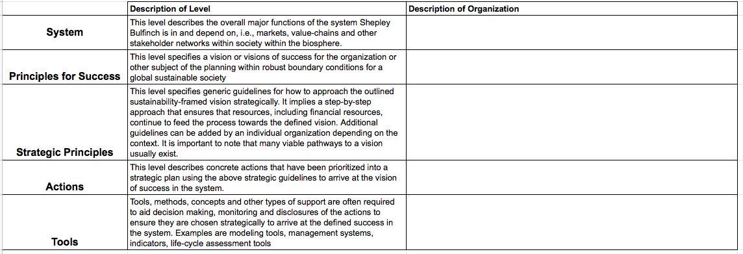
Step 1: Five-level Organizational Sustainability Systems Map
The first step was to identify what Shepley Bulfinch is doing in regards to five organization levels from system down to tools (Basile, 2011).

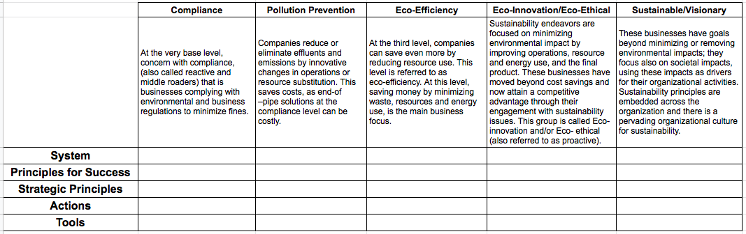
Step 2: Assessment of Current Sustainability Implementation
The second step was to identify how well Shepley Bulfinch is currently doing. This involved comparing the same organizational levels from Step 1 against five levels of sustainability implementation (from Compliance to Sustainable/Visionary) (Behravesh, 2017).

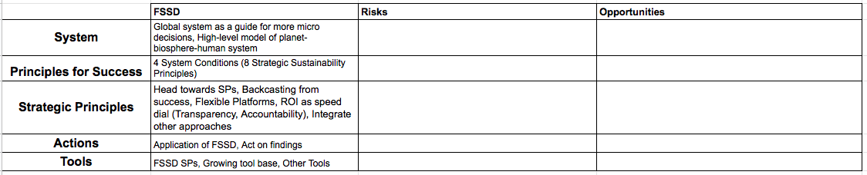
Step 3: Applying a Framework for Strategic Sustainable Development (FSSD)
Finally, step three compared the five levels of organization with the FSSD to identify risks and opportunities (Broman, 2017). The results of the assessment and the stakeholder engagement session will be used to inform a future education and action plan. These steps are to be repeated for three peer firms: Lake | Flato, Gensler, and WRNS Studio.

Firm Sustainability Engagement
After the business sustainability assessment was complete, the project moved into stakeholder engagement. The purpose of this step was to collaborate with the Shepley Bulfinch stakeholders. The desired outcome was to identify challenges, assets, and opportunities for both business operations, and the design process. During the stakeholder engagement session, I involved the members of the firm in an exercise following the Framework for Strategic Sustainable Development (FSSD) ABCD-procedure (Broman, 2017):
    - Participants learn about sustainability challenges and related opportunities, they share and discuss the subject of the planning endeavor and agree on a preliminary vision of success framed by the basic sustainability principles
    - Participants analyze and assess the current situation of the organization in relation to the vision and list current challenges as well as current assets to deal with the current challenges or that can in other ways potentially support the transition towards the vision
    - Participants apply creative methods such as brainstorming to identify possible solutions to the challenges and for capturing of the opportunities implied by the gap between the vision established in (A) and the current reality in (B). All possible actions that can help close the gap are listed, including ideas for how to utilize existing assets listed in (B). (Constraints implied by the current assets are temporarily disregarded. During this step, additional overall ‘end-goals’ may come up and then be added to the vision, or the goals already there might be adjusted based on the new ideas.)
    - Participants apply strategic guidelines to prioritize among the possible solutions established in (C) into a strategic plan. The most basic guidelines imply that early steps should be:
        - flexible platforms for forthcoming steps that, taken together, are likely to support society's transition towards sustainability and take the organization to the sustainability- framed vision, while striking a good balance between
        - the pace of progress towards the vision and
        - return on investment (Broman, 2017)

In Spring semester 2019 I took SOS 591/ASB 591: “Rethinking Community Engagement: Toward Ethical and Reflexive Engagement Approaches in Sustainability” class to help me build skills to engage with groups of people. The principles and concepts from the class that were employed in the engagement sessions included: epistemologies of engagement and knowledge, awareness of normativities, creating an ecology of actors, role of the researcher and institutions of higher education, power and engagement, ethics of engagement and participation, humble engagement, and shifting from engagement to co-creative collaboration.

- Outcomes/Findings
This section of the report includes summaries of the findings of the business sustainability assessments of Shepley Bulfinch, Lake | Flato, Gensler, and WRNS Studio. A full write up of the business sustainability assessments can be found in the Sustainability Consultant Report attached in Appendix A. This section also includes a write up of the sustainability engagement session with Shepley Bulfinch. This session included representation by a Principal, Director, Business Development/Marketing lead, Architecture team member, Interiors team member, and Project Support staff. Finally, this section summarizes the findings of the business sustainability assessments and envisions what a fully sustainable design firm could look like.

Business Sustainability Assessment: Shepley Bulfinch
Shepley Bulfinch is a national architecture and design firm with offices in Boston, Hartford, Houston, and Phoenix. Founded in 1874, the firm has a notable legacy of challenging convention, pioneering visionary design ideas, and collaborating with clients who seek to drive measurable change (Shepley, n.d.). Shepley Bulfinch is a family of 180, including more than 70 architects registered in 35 states (Shepley, 2019).

Sustainability
Shepley Bulfinch is a corporate member of the U.S. Green Building Council and a signatory to the AIA 2030 Challenge (Shepley, 2019).

Key Numbers
  - 55 LEED Accredited Professionals
  - 22 LEED Certified buildings
  - 8 more currently registered with LEED (Shepley, 2019)

Finch: Company Intranet
Shepley Bulfinch has a Sustainability page on Finch where employees can find resources and tools to incorporate sustainability into their projects. Teams can find explanations and tools to report their projects to be included in the AIA 2030 measurements. Employees can use Finch to share relevant articles highlighting successes on projects, or new strategies.

Sustainable Design Leadership Group
Shepley Bulfinch has many groups that cross office boundaries. Most groups meet twice a month through video conference calls. The Sustainable Design Leadership Group (SDLG) is dedicated to sustainability education and implementation at Shepley Bulfinch. SDLG works to help project teams start the sustainability conversations with their clients and project partners. SDLG is working on a number of initiatives and office engagements to educate and involve all Shepley Bulfinch employees in the sustainability conversation. These initiatives include firm educational opportunities and a ‘Wellness Framework’ which simply explains 12 sustainability principles and provides resources to set goals early on in the project.

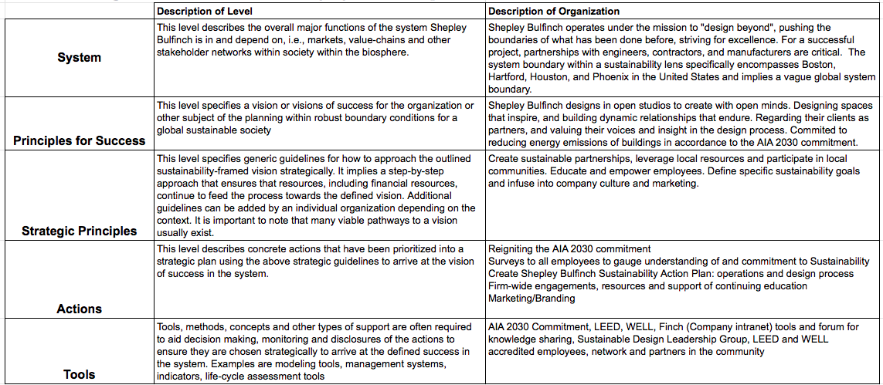
Step 1: Five-level Organizational Sustainability Systems Map

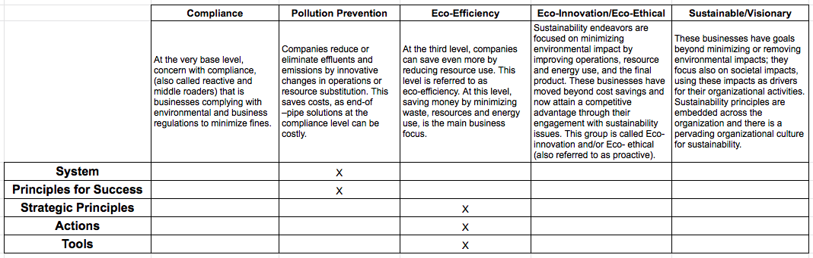
Step 2: Assessment of Current Sustainability Implementation

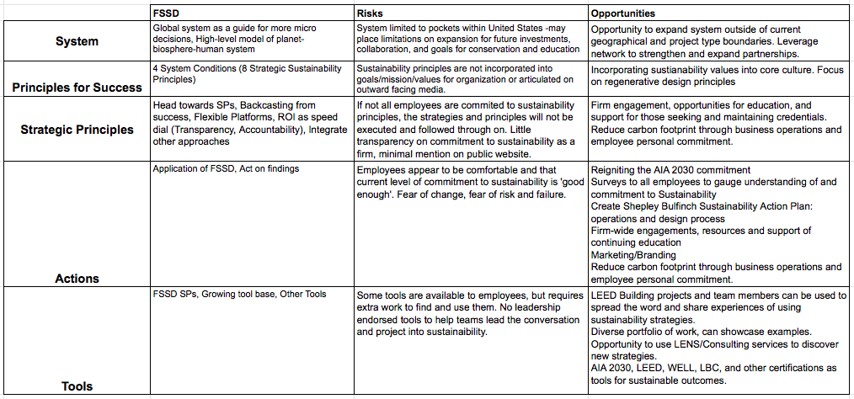
Step 3: Applying a Framework for Strategic Sustainable Development (FSSD)

Summary
The Business Sustainability Assessment revealed that there are many opportunities for Shepley Bulfinch to increase sustainability in the operations of the business as well as in the mission and culture of the firm. There are some tools and support for employees to use sustainability principles on projects, however the firm doesn’t seem to take a strong stand. The only mention of sustainability principles on Shepley Bulfinch’s website is a small note affirming their support of the AIA 2030 challenge and their USGBC membership (Shepley, 2019). The SDLG can be a huge asset in leading the firm to sustainability. These results will be combined with the outcomes of the Sustainability Engagement Session, and compared to the following assessments to inform an action and education plan.

Business Sustainability Assessment: Lake | Flato
Lake | Flato is located in San Antonio and Austin, Texas with over 100 professional staff, including 31 registered architects, 42 LEED-accredited professionals, and a sustainability manager and coordinator (Lake | Flato, 2019).

Sustainable Design Process
Lake | Flato’s work reflects the belief that sustainability and design are two sides of the same coin — balanced, integrated, and inseparable. They strive for a healthy, coherent, place-based approach to building. Lake | Flato’s design process is interactive, engaging, and explorative. For each project, they implement the following: early design phase energy modeling, simulation and analysis, passive strategies, active systems, renewable energy systems, and post-occupancy evaluations (Lake | Flato, 2017).

Sustainability Practices
Sustainable Business Practices
Since 2007 Lake | Flato has offset 100% of their office and travel-related carbon dioxide emissions. They track recycling and trash quantities and have achieved a recycling rate of 53% of waste that leaves the building, by weight, and choose vendors and caterers that promote minimizing waste. Through office initiatives, approximately 47% of their employees now commute to work via bicycle, foot or public transit (Lake | Flato, 2019).

AIA 2030 Commitment
For over 30 years, Lake | Flato has passionately advocated for environmental stewardship through sustainable design. They adopted the Architecture 2030 Challenge, and joined the AIA 2030 Commitment to measure their projects’ progress towards carbon neutrality. Each year they measure predicted energy use intensity (pEUI) and actual energy use intensity (EUI) for all of their projects. Making the connection between design intent and actual building performance is critical to their progress towards carbon neutrality by 2030 (Lake | Flato, 2017).

Committee on the Environment
Lake | Flato’s Committee on the Environment (COTE) works to advance, disseminate, and advocate — to the profession, the building industry, the academy, and the public — design practices that integrate built and natural systems, and enhance both the design quality and environmental performance of the built environment. Lake | Flato is active in national, regional and local AIA COTE organizations, helping to further advance the COTE’s mission. Ten Lake | Flato projects have received national AIA COTE Top Ten Project Awards, — the American Institute of Architects' highest honor for excellence in sustainable design (Lake | Flato, 2019).

LEED
Lake | Flato employs practical and thoughtful sustainable strategies that conserve resources, engage nature, and promote healthy living through buildings that are rooted to their place. They strive to create restorative environments that enhance understanding of our relationship to the natural world. Lake | Flato has 32 LEED Certified projects, 24 LEED registered projects, and one Living Building Challenge Registered project (Lake | Flato, 2019).
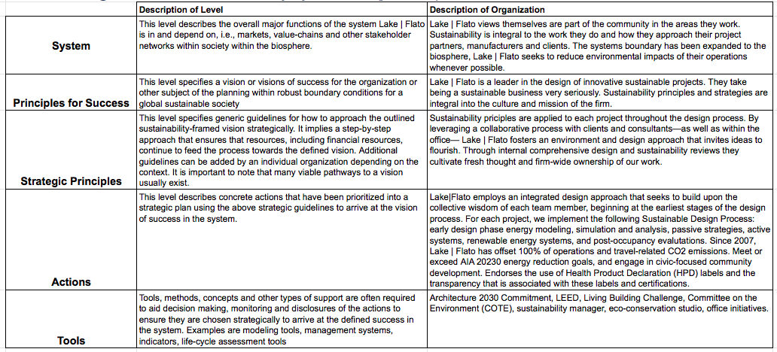
Step 1: Five-level Organizational Sustainability Systems Map

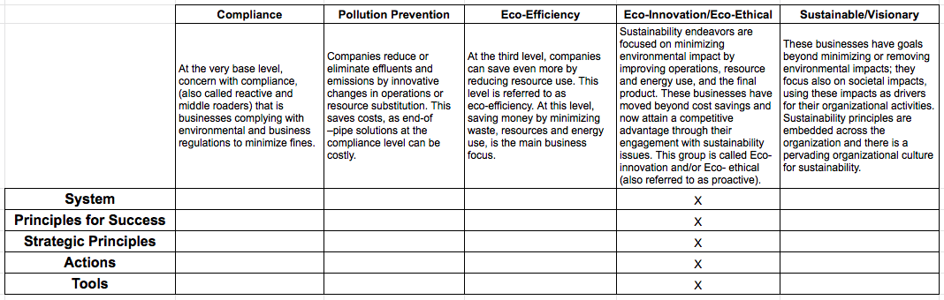
Step 2: Assessment of Current Sustainability Implementation

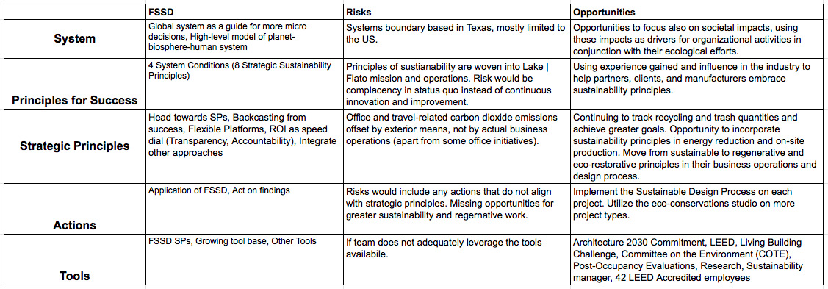
Step 3: Applying a Framework for Strategic Sustainable Development (FSSD)

Summary
Lake | Flato is an inspirational leader in sustainable design. Sustainability principles are integrated into the culture and mission of the firm. The website and branding materials have sustainability front and center, sharing the process and tools they use on each project. Lake | Flato goes even further than just thinking about sustainability in their ‘eco-conservation studio for innovative design’ (Seward, 2019). Ten projects have received national AIA COTE Top Ten Project Awards, — the highest honor for excellence in sustainable design. In terms of their business operations, Lake | Flato has offset 100% of their office and travel-related carbon dioxide emissions since 2007. They track recycling and trash quantities and have achieved a recycling rate of 53% of their office waste (Lake | Flato, 2019).

Business Sustainability Assessment: Gensler
Gensler is a global design firm grounded in the belief that design strategy optimizes performance and enriches experience. They have 6,000 practitioners networked across 46 offices who use a global perspective and local presence to innovate at every scale. Whether they are refreshing a retailer’s brand, planning a new urban district, or designing a super tall building, they strive to make the everyday places people occupy more inspiring, more resilient, and more impactful (Gensler, 2019).

Sustainability
Design is being redefined by sustainability. Gensler is continually evolving their organization and design processes to deliver innovation aimed at helping clients and communities become more resourceful, resilient and regenerative. They see sustainable design as a “triple win”: good for business, people and the planet. Since 1970, when Gensler designed an energy-efficient “office of the future” for Pacific Gas & Electric, their design practice has considered how decisions made today affect our lives tomorrow. Today, Gensler is a global sustainability leader (Gensler, 2019).

Key Metrics
  - 600+ million square feet of sustainable work
  - 110 million square feet of LEED certified projects
  - 188 million square feet registered for LEED certification
  - 150 million tons of waste diverted
  - 1.2 billion gallons of water saved annually
  - 700+ USGBC certified projects
  - 1200+ LEED accredited professionals (Gensler, 2019)

Sustainable Leadership
Gensler uses a whole systems view to gain an understanding of their client’s context and challenges, applying the appropriate lenses of community, wellness, ecology, materials, water and energy. This approach reveals connections between lenses, enabling design solutions that enhance human wellness, performance, collaboration and experience (Gensler, 2019).

Design Performance
Gensler’s integrated sustainability delivery model provides complete sustainable design services including LEED strategy and LEED documentation for existing buildings, new construction, commercial interiors and neighborhood development projects (Gensler, 2019).

The Environment
Gensler is committed to protecting the environment, and many of the cities in which they work are already feeling the effects of climate change. Gensler designs resilient and sustainable buildings, communities, and cities. They develop innovative practices to mitigate the effects of climate change and combat its root causes. Gensler strives to provide support for the creation, design, and preservation of open space and the natural environment (Gensler, 2019).

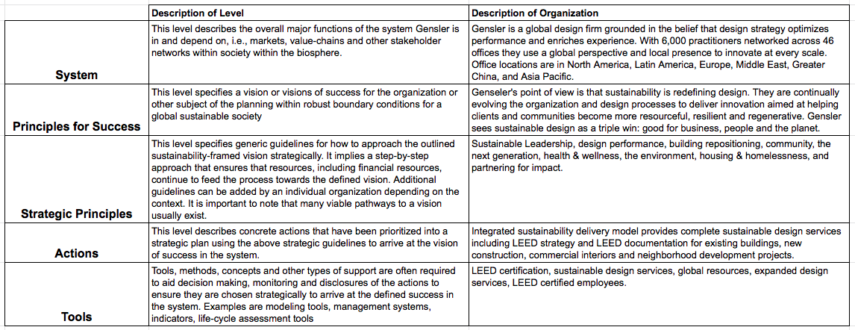
Step 1: Five-level Organizational Sustainability Systems Map

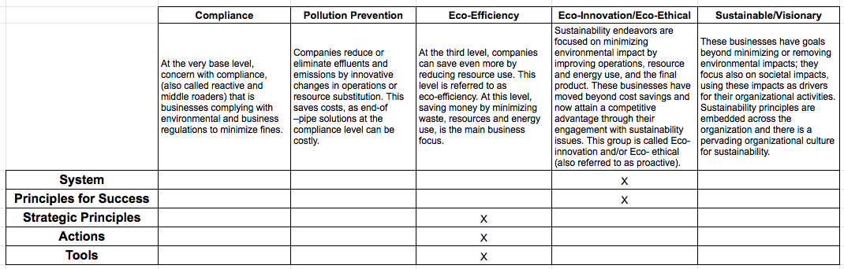
Step 2: Assessment of Current Sustainability Implementation

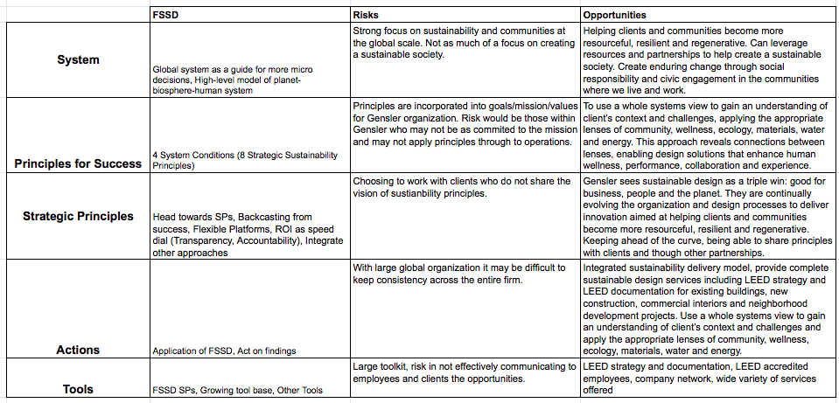
Step 3: Applying a Framework for Strategic Sustainable Development (FSSD)

Summary
Gensler has sustainability principles embedded into the global culture of the firm. It is unique in its global reach, and in the variety of services offered. Gensler has developed innovative practices to mitigate the effects of climate change and combat its root causes. They use a whole systems view to gain understanding of their client’s specific context and challenges, applying the appropriate lenses of community, wellness, ecology, materials, water, and energy. They seek to provide support for the creation, design, and preservation of open space and the natural environment. Gensler designs resilient and sustainable buildings, communities, and cities (Gensler, 2019).

Business Sustainability Assessment: WRNS Studio
WRNS Studio is a mid-sized architectural and planning firm with a diverse portfolio of high-quality, sustainable design with offices in San Francisco, New York, Honolulu, and Seattle. WRNS Studio’s staff of 170 work in creative studios on these project types: workplace, civic, education, transportation, and urban mixed-use. Recognized for identity-rich, site-specific design at any scale, they bring an informed, unique point of view to each project (WRNS Studio, n.d.).

Sustainability
Today's most transformative organizations have entrusted WRNS Studio with crafting environments that spurs innovation, connectivity, and community. They are redefining what it means to be comfortable, healthy and productive at home, work, and school. WRNS thinks a lot about public/private interface, and how it might be enriched. Problem solvers at heart, they tinker in models, garages, even under the hood of their design software. When WRNS talks about sustainability, they consider the ways in which wellness and resource conservation support economic, social, and environmental health. All of this work is bracketed by a vigorous culture of education, linking academia with practice to advance architectural excellence (WRNS Studio, n.d.).

Sustainability Champion Spotlight
Pauline Souza AIA, LEED Fellow, LBC Hero, USGBC National Green Schools Advocate, USGBC Green Schools National Chair / Partner, Director of K - 12 and Community Studio is one example of the passion for sustainability at WRNS Studio.
Pauline’s practice is rooted in a deep respect for people — those with whom she’s working with to build something healthy, inspirational, and functional, and those who will spend their days in the environments they craft. With three decades of experience, she has dedicated her career to the building and advocacy of high-quality sustainable environments that serve our communities, with a particular focus on education and civic projects. The driving force behind her work is a passion for advancing the role of design as a medium for building a more sustainable future in which the next generation can flourish. What designers build has a huge impact on our health and our planet, and for Pauline, it is critical to share what she has learned about holistic sustainability with just about anyone who will listen — clients, project teams, consultants, kids, and the broader community (WRNS Studio, n.d.).
Pauline brings a tenacious leadership approach rooted in the idea that good design and sustainable design are synonymous. As WRNS Studio’s Director of Sustainability, she is responsible for implementing sustainable design principles into all of the studio’s projects and business operations. A recognized leader within the green building movement, she currently serves as a USGBC Green Schools National Chair, and has served as the Green Schools Advocate for the USGBC Green Schools Campaign since 2007. She speaks regularly at conferences and contributes often to publications focused on sustainability (WRNS Studio, n.d.).
As a LEED Fellow, WRNS Studio’s Director of K-12 and Community Studio, Pauline has lead award-winning and community-focused projects like Sacred Heart Schools Net Zero Stevens Library and the Atherton Civic Center. She is currently leading a large effort with the Department of Hawaii to develop a statewide sustainability master plan for all new public schools. She also led the Watsonville Water Resources Center (LEED Platinum and Net Zero Electricity) which earned the 2010 AIA COTE Top Ten Green Project award — the highest honor for sustainable design in our industry. Pauline was recently awarded the USGBC Green Business Leader Award, presented at the 2016 Green Schools Conference and the UCSGBC Greenest Apple Award. Pauline earned her Bachelor in Architecture from the University of California, Berkeley (WRNS Studio, n.d.).

JUST
WRNS Studio has earned the distinction of being the first JUST labeled architecture firm with a head office in the State of California. JUST is a voluntary disclosure tool for organizations - including how they treat their employees and where they make financial and community investments (International Living Future Institute, 2019). The JUST Label is reflective of WRNS Studio's long standing commitment to sustainable design and the role that social equity plays in truly sustainable organizations. “Being the first architecture firm with a head office in California to earn the JUST Label is an honor and a responsibility. If we can spark an industry trend in this direction, everyone wins,” says Melinda (Rosenberg, 2019).
The International Living Futures Institute describes the JUST Label as a nutrition label for socially just and equitable organizations, which allows companies and organizations to disclose their commitments to the following social equity indicators:
  - Diversity
  - Equity
  - Safety
  - Worker Benefit
  - Local Benefit
  - Stewardship

These indicators align closely with WRNS’ values, and as they’ve grown, their commitment to these principles has only amplified (Rosenberg, 2019).

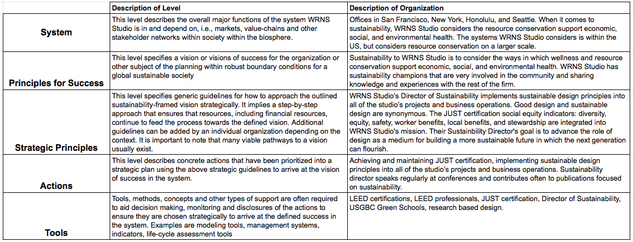
Step 1: Five-level Organizational Sustainability Systems Map

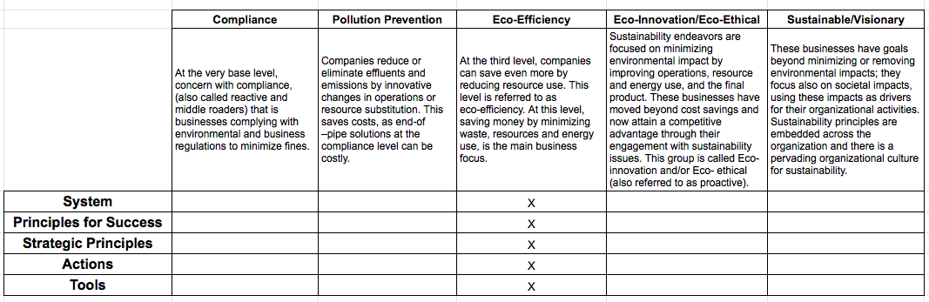
Step 2: Assessment of Current Sustainability Implementation

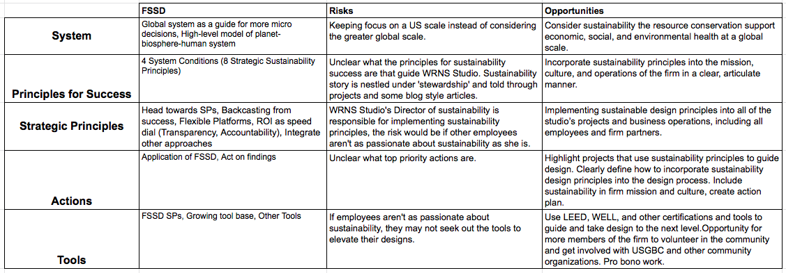
Step 3: Applying a Framework for Strategic Sustainable Development (FSSD)

Summary
WRNS Studio includes sustainability under ‘stewardship’ on their website. Sustainability is listed as a separate project type to highlight the strategies used. Pauline Souza, the Director of Sustainability, seems to be the driving force behind sustainability efforts. She is responsible for implementing sustainable design principles into all of the studio’s projects and business operations. WRNS Studio is concerned with social justice, and recently earned their JUST label. They are committed to the JUST principles of diversity, equity, safety, worker benefit, local benefit, and stewardship (Rosenberg, 2019). When they talk about sustainability, WRNS Studio considers the ways in which wellness and resource conservation support economic, social, and environmental health. WRNS Studio is dedicated to education and research-based design (WRNS Studio, n.d.).

Summary of Business Sustainability Assessments
If we were to rank the assessed firms in terms of sustainable operations and design practice, Lake | Flato would be the clear leader. Sustainability principles are integrated into the very fabric of the firm. The website clearly states their commitment to sustainability and outlines how the principles are practiced on every project. They strive for innovative design with their eco-conservation studio (Seward, 2019). Gensler, and WRNS would be a close second and third. Gensler has a global presence and a wide range of services. With over 700 projects LEED certified, sustainability is a part of the firm culture. Taking it a step further, Gensler has developed innovative practices when they work in communities to mitigate the effects of climate change and combat its root causes (Gensler, 2019). WRNS considers sustainability to be under their stewardship. With their sustainability champion leading the way, they seek to link academia with practice and advance the architectural experience. WRNS also values transparency and social equity as evident by their Just certification (WRNS Studio, n.d.).
Shepley Bulfinch would be fourth in comparison to these peer firms. One big difference is the appearance of commitment to sustainability. On their website, the only mention of anything related to sustainability is a small note that Shepley Bulfinch is a corporate member of the U.S. Green Building Council and a signatory to the AIA 2030 Challenge (Shepley, 2019). While sustainability may be implied in more discreet ways in the description of firm history and culture such as “the firm has a notable legacy of challenging convention, pioneering visionary design ideas, and collaborating with clients who seek to drive measurable change” (Shepley, n.d.). In discussion with some members of the SDLG team, I discovered that in the past this point was made to leadership and the decision was made not to separate any sustainability efforts from the projects. From what I could find, there was no sustainable design strategies highlighted on the project pages, although Shepley Bulfinch has many LEED Certified projects (most recently an Austin City Library project in partnership with Lake | Flato). There are additional resources for sustainable design available to employees through the company intranet and the Sustainable Design Leadership Group. The business sustainability assessment has brought to light some great examples of sustainability in other firms, and opportunities for Shepley Bulfinch to improve.

Sustainability Engagement Session: Shepley Bulfinch
This sustainability engagement session held on March 21st, 2019 followed the Framework for Strategic Sustainable Development (FSSD) ABCD-procedure (Basille, 2017). This session included representation by a Principal, Director, Business Development/Marketing lead, Architecture team member, Interiors team member, and Project Support staff.

Part A: Vision
  - Sustainability integrated in all levels of projects
    - Part of the culture, part of ethos, across all practice groups
      - Higher ed/libraries – pushed to greater degree (clients come with higher level of knowledge)
    - Shepley Bulfinch leading the conversation
    - Shepley Bulfinch being a leader in the construction and design industry
  - Sustainability obvious part of the firm identity
  - Transparency
  - People can easily tell “They care about sustainability”
  - Thinking on a regenerative level, what can we be doing to make this project support the community it is nested it – better for the people and the planet.
  - Positive conversation

Part B: Assess Current Situation
Challenges
  - Employees are comfortable, conditioned, and have an “it’s good enough” attitude
  - It’s too hard, overwhelming to try and change
  - Lack of knowledge at leadership level
  - Fear of change/failure/risk
  - Doesn’t appear to be a priority in branding/marketing/HR
  - Lack of transparency

Assets
  - LEED Building projects
  - People:
    - Sonja Bochart
    - Matthew Gifford
    - Carol Wedge
  - Diverse work/portfolio
  - LENS/Consulting services
  - Language that we use in explaining to clients in a way they can relate
    - “sustainable” vs “resilient”
  - Highlighting stories
    - LEED Platinum project - Austin Public Library: Sid Bowen, Jim Chambers – how process worked partnered with Lake | Flato
    - Smith College: Siiri Julianus - materials
    - Groton School

Part C: Possible Solutions
  - Better consultants – field leaders in sustainability
  - Better partnerships
  - Leverage Sonja’s contacts
    - LBC
  - Leverage local resources
    - Community participation
    - AIA
  - Motivate Leadership
    - Engage all staff
  - Attend conferences
  - Invest in education of employees
    - Accreditation/Continuing education
  - Market what we have
  - Update website to reflect sustainability goals/principles

Part D: Strategic Plan
  - Reigniting the AIA 2030 commitment
  - Surveys to all employees to gauge understanding of and commitment to Sustainability
  - Create Shepley Bulfinch Sustainability Action Plan
    - Include SDLG initiatives:
      - Wellness Framework
      - Well-thy Initiative
  - Elevating Proposals/Interviews
    - Include sustainability principles and strategies when seeking jobs
  - Firm-wide engagements
    - Finch Posts
    - Presentations
    - Workshops
    - Include firm sustainability commitment in:
      - Candidate Interviews
      - On-boarding
  - Marketing/Branding
    - Show sustainability commitment in culture

Vision of a Sustainable Architecture Firm (SAF)
Walking into the offices of SAF Design you can see, hear, and feel the commitment to true sustainability. Natural daylight diffuses across the room filled with plants and biophilic design elements. SAF sets the example for their clients by using renewable energy to power their offices and have been carbon neutral for years. One of the integrated design teams is having a kickoff meeting for a new project. Each of the team members shares priorities and goals, and together they begin to align their expertise to create the most sustainable plan for this building and site.
The marketing messages on their website and other materials clearly show how sustainable principles are integrated into the culture of the firm. The online portfolio is full of successful sustainable and regenerative buildings. The research portion of the website highlights studies on their buildings and research into the latest technology to create buildings that contribute to the health of the users and the environment.
SAF employees are engaged in the community, often volunteering their time in schools and other events. They are active in many professional organizations and advocate for more sustainable building codes and policies. SAF employees integrate sustainability into their designs, and model sustainable behavior in their personal lives. Many employees bike to work, and once a month they have an in-office potluck with produce from their gardens or local farmer’s markets.

- Recommendations
These recommendations were informed by the business sustainability assessment of Shepley Bulfinch, Lake | Flato, Gensler, and WRNS Studio. The results of the sustainability engagement session with Shepley Bulfinch were also used to create the focus areas. During the ABCD-procedure (Broman, 2017) the discussion of what a ‘Sustainable Shepley Bulfinch’ could look like focused on having sustainability integrated into the identity and culture of the firm. Making their projects support the communities they are nested in – better for the people and the planet with Shepley Bulfinch leading the conversation on sustainability. Shepley Bulfinch could become a more sustainable firm by focusing on four areas: company culture, education, marketing/branding, and business operations.

Company Culture
Create a company culture that has sustainability integrated at every level. Lead the conversation and truly ‘design beyond.’
  - Develop a Sustainability Action Plan to include sustainable business operations, AIA 2030 Commitment, and design tools and processes
  - Support Sustainable Design Leadership Group (SDLG) Initiatives:
    - Wellness Framework
    - Well-thy Initiative
  - Have all projects report necessary data for AIA 2030 goals
  - Pursue JUST Certification

Education
Support employees in learning about sustainability tools and practices through a variety of opportunities.
  - Firm-wide engagements:
    - Finch Posts
    - Presentations
    - Workshops
  - Support for employees seeking and maintaining accreditations (Such as LEED AP and WELL AP)
  - Lunch and Learns/CEUs
    - Invite Manufacturer Reps to present on the sustainable qualities of their products
    - Webinar viewing opportunities on sustainable building strategies
  - Support and host community events related to sustainability

Marketing/Branding
Make it very clear to everyone that Shepley Bulfinch is a firm that cares about people and the environment and is striving to lead the way to sustainable, regenerative design.
  - Shepley Bulfinch Website
    - Add sustainability commitment and principles to firm description page
    - Include accreditations (such as LEED AP) on employee pages
    - Highlight how many projects have received certifications
  - Elevate project proposals and Interviews by including sustainable design solutions in all proposals and having the conversation in interviews in a way that is natural and inspiring

Business Operations
Lead by example by integrating sustainability into company culture, business operations, and design development
  - Green Business Opportunities
    - Align business operations with sustainability principles by working with an organization such as the Green Business Bureau (Vertuous, 2016).
    - Or have each office certify separately. The City of Phoenix Green Business Leader program (City of Phoenix, 2018) for example, would be a good starting point.

In addition to these focus areas, I would suggest that Shepley Bulfinch continue to seek input from all employees to help guide the mission and future of Shepley Bulfinch. Clearly define what the priorities are (for business operations, and the design processes) and articulate them plainly. Dive deeper into strategic partnerships and use the influence as a successful firm to help create positive change in the building design and construction industry.

- Conclusions
Buildings have many negative effects on the environment and people. The development industry needs to reduce those impacts to improve sustainable outcomes. Opportunities for the biggest gains in sustainable development begin with design professionals like Shepley Bullfinch. Shepley Bulfinch influences millions of square feet of new and existing buildings per year. By making even small improvements, there is great potential to increase sustainability within the firm and influence the industry through their partnerships, consultants, and clients.
The results of the investigation into the business sustainability of Shepley Bulfinch revealed some opportunities for improvement. As we found from Lake | Flato’s example, it is possible to engrain sustainability principles into the mission, culture, and day to day processes of the firm. From Gensler and WRNS Studio we saw the importance of sustainability champions and the potential of innovative practices to mitigate the effects of climate change and combat root causes.
The sustainability engagement session brought to life a vision of what a ‘Sustainable Shepley Bulfinch’ could look like and formed first steps towards that vision. A compilation of the business sustainability assessments and the engagement session clearly formed four focus areas: company culture, education, marketing/branding, and business operations. Shepley Bulfinch has many assets and opportunities that could transform the firm into a sustainability leader in the building design and development industry.
This project had opportune timing. The Sustainable Design Leadership Group (SDLG) at Shepley Bulfinch has been developing a “Wellness Framework” over the last two years and is close to beta testing it with key projects. The framework includes a toolkit to support the sustainability conversation with clients and project partners. The hope is to introduce the framework to the firm at the second quarterly meeting. Some members of the SDLG have also recently started to reenergize the firm’s commitment to the Architecture 2030 challenge and others have started working on a Sustainability Action Plan. At the last SDLG meeting, Shepley Bulfinch’s CEO sat in and offered direction and encouragement. I have high hopes that the results and recommendations of this report will be put to good use in the near future.
There could be an opportunity for another student to continue this work. The work already done was a broad overview of the business as a whole - operations, and design processes. Future work could focus on one or the other - a deeper dive into the business operations for instance. A natural progression of this work would be to create a sustainability action plan for Shepley Bulfinch.

- Appendices and Acknowledgements

Appendix A: Copy of Sustainability Consultation Report: Shepley Bulfinch

Sustainability Consultation Report: Shepley Bulfinch


By Tari Wager

Table of Contents

1. Introduction 3
2. Findings 5
Business Sustainability Assessment: Shepley Bulfinch 5
Business Sustainability Assessment: Lake | Flato 8
Business Sustainability Assessment: Gensler 13
Business Sustainability Assessment: WRNS Studio 18
Summary of Business Sustainability Assessments 22
Sustainability Engagement Session: Shepley Bulfinch 23
Vision of a Sustainable Architecture Firm (SAF) 26
3. Recommendations 27
Company Culture 27
Education 27
Marketing/Branding 27
Business Operations 28
4. Additional Resources 29
The Just Label 29
The 2030 Challenge 31
The Habits of High-Performing Firms 32
AIA 2030 Sustainability Action Plan 34
Carbon 36
5. References 38
1. Introduction
The building design and construction industry plays an important role in satisfying the needs of society, enhancing the quality of life, and contributing to the economic growth of a country. However, it has been heavily criticized for being a major contributor to carbon emissions, environmental degradation, and global warming due to its utilization of a large proportion of natural resources and energy consumption (Doan, 2017).
Building design and construction directly affects the environment, economy, and human health. Polluted air is the number one environmental cause of premature mortality worldwide. Concentrations of some pollution indicators can be 2-5 times higher indoors compared to outdoors (IWBI, 2017). The average American spends 90% of their time indoors (Sethi, 2018). Building materials, ventilation system design, finishes, furniture, and equipment (FF&E) have the potential to positively or negatively affect human health.
The building sector is a large consumer of environmental resources and a force in the economy. The industry consumes 33% of global resources, 16% of global freshwater withdrawals, 25% of wood harvested, and 40% of all raw materials. The building industry also generates a large amount of construction and demolition waste, accounting for 40% of total solid waste in developed countries. The construction sector is responsible for major energy consumption, accounting for 40-50% of all energy usage and anthropogenic greenhouse gas emissions globally (Doan, 2017). In the United States, private construction spending reached around 899 billion dollars in 2016. New construction is forecast to reach over 1.4 trillion dollars by 2021 (Laporte, 2018). In addition to the new construction, approximately two-thirds of the building area that exists today will still exist in 2050 (Architecture 2030, n.d.). Design and construction decisions have long lasting and far reaching effects.
The creation of a building is a highly complex process, involving many stakeholders. The client or developer initiates the project, then teams of architects, designers, specialists, and consultants create and document plans for the building. Contractors, subcontractors, and laborers bring the plans into reality. Usually, the selection and specification of materials and FF&E falls to the design team. Vendors and product reps support design teams and can influence selections. The design of the building and FF&E selection are often ultimately determined by the client’s budget and needs, the preferences of the design team and contractors, and by building and city code, zoning and permitting requirements. There are no simple solutions to spark lasting change in the building industry.
To create a sustainable building, all parties have to be in agreement. Materials need to be sourced from sustainable locations. Building materials and interior finishes need to be free of toxic chemicals. Local zoning and building codes have to be conducive to the desired technology and building techniques. Collaboration, innovation, and creativity are all necessary for a successful project. There are opportunities for sustainability in the design process and within operations of each individual business. If design professionals are knowledgeable of and passionate about sustainability, they can use their influence to create sustainable outcomes in their projects.
Buildings create many negative effects on the environment and people. The building sector is a field with immediate need for reducing environmental impacts (Mulutiene, 2012). Many architects, engineers, builders, and owners are taking steps toward sustainability, but they need to be taken more quickly and adopted more broadly (Edelstein, 2018).

2. Findings
This section of the report includes the findings of the business sustainability assessments of Shepley Bulfinch, Lake | Flato, Gensler, and WRNS Studio. This section also includes a write up of the sustainability engagement session with Shepley Bulfinch. Finally, this section summarizes the findings of the business sustainability assessments and envisions what a fully sustainable design firm could look like.

Business Sustainability Assessment: Shepley Bulfinch
Shepley Bulfinch is a national architecture and design firm with offices in Boston, Hartford, Houston, and Phoenix. Founded in 1874, the firm has a notable legacy of challenging convention, pioneering visionary design ideas, and collaborating with clients who seek to drive measurable change (Shepley, n.d.). Shepley Bulfinch is a family of 180, including more than 70 architects registered in 35 states (Shepley, 2019).

Project Categories
  - Education
  - Libraries
  - Planning
  - Healthcare
  - Mixed Use
  - Science
  - Student Life
  - Pediatrics

Sustainability
Shepley Bulfinch is a corporate member of the U.S. Green Building Council and a signatory to the AIA 2030 Challenge (Shepley, 2019).

Key Numbers
  - 55 LEED Accredited Professionals
  - 22 LEED Certified buildings
  - 8 more currently registered with LEED

Finch: Company Intranet
Shepley Bulfinch has a Sustainability page on Finch where employees can find resources and tools to incorporate sustainability into their projects. Teams can find explanations and tools to report their projects to be included in the AIA 2030 measurements. Employees can use Finch to share relevant articles highlighting successes on projects, or new strategies.

Sustainable Design Leadership Group
Shepley Bulfinch has many groups that cross office boundaries. Most groups meet twice a month through video conference calls. The Sustainable Design Leadership Group (SDLG) is dedicated to sustainability education and implementation at Shepley Bulfinch. SDLG works to help project teams start the sustainability conversations with their clients and project partners. SDLG is working on a number of initiatives and office engagements to educate and involve all Shepley Bulfinch employees in the sustainability conversation. These initiatives include firm educational opportunities and a ‘Wellness Framework’ which simply explains 12 sustainability principles and provides resources to set goals early on in the project.

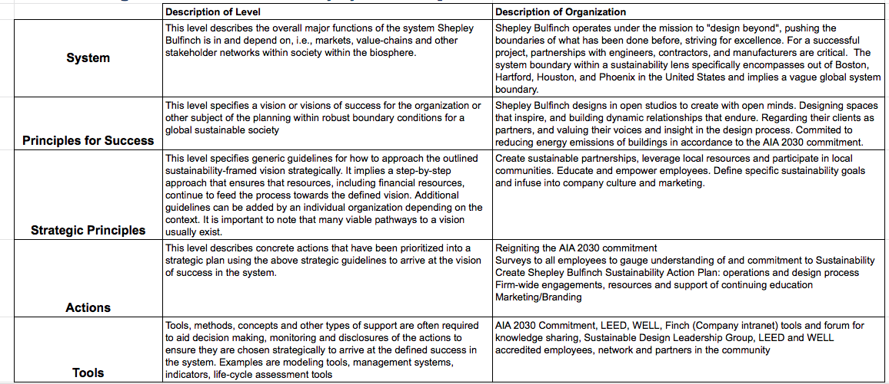
Step 1: Five-level Organizational Sustainability Systems Map

Step 2: Assessment of Current Sustainability Implementation

Step 3: Applying a Framework for Strategic Sustainable Development (FSSD)

Summary
The Business Sustainability Assessment revealed that there are many opportunities for Shepley Bulfinch to increase sustainability in the operations of the business as well as in the mission and culture of the firm. There are some tools and support for employees to use sustainability principles on projects, however the firm doesn’t seem to take a strong stand. The only mention of sustainability principles on Shepley Bulfinch’s website is a small note affirming their support of the AIA 2030 challenge and their USGBC membership (Shepley, 2019). The SDLG can be a huge asset in leading the firm to sustainability. These results will be combined with the outcomes of the Sustainability Engagement Session, and compared to the following assessments to inform an action and education plan.

Business Sustainability Assessment: Lake | Flato
Lake | Flato is located in San Antonio and Austin, Texas with over 100 professional staff, including 31 registered architects, 42 LEED-accredited professionals, and a sustainability manager and coordinator (Lake | Flato, 2019).

Project Types
  - Eco-Conservation
  - Schools
  - Higher Education
  - Houses
  - Ranches
  - Porch House
  - Civic/Cultural
  - Development
  - Hospitality
  - Sustainability

Sustainable Design Process
Lake | Flato’s work reflects the belief that sustainability and design are two sides of the same coin — balanced, integrated, and inseparable. They strive for a healthy, coherent, place-based approach to building. Lake | Flato’s design process is interactive, engaging, and explorative. For each project, they implement the following:
- Early Design Phase Energy Modeling
    - During Pre-design, carefully study the unique context of each project to determine which energy strategies are attainable, taking into account the climate and microclimate, site orientation, natural resources and materials, and cost considerations and payback scenarios (Lake | Flato, 2019).
- Simulation and Analysis
    - Use computer simulations to perform building analysis for all projects. From preliminary climate analysis to daylight, solar radiation and exterior views analysis, this process informs early design and building systems to create comfortable and high performing environments (Lake | Flato, 2019).
- Passive Strategies
    - The study of vernacular architecture, designed well before the advent of modern mechanical systems, provides enduring lessons of building orientation, shading, natural ventilation and rainwater collection. These basic principles often provide a starting point for passive design, which is then refined with the latest scientific approaches to the thermal envelope, passive ventilation, daylight harvesting and water collection (Lake | Flato, 2019).
- Active Systems
    - After employing appropriate passive strategies, they consider how advanced technologies can be applied in innovative and practical ways, identifying the active systems that meet the project’s requirements for low energy and water consumption, as well as energy generation (Lake | Flato, 2019).
- Renewable Energy Systems
    - In alignment with the AIA 2030 Commitment, Lake | Flato is currently striving for a 70% energy reduction over the national average for each building type. They can achieve this target without renewable energy systems, but can employ renewable energy when clients have more rigorous sustainability goals, such as net-zero energy consumption (Lake | Flato, 2019).
- Post-Occupancy Evaluation
    - Post-occupancy evaluation is an important tool to ensure our buildings are performing as intended, with feedback that improves the design process and their clients’ operations. Evaluation helps occupants understand the impact of their behavior on the building’s resource consumption, thus often reducing consumption even further (Lake | Flato, 2019).

Other Sustainability Practices:
Sustainable Business Practices
Since 2007 Lake | Flato has offset 100% of their office and travel-related carbon dioxide emissions. They track recycling and trash quantities and have achieved a recycling rate of 53% of waste that leaves the building, by weight, and choose vendors and caterers that promote minimizing waste. Through office initiatives, approximately 47% of their employees now commute to work via bicycle, foot or public transit (Lake | Flato, 2019).

AIA 2030 Commitment
For over 30 years, Lake | Flato has passionately advocated for environmental stewardship through sustainable design. They adopted the Architecture 2030 Challenge, and joined the AIA 2030 Commitment to measure their projects’ progress towards carbon neutrality. Each year they measure predicted energy use intensity (pEUI) and actual energy use intensity (EUI) for all of their projects. Making the connection between design intent and actual building performance is critical to their progress towards carbon neutrality by 2030 (Lake | Flato, 2017).

Committee on the Environment
Lake | Flato’s Committee on the Environment (COTE) works to advance, disseminate, and advocate — to the profession, the building industry, the academy, and the public — design practices that integrate built and natural systems, and enhance both the design quality and environmental performance of the built environment. Lake | Flato is active in national, regional and local AIA COTE organizations, helping to further advance the COTE’s mission. Ten Lake | Flato projects have received national AIA COTE Top Ten Project Awards, — the American Institute of Architects' highest honor for excellence in sustainable design (Lake | Flato, 2019).

LEED
Lake | Flato employs practical and thoughtful sustainable strategies that conserve resources, engage nature, and promote healthy living through buildings that are rooted to their place. They strive to create restorative environments that enhance understanding of our relationship to the natural world. Lake | Flato has 32 LEED Certified projects, 24 LEED registered projects, and one Living Building Challenge Registered project (Lake | Flato, 2019).

Transparency
Lake | Flato is committed to making informed decisions regarding the architectural building products they specify, and has endorsed the use of the Health Product Declaration (HPD), an open standard for manufacturers to accurately disclose product contents using a standard, consistent, and transparent format. As an endorser, Lake | Flato has been asking manufacturers to adhere to the guidelines of the HPD and provide the required documentation to their firm (Lake | Flato, 2019).

Community Involvement
Since inception, Lake | Flato has always engaged in civic-focused community development. They often team with other local groups, like the Nature Conservancy or the Green Spaces Alliance, to educate the public about alternative sustainable solutions in design. Lake | Flato actively promotes the health and well-being of the community, uniting with other contingencies that do the same. Through the 1+ Architecture program they also donate a percentage of our annual billable time to nonprofit work, benefiting organizations such as the San Antonio Food Bank and Big Brothers Big Sisters. Designers are encouraged to participate in organizations that strengthen and give back to the local community (Lake | Flato, 2019).

Step 1: Five-level Organizational Sustainability Systems Map

Step 2: Assessment of Current Sustainability Implementation

Step 3: Applying a Framework for Strategic Sustainable Development (FSSD)

Summary
Lake | Flato is an inspirational leader in sustainable design. Sustainability principles are integrated into the culture and mission of the firm. The website and branding materials have sustainability front and center, sharing the process and tools they use on each project. Lake | Flato goes even further than sustainability in their eco-conservation studio for innovative design (Seward, 2019). Ten projects have received national AIA COTE Top Ten Project Awards, — the highest honor for excellence in sustainable design. In terms of their business operations, Lake | Flato has offset 100% of their office and travel-related carbon dioxide emissions since 2007. They track recycling and trash quantities and have achieved a recycling rate of 53% of their office waste (Lake | Flato, 2019).

Business Sustainability Assessment: Gensler
Gensler is a global design firm grounded in the belief that design strategy optimizes performance and enriches experience. They have 6,000 practitioners networked across 46 offices who use a global perspective and local presence to innovate at every scale. Whether they are refreshing a retailer’s brand, planning a new urban district, or designing a super tall building, they strive to make the everyday places people occupy more inspiring, more resilient, and more impactful (Gensler, 2019).

Locations
North America
Atlanta, Austin, Baltimore, Boston, Charlotte, Chicago, Dallas, Denver, Detroit, Houston, La Crosse, Las Vegas, Los Angeles, Miami, Minneapolis, Morristown NJ, New York, Newport Beach, Oakland, Philadelphia Phoenix, Portland, Raleigh-Durham, San Antonio, San Diego, San Francisco, San Jose, Seattle, Tampa,Toronto, Washington, D.C.

Latin America
Bogotá, Mexico City, San José Costa Rica, São Paulo

Europe
Birmingham, London, Munich

Middle East
Abu Dhabi Dubai

Greater China
Beijing, Hong Kong, Shanghai

Asia Pacific
Bangalore, Bangkok, Singapore, Sydney, Tokyo

Sustainability
Design is being redefined by sustainability. Gensler is continually evolving their organization and design processes to deliver innovation aimed at helping clients and communities become more resourceful, resilient and regenerative. They see sustainable design as a triple win: good for business, people and the planet. Since 1970, when Gensler designed an energy-efficient “office of the future” for Pacific Gas & Electric, their design practice has considered how decisions made today affect our lives tomorrow. Today, Gensler is a global sustainability leader (Gensler, 2019).

Key Metrics
  - 600+ million square feet of sustainable work
  - 110 million square feet of LEED certified projects
  - 188 million square feet registered for LEED certification
  - 150 million tons of waste diverted
  - 1.2 billion gallons of water saved annually
  - 700+ USGBC certified projects
  - 1200+ LEED accredited professionals (Gensler, 2019)

Sustainable Leadership
Gensler uses a whole systems view to gain an understanding of their client’s context and challenges, applying the appropriate lenses of community, wellness, ecology, materials, water and energy. This approach reveals connections between lenses, enabling design solutions that enhance human wellness, performance, collaboration and experience (Gensler, 2019).

Design Performance
Gensler’s integrated sustainability delivery model provides complete sustainable design services including LEED strategy and LEED documentation for existing buildings, new construction, commercial interiors and neighborhood development projects (Gensler, 2019).

Building Repositioning
Driving innovation, while simultaneously cutting costs, is more important than ever. Gensler’s optimization analysis considers building systems and aesthetic improvement opportunities concurrently and delivers a customized sustainability action plan aimed at reducing operating expenses, while increasing asset value and occupant satisfaction (Gensler, 2019).

Community
Gensler is committed to creating positive, enduring change through social responsibility and civic engagement in the communities where we live and work (Gensler, 2019).

The Next Generation
Gensler maintains community relationships with programs like ACE, NOMA, and City Year. Through these partnerships, they help foster the well-being of children, support the education and training of students, and ensure a diverse and inclusive pipeline of talent in the architecture and design professions (Gensler, 2019).

Health & Wellness
As designers, Gensler know our work affects the communities in which we live. That’s why they commit to building healthy places that blend functionality and comfort. Gensler is creating active places that inspire movement and improve the health of the people who use them (Gensler, 2019).

The Environment
Gensler is committed to protecting the environment, and many of the cities in which they work are already feeling the effects of climate change. Gensler designs resilient and sustainable buildings, communities, and cities. They develop innovative practices to mitigate the effects of climate change and combat its root causes. Gensler strives to provide support for the creation, design, and preservation of open space and the natural environment (Gensler, 2019).

Housing & Homelessness
Gensler, believes safe and secure shelter is a human right. That’s why they conduct research, design based on their findings, and build both temporary and permanent housing solutions for communities facing the crises of homelessness, displacement, and lack of workforce housing (Gensler, 2019).

Partnering for Impact
By establishing a network with more than 200 community partner organizations, Gensler amplifies its outreach activities, creating new opportunities to foster relationships with like-minded partners and clients, from the ACE Mentor Program to the American Red Cross, Boys & Girls Clubs of America, Canstruction, DIFFA, Goodwill, Habitat for Humanity, United Way, We Care and many more (Gensler, 2019).

Step 1: Five-level Organizational Sustainability Systems Map

Step 2: Assessment of Current Sustainability Implementation

Step 3: Applying a Framework for Strategic Sustainable Development (FSSD)

Summary
Gensler has sustainability principles embedded into the global culture of the firm. It is unique in its global reach, and in the variety of services offered. Gensler has developed innovative practices to mitigate the effects of climate change and combat its root causes. They use a whole systems view to gain understanding of their client’s specific context and challenges, applying the appropriate lenses of community, wellness, ecology, materials, water, and energy. They seek to provide support for the creation, design, and preservation of open space and the natural environment. Gensler designs resilient and sustainable buildings, communities, and cities. (Gensler, 2019).

Business Sustainability Assessment: WRNS Studio
WRNS Studio is a mid-sized architectural and planning firm with a diverse portfolio of high-quality, sustainable design with offices in San Francisco, New York, Honolulu, and Seattle. WRNS Studio’s staff of 170 work in creative studios on these project types: workplace, civic, education, transportation, and urban mixed-use. Recognized for identity-rich, site-specific design at any scale, they bring an informed, unique point of view to each project (WRNS Studio, n.d.).

Project Types
  - Workplace
  - Civic & Cultural
  - K-12
  - Recreation & Wellness
  - Higher Education
  - Urban Mixed Use
  - Transportation
  - Healthcare
  - Sustainability
  - Residential

Sustainability
Today's most transformative organizations have entrusted WRNS Studio with crafting environments that spurs innovation, connectivity, and community. They are redefining what it means to be comfortable, healthy and productive at home, work, and school. WRNS thinks a lot about public/private interface, and how it might be enriched. Problem solvers at heart, they tinker in models, garages, even under the hood of their design software. When they talk about sustainability, we consider the ways in which wellness and resource conservation support economic, social, and environmental health. All of this work is bracketed by a vigorous culture of education, linking academia with practice to advance architectural excellence (WRNS Studio, n.d.).

Sustainability Champion Spotlight
Pauline Souza AIA, LEED Fellow, LBC Hero, USGBC National Green Schools Advocate, USGBC Green Schools National Chair / Partner, Director of K - 12 and Community Studio is one example of the passion for sustainability at WRNS Studio.
Pauline’s practice is rooted in a deep respect for people — those with whom she’s working with to build something healthy, inspirational, and functional, and those who will spend their days in the environments they craft. With three decades of experience, she has dedicated her career to the building and advocacy of high-quality sustainable environments that serve our communities, with a particular focus on education and civic projects. The driving force behind her work is a passion for advancing the role of design as a medium for building a more sustainable future in which the next generation can flourish. What designers build has a huge impact on our health and our planet, and for Pauline, it is critical to share what she has learned about holistic sustainability with just about anyone who will listen — clients, project teams, consultants, kids, and the broader community (WRNS Studio, n.d.).
Pauline brings a tenacious leadership approach rooted in the idea that good design and sustainable design are synonymous. As WRNS Studio’s Director of Sustainability, she is responsible for implementing sustainable design principles into all of the studio’s projects and business operations. A recognized leader within the green building movement, she currently serves as a USGBC Green Schools National Chair, and has served as the Green Schools Advocate for the USGBC Green Schools Campaign since 2007. She speaks regularly at conferences and contributes often to publications focused on sustainability (WRNS Studio, n.d.).
As a LEED Fellow, WRNS Studio’s Director of K-12 and Community Studio, Pauline has lead award-winning and community-focused projects like Sacred Heart Schools Net Zero Stevens Library and the Atherton Civic Center. She is currently leading a large effort with the Department of Hawaii to develop a statewide sustainability master plan for all new public schools. She also led the Watsonville Water Resources Center (LEED Platinum and Net Zero Electricity) which earned the 2010 AIA COTE Top Ten Green Project award — the highest honor for sustainable design in our industry. Pauline was recently awarded the USGBC Green Business Leader Award, presented at the 2016 Green Schools Conference and the UCSGBC Greenest Apple Award. Pauline earned her Bachelor in Architecture from the University of California, Berkeley (WRNS Studio, n.d.).

JUST
WRNS Studio has earned the distinction of being the first JUST labeled architecture firm with a head office in the State of California. The JUST Label is reflective of WRNS Studio's long standing commitment to sustainable design and the role that social equity plays in truly sustainable organizations. “Being the first architecture firm with a head office in California to earn the JUST Label is an honor and a responsibility. If we can spark an industry trend in this direction, everyone wins,” says Melinda (Rosenberg, 2019).
The International Living Futures Institute describes the JUST Label as a nutrition label for socially just and equitable organizations, which allows companies and organizations to disclose their commitments to the following social equity indicators:
  - Diversity
  - Equity
  - Safety
  - Worker Benefit
  - Local Benefit
  - Stewardship

These indicators align closely with WRNS’ values, and as they’ve grown, their commitment to these principles has only amplified (Rosenberg, 2019).

Step 1: Five-level Organizational Sustainability Systems Map

Step 2: Assessment of Current Sustainability Implementation

Step 3: Applying a Framework for Strategic Sustainable Development (FSSD)

Summary
WRNS Studio includes sustainability under ‘stewardship’ on their website. Sustainability is listed as a separate project type to highlight the strategies used. Pauline Souza, the Director of Sustainability, seems to be the driving force behind sustainability efforts. She is responsible for implementing sustainable design principles into all of the studio’s projects and business operations. WRNS Studio is concerned with social justice, and recently earned their JUST label. They are committed to the JUST principles of diversity, equity, safety, worker benefit, local benefit, and stewardship (Rosenberg, 2019). When they talk about sustainability, WRNS Studio considers the ways in which wellness and resource conservation support economic, social, and environmental health. WRNS Studio is dedicated to education and research-based design (WRNS Studio, n.d.).

Summary of Business Sustainability Assessments
If we were to rank the assessed firms in terms of sustainable operations and design practice, Lake | Flato would be the clear winner. Sustainability principles are integrated into the very fabric of the firm. The website very clearly states their commitment to sustainability and outlines how the principles are practiced in every project. They strive for innovative design with their eco-conservation studio (Seward, 2019). Gensler, and WRNS would be a close second and third. Gensler has a global presence and a wide range of services. With over 700 projects LEED certified, sustainability is a part of the firm culture. Taking it a step further, Gensler has developed innovative practices to mitigate the effects of climate change and combat its root causes (Gensler, 2019). WRNS considers sustainability to be under their stewardship. With their sustainability champion leading the way, they seek to link academia with practice and advance the architectural experience. WRNS also values transparency and social equity as evident by their Just certification (WRNS Studio, n.d.).
Shepley Bulfinch would be fourth in comparison to these peer firms. One big difference is the appearance of commitment to sustainability. On their website, the only mention of anything related to sustainability is a small note that Shepley Bulfinch is a corporate member of the U.S. Green Building Council and a signatory to the AIA 2030 Challenge (Shepley, 2019). While sustainability may be implied in more discreet ways in the description of firm history and culture such as “the firm has a notable legacy of challenging convention, pioneering visionary design ideas, and collaborating with clients who seek to drive measurable change” (Shepley, n.d.). There are additional resources for sustainable design available to employees, through the company intranet and the Sustainable Design Leadership Group. The business sustainability assessment has brought to light some great examples of sustainability in other firms, and opportunities for improvement.
Sustainability Engagement Session: Shepley Bulfinch
This sustainability engagement session held on March 21st, 2019 followed the Framework for Strategic Sustainable Development (FSSD) ABCD-procedure (Basille, 2017). This session included representation by a Principal, Director, Business Development/Marketing lead, Architecture team member, Interiors team member, and Project Support staff.
An exercise following the Framework for Strategic Sustainable Development (FSSD) ABCD-procedure:
- Participants learn about sustainability challenges and related opportunities, they share and discuss the subject of the planning endeavor and agree on a preliminary vision of success framed by the basic sustainability principles

Part A: Vision
  - Sustainability integrated in all levels of projects
    - Part of the culture, part of ethos, across all practice groups
      - Higher ed/libraries – pushed to greater degree (clients come with higher level of knowledge)
    - Shepley Bulfinch leading the conversation
    - Shepley Bulfinch being a leader in the construction and design industry
  - Sustainbility obvious part of the firm identity
  - Transparency
  - People can easily tell “They care about sustainability”
  - Thinking on a regenerative level, what can we be doing to make this project support the community it is nested it – better for the people and the planet.
  - Positive conversation

- Participants analyze and assess the current situation of the organization in relation to the vision and list current challenges as well as current assets to deal with the current challenges or that can in other ways potentially support the transition towards the vision

Part B: Assess Current Situation
Challenges
  - Employees are comfortable, conditioned, and have an “it’s good enough” attitude
  - It’s too hard, overwhelming to try and change
  - Lack of knowledge at leadership level
  - Fear of change/failure/risk
  - Doesn’t appear to be a priority in branding/marketing/HR
  - Lack of transparency

Assets
  - LEED Building projects
  - People:
    - Sonja Bochart
    - Matthew Gifford
    - Carol Wedge
  - Diverse work/portfolio
  - LENS/Consulting services
  - Language that we use in explaining to clients in a way they can relate
    - “sustainable” vs “resilient”
  - Highlighting stories
    - LEED Platinum project - Austin Public Library: Sid Bowen, Jim Chambers – how process worked partnered with Lake | Flato
    - Smith College: Siiri Julianus - materials
    - Groton School

- Participants apply creative methods such as brainstorming to identify possible solutions to the challenges and for capturing of the opportunities implied by the gap between the vision established in (A) and the current reality in (B). All possible actions that can help close the gap are listed, including ideas for how to utilize existing assets listed in (B). (Constraints implied by the current assets are temporarily disregarded. During this step, additional overall ‘end-goals’ may come up and then be added to the vision, or the goals already there might be adjusted based on the new ideas.)

Part C: Possible Solutions
  - Better consultants – field leaders in sustainability
  - Better partnerships
  - Leverage Sonja’s contacts
    - LBC
  - Leverage local resources
    - Community participation
    - AIA
  - Motivate Leadership
    - Engage all staff
  - Attend conferences
  - Invest in education of employees
    - Accreditation/Continuing education
  - Market what we have
  - Update website to reflect sustainability goals/principles

- Participants apply strategic guidelines to prioritize among the possible solutions established in (C) into a strategic plan. The most basic guidelines imply that early steps should be:
    - Flexible platforms for forthcoming steps that, taken together, are likely to support society's transition towards sustainability and take the organization to the sustainability- framed vision, while striking a good balance between
    - The pace of progress towards the vision and
    - Return on investment (Broman, 2017)

Part D: Strategic Plan
  - Reigniting the AIA 2030 commitment
  - Surveys to all employees to gauge understanding of and commitment to Sustainability
  - Create Shepley Bulfinch Sustainability Action Plan
    - Include SDLG initiatives:
      - Wellness Framework
      - Well-thy Initiative
  - Elevating Proposals/Interviews
    - Include sustainability principles and strategies when seeking for jobs
  - Firm-wide engagements
    - Finch Posts
    - Presentations
    - Workshops
    - Include firm sustainability commitment in:
      - Candidate Interviews
      - On-boarding
  - Marketing/Branding
    - Show sustainability commitment in culture

Vision of a Sustainable Architecture Firm (SAF)
Walking into the offices of SAF Design you can see, hear, and feel the commitment to true sustainability. Natural daylight diffuses across the room filled with plants and biophilic design elements. SAF sets the example for their clients by using renewable energy to power their offices and have been carbon neutral for years. One of the integrated design teams is having a kickoff meeting for a new project. Each of the team members shares priorities and goals, and together they begin to align their expertise to create the most sustainable plan for this building and site.
The marketing messages on their website and other materials clearly show how sustainable principles are integrated into the culture of the firm. The online portfolio is full of successful sustainable and regenerative buildings. The research portion of the website highlights studies on their buildings and research into the latest technology to create buildings that contribute to the health of the users and the environment.
SAF employees are engaged in the community, often volunteering their time in schools and other events. They are active in many professional organizations and advocate for more sustainable building codes and policies. SAF employees integrate sustainability into their designs, and also model sustainable behavior in their personal lives. Many employees bike to work, and once a month they have an in-office potluck with produce from their gardens or local farmer’s markets.

3. Recommendations
These recommendations were informed by the business sustainability assessment of Shepley Bulfinch, Lake | Flato, Gensler, and WRNS Studio. The results of the sustainability engagement session with Shepley Bulfinch were also used to create the focus areas. During the ABCD-procedure (Broman, 2017) the discussion of what a ‘Sustainable Shepley Bulfinch’ could look like focused on having sustainability integrated into the identity and culture of the firm. Making their projects support the communities they are nested in – better for the people and the planet with Shepley Bulfinch leading the conversation on sustainability. Shepley Bulfinch could become a more sustainable firm by focusing on four areas: company culture, education, marketing/branding, and business operations.

Company Culture
Create a company culture that has sustainability integrated at every level. Lead the conversation and truly ‘design beyond.’
  - Develop a Sustainability Action Plan to include sustainable business operations, AIA 2030 Commitment, and design tools and processes
  - Support Sustainable Design Leadership Group (SDLG) Initiatives:
    - Wellness Framework
    - Well-thy Initiative
  - Have all projects report necessary data for AIA 2030 goals
  - Pursue JUST Certification

Education
Support employees in learning about sustainability tools and practices through a variety of opportunities.
  - Firm-wide engagements:
    - Finch Posts
    - Presentations
    - Workshops
  - Support for employees seeking and maintaining accreditations (Such as LEED AP and WELL AP)
  - Lunch and Learns/CEUs
    - Invite Manufacturer Reps to present on the sustainable qualities of their products
    - Webinar viewing opportunities on sustainable building strategies
  - Support and host community events related to sustainability

Marketing/Branding
Make it very clear to everyone that Shepley Bulfinch is a firm that cares about people and the environment and is striving to lead the way to sustainable, regenerative design.
  - Shepley Bulfinch Website
    - Add sustainability commitment and principles to firm description page
    - Include accreditations (such as LEED AP) on employee pages
    - Highlight how many projects have received certifications
  - Elevate project proposals and Interviews by including sustainable design solutions in all proposals and having the conversation in interviews in a way that is natural and inspiring

Business Operations
Lead by example by integrating sustainability into company culture, business operations, and design development
  - Green Business Opportunities
    - Align business operations with sustainability principles by working with an organization such as the Green Business Bureau (Vertuous, 2016).
    - Or have each office certify separately. The City of Phoenix Green Business Leader program (City of Phoenix, 2018) for example, would be a good starting point.

In addition to these focus areas, I would suggest that Shepley Bulfinch continue to seek input from all employees to help guide the mission and future of Shepley Bulfinch. Clearly define what the priorities are (for business operations, and the design processes) and articulate them plainly. Dive deeper into strategic partnerships and use the influence as a successful firm to help create positive change in the building design and construction industry.

4. Additional Resources
The Just Label

Make Social Justice Your Business.

Help your organization optimize policies that improve social equity and enhance employee engagement.

The Just program is a voluntary disclosure tool for organizations under the International Living Future Institute (ILFI)

Just is not a certification program, it is a transparency platform for organizations to disclose their operations, including how they treat their employees and where they make financial and community investments.

Just is a nutrition label for socially just and equitable organizations.

This approach requires reporting on a range of organization- and employee-related indicators. Each of the indicator metrics asks for simple yet specific and measurable accountabilities in order for the organization to be recognized at a One, Two, or Three Star Level, which is then summarized elegantly on a label.

Organizations can use the label on their website or marketing to demonstrate their commitments to these issues. ILFI also transparently posts the detailed information in our publicly viewable database.

Just marks the beginning of a new era of corporate transparency. ILFI invites organizations everywhere to evaluate themselves through this social justice and equity lens and become a Just organization.

With support from participating organizations, JUST will help create a better, more socially just and equitable world.

Benefits

- JUST is a robust management tool that will help organizations enhance human resources policies, programs and practices.
- JUST helps organizations through the process of building a culture that values diversity, equity and inclusion.

- JUST is a powerful recruiting tool and helps organizations attract millennials as this generation has shown a preference to work for organizations that demonstrate corporate social responsibility.
- JUST helps organizations improve levels of morale and retention as the process of information disclosure and transparency builds trust and loyalty.
- JUST offers a roadmap for organizations to deepen levels of employee engagement.
- JUST provides a compliance pathway and credit in green building certification frameworks such as Living Building Challenge, LEED v.4 and WELL.
- JUST complements existing sustainability and corporate social responsibility programs such as B Corp and Global Reporting Initiative (GRI).
- JUST can help enhance existing community stewardship practices and build a stronger brand. (International Living Future Institute, 2019)

Sample JUST Label:

The 2030 Challenge

The urban built environment is responsible for 75% of annual global GHG emissions: buildings alone account for 39%. Eliminating these emissions is the key to addressing climate change and meeting Paris Climate Agreement targets.

To accomplish this, Architecture 2030 issued The 2030 Challenge in 2006 asking the global architecture and building community to adopt the following targets:
- All new buildings, developments and major renovations shall be designed to meet a fossil fuel, GHG-emitting, energy consumption performance standard of 70% below the regional (or country) average/median for that building type.
- At a minimum, an equal amount of existing building area shall be renovated annually to meet a fossil fuel, GHG-emitting, energy consumption performance standard of 70% of the regional (or country) average/median for that building type.
- The fossil fuel reduction standard for all new buildings and major renovations shall be increased to:
  - 80% in 2020
  - 90% in 2025
  - Carbon-neutral in 2030 (using no fossil fuel GHG emitting energy to operate).

These targets may be met by implementing innovative sustainable design strategies, generating on-site renewable energy, and/or purchasing (20% maximum) off-site renewable energy. (Architecture 2030, n.d.)

The Habits of High-Performing Firms
Lessons from frequent winners of the AIA COTE Top Ten Award, 1997 - 2016

The annual AIA COTE Top Ten Awards, which AIA calls “the best known recognition program for sustainable design excellence,” launched in 1997. Of the 130 architecture firms that have won at least one award to date, only 29 have done so more than once, and only 17 have won three or more times. Closely studying these firms reveals a number of common traits and measures of excellence. The report summarizes findings from all firms with multiple Top Ten Awards and focuses on 10 chosen for closer study. All of these High-Performance Firms (HPFs) are leading the profession in virtually every way—not just in the number of Top Ten Awards (The American Institute of Architects, 2017).

Top ten takeaways from High-Performance Firms
1. They raise the bar
By virtually every measure, HPFs excel. Award-winning projects are not accidental—they are the inevitable outcome of creating habits that dramatically increase the likelihood of success.

2. They are deeply committed
From the principal to the intern, there is an understanding that sustainability is not just an add-on; it is integral to everything. “It’s in our DNA” is a common statement at HPFs. “It’s at the core of our being.” “It’s who we are.” HPFs have the passion and commitment to make sure the job is done right.

3. They live sustainability
Riding a bike, taking a bus, planting a tree. These are all extensions of the mindfulness of the people at HPFs. They buy products that are Fair Trade or sustainably harvested. They test sustainability strategies in their own homes and lives.

4. They work with the best
They have a deep understanding of their collective knowledge, and they understand their limitations. If something is outside their realm of understanding, they seek expert advice from the industry’s best partners in engineering, landscape architecture, natural sciences, and information technology. BNIM’s credo, “No one knows as much as everyone,” applies to all the HPFs.

5. They hire the best
Having a strong reputation for sustainable design gives these firms an advantage in recruiting. They now have the hard-earned luxury of being able to choose from the brightest, most passionate designers from all over the world, and they do. Each firm has their own approach to finding the right people. One commonality across all HPFs is that new recruits have to express and demonstrate their passion and dedication for sustainability in the interview process.

6. They invest in their people
Return on investment is high when you invest in your people. These firms make it easy for their people to grow. Continuing education is continuous. They support and encourage their people in extracurricular activities. They provide incentives to make sure their people stay healthy. People are the most important asset.

7. They are not afraid of the unknown
Whether it’s a new product, new materials, or creating new software, their willingness to explore the unknown is where HPFs excel. Risk-taking is part of their cultures. They have a voracious curiosity. Their experience and success allow HPFs the creative freedom to explore new possibilities.

8. They recognize that great ideas can come from anywhere
Principals and project managers are happy to defer to an intern or facilities manager if they have a great idea. If there is a compelling reason, the idea is implemented into a project or within the organization’s processes. Everyone is encouraged and expected to contribute to design.

9. They are forward-thinking
If a solution is not out there, they create it. If a building code does not allow it, they challenge it. These HPFs are creating and advocating for tools, materials, and designs that are addressing the challenges of the future. They constantly question their own habits. Business-as-usual is never a given.

10. They give back
These firms go beyond billable hours to raise awareness about social and environmental issues and elevate the quality of life in their communities. Volunteerism and advocacy are ingrained in their cultures. (The American Institute of Architects, 2017)

AIA 2030 Sustainability Action Plan

2030 Mission Statement
The mission of The AIA 2030 Commitment is to transform the practice of architecture in a way that is holistic, firm-wide, project-based and data-driven, so that the AIA and the participating firms can prioritize energy performance and carbon reductions in the design toward carbon neutral buildings, developments and major renovations by 2030.

What is a Sustainability Action Plan?
At its core, an SAP is a statement of your firm’s approach to sustainable design.. It provides an opportunity to think through — strategically and methodically — how to translate your sustainability values and aspirations into a comprehensive approach for transforming your practice and portfolio.

Specifically, your SAP serves as:
- An actionable, firm wide strategy for developing sustainable design best practices.
- A measurement framework with a continual focus on evaluation, adaptation, and improvement.
- A long-term planning tool to ensure ongoing alignment of values, goals, and practice.
- An information-sharing platform that enables you to communicate your firm’s value to your clients and peers.

Resources:
- AIA 2030 Commitment Mentorship Program. Request a mentor (if interested).
- Review examples of SAP documents from other firms.

Engage Your Firm:
Hold an initial all-staff brainstorm, workshop, or survey covering:
- Best Practices Review
  - What are our peers and competitors doing that we can emulate or improve upon?)
- Firm Values and Goals
  - How do we understand sustainability and our firm’s areas of impact?
  - How does our practice/firm mission relate to the 2030 Commitment?
- Design Process
  - What is our current process?
  - What do we want our process to be?
- Design Standards
  - What do we want our buildings to be/do?
- Structure
  - How is sustainability currently approached/structured in our firm?
- Challenges
  - What challenges do you face in implementing goals/actions?
  - How do you currently respond? How might you best respond in the future?

Create Your Sustainability Action Plan:
Recommended Framework
1. Firm Commitment (summary of firm philosophy as it relates to sustainability objectives)
    - How do you/will you relate sustainability to your overall firm goals?
      - How do people know? (message/strategy/culture)
      - What are your biggest successes? What’s working?
      - How are you measuring success?
    - The following five topics should each include discussion of your current practice, areas for action, and 1-5 year goals.

2. Design & Approach (this includes design-phase analysis, OPR/goal-setting + BOD)
    - How have you integrated the 2030 Commitment across your firm?
    - How are you integrating energy modeling into your design process?
    - What green certifications are common practice in your firm, and how do certified projects contribute to 2030 goals?

3. Evaluation & Reporting (this includes pEUI reporting, utility data collection and POE)
    - What is your current portfolio pEUI and/or LPD and how do they compare to current 2030 goals?
    - What are your goals/targets for incremental improvement?
    - How do you handle project evaluation and 2030 reporting?
    - What approaches are you using to reach your energy targets?

4. Outreach & Advocacy (like BCA, this is “external” knowledge sharing)
    - How do you communicate your strategies to your clients?
    - How do you contribute to the sustainable design community?

5. Training & Education (...and “internal” knowledge sharing)
    - How do you support staff growth in sustainable design disciplines?

6. Operations & Outlook
    - Evaluate your firm’s carbon footprint
    - Identify ways to reduce your firm’s footprint or increase its handprint (The American Institute of Architects, n.d.)

Carbon
Though many living things emit carbon dioxide when they breathe, the gas is widely considered to be a pollutant when associated with cars, planes, power plants, and other human activities that involve the burning of fossil fuels such as gasoline and natural gas. That's because carbon dioxide is the most common of the greenhouse gases, which trap heat in the atmosphere and contribute to climate change. Humans have pumped enough carbon dioxide into the atmosphere over the past 150 years to raise its levels higher than they have been for hundreds of thousands of years (Essick, 2019).

Reducing Carbon Footprint at Work
A compilation of carbon footprint reducing suggestions from Center for Climate and Energy Solutions (Center for Climate and Energy Solutions, 2017), Small Business Trends (Pickard-Whitehead, 2017), Carbon Offsets to Alleviate Poverty (COTAP, 2019), Recycle Nation (RecycleNation, 2015), and Inhabitat (Inhabitat, 2012).

Green Your Commute
  - Alternate transportation
      - Carpool, cycle, or take public transportation
  - Car maintenance
      - Routine maintenance
      - Correct tire pressure
      - Work from home

Reduce Physical Waste
  - Reduce paper use
      - Go paperless where possible
  - Switch to rechargeable batteries
  - Minimize food waste

Recycling/Composting
  - Recycle as much as possible
  - Research local opportunities to recycle difficult items
  - Compost food waste

Reduce Energy Consumption
  - Energy consumption audit
  - Switch to LED Lighting
  - Enable Power save mode
  - Unplug/switch off equipment/appliances at the end of the day
  - Ensure efficient heating/cooling
  - Reduce water use
      - Low flow faucets, water efficient toilets, dishwasher
      - Check for leaks
      - Drought tolerant plants

Make Smart Buying Choices
  - Minimize purchases of new products, especially resource-intensive, or heavily packaged products
  - Buy locally sourced, organic, plant-based, unprocessed foods
  - Take the time to research the energy efficiency of large purchases as these offer the biggest opportunities to reduce your ongoing impact
  - Use sustainable office furniture

Big-Picture Choices
  - Replace Business trips with video conferencing where possible
      - Fly less, and when you do fly, purchase carbon offsets
  - Choose green hotels and encourage hotels you visit to green their practices
  - Use Hybrid Company Cars
  - Evaluate Company Carbon Use, monitor progress
  - Install solar panels on offices
  - Switch to a renewable energy option through your utility or a certified renewable energy provider
  - Calculate your carbon footprint and buy carbon offsets from a certified provider
  - Support climate action organizations

Miscellaneous
  - Office “Meat-free Mondays”
  - Offset carbon emissions with tree planting
  - Encourage and support greenhouse gas reducing practices in your community

5. References

Anonymous. (2018, May). Benefits of Green Building. Retrieved from https://www.usgbc.org/articles/green-building-facts

Architecture 2030. (n.d.). Why the Building Sector? Retrieved November 5, 2018, from https://architecture2030.org/

Architecture 2030. (n.d.). The 2030 Challenge Retrieved April 1, 2019, from https://architecture2030.org/2030_challenges/2030-challenge/

Basile, G., Hershauer, J. C., & McNall, S. G. (2011). The Business of Sustainability: Trends, Policies, Practices, and Stories of Success. Santa Barbara, Calif: Praeger. Retrieved from http://search.ebscohost.com.ezproxy1.lib.asu.edu/login.aspx?direct=true&db=nlebk&AN=442952&site=ehost-live

Boss Controls. (2016, September 27). How Buildings Impact the Environment. Retrieved from https://bosscontrols.com/buildings-impact-environment/

Behravesh, S.-A. (2017). Uncovering Relationships between Sustainable Business Practice Bundles, Organizational Culture, and Performance.(PhD), Arizona State University, ProQuest Dissertations Publishing. (10274815)

Broman, G. I., & Robèrt, K. H. (2017). A framework for strategic sustainable development. Journal of Cleaner Production, 140, 17-31.

Center for Climate and Energy Solutions. (2017, October 27). Reducing Your Carbon Footprint At Work. Retrieved from https://www.c2es.org/content/reducing-your-carbon-footprint-at-work/

City of Phoenix. (2018). Recognizing Phoenix Businesses Dedicated to Sustainability. Retrieved from https://www.phoenix.gov/publicworks/green-business

COTAP. (2019). Carbon Offsets To Alleviate Poverty. Retrieved April 2, 2019, from https://cotap.org/reduce-carbon-footprint/

Doan, Dat Tien, Ghaffarianhoseini, Ali, Naismith, Nicola, Zhang, Tongrui, Ghaffarianhoseini, Amirhosein, & Tookey, John. (2017). A critical comparison of green building rating systems. Building and Environment, 123(C), 243-260.

Edelstein, K. (2018, October 08). IPCC: Buildings must play big role in climate reversal. Retrieved from https://livingbuilding.kendedafund.org/2018/10/08/ipcc-buildings-play-key-role-climate-change-reversal/

EPA. (2018, August 22). Sustainable Management of Construction and Demolition Materials. Retrieved from https://www.epa.gov/smm/sustainable-management-construction-and-demolition-materials

EPA. (2018, August 01). Fundamentals of Indoor Air Quality in Buildings. Retrieved from https://www.epa.gov/indoor-air-quality-iaq/fundamentals-indoor-air-quality-buildings#Factors

Essick, P. (2019, February 25). Air Pollution Causes, Effects, and Solutions. Retrieved from https://www.nationalgeographic.com/environment/global-warming/pollution/

França, Broman, Robèrt, Basile, & Trygg. (2017). An approach to business model innovation and design for strategic sustainable development. Journal of Cleaner Production, 140(P1), 155-166.

Gensler. (2019). Community. Retrieved March 28, 2019, from https://www.gensler.com/about/community

Gensler. (2019). Expertise. Retrieved March 28, 2019, from https://www.gensler.com/expertise

Gensler. (2019). Sustainability. Retrieved March 28, 2019, from https://www.gensler.com/about/sustainability?bust=3210ab80cb

Hernandez, & Kenny. (2010). From net energy to zero energy buildings: Defining life cycle zero energy buildings (LC-ZEB). Energy & Buildings, 42(6), 815-821.

Inhabitat. (2012, February 28). 6 Simple Ways to Reduce Your Company's Carbon Footprint. Retrieved from https://inhabitat.com/6-simple-ways-to-reduce-your-company’s-carbon-footprint/

International Living Future Institute. (2019, March 25). About Just. Retrieved from https://living-future.org/just/

International Living Future Institute. (2018, November 08). Footprints and Handprints: The Ripple Effects of our Presence | Trim Tab. Retrieved from https://trimtab.living-future.org/trim-tab/issue-35/footprints-and-handprints-the-ripple-effects-of-our-presence/

The International WELL Building Institute (IWBI). (2017, July 21). Air Quality Index (AQI) Basics. Retrieved from https://www.wellcertified.com/en/start-a-project

Lake | Flato. (2019, March 25). Sustainability. Retrieved from https://www.lakeflato.com/vision/sustainability

Lake | Flato. (2017, January 30). Our Process. Retrieved from https://www.lakeflato.com/vision/our-process

Laporte, J. (2018). Topic: Construction Industry. Retrieved October 2, 2018, from https://www.statista.com/topics/974/construction/

Living Building Challenge Sonoran Collaborative (n.d.) Posts [LinkedIn page]. Retrieved October 11, 2018 from https://www.linkedin.com/groups/4911372//

Milutienė, E., Staniškis, J., Kručius, K., Augulienė, A., & Ardickas, V. (2012). Increase in buildings sustainability by using renewable materials and energy. Clean Technologies and Environmental Policy, 14(6), 1075-1084.

Pickard-Whitehead, G. (2017, November 01). 25 Ways for Your Small Business Reduce Its Carbon Footprint. Retrieved from https://smallbiztrends.com/2017/04/how-to-reduce-your-carbon-footprint.html

RecycleNation. (2015, August 25). 15 Ways Your Office Can Reduce its Carbon Footprint. Retrieved from https://recyclenation.com/2015/08/15-ways-your-office-can-reduce-its-carbon-footprint/

Rosenberg, M., & Souza, P. (2019, January 02). Walking the Talk: WRNS Studio is the First Design Firm With a Head Office in California to Earn the International Living Futures Institute's Social Justice Label. Retrieved from https://www.wrnsstudio.com/walking-the-talk-wrns-studio-is-the-first-design-firm-with-a-head-office-in-california-to-earn-the-international-living-futures-institutes-social-justice-label/

Sethi, A. (2018, September 20). Breathe Easy: You Can Improve Indoor Air Quality by Design. Retrieved from http://www.dlrgroup.com/insights/articles/sethi-iaq-design-strategies/

Seward, A. (2019, March 27). Inside Lake|Flato's Eco-Conservation Studio - Metropolis Magazine. Retrieved from https://www.metropolismag.com/architecture/lake-flato-eco-conservation/pic/53792/

Shepley Bulfinch. (n.d.) Posts [LinkedIn page]. Retrieved March 27, 2019 from https://www.linkedin.com/company/shepley-bulfinch/about/

Shepley Bulfinch. (2019). About. Retrieved from https://www.shepleybulfinch.com/scrolling_image_page/about/

Shepley Bulfinch. (2019). About. Retrieved from https://shepleybulfinch.com/landing_page/portfolio/

The American Institute of Architects. (March 29, 2017). The Habits of High-Performance Firms Lessons from frequent winners of the AIA COTE Top Ten Award, 1997-2016 [PDF file]. Retrieved from https://www.aia.org/resources/72031-the-habits-of-high-performance-firms

The American Institute of Architects. (n.d.). AIA 2030. Retrieved April 1, 2019, from https://2030ddx.aia.org/helps/SAP Framework

U.S. Green Building Council. (2018). LEED is Green Building. Retrieved from https://new.usgbc.org/leed

Vertuous. (2016). Green Business Bureau. Retrieved from http://greenbusinessbureau.com/

WRNS Studio. (n.d.). Careers. Retrieved March 28, 2019, from https://www.wrnsstudio.com/careers/

WRNS Studio. (n.d.). Pauline Souza. Retrieved March 28, 2019, from https://www.wrnsstudio.com/people/pauline-souza/

WRNS Studio. (n.d.) Posts [LinkedIn page]. Retrieved March 27, 2019 https://www.linkedin.com/company/wrns-studio/about/

WRNS Studio. (n.d.). Sustainability. Retrieved March 28, 2019, from https://www.wrnsstudio.com/category/sustainability/

Acknowledgments
Big thanks to Paul Prosser, Nathan Parker, and Dr. Scott Cloutier for helping me to create a new MSUS project after my original project fell apart due to circumstances outside of my control.
Thank you to Alex Gino, Sonja Bochart, and the SDLG at Shepley Bulfinch for being committed to sustainability and being supportive of my project.

- References

Allu, Evelyn & Ashelo, Lami. (2014). Sustainability and Architectural Education in the University of Jos-Nigeria. ISSN. 1943-6114.

Anonymous. (2018, May). Benefits of Green Building. Retrieved from https://www.usgbc.org/articles/green-building-facts

Architecture 2030. (n.d.). Why the Building Sector? Retrieved November 5, 2018, from https://architecture2030.org/

The Art Career Project. (2017). 25 Best Environmentally Friendly Architecture Firms. Retrieved April 10, 2019, from https://www.theartcareerproject.com/blog/25-best-environmentally-friendly-architecture-firms

Basile, G., Hershauer, J. C., & McNall, S. G. (2011). The Business of Sustainability: Trends, Policies, Practices, and Stories of Success. Santa Barbara, Calif: Praeger. Retrieved from http://search.ebscohost.com.ezproxy1.lib.asu.edu/login.aspx?direct=true&db=nlebk&AN=442952&site=ehost-live

Boss Controls. (2016, September 27). How Buildings Impact the Environment. Retrieved from https://bosscontrols.com/buildings-impact-environment/

Behravesh, S.-A. (2017). Uncovering Relationships between Sustainable Business Practice Bundles, Organizational Culture, and Performance.(PhD), Arizona State University, ProQuest Dissertations Publishing. (10274815)

Broman, G. I., & Robèrt, K. H. (2017). A framework for strategic sustainable development. Journal of Cleaner Production, 140, 17-31.

City of Phoenix. (2018). Recognizing Phoenix Businesses Dedicated to Sustainability. Retrieved from https://www.phoenix.gov/publicworks/green-business

De Eyto, A. (2010). Sustainable Design Education: Learning Strategies for Multidisciplinary Education of Undergraduates and Professionals, PQDT - UK & Ireland.

Doan, Dat Tien, Ghaffarianhoseini, Ali, Naismith, Nicola, Zhang, Tongrui, Ghaffarianhoseini, Amirhosein, & Tookey, John. (2017). A critical comparison of green building rating systems. Building and Environment, 123(C), 243-260.

Edelstein, K. (2018, October 08). IPCC: Buildings must play big role in climate reversal. Retrieved from https://livingbuilding.kendedafund.org/2018/10/08/ipcc-buildings-play-key-role-climate-change-reversal/

EPA. (2018, August 22). Sustainable Management of Construction and Demolition Materials. Retrieved from https://www.epa.gov/smm/sustainable-management-construction-and-demolition-materials

EPA. (2018, August 01). Fundamentals of Indoor Air Quality in Buildings. Retrieved from https://www.epa.gov/indoor-air-quality-iaq/fundamentals-indoor-air-quality-buildings#Factors

França, Broman, Robèrt, Basile, & Trygg. (2017). An approach to business model innovation and design for strategic sustainable development. Journal of Cleaner Production, 140(P1), 155-166.

Gensler. (2019). Community. Retrieved March 28, 2019, from https://www.gensler.com/about/community

Gensler. (2019). Expertise. Retrieved March 28, 2019, from https://www.gensler.com/expertise

Gensler. (2019). Sustainability. Retrieved March 28, 2019, from https://www.gensler.com/about/sustainability?bust=3210ab80cb

Hernandez, & Kenny. (2010). From net energy to zero energy buildings: Defining life cycle zero energy buildings (LC-ZEB). Energy & Buildings, 42(6), 815-821.

International Living Future Institute. (2018, November 08). Footprints and Handprints: The Ripple Effects of our Presence | Trim Tab. Retrieved from https://trimtab.living-future.org/trim-tab/issue-35/footprints-and-handprints-the-ripple-effects-of-our-presence/

The International WELL Building Institute (IWBI). (2017, July 21). Air Quality Index (AQI) Basics. Retrieved from https://www.wellcertified.com/en/start-a-project

Jankalová, M., & Jankal, R. (2018). Sustainability assessment according to the selected Business Excellence models. Sustainability (Switzerland), 10(10), .

Lake | Flato. (2019, March 25). Sustainability. Retrieved from https://www.lakeflato.com/vision/sustainability

Lake | Flato. (2017, January 30). Our Process. Retrieved from https://www.lakeflato.com/vision/our-process

Laporte, J. (2018). Topic: Construction Industry. Retrieved October 2, 2018, from https://www.statista.com/topics/974/construction/

Living Building Challenge Sonoran Collaborative (n.d.) Posts [LinkedIn page]. Retrieved October 11, 2018 from https://www.linkedin.com/groups/4911372//

Melkonyan, Gottschalk, & V.P. (2017). Sustainability assessments and their implementation possibilities within the business models of companies. Sustainable Production and Consumption, 12, 1-15.

Milutienė, E., Staniškis, J., Kručius, K., Augulienė, A., & Ardickas, V. (2012). Increase in buildings sustainability by using renewable materials and energy. Clean Technologies and Environmental Policy, 14(6), 1075-1084.

Rider, Traci & Elliott, Jack. (2007). Education, Environmental Attitudes and the Design Professions. Enquiry: A Journal for Architectural Research. 4. 10.17831/enq:arcc.v4i2.46.

Rosenberg, M., & Souza, P. (2019, January 02). Walking the Talk: WRNS Studio is the First Design Firm With a Head Office in California to Earn the International Living Futures Institute's Social Justice Label. Retrieved from https://www.wrnsstudio.com/walking-the-talk-wrns-studio-is-the-first-design-firm-with-a-head-office-in-california-to-earn-the-international-living-futures-institutes-social-justice-label/

Sethi, A. (2018, September 20). Breathe Easy: You Can Improve Indoor Air Quality by Design. Retrieved from http://www.dlrgroup.com/insights/articles/sethi-iaq-design-strategies/

Seward, A. (2019, March 27). Inside Lake|Flato's Eco-Conservation Studio - Metropolis Magazine. Retrieved from https://www.metropolismag.com/architecture/lake-flato-eco-conservation/pic/53792/

Shepley Bulfinch. (n.d.) Posts [LinkedIn page]. Retrieved March 27, 2019 from https://www.linkedin.com/company/shepley-bulfinch/about/

Shepley Bulfinch. (2019). About. Retrieved from https://www.shepleybulfinch.com/scrolling_image_page/about/

Shepley Bulfinch. (2019). About. Retrieved from https://shepleybulfinch.com/landing_page/portfolio/

U.S. Green Building Council. (2018). LEED is Green Building. Retrieved from https://new.usgbc.org/leed

Vertuous. (2016). Green Business Bureau. Retrieved from http://greenbusinessbureau.com/

WRNS Studio. (n.d.). Careers. Retrieved March 28, 2019, from https://www.wrnsstudio.com/careers/

WRNS Studio. (n.d.). Pauline Souza. Retrieved March 28, 2019, from https://www.wrnsstudio.com/people/pauline-souza/

WRNS Studio. (n.d.) Posts [LinkedIn page]. Retrieved March 27, 2019 https://www.linkedin.com/company/wrns-studio/about/

WRNS Studio. (n.d.). Sustainability. Retrieved March 28, 2019, from https://www.wrnsstudio.com/category/sustainability/

